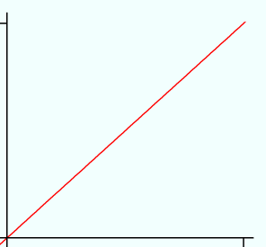
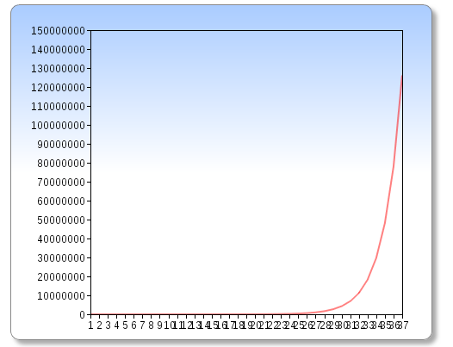
Recursive, runs in O(2^n) time:

Memoized (y=x-1), runs in O(n) [linear] time:

