**LCD 16x2**

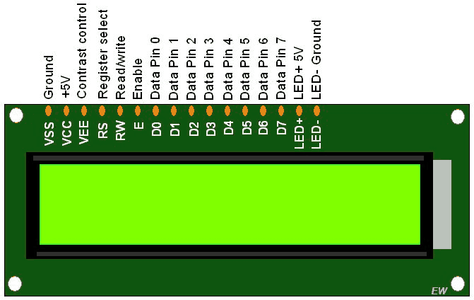

**+Definition:**

**LCD** is a electric device for display data. It has 16 Column with 2 Row.

**+ Library**: LiquidCrystal.h

- LiquidCystal allows you to control LCD displays that are compatible with the Hitachi HD44780 Driver.  
 - It has 16-pin interface.  
**+ PIN**:

- **Register select** (RS) pin: that select reading or writing mode.  
 - **Enable pin**: that enables writing to the registers.  
 - **8 data pins** (D0-D7): The state of these pins (High or Low) are the bits that you’re writing to a register when you write or value you’re reading when you read.  
 **-** display constrast pin (Vo): Use for contrast data on LCD when you display.

**+** (+5V, Gnd, LED+, LED-) :   
 - are power supply pins that you can use to power the LCD

- control the display contrast  
 - turn on and off the LED backlight  
  
**+ Processing**:

- putting the data that form we want to display into the data register.   
 - The LiquidCrystal Library simplifies this for you so you don’t need to know the low-level instructions.

+ The Hitachi-compatible LCDs: can control in two modes: 4-bit or 8-bit

- The 4-bit mode requires seven I/O pins from the arduino.  
 - The 8-bit mode requires eleven I/O pins from the arduino.  
 **+Set up:**  
  
 1. connect 5v with VCC, ( LED+, or A )  
 2. connect gnd with VSS, RW, ( LED**-** , K )

3. connect PIN 6 with (VEE, Or Vo)  
 4. connect PIN 12 with RS  
 5. connect PIN 11 with E

**Digital PIN for data**  
 6. connect D5(Arduino) with D4(LCD)  
 7. connect D4(Arduino) with D3(LCD)  
 8. connect D3(Arduino) with D2(LCD)  
 9. connect D2(Arduino) with D1(LCD)

10. add 240Ω between 5v and (LED+ , A)  
**+ Code**:

#include<LiquidCrystal.h>

LiquidCrystal lcd(12, 11, 5, 4, 3, 2);

void setup(){

analogWrite(6, 70);

lcd.begin(16, 2);

lcd.setCursor(0, 0);

lcd.print("Group 3");

lcd.setCursor(0, 1);

lcd.print("Calculator");

}  
**+ Explain**:  
 1. We include header file name LiquidCrystal.h  
 2. We declare lcd variable with digital pin of LCD(12, 11, 5, 4, 3, 2)  
 3. we call analogWrite and put Digital pin 6 on arduino that connect to **Vo** on LCD with contrast 70  
 4. we call lcd.begin(16, 2) to initalize lcd with 16 column and 2 row  
 5. we set cursor for display row0 and colum0 by call **lcd.setCursor(0, 0)** 6. and then we display “Group 3” on lcd by call **lcd.print(“Group 3”);**

**+ Result**:

