Group: 3
Name: Corn Daveat

Exercise

Sample Receipt:
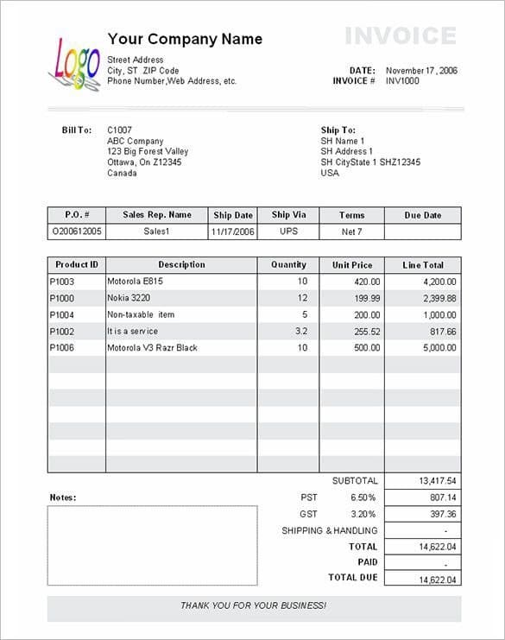

UNF Form

Master section:

Invoice no | Date | Street | City | Phone | Bill to | Ship to | Sub Total | PST 6.50% | GST3.20% | Shipping & Handling | Total | Paid | PID | Des | Qty | Unit Price | Line Total | P.0.# | Sales Re Name | Ship Date | Ship Via | Terms | Due Date | Due
INV1000 | Novermber 17, 2006 | 22E1 | Phnom penh | +85511223344 | C1007, PP | 2119  BTB | 13,417.54 | 807.14 | 397.36 | - | 14,622.04 | 14,622.04 |  |  |  |  |  |  |  |  |  |  |  | -

PID | Des | Qty | Unit Price | Line Total
P1003 | Motorola E815 | 10 | 420.0 | 4,200.00
P1000 | Nokia 3220 | 12 | 199.99 | 2,399.88
P1004 | Non-taxable item | 5 | 200.00 | 1,000.00
P1002 | It is a service | 32 | 255.52 | 817.66
P1006 | Motorola V3 Razer Black | 10 | 500.00 | 5,000.00

