**+ ADC Inputs or Analog PIN (A0, A1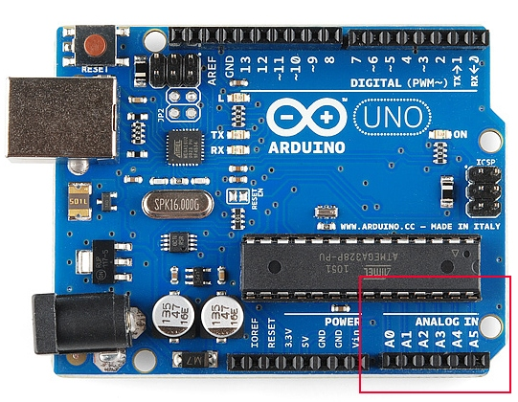, A2, A3, A4, A5):**

- Analog pin has 6 channels – PORTC0 to PORTC5 – with 10-bit resolution A/D convertor.

- These pins are connected to the analog header on the Arduino board.

**- It doesn’t only dedicated input for A/D function, But the reality is that you can use them as digital I/0.  
  
+ TWI:**

The I2C or Two Wire Interface is an interface consisting of only two wires, serial data, and a serial clock: SDA, SCL.

You can reach these pins from the last two pins in the digital header or pin4 and pin5 in the analog header.  
  
+PIN13:

- This is connected to the SCK pin from the MCU and is also connected to an LED. ­The Arduino board uses a buffer (the LMV358) to drive the LED