**Keypad**

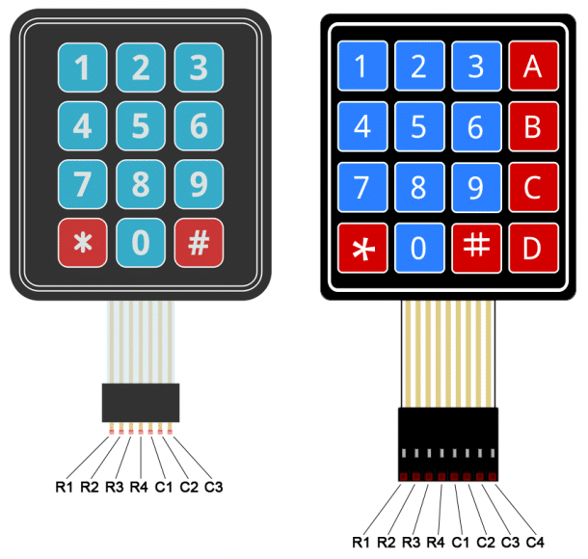

**+Definition:**  
 - A Keypad is a set of buttons arranged in block or pad which bear digit, symbols or alphabetical letters

- Keypad has 2 type 4x4 (4Colum, 4Row) and 4x3(4Column, 3Row).

**+ Library**: Keypad.h

- Keypad is a library for using matrix style keypads with arduino.  
 - It is readability of the code by hiding the pinMode and digitalRead calls for the user.

**+ Set up:**

1. connect R1 with D10

2. connect R2 with D9  
 3. connect R3 with D8  
 4. connect R4 with D7  
 **Use Analog PIN**  
 5. connect C1 with A0  
 6. connect C2 with A1  
 7. connect C3 with A2  
 8. connect C4 with A3  
  
**+ Code**:

#include<Keypad.h>

const int ROWS = 4; // declare variable for rows

const int COLS = 4; // declare variable for column

char customKey;

char hexaKeys[ROWS][COLS] = {

{'1', '2', '3', '+'},

{'4', '5', '6', '-'},

{'7', '8', '9', '*'},

{'C', '0', '=', '/'},

}  
 byte rowPins[ROWS] = {10, 9, 8, 7};

byte colPins[COLS] = {A0, A1, A2, A3};

Keypad customKeypad = Keypad(

makeKeymap(hexaKeys),

rowPins,

colPins,

ROWS,

COLS

);  
  
 void setup(){

Serial.begin(9600);

}

void loop(){  
 customKey = customKeypad.getKey(); // Get data press key  
 if (customKey != NO_KEY){

Serial.println(customKey);

}

}

**+ Explain:** 1. we include header file name Keypad.h.  
 2. declare 2 variable row and column type integer and assign value 4.  
 3. declare variable **customKey** type char for get data from Keypad.  
 4. we declare 2 dimensional array for row and column and assign with value follow along keypad and change   
 last column for arithmetic symbol.  
 5. we declare 2 variables type byte rows and column for connect with arduino pin, Row{10, 9, 8, 7}, Column{A0, A1, A2, A3}.  
 6. We declare customKeypad type Keypad and initialize with our variable we were declared,   
 - first paremter: take address **makeKeymap(hexaKeys). MakeKeymap** that address to a char pointer.  
 - second and third paremter: take rows and column that assign with digital pin on arduino.  
 - fourth and fifth parameter: take and row and column size.   
 7. We use serial monitor for display data and call Serial.begin(9600) for initialize serial monitor with address 9600.  
 8. Inside loop function, we assign our customKey assign equal customKeypad.key() method.  
 9. We check customKey for input key  
 - if not yet pressed and then wait.  
 - else display our data that value get as ASCII code display on Serial monitor