**LCD 16x2**

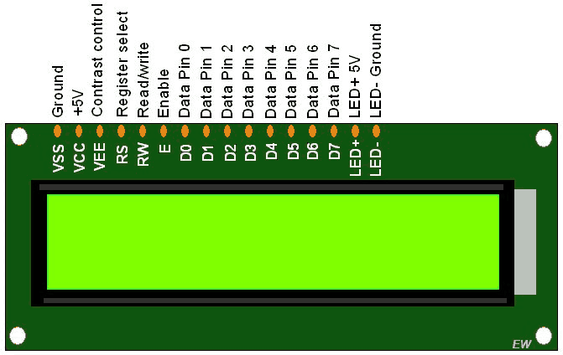

**+Definition:**

**LCD** is a electric device for display data. It has 16 Column with 2 Row.

**+ Library**: LiquidCrystal.h

- LiquidCystal allows you to control LCD displays that are compatible with the Hitachi HD44780 Driver.  
 - It has 16-pin interface.  
**+ PIN**:

- **Register select** (RS) pin: that select reading or writing mode.  
 - **Enable pin**: that enables writing to the registers.  
 - **8 data pins** (D0-D7): The state of these pins (High or Low) are the bits that you’re writing to a register when you write or value you’re reading when you read.  
 **-** display constrast pin (Vo): Use for contrast data on LCD when you display.

**+** (+5V, Gnd, LED+, LED-) :   
 - are power supply pins that you can use to power the LCD

- control the display contrast  
 - turn on and off the LED backlight  
  
**+ Processing**:

- putting the data that form we want to display into the data register.   
 - The LiquidCrystal Library simplifies this for you so you don’t need to know the low-level instructions.

+ The Hitachi-compatible LCDs: can control in two modes: 4-bit or 8-bit

- The 4-bit mode requires seven I/O pins from the arduino.  
 - The 8-bit mode requires eleven I/O pins from the arduino.  
 **+Set up:**  
  
 1. connect 5v with VCC, ( LED+, or A )  
 2. connect gnd with VSS, RW, ( LED**-** , K )

3. connect PIN 6 with (VEE, Or Vo)  
 4. connect PIN 12 with RS  
 5. connect PIN 11 with E

**Digital PIN for data**  
 6. connect D5(Arduino) with D4(LCD)  
 7. connect D4(Arduino) with D3(LCD)  
 8. connect D3(Arduino) with D2(LCD)  
 9. connect D2(Arduino) with D1(LCD)

10. add 240Ω between 5v and (LED+ , A)  
**+ Code**:

#include<LiquidCrystal.h>

LiquidCrystal lcd(12, 11, 5, 4, 3, 2);

void setup(){

lcd.setCursor(0, 0);

lcd.print("Group 3");

lcd.setCursor(0, 1);

lcd.print("Calculator");

}

**+ Result**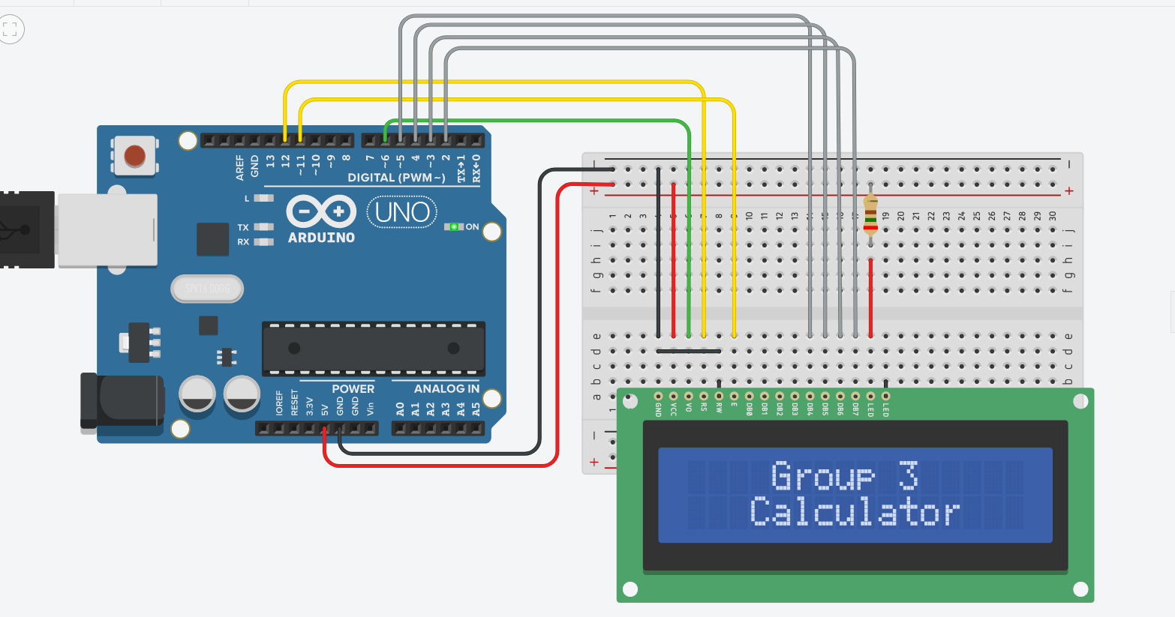:

---------------------------------------------------------------------------------------------------------

**Keypad**

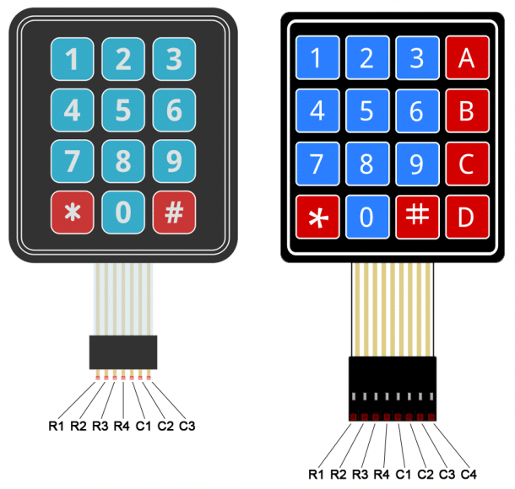

**+Definition:**  
 - A Keypad is a set of buttons arranged in block or pad which bear digit, symbols or alphabetical letters

- Keypad has 2 type 4x4 (4Colum, 4Row) and 4x3(4Column, 3Row).

**+ Library**: Keypad.h

- Keypad is a library for using matrix style keypads with arduino.  
 - It is readability of the code by hiding the pinMode and digitalRead calls for the user.

**+ Set up:**

1. connect R1 with D10

2. connect R2 with D9  
 3. connect R3 with D8  
 4. connect R4 with D7  
 **Use Analog PIN**  
 5. connect C1 with A0  
 6. connect C2 with A1  
 7. connect C3 with A2  
 8. connect C4 with A3  
  
**+ Code**:

#include<Keypad.h>

const int ROWS = 4; // declare variable for rows

const int COLS = 4; // declare variable for column