OUR LADY OF GUADALUPE QUASI-PARISH
Brgy. Mua-an, Kidapawan City
PROPOSAL FOR THE PURCHASE OF THE PARISH DOMAIN NAME
guadalupemuaan.org
To: | OLG Quasi-Parish Finance Council
Noted by: | Rev. Fr. Maximo Lapaz__________,  Parish Priest / Administrator
Prepared by: | Ruben B. Duran  Volunteer App/Website Developer
Date: | October 6, 2026
Amount requested: | ₱1,826.12 (one-time upfront payment)

1. Purpose
This proposal requests approval and release of funds to purchase the internet domain name guadalupemuaan.org or any better domain name that the PPC thinks best through Hostinger. The domain will serve as the official web address of Our Lady of Guadalupe Quasi-Parish, where parishioners register and conduct online census easily, also the public can find Mass schedules, announcements, sacramental requirements and contact details.

2. Benefits and Importance
- Official and trustworthy presence. A parish-owned web address shows that information comes from the parish itself, not from an unofficial or personal page.
- Protects the parish name. Securing the name now prevents other people from registering it and using it in a misleading way.
- Reaches more people. Parishioners working away from home, OFW families, visitors and pilgrims can find the parish through Google search, not only through Facebook.
- Professional parish email (optional). The domain can later be used for addresses such as office@guadalupemuaan.org, which look more official than personal email accounts.
- Low cost. The total of ₱1,826.12 covers two years, roughly ₱76 per month.

3. Scope of the Deal

3.1 What is included in this purchase
Item | Regular price | Price to pay
Domain registration: guadalupemuaan.org (2 years) | ₱2,138.00 | ₱1,608.00
ICANN fee (required registry fee) | — | ₱22.46
Domain privacy protection (hides personal contact details from public records) | — | Free
Hostinger Unlimited hosting plan (1 month trial) | ₱449.00 | Free
Taxes | — | ₱195.66
TOTAL (one-time upfront payment) | ₱2,805.12 | ₱1,826.12
Note: Although this is the first payment, it covers the first two (2) years of domain registration, not just one year. Hostinger requires a 2-year minimum at this promotional price.

3.2 What is NOT included
- Optional "Domain Shield" premium protection (₱1,176 for 2 years). Not needed if auto-renew is turned on and renewals are paid on time.
- Website hosting beyond the free first month. Hosting will be the subject of a separate proposal once the website plan is final. Free hosting options are also being considered.
- Other domain extensions (.com, .net, .io, .online) offered at checkout.
- Website design and content. This purchase secures the address only. The website itself will be built separately.

3.3 Renewal (future cost)
After the first two years, Hostinger lists the renewal at ₱1,069.00 per year, billed for two years at a time (about ₱2,138 per renewal, plus ICANN fee and applicable taxes). The Finance Council should include this in the parish budget for October 2028. Renewal prices may change; the actual amount will be confirmed before renewal.

3.4 Conditions and safeguards
- The domain will be registered in the name of Our Lady of Guadalupe Quasi-Parish, using an official parish email account, not a volunteer's personal account.
- Login details will be kept by the parish office, with at least two authorized persons having access.
- Auto-renew and two-factor authentication (2FA) will be turned on to avoid losing the domain.
- The official receipt / invoice from Hostinger will be submitted to the Finance Council after payment.

Attachment A: Hostinger Price Quotation
Screenshot of the Hostinger checkout page for guadalupemuaan.org, taken October 6, 2026, showing the order summary and total of ₱1,826.12.
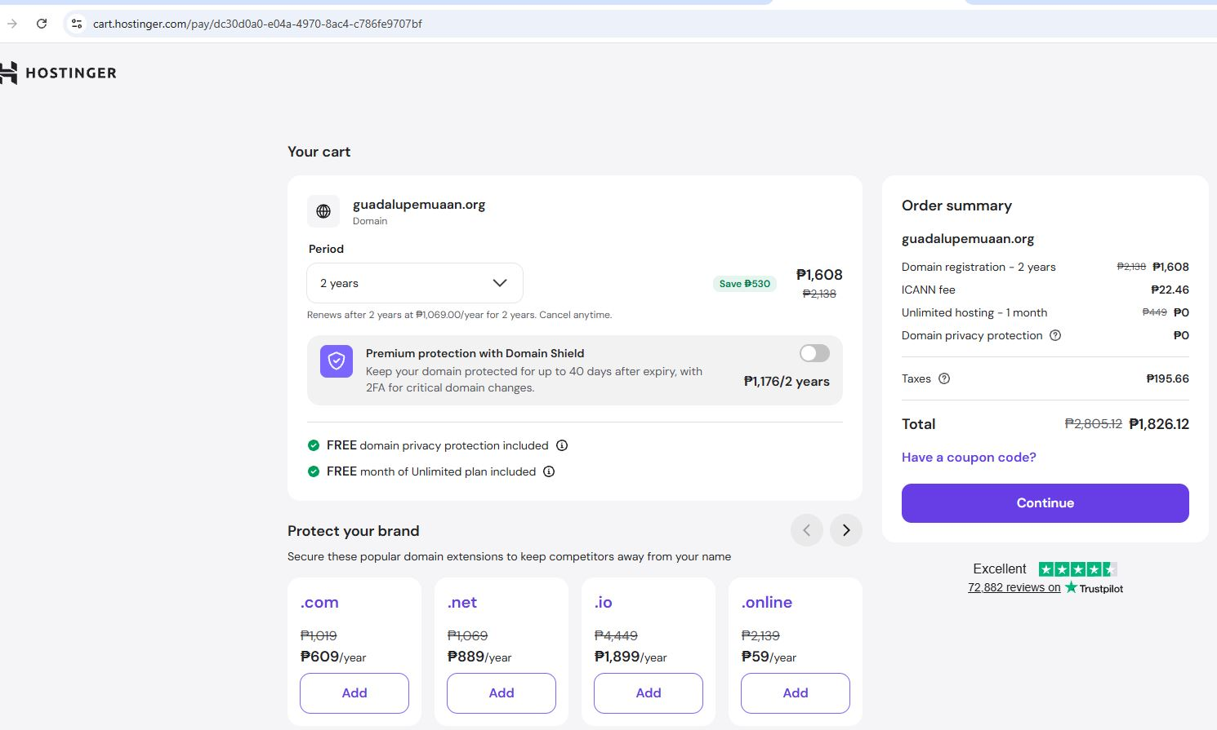
Promotional prices shown are valid at the time of the screenshot and may change if payment is delayed.
4. Request for Approval
The Finance Council is respectfully requested to approve the release of ₱1,826.12 for the purchase of the domain name guadalupemuaan.org as described above.
______________________________________  Prepared by  Name and Signature | ______________________________________  Noted by  Parish Priest / Administrator
______________________________________  Approved by  Chairperson, Parish Finance Council | ______________________________________  Date approved

