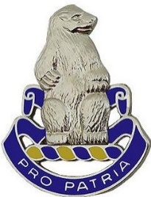**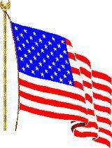ProPatriaPress**

**#93**  **November 2019**

**Newsletter of the 31st US Infantry Regiment Association**

***Editor:Louis Dominguez (louisca5@global.net)* _________________________________________________________________________________________**

**FIRST AN APOLOGY**

This edition of the Newsletter was planned to be published and distributed by the end of July. Due to medical issues, other commitments, and incomplete coordination/follow-up it did not happen. For that failure all of us responsible for making it happen ask for forgiveness. This updated edition has the first details of the Reunion 2020. The next edition of the Newsletter will be in February 2020

**OUR COMMANDER SAYS: “IT’S GETTING CLOSER”**

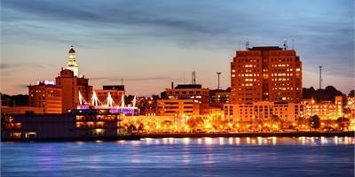Our ever capable, ever ready, and always smiling Commander Charlie Tapp has done it again. He has been busy doing the important leg work to build a reunion program for next year’s 2020 Reunion in September at the Quad Cities along the Mississippi. Not only has he found a wonderful hotel that can accommodate our reunion needs but he negotiated a really great rate. In addition, he has put together a schedule of events that will ensure that everyone who attends will have a grand time. The registration form and a flier about Reunion 2020 are in this edition of the Newsletter. More details of the Reunion will be published in the February 2020 Newsletter. So, put the dates of 19-23 September 2020 on your calendar and get ready for a great reunion of current and former Soldiers of the 31st US Infantry Regiment and their families at the Quad Cities of Moline, IL; East Moline, IL; Rock Island, IL; Bettendorf, Iowa; and Davenport, Iowa. **You All Come Now, You Hear!**

**Hightlights in this Edition**

Bringing Them Home - Page 2 The Other Polar Bears - Page 3

Reunion 2020 Flier - Page 4 Reunion Registration Form - Page 5

Farrell Lowe the Oldest Member - Page 6 4/31 Redeploys Home - Page 7

A Bataan Soldier Comes Home - Page 7 QM Sales Order Form - Page 9

**BRINGING THEM HOME**

During the Polar Bear deployment to Siberia, 32 soldiers became combat casualties. Another 59 members of the Regiment died from other causes, almost all from disease--victims of the influenza pandemic of 1918-19. The dead were buried in Siberia and remained there when the last 31st contingent left in April 1920. But based on the Army’s tradition of bringing all our troops home, the remains were soon returned, in October of that year.

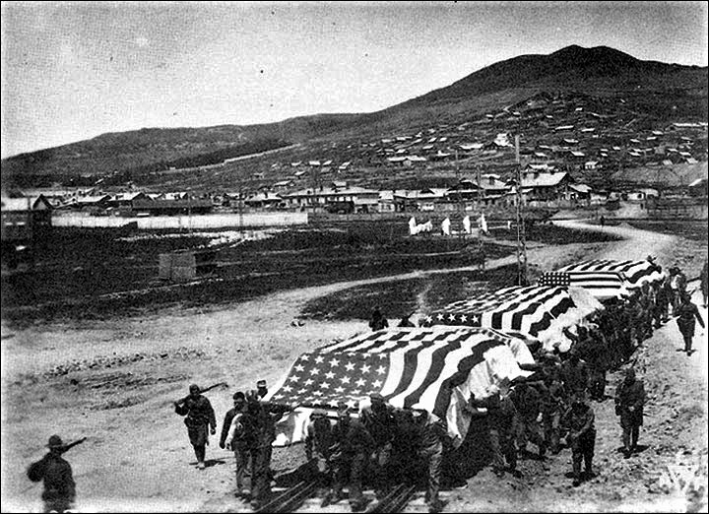

Bringing our KIAs home is a long-standing tradition, no matter how long it takes. As reported in an earlier Newsletter PFC Morris Worrell, F Company, 2-31 having survived the Bataan Death March, died in the Cabanatuan POW Camp. At the end of the war his remains couldn’t be identified, so he was buried in a common grave in the Manila American Cemetery. Over seven decades later, with new identification methods available, his remains were exhumed. In 2018 he was positively identified and interred with honors in his hometown of Wisner, NE.

Perhaps the 31st Infantry’s best known example of delayed identification is the return of LTC Don Faith’s remains. LTC Faith was the commander of 1st Battalion 32nd Infantry attached to the 32st Infantry Regiment for operations at the Chosin Reservoir in the Korean War. LTC Faith became the commander of the 31st Infantry Regiment during the battle and was killed leading counterattacks to keep the withdrawal route open for elements of the Regiment and the 5th Marine Division. For his actions he won a posthumous Medal of Honor. He was declared KIA, Remains Not Recovered. Sixty-three years later, North Korea released his remains and he was interred with full military honors at Arlington National Cemetery.

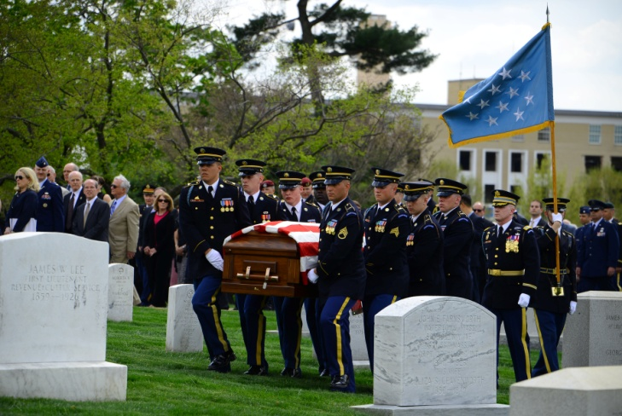

The work goes on. The Defense POW/MIA Accounting Agency has the lead and continues to seek the remains of 16,724 soldiers from WWII, 5,823 from Korea, and 512 from Vietnam. The searchable website, with names, is [www.dpaa.mil](http://www.dpaa.mil).

**The Other Polar Bears**

# Recently, one of our members gave a talk at a local library on the history of the 31st Infantry Regiment. The librarian put out some books on the Army including one that was brand new. This book was called ***The Polar Bear Expedition: The Heroes of America's Forgotten Invasion of Russia,*** *1918-1919* byaward-winning historian James Carl Nelson*.* Our member was confused when he saw it as he had no idea of what it was about. It turned out to be about the 339th Infantry Regiment (Detroit’s Own) of the 85th Infantry Division.

# The 339th trained thinking they would be joining the war on the western front but instead were sent to north of the Arctic Circle to Archangel, Russia. There they were put under the control of the British Army who were under the false impression that all the allies had to do was show the flag and the people of Russia would rise**-**up and turn on the Bolsheviks. To accomplish this the British ignored one of the basic principles of warfare and pieced out the regiment in small units, often as small as platoons. During the summer and fall they British had gunboats to support and supply the troops. However, when the cold came and the rivers froze the allied troops were left cut off while the Red army, using superior internal lines of communication, eventually grew to an army estimated at 60,000.

# One interesting item was the fact that the Reds had to take off some of the pressure on the 339th to move to another trouble spot in Siberia. So there was a definite tie between the two regiments even if they did not know it.While the west has forgotten that once a hundred years ago Americans fought Russians on their soil the Russians have not and have brought it up at various times up to the present. It appears that most Americans haves forgotten, but Russia has not.

# A lost chapter of American history—the invasion of Russia one hundred years ago during the last days of the Great War.In the winter of 191**8**, 5,000 U.S. soldiers, nicknamed “The Polar Bears,” found themselves hundreds of miles north of Moscow in desperate, bloody combat against the newly formed Soviet Union’s Red Army. Temperatures plummeted to sixty below zero. Their guns and their flesh froze. The Bolsheviks, camouflaged in white, advanced in waves across the snow like ghosts.This group of Polar Bears, hailing largely from Michigan, heroically waged a courageous campaign in the brutal, frigid subarctic of northern Russia for almost a year. And yet they are all but unknown today. Indeed, during the Cold War, two U.S. presidents, Ronald Reagan and Richard Nixon, would assert that the American and the Russian people had never directly fought each other. They were spectacularly wrong, and so too is the nation’s collective memory.

# The American Expeditionary Force, North Russia, had been sent to fight the Soviet Red Army and aid anti-Bolshevik forces in hopes of reopening the Eastern Front against Germany. And yet even after the Great War officially ended in November 1918**.** More than two hundred Polar Bears perished before their withdrawal in July 1919. But their story does not end there. Ten years after they left, a contingent of veterans returned to Russia to recover **t**he remains of more than a hundred of their fallen brothers and lay them to rest in Michigan, where a monument honoring their service still stands.More than two hundred Polar Bears perished before their withdrawal in July 1919. But their story does not end there. Ten years after they left, a contingent of veterans returned to Russia to recover the remains of more than a hundred of their fallen brothers and lay them to rest in Michigan, where a monument honoring their service still stands. In the century since, America has forgotten the Polar Bears’ harrowing campaign. Russia,

REUNION 2020 QUAD CITIES IL/IL – SEPTEMBER 19-23

**REGISTRATION FORM REUNION 2020**

31st U.S. Infantry Regiment Association

Quad City; Rock Island; IL

Sept 19-23, 2020

Name: _______________________________________________________________________________

Guest(s): _____________________________________________________________________________

Home Street Address: __________________________________________________________________

City: ______________________________________ State: _____________ ZIP Code: ______________

E-mail: ________________________________________ Phone: _______________________________

Company & Battalion of the 31st Infantry: ________________________ When: __________________

If active duty, Current Rank: __________________ Post stationed at: ___________________________

Served in Combat Zone: Yes / No (Circle) If Yes, where: _________________________________

Will you be staying at Holiday Inn Rock Island Yes / No (Circle)?

Have a car at the reunion? Yes / No If needed, are you willing to assist in local driving? Yes / No

**Reunion Activity Cost per Person X # Participating = Event Cost**

Reunion Registration $40 x _______ $ _________

Reunion Arrival Dinner $27 x _______ $ _________

Rock Island Arsenal Tour $15 x ________ $__________

Celebration Dinner Cruise $60 x ________ $__________

Reunion Banquet $40 x _______ $__________

John Deere Factory Tour $15 x _______ $__________

**Grand Total** **$ __________**

Make checks payable to**: 31st US Infantry Regiment Association Attn: Joe DeAngelis 3035 El Rio Dr Meridian Idaho 83642**

**Hotel and Travel Information: $85.00 all In Daily Hot Breakfast**

**Holiday Inn & Conference Center Quad City International Airport (MOL)**

**226 17th Street**  Free airport / Hotel Shuttle

Rock Island Il 61201Airport serviced by all major carriers. www.holidayinn.com/rockisland

**Reserve Room at (309-794-1212)**

The Story of Farrell Lowe

Once the Oldest Living Association Member - Part One

Composed by Ron Corson; Narrated and Lived by Farrell Lowe

This is a re-edition of a piece first published 5 years ago. Farrell Lowe has since passed on.

A few years ago when I was the membership chairman of the Association, I had the opportunity and tasking to routinely call a number of our members, especially some of our older members, to verify things such as addresses and membership status. While these calls were a part of my duties, they are much more than that because they have given me the opportunity to meet and know, over the phone, some really interesting and engaging veterans of our Regiment. One call that I made turned out to be to the then oldest living member of the Association and the Regiment. I called Mr. Farrell D. Lowe at his home in Kirkwood, Missouri. He served in the Regiment in the Philippines from 1932 to 1936. I first called Farrell in 2012. He announced that he knew that he was the oldest Polar Bear because he was 102 years old.

What I found out during that wonderful telephone call was that Farrell Lowe was born on November 13, 1912, in Willard, Utah. His family later moved to a farm in Parker, Idaho. Farrell had to drop out of the University of Idaho after his first semester due to bank failures which caused his father to lose his farm. He moved with his parents back to Willard. After a few months of doing odd jobs, Farrell was advised by an uncle to enlist in the Army and to apply for an appointment to West Point. Almost overnight, he was on a ship headed to the Philippines where he joined the 31st Infantry Regiment. He was initially assigned to “F” Company where he received the nickname “Chick” when someone commented that “the kid would be eaten like a spring chicken” after being assigned to “F” Company.

He found out through his First Sergeant that two appointments to West Point were open to the Philippines Department. Farrell was one of five applicants – the other four were sons of West Point graduates stationed in the Philippines. The five applicants were sent to Nichols Field for a period of time to determine who would get the two appointments. Farrell was #2 but, a few days before getting on the troop transport back to the U.S., Farrell received instructions to report for a final physical examination. Having “farm boy experience”, he was in good physical condition and worried not one bit. He was surprised to receive the report of his physical examination, which he still has, stating that a hearing defect made him ineligible for West Point. The next applicant in line took his place at West Point!

One of Chick’s interesting experiences in the Philippines involved the heavyweight champion of the 31st Infantry Regiment, Floyd Barnhart, who decided that F Company should have another regimental boxing title. He trained Chick to enter the Regimental Day boxing tournament as an applicant for the flyweight title. When Chick entered the ring there were no other applicants for the title, so it was granted to him without a punch being thrown!

In late 1932, the Regimental Sergeant Major, Jim Screen, sent an invitation through First Sergeant Keyes for Chick to transfer to Service Company and come to work at Regimental/Post HQ. Lowe accepted, with First Sergeant Keyes advice, and was assigned to the Message Center. The Message Center was the nerve center of the Regiment. It received all the incoming and outgoing communications, published internal orders, prepared the monthly newsletter, and filed all Army Department Regulations, Regiment Regulations/Orders. Back in those days, every rank from PFC to Sergeant E-5, including specialists, belonged to the unit. When a person left the unit, they left their rank and were reassigned as Privates to their new unit. In a year, Chick was quickly promoted to PFC. Making rank that fast was almost unheard. Typically, occupants of any of non-rank holding positions stayed in the unit as long as possible. When a Soldier’s three-year appointment was completed, the occupants usually applied for an extension of their service. But this is only Part One of the PFC “Chick” Lowe story – to be continued.

**The 4th Battalion Redeploys to Home Station**

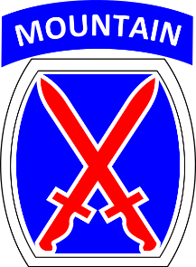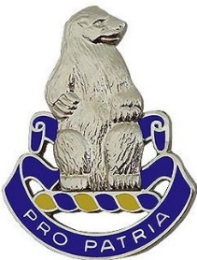It started in July of this year, but it took several weeks before all elements of 4/31 Infantry to return home to Fort Drum from a nine-month deployment to Afghanistan. The battalion spent its tour split between Bagram Airfield (BN HQs, HHC, Charlie, Bravo, and Hotel Companies) and Kandahar Airfield (Alpha and Delta Companies). The overall mission of the unit on its deployment was to execute rapid response missions as the Theater Response Force. The Battalion was used by GEN Scott Miller, the Commander of Resolute Support, to secure remote bases temporarily to enable SOF operations and support Advisory Missions. The Polar Bears conducted operations throughout the country in all seven Train Advise Assist Commands (TAACs) in Afghanistan. While the mission was training and assistance, that did not mean the Soldiers of the 31st were not engaged in combat actions. The Battalion earned over 400 Combat Infantry Badges, Combat Air Badges and Combat Medical Badges. Two Polar Bears earned Purple Hearts and luckily there were no serious injuries. Since redeploying, all the battalion’s companies have re-integrated into 10th Mountain training and will deploy to the Joint Readiness Training Center at Fort Polk. LA in April of 2020.

**ANOTHER BATAAN SOLDIER COMES HOME**

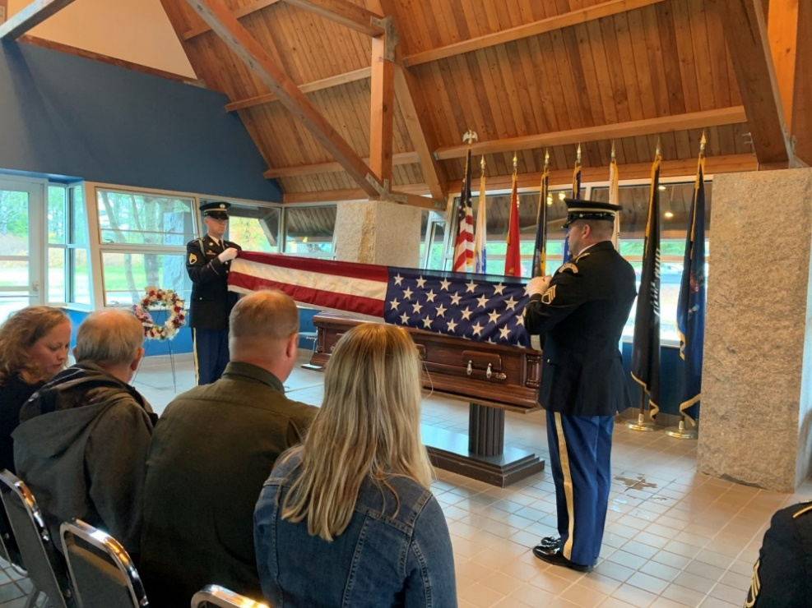In late October, the commander of the 4th Battalion, LTC Steven Wallace and the Battalion Sergeant Major, CSM Gavin Holmes, participated in a repatriation ceremony in Augusta, Maine Veterans Cemetery for a Soldier of the 31st US Infantry Regiment. While the remains were discovered in the Philippines in 2014, to took DNA Testing now available for the Army to identify the remains as those of SGT Lawrence Hanscom. SGT Hanscom served in E Company, 2nd Battalion, 31st US Infantry Regiment in the Philippines. He had fought in Bataan in World War II and survived the Bataan Death March only later to dieas a POW in Camp Cabanatuan Prison in the Philippines. As part of the burial ceremony, Dave Erickson, Hanscom’s nephew, was presented with SGT Hanscom’s awards by LTC Wallace – the Bronze Star Medal and Purple Heart. Following the service, CSM Holmes placed a regimental unit coin in the casket before it was sealed. After the ceremony, SGT Hanscom’s niece, Lisa Erickson, said it was difficult to express how honored their family was to have members of 4-31 Infantry travel from Fort Drum for the ceremony. She said it was especially poignant for the command team to present their uncle’s service medals to his nephew. **Pro Patria**

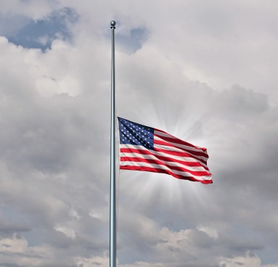

**TAPS**

At the time this edition was assembled, no listing of those members who have passed on since our reunion in May was available. Determining who of our members have died is and has been a problematic issue. If you as a member have a buddy or know of one of our members who have died, please send that information to our Membership Chairman, Jim Tierney or Jim Simms (Their contact info is on the listing of Association Officers).

**\*\*\***

**NEW MEMBERS - 2019**

|  |  |  |  |  |
| --- | --- | --- | --- | --- |
| Cameran Jacques | A CO | 4/31st | SP4 | Active duty |
| Sean Petit | D CO | 4/31st | SSG | Active duty |
| Michael S Bathrick | C CO | 4/31st | SP4 | Active duty |
| George Allen | B CO | 4/31st | SP4 | Active duty |
| Colter Guion | D CO | 4/31st | PFC | Active duty |
| Zachary Harnish | D CO | 4/31st | CPT | Active duty |
| Gerard (Jerry) G Keller | HHC | 1/87th |  | Active duty Dave Wilson's Son-in-Law |
| John M Wylie | E CO | 6/31st | SP4 | 4/1968-4/1969 |
| Richard A Martinez | C CO | 4/31st | SGT | 1968-1969 |
| Lynn W Folliott | D CO | 4/31st | SGT | 6/1968-4/1969 |
| Timothy F Ryan | C CO | 4/31st | SP4 | 1970-1971 |
| David M Pruitt | B CO | 6/31st | SP4 | 1968-1969 |
| Isamu M Long | C CO | 6/31st | SP5 | 1968-1970 |
| Daniel P Rayca | HCC | 4/31st | CPT | 1999-2002 |

**31st US INFANTRY REGIMENT ASSOCIATION QUARTERMASTER STORE ORDER FORM**

***Visit 31stinfantry.org and click on 31st Infantry Store to see a full color catalogue of these and many more items***

**Name:___________________________________________ Telephone ________________________________________**

**Address:_______________________________________________________________________________________­____**

**City:_______________________________ State:___________ Zip:__________ E-mail :_________________________**

**Cat # Description Price Qty Total**

B 102 Book, 31st Infantry Regiment “America’s Foreign Legion” in peace and war (Includes shipping)

Do not include this in shipping cost at bottom of form $40.00 X___=________

C 100 Coin, Commemorative, 100th Anniversary $10.00 X___=_______

C100AT Air Tight capsule for 100th Anniversary commemorative coin $1.50 X___=_______

C100EB Easel, black *both the black and clear easels are for Air Tight capsule with 100th* $1.50 X___=_______

C100EC Easel, clear *Anniversary commemorative coin or the Commemorative coin alone* $1.50 X___=_______

C RB 02 Cap, Royal Blue, 31st INFANTRY REGIMENT, POLAR BEARS, and crest embroidered $17.00 X ___=_______ directly on cap and US ARMY embroidered on back.

C RB Cap same as C RB 02 above with the addition of a waving U.S. flag on the left side and a combat

patch (Philippines Division; 7th Infantry Division; 196 Light Infantry Brigade; 9th Infantry Division;

10th Mountain Div) on the right side. Circle the patch you want. $18.00 X___=_______

C K *NEW CAP!* same as C RB above but in Khaki with a waving U.S.flag on the left side and a combat patch

*(Philippines Division; 7th Infantry Division; 196 Light Infantry Brigade; 9th Infantry Division;*

*10th Mountain Div)* on the right side. Circle the patch you want). All embroidery is subdued.$18.00 X___=_______

SP Shirt, Polo/golf w/31st INFANTRY REGIMENT and polar bear crest on left chest, no pocket

Please circle color and size. Size S, M, L, XL White, Light Blue, Navy Blue $29.00 X___=_______

Size 2XL White, Light Blue, Navy Blue $31.00 X___=_______

SP100 Same as above with 100th Anniversary logo in White only Size: S ~~M~~ (Sold out), L XL $31.00 X___=_______

Size: 2XL $33.00 X___=_______

Size: 3XL $35.00 X___=_______

ST Shirt, Tee, w/31st INFANTRY REGIMENT and polar bear crest on left chest, no pocket

Size S, M, L, XL Light Blue, Navy Blue $ 16.00 X___=_______

Size 2XL Light Blue, Navy Blue $ 19.00 X___=_______

Size 3XL Light Blue, Navy Blue $ 21.00 X___=_______

SLSVC Shirt, Long Sleeve, Dress in various colors w/31st INFANTRY REGIMENT and polar bear crest on left chest above pocket.

**Please circle color and size.** **Size**  S M L XL $30.00 X ___=_______

**Colors:** Black, Navy Blue, Light Blue, Red, White, Texas Orange, Burgundy, or Denim **Size**  2XL $32.00 X___=_______

**Size** 3XL $36.00 X___=_______

MS 01 Shanghai Bowl Cup, silver, 2007 reproduction of original. (Includes shipping)

**Do not include this in shipping cost at bottom of form** $165.00X___=_______

DCL 01 Bumper sticker, 31st Infantry crest (Polar Bear), 4-3/8” tall, 4-1/4 wide $3.00 X___=_______

PN 01 Pin, 31st Infantry Regimental crest (Polar Bear) , regulation size, facing set. $ 8.00 X___=_______

PN 02 Pin, 31st Infantry Reg crest (Polar Bear) , lapel/hat pin. 7/8” tall, ¾” wide 1-1/4” wide $ 3.00 X___=_______

PN 74 Pin, Combat Infantry Badge, regulation size, 1-1/4” tall, 3” wide $ 4.00 X___=_______

PN 82 Pin, Purple Heart, lapel/hat pin. 1-1/8” tall, 5/8” wide $ 3.00 X___=_______

PN 85 Pin, Silver Star, lapel/hat pin. 1-1/8” tall, 5/8” wide $ 3.00 X___=_______

PN 71 Pin, Bronze Star, lapel/hat pin. 1-1/8” tall, 5/8” wide $ 3.00 X___=_______

**Shipping Charges:** Orders under $10.00 add $2.50; Orders $10.01 - $25.00add $6.00; **SUBTOTAL $_______________**

Orders $25.01 - $50.00, add $7.00; Orders over $50.00, add $9.00 **SHIPPING** **$_______________**

**Add the appropriate shipping charge to your order**

MAKE CHECK OR MONEY ORDER PAYABLE TO: **31ST INFANTRY REGIMENT ASSOCIATION TOTAL $_______________**

**For Credit Cards (American Express, Discover, Master Card, or Visa) or Debit card (with Master Card or Visa logo)** please include

**NAME** (on card):___________________________________ **CARD #:______________________________EXP DATE:_____/_____**

**SECURITY CODE** (on back of card): _________ **ZIP CODE** (where credit card bill is mailed to): ____________________________

**Mail the order form and payment to:** **Dale Mills 337 Carillon Lane. Macon, GA 31210-9711**

**Association Officers**

**Honorary Colonel of the Regiment Robert “Sam” Wetzel LTG Ret** (LTC, 4th Bn, VN 1968)

1425 Dartmouth Rd, Columbus GA 31904 706-576-4204 [wiint322@aol.com](mailto:wiint322@aol.com)

**Commander**: **Charlie Tapp** (SGT/D/6thBn, VN, 1968-69)

215 Waterford Drive Inman, SC 29349 864-473-1999 [ctapp94@$mail](mailto:ctapp94@$mail)

**Vice Commander**: **Dan (Silver Fox) Wood** (CSM/4th Bn, Ft. Drum, 2000-02)

1484 McGill Road Vass, NC 28394 910-633-8397 [wooddr3@gmail.com](mailto:wooddr3@gmail.com)

**Adjutant**: **Vin Zike** (SGT,D/6th Bn,VN, 1969-7

3036 Park Ave,Apt. 3, Rivera Beach,FL33404 914-850-0095 [vinzike@gmail.com](mailto:vinzike@gmail.com)

**Treasurer: Joe DeAngeli**  (SGT,C/6thBn,FtLewis&VN,1967-69)

3035S. El RioDr,Meridian,ID83642 208-362-9468 [jangels10@gmail.com](mailto:jangels10@gmail.com)

**Membership**: **Jim Tierney**  (SSG, A/6th Bn, VN, 1969-70)

1484 Loretta Dr., Pennhills, PA 15235 412-793-7214 [jtier64999@aol.com](mailto:jtier64999@aol.com)

**Quartermaster**: **Dale Mills** (SGT,C/6thBn,VN,1968-69)

6331 Dobson Rd., Macon, GA 31220 478-787-2679 [sdalem@bellsouth.net](mailto:sdalem@bellsouth.net)

**Sergeant at Arms**: **Jim Jaggers** (SGT, D/6th Bn,VN1969)

5638 Camellia Ave,Sacramento,CA 95819 916-455-7879 jaggers.j@att.net

**Historian: Grady Smith** (CPT, D/6th Bn, Ft Lewis &VN, 1967-68)

2321 S. QueenSt, Arlington, VA 22202 703-769-2778 [smithga@verizon.net](mailto:smithga@verizon.net)

**Senior Director: Ron Corson** (CPT, A/6th Bn, VN, 1969-70)

108 Mershon Way, Williamsburg, VA 23185 757-253-1311 [jrcorson@aol.com](mailto:jrcorson@aol.com)

**Northeast Region (**ME, NH, VT, MA, RI, CT, NY) Ivan Barker(1st SGT,F/HHC/4th Bn, Ft Drum, 2012-17)

3127 Cataract ST Copenhagen NY13626 315-286-7696 [barker.ivan@hotmail.com](mailto:barker.ivan@hotmail.com)

**Mid-Atlantic Region** (NJ, PA, DE, MD, DC, VA, WV) **Jim Simms** (LT,HHC &C/4thBn,VN,1969-70)

104 Cumberland Dr, Carlisle, PA17013 717-243-5570 [jnpsim@comcast.net](mailto:jnpsim@comcast.net)

**Southeast Region** (NC, SC, GA, FL, AL, MS, TN, AR, LA, PR, VI) **Noah Halfacre** (LT,E/6thBn,VN, 1968)

2740 Oxford Hall Ave, Murfreesboro, TN 37128 615-892-9715 [gimlet3a@gmail.com](mailto:gimlet3a@gmail.com)

**Great Lakes Region** (KY, OH, MI, IN, IL, WI) **John Howdeshelt** (SGT,D/6th Bn,VN,1969)

78 8 Eagledale Dr, Kettering, OH 45429 937-435-0669 [mamahowdy@yahoo.com](mailto:mamahowdy@yahoo.com)

**Midwest Region** (MN, ND, SD, NE, IA, MO,KS, OK, TX ,NM, CO) **John Mansfield** (LT, A&B/4th Bn, VN 1968)

3100 Chambers St, Sioux City IA 51104 712-277-4498 [arctic6@aol.com](mailto:arctic6@aol.com)

**Western Region** (HI,AK,WA,OR,CA,NV,AZ,UT,ID, MT,WY) **Ron Belloli** (LT,C/6thBn,VN,1967-68)

1250 American Pacific Dr, Apt 214, Henderson, NV 89074 928-380-9577 [ronbob22631@gmail.com](mailto:ronbob22631@gmail.com)

**. . . . . . . . . . . . . . . . . . . . . . . . . . .**

NEWSLETTER CHANGE OF ADDRESS

Cut along dotted line. Fill in requested information & mail to James F. Tierney, Membership Chair, address below.

OR EMAIL JimTierney with this information at [jtier64999@aol.com](mailto:jtier64999@aol.com) Subject: Change of Address.

Name: ________________________________________ Phone number if new: ______________________________

Old Address New Address Mail To:

___________________________ __________________________ JimTierney, Membership Chair

Street or P.O. Box Street or P.O. Box 1484 Loretta Drive

Pennhills, PA 15235

___________________________ __________________________

City/State/Zip City/State/Zip

**Membership Application – 31st US Infantry Regiment Association**

First Name Nickname Middle Initial Last Name

Street Address City State Zip Code Phone Number

E-mail address Alternate E-mail Address

Please fill in as much information about your service/connection with the 31stInfantry as possible:

Platoon__________ Company Battalion

________

Highest Award Earned

Rank & Duty Position when serving with the 31st Rank When Retired/Separated

**Where did you serve with the 31st? When?**

Philippines __________ _______________________________________

Korea __________ _______________________________________

Japan __________ _______________________________________

Vietnam __________ _______________________________________

Iraq __________ _______________________________________

Afghanistan __________ _______________________________________

Other Overseas __________ _______________________________________

USA __________ _______________________________________

**Membership Desired**

**Life Membership Annual Membership per Year**

Active Duty __$25 Current Active Duty Member __$5

Age 49 & under __$60 Prior Member of 31st Unit __$10

Age 50 – 59 __$45 Associate Member (family) __$5

Age 60 & over __$35

Associate Life __$25

Member (family)

Make your check out to **31st Inf Regt Assn** and mail it to our membership chairman**Jim Tierney, 1484 Loretta Drive, Pennhills, PA 15235.**

**31st InfantryRegimentAssociation**

**Jim Tierney**

**1484 Loretta Drive**

**Pennhills, PA 15235**

**Newsletter 93**

### RETURNSERVICEREQUESTED

**Time to Mark your CALENDARS FOR the Next Reunion, 19-23 September 2020**