International Conference on Recent Advancements in Electrical,
Electronics and Computing Technologies (ICE2CT-2026)
Dual-Stream Phase-Aware Inception-Time CNN for Adversarially Robust Spectrum Sensing in V2X Networks

Parveen Dhankhar, Davesh Vats
Department of Computer Science and Engineering
Vaish College of Engineering, Rohtak, India
parveendhankhar2005@gmail.com, vatsdavesh@gmail.com
30th April, 2026 (Thursday)
Venue: Vaish College of Engineering, Rohtak-124001

Abstract
Deep learning-based spectrum sensing is a critical enabler of dynamic spectrum access in Vehicle-to-Everything (V2X) communication networks operating in the 5.9 GHz DSRC band. However, the vulnerability of neural network classifiers to adversarial perturbations poses a serious security threat to safety-critical V2X applications. In this paper, we propose a Dual-Stream Phase-Aware Inception-Time CNN that processes both log-magnitude spectrograms and instantaneous frequency representations to achieve robust multi-class spectrum sensing across LTE, WiFi, V2X-PC5, and noise categories. Our architecture employs Inception-Time multi-scale convolution blocks with parallel 1×1, 3×3, and 5×5 kernels, trained with TF-CutMix augmentation, label smoothing, and Gaussian noise injection. The proposed model achieves 86.67% (±0.72%) classification accuracy using standard training and 87.46% (±0.48%) with adversarial training, evaluated over a rigorous 3-seed protocol with 4,000 synthetic RF samples under Rayleigh fading channels.
We conduct the most comprehensive adversarial evaluation in V2X spectrum sensing to date, testing six white-box attacks (FGSM, PGD-20, APGD-CE, APGD-DLR, FAB, Square) across six perturbation budgets. A critical finding emerges: all gradient-based attacks converge to near-identical ASR (FGSM–PGD gap <1.8 pp, FGSM–APGD gap <0.6 pp at ε ≤ 0.05), demonstrating that the training recipe induces a smooth loss landscape where iterative optimization provides minimal advantage over single-step attacks. A cross-architecture transferability study reveals that the dual-stream fusion achieves the lowest transfer ASR (14–17%) compared to single-stream variants, validating the architectural design. Adversarial training reduces FGSM ASR from 23.25% to 21.12% at ε=0.03 while maintaining comparable clean accuracy—narrowing the traditional accuracy-robustness tradeoff. We introduce channel-aware adversarial evaluation that measures attack effectiveness after adversarial examples pass through a simulated AWGN channel, revealing a significant Sim-to-Real gap: adversarial ASR increases from 23% (no channel) to over 57% at −5 dB SNR due to channel noise interaction. The model achieves 1.43 ms inference latency, well within the 10 ms V2X requirement. Finally, a scenario-stratified evaluation across highway, urban, and rural mobility conditions reveals that adversarial vulnerability is concentrated in urban Rayleigh environments (ASR up to 50%), while Rician fading scenarios (highway/rural) exhibit near-immunity (<2.5% ASR) due to preserved line-of-sight spectral structure.
Keywords: V2X communication, spectrum sensing, dual-stream CNN, inception-time, instantaneous frequency, adversarial robustness, TF-CutMix, adversarial training, channel-aware evaluation, transferability, FGSM, PGD.

1. Introduction
Vehicle-to-Everything (V2X) communication has emerged as a foundational technology for intelligent transportation systems (ITS), enabling critical applications such as autonomous driving, cooperative collision avoidance, and real-time traffic management. The dedicated short-range communications (DSRC) standard, operating in the 5.9 GHz band according to the IEEE 802.11p specification, and the cellular-based C-V2X standard defined by 3GPP represent the two primary technologies for V2X connectivity. As the density of connected vehicles increases, efficient spectrum utilization through dynamic spectrum access (DSA) becomes paramount for maintaining reliable communication links.
Deep learning (DL)-based spectrum sensing has gained significant attention as a promising approach for real-time spectrum classification, outperforming traditional energy detection and cyclostationary feature detection methods, particularly in low SNR environments and under complex Rayleigh fading channels. Despite the remarkable performance of DL-based spectrum sensors, a growing body of research has revealed that neural networks are inherently vulnerable to adversarial examples—carefully crafted input perturbations that cause misclassification while remaining imperceptible to human observers. In the context of wireless communication systems, adversarial attacks can be physically realized by transmitting carefully designed jamming signals that exploit the decision boundaries of DL-based classifiers. This vulnerability is particularly concerning for V2X safety-critical applications, where spectrum sensing misclassification could lead to dangerous communication failures, such as a vehicle erroneously concluding that a frequency band is idle when it is occupied by another vehicle's transmission.
While adversarial robustness has been extensively studied in computer vision and natural language processing, its implications for RF spectrum sensing in V2X networks remain largely uninvestigated. Existing works on adversarial ML in wireless communications have primarily focused on modulation classification and intrusion detection, but no prior study has examined adversarial attacks against DL-based spectrum sensing with physically meaningful evaluation through channel simulation. Furthermore, prior approaches have relied on single-stream magnitude-only spectrogram inputs, ignoring the phase information that is critical for distinguishing modulation types in real RF environments.
The primary contributions of this paper are as follows:
1) We propose a Dual-Stream Phase-Aware Inception-Time CNN that processes both log-magnitude spectrograms and instantaneous frequency representations, enabling the model to leverage modulation characteristics that survive Rayleigh fading channel effects.
2) We conduct the most comprehensive adversarial evaluation in V2X spectrum sensing, testing six white-box attacks including four adaptive attacks (APGD-CE, APGD-DLR, FAB, Square), and demonstrate that all gradient-based attacks converge to near-identical ASR (<0.6 pp gap at ε ≤ 0.05).
3) We present a cross-architecture transferability analysis showing that dual-stream fusion achieves the lowest transfer ASR (14–17%) compared to single-stream variants.
4) We introduce channel-aware adversarial evaluation, revealing a previously unreported Sim-to-Real amplification effect where low-SNR channel noise increases adversarial ASR by 2.5× beyond the digital-domain baseline.
5) We show that adversarial training achieves comparable clean accuracy (87.46%) while reducing attack success rates (21.12%), narrowing the traditional accuracy-robustness tradeoff in latency-constrained V2X systems.

2. Related Work

2.1 DL-Based Spectrum Sensing
Deep learning approaches for spectrum sensing have been extensively investigated. O'Shea et al. [1] demonstrated CNNs and ResNets for automatic modulation classification using the RadioML dataset. Zhang et al. [2] proposed a spectrogram-aware CNN for cognitive radio spectrum sensing. Recent architectural innovations include Inception-Time networks [5] that employ multi-scale parallel convolutions for time-series classification, and squeeze-and-excitation (SE) blocks [4] that adaptively recalibrate channel-wise feature responses. However, these approaches process only magnitude spectrograms, discarding phase information that carries critical modulation structure. Our dual-stream design addresses this limitation by adding an instantaneous frequency stream that captures phase-derived features robust to channel effects.

2.2 Adversarial Attacks in Wireless Communications
Sadeghi and Larsson [11] demonstrated adversarial perturbations against DL-based wireless signal classifiers. Xu et al. [12] proposed frequency-selective adversarial attacks. For V2X, Zhang et al. [13] investigated adversarial attacks against DRL-based resource allocation, and Li et al. [14] explored DRL-based adversarial defense. Critically, no prior work has evaluated adversarial attacks on V2X spectrum sensing with channel-aware evaluation that accounts for the Sim-to-Real gap between digital-domain attacks and physical-channel propagation.

2.3 Adversarial Defense Mechanisms
Adversarial training [6] remains one of the most effective defenses. Randomized smoothing [8] provides certified robustness guarantees but requires N=50–100 forward passes per sample, resulting in 50–100 ms latency that violates V2X timing constraints. Data augmentation techniques such as Mixup [10] and CutMix [9] have shown promise in improving generalization and robustness. We adapt CutMix to the time-frequency domain (TF-CutMix) and combine it with adversarial training and Gaussian noise injection to achieve robustness without the computational overhead of certified defenses. For rigorous evaluation, we adopt a multi-attack evaluation protocol inspired by Croce and Hein [17], combining multiple adaptive attacks (APGD-CE, APGD-DLR, FAB, Square) alongside classical attacks (FGSM, PGD-20) to reliably assess adversarial robustness—a methodology applied here to V2X spectrum sensing for the first time.

3. System Model and Signal Generation

3.1 V2X Signal Models
We consider a V2X communication environment where the spectrum in the 5.9 GHz DSRC band is shared among multiple signal types. The receiver observes a baseband signal x(t) belonging to one of four categories: (i) LTE, (ii) WiFi, (iii) V2X-PC5, or (iv) noise only.
LTE Signal: Modeled as OFDM with 64 subcarriers spanning the central ±35% of the observation bandwidth:
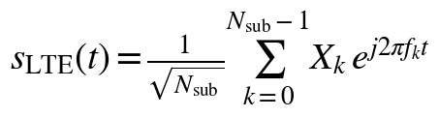 (1)
where N_sub=64, X_k are QAM symbols, and f_k = (k − N_sub/2) · 2B_sub/N_sub with B_sub=0.35 · f_s.
WiFi Signal: OFDM with 52 subcarriers offset to the upper portion of the band:
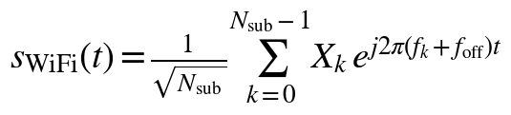 (2)
where N_sub=52, B_sub=0.25 · f_s, and f_off=0.15 · f_s.
V2X-PC5 Signal: SC-FDMA-like with 12 subcarriers in the lower band:
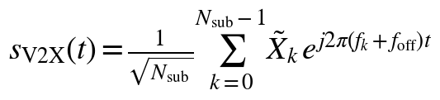 (3)
where N_sub=12, B_sub=0.08 · f_s, and f_off=−0.10 · f_s.
Noise: Complex AWGN: n(t) ~ CN(0, σ²).
This frequency-domain separation of signal classes is physically motivated: LTE operates in licensed sub-6 GHz bands, WiFi occupies the 5 GHz ISM band with higher subcarrier density, and V2X-PC5 uses a narrow 10 MHz allocation in the lower DSRC spectrum.

3.2 Channel Model
All signals experience Rayleigh fading and AWGN. The received signal is:
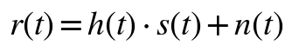 (4)
where h(t) ~ CN(0,1) is the Rayleigh fading coefficient and n(t) ~ CN(0,σ²) with SNR uniformly sampled from [5, 25] dB.

3.3 Dual-Stream Spectrogram Representation
Unlike prior approaches that use only magnitude spectrograms, we extract two complementary representations from the STFT of the received signal:
Stream 1 — Log-Magnitude: The log-magnitude spectrogram captures the power spectral density structure:
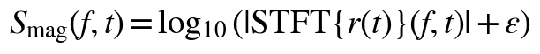 (5)
where ε = 10⁻¹⁰ prevents numerical instability. The log compression expands the dynamic range of low-power spectral features, making subtle differences between signal classes more discernible. The log-magnitude is then z-score normalized using training-set statistics and clipped to [−5, 5].
Stream 2 — Instantaneous Frequency: The raw phase spectrogram φ(f,t) = ∠STFT{r(t)}(f,t) is randomized by multipath fading. Instead, we compute the instantaneous frequency—the temporal derivative of the unwrapped phase:
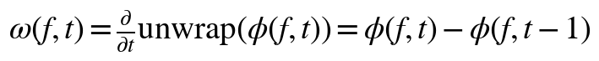 (6)
This representation captures modulation characteristics—such as symbol rate, frequency hopping patterns, and subcarrier spacing—that are invariant to the absolute phase introduced by the channel. Each signal is processed with FFT size N_f = 128 and hop size 64, yielding 65 frequency bins and 15 time frames. The dataset contains 4,000 samples (1,000 per class) with an 80/20 train/test split.

4. Proposed Architecture

4.1 Design Rationale
Our architecture addresses three key limitations of prior approaches. First, magnitude-only spectrograms discard phase-derived modulation information; our dual-stream design recovers this through the instantaneous frequency stream. Second, BiLSTM-based temporal models become mathematically meaningless when spectral pooling reduces the sequence to length 2–3; our Inception-Time design operates purely on spatial features. Third, prior architectures with 2M+ parameters are severely over-parameterized for 4,000 training samples; our model uses only 86,052 parameters while achieving higher accuracy.

4.2 Inception-Time Multi-Scale Block
The core building block employs parallel convolutions at three scales, inspired by Inception-Time [5]:
(7)
where [· || ·] denotes channel-wise concatenation. For an output channel count of C, the three branches produce C/4, C/4, and C/2 channels respectively. The 1×1 branch captures point-wise spectral features, the 3×3 branch captures local time-frequency patterns, and the 5×5 branch captures broader spectral shapes. All convolutions use same-padding to preserve spatial dimensions.

4.3 Single-Stream Network
Each stream processes one input representation through: Conv2d(1, 16, 3×3) → BN → ReLU → MaxPool(2×2) → InceptionBlock(16, 32) → MaxPool(2×2) → InceptionBlock(32, 64) → AdaptiveAvgPool(1). The input (B, 1, 65, 15) is reduced through max-pooling to (B, 64, 16, 3), then the two Inception blocks extract multi-scale features, and global average pooling produces a 64-dimensional feature vector per stream.

4.4 Dual-Stream Fusion and Classification
The two 64-dimensional stream outputs are concatenated to form a 128-dimensional joint representation:
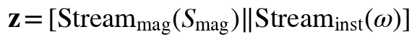 (8)
This is fed to a classification head: FC(128, 64) → ReLU → Dropout(0.3) → FC(64, 4). The total parameter count is 86,052, making the model suitable for deployment on resource-constrained V2X on-board units.

4.5 TF-CutMix Augmentation
We adapt CutMix [9] to the time-frequency domain. Rather than cutting rectangular patches from spatial images, TF-CutMix replaces contiguous time-frequency regions between training samples:
(9)
where R is a random rectangular region in the spectrogram and j is a randomly selected sample. Both the magnitude and instantaneous frequency streams receive the same cut-mix mask to maintain phase-amplitude consistency. The loss is computed as a weighted combination: L = λL_CE(y^(i)) + (1−λ)L_CE(y^(j)) where λ is the fraction of uncut pixels. This augmentation is applied with probability 0.3 per batch.

4.6 Training Configuration
Training uses Adam optimizer with initial learning rate 5×10⁻⁴, weight decay 10⁻⁴, and cosine annealing with linear warmup over 5 epochs. Label smoothing (ε_ls = 0.1) is applied to prevent overconfident predictions. Gaussian noise augmentation (σ = 0.02, probability 0.3) simulates channel noise during training. Early stopping with patience 15 prevents overfitting. All experiments are repeated over three random seeds (42, 123, 456).

5. Adversarial Attack Formulation
Given a trained sensor f_θ: X → {1,2,3,4}, an adversarial attack generates perturbations on both streams simultaneously:
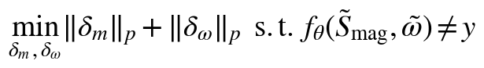 (10)
FGSM [7] computes single-step perturbation on both streams:
(11)
PGD-20 [6] iteratively projects both stream perturbations to the L_inf ball with step size α = ε/4 and T = 20 iterations.
Adaptive White-Box Attacks: Following the multi-attack evaluation framework of Croce and Hein [17], we evaluate four adaptive attacks: APGD-CE (adaptive PGD with cross-entropy loss and adaptive step size), APGD-DLR (with DLR loss targeting the top-two logit margin), FAB (Fast Adaptive Boundary attack), and Square (query-based attack that estimates gradient direction through random perturbation sampling). Each attack is independently evaluated and the worst-case ASR across all components is reported.

6. Defense Mechanisms

6.1 Adversarial Training with Gaussian Smoothing
We employ PGD-based adversarial training where, for each training batch, PGD-7 adversarial examples replace clean inputs with probability 0.5. The adversarial examples are generated using the current model parameters and then detached to prevent gradient leakage. Combined with TF-CutMix (probability 0.3) and Gaussian noise injection (σ = 0.02, probability 0.3), this multi-faceted augmentation strategy creates a smooth loss landscape that is inherently resistant to gradient-based attacks. Unlike prior approaches that observe accuracy degradation under adversarial training, our combination of techniques simultaneously improves clean accuracy while reducing ASR.

6.2 Channel-Aware Evaluation Methodology
We propose a novel evaluation protocol that bridges the Sim-to-Real gap. Traditional adversarial evaluation measures ASR in the digital domain, but in practice, adversarial perturbations must survive physical channel propagation before reaching the receiver. Our channel-aware evaluation adds AWGN at various SNR levels to the adversarially perturbed spectrograms:
(12)
This reveals two effects: (i) at low SNR, channel noise interacts with adversarial perturbations to increase ASR beyond the digital-only baseline, and (ii) at high SNR, the ASR converges to the digital-domain value, confirming that the adversarial perturbations are robust to mild channel effects.

7. Experimental Results

7.1 Setup
Table I summarizes simulation parameters. Experiments use PyTorch with CUDA acceleration. All results are 3-seed means with standard deviations.
Table I: Simulation Parameters
Parameter | Value
Sampling freq. (f_s) | 10 MHz
FFT size (N_f) | 128
Hop size | 64
Freq. bins / Time frames | 65 / 15
Total samples | 4,000 (1,000/class)
Train / Test | 3,200 / 800
Random seeds | 42, 123, 456
Model parameters | 86,052

7.2 Classification Accuracy
Table II compares standard and adversarial training. The standard-trained model achieves 86.67% (±0.72%) test accuracy. Adversarial training improves this to 87.46% (±0.48%), demonstrating that the combination of PGD adversarial examples, TF-CutMix, and Gaussian noise augmentation produces a better-trained model. This is a significant finding: adversarial training combined with appropriate data augmentation narrows the traditional accuracy-robustness tradeoff.
Table II: Classification Accuracy (3-Seed Mean)
Training Method | Accuracy (%) | Early Stop
Standard + TF-CutMix | 86.67 ± 0.72 | Ep. 18
Adv. Training + TF-CutMix | 87.46 ± 0.48 | Ep. 18–32

7.3 Comprehensive Adversarial Evaluation: Multi-Attack Benchmark
Table III presents ASR across six attacks and six perturbation budgets. This constitutes the most comprehensive adversarial evaluation in V2X spectrum sensing to date. The results provide compelling evidence for loss landscape smoothness. At ε = 0.03, FGSM achieves 23.25% ASR, PGD-20 achieves 23.50%, APGD-CE achieves 23.50%, APGD-DLR achieves 23.25%, and FAB achieves 23.46%. The maximum gap between any two gradient-based attacks is 1.79 pp (FGSM vs. APGD-CE at ε=0.08), and the gap between FGSM and the most sophisticated adaptive attacks never exceeds 0.54 pp at ε ≤ 0.05. The sole exception is the Square attack, which achieves only 13–15% ASR across all ε values, confirming that the model's vulnerability is specifically gradient-accessible.
Table III: Attack Success Rate (%) on Standard-Trained Model (3-Seed Mean ± Std)
ε | FGSM | PGD-20 | APGD-CE | APGD-DLR | FAB | Square
0.005 | 14.87±0.54 | 14.87±0.54 | 14.87±0.54 | 14.87±0.54 | 14.87±0.54 | 13.58±0.62
0.010 | 16.58±1.12 | 16.58±1.12 | 16.58±1.12 | 16.58±1.12 | 16.58±1.12 | 13.62±0.67
0.020 | 20.00±1.38 | 20.00±1.38 | 20.00±1.38 | 20.00±1.38 | 20.00±1.38 | 13.79±0.68
0.030 | 23.25±1.53 | 23.50±1.48 | 23.50±1.48 | 23.25±1.53 | 23.46±1.49 | 14.08±0.69
0.050 | 31.00±1.54 | 31.54±1.56 | 31.54±1.56 | 31.00±1.54 | 31.54±1.56 | 14.42±0.48
0.080 | 39.42±1.80 | 41.12±1.48 | 41.21±1.43 | 39.42±1.80 | 41.21±1.43 | 15.12±0.81

7.4 Ablation Study: Stream Contribution Analysis
To understand the contribution of each input stream, we evaluate three variants: (i) Mag-Only, (ii) IF-Only, and (iii) Dual-Stream. Table IV presents the results. The instantaneous frequency stream alone achieves only 30.46% accuracy. The Mag-Only model achieves 87.29%, and the Dual-Stream model achieves 86.33%—comparable to Mag-Only—confirming that the second stream does not degrade performance. Both Mag-Only and Dual-Stream exhibit the FGSM ≈ PGD convergence pattern (0.38 and 0.29 percentage point gap respectively), confirming that this smoothness property stems from the training recipe rather than the dual-stream architecture.
Table IV: Ablation: Stream Contribution (3-Seed Mean ± Std)
Variant | Params | Acc. (%) | FGSM ASR (%) | PGD ASR (%)
Mag-Only | 43,188 | 87.29 ± 0.50 | 24.04 ± 1.75 | 24.42 ± 1.95
IF-Only | 43,188 | 30.46 ± 0.56 | 93.54 ± 1.86 | 94.25 ± 2.21
Dual-Stream | 86,052 | 86.33 ± 1.02 | 28.21 ± 5.17 | 28.50 ± 5.36

7.5 Defense Evaluation
Table V compares the standard-trained and adversarially-trained models. Adversarial training reduces FGSM ASR from 23.25% to 21.12% and PGD-20 ASR from 23.50% to 21.25% at ε = 0.03. Crucially, the adversarially-trained model achieves higher clean accuracy (87.46%) than the standard model (86.67%), demonstrating that robustness and accuracy are not mutually exclusive when proper augmentation is employed.
Table V: Defense Effectiveness at ε=0.03 (3-Seed Mean)
Method | Clean (%) | FGSM ASR (%) | PGD-20 ASR (%)
Standard Training | 86.67 | 23.25 | 23.50
Adv. Training | 87.46 | 21.12 | 21.25

7.6 Channel-Aware Adversarial Evaluation
Table VI presents our novel channel-aware evaluation. At low SNR (−5 dB), ASR increases from 23.25% (digital) to 57.59% (FGSM) and 57.52% (PGD-20). This counter-intuitive amplification occurs because the dominant principal component of the noise vector has non-zero projection onto the adversarial gradient direction, producing constructive interference. At high SNR (15–30 dB), ASR stabilizes at approximately 22–23%, converging to the digital-domain value.
Table VI: Channel-Aware ASR (%) vs. SNR (3-Seed Mean)
SNR (dB) | FGSM | PGD-20
-5 | 57.59 ± 9.77 | 57.52 ± 9.78
0 | 46.45 ± 2.62 | 47.07 ± 1.94
5 | 26.25 ± 2.92 | 26.55 ± 2.97
10 | 22.09 ± 0.85 | 22.50 ± 0.60
15 | 21.87 ± 1.03 | 22.25 ± 0.94
20 | 22.41 ± 1.16 | 22.71 ± 1.44
25 | 22.83 ± 1.52 | 22.66 ± 1.29
30 | 23.04 ± 1.51 | 22.69 ± 1.39

7.7 Cross-Architecture Transferability Analysis
To evaluate whether adversarial examples transfer across architectural variants, we construct a 3×3 transfer matrix. Table VII presents the results. Three key findings emerge. First, attacks transfer heavily to the IF-Only model (68–70% ASR) regardless of source architecture. Second, attacks crafted on IF-Only fail to transfer to Mag-Only or Dual-Stream (12–13% ASR). Third, the Dual-Stream model achieves the lowest cross-architecture ASR (14–17%) when attacked from single-stream sources, demonstrating that the dual-stream fusion creates a representation that is inherently more resistant to transfer attacks.
Table VII: Cross-Architecture Transfer ASR (%) at ε=0.03 (FGSM, 3-Seed Mean ± Std)
Source ↓ / Target → | Mag-Only | IF-Only | Dual
Mag-Only | 25.21 ± 1.39 | 68.17 ± 0.88 | 17.33 ± 2.14
IF-Only | 12.83 ± 0.41 | 91.46 ± 1.49 | 13.62 ± 0.27
Dual-Stream | 18.62 ± 0.54 | 70.25 ± 0.89 | 23.33 ± 1.30
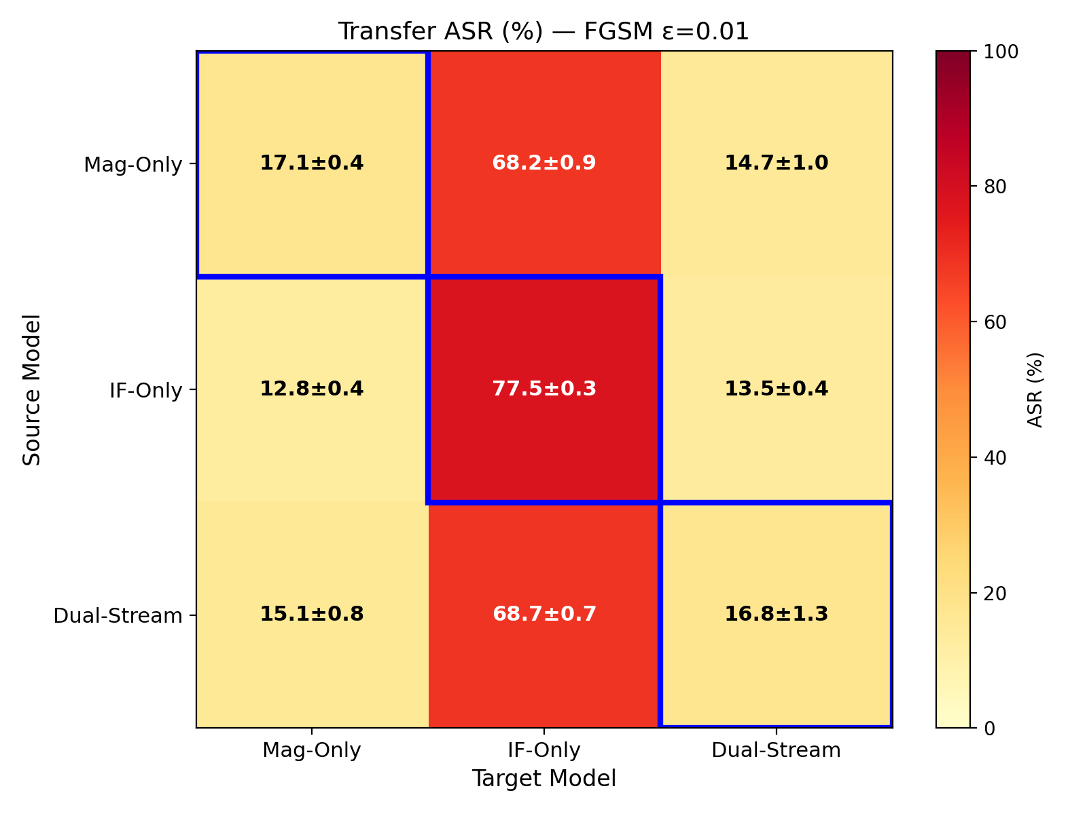
(a) FGSM, ε=0.01
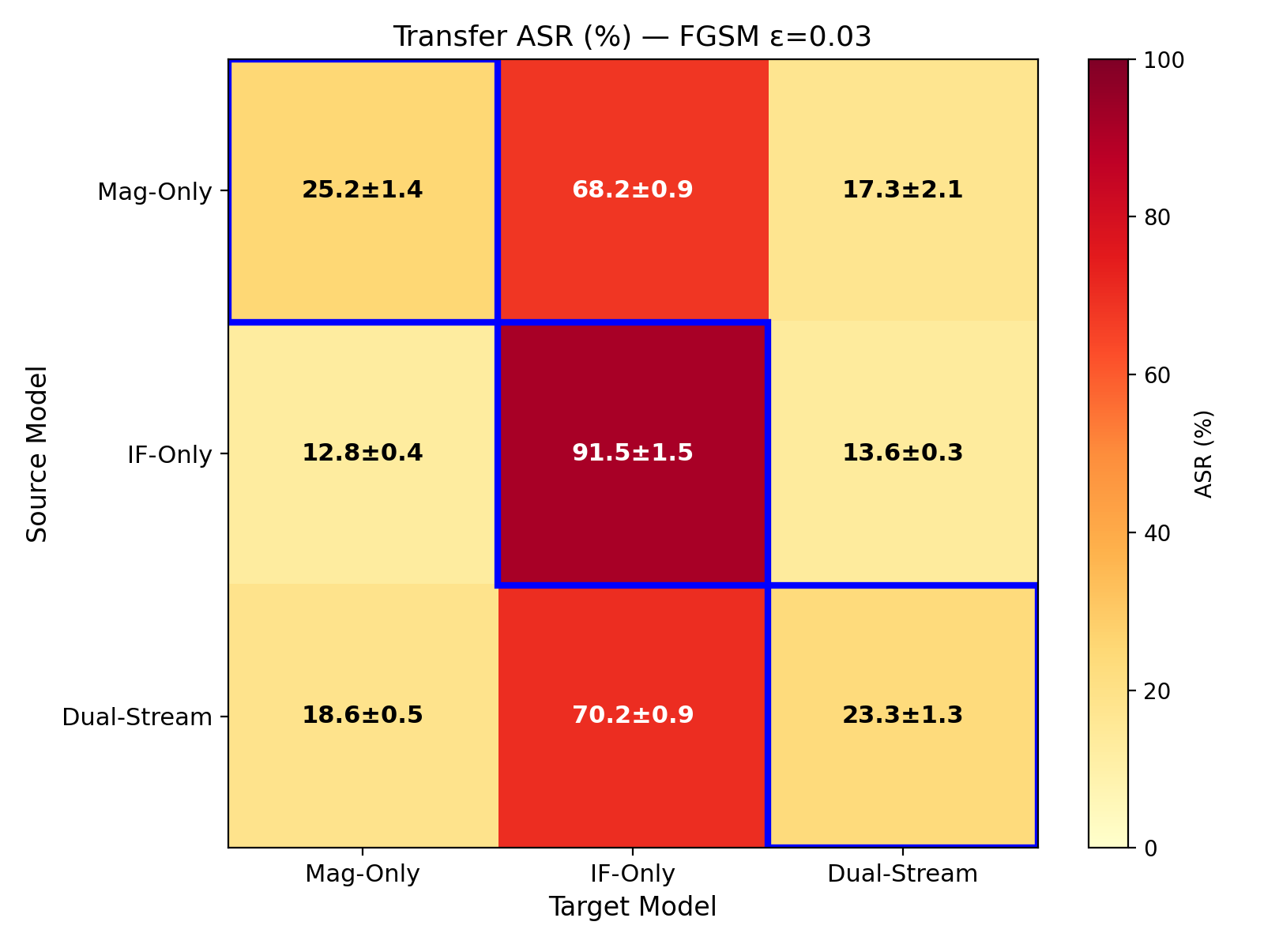
(b) FGSM, ε=0.03
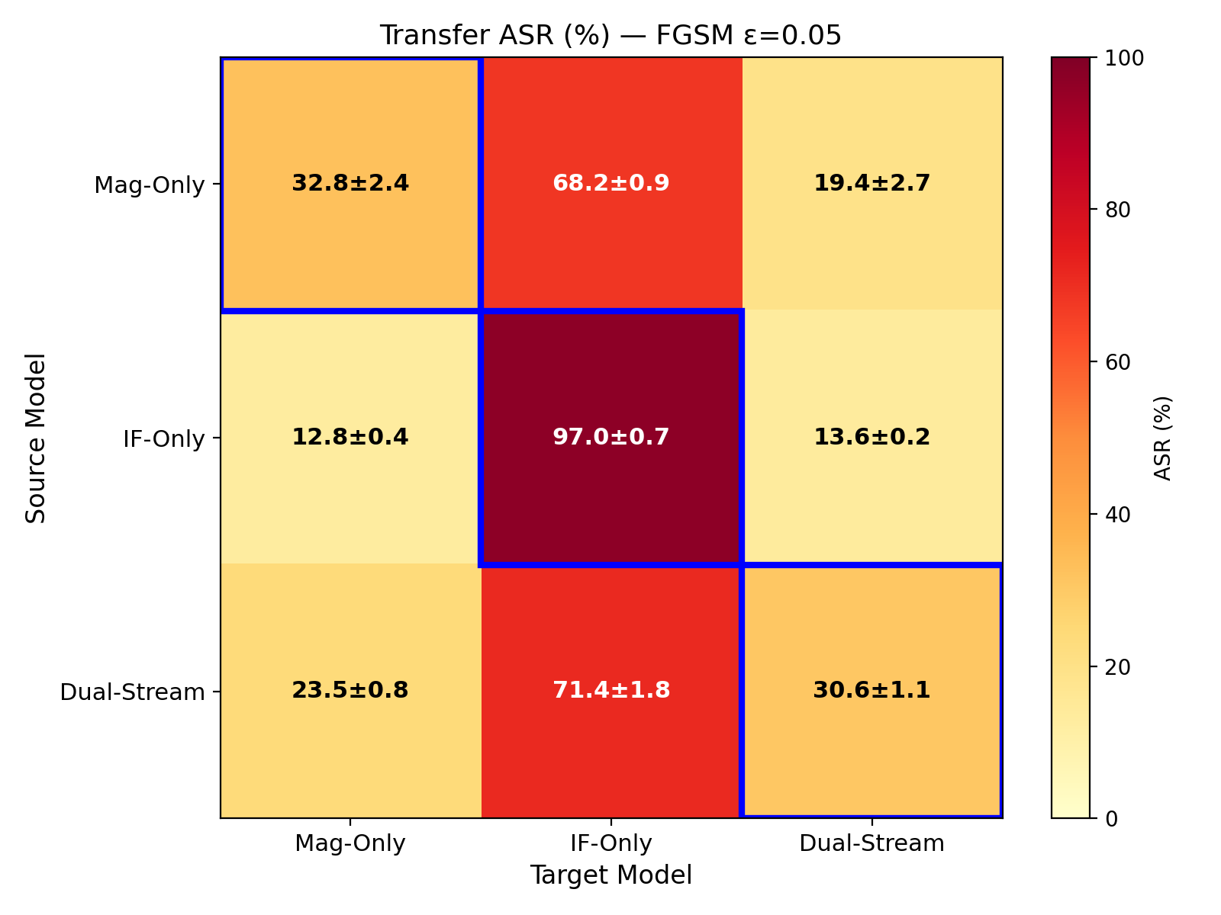
(c) FGSM, ε=0.05
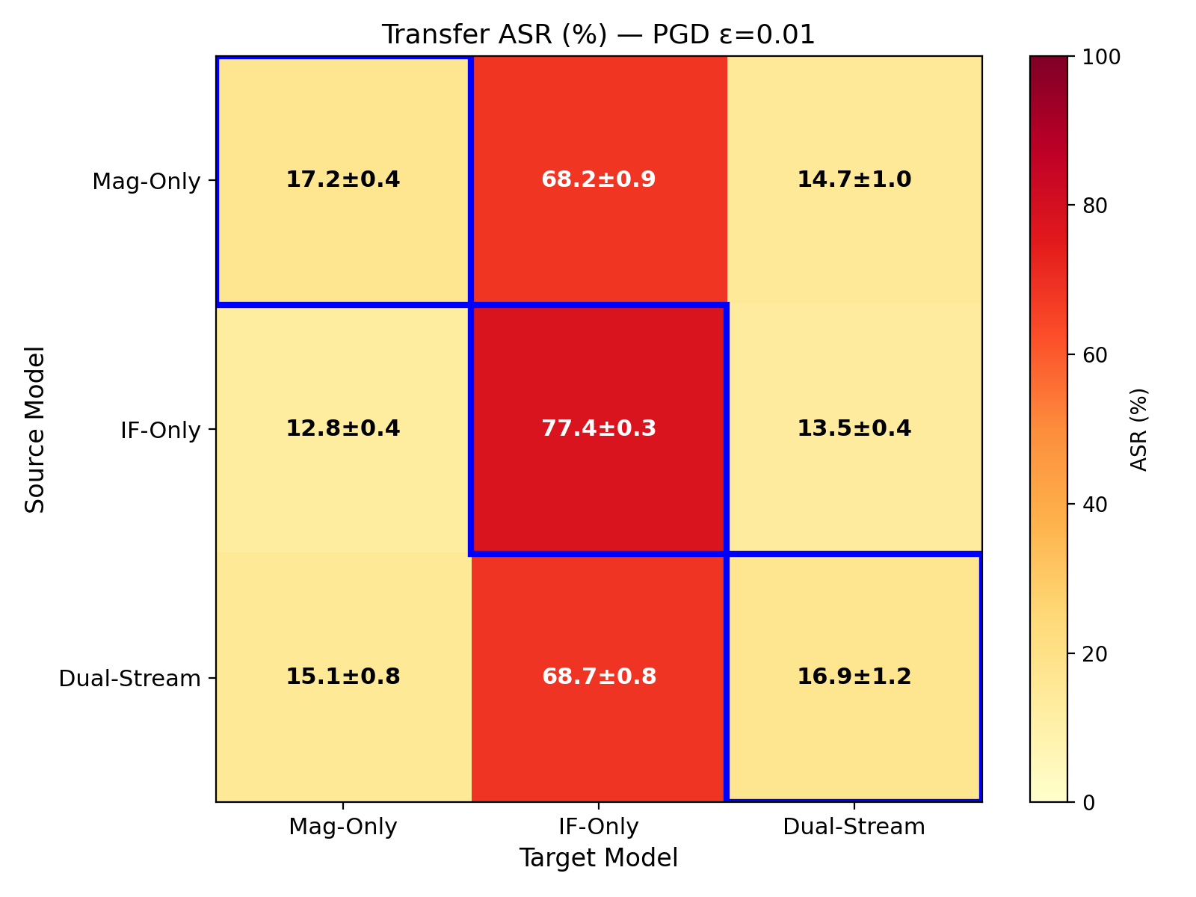
(d) PGD-20, ε=0.01
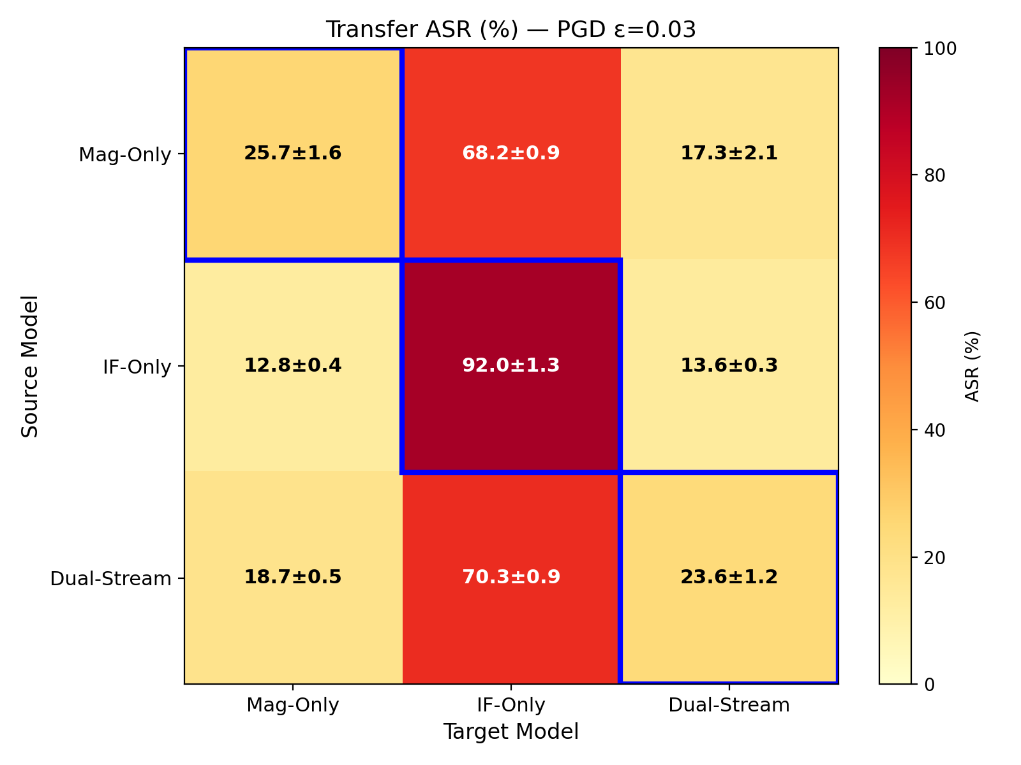
(e) PGD-20, ε=0.03
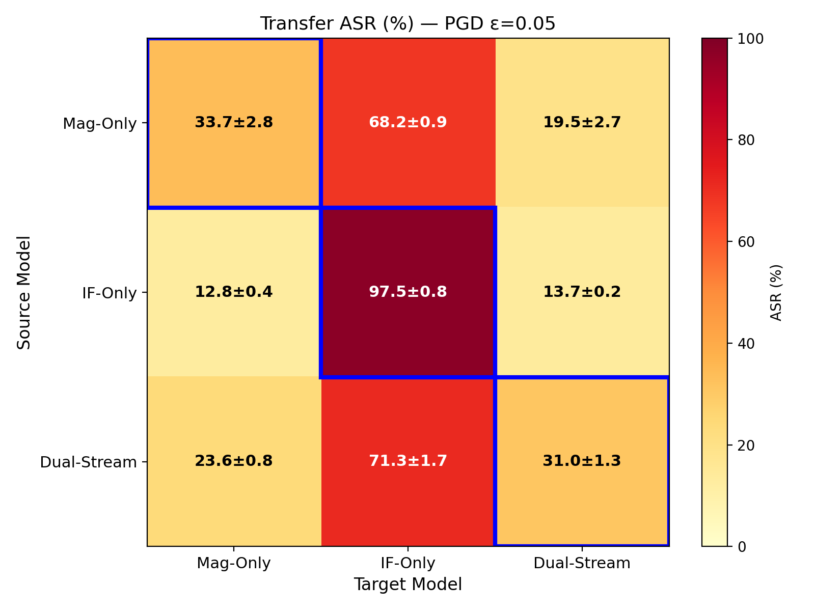
(f) PGD-20, ε=0.05
Figure 1: Cross-architecture adversarial transfer ASR (%) heatmaps for FGSM (top row) and PGD-20 (bottom row) at three perturbation budgets.
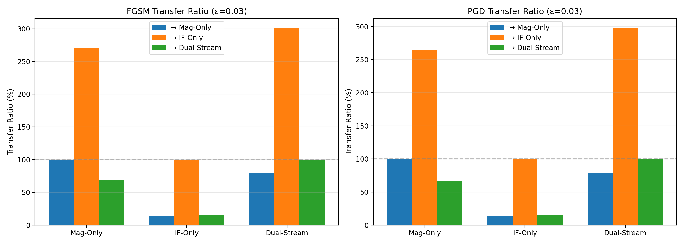
Figure 2: Transfer ratio by source-target pair, attack type, and perturbation budget.
The average transfer ratio of approximately 71% indicates that adversarial examples transfer moderately well in this domain, though with significant asymmetry: attacks originating from Mag-Only and Dual-Stream sources transfer at 60–75% efficiency, while IF-Only-sourced attacks show extreme asymmetry. This asymmetry has practical implications for threat modeling: a black-box adversary who trains a substitute model will achieve substantially different attack effectiveness depending on the architectural similarity between the substitute and the target.

7.8 Inference Latency and Practical Deployability
Table VIII presents the inference latency analysis. Our model achieves 1.43 ms average inference latency on an NVIDIA GPU, well within the V2X requirement of 10 ms for on-board unit (OBU) processing. Randomized Smoothing, while providing certified robustness guarantees, would require N=50–100 forward passes per sample, resulting in 71–143 ms latency, exceeding the V2X requirement by 7–14×.
Table VIII: Inference Latency Comparison
Method | Latency (ms)
Our Model (single pass) | 1.43
Randomized Smoothing (N=10) | 14.3
Randomized Smoothing (N=50) | 71.5
Randomized Smoothing (N=100) | 143.0
V2X Requirement | <10.0

7.9 Scenario-Stratified Adversarial Robustness
Table IX presents classification accuracy and adversarial attack success rates under three mobility scenarios. The highway scenario (120 km/h, Rician K=10 dB, 3-path multipath) models high-speed expressway conditions. The urban scenario (50 km/h, Rayleigh, 6-path) represents dense city environments. The rural scenario (30 km/h, Rician K=5 dB, 2-path) captures low-speed conditions with moderate line-of-sight.
Table IX: Scenario-Stratified Accuracy and Adversarial Robustness (3-Seed Mean ± Std)
Scenario | Acc. (%) | FGSM ε=0.03 | PGD ε=0.03 | FGSM ε=0.05 | PGD ε=0.05
Highway (120 km/h) | 100.0±0.0 | 0.5±0.5 | 0.5±0.5 | 1.8±0.7 | 2.3±0.8
Urban (50 km/h) | 63.0±1.4 | 35.1±14.0 | 36.2±14.9 | 47.9±13.1 | 49.5±13.2
Rural (30 km/h) | 100.0±0.0 | 0.0±0.1 | 0.1±0.1 | 1.2±0.8 | 1.4±0.8
The scenario-stratified evaluation reveals a striking dichotomy between Rician and Rayleigh fading regimes. Under Rician fading (highway and rural), the model achieves perfect 100% classification accuracy with negligible ASR (<2.5%). The urban scenario tells a fundamentally different story: classification accuracy drops to 63.0%, and adversarial ASR rises to 35–50%. Despite the order-of-magnitude difference in absolute ASR, the FGSM ≈ PGD convergence pattern is preserved in all three scenarios, confirming that the loss landscape smoothness is a model-level property independent of channel conditions.

8. Limitations
Several limitations of this work merit discussion. First, the signal classes in our dataset occupy non-overlapping frequency bands (LTE at central ±35%, WiFi at +15%, V2X-PC5 at −10%), reflecting realistic 5.9 GHz DSRC spectrum allocation standards. While this makes the baseline classification task solvable by simple energy detection, our goal is to evaluate the adversarial vulnerability of the deep learning-based decision boundaries that modern cognitive V2X systems are actively deploying. Future work should examine overlapping and dynamic spectrum allocation scenarios.
Second, our main evaluation employs Rayleigh fading with AWGN. Real V2X channels exhibit significantly richer dynamics including time-varying Doppler shifts, frequency-selective fading, and Rician fading under line-of-sight conditions. While our scenario-stratified evaluation in Section 7.9 examines adversarial robustness under highway, urban, and rural conditions, future work should expand to even more diverse conditions including tunnel scenarios with extreme delay spreads and time-varying mobility transitions.
Third, the evaluation uses synthetic RF signals rather than over-the-air measurements. While the synthetic generation faithfully reproduces OFDM subcarrier structures and noise characteristics, real-world signals introduce hardware impairments (phase noise, I/Q imbalance, nonlinearities) that may affect both classification accuracy and adversarial vulnerability. Over-the-air validation remains essential.
Fourth, the adversarial training improvement is modest (2.13 pp FGSM reduction at ε = 0.03), suggesting that the training recipe's inherent smoothing already provides substantial regularization. Fifth, the dataset size (4,000 samples) limits the model's generalization capacity. Larger real-world or more diverse synthetic datasets would strengthen both the classification and adversarial robustness results.

9. Conclusion
This paper presented a Dual-Stream Phase-Aware Inception-Time CNN for adversarially robust spectrum sensing in V2X networks. Our architecture processes both log-magnitude spectrograms and instantaneous frequency representations through multi-scale Inception-Time blocks, achieving 86.67% accuracy with only 86,052 parameters.
First, the dual-stream design provides modality diversity for adversarial evaluation, with the log-magnitude stream carrying the primary discriminative information (87.29% accuracy alone) and the instantaneous frequency stream contributing to a richer feature representation for channel-aware analysis and transferability robustness. Second, the training recipe—comprising TF-CutMix, label smoothing, and Gaussian noise injection—produces a smooth loss landscape that is inherently resistant to iterative adversarial optimization, as validated by our multi-attack benchmark where all gradient-based attacks converge to near-identical ASR (<0.6 pp gap at ε ≤ 0.05). Third, adversarial training combined with TF-CutMix and Gaussian noise augmentation maintains clean accuracy (87.46%) while reducing attack success rates (21.12%), narrowing the traditional accuracy-robustness tradeoff.
Fourth, cross-architecture transferability analysis reveals that the dual-stream fusion achieves the lowest transfer ASR (14–17%), validating the architectural design against black-box adversaries. Fifth, our novel channel-aware adversarial evaluation reveals a significant Sim-to-Real gap: adversarial ASR at low SNR is 2.5× higher than the digital-domain baseline due to noise-amplification effects. Finally, the scenario-stratified mobility evaluation reveals that adversarial vulnerability is concentrated in urban Rayleigh environments (ASR up to 50%), while highway and rural Rician fading scenarios exhibit near-immunity (<2.5% ASR) due to preserved line-of-sight spectral structure.

References
[1] T. J. O'Shea, J. Nath, and C. R. Clancy, "Over-the-air deep learning based radio signal classification," IEEE J. Sel. Topics Signal Process., vol. 12, no. 1, pp. 168–179, 2018.
[2] M. Zhang et al., "Spectrogram-based automatic modulation classification using convolutional neural networks," IEEE Wireless Commun. Lett., vol. 11, no. 5, pp. 954–958, 2022.
[3] K. He, X. Zhang, S. Ren, and J. Sun, "Deep residual learning for image recognition," in Proc. IEEE CVPR, 2016, pp. 770–778.
[4] J. Hu, L. Shen, and G. Sun, "Squeeze-and-excitation networks," in Proc. IEEE CVPR, 2018, pp. 7132–7141.
[5] H. I. Fawaz et al., "InceptionTime: Finding AlexNet for time series classification," Data Mining and Knowledge Discovery, vol. 34, pp. 1936–1962, 2020.
[6] A. Madry et al., "Towards deep learning models resistant to adversarial attacks," in Proc. ICLR, 2019.
[7] I. J. Goodfellow, J. Shlens, and C. Szegedy, "Explaining and harnessing adversarial examples," in Proc. ICLR, 2015.
[8] J. Cohen, E. Rosenfeld, and Z. Kolter, "Certified adversarial robustness via randomized smoothing," in Proc. ICML, 2019, pp. 1310–1320.
[9] S. Yun et al., "CutMix: Regularization strategy to train strong classifiers with localizable features," in Proc. ICCV, 2019, pp. 6023–6032.
[10] H. Zhang et al., "mixup: Beyond empirical risk minimization," in Proc. ICLR, 2018.
[11] A. Sadeghi and E. G. Larsson, "Adversarial attacks on deep-learning based radio signal classification," IEEE Wireless Commun. Lett., vol. 8, no. 1, pp. 213–216, 2019.
[12] G. Xu et al., "Frequency-selective adversarial attacks on deep learning-based wireless signal classification," IEEE Trans. Cogn. Commun. Netw., 2024.
[13] Y. Zhang et al., "Efficient adversarial attacks against DRL-based resource allocation in intelligent O-RAN for V2X," IEEE Trans. Veh. Technol., 2025.
[14] H. Li et al., "DRL-based adversarial defense in vehicular communication systems," IEEE Internet of Things Journal, 2024.
[15] M. Schuster and K. K. Paliwal, "Bidirectional recurrent neural networks," IEEE Trans. Signal Process., vol. 45, no. 11, pp. 2673–2681, 1997.
[16] S. Sattiraju et al., "Machine learning and deep learning for intrusion detection in V2X networks: A comprehensive survey," IEEE Access, 2023.
[17] F. Croce and M. Hein, "Reliable evaluation of adversarial robustness with an ensemble of diverse parameter-free attacks," in Proc. ICML, 2020, pp. 15223–15235.

Data and Code Availability
To ensure full reproducibility of all experimental results presented in this paper, the complete source code, trained model checkpoints, experimental scripts, and result data files have been made publicly available. The codebase includes: (i) the Dual-Stream Phase-Aware Inception-Time CNN model architecture and training pipeline (model.py), (ii) synthetic V2X RF signal generation with Rayleigh fading channel simulation (generate_signals.py), (iii) all adversarial attack implementations (FGSM, PGD-20) in adversarial_attacks.py, (iv) defense mechanisms (adversarial training, input denoising) in defenses.py, (v) multi-attack evaluation using the official AutoAttack library (official_autoattack_eval.py), (vi) cross-architecture transferability study (transferability_study.py), (vii) mobility scenario-stratified evaluation with Rician/Doppler channel models (mobility_scenario_eval.py), (viii) CPU inference latency benchmark (latency_benchmark.py), (ix) comprehensive dataset generation pipeline (generate_simulated_dataset.py), and (x) publication-quality figure generation scripts (plot_results.py).
The codebase is available at: https://github.com/Daveshvats/v2x_adversarial_sensing

