1. Menu/ 页脚/ 移动导航栏：Home Cam放最前面



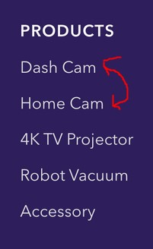

1. About页面：

LIFE MADE SIMPLE换成SMART MADE SIMPLE



1. Speakers换成dash cam

One-stop car camera solutions换成cutting edge 4K laser projector



1. 整段替换

In 2015, VAVA was established to become a pioneer in home living. Our flagship, the Voom 21 Bluetooth speaker, met with great success and in 2016 the company received its first Red Dot Design Award. Since then we have been committed in bringing meaningful innovation to modern lifestyles.

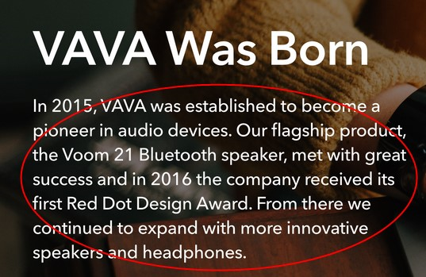

1. 整段替换

Today, VAVA is continuously evolving to meet the needs of our customers. In addition to our first-class home cam, which raised over $900,000 through crowd funding, we’re also launching multiple new product lines, including ones for automobiles and home living. These additions enable our connected-customers do practically everything they need to in all spheres of their lives. VAVA only has one goal: to make life simple.

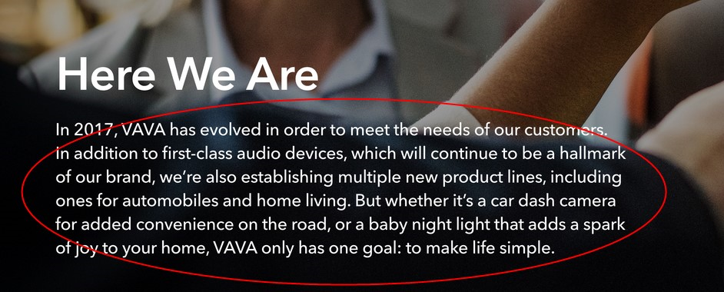

1. 划线句子替换成：

Where will VAVA go next? Join us as we imagine, design and create a new generation of products.

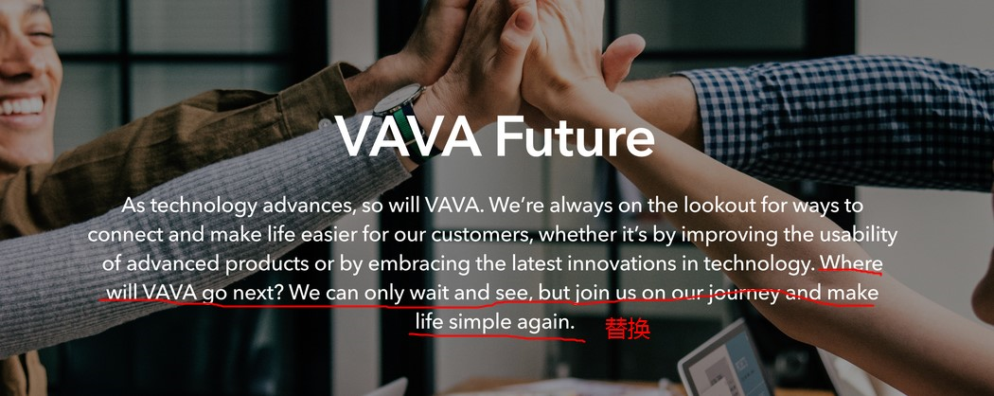

1. PRIVATE POLICY

公司名字更新：Shenzhen Sunvalley Innovation Technology Company Limited

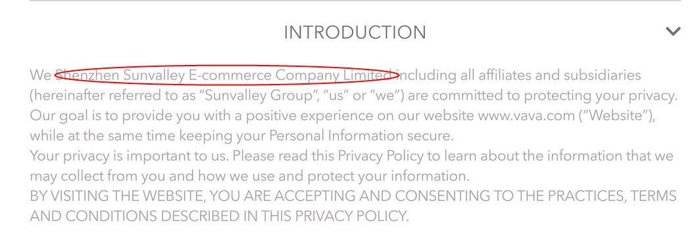

句号和后面有个空格

