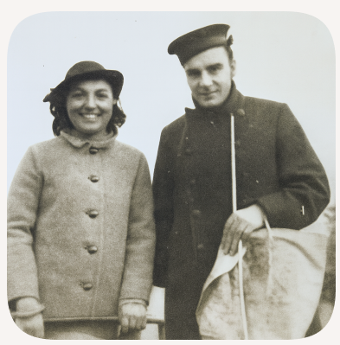
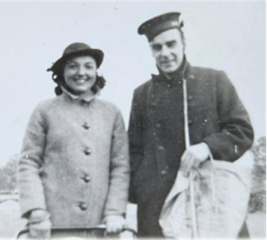

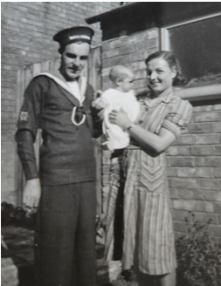
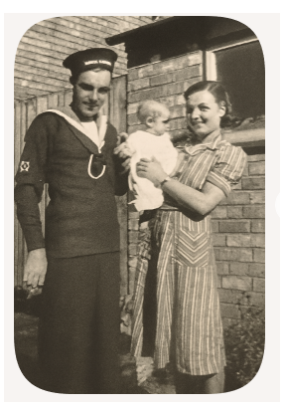

Geoffrey Oliver Kiddle born on the 31/10/1909 in Hinckley Leicestershire
He lived and worked in his home town following a family tradition of working in the local bank
As a Clerk
Geoffrey Oliver Kiddle married Margaret Jennetta Cholerton at St Marys Church in Hinckley on the 15th of April 1939
War came along in September 1939 and Geoffrey was old enough to remember his mother's distress at the losses suffered by friends and neighbours in the trenches in the first world war so in 1939 when he was thirty he volunteered for the navy to avoid being called up for the army.
He served in the Royal Navy from 1940 – 1945
Initially trained at HMS Osprey: Anti-Submarine Warfare School at the Isle of Portland, Dorset, response to the growing threat of submarines after WWI and at some point to HMS Curlew a shore base in Northern Ireland and was then eventually posted to Bembridge Fort
He was given a cottage to live in within Bembridge village with his wife and young children Bob and Jeanetta
He spoke of his time on the Isle of Wight and described his accommodation and colleagues with great detail.
My new station was a huge brick build fort sunk into a deep dry moat on the summit of Bembridge Down. I believe it was constructed to withstand invasion by the armies of Napoleon. It was a fascinating place. From the ramparts the whole length of Spithead was visible.
Beneath were barrack rooms, converted into dormitories, galley, engine rooms, etc. Behind these rooms a tunnel formed
a circle of the fort so that each room had two entrances one from the central parade ground and one into the tunnel.
At intervals were steep cuttings for the storage of gunpowder. It really was most impressive. we settled in quite quickly and after HMS Curlew it was delightfully free and cosy.
Our new commander was a Harley St. dentist cast in the role of Henry V but not chosen for his knowledge of HD Loops or whatever. Nor were his officers.
The whole place was run by CPO Bishop a regular since boyhood, qualified in engineering and with a justified suspicion of human nature. He was ugly, sarcastic of tongue but efficient. Of his pupils (us) only one was worthy of preferment, a professional electrician in civvy street and a charming fellow who was very rightly commissioned the following year.
The bosun, leading seaman Pickard RNVR was a likeable fellow though absurdly self-important. He was foul mouthed but without vice. I appreciated his vocabulary and we always had a laugh. I thought he did a good job. Ordering men about is made so much easier for the officer who does not have to mess and live with those he orders about. He does not need such a wide vocabulary.
He listed the names of men at Bembridge Fort Christmas 1940 at with 45 Royal Navy personnel present.
Later in the war he was posted to Beirut where he did similar work with Anti-Submarine Warfare until the war came to a close in 1945 watching for an invasion that never came.
several letters he wrote home from there which talk about the fine weather, missing home, his wife and baby daughter, but the overall beauty of the country.
After the war he returned to Hinckley Leicestershire and was Manager of the Hinckley Permanent Building Society from June 1959 until his retirement in October 1974 and living in Sharnford
Generations of the Kiddle family played a significant role in Hinckley's financial history, through their leadership of the Hinckley Permanent Society. Geoffrey’s father grandfather, great grandfather were all managers of the branch.
He passed away in Doncaster in November 2005

