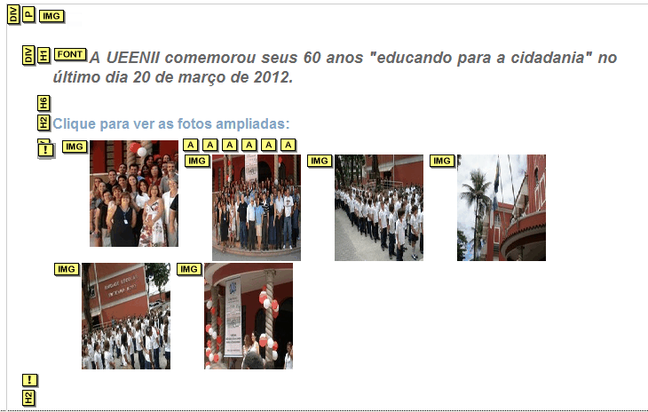
1 – columm midle – 193
2 – content box middle – 196 - 317
3 – galeria de imagens – 203 - 227

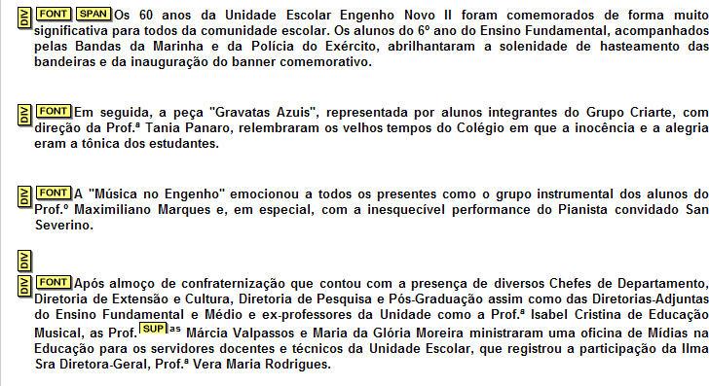
2 – text align justify – 230-248 – os 60 anos…

