Industrial Informatics 2023

-Homework 2 –

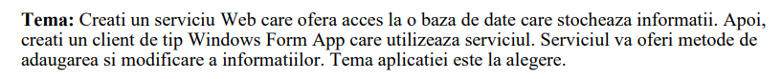 The second Homework consists of a Web Application that has access to a database. The Web Service of this WebApp is then consumed by a Windows Form App.

The theme of the following project is a video game where players can create, view, and accept quests. Said quests grant them prices which determine the player’s rank in a leaderboard. Certain aspects of the application are simplified as they were unnecessary for presenting a general understanding of functionality of the project. Project will be nicknamed “QuestBringer”.

# 1.QuestWebApp

First, the QuestWebApp is a ASP.NET Web Application which will provide a number of webservices, which also access the database: “QuestBringer”. The QuestWebService has the following functions:

* AddQuest receives parameters with which it creates a new entry in the “Quests” Table
* AddUser receives parameters with which it creates a new entry in the “Users” Table
* CheckUser is part of the login process and identifies the user corresponding to the given parameters (username and password). It will either return the id of the identified user or ‘0’ which represents that no user was found with the given credentials
* ShowUser returns data of the user with a given id
* ShowQuest returns data of a quest with a given id
* SHowLeaderboard returns a list of all registered users ranked by their game currency
* ShowQuestBoard returns a list of all quest entries
* AcceptQuest will delete a quest of a given id, as a player/user “claims it”
* Text

  Description automatically generatedText

  Description automatically generatedReward adds the in-game currency related to the quest they claimed (through an update query)

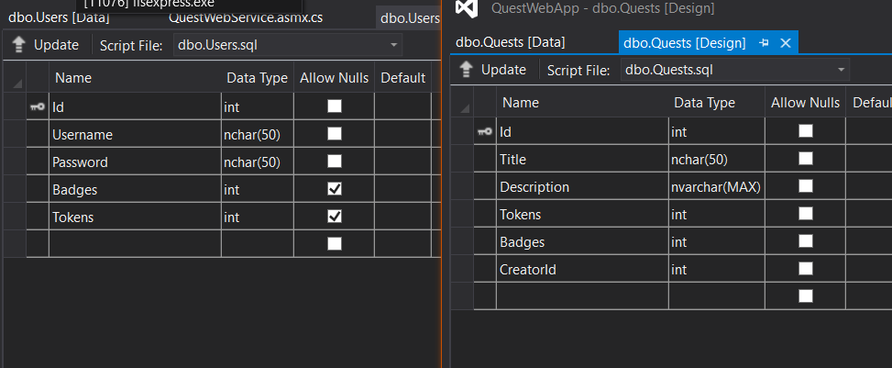 The Database consists of two tables, Users, and Quests, with the following fields:

We also start with the following data already added to the table:

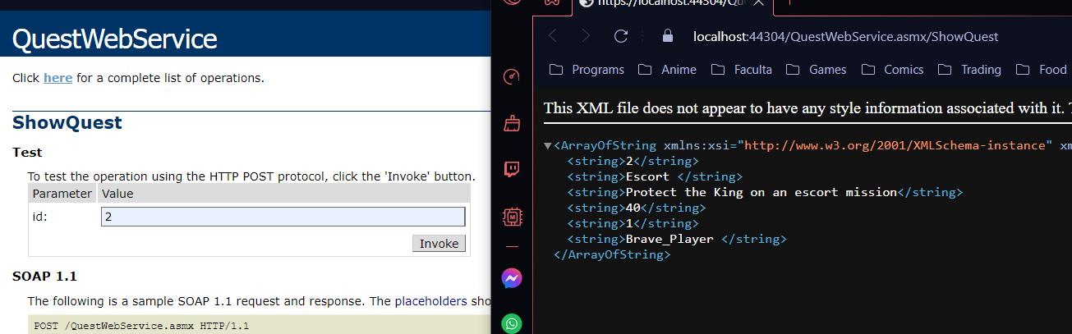As for an example, here we test the ShowQuest(id) function:

# 2.QuestWinForm

QuestWinForm is a ASP.NET Windows Form that will connect to the QuestWebService and be the interface of the project. It consists of 4 forms: Login (sign in for the user or creating a new account ) , Form2 (Home/ User Page), Leaderboard (showing the users’ rankings) and Questboard (showing the available quests and letting the user pick and accept a quest).

The Login will ask for a user’s username and password. Failing to fill one of the fields prompts a warning message. If the user tries to log in with wrong information, a warning prompt will appear as well.

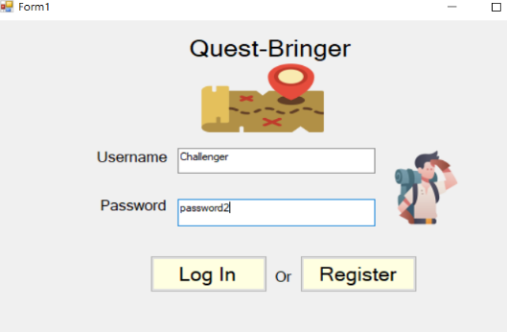

Once we are logged in, we have the options to logout, see the leaderboard, see the questboard or create a quest.

The leaderboard will be displayed with a listBox in descending order. The “Home” button brings us back to the user menu.

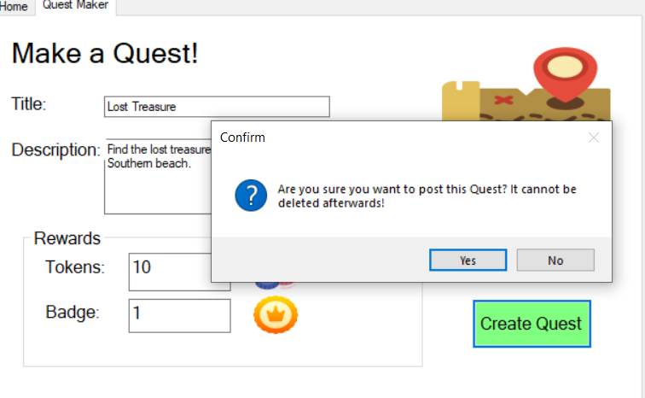

We add a quest, and if the user does have the resources for the reward, the quest will be added to the database and displayed in the Questboard page. Here are also examples of displayed quests that we picked:

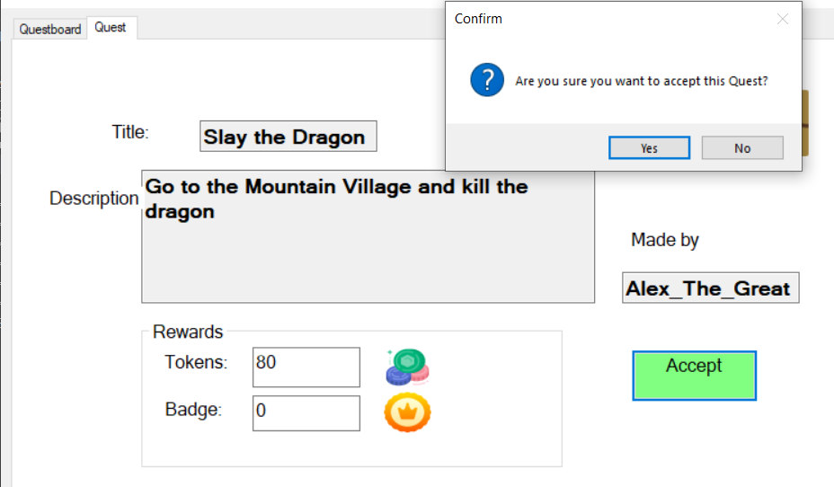

Before accepting a quest, we confirm it. Then after exiting the form and reentering, the quest will no longer be present on the QuestBoard. We can also see the rewards added to the user’s Loot section:

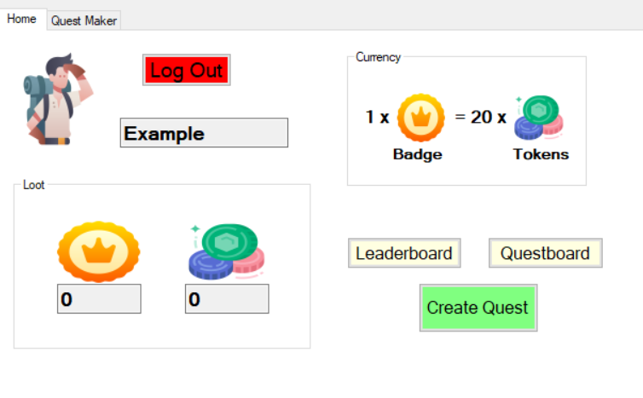 Finally, we log out, enter new user data and register, seeing that a new user starts with no loot:

Here are the Tables at the end of all the previous operations:

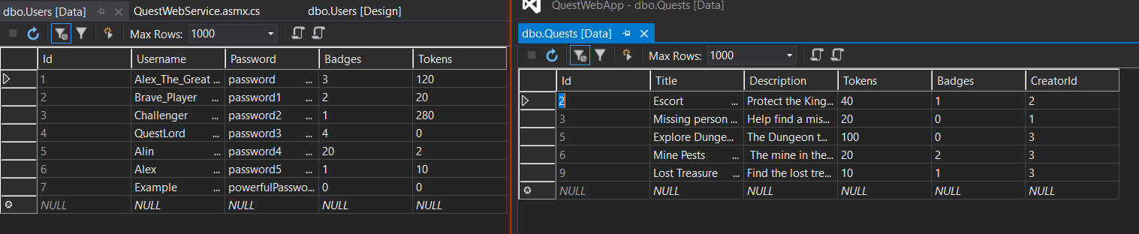

# 3. Conclusions

As presented, the application allows a user to log in and interact with the quest system through the webservice functions. The WebApp offers the ability to insert into, update, select and delete from the given tables, using primarily the id of the Users entry and of the Quests entry. Besides improvements to the visual aspect of the interface, there are several features that could be implemented in the future:

* Users able to modify their username or password
* Creating a quest consumes your in-game currency
* Admin user-type
* User not being allowed or accept quests made by themselves