CUSTOMSTRACK AI
DATABASE DESIGN
This document designs the complete MongoDB database for CustomsTrack AI: twenty collections covering users and access control, declarations and their supporting entities, AI analysis, field inspections, communication and audit trails, CAMCIS-side reference data, geographic locations, and operational statistics. No implementation code is included; this is a design-level reference for Chapter Four.
Normalization Approach
MongoDB is a document database, so "normalization" here does not follow relational Third Normal Form mechanically; it follows the same underlying principle, that each fact is stored in exactly one place and referenced, rather than copied, wherever else it is needed. Each collection below represents a single, well-defined entity. Relationships between collections are implemented through reference fields, storing the ObjectId of a related document, rather than by duplicating that document's data inline.
This reference-based approach was chosen over embedding (nesting one entity's data directly inside another) for two reasons specific to this system. First, several entities are referenced from more than one place, a Location is referenced by both a Declaration (as a destination) and an InspectionReport (as an inspection site), so embedding would require the same location data to be duplicated and kept in sync in two places. Second, several collections, particularly Documents, InspectionPhotos, AuditLogs, and SynchronizationLogs, can grow large and unboundedly over the lifetime of a declaration or user; MongoDB documents have a 16MB size limit, so unbounded child data is kept in its own collection rather than embedded as a growing array inside a parent document.
The one place this design deliberately departs from strict normalization is Statistics, which is explicitly a denormalized, precomputed snapshot collection, not a source of truth. This is addressed directly in its own section below, since it might otherwise appear to contradict the dynamic-computation approach described in Chapter Two.
Collections
1. Users
Field | Type | Description
_id | ObjectId | Primary key
name | String | Full name
email | String | Login identifier, unique
passwordHash | String | Bcrypt-hashed password
roleId | ObjectId (ref: Roles) | Assigned role
phone | String | Contact number
status | String | active / deactivated
createdAt / updatedAt | Date | Record timestamps
2. Roles
Field | Type | Description
_id | ObjectId | Primary key
name | String | Administrator / Customs Officer / Mobile Brigade / Supervisor
description | String | Role description
createdAt | Date | Record timestamp
3. Permissions
Field | Type | Description
_id | ObjectId | Primary key
name | String | Permission key, e.g. declarations:read, users:manage
description | String | Human-readable description
roleIds | ObjectId[] (ref: Roles) | Roles granted this permission (many-to-many)
4. Importers
Field | Type | Description
_id | ObjectId | Primary key
name | String | Importer / company name
niu | String | Numéro d'Identifiant Unique (unique taxpayer number)
rccm | String | Registre de Commerce et du Crédit Mobilier (trade register number)
address | String | Registered address
contactPhone / contactEmail | String | Contact details
5. TransportCompanies
Field | Type | Description
_id | ObjectId | Primary key
name | String | Carrier company name
contactPhone / contactEmail | String | Contact details
address | String | Registered address
6. Vehicles
Field | Type | Description
_id | ObjectId | Primary key
transportCompanyId | ObjectId (ref: TransportCompanies) | Owning carrier
plateNumber | String | Vehicle registration plate
type | String | Vehicle type (truck, trailer, etc.)
chassisNumber | String | Chassis / VIN number, where available
7. Drivers
Field | Type | Description
_id | ObjectId | Primary key
transportCompanyId | ObjectId (ref: TransportCompanies) | Employing carrier
name | String | Driver full name
licenseNumber | String | Driving license number
nationalIdNumber | String | National ID number
phone | String | Contact number
8. Declarations
Field | Type | Description
_id | ObjectId | Primary key
declarationNumber | String | Local reference number
importerId | ObjectId (ref: Importers) | Declaring importer
transportCompanyId | ObjectId (ref: TransportCompanies) | Carrier
driverId | ObjectId (ref: Drivers) | Assigned driver
vehicleId | ObjectId (ref: Vehicles) | Assigned vehicle
destinationLocationId | ObjectId (ref: Locations) | Declared destination
status | String | pending / verified / flagged
source | String | simulated (development) / camcis (production)
createdAt / camcisSyncDate | Date | Record and last-retrieval timestamps
9. Goods
Field | Type | Description
_id | ObjectId | Primary key
declarationId | ObjectId (ref: Declarations) | Parent declaration
description | String | Goods description
hsCode | String | Harmonised System classification code
weightKg | Number | Weight in kilograms
packages | Number | Number of packages
value | Number | Declared value
10. Documents
Field | Type | Description
_id | ObjectId | Primary key
declarationId | ObjectId (ref: Declarations) | Parent declaration
type | String | billOfLading / invoice / packingList / transportDoc
fileUrl | String | Stored file location
uploadedBy | ObjectId (ref: Users) | Uploading officer
aiAnalysisId | ObjectId (ref: AIAnalysis) | Linked analysis record, once processed (nullable)
uploadedAt | Date | Upload timestamp
11. AIAnalysis
Note: per Chapter One's delimitation, AI-based document analysis is architected but not implemented in the current phase. This collection's structure is defined now so no schema redesign is needed once the future-phase AI Module is built; in the interim, no documents in this collection are created by the running system.
Field | Type | Description
_id | ObjectId | Primary key
documentId | ObjectId (ref: Documents) | Source document (one-to-one)
status | String | not_processed / processing / completed / failed
extractedDestination | String | AI-extracted destination
extractedWeight | Number | AI-extracted weight
extractedTransporter | String | AI-extracted transporter name
extractedGoods | String | AI-extracted goods description
confidenceScore | Number | Extraction confidence (0–1)
rawText | String | Raw OCR output, retained for audit
processedAt | Date | Analysis completion timestamp
12. InspectionReports
Field | Type | Description
_id | ObjectId | Primary key
declarationId | ObjectId (ref: Declarations) | Exactly one parent declaration
officerId | ObjectId (ref: Users) | Inspecting officer
locationId | ObjectId (ref: Locations) | Inspection site
result | String | compliant / non-compliant / needs-review
comments | String | Officer remarks
status | String | draft / submitted / queued / synced / failed
date / createdAt | Date | Inspection and record timestamps
13. InspectionPhotos
Field | Type | Description
_id | ObjectId | Primary key
reportId | ObjectId (ref: InspectionReports) | Parent inspection report
fileUrl | String | Stored photo location
caption | String | Optional officer caption
uploadedAt | Date | Upload timestamp
14. Alerts
Field | Type | Description
_id | ObjectId | Primary key
declarationId | ObjectId (ref: Declarations) | Related declaration
type | String | destinationMismatch / missingInfo / other
message | String | Alert description
status | String | active / resolved
resolvedBy | ObjectId (ref: Users) | Officer who resolved it (nullable)
createdAt | Date | Alert creation time
15. Notifications
Notifications are distinct from Alerts: an Alert describes a condition about a declaration (e.g., a destination mismatch); a Notification is a message delivered to a specific user's device or dashboard, which may be generated from an Alert, a synchronisation failure, an inspection assignment, or a system message.
Field | Type | Description
_id | ObjectId | Primary key
userId | ObjectId (ref: Users) | Recipient
type | String | alert / sync-failed / inspection-assigned / system
message | String | Notification text
isRead | Boolean | Read/unread state
relatedEntityType / relatedEntityId | String / ObjectId | Polymorphic reference to the source record (e.g. an Alert or InspectionReport)
createdAt | Date | Notification timestamp
16. AuditLogs
Field | Type | Description
_id | ObjectId | Primary key
userId | ObjectId (ref: Users) | Acting user
action | String | Action performed, e.g. login, user.deactivate, inspection.submit
targetEntity | String | Name of the affected collection
targetId | ObjectId | ID of the affected document
ipAddress | String | Request origin, where available
timestamp | Date | Action timestamp
17. SynchronizationLogs
Note: this consolidates the three-collection synchronisation design (SynchronizationQueue, SynchronizationLogs, SyncStatus) used in Chapter Two's architecture into the single collection named in this request. One row is written per synchronisation attempt, so the full attempt history is preserved; the current status of a report is obtained by reading its most recent entry (or, for frequent lookups, by also maintaining a lightweight status field directly on InspectionReports, updated each time a new log entry is written).
Field | Type | Description
_id | ObjectId | Primary key
inspectionReportId | ObjectId (ref: InspectionReports) | Report being synchronised
attemptNumber | Number | Sequential attempt count
status | String | pending / processing / completed / failed
responseMessage | String | CAMCIS response or failure reason
attemptedAt | Date | Timestamp of this attempt
18. CAMCISReferences
This collection stores the CAMCIS-side identifiers associated with a declaration, using the terminology CAMCIS itself uses (confirmed against the CAMCIS platform's own interface), so that a local declaration can be reliably matched against its CAMCIS source record, both for retrieval and for the future synchronisation of inspection reports back to CAMCIS.
Field | Type | Description
_id | ObjectId | Primary key
declarationId | ObjectId (ref: Declarations) | Local declaration (one-to-one)
camcisDeclarationNumber | String | CAMCIS DAU (Document Administratif Unique) declaration number
crn | String | Cargo Reference Number, used by CAMCIS to identify a transport/cargo record
blNumber | String | Bill of Lading / LTA (Lettre de Transport Aérien) number
officeCode | String | CAMCIS customs office (bureau) code
companyActivityCode | String | CAMCIS company activity code (consignee, carrier, CDA, etc.)
customsRegimeCode | String | CAMCIS declaration model code, e.g. MACXXX, MCVXXX
retrievedAt | Date | Timestamp this reference data was last retrieved from CAMCIS
19. Locations
Field | Type | Description
_id | ObjectId | Primary key
name | String | Place name, e.g. Odza
latitude / longitude | Number | Geocoded coordinates
type | String | destination / inspection-site
geocodedFrom | String | Original text used for geocoding
20. Statistics
Note: Chapter Two's project management plan states that dashboard statistics are computed dynamically rather than stored, to avoid stale data. This collection does not contradict that decision; it serves a different purpose, a periodically generated snapshot (for example, once daily) used for historical trend reporting ("how many inspections happened each day this month"), which would be expensive to recompute from raw data on every request. Live, current-moment dashboard figures (e.g., "pending inspections right now") should still be computed dynamically as originally designed; only historical rollups belong in this collection.
Field | Type | Description
_id | ObjectId | Primary key
date | Date | The day this snapshot covers
totalDeclarations | Number | Declarations retrieved that day
totalInspections | Number | Inspections submitted that day
pendingSync / failedSync | Number | Synchronisation queue counts at snapshot time
topDestinations | Array | Ranked list of most frequent destinations that day
generatedAt | Date | When this snapshot was computed
Relationships Between Collections
The table below summarises every relationship in the schema. All relationships are implemented as reference fields (storing an ObjectId), never as embedded copies, per the normalisation approach described above.
From Collection | Relationship | To Collection | Notes
Users | N : 1 | Roles | Each user has exactly one role
Roles | N : M | Permissions | A role has many permissions; a permission may apply to many roles
Declarations | N : 1 | Importers | Each declaration has one declaring importer
Declarations | N : 1 | TransportCompanies | Each declaration has one carrier
Declarations | N : 1 | Drivers | Each declaration has one assigned driver
Declarations | N : 1 | Vehicles | Each declaration has one assigned vehicle
Declarations | N : 1 | Locations | Each declaration has one destination location
Vehicles | N : 1 | TransportCompanies | Each vehicle belongs to one carrier
Drivers | N : 1 | TransportCompanies | Each driver is employed by one carrier
Goods | N : 1 | Declarations | Each goods line item belongs to one declaration
Documents | N : 1 | Declarations | Each document belongs to one declaration
Documents | N : 1 | Users | Each document records its uploading officer
AIAnalysis | 1 : 1 | Documents | Each analysis record corresponds to exactly one document
InspectionReports | N : 1 | Declarations | Each inspection belongs to exactly one declaration (Business Rule)
InspectionReports | N : 1 | Users | Each inspection records its officer
InspectionReports | N : 1 | Locations | Each inspection records its site location
InspectionPhotos | N : 1 | InspectionReports | Each photo belongs to one inspection report
Alerts | N : 1 | Declarations | Each alert relates to one declaration
Alerts | N : 1 | Users | Each alert may record the user who resolved it
Notifications | N : 1 | Users | Each notification is delivered to one user
AuditLogs | N : 1 | Users | Each log entry records the acting user
SynchronizationLogs | N : 1 | InspectionReports | Each log entry records one synchronisation attempt for one report
CAMCISReferences | 1 : 1 | Declarations | Each declaration has at most one set of CAMCIS reference identifiers
Statistics | derived | Declarations, InspectionReports | Snapshot rollups computed from these collections; not a live reference
Entity-Relationship Diagram
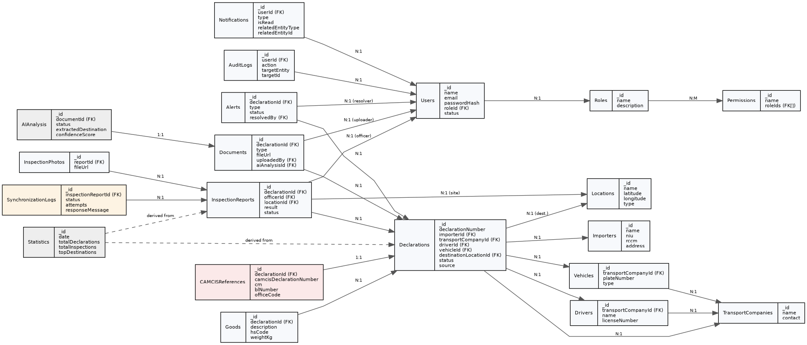
Figure 1: Entity-relationship diagram of the complete CustomsTrack AI database (20 collections).

