CUSTOMSTRACK AI
UI / UX SCREEN-BY-SCREEN DESIGN
This document designs every screen of CustomsTrack AI before any code is written, covering all fourteen screens in the requested application flow: Splash, Login, Dashboard, Declarations, Declaration Details, Google Maps, AI Analysis (future phase), Inspection, Inspection History, Reports, Synchronisation Status, Users (Admin), Settings, and Logout. For each screen, this document specifies its purpose, user role, every UI component present (cards, tables, search bars, buttons, forms, maps, charts), navigation behaviour, validation rules, loading states, empty states, error messages, permissions, and available actions. Low-fidelity wireframes illustrate the approximate layout of each screen; these are structural references for development, not final visual designs. No implementation code is included.
Unless otherwise noted, screens are designed for the React Native mobile application, the system's main operational tool per the approved architecture. Reports, Synchronisation Status, and Users (Admin) are primarily Supervisor/Administrator-facing and have equivalent, typically fuller, views on the lightweight React.js Web Dashboard; their mobile versions are described here since they appear in the requested application flow.
How Users Move Between Screens
The requested screen sequence, Splash through Logout, represents the deepest possible path through the application, not a single linear flow every user follows in order. In practice, CustomsTrack AI uses a hub-and-spoke navigation structure: Dashboard is the central hub that every root-level screen (Search, History, Settings, and, for Supervisor/Administrator, Reports and Synchronisation Status) branches from and returns to, while Declaration Details, Google Maps, AI Analysis, and Inspection form a deeper stack reached only after a specific declaration has been selected.
Concretely: Splash silently resolves to either Login or Dashboard depending on session state. From Dashboard, a bottom navigation bar gives persistent access to Search (Declarations), History (Inspection History), and Settings; Supervisor and Administrator accounts additionally see Reports and Synchronisation Status from this same hub. Selecting a declaration from Search opens Declaration Details, from which an officer can branch further into Google Maps (view destination), the future AI Analysis screen, or Inspection (record findings); all three of these return to Declaration Details when finished, and a submitted inspection additionally forwards the user to Inspection History. Users (Admin) and Change Password are reached only from Settings, as modal-style sub-screens rather than root-level destinations, and are shown in navigation only to the roles permitted to use them, Users (Admin) exclusively to Administrator. Logout is a confirmation dialog layered over Settings, not a standalone screen with its own further navigation; confirming it clears the session and returns the user to Login.
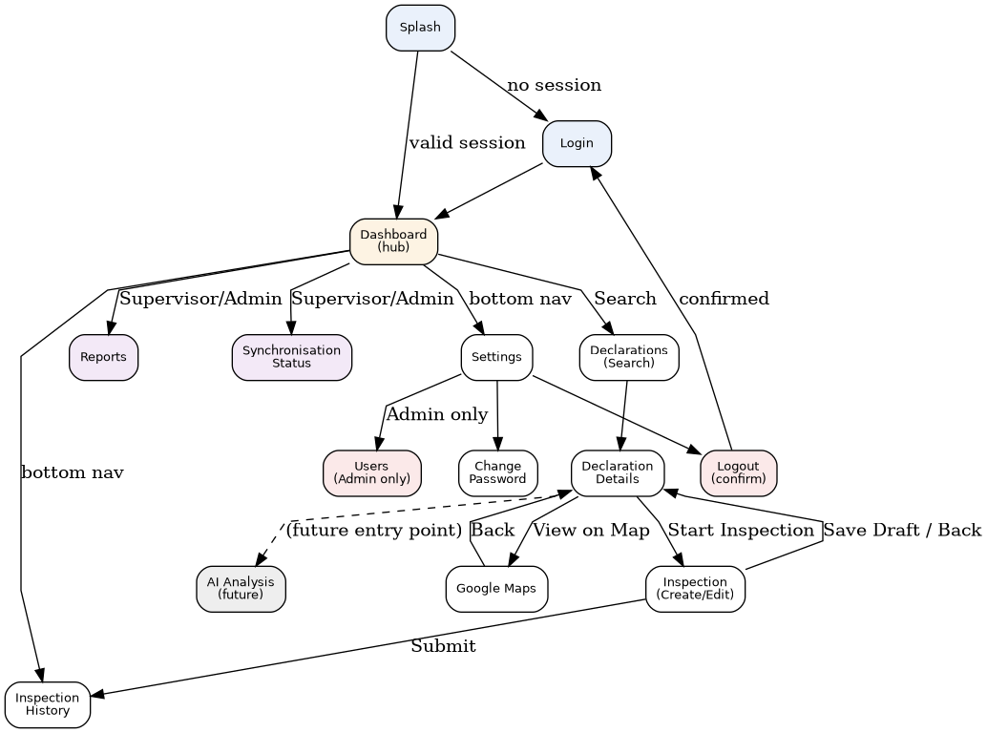
Figure 1: Navigation map — hub-and-spoke structure radiating from Dashboard, with role-gated branches shown in colour (Administrator-only in red, Supervisor/Administrator in purple, future-phase in grey).
1. Splash Screen
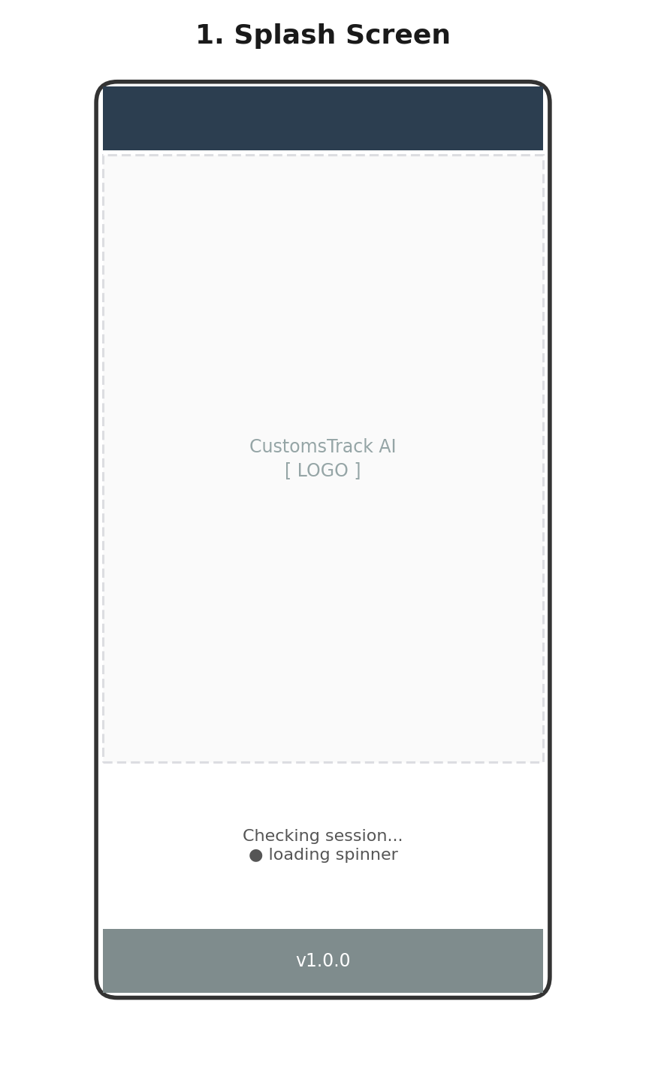
Wireframe 1: Splash Screen (low-fidelity layout reference)
Purpose | Branded app launch screen that checks for an existing valid session token and silently routes the user to Dashboard (if logged in) or Login (if not), without requiring interaction.
User Role | All roles (Administrator, Customs Officer, Mobile Brigade, Supervisor)
Components | Logo/branding, loading indicator, version label
Cards | None
Tables | None
Search Bars | None
Buttons | None — no user interaction is expected on this screen
Forms | None
Maps | None
Charts | None
Navigation | Auto-navigates after session check (typically under 2 seconds) to Login or Dashboard; no manual navigation available
Validation Rules | Not applicable — no user input
Loading States | Indeterminate spinner while the stored token is validated
Empty States | Not applicable
Error Messages | If token validation fails unexpectedly (e.g., corrupted local storage), the app silently falls back to Login rather than showing an error
Permissions | None required to view
Actions | None — automatic transition only
2. Login Screen
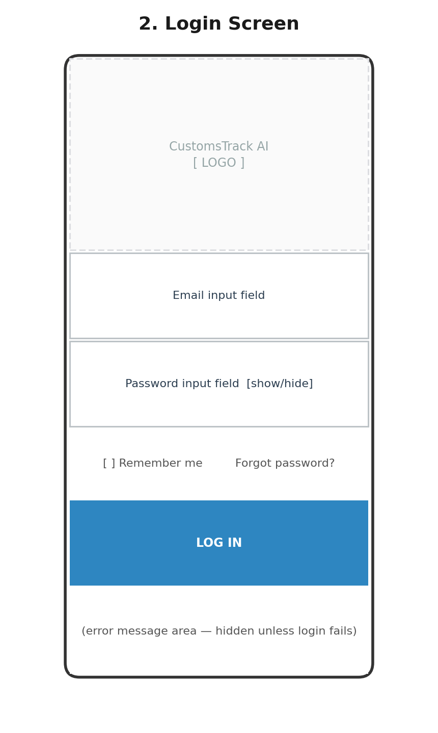
Wireframe 2: Login Screen (low-fidelity layout reference)
Purpose | Authenticate a user and issue a session (JWT) so they can access role-appropriate screens.
User Role | All roles
Components | Logo, email field, password field, remember-me checkbox, forgot-password link, login button, error banner
Cards | None
Tables | None
Search Bars | None
Buttons | "Log In" (primary); "Forgot password?" (text link)
Forms | Email + password login form
Maps | None
Charts | None
Navigation | On success, navigates to Dashboard; "Forgot password?" navigates to a password-reset flow
Validation Rules | Email must be non-empty and a valid email format; password must be non-empty; both fields required before "Log In" is enabled
Loading States | Button shows a spinner and disables while the login request is in flight
Empty States | Not applicable
Error Messages | "Incorrect email or password" for invalid credentials (401); "No internet connection" if the request cannot reach the server; inline field-level errors for malformed email
Permissions | None required to view (pre-authentication screen)
Actions | Submit credentials; toggle password visibility; navigate to password reset
3. Dashboard (Home)
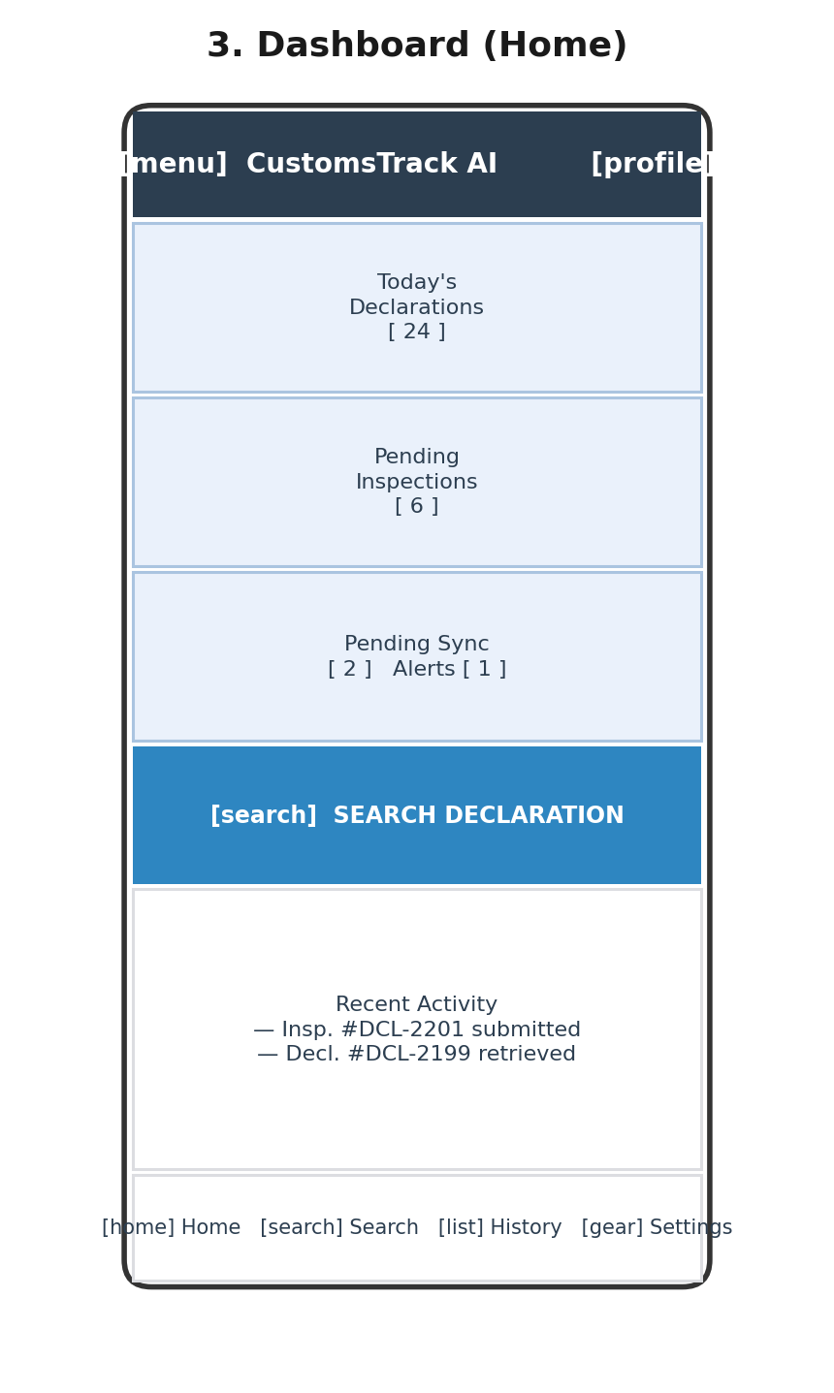
Wireframe 3: Dashboard (Home) (low-fidelity layout reference)
Purpose | Give the logged-in user a role-scoped, at-a-glance operational summary and fast access to the most common next action (search or new inspection).
User Role | Customs Officer, Mobile Brigade primarily on mobile; Administrator/Supervisor see an equivalent summary on the Web Dashboard
Components | App bar with profile icon, summary cards row, primary action button, recent activity list, bottom navigation bar
Cards | Today's Declarations count; Pending Inspections count; Pending Synchronisations and Active Alerts count
Tables | None — recent activity is shown as a list, not a full table
Search Bars | None directly present; search is reached via the "Search Declaration" button
Buttons | "Search Declaration" (primary call-to-action)
Forms | None
Maps | None
Charts | None on this screen — summary counts only; full charts live on the Reports screen
Navigation | "Search Declaration" -> Declarations screen; recent activity item tap -> Declaration Details or Inspection detail; bottom nav -> Search / History / Settings
Validation Rules | Not applicable (read-only screen)
Loading States | Skeleton placeholders for summary cards and activity list while dashboard data loads
Empty States | "No recent activity yet" if the officer has no declarations or inspections logged
Error Messages | "Unable to load dashboard data — pull down to retry" if the aggregation request fails
Permissions | Card contents are role-scoped; an Administrator's equivalent view emphasises user/sync metrics rather than personal inspection counts
Actions | Pull-to-refresh; tap a summary card to jump to the relevant filtered list (e.g., tapping "Pending Inspections" opens Inspection History pre-filtered)
4. Declarations (Search)
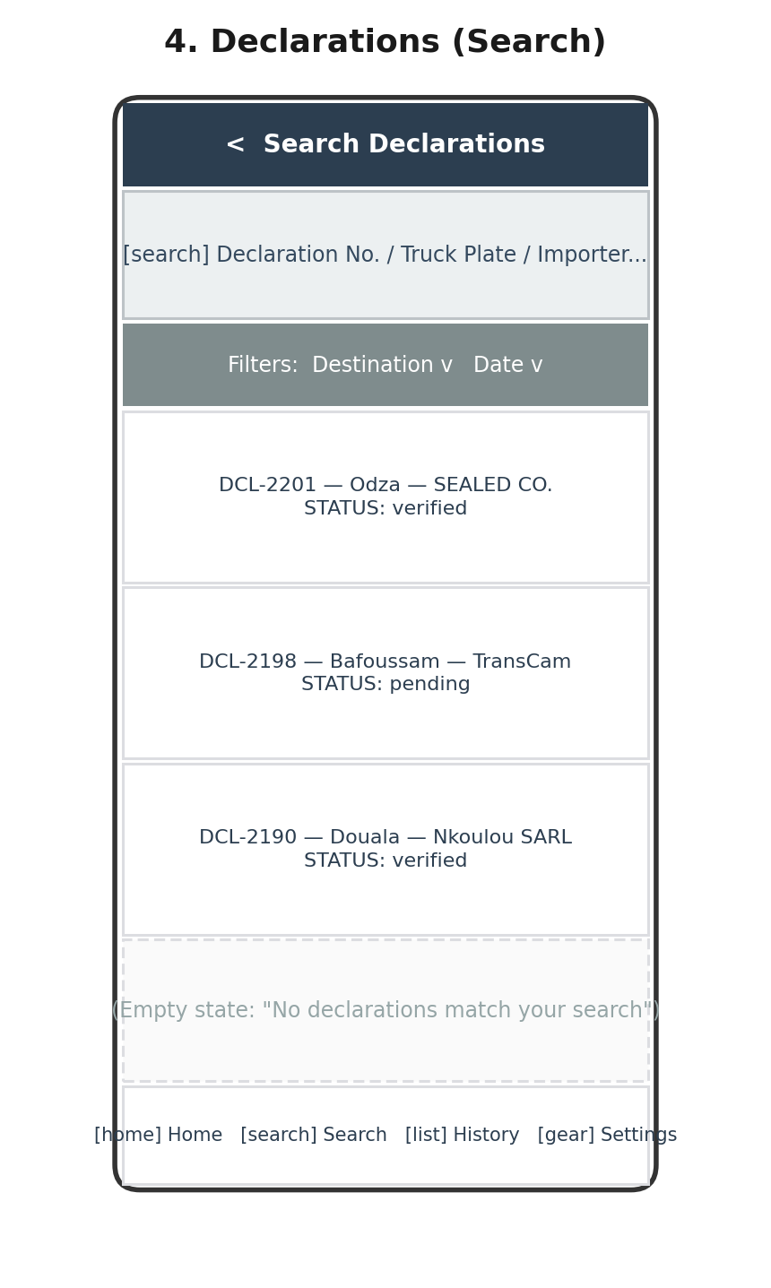
Wireframe 4: Declarations (Search) (low-fidelity layout reference)
Purpose | Let an officer locate a specific declaration quickly by any of several identifiers before viewing its details.
User Role | Customs Officer, Mobile Brigade
Components | Search bar, filter chips, results list, empty state
Cards | None — results shown as list rows, not cards, to maximise scannable density
Tables | None
Search Bars | Single field accepting declaration number, truck plate, importer name, or destination, with an adjacent date filter
Buttons | Filter toggle chips (Destination, Date); no separate "search" button — search executes as the user types (debounced)
Forms | None
Maps | None
Charts | None
Navigation | Tapping a result -> Declaration Details screen; back arrow -> Dashboard
Validation Rules | No strict input format, since it matches across multiple field types; minimum 2 characters before a query is issued, to avoid excessive requests
Loading States | Skeleton list rows while a search is in flight; debounce delay (approx. 300ms) before triggering a new search as the user types
Empty States | "No declarations match your search", with a suggestion to check the spelling or try a different identifier
Error Messages | "Search failed — check your connection and try again" if the request fails
Permissions | Available to Customs Officer and Mobile Brigade; Administrator/Supervisor use an equivalent search on the Web Dashboard
Actions | Type to search; tap filter chip to narrow results; tap result row to open details; pull-to-refresh
5. Declaration Details
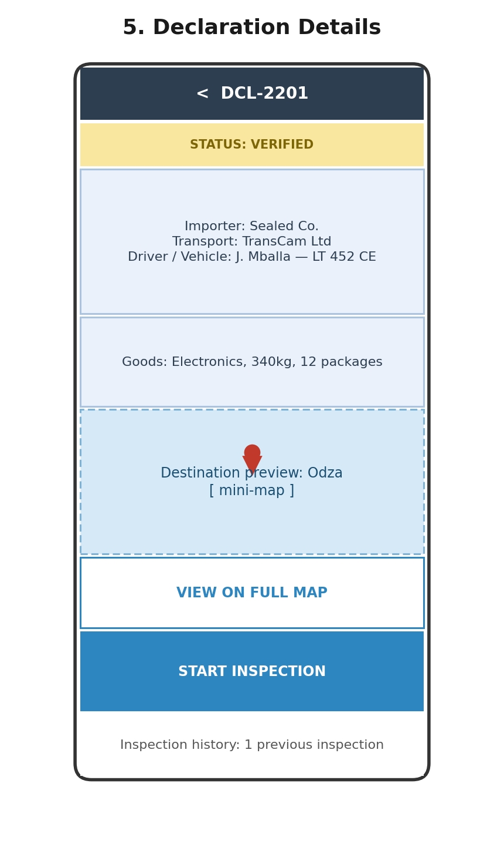
Wireframe 5: Declaration Details (low-fidelity layout reference)
Purpose | Present everything known about one declaration, retrieved declaration data, destination, and past inspections, and launch the two things an officer does next: view the map or start an inspection.
User Role | Customs Officer, Mobile Brigade
Components | Status badge, info card, goods card, destination mini-map preview, action buttons, inspection history summary
Cards | Declaration info card (importer, transport company, driver, vehicle); Goods card (description, weight, packages)
Tables | None
Search Bars | None
Buttons | "View on Full Map" (secondary); "Start Inspection" (primary)
Forms | None
Maps | Small, non-interactive map preview showing the destination marker; tapping it, or the "View on Full Map" button, opens the full Google Maps screen
Charts | None
Navigation | "View on Full Map" -> Google Maps screen; "Start Inspection" -> Inspection screen (pre-linked to this declaration); inspection history summary tap -> Inspection History filtered to this declaration
Validation Rules | Not applicable (read-only screen)
Loading States | Skeleton cards while declaration detail is being retrieved
Empty States | "No prior inspections for this declaration" in the inspection history summary, when applicable
Error Messages | "Declaration could not be loaded" if retrieval fails, with a retry button
Permissions | Viewable by Customs Officer and Mobile Brigade; "Start Inspection" available to both roles per the approved SRS
Actions | View full map; start inspection; view inspection history; pull-to-refresh to re-sync declaration data
6. Google Maps Screen
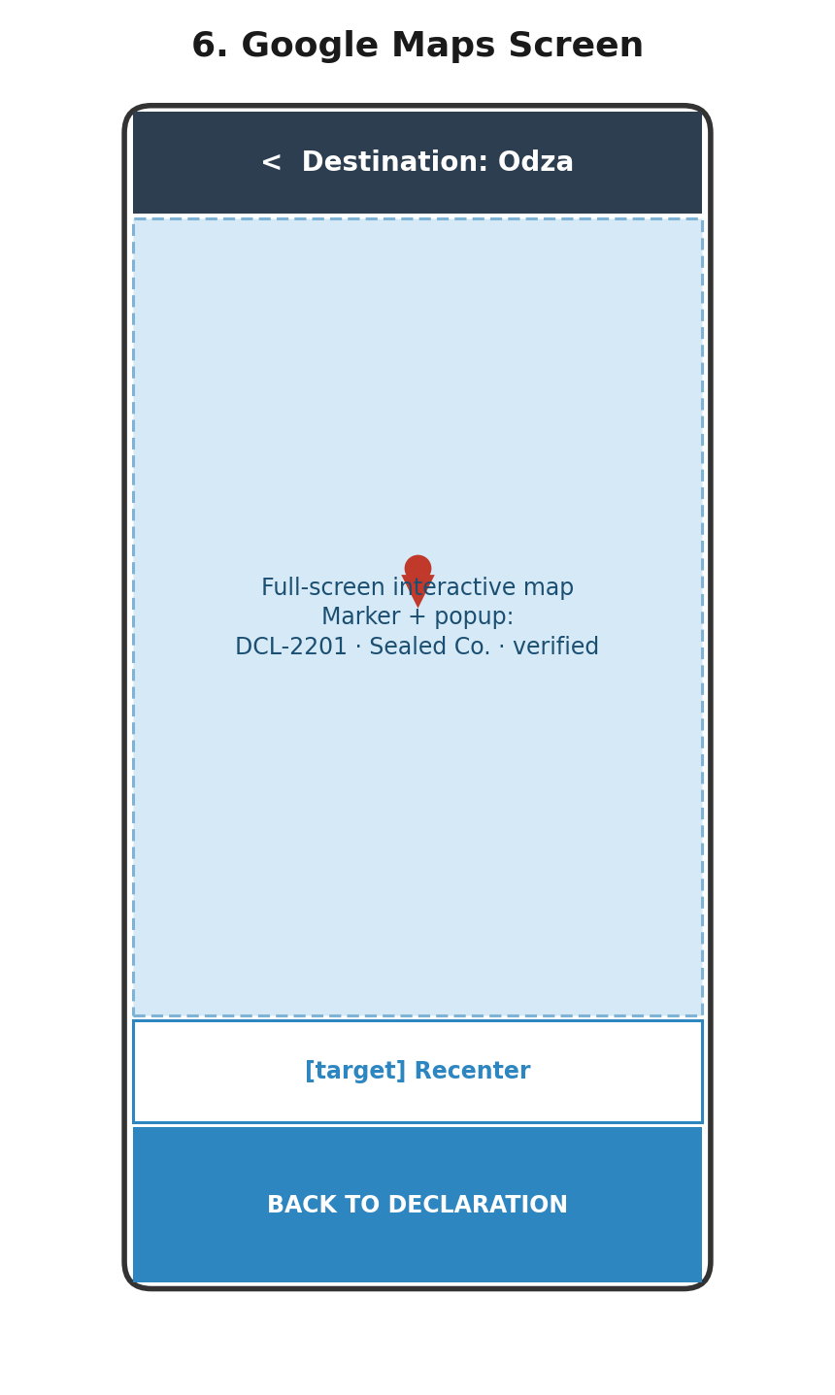
Wireframe 6: Google Maps Screen (low-fidelity layout reference)
Purpose | Give the officer a full, interactive visual of exactly where the shipment is declared to go, replacing a line of text with a location they can immediately recognise.
User Role | Customs Officer, Mobile Brigade
Components | Full-screen map, marker with info popup, recenter button, back button
Cards | Popup card appears on marker tap, showing declaration number, importer, and status
Tables | None
Search Bars | None
Buttons | "Recenter" (secondary, floating); "Back to Declaration" (primary)
Forms | None
Maps | Primary content of the screen — interactive Google Maps view centred on the geocoded destination coordinate
Charts | None
Navigation | "Back to Declaration" -> Declaration Details screen
Validation Rules | Not applicable
Loading States | Map placeholder with spinner while geocoding/tile loading completes
Empty States | Not applicable — a declaration always has a destination once retrieved
Error Messages | "Destination could not be located on the map" if geocoding fails, with an option to report the issue rather than a blank map
Permissions | Viewable by Customs Officer and Mobile Brigade
Actions | Pinch/zoom, pan, tap marker for popup, recenter, return to declaration
7. AI Analysis (Future Phase)
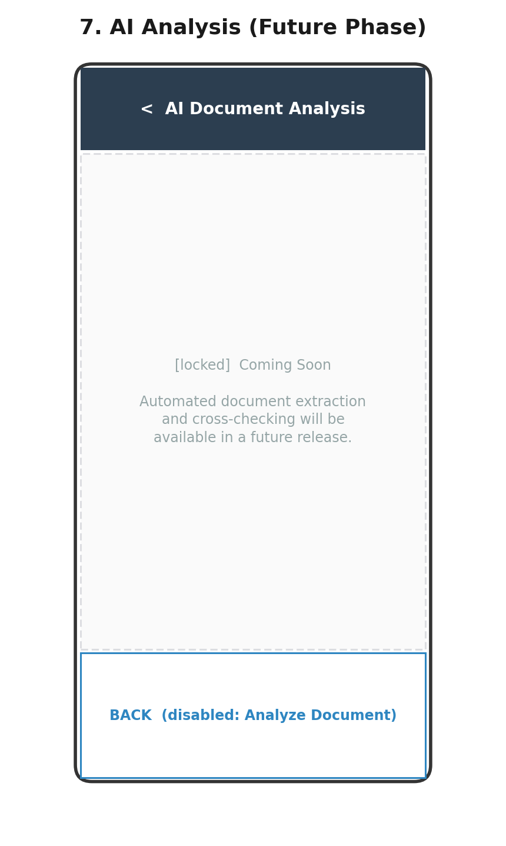
Wireframe 7: AI Analysis (Future Phase) (low-fidelity layout reference)
Purpose | Placeholder screen reserving the navigation slot and layout for automated document extraction and cross-referencing, explicitly deferred to a future phase per the approved SRS and Chapter One's delimitation (Section 1.8.1).
User Role | Customs Officer (intended, once implemented)
Components | Header, "coming soon" empty-state message, disabled action button
Cards | None
Tables | None
Search Bars | None
Buttons | "Analyze Document" — present but disabled/greyed out, with a label explaining it is not yet available
Forms | None
Maps | None
Charts | None
Navigation | Reachable from Declaration Details if a document-analysis entry point is surfaced; back arrow returns to the previous screen
Validation Rules | Not applicable
Loading States | Not applicable — no backend call is made in the current phase
Empty States | "Coming Soon — automated document extraction and cross-checking will be available in a future release" is the screen's permanent state for this phase
Error Messages | Not applicable
Permissions | Not enforced yet, since the feature is inactive; role restrictions will be defined when implemented
Actions | None functional in this phase; the screen exists to preserve the designed information architecture for later implementation
8. Inspection (Create / Edit)
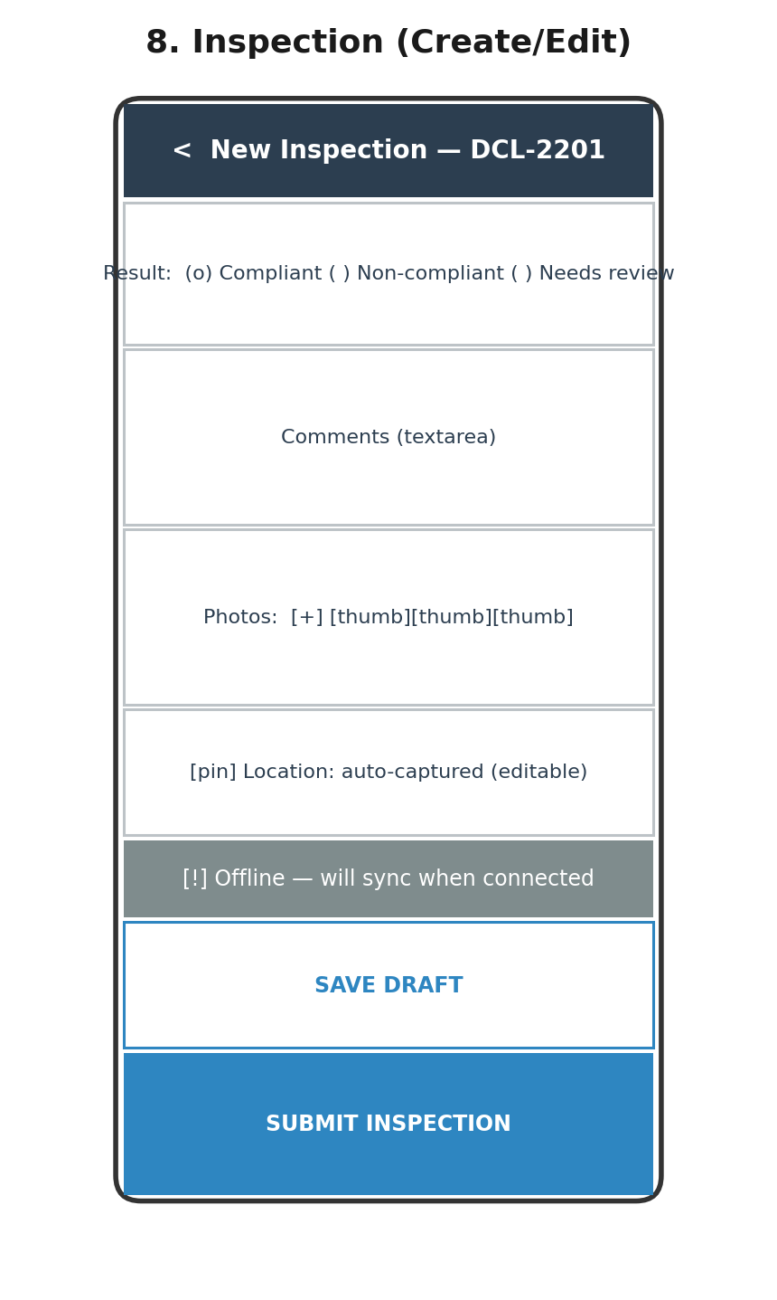
Wireframe 8: Inspection (Create / Edit) (low-fidelity layout reference)
Purpose | Let an officer record what they found during a field inspection, result, comments, and photographic evidence, against a specific declaration, whether or not connectivity is available at the time.
User Role | Customs Officer, Mobile Brigade
Components | Result selector, comments field, photo capture/upload, auto-captured location, offline indicator, save/submit buttons
Cards | None
Tables | None
Search Bars | None
Buttons | "Save Draft" (secondary); "Submit Inspection" (primary)
Forms | Result (radio: Compliant / Non-compliant / Needs Review); comments (multi-line text); photo attachments (camera or gallery, multiple); inspection location (auto-captured via device GPS, manually adjustable)
Maps | Not the primary content, but the captured inspection-site coordinate may be shown as a small confirmation pin
Charts | None
Navigation | "Submit Inspection" -> confirmation, then Inspection History (or back to Declaration Details); "Save Draft" keeps the officer on the same screen with a saved-locally confirmation
Validation Rules | Result selection is required; comments are required if result is "Non-compliant" or "Needs Review"; at least one photo is required before submission; location must be captured or manually set before submission
Loading States | Spinner on "Submit Inspection" while the request is in flight (or while queuing locally if offline); photo thumbnails show individual upload progress
Empty States | "No photos attached yet" placeholder in the photo section before any are added
Error Messages | "Photo upload failed — tap to retry" per photo; "Inspection could not be submitted — saved locally and will sync when possible" if offline or the server is unreachable
Permissions | Available to Customs Officer and Mobile Brigade, consistent with the approved SRS assigning inspection responsibility to both roles
Actions | Select result; write comments; attach/remove photos; adjust location; save draft; submit (enqueues the report for synchronisation per Chapter Two's Synchronisation Flow)
9. Inspection History
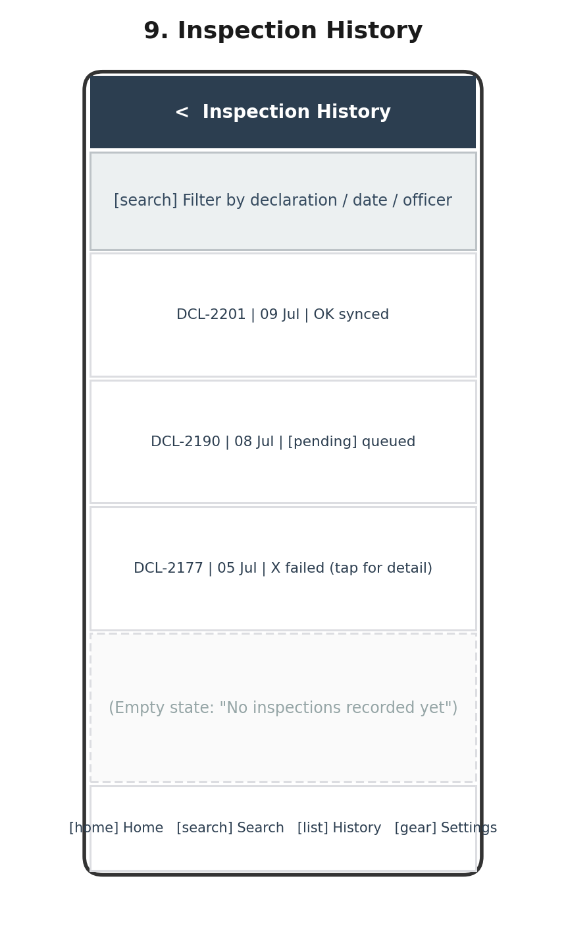
Wireframe 9: Inspection History (low-fidelity layout reference)
Purpose | Let an officer or supervisor review past inspections and their current synchronisation status, without needing to consult CAMCIS directly.
User Role | Customs Officer, Mobile Brigade (own inspections); Supervisor (all inspections, via the equivalent Web Dashboard view)
Components | Search/filter bar, inspection list/table with status badges, empty state
Cards | None
Tables | Inspection list presented as a lightweight table: declaration number, date, synchronisation status icon
Search Bars | Filter by declaration number, date, or officer
Buttons | None beyond row taps — detail view opens on tap, not a separate button
Forms | None
Maps | None
Charts | None
Navigation | Row tap -> Inspection detail (read-only view of a submitted report); back arrow -> Dashboard
Validation Rules | Not applicable (read-only screen)
Loading States | Skeleton rows while inspection history loads
Empty States | "No inspections recorded yet" for an officer with no history
Error Messages | "Unable to load inspection history" with retry, if the request fails
Permissions | An officer sees only their own inspections; Supervisor sees all officers' inspections via the Web Dashboard's equivalent screen
Actions | Filter/search; tap row for detail; pull-to-refresh to check for updated sync status
10. Reports
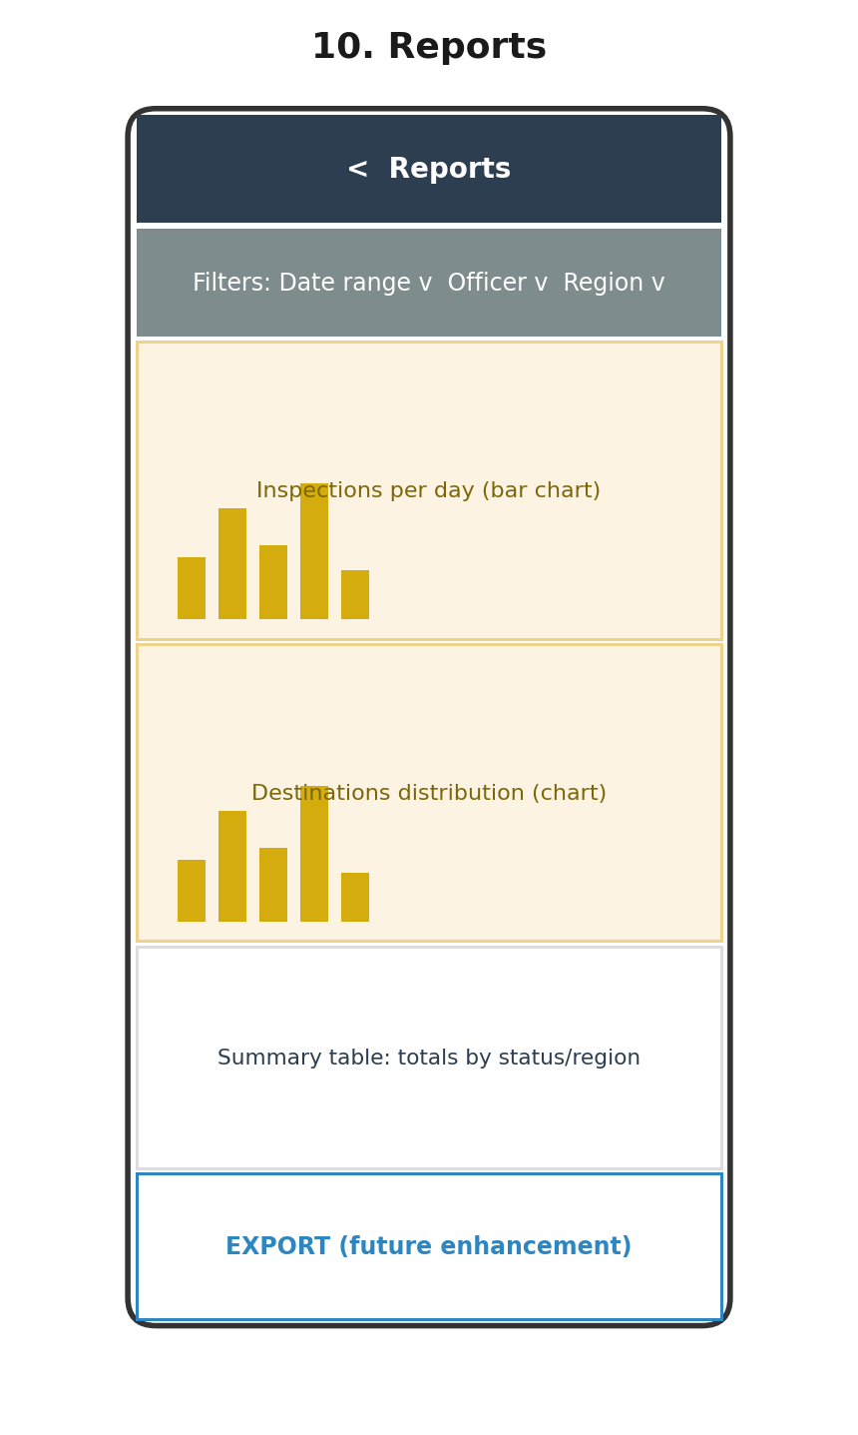
Wireframe 10: Reports (low-fidelity layout reference)
Purpose | Give Supervisors, and in summary form Administrators, an aggregated operational view of inspection activity without manually compiling data from individual reports.
User Role | Supervisor primarily; Administrator secondarily, via the Web Dashboard
Components | Filter bar, chart region, summary table
Cards | None — chart panels used instead
Tables | Summary table of totals by status/region beneath the charts
Search Bars | None — filter dropdowns used instead of free-text search
Buttons | "Export" — present, explicitly noted as a future enhancement per SRS Section 14 (Future Improvements)
Forms | Filter controls (date range, officer, region) — a lightweight filter form, not a data-entry form
Maps | None on this screen — destination-level detail lives on the Google Maps screen
Charts | Bar chart of inspections per day; distribution chart of most common destinations
Navigation | Reachable from Dashboard or bottom navigation (role-permitting); tapping a chart segment opens filtered Inspection History
Validation Rules | Date range filter must have a valid start date on or before the end date
Loading States | Chart skeletons while aggregated data loads
Empty States | "No data available for the selected filters" if a filter combination returns nothing
Error Messages | "Unable to load report data" with retry
Permissions | Full access for Supervisor and Administrator; not exposed to Customs Officer or Mobile Brigade roles
Actions | Adjust filters; tap a chart segment to drill into filtered Inspection History; export (future)
11. Synchronization Status
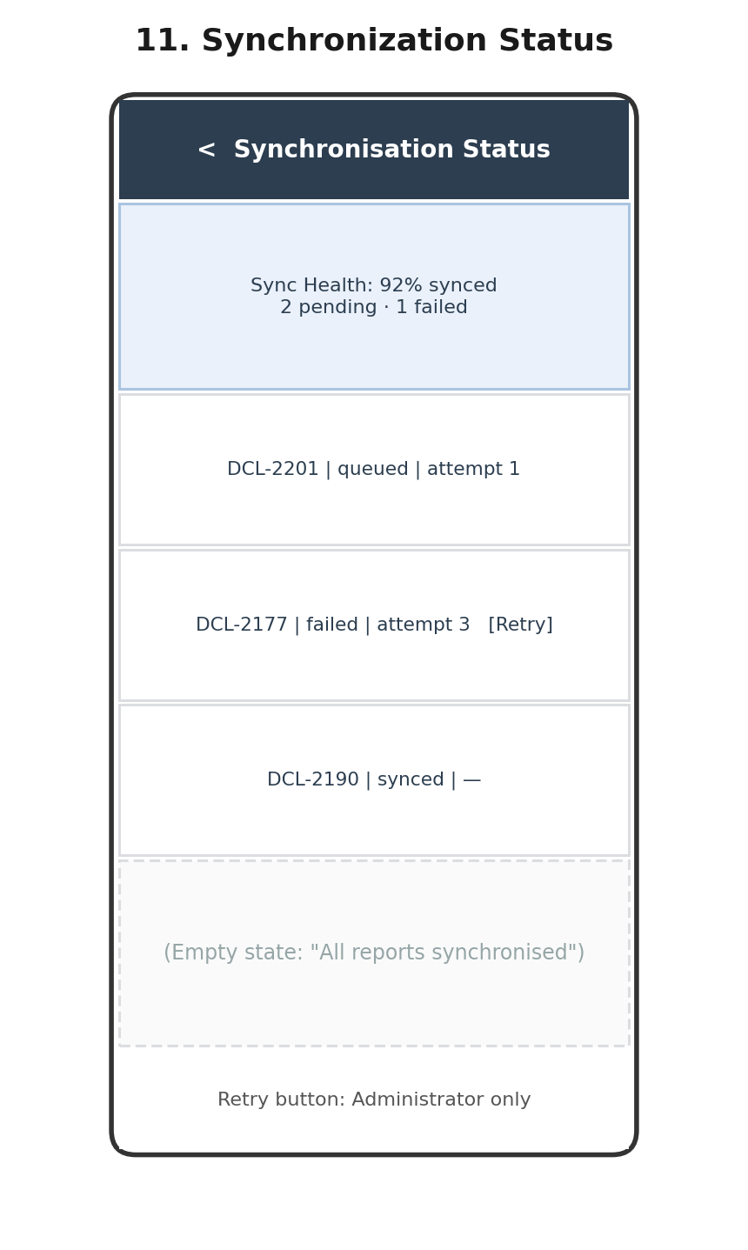
Wireframe 11: Synchronization Status (low-fidelity layout reference)
Purpose | Give visibility into the health of the CAMCIS synchronisation pipeline, how many reports are synced, pending, or failed, and allow manual intervention when needed.
User Role | Administrator, Supervisor
Components | Sync health summary card, queue table, retry action
Cards | Sync health summary card (percentage synced, counts of pending/failed)
Tables | Synchronisation queue table: declaration/report reference, status, attempt count, last attempt time
Search Bars | None — the queue is typically short enough not to require search; filter by status instead
Buttons | "Retry" per failed row (Administrator only)
Forms | None
Maps | None
Charts | None
Navigation | Row tap -> Synchronisation log detail (full attempt history for that report); back arrow -> Dashboard or Web Dashboard home
Validation Rules | Not applicable
Loading States | Skeleton rows while queue data loads
Empty States | "All reports synchronised" when the queue is empty
Error Messages | Expandable error detail per failed row, showing the actual response/failure reason from the synchronisation attempt
Permissions | Viewable by Administrator and Supervisor; "Retry" action restricted to Administrator only, consistent with Chapter Two's API Architecture
Actions | View queue; expand failure detail; manually retry a failed synchronisation
12. Users (Admin)
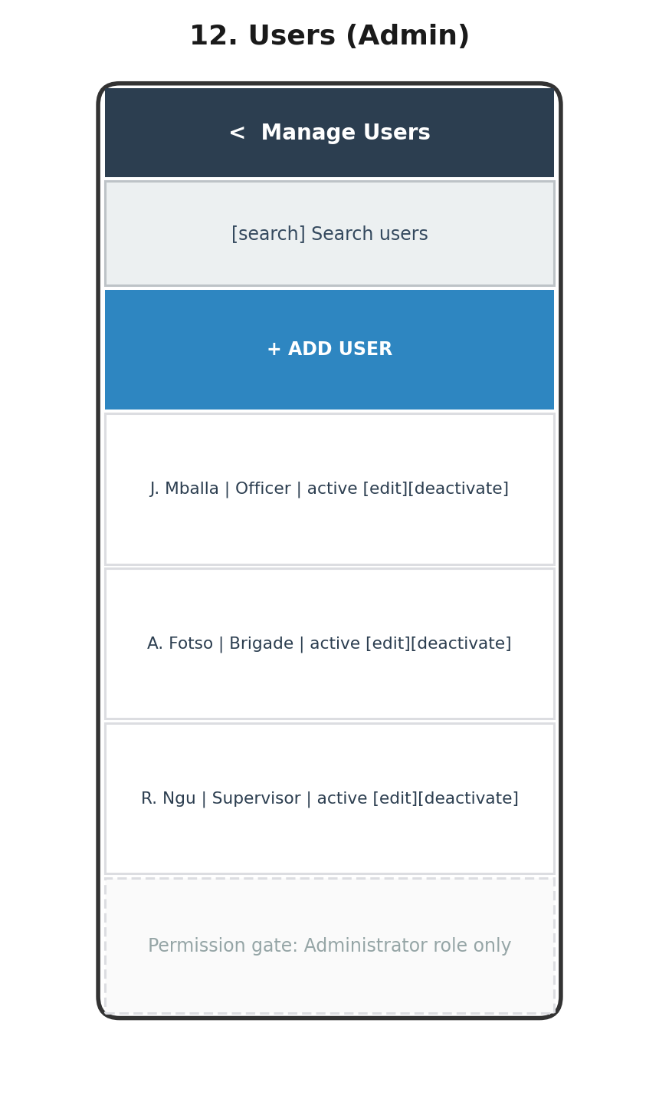
Wireframe 12: Users (Admin) (low-fidelity layout reference)
Purpose | Let an Administrator create, edit, and deactivate user accounts and assign roles, the only role permitted to manage users per the SRS's Business Rules.
User Role | Administrator only
Components | Search bar, "Add User" button, user table, edit/deactivate actions
Cards | None
Tables | User list table: name, role, status, action icons
Search Bars | Search by name or email
Buttons | "+ Add User" (primary); inline "Edit" and "Deactivate" per row
Forms | Add/Edit User form: name, email, role (dropdown: Administrator, Customs Officer, Mobile Brigade, Supervisor), initial password or invite mechanism
Maps | None
Charts | None
Navigation | "Add User" -> modal/form overlay; "Edit" -> same form pre-filled; back arrow -> Dashboard/Web Dashboard home
Validation Rules | Name and email required; email must be valid format and unique; role must be selected from the fixed set of four; a confirmation step is required before deactivating a user
Loading States | Skeleton rows while the user list loads; spinner on form submission
Empty States | "No users found" (unlikely in practice, but handled for a fresh installation)
Error Messages | "Email already in use" for duplicate accounts; "User could not be saved — check the form and try again" for other failures
Permissions | Entire screen restricted to Administrator role; hidden from navigation entirely for other roles rather than shown-but-disabled
Actions | Search users; add user; edit user; deactivate user (soft delete, consistent with audit-logging requirements)
13. Settings
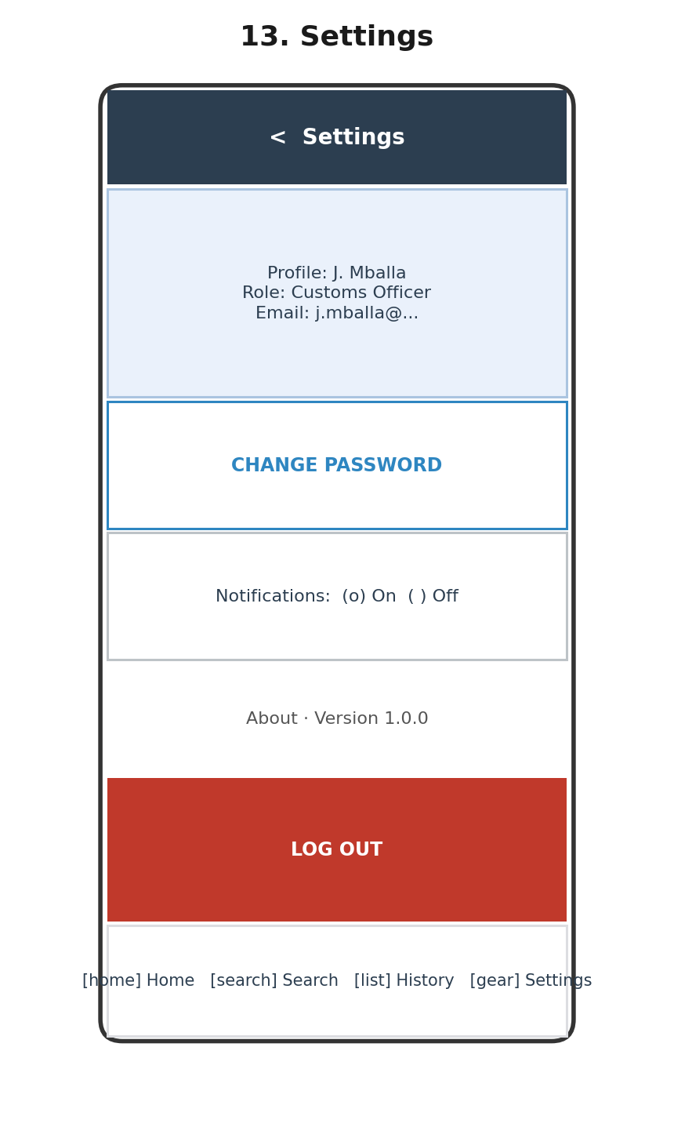
Wireframe 13: Settings (low-fidelity layout reference)
Purpose | Let any authenticated user view their own profile, change their password, adjust basic preferences, and log out.
User Role | All roles
Components | Profile summary card, change-password action, preference toggle, about section, logout button
Cards | Profile card (name, role, email — read-only)
Tables | None
Search Bars | None
Buttons | "Change Password" (secondary); "Log Out" (destructive style)
Forms | Change-password form (current password, new password, confirm new password), reached via the "Change Password" action
Maps | None
Charts | None
Navigation | "Change Password" -> password form (modal or sub-screen); "Log Out" -> Logout confirmation; bottom nav -> Dashboard/Search/History
Validation Rules | New password must meet minimum length/complexity; confirm-password must match new password; current password must be correct before the change is accepted
Loading States | Spinner while the password-change request is in flight
Empty States | Not applicable
Error Messages | "Current password is incorrect"; "Passwords do not match"; generic "Unable to update settings — try again"
Permissions | Profile and password fields apply to all roles; Administrator sees an additional link to Users management from this screen
Actions | Change password; toggle notification preference; view app version; log out
14. Logout (Confirmation)
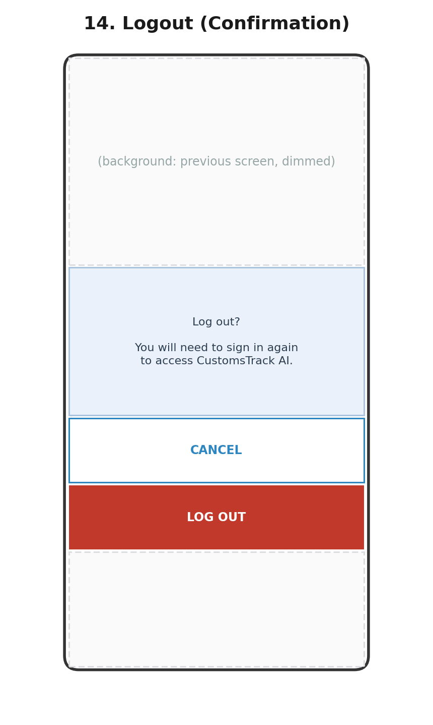
Wireframe 14: Logout (Confirmation) (low-fidelity layout reference)
Purpose | Prevent accidental sign-out by requiring explicit confirmation before ending the session.
User Role | All roles
Components | Confirmation dialog, cancel and confirm buttons
Cards | Confirmation message card
Tables | None
Search Bars | None
Buttons | "Cancel" (secondary); "Log Out" (destructive/primary)
Forms | None
Maps | None
Charts | None
Navigation | "Cancel" dismisses the dialog and returns to Settings; "Log Out" clears the session token and navigates to Login
Validation Rules | Not applicable
Loading States | Brief spinner on "Log Out" while the local session/token is cleared
Empty States | Not applicable
Error Messages | Not applicable — logout is a local, always-succeeds operation once confirmed
Permissions | Available to all authenticated roles
Actions | Confirm logout; cancel and remain signed in

