Diagrams

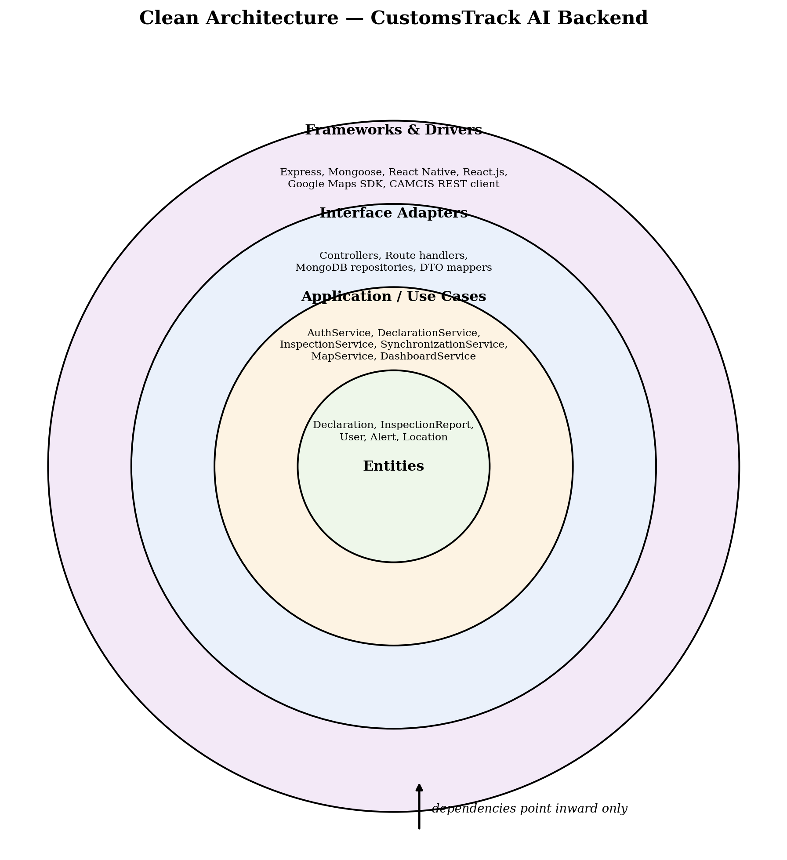
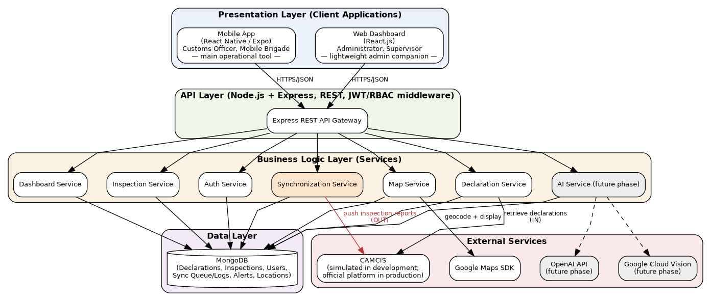 Layered architecture showing both client interfaces and the bidirectional CAMCIS relationship

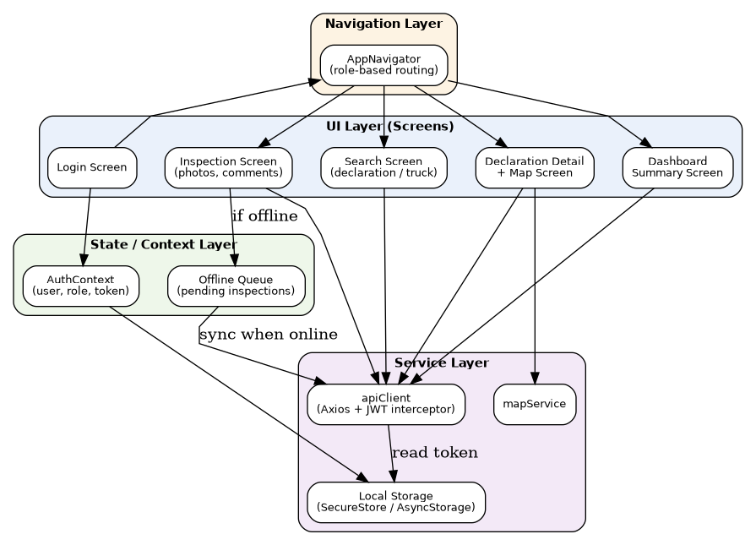
Mobile application internal architecture
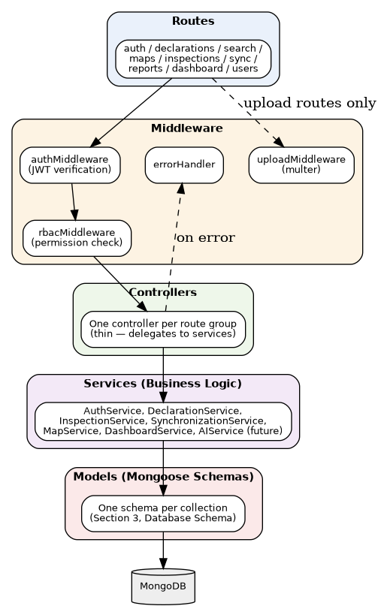
Figure 4: Backend internal architecture (request pipeline).
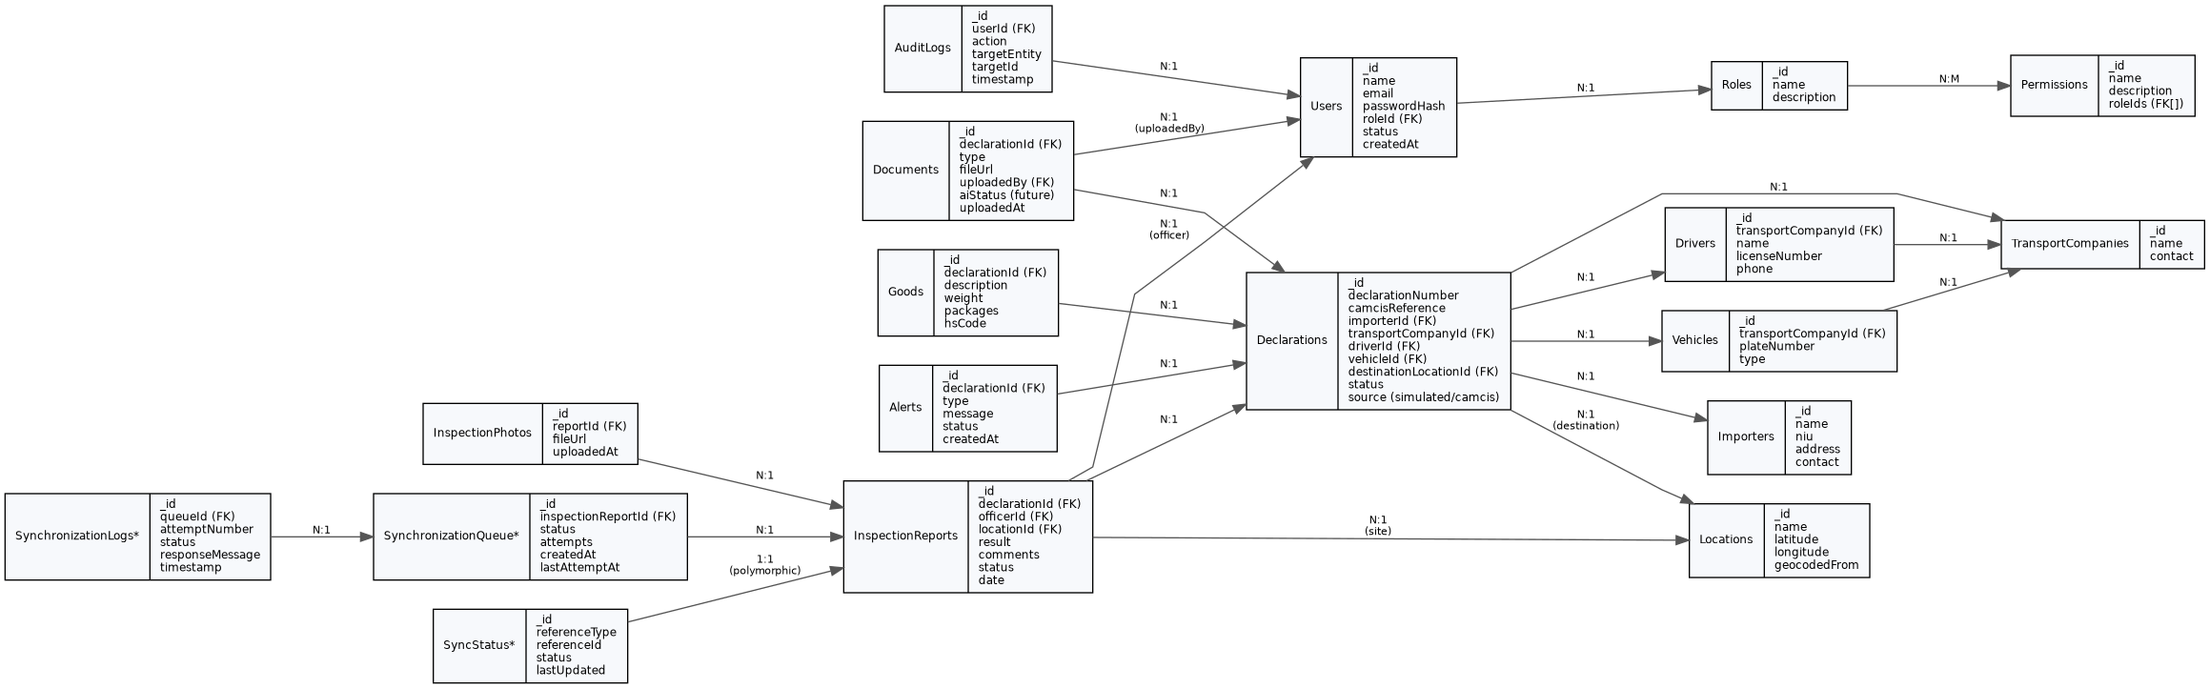
Figure 5: Entity-relationship diagram (entities marked * are recommended additions beyond the approved SRS entity list).
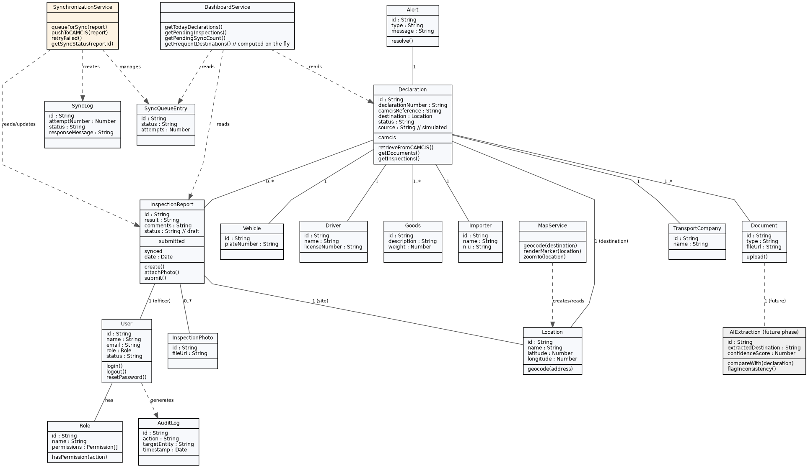
Figure 6: Conceptual class diagram, including the Synchronization Service and future-phase AI classes (shaded).
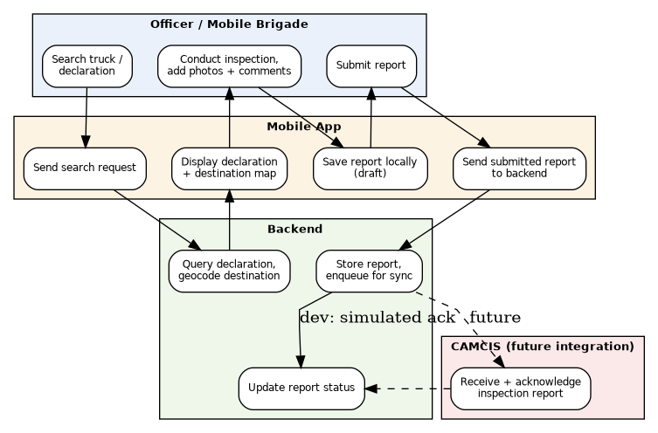
Figure 11: Activity diagram — inspection process by responsibility (swimlane).

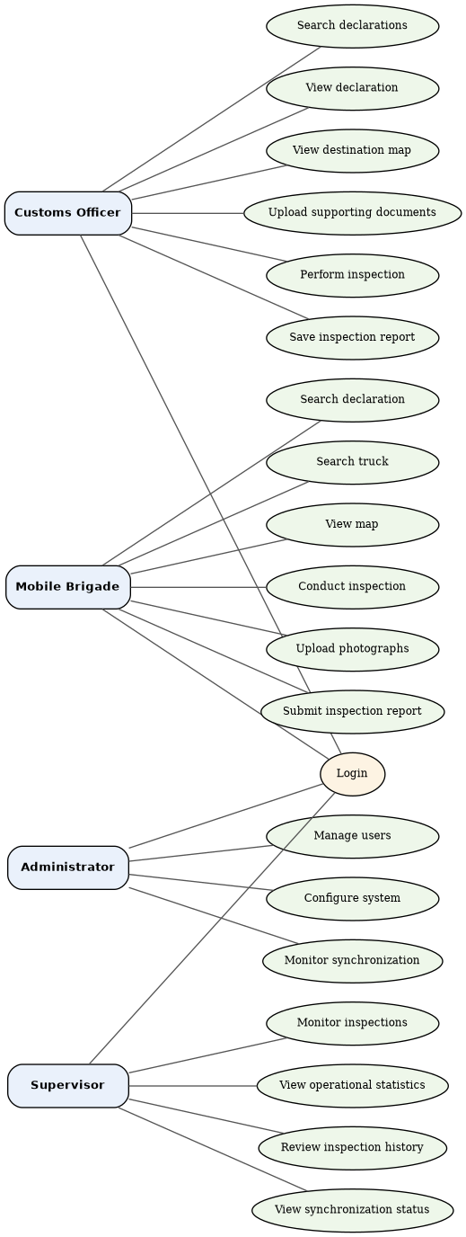
Figure 12: Use case diagram, matching SRS Section 15 exactly.
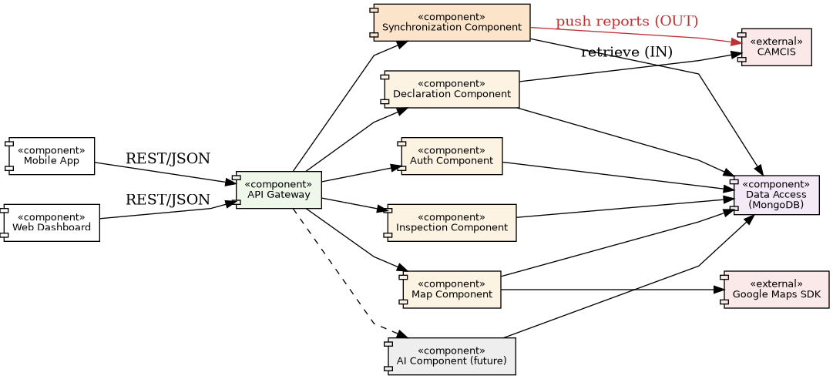
Figure 13: Component diagram showing provided/required interfaces between system components.
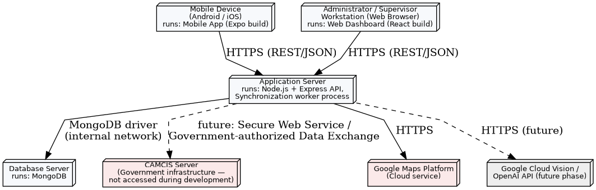
Figure 14: Deployment diagram showing physical/logical nodes
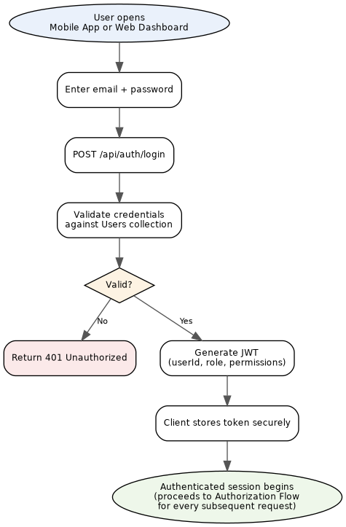
Figure 15: Authentication flow (shared by Mobile App and Web Dashboard).
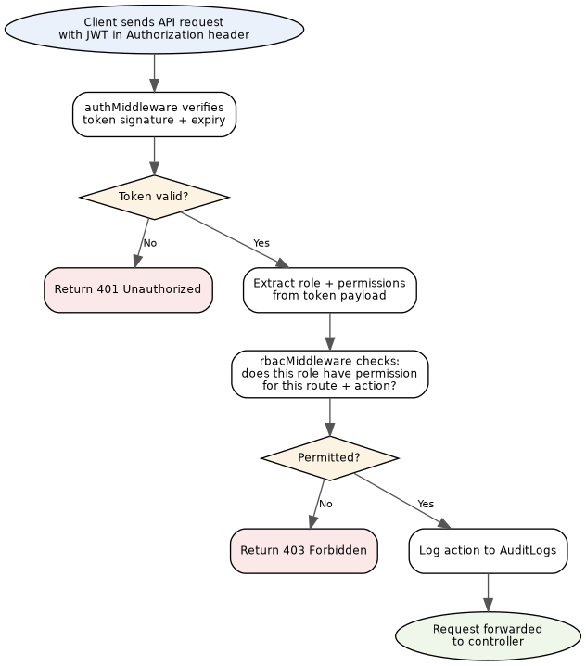
Figure 16: Authorization (RBAC) flow, applied to every authenticated request.
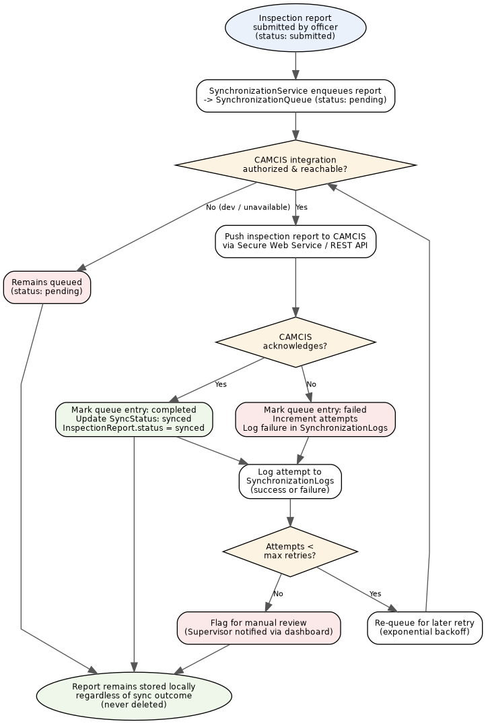
Figure 17: Synchronization flow, including retry logic and manual-review escalation.
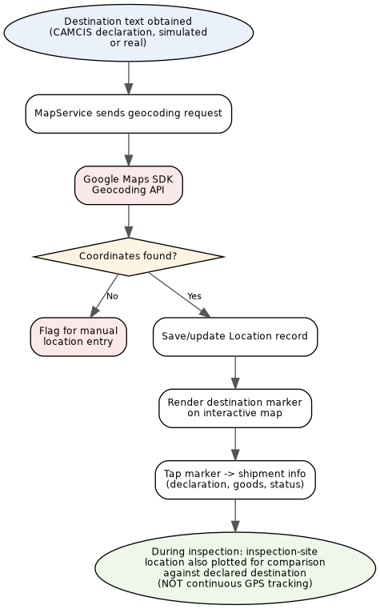
Figure 18: Google Maps destination visualisation workflow.
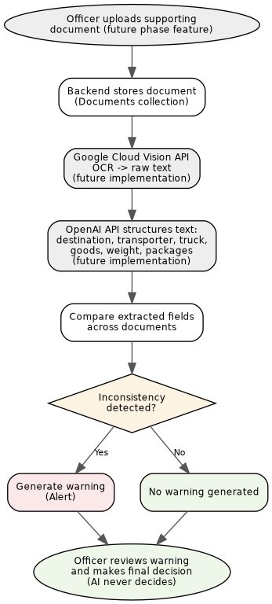
Figure 19: AI document analysis workflow — architecture defined now, implementation deferred
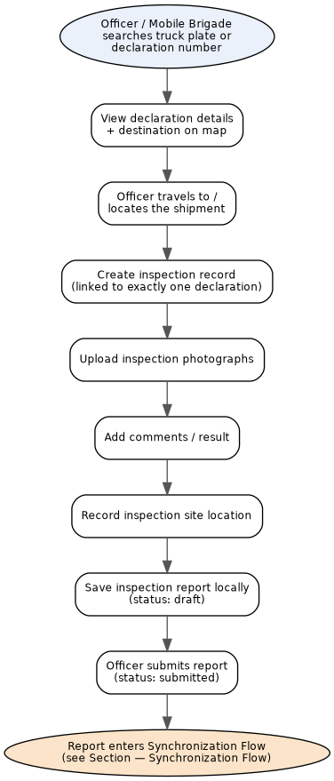
Figure 20: End-to-end inspection workflow, from search to synchronization handoff.
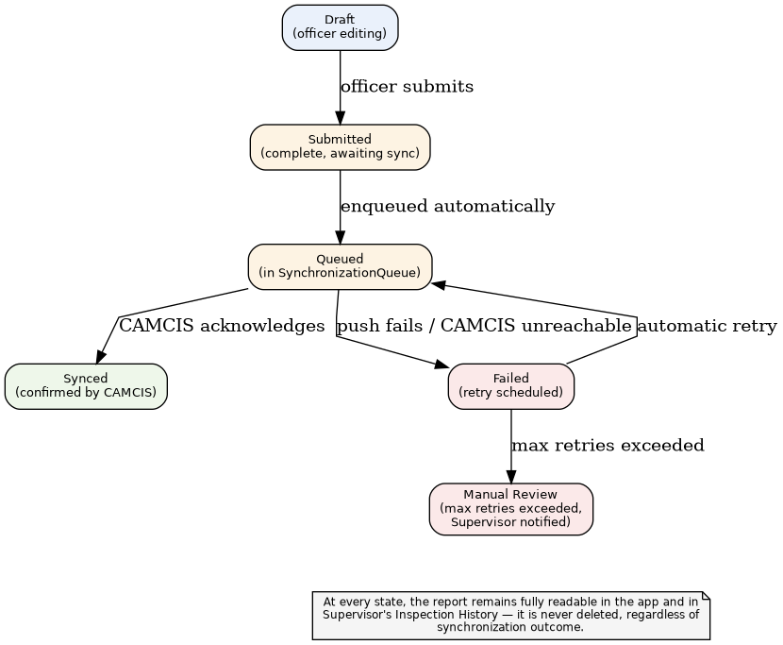
Figure 21: Report synchronization workflow, expressed as report lifecycle states
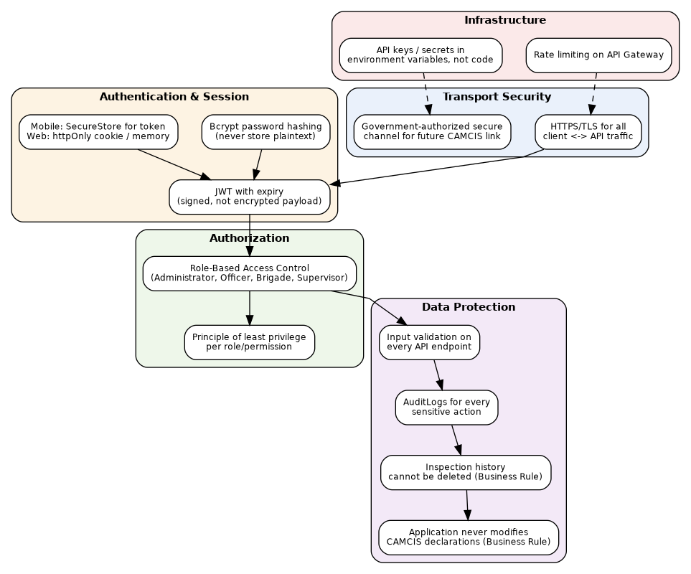
Figure 22: Security architecture, layered from transport through infrastructure.

