week03_class05.R

David Alvarez

2023-10-22

# Week 3 Data Visualization Lab 5  
  
# Any time I want to use this package I need to load it  
library("ggplot2")  
  
# Install the package ggplot2  
# install.packages("ggplot2")  
  
View(cars)  
  
# A quick base R plot - not ggplot  
plot(cars)

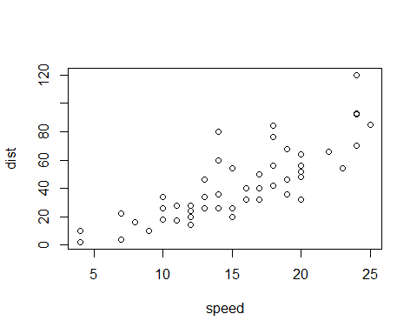

# First ggplot  
# Need data + aes + geoms  
ggplot(data =cars) + aes(x=speed, y=dist) + geom_point()

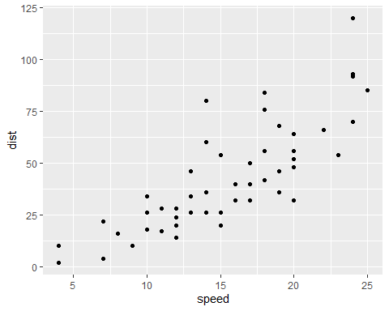

p <- ggplot(data =cars) + aes(x=speed, y=dist) + geom_point()  
  
# Add a line geom with geom_line()  
p + geom_line()

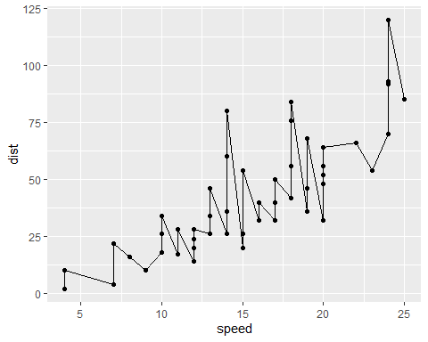

# Add a trend line close to the data  
p + geom_smooth()

## `geom_smooth()` using method = 'loess' and formula = 'y ~ x'

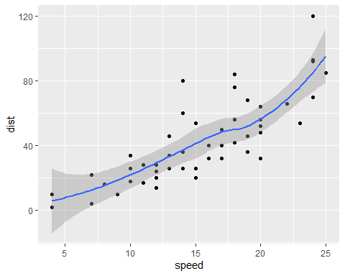

p + geom_smooth(method="lm")

## `geom_smooth()` using formula = 'y ~ x'

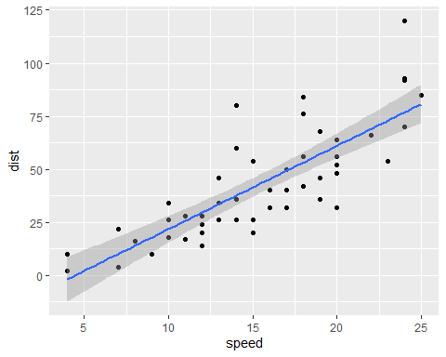

# Read in our drug expression data  
url <- "https://bioboot.github.io/bimm143_S20/class-material/up_down_expression.txt"  
genes <- read.delim(url)  
head(genes)

## Gene Condition1 Condition2 State  
## 1 A4GNT -3.6808610 -3.4401355 unchanging  
## 2 AAAS 4.5479580 4.3864126 unchanging  
## 3 AASDH 3.7190695 3.4787276 unchanging  
## 4 AATF 5.0784720 5.0151916 unchanging  
## 5 AATK 0.4711421 0.5598642 unchanging  
## 6 AB015752.4 -3.6808610 -3.5921390 unchanging

# Q. How many genes are in this dataset  
nrow(genes)

## [1] 5196

# Q. How many columns are in this dataset  
ncol(genes)

## [1] 4

# Q. How many 'up' regulated genes  
table(genes$State)

##   
## down unchanging up   
## 72 4997 127

# Q. What fraction of total genes is up-regulated  
round( (table(genes$State) / nrow(genes)) * 100, 2 )

##   
## down unchanging up   
## 1.39 96.17 2.44

library(ggplot2)  
  
# First plot attempt  
g <- ggplot(data=genes) + aes(x=Condition1, y=Condition2, col=State) + geom_point()  
  
g

# Adding color  
  
g + scale_color_manual( values = c("blue", "gray", "red")) +   
 labs(title= "Gene expression Changes Upon Drug Treatment", x="Control (no drug)", y="Drug Treatment") +  
 theme_bw()