Wind Farm Design for a Small Data Center in North Carolina
Midterm Project Report
AEEE 5250 Analysis of Renewable Energy Systems, Fall 2026
Prepared by
David Salisbury
Dmitrii Nikiforov

Submitted to: Dr. Maciej Noras
Date: 10/26/2026

1. Design Basis
Parameter | Value | Basis
IT critical load | 10 MW | Given
Power usage effectiveness (PUE) | 1.4 | Given
Total facility demand | 14 MW | 10 MW × 1.4
Annual energy demand | 122,640 MWh/yr | 14 MW × 8,760 h/yr
Reliability requirement | Near-continuous | Firm grid interconnection for backup and balancing
Table 1-1. Data center design load

2. Site Selection and Screening

2.1 Candidate Sites
Three candidate sites were chosen in the northeastern coastal plain, which has the best wind resource in North Carolina outside the ridges protected by the Mountain Ridge Protection Act. All three are open farmland within reach of transmission. Wind resources for all three sites are evaluated from year 2007 to year 2014 using WIND Toolkit at elevation of 100 m above the ground. The NLCD/PAD-US, FAA, IPaC, and NCNHP resources were evaluated for each site and results are stated in the Table 2-1.
Criterion | Site A | Site B | Site C
County / location | Perquimans County (Durants Neck)  36.130° N, 76.450° W | Camden County (South of Shiloh)  36.235° N, 76.030° W | Hyde County  (near Engelhard)  35.525° N, 76.000° W
Wind resource (m/s) | 6.91 | 7.23 | 7.30
Land availability (acres) | ~5,600 open;  ~2,100 after setbacks | ~3,500 open;  ~800 after setbacks | ~6,700 open;  ~4,400 after setbacks
Transmission proximity (mi) | ~4  (230 kV substation) | ~10  (230 kV substation) | ~20  (115 kV line)
Airports / airspace | KEDE 9.5 mi; outside Navy radar zone | USCG Air Sta. Elizabeth City 7.3 mi; inside Navy radar zone | Hyde Co. Airport 3.5 mi; near Dare Co. Bombing Range
Protected ridges | None | None | None
Wetlands | Few | Feasible, but land is fragmented | Feasible
Residential setbacks | Feasible | Feasible, but land is fragmented | Feasible
Table 2-1. Candidate site screening
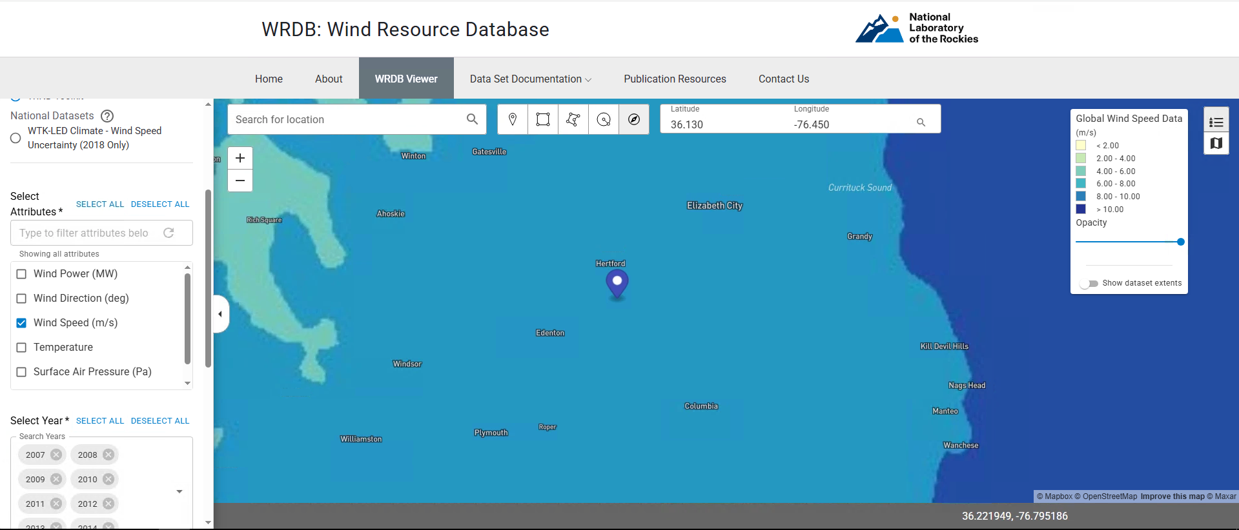
Figure 2-1-1: Site A WIND Prospector Map (100m)

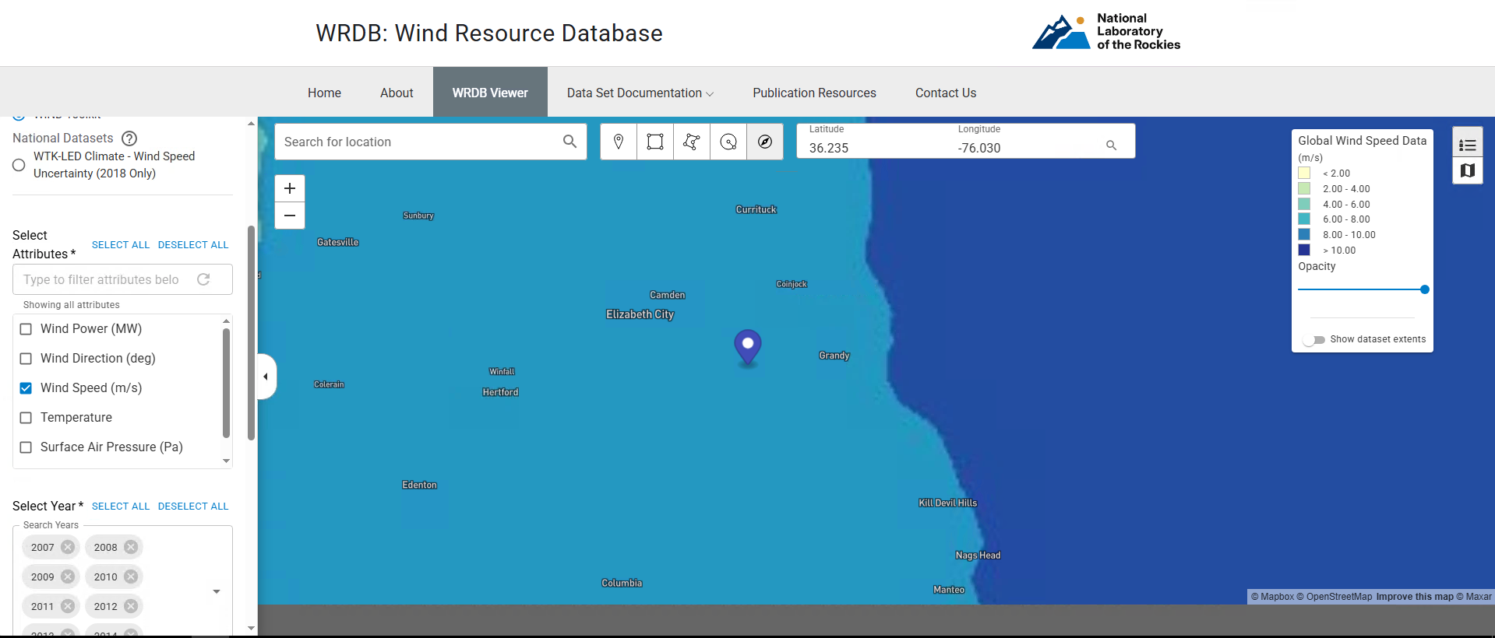
Figure 2-1-2: Site B WIND Prospector Map (100m)

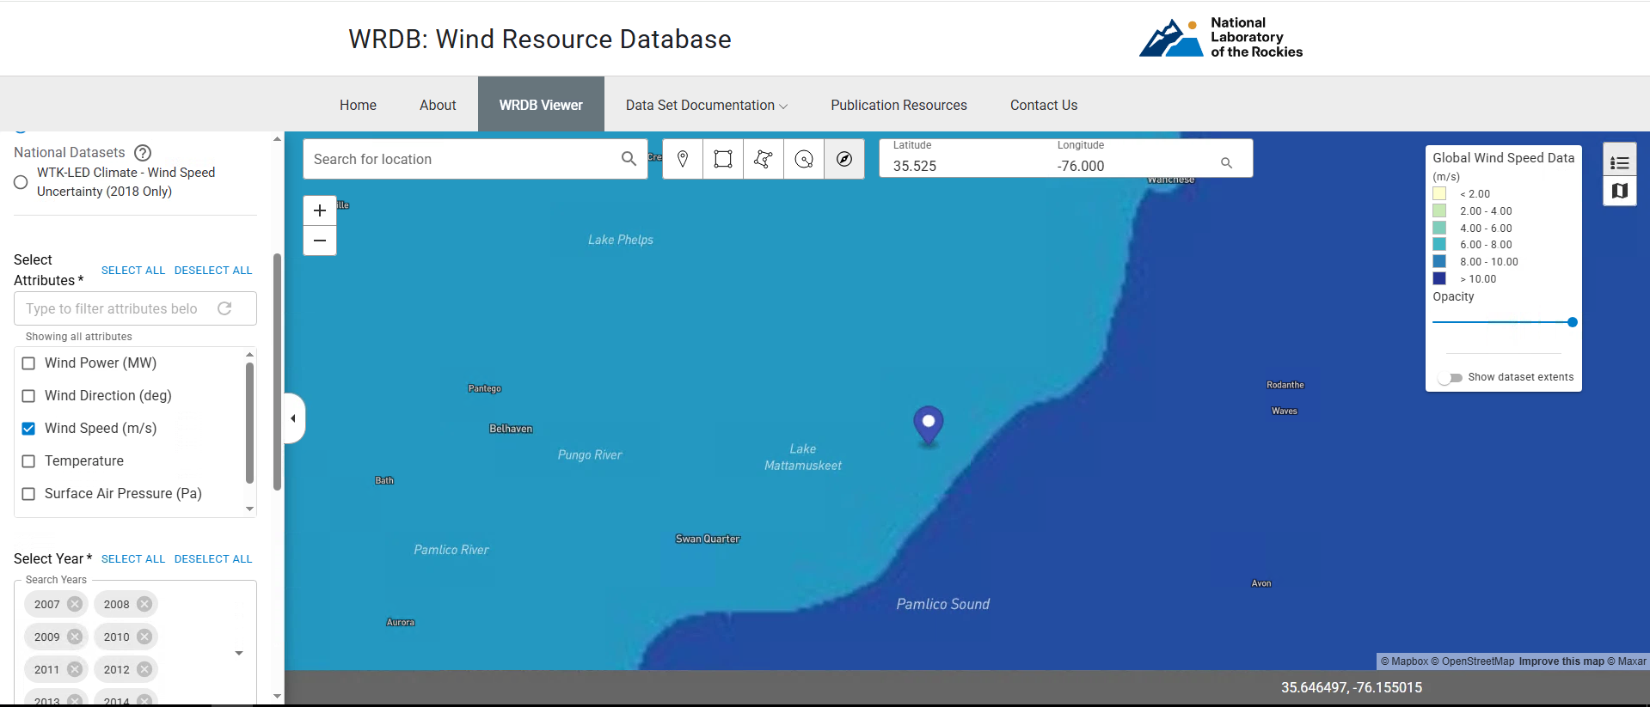
Figure 2-1-3: Site C WIND Prospector Map (100m)

Year | Average Wind Speed at 100 m - Site A (m/s) | Average Wind Speed at 100 m - Site B (m/s) | Average Wind Speed at 100 m - Site C (m/s)
2007 | 6.7756621 | 7.078539954 | 7.259392694
2008 | 7.08486908 | 7.444641393 | 7.447464709
2009 | 6.939434932 | 7.291009132 | 7.342361872
2010 | 7.044989726 | 7.426824201 | 7.454986301
2011 | 6.950275114 | 7.247930365 | 7.458334475
2012 | 6.685724044 | 6.946732696 | 7.033091985
2013 | 6.93309589 | 7.18926484 | 7.215059361
2014 | 6.887342466 | 7.200034247 | 7.221090183
Mean Wind Speed Resource (m/s) | 6.91265543 | 7.228099903 | 7.303929101
Table 2-1: WIND Mean Speed Resource Data for each site

2.2 Screening Outcomes

Each candidate site was screened with the four tools required by the assignment: the FAA OE/AAA Pre-Screening (Notice Criteria) Tool for airspace, the USGS PAD-US Data Explorer for protected and managed land, the USFWS IPaC tool for federally listed species, and the NC Natural Heritage Program (NCNHP) Data Explorer for state natural areas and managed areas. All three sites were entered at the coordinates in Table 2-1, and the results for each tool are summarized below. None of the four screens rules out Site A, while Sites B and C each sit next to protected land or highly rated natural areas that add significant permitting and environmental risk.

2.2.1 FAA
The FAA OE/AAA Pre-Screening Tool was run for each site with the structure type set to Wind Turbine, a structure height of 493 ft above ground level (95 m hub plus 55 m blade, 150 m tip height), and site elevations of 12 ft (Site A), 5 ft (Site B) and 1 ft (Site C) (Figures 2-2-1-1 to 2-2-1-3). The tool returned the same result for all three sites: notice must be filed with the FAA (Form 7460-1) at least 45 days before construction starts, because each turbine is taller than 200 ft (14 CFR 77.9). Because a wind turbine is classed as an energy structure, the FAA also sends the filing to the Department of Defense (DoD) for formal review, and an informal review through the DoD Energy Siting Clearinghouse is recommended before filing. The tool therefore does not rule out any site on its own, so the airspace risk was judged from the airports and military facilities near each site. Site A is about 9.5 mi from the nearest public-use airport (Northeastern Regional, KEDE) and about 31 mi from the Navy ROTHR radar in Chesapeake, VA, outside the 28 mi zone in which the Navy has objected to wind farms, so a Determination of No Hazard is likely. Site B is about 7.3 mi from USCG Air Station Elizabeth City and inside the radar zone, so it would likely need a DoD mitigation agreement. Site C is about 3.5 mi from Hyde County Airport and near the Dare County Bombing Range military airspace, so the risk of an FAA or DoD objection is high.

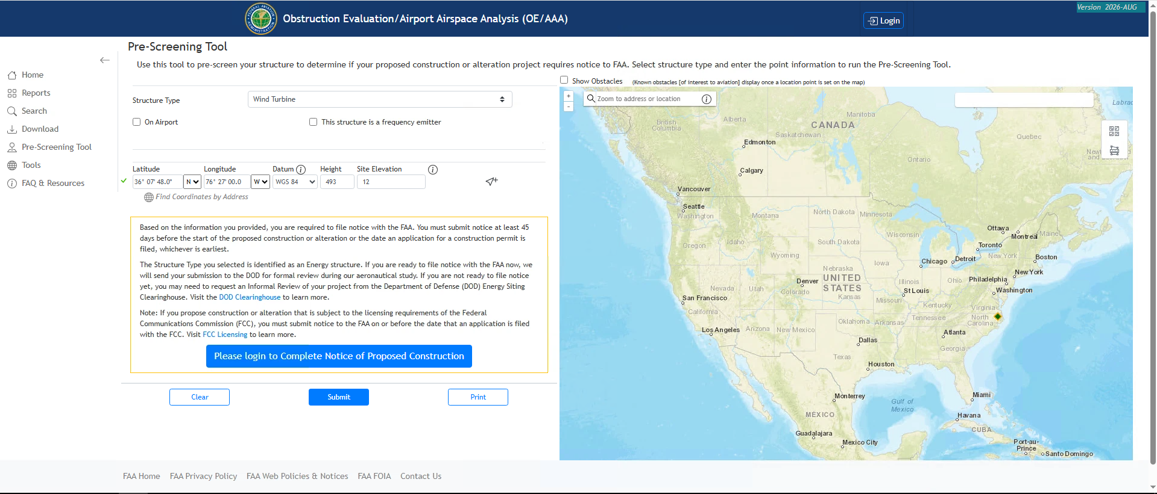
Figure 2-2-1-1: FAA Result for the Site A
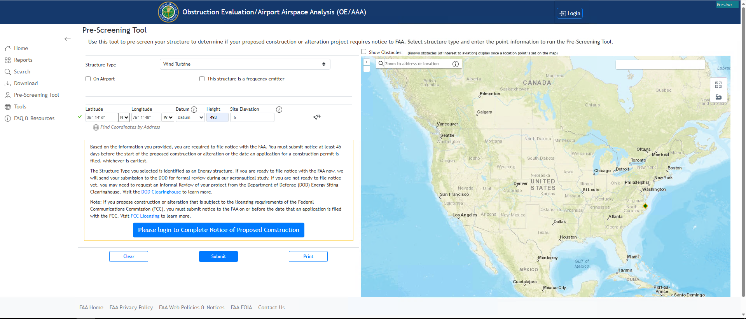
Figure 2-2-1-2: FAA Result for the Site B
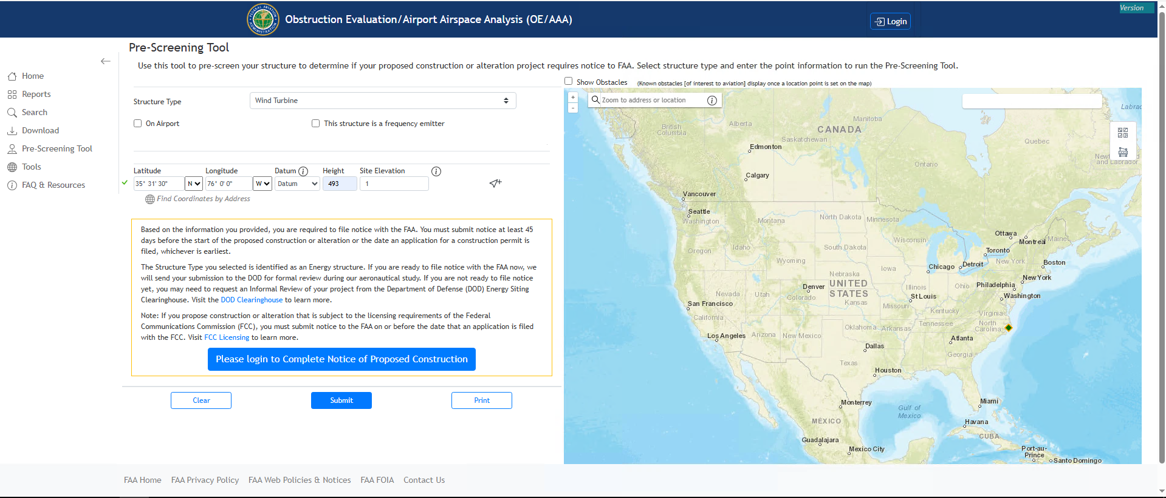
Figure 2-2-1-3: FAA Result for the Site C

2.2.2 USGS National Land Cover Database
The USGS PAD-US Data Explorer was used to check for protected and managed land at and around each site (Figures 2-2-2-1 to 2-2-2-3). Site A sits on private cropland with scattered woodlots, and no protected area covers the site. The nearest PAD-US unit is the Harvey Point Defense Testing Activity, a 3,019-acre military property (GAP 3) about 4 to 5 mi to the southeast. It is not a land-use conflict, but it supports the need for early DoD coordination. Site B is immediately west of the North River Game Land Dedicated Nature Preserve, a 7,701-acre state conservation area, and the remaining open land around it is broken up by water and marsh. Site C is surrounded by state Conservation Reserve Enhancement Program (CREP) easements on nearby farm parcels and is about 3 mi east of Mattamuskeet National Wildlife Refuge. No protected land blocks Site A, and it has enough open cropland for the 16-turbine array, while Sites B and C are constrained by the conservation land next to them.
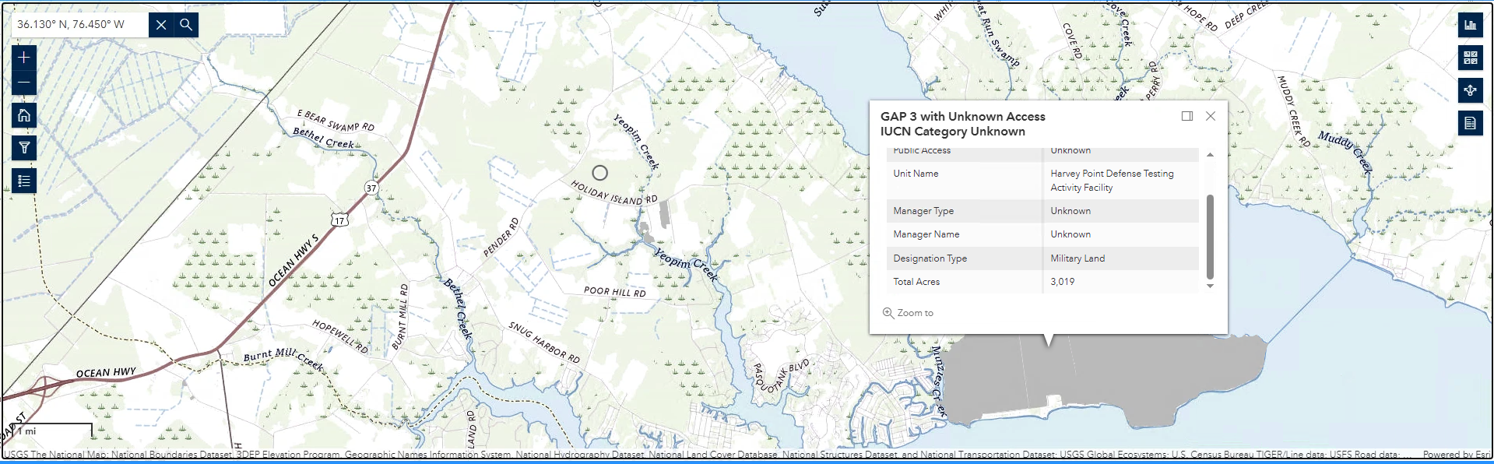
Figure 2-2-2-1: PAD-US Result for the Site A
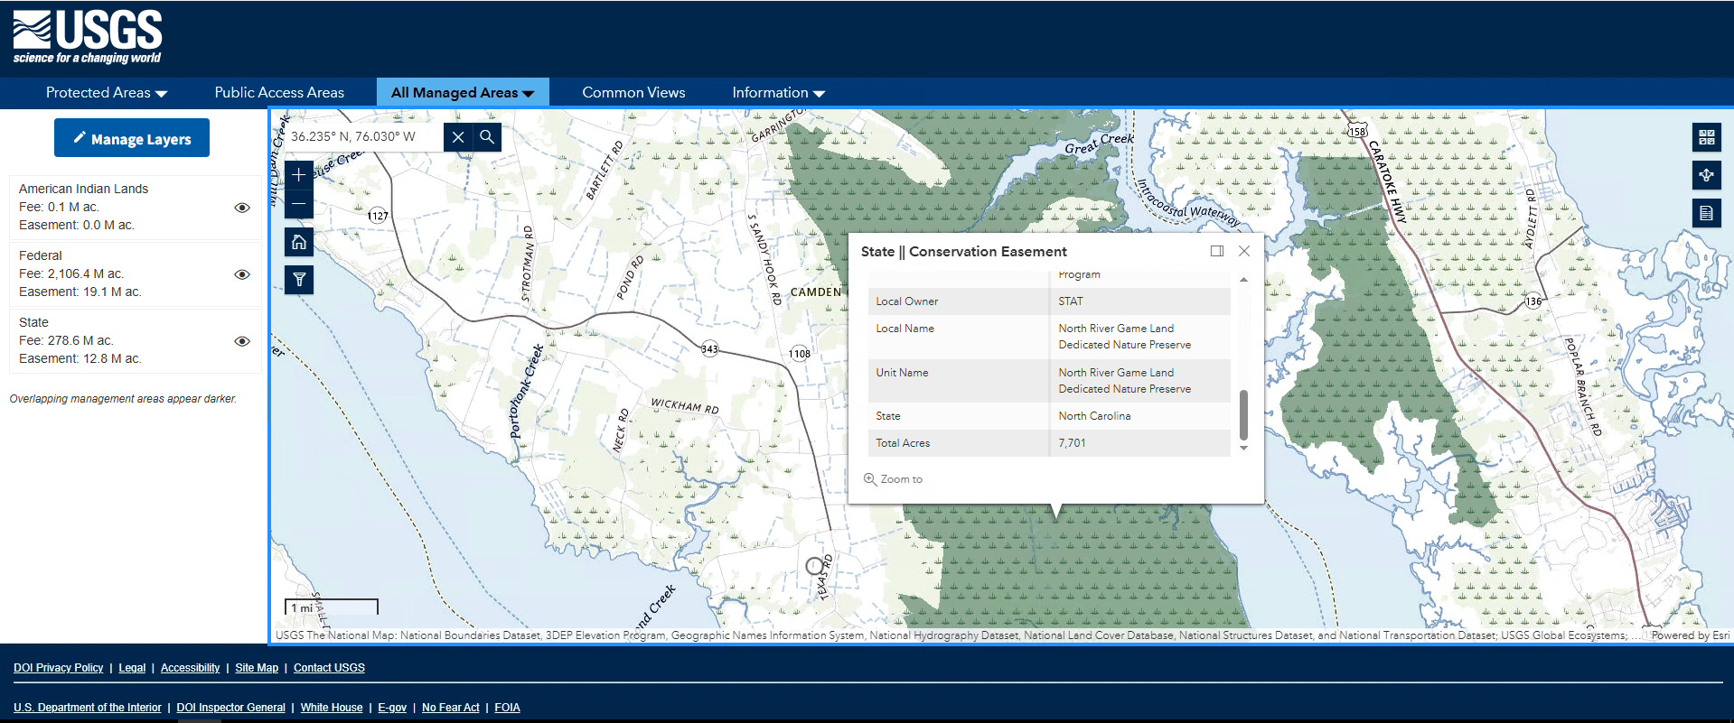
Figure 2-2-2-2: PAD-US Result for the Site B
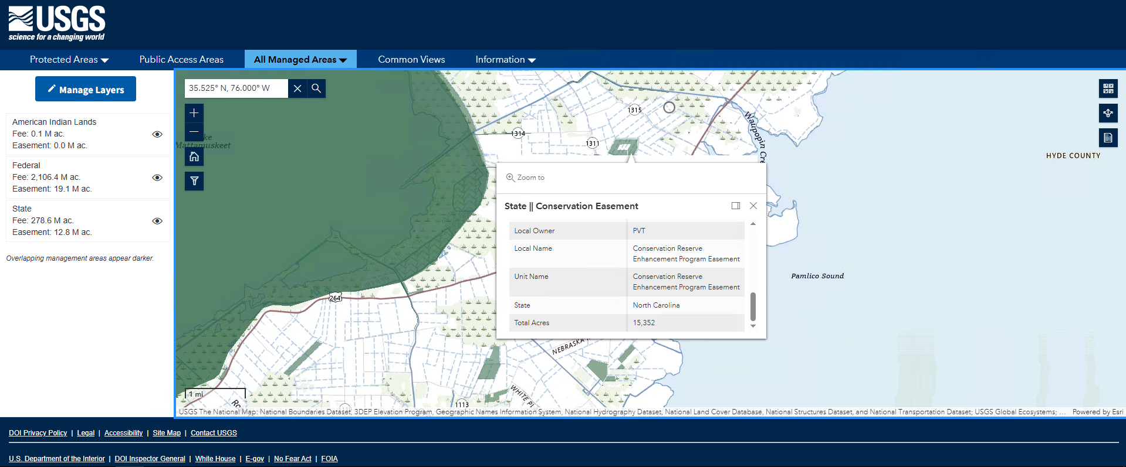
Figure 2-2-2-3: PAD-US Result for the Site C

2.2.3 USFWS Critical Habitat
USFWS IPaC was run for a project area at each site, and the results are listed in Table 2-2-3-1. IPaC is a preliminary screen, not a formal Section 7 consultation. No designated critical habitat was returned at any of the three sites. All three sites returned the tricolored bat, the monarch butterfly, the rufa red knot and the bald eagle, along with migratory birds of conservation concern. For a wind project the bats are the main concern: Site B also returned the northern long-eared bat, and either bat species could require seasonal low-wind-speed curtailment at night and post-construction monitoring. Site A returned the shortest list. Its only aquatic species, the West Indian manatee, would not be affected by turbines on farmland, and its migratory birds are mostly upland and woodland species. Site B added the eastern black rail, the red-cockaded woodpecker and the American alligator, which point to marsh and pine habitat near the site. Site C returned the longest list, including the red wolf, piping plover, eastern black rail and sea turtles, and many coastal and water birds such as loons, terns, gulls and pelicans, reflecting its location on Pamlico Sound next to Lake Mattamuskeet. The wildlife risk is therefore low to moderate at Site A, moderate at Site B and high at Site C.
 | Site A | Site B | Site C
Endangered | Tricolored Bat | Tricolored Bat, Northern Long-Eared Bat | Red wolf, Tricolored Bat, rufa red knot, Monarch Butterfly, Eastern Black rail, red-cockaded woodpecker, Hawksbill sea turtle
Federally Threatened | West Indian Manatee, Monarch Butterfly, Rufa Red Knot | Eastern Black Rail, Rufa Red Knot, Red-cockaded Woodpecker, Monarch Butterfly, American Alligator | West Indian Manatee, Eastern Black Rail, Rufa Red Knot, Red-cockaded Woodpecker, Piping Plower, Monarch Butterfly, American Alligator, Green sea turtle
Designed Critical Habitat | N/A | N/A | N/A
Migratory Birds | American Kestrel, Brown-headed Nuthatch, Chimney Swift, Pectoral Sandpiper, Prairie Warbler, Wood Thrush, Short-billed Dowitcher, Semipalmated Sandpiper, Red-headed Woodpecker, Prothonotary Warbler | American Kestrel, Brown-headed Nuthatch, Chimney Swift, Painted Bunting, Prairie Warbler, Short-billed Dowitcher, Red-headed Woodpecker, Prothonotary Warbler | American Kestrel, Brown-headed Nuthatch, Chimney Swift, Black Skimmer, Brown Pelican, Common Loon, Willet, Swallow-tailed Kite, Short-billed Dowitcher, Semipalmated Sandpiper, Rusty Blackbird, Ruddy Turnstone, Royal Tern, Ring-billed Gull, Red-throated Loon, Red-headed Woodpecker, Red-necked Phalarope, Prothonotary Warbler, Pectoral Sandpiper
Bald/Golden Eagles | Bald Eagle | Bald Eagle | Bald Eagle

Table 2-2-3-1: IPaC Species Results for each site

2.2.4 NC Natural Heritage Program
The NCNHP Data Explorer map was checked at each site with the Natural Areas and Managed Areas layers turned on, looking at about a 1 mi buffer around each point (Figures 2-2-4-1 to 2-2-4-3). Site A has no NCNHP natural area within 1 mi, and only a few small conservation-easement parcels lie nearby. The closest natural areas are a High-rated area and the Harvey Point federal land on the Albemarle Sound shore about 3.5 to 4 mi to the southeast. Site B is about 1 mi from a large Very High-rated natural area that overlaps the state-owned North River Game Land, with an Exceptional-rated area farther east along the North River. Site C is about 1 mi from a High-rated natural area along the Pamlico Sound shoreline and about 3 mi from Lake Mattamuskeet, which is rated Exceptional and is under federal ownership, and several conservation easements lie within 1 mi. The state-level risk is therefore low at Site A and moderate to high at Sites B and C, because both are next to highly rated natural areas.
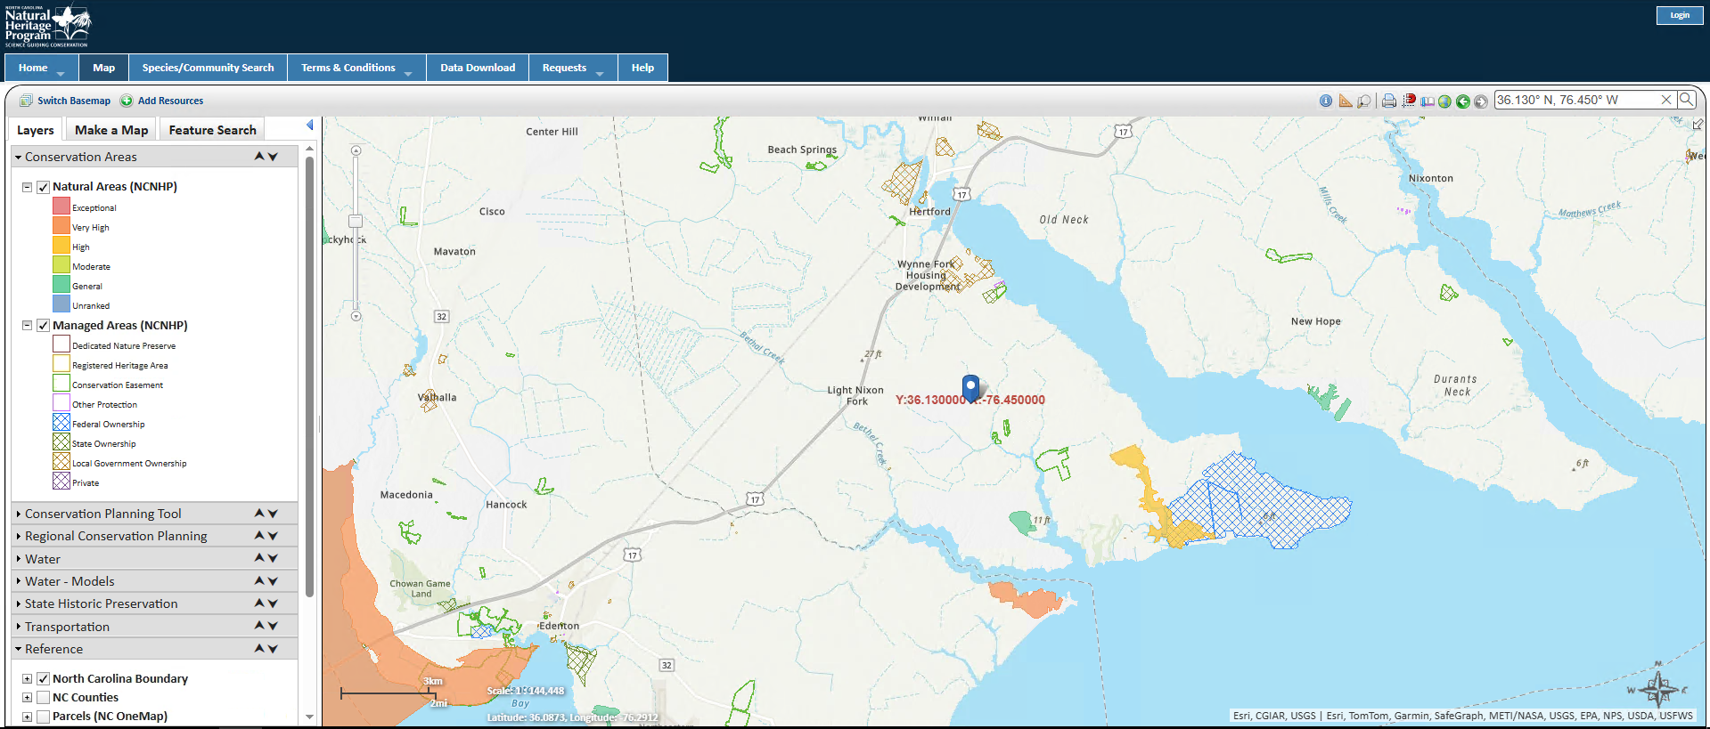
Figure 2-2-4-1: NCNHP Result for the Site A
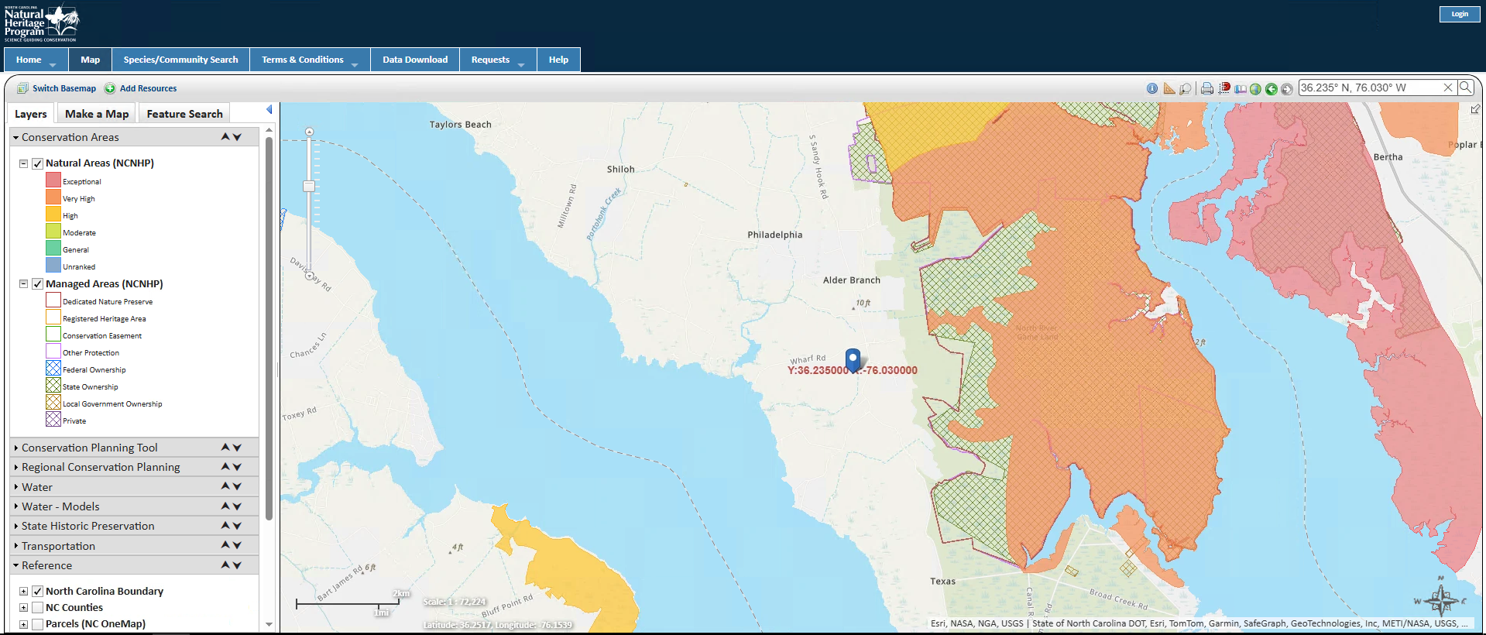
Figure 2-2-4-2: NCNHP Result for the Site B
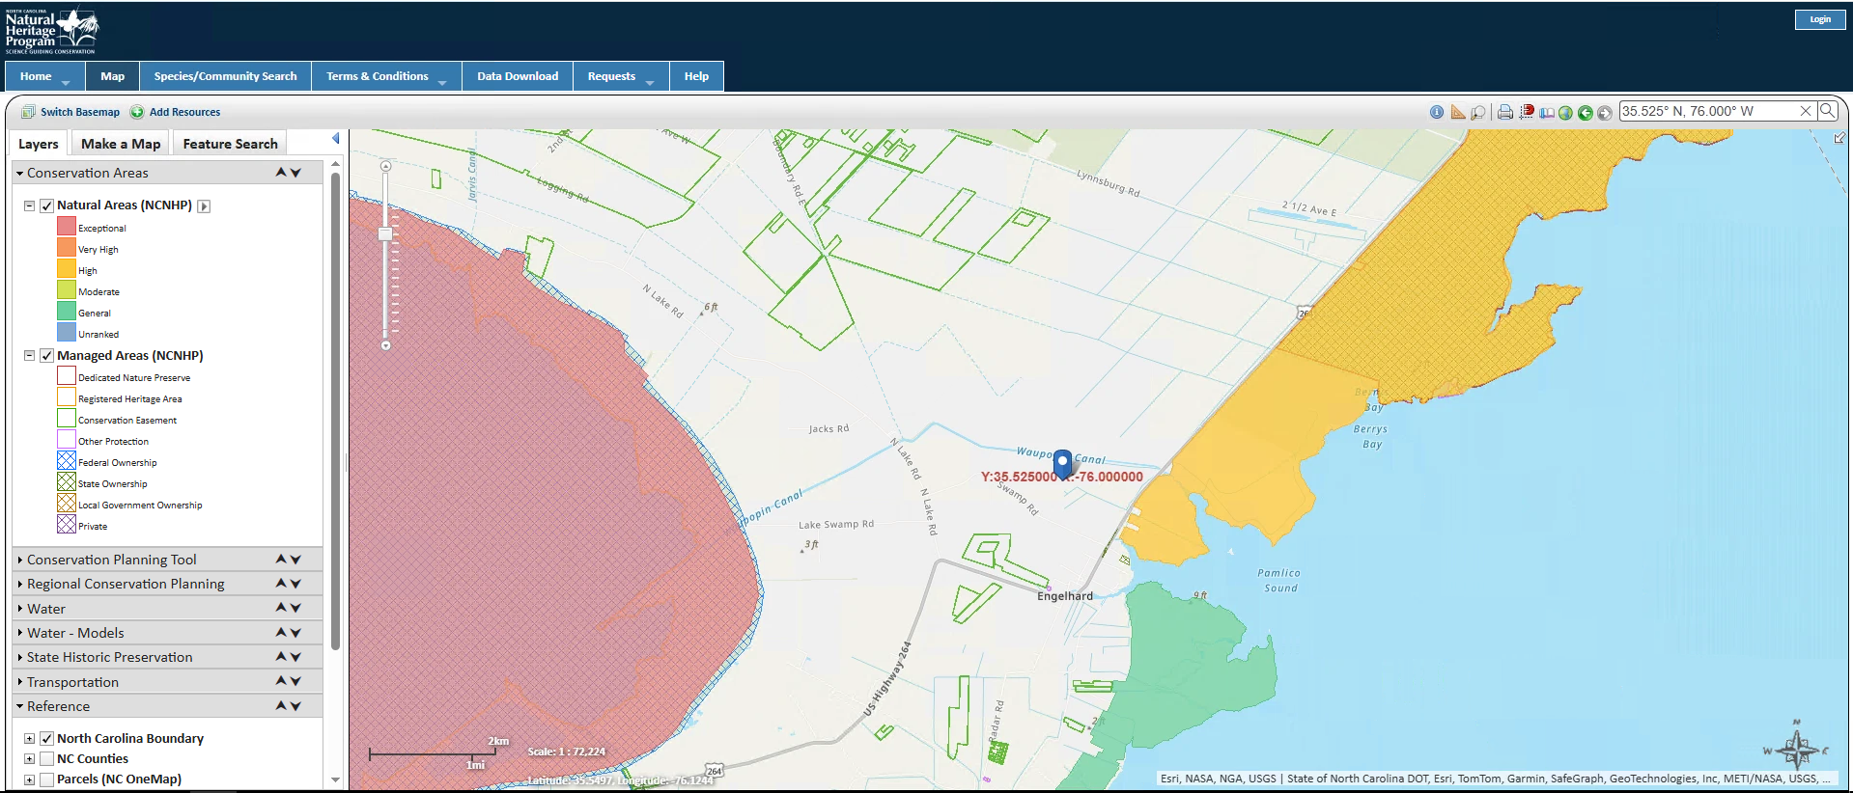
Figure 2-2-4-3: NCNHP Result for the Site C

2.3 Final Site Selection and Justification
Selected site: Site A, Perquimans County (36.130° N, 76.450° W). Ranking: A, B, C. Site A has the lowest wind (6.91 m/s at 100 m), but it is the only site with no fatal flaw: it is open farmland with few wetlands, ~5 mi from a 230 kV substation, outside the Navy radar zone and away from airports. It also lies near two operating NC wind farms (Amazon Wind Farm US East and Timbermill Wind). Site B is limited by water, wetlands and the Navy radar, and Site C by wetlands, wildlife refuges, military airspace and distance to transmission. The main risk at Site A is the county permit, since Perquimans County denied a wind permit in 2016.

3. Wind Resource Assessment
WIND Toolkit data for grid point 36.1333° N, 76.4470° W (POINT(-76.447 36.133)) were used for all eight years, 2007 to 2014, at 80, 100 and 120 m. The data were read directly from the WIND Toolkit HDF5 datasets, the second download method in Lecture 1 (HSDS); the Lecture 1 MATLAB API script returns the same data. The 5-minute values were averaged to hourly values. The hub height is 95 m.

3.1 Wind Resource Summary
All values are at the 95 m hub height.
Parameter | Value | Units
Hub height, H | 95 | m
Mean wind speed | 6.82 | m/s
Weibull shape parameter, k | 2.40 | dimensionless
Weibull scale parameter, a | 7.69 | m/s
Shear exponent, α | 0.262 | dimensionless
Turbulence intensity, TI | 9.4 | %
IEC wind class | IIIA | dimensionless
Table 3-1. Hub-height wind resource

3.2 Weibull Distribution
Figure 3-1 shows the hub-height histogram and the Weibull fit (MATLAB fitdist, maximum likelihood).

$f_{Weibull}(v)=\frac{k}{a}{\left(\frac{v}{a}\right)}^{k−1}exp\left[−{\left(\frac{v}{a}\right)}^{k}\right]$ (1)
$v_{avg}=aΓ\left(1+\frac{1}{k}\right)$ (2)
where f_{Weibull}(v) = probability density of wind speed v (s/m); v = wind speed (m/s); k = shape parameter; a = scale parameter (m/s); v_{avg} = mean wind speed (m/s); Γ = gamma function.
k = 2.40 and a = 7.69 m/s, so from Eq. (2) v_avg = 7.69 × Γ(1 + 1/2.40) = 6.82 m/s.

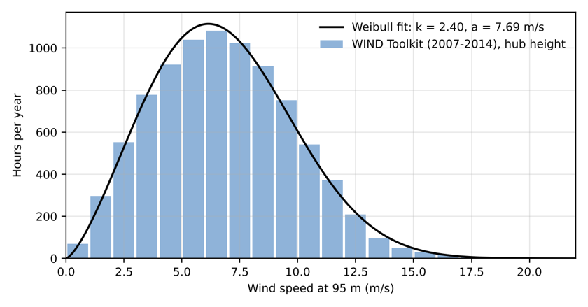
Figure 3-1. Hub-height wind speed distribution and Weibull fit

3.3 Wind Shear
Annual means were v80 = 6.52 m/s and v100 = 6.91 m/s.
$\left(\frac{v}{v_{0}}\right)={\left(\frac{H}{H_{0}}\right)}^{α} → α=\frac{ln\left(\frac{v}{v_{0}}\right)}{ln\left(\frac{H}{H_{0}}\right)}$ (3)
where v = wind speed at height H (m/s); v₀ = wind speed at the reference height (m/s); H = hub height (m); H₀ = reference height (m); α = shear (Hellman) exponent.
α = ln(6.911/6.519) / ln(100/80) = 0.262. Extrapolating to the hub: v95 = 6.91 × (95/100)0.262 = 6.82 m/s.

3.4 Turbulence Intensity
WIND Toolkit data are 5-minute averages, so TI was approximated as the standard deviation of the 5-minute values within each hour divided by the hourly mean, evaluated in the 15 m/s bin. This approximation underestimates IEC turbulence.

$TI=\frac{σ_{v}}{v_{avg,10min}}$ (4)
where TI = turbulence intensity; σ_{v} = standard deviation of wind speed (m/s); v_{avg,10min} = 10-minute mean wind speed (m/s).
The representative TI at 15 m/s is about 9.4%.

3.5 Seasonal and Diurnal Variation
The wind is strongest from November to April (peak in March, 7.9 m/s) and calmest in summer (August, 5.3 m/s). Each day it is strongest at night (about 7.6 m/s) and weakest in late morning (about 5.7 m/s). Times were converted from UTC to local time.
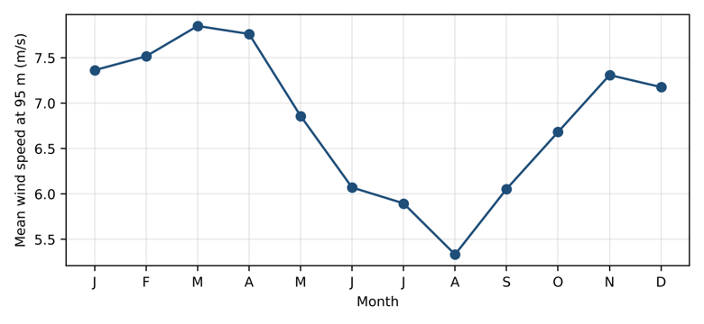
Figure 3-2. Seasonal variation

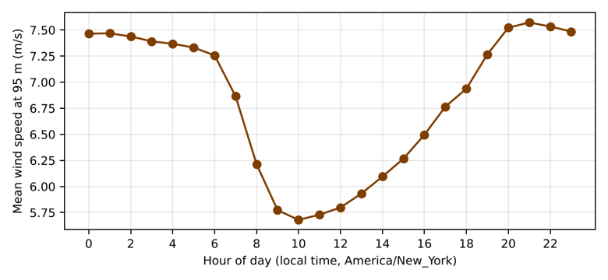
Figure 3-3. Diurnal variation

3.6 IEC Wind Class
The hub-height mean of 6.82 m/s is below 7.5 m/s, so the site is Class III. The TI estimate falls in category C, but because the method underestimates turbulence, category A is used: Class IIIA.

IEC 61400-1 Class | I | II | III
Average wind speed at hub height (m/s) | 10.0 | 8.5 | 7.5
50-year maximum 10-minute wind speed (m/s) | 50 | 42.5 | 37.5
50-year extreme 3-second gust (m/s) | 70 | 59.5 | 53.5
Turbulence Class A | 16% | 16% | 16%
Turbulence Class B | 14% | 14% | 14%
Turbulence Class C | 12% | 12% | 12%
Table 3-2. IEC 61400-1 wind turbine classes

4. Turbine Selection, Sizing, and Micrositing

4.1 Selected Turbine

The Vestas V110-2.0 MW (IEC IIIA) was selected. Its large rotor for its rating (210 W/m²) suits a low-wind site. It is the Lecture 3/4 example turbine, and its power curve is in the SAM turbine library. At a 95 m hub its tip height is 150 m (492 ft).

Parameter | Value
Manufacturer / model | Vestas V110-2.0 MW
Rated power (MW) | 2.0
Rotor diameter, D (m) | 110
Hub height (m) | 95
Cut-in / cut-out speed (m/s) | 3/20
IEC class | IIIA
Table 4-1. Selected turbine

4.2 Number of Turbines
Using CF from Section 5.1:
$n_{T}=\frac{E_{demand}}{P_{rated}×8760×CF}, P_{inst}=n_{T}×P_{rated}$ (5)
where n_{T} = number of turbines, rounded up; E_{demand} = annual energy demand, 122,640 MWh/yr; P_{rated} = turbine rated power (MW); 8760 = hours per year (h/yr); CF = capacity factor; P_{inst} = installed capacity (MW).

nT = 122,640 / (2.0 × 8,760 × 0.460) = 15.2, rounded up to 16 turbines, so Pinst = 16 × 2.0 = 32 MW.

4.3 Array Layout
The rows are perpendicular to the prevailing wind (from about 210°), as in the Lecture 5 example (5D × 10D). The 16 turbines are placed in 5 rows on open farmland, at least 375 m from homes.

$S_{down}=x×D, S_{cross}=y×D$ (6)
where S_{down} = downwind spacing (m); S_{cross} = crosswind spacing (m); D = rotor diameter (m); x = downwind multiplier, 6 to 10 rotor diameters; y = crosswind multiplier, 3 to 5 rotor diameters.
Turbines are spaced at 10D (1,100 m) downwind and 5D (550 m) crosswind relative to the prevailing wind direction. Wake losses are not included in this analysis.
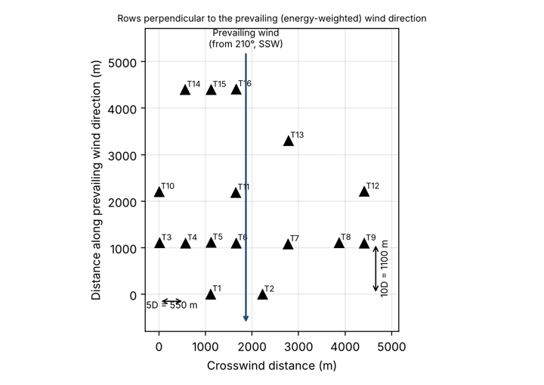
Figure 4-1. Array layout

4.4 SAM Analysis
[Graduate students: repeat the Phase 3 analysis in NLR SAM (Wind model). Download the WIND Toolkit resource file for the site from within SAM, select the turbine from the SAM library (or enter the datasheet power curve), and enter the array layout. Compare SAM's results to the hand calculation.]
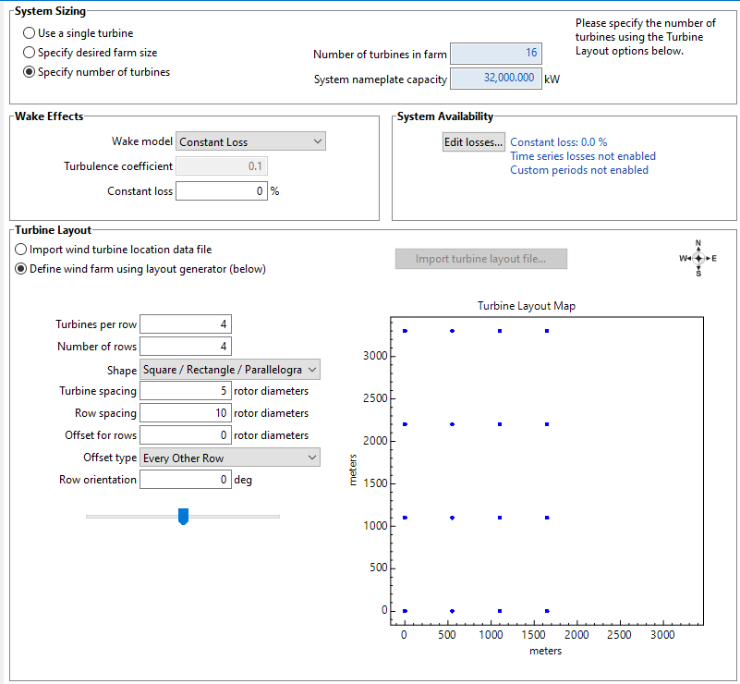

Need this information - I think it should look like this

5. Annual Energy Production and System Sizing

5.1 AEP and Capacity Factor
[Follow the Lecture 3/4 workflow: Weibull fit, then manufacturer power curve, then AEP. Build a bin table (wind speed, Weibull probability, hours/yr, turbine power, energy) using Eqs. (7) and (8), sum the energy column for one turbine, and multiply by the number of turbines. Compute capacity factor with Eq. (9). Note that no wake losses are included. Include the bin table.]

Weibull fit (Section 3.2), then the V110-2.0 power curve, then the bin table below. There are no wake losses.
$h_{i}=8760×f_{Weibull}\left(v_{i}\right)×Δv$ (7)
${AEP}_{turbine}=\sum_{i}{}P\left(v_{i}\right)×h_{i}, {AEP}_{farm}=n_{T}×{AEP}_{turbine}$ (8)
$CF=\frac{P_{avg}}{P_{rated}}=\frac{AEP}{P_{rated}×8760}$ (9)
where h_{i} = hours per year in wind speed bin i (h/yr); v_{i} = wind speed of bin i (m/s); Δv = bin width, 1 m/s; P(v_{i}) = turbine power output from the manufacturer power curve (kW); AEP_{turbine} = annual energy production of one turbine (kWh/yr); AEP_{farm} = annual energy production of the wind farm (MWh/yr); P_{avg} = annual average power output (kW); P_{rated} = turbine rated power (kW); CF = capacity factor.

v_{i}  (m/s) | h_{i}  (h/yr) | P  (v_{i}) (kW) | E_{i} (MWh/yr) | v_{i}  (m/s) | h_{i}  (h/yr) | P  (v_{i}) (kW) | E_{i} (MWh/yr)
1 | 156 | 0 | 0 | 11 | 426 | 1,998 | 850
2 | 398 | 0 | 0 | 12 | 278 | 2,000 | 555
3 | 659 | 28 | 18 | 13 | 168 | 2,000 | 335
4 | 889 | 143 | 127 | 14 | 93 | 2,000 | 187
5 | 1,049 | 315 | 330 | 15 | 48 | 2,000 | 96
6 | 1,114 | 552 | 614 | 16 | 23 | 2,000 | 46
7 | 1,080 | 904 | 976 | 17 | 10 | 2,000 | 20
8 | 963 | 1,349 | 1,299 | 18 | 4 | 2,000 | 8
9 | 793 | 1,774 | 1,407 | 19 | 1 | 2,000 | 3
10 | 604 | 1,970 | 1,190 | 20 | 1 | 0 | 0
 |  |  |  | Total | 8,755 |  | 8,063
Table 5-1. AEP bin table, one turbine

AEPturbine = 8,063 MWh/yr, AEPfarm = 16 × 8,063 = 129,003 MWh/yr, and CF = 8,063 / (2 × 8,760) = 46.0%.

Metric | Hand Calculation | SAM
AEP, one turbine (MWh/yr) | 8,063 | 7,861
AEP, wind farm (MWh/yr) | 129,003 | 124,809
Capacity factor (%) | 46.0 | 44.5
Table 5-2. Energy production

5.2 Comparison to Data Center Demand
Annual comparison:
$Share=\frac{{AEP}_{farm}}{E_{demand}}×100\%$ (10)
where Share = fraction of annual demand supplied by wind (%); AEPfarm = wind farm annual energy production (MWh/yr); Edemand = annual energy demand, 122,640 MWh/yr.
The wind farm produces 129,003 MWh/yr, supplying 105.2% of the data center's 122,640 MWh/yr demand.
Following the seasonal and diurnal patterns in Section 3.5, wind output exceeds the flat 14 MW load from October to May and at night, and falls short in June to September and during the day.

5.3 Grid Backup Sizing
The hourly WIND Toolkit speeds were run through the power curve for 16 turbines and compared with the 14 MW load.
$P_{backup}=P_{load}=14 MW$ (11)
Wind output falls to zero below cut-in and above cut-out wind speed, and the data center cannot tolerate interruption. The grid backup is therefore sized to carry the full 14 MW facility load. Wind output is below 14 MW for 4,660 h/yr, requiring 42,069 MWh/yr of grid energy.

5.4 Interconnection Capacity
From Eq. (12):

$P_{IC}=max\left(P_{load}, P_{inst}−P_{load}\right)$ (12)
where PIC = required interconnection capacity (MW); Pload = import required when wind output is zero, 14 MW; Pinst = installed wind capacity (MW).
With 32 MW installed, maximum export is 18 MW. The required interconnection capacity is 18 MW.

5.5 SAM Analysis
[Graduate students: repeat the Phase 4 analysis in NLR SAM. Report SAM's AEP and capacity factor and compare it to the hand calculation.]
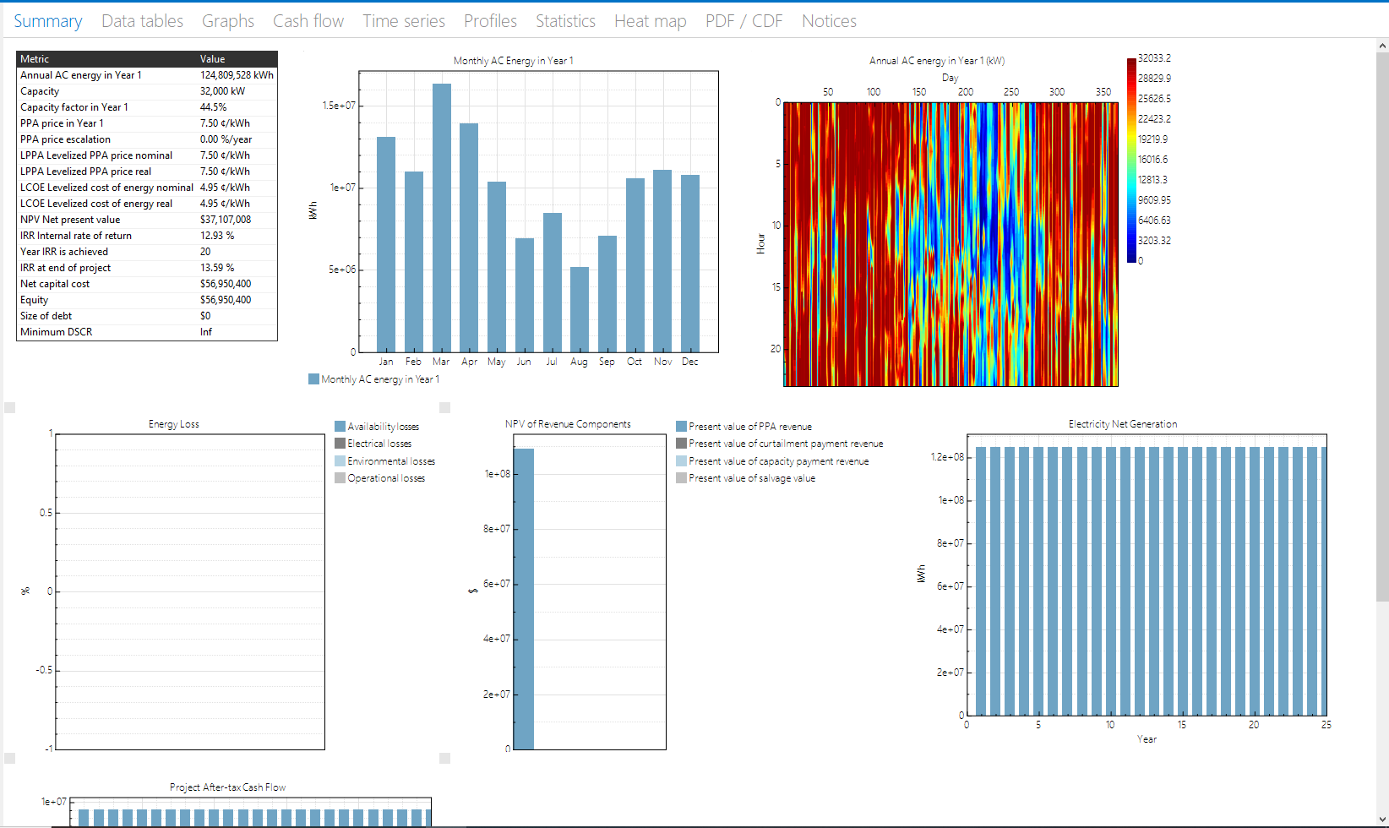
Figure 5-5: SAM Analysis of the Wind Farm for AEP and Capacity factor (Vestas V110-2.0)

The annual energy production (AEP) of the proposed 32-MW wind farm was independently evaluated using the NLR System Advisor Model (SAM) with 2014 WIND Toolkit data and sixteen Vestas V110-2.0 MW turbines operating at a 95-m hub height. The simulation assumed zero specified wake and operational losses and predicted an annual energy production of 124,809.53 MWh with a capacity factor of 44.5%. In comparison, the hand calculation based on the 2007–2014 Weibull wind-speed distribution estimated approximately 129,003 MWh/year and a capacity factor of 46.0%. Thus, the SAM estimate was approximately 3.25% lower, primarily reflecting differences in the wind-resource period and calculation methodology. Although the simulated annual production slightly exceeds the data center's annual demand of 122,640 MWh, grid backup is still required because electricity generation varies with wind conditions.
Need this information

6. Economic Analysis

6.1 Capital and O&M Cost
NLR ATB 2025, land-based wind, Moderate scenario, 2025, wind Class 8 (2023$): OCC $1,780/kW and fixed O&M $40.3/kW-yr. The grid price is the EIA NC industrial average.

$CAPEX=OCC×P_{inst}$ (13)
where CAPEX = total plant capital cost ($); OCC = overnight capital cost ($/kW); P_{inst} = installed capacity (kW).
Input | Value | Source
CAPEX ($) | 56,950,400 | ATB 2025: $1,779.7/kW × 32 MW
OPEX ($/yr) | 1,289,600 | ATB 2025: $40.3/kW-yr × 32 MW
Grid power price ($/MWh) | 75 | EIA, NC industrial avg. (7.51 ¢/kWh)
Required rate of return, r | 7% | Given
Project life, N (yr) | 25 | Lecture 5 example
Table 6-1. Cost inputs

6.2 Levelized Cost of Energy
With r = 7% and N = 25 yr:

$LCOE=\frac{CAPEX×CRF+OPEX}{AEP}, CRF=\frac{r{\left(1+r\right)}^{N}}{{\left(1+r\right)}^{N}−1}$ (14)
where LCOE = levelized cost of energy ($/MWh); CRF = capital recovery factor (1/yr); OPEX = annual operating cost ($/yr); AEP = wind farm annual energy production (MWh/yr); r = required rate of return, 0.07; N = project life (yr).
CRF = 0.08581, LCOE = (56,950,400 × 0.08581 + 1,289,600) / 129,003 = $47.88/MWh, which is $27.12/MWh below the $75/MWh grid price.

6.3 Net Present Value and Internal Rate of Return
Revenue is the avoided grid purchase.

$Revenue=AEP×P_{e}, {CF}_{t}=Revenue−OPEX$ (15)
$NPV=−CAPEX+\sum_{t=1}^{N}{}\frac{{CF}_{t}}{{\left(1+r\right)}^{t}}$ (16)
$0=−CAPEX+\sum_{t=1}^{N}{}\frac{{CF}_{t}}{{\left(1+IRR\right)}^{t}}$ (17)
where Revenue = annual value of energy produced (avoided grid purchases) ($/yr); P_{e} = grid electricity price ($/MWh); CF_{t} = net cash flow in year t ($/yr); NPV = net present value ($); IRR = internal rate of return (%); r = required rate of return, 0.07; t = year (yr); N = project life (yr).

Revenue = 129,003 × $75 = $9,675,230/yr and CFt = $8,385,630/yr, so NPV = $40.8 M and IRR = 14.2%. Because NPV > 0 and IRR > 7%, the project is viable.

Metric | Hand Calculation | SAM
LCOE ($/MWh) | 47.88 | 49.50
Grid power price ($/MWh) | 75.00 | 75.00
NPV at 7% ($) | 40,772,236 | 37,107,008
IRR (%) | 14.2 | 13.59
Table 6-2. Economic results

6.4 SAM Analysis
[Graduate students: repeat the Phase 5 analysis in the NLR SAM financial model with the same CAPEX, O&M, 7% rate, and project life. Report SAM's LCOE, NPV, and IRR, and compare to the hand calculation.]

Figure 6-4: SAM Analysis of the Wind Farm for LCOE, NPV, IRR, and financial results (Vestas V110-2.0)

The economic performance of the proposed wind farm was evaluated using the NLR System Advisor Model (SAM), assuming a capital cost of $56,950,400, annual operating expenses of $1,289,600, a 25-year project lifetime, a 7% discount rate, and an assumed electricity value of $75/MWh. The simplified SAM comparison excluded income taxes, project debt, annual AC degradation, and specified wake and operational losses. The simulation produced a levelized cost of energy (LCOE) of $49.50/MWh, a net present value (NPV) of approximately $37.11 million, and an end-of-project internal rate of return (IRR) of 13.59%. Compared with the hand-calculated values of $47.88/MWh, $40.77 million, and 14.2%, respectively, SAM predicted slightly less favorable economic performance, partly due to its lower estimated electricity generation and differences in financial modeling. Both analyses indicate favorable preliminary economics under the assumed costs and electricity value; however, actual feasibility remains dependent on site-specific conditions and a verified electricity-pricing arrangement.

Still need this information

7. Permitting Checklist and Timeline
Site A: Perquimans County, coastal plain.
Permit / Approval | Agency | Applies (Y/N) | Est. Duration
FAA Determination of No Hazard (14 CFR Part 77) | FAA | Y | 3-6 Months
Mountain Ridge Protection Act (NCGS 113A, Art. 14) | County | N | N/a - not near a protected ridge
Coastal wind energy facility permit (NCGS 143-215.115 to .121) | NCDEQ | Y | 12-18 Months
County zoning / conditional use permit | County | Y | 4-9 Months
Generator interconnection | Duke Energy | Y | 2-4 Years
Table 7-1. Permitting checklist
Interconnection is the critical path, so commercial operation is about 3 to 4 years out. Note: Site A is served by Dominion Energy NC (PJM), which follows an interconnection process equivalent to Duke Energy's.

8. Site Plan and Single-Line Diagram

8.1 Site Plan
[Drawing of the selected site showing turbine locations, access roads, collection cable routes, project substation, and point of interconnection. A Wind Prospector or Google Earth base map with overlays is fine.] - I’m not sure about the point of interconnection, but I think major components I have included. My distance between the substation and my project substation is about 6km, exact 5.84km (differences in numbers due to project site location differences/setups)
The 16 turbines, 34.5 kV collection along the access roads, the project substation, and a 5.8 km 230 kV line to the South Hertford 230 kV substation (point of interconnection).

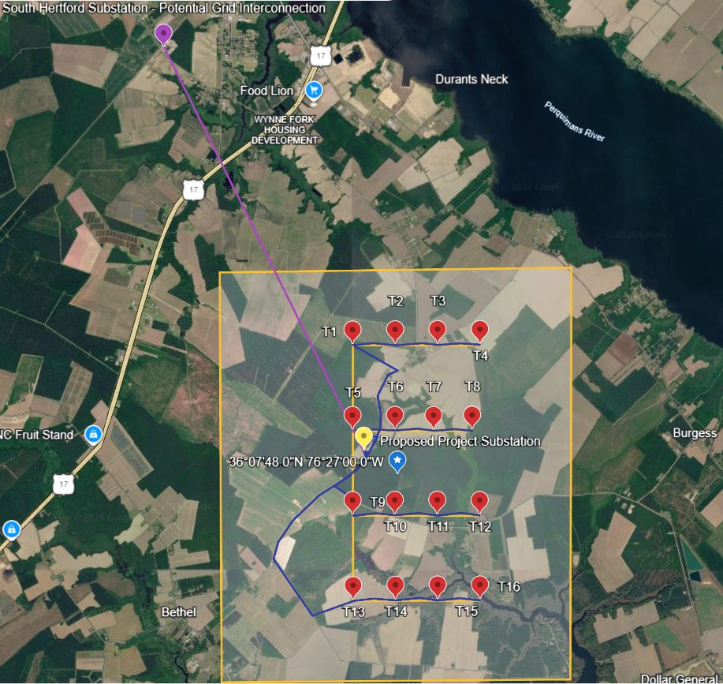
Figure 8-1. Site plan

8.2 Single-Line Electrical Diagram

Figure 8-2 shows the electrical system from the turbines to the grid. Each Vestas V110-2.0 turbine has a doubly fed induction generator at 690 V and a 2.3 MVA pad-mount step-up transformer (0.69/34.5 kV) at the tower base. The four turbines in each row are daisy-chained on one underground 34.5 kV collector circuit, so the array has four 8 MW feeders (T1-T4, T5-T8, T9-T12 and T13-T16) that land on feeder breakers at the project substation's 34.5 kV collector bus. A 34.5/230 kV, 40 MVA main power transformer, with breakers on both sides, steps the output up to the 230 kV project bus. The data center is fed from the same bus through its own 230 kV breaker and a 230/34.5 kV, 20 MVA transformer. A POI breaker and bidirectional revenue metering connect the project bus to the 5.8 km, 230 kV gen-tie to the South Hertford 230 kV substation, where the project joins the utility transmission grid. The metering measures the net exchange with the grid: up to 14 MW of import when the wind is calm and up to 18 MW of export at full wind output (Section 5.4).
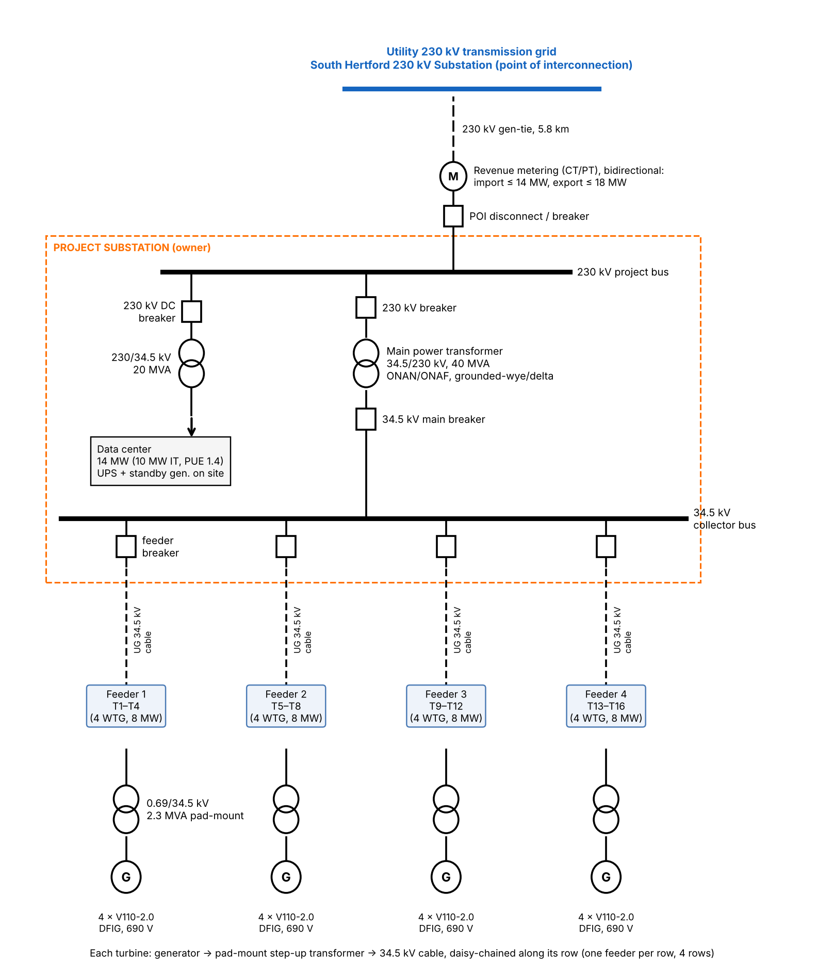

Figure 8-2. Single-line diagram

References
[1] NLR WIND Toolkit (Draxl et al., 2015, Applied Energy 151, 355–366).
[2] NLR System Advisor Model (SAM), https://sam.nlr.gov
[3] NLR Annual Technology Baseline 2025, Land-Based Wind, https://atb.nlr.gov
[4] LBNL, Land-Based Wind Market Report, https://emp.lbl.gov/wind-technologies-market-report
[5] Vestas, V110-2.0 MW datasheet, https://www.vestas.com/content/dam/vestas-com/global/en/brochures/onshore/2MW_Platform_Brochure_.pdf.coredownload.inline.pdf
[6] IEC 61400-1 Ed. 4, Wind turbines: Design requirements.
[7] FAA, 14 CFR Part 77 and OE/AAA Notice Criteria Tool, https://oeaaa.faa.gov
[8] USGS, NLCD (https://www.mrlc.gov) and PAD-US Data Explorer.
[9] USFWS, IPaC, https://ipac.ecosphere.fws.gov
[10] NC Natural Heritage Program Data Explorer, https://ncnhp.org
[11] NCGS Chapter 113A, Article 14 (Mountain Ridge Protection Act); NCGS 143-215.115 to .121 (wind energy facility permits).
[12] Perquimans County wind energy ordinance. https://perquimanscountync.gov/county-information/ordinances?download=366:zoning-ordinance-262012
[13] Duke Energy, NC Generator Interconnection Procedures, https://www.duke-energy.com
[14] EIA, Electric Power Monthly, Table 5.6.A.

