Wind Farm Design for a Small Data Center in North Carolina
Midterm Project Report
AEEE 5250 Analysis of Renewable Energy Systems, Fall 2026
Prepared by
David Salisbury
Dmitrii Nikiforov

Submitted to: Dr. Maciej Noras
Date: 10/09/26

1. Design Basis
Parameter | Value | Basis
IT critical load | 10 MW | Given
Power usage effectiveness (PUE) | 1.4 | Given
Total facility demand | 14 MW | 10 MW × 1.4
Annual energy demand | 122,640 MWh/yr | 14 MW × 8,760 h/yr
Reliability requirement | Near-continuous | Firm grid interconnection for backup and balancing
Table 1-1. Data center design load

2. Site Selection and Screening

2.1 Candidate Sites
Three candidate sites were chosen in the northeastern coastal plain, which has the best wind resource in NC outside the ridges protected by the Mountain Ridge Protection Act. All three are open farmland within reach of transmission. Wind speeds are 2007 to 2014 WIND Toolkit means at 100 m.
Preliminary values below come from public map data (OpenStreetMap, ESA WorldCover). Confirm or replace each one with the Wind Prospector, NLCD/PAD-US and FAA results, and add a Wind Prospector screenshot of the three sites.
Criterion | Site A | Site B | Site C
County / location | Perquimans Co.  36.130° N, 76.450° W | Camden Co.  36.235° N, 76.030° W | Hyde Co.  35.525° N, 76.000° W
Wind resource (m/s) | 6.91 | 7.23 | 7.30
Land availability (acres) | about 5,600 open; about 2,100 after setbacks | about 3,500 open; about 800 after setbacks | about 6,700 open; about 4,400 after setbacks
Transmission proximity (mi) | 3.9 (230 kV substation) | 9.4 (230 kV substation) | 18 (115 kV line)
Airports / airspace | KEDE 9.5 mi; outside Navy radar zone | USCG Air Sta. Elizabeth City 7.3 mi; inside Navy radar zone | Hyde Co. Airport 3.5 mi; near Dare Co. Bombing Range
Protected ridges | None | None | None
Wetlands | Few | Extensive (marsh, open water) | Extensive (herbaceous wetland)
Residential setbacks | 375 m (2.5 × tip height) feasible | Feasible, but land is fragmented | Feasible
Table 2-1. Candidate site screening

2.2 Screening Outcomes
Each resource below was checked for all three sites.

2.2.1 FAA
The turbine tip height is 150 m (492 ft) above ground, so a Form 7460-1 notice is required for every turbine at all three sites (more than 200 ft, 14 CFR 77.9). Site A is 9.5 mi from the nearest public-use airport (KEDE) and 31 mi from the Navy ROTHR radar in Chesapeake, VA, outside the 28 mi zone where the Navy has objected to wind farms. A Determination of No Hazard is likely. Site B is 7.3 mi from USCG Air Station Elizabeth City and inside the radar zone, so it would need DoD mitigation. Site C is 3.5 mi from Hyde County Airport and near the Dare County Bombing Range military airspace, so there is a high risk of objection. Insert the OE/AAA Notice Criteria Tool result for each site.

2.2.2 USGS National Land Cover Database
Site A is mostly cultivated cropland with scattered woodlots, few wetlands and no protected areas nearby, and it has enough open land for the 16-turbine array (about 4,500 acres). Site B is limited by open water, marsh and the adjacent North River Game Land. Site C is farmland but has extensive wetland and is 3 mi from Mattamuskeet National Wildlife Refuge. Insert the NLCD / PAD-US Data Explorer result for each site.

2.2.3 USFWS Critical Habitat
The northern long-eared bat (endangered) and tricolored bat (proposed endangered) are the main wind concern at all three sites, and could require seasonal low-wind curtailment. Site C also sits in the red wolf recovery area and next to Lake Mattamuskeet, which has large wintering waterfowl flocks. Replace with the IPaC species list for each site (IPaC is a preliminary screen, not a consultation).

2.2.4 NC Natural Heritage Program
Site A's interior is farmland, with no significant natural areas expected outside the river shoreline. Site B borders the North River Game Land marshes, and Site C borders the Lake Mattamuskeet natural area. Replace with the NCNHP Data Explorer results (site plus a 1 mile buffer).

2.3 Final Site Selection and Justification
Selected site: Site A, Perquimans County (36.130° N, 76.450° W). Ranking: A, B, C. Site A has the lowest wind (6.91 m/s at 100 m), but it is the only site with no fatal flaw: it is open farmland with few wetlands, 3.9 mi from a 230 kV substation, outside the Navy radar zone and away from airports. It also lies near two operating NC wind farms (Amazon Wind Farm US East and Timbermill Wind). Site B is limited by water, wetlands and the Navy radar, and Site C by wetlands, wildlife refuges, military airspace and distance to transmission. The main risk at Site A is the county permit, since Perquimans County denied a wind permit in 2016.

3. Wind Resource Assessment
WIND Toolkit data for grid point 36.1333° N, 76.4470° W were used for all eight years, 2007 to 2014, at 80, 100 and 120 m. The data were averaged to hourly values. The hub height is 95 m.

3.1 Wind Resource Summary
All values are at the 95 m hub height.
Parameter | Value | Units
Hub height, H | 95 | m
Mean wind speed | 6.82 | m/s
Weibull shape parameter, k | 2.40 | dimensionless
Weibull scale parameter, a | 7.69 | m/s
Shear exponent, α | 0.262 | dimensionless
Turbulence intensity, TI | 9.4 | %
IEC wind class | IIIA
Table 3-1. Hub-height wind resource

3.2 Weibull Distribution
Figure 3-1 shows the hub-height histogram and the Weibull fit (MATLAB fitdist, maximum likelihood).
$f_{Weibull}(v)=\frac{k}{a}{\left(\frac{v}{a}\right)}^{k−1}exp\left[−{\left(\frac{v}{a}\right)}^{k}\right]$ (1)
$v_{avg}=aΓ\left(1+\frac{1}{k}\right)$ (2)
where f_{Weibull}(v) = probability density of wind speed v (s/m); v = wind speed (m/s); k = shape parameter (dimensionless); a = scale parameter (m/s); v_{avg} = mean wind speed (m/s); Γ = gamma function (dimensionless).
k = 2.40 and a = 7.69 m/s, so from Eq. (2) v_{avg} = 7.69 × Γ(1 + 1/2.40) = 6.82 m/s.
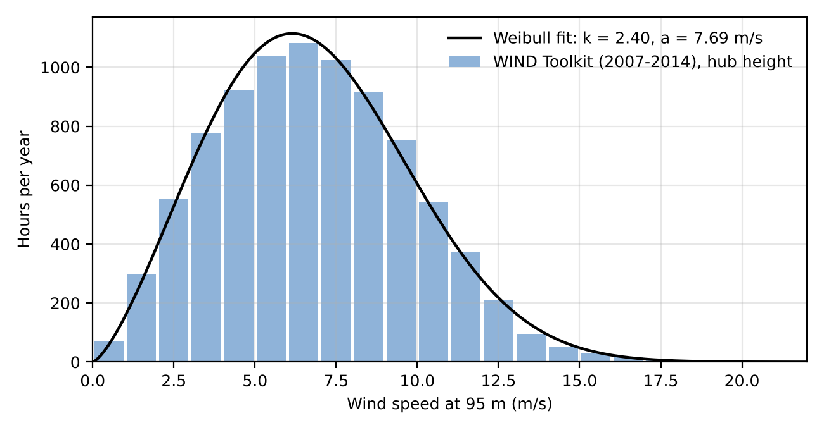
Figure 3-1. Hub-height wind speed distribution and Weibull fit

3.3 Wind Shear
Annual means were v₈₀ = 6.52 m/s and v₁₀₀ = 6.91 m/s.
$\left(\frac{v}{v_{0}}\right)={\left(\frac{H}{H_{0}}\right)}^{α} → α=\frac{ln\left(\frac{v}{v_{0}}\right)}{ln\left(\frac{H}{H_{0}}\right)}$ (3)
where v = wind speed at height H (m/s); v₀ = wind speed at the reference height (m/s); H = hub height (m); H₀ = reference height (m); α = shear (Hellman) exponent (dimensionless).
α = ln(6.911/6.519) / ln(100/80) = 0.262. Extrapolating to the hub: v₉₅ = 6.91 × (95/100)^{0.262} = 6.82 m/s.

3.4 Turbulence Intensity
WIND Toolkit data are 5-minute averages, so TI was approximated as the standard deviation of the 5-minute values within each hour divided by the hourly mean, evaluated in the 15 m/s bin. This approximation underestimates IEC turbulence.
$TI=\frac{σ_{v}}{v_{avg,10min}}$ (4)
where TI = turbulence intensity (dimensionless); σ_{v} = standard deviation of wind speed (m/s); v_{avg,10min} = 10-minute mean wind speed (m/s).
The representative TI at 15 m/s is about 9.4%.

3.5 Seasonal and Diurnal Variation
The wind is strongest from November to April (peak in March, 7.9 m/s) and calmest in summer (August, 5.3 m/s). Each day it is strongest at night (about 7.6 m/s) and weakest in late morning (about 5.7 m/s). Times were converted from UTC to local time.
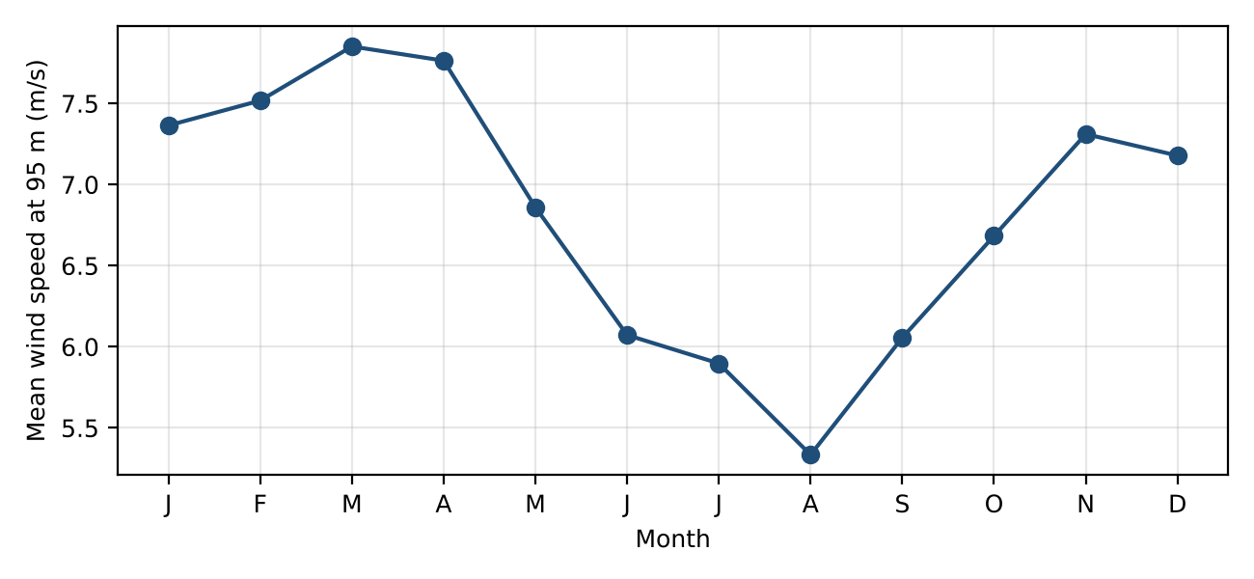
Figure 3-2. Seasonal variation
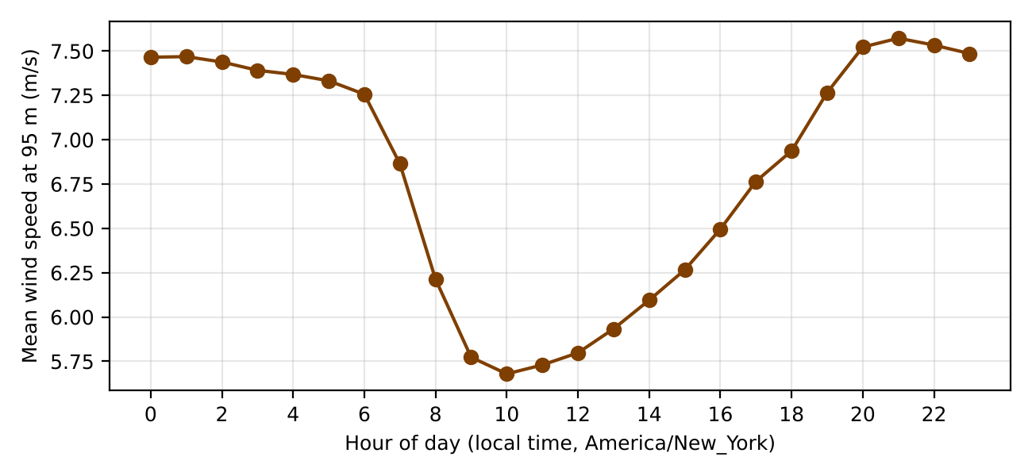
Figure 3-3. Diurnal variation

3.6 IEC Wind Class
The hub-height mean of 6.82 m/s is below 7.5 m/s, so the site is Class III. The TI estimate falls in category C, but because the method underestimates turbulence, category A is used: Class IIIA.
IEC 61400-1 Class | I | II | III
Average wind speed at hub height (m/s) | 10.0 | 8.5 | 7.5
50-year maximum 10-minute wind speed (m/s) | 50 | 42.5 | 37.5
50-year extreme 3-second gust (m/s) | 70 | 59.5 | 53.5
Turbulence Class A | 16% | 16% | 16%
Turbulence Class B | 14% | 14% | 14%
Turbulence Class C | 12% | 12% | 12%
Table 3-2. IEC 61400-1 wind turbine classes

4. Turbine Selection, Sizing, and Micrositing

4.1 Selected Turbine
The Vestas V110-2.0 MW (IEC IIIA) was selected. Its large rotor for its rating (210 W/m²) suits a low-wind site. It is the Lecture 3/4 example turbine, and its power curve is in the SAM turbine library. At a 95 m hub its tip height is 150 m (492 ft). Cite the Vestas datasheet.
Parameter | Value
Manufacturer / model | Vestas V110-2.0 MW
Rated power (MW) | 2.0
Rotor diameter, D (m) | 110
Hub height (m) | 95
Cut-in / cut-out speed (m/s) | 3 / 20
IEC class | IIIA
Table 4-1. Selected turbine

4.2 Number of Turbines
Using CF from Section 5.1:
$n_{T}=\frac{E_{demand}}{P_{rated}×8760×CF}, P_{inst}=n_{T}×P_{rated}$ (5)
where n_{T} = number of turbines, rounded up; E_{demand} = annual energy demand, 122,640 MWh/yr; P_{rated} = turbine rated power (MW); 8760 = hours per year (h/yr); CF = capacity factor (dimensionless); P_{inst} = installed capacity (MW).
n_{T} = 122,640 / (2.0 × 8,760 × 0.460) = 15.2, rounded up to 16 turbines, so P_{inst} = 16 × 2.0 = 32 MW.

4.3 Array Layout
The rows are perpendicular to the prevailing wind (from about 210°), as in the Lecture 5 example (5D × 10D). The 16 turbines are placed in 5 rows on open farmland, at least 375 m from homes.
$S_{down}=x×D, S_{cross}=y×D$ (6)
where S_{down} = downwind spacing (m); S_{cross} = crosswind spacing (m); D = rotor diameter (m); x = downwind multiplier, 6 to 10 rotor diameters; y = crosswind multiplier, 3 to 5 rotor diameters.
Turbines are spaced at 10D (1,100 m) downwind and 5D (550 m) crosswind relative to the prevailing wind direction. Wake losses are not included in this analysis.
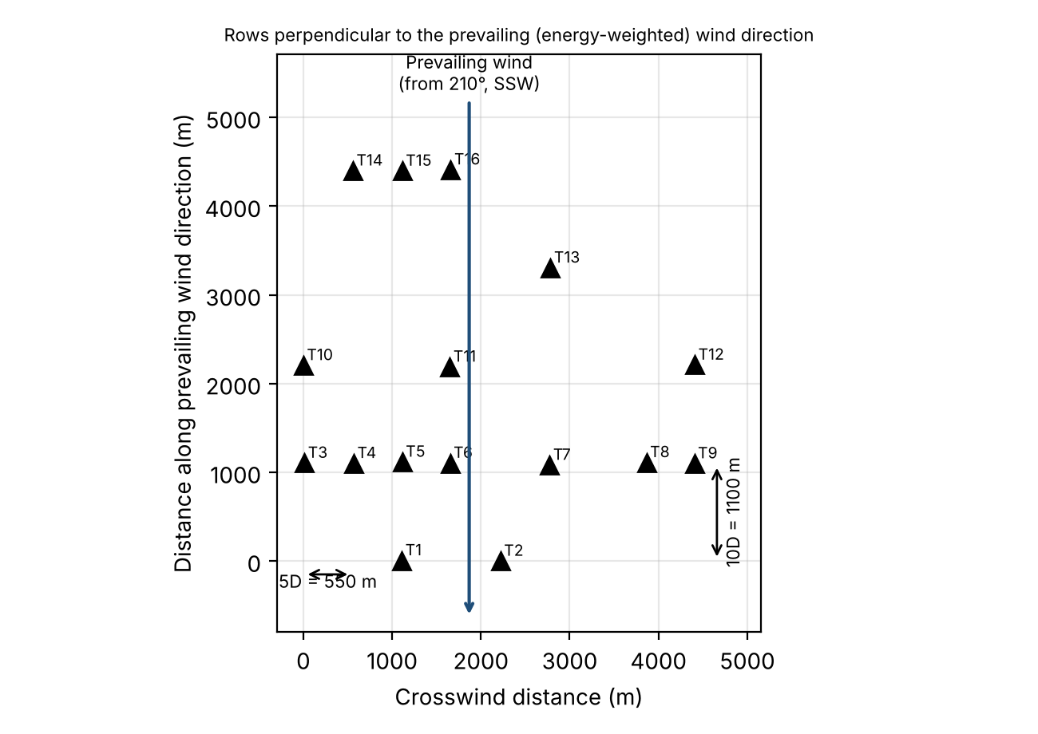
Figure 4-1. Array layout

4.4 SAM Analysis
SAM (Wind model, same WIND Toolkit data, SAM library V110-2.0 curve, wakes and losses off) gives 8,111 MWh/yr per turbine (CF 46.3%), which also requires 16 turbines. Replace with your SAM desktop run and screenshots.

5. Annual Energy Production and System Sizing

5.1 AEP and Capacity Factor
Weibull fit (Section 3.2), then the V110-2.0 power curve, then the bin table below. There are no wake losses.
$h_{i}=8760×f_{Weibull}\left(v_{i}\right)×Δv$ (7)
${AEP}_{turbine}=\sum_{i}{}P\left(v_{i}\right)×h_{i}, {AEP}_{farm}=n_{T}×{AEP}_{turbine}$ (8)
$CF=\frac{P_{avg}}{P_{rated}}=\frac{AEP}{P_{rated}×8760}$ (9)
where h_{i} = hours per year in wind speed bin i (h/yr); v_{i} = wind speed of bin i (m/s); Δv = bin width, 1 m/s; P(v_{i}) = turbine power output from the manufacturer power curve (kW); AEP_{turbine} = annual energy production of one turbine (kWh/yr); AEP_{farm} = annual energy production of the wind farm (MWh/yr); P_{avg} = annual average power output (kW); P_{rated} = turbine rated power (kW); CF = capacity factor (dimensionless).
v_{i} (m/s) | h_{i} (h/yr) | P(v_{i}) (kW) | E_{i} (MWh/yr) | v_{i} (m/s) | h_{i} (h/yr) | P(v_{i}) (kW) | E_{i} (MWh/yr)
1 | 156 | 0 | 0 | 11 | 426 | 1,998 | 850
2 | 398 | 0 | 0 | 12 | 278 | 2,000 | 555
3 | 659 | 28 | 18 | 13 | 168 | 2,000 | 335
4 | 889 | 143 | 127 | 14 | 93 | 2,000 | 187
5 | 1,049 | 315 | 330 | 15 | 48 | 2,000 | 96
6 | 1,114 | 552 | 614 | 16 | 23 | 2,000 | 46
7 | 1,080 | 904 | 976 | 17 | 10 | 2,000 | 20
8 | 963 | 1,349 | 1,299 | 18 | 4 | 2,000 | 8
9 | 793 | 1,774 | 1,407 | 19 | 1 | 2,000 | 3
10 | 604 | 1,970 | 1,190 | 20 | 1 | 0 | 0
 |  |  |  | Total | 8,755 |  | 8,063
Table 5-1. AEP bin table, one turbine
AEP_{turbine} = 8,063 MWh/yr, AEP_{farm} = 16 × 8,063 = 129,003 MWh/yr, and CF = 8,063 / (2 × 8,760) = 46.0%.
Metric | Hand Calculation | SAM
AEP, one turbine (MWh/yr) | 8,063 | 8,111
AEP, wind farm (MWh/yr) | 129,003 | 129,780
Capacity factor (%) | 46.0 | 46.3
Table 5-2. Energy production

5.2 Comparison to Data Center Demand
Annual comparison:
$Share=\frac{{AEP}_{farm}}{E_{demand}}×100\%$ (10)
where Share = fraction of annual demand supplied by wind (%); AEP_{farm} = wind farm annual energy production (MWh/yr); E_{demand} = annual energy demand, 122,640 MWh/yr.
The wind farm produces 129,003 MWh/yr, supplying 105.2% of the data center's 122,640 MWh/yr demand.
Following the seasonal and diurnal patterns in Section 3.5, wind output exceeds the flat 14 MW load from October to May and at night, and falls short in June to September and during the day.

5.3 Grid Backup Sizing
The hourly WIND Toolkit speeds were run through the power curve for 16 turbines and compared with the 14 MW load.
$P_{backup}=P_{load}=14 MW$ (11)
Wind output falls to zero below cut-in and above cut-out wind speed, and the data center cannot tolerate interruption. The grid backup is therefore sized to carry the full 14 MW facility load. Wind output is below 14 MW for 4,660 h/yr, requiring 42,069 MWh/yr of grid energy.

5.4 Interconnection Capacity
From Eq. (12):
$P_{IC}=max\left(P_{load}, P_{inst}−P_{load}\right)$ (12)
where P_{IC} = required interconnection capacity (MW); P_{load} = import required when wind output is zero, 14 MW; P_{inst} = installed wind capacity (MW).
With 32 MW installed, maximum export is 18 MW. The required interconnection capacity is 18 MW.

5.5 SAM Analysis
SAM gives 129,780 MWh/yr (CF 46.3%), within 1% of the hand calculation (Table 5-2). Replace with your SAM desktop results.

6. Economic Analysis

6.1 Capital and O&M Cost
NLR ATB 2025, land-based wind, Moderate scenario, 2025, wind Class 8 (2023$): OCC $1,780/kW and fixed O&M $40.3/kW-yr. The grid price is the EIA NC industrial average.
$CAPEX=OCC×P_{inst}$ (13)
where CAPEX = total plant capital cost ($); OCC = overnight capital cost ($/kW); P_{inst} = installed capacity (kW).
Input | Value | Source
CAPEX ($) | 56,950,400 | ATB 2025: $1,779.7/kW × 32 MW
OPEX ($/yr) | 1,289,600 | ATB 2025: $40.3/kW-yr × 32 MW
Grid power price ($/MWh) | 75 | EIA, NC industrial avg. (7.51 ¢/kWh) verify
Required rate of return, r | 7% | Given
Project life, N (yr) | 25 | Lecture 5 example
Table 6-1. Cost inputs

6.2 Levelized Cost of Energy
With r = 7% and N = 25 yr:
$LCOE=\frac{CAPEX×CRF+OPEX}{AEP}, CRF=\frac{r{\left(1+r\right)}^{N}}{{\left(1+r\right)}^{N}−1}$ (14)
where LCOE = levelized cost of energy ($/MWh); CRF = capital recovery factor (1/yr); OPEX = annual operating cost ($/yr); AEP = wind farm annual energy production (MWh/yr); r = required rate of return, 0.07; N = project life (yr).
CRF = 0.08581, LCOE = (56,950,400 × 0.08581 + 1,289,600) / 129,003 = $47.88/MWh, which is $27.12/MWh below the $75/MWh grid price.

6.3 Net Present Value and Internal Rate of Return
Revenue is the avoided grid purchase.
$Revenue=AEP×P_{e}, {CF}_{t}=Revenue−OPEX$ (15)
$NPV=−CAPEX+\sum_{t=1}^{N}{\frac{{CF}_{t}}{{\left(1+r\right)}^{t}}}$ (16)
$0=−CAPEX+\sum_{t=1}^{N}{\frac{{CF}_{t}}{{\left(1+IRR\right)}^{t}}}$ (17)
where Revenue = annual value of energy produced (avoided grid purchases) ($/yr); P_{e} = grid electricity price ($/MWh); CF_{t} = net cash flow in year t ($/yr); NPV = net present value ($); IRR = internal rate of return (%); r = required rate of return, 0.07; t = year (yr); N = project life (yr).
Revenue = 129,003 × $75 = $9,675,230/yr and CF_{t} = $8,385,630/yr, so NPV = $40.8 M and IRR = 14.2%. Because NPV > 0 and IRR > 7%, the project is viable.
Metric | Hand Calculation | SAM
LCOE ($/MWh) | 47.88 | 47.59
Grid power price ($/MWh) | 75.00 | 75.00
NPV at 7% ($) | 40,772,236 | 41,450,954
IRR (%) | 14.2 | 14.3
Table 6-2. Economic results

6.4 SAM Analysis
SAM Single Owner with the same CAPEX, O&M, 7% rate and 25-year life, with no taxes, debt or incentives and a PPA price equal to the grid price. Results are in Table 6-2. Replace with your SAM desktop results.

7. Permitting Checklist and Timeline
Site A: Perquimans County, coastal plain. Cite the Perquimans County wind ordinance.
Permit / Approval | Agency | Applies (Y/N) | Est. Duration
FAA Determination of No Hazard (14 CFR Part 77) | FAA | Y | 3–6 months
Mountain Ridge Protection Act (NCGS 113A, Art. 14) | County | N | n/a (not near a protected ridge)
Coastal wind energy facility permit (NCGS 143-215.115 to .121) | NCDEQ | Y | 12–18 months
County zoning / conditional use permit | County | Y | 4–9 months
Generator interconnection | Duke Energy | Y | 2–4 years
Table 7-1. Permitting checklist
Interconnection is the critical path, so commercial operation is about 3 to 4 years out. Note: Site A is served by Dominion Energy NC (PJM), which follows an interconnection process equivalent to Duke Energy's.

8. Site Plan and Single-Line Diagram

8.1 Site Plan
The 16 turbines, 34.5 kV collection along the access roads, the project substation, and a 2.8 km 230 kV line to the South Hertford 230 kV substation (point of interconnection).
Insert a Google Earth screenshot made from the provided KML file (turbines, roads, collection, substation, POI).
Figure 8-1. Site plan

8.2 Single-Line Electrical Diagram
Turbine generators (690 V) with pad-mount transformers to 34.5 kV, five 34.5 kV collector feeders, a 34.5/230 kV main transformer with breakers, POI metering, the grid connection, and the data center feed.
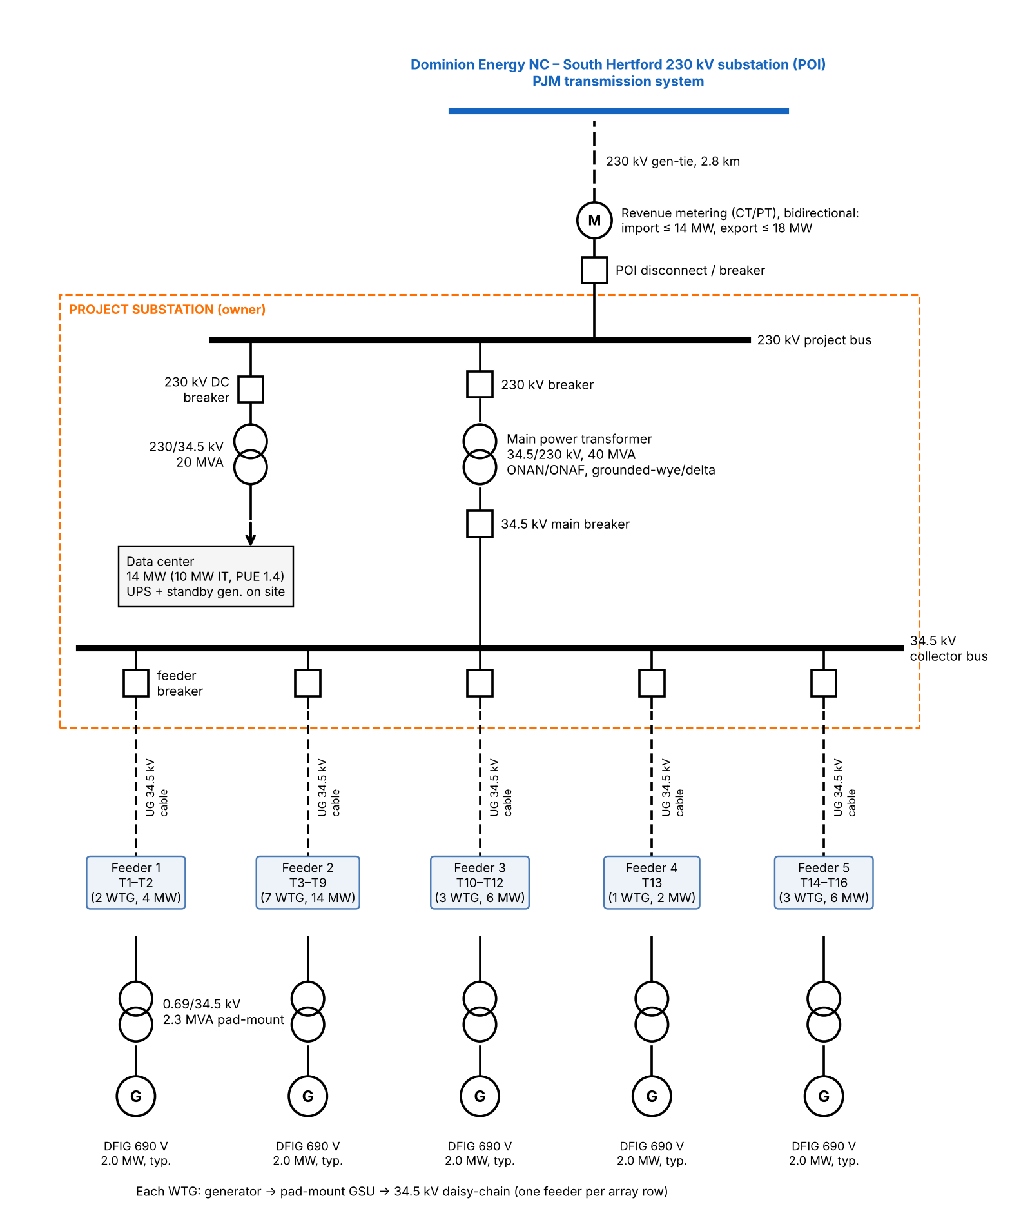
Figure 8-2. Single-line diagram

References
[1] NLR WIND Toolkit (Draxl et al., 2015, Applied Energy 151, 355–366).
[2] NLR System Advisor Model (SAM), https://sam.nlr.gov
[3] NLR Annual Technology Baseline 2025, Land-Based Wind, https://atb.nlr.gov
[4] LBNL, Land-Based Wind Market Report, https://emp.lbl.gov/wind-technologies-market-report
[5] Vestas, V110-2.0 MW datasheet. add URL/date
[6] IEC 61400-1 Ed. 4, Wind turbines: Design requirements.
[7] FAA, 14 CFR Part 77 and OE/AAA Notice Criteria Tool, https://oeaaa.faa.gov
[8] USGS, NLCD (https://www.mrlc.gov) and PAD-US Data Explorer.
[9] USFWS, IPaC, https://ipac.ecosphere.fws.gov
[10] NC Natural Heritage Program Data Explorer, https://ncnhp.org
[11] NCGS Chapter 113A, Article 14 (Mountain Ridge Protection Act); NCGS 143-215.115 to .121 (wind energy facility permits).
[12] Perquimans County wind energy ordinance. add citation
[13] Duke Energy, NC Generator Interconnection Procedures, https://www.duke-energy.com
[14] EIA, Electric Power Monthly, Table 5.6.A.

