Wind Farm Design for a Small Data Center in North Carolina
Midterm Project Report
AEEE 5250 Analysis of Renewable Energy Systems, Fall 2026
Prepared by
David Salisbury
Dmitrii Nikiforov

Submitted to: Dr. Maciej Noras
Date: 10/09/26

1. Design Basis
Parameter | Value | Basis
IT critical load | 10 MW | Given
Power usage effectiveness (PUE) | 1.4 | Given
Total facility demand | 14 MW | 10 MW × 1.4
Annual energy demand | 122,640 MWh/yr | 14 MW × 8,760 h/yr
Reliability requirement | Near-continuous | Firm grid interconnection for backup and balancing
Table 1-1. Data center design load

2. Site Selection and Screening

2.1 Candidate Sites
Three candidate sites were identified in the northeastern North Carolina coastal plain, the part of the state with the best land-based wind resource outside the western mountain ridges covered by the Mountain Ridge Protection Act (Figure 2-1). The NLR WIND Toolkit 100 m wind speed field was used to find the windiest band of land (7.0 to 7.8 m/s, concentrated in Pasquotank, Camden, Currituck, Tyrrell and Hyde counties), and the land-use, transmission and exclusion layers were then used to pick one representative open-agricultural location in each of three different settings: an interior farm-belt site near existing wind projects and 230 kV transmission (Site A, Perquimans), a higher-wind sound-side site (Site B, Camden), and the windiest mainland site on the Pamlico Sound (Site C, Hyde).
Each site was screened over a 4 km (2.5 mi) radius study area (12,430 acres). Wind speed is the 2007 to 2014 mean at the nearest WIND Toolkit grid point at 100 m. Land cover is from the ESA WorldCover 10 m (2021) map, and structures, wetlands, power lines, substations, airports and protected areas are from the Overture Maps / OpenStreetMap layers. "Setback-compliant land" is open cropland or grassland that is outside mapped wetlands, at least 375 m (2.5 × the 150 m tip height, the Perquimans County standard) from any mapped structure, and at least 1.1 × tip height from public roads. Screenshots of the same three locations in the NLR Wind Prospector (100 m wind, land use and transmission layers) should be added here.
Criterion | Site A | Site B | Site C
County / location | Perquimans Co. (Durants Neck)  36.130° N, 76.450° W | Camden Co. (south of Shiloh)  36.235° N, 76.030° W | Hyde Co. (near Engelhard)  35.525° N, 76.000° W
Wind resource (m/s) | 6.91 at 100 m | 7.23 at 100 m | 7.30 at 100 m
Land availability (acres) | 5,643 open (34% crop); 2,094 setback-compliant | 3,508 open (23% crop); 756 setback-compliant | 6,677 open (46% crop); 4,350 setback-compliant
Transmission proximity (mi) | 3.7 mi to 230 kV line; 3.9 mi to South Hertford 230 kV sub (Dominion) | 7.0 mi to 230 kV line; 9.4 mi to Aydlett 230 kV sub | 18.1 mi to 115 kV (Tideland EMC); 40 mi to 230 kV
Airports / airspace | Nearest public-use: Northeastern Regional (KEDE) 9.5 mi; Harvey Point DoD site 4.7 mi; Navy ROTHR receiver 31 mi (outside 28 mi zone) | USCG Air Station / Elizabeth City Regional (KECG) 7.3 mi; Currituck Co. (KONX) 11.3 mi; ROTHR 26 mi (inside 28 mi zone) | Hyde Co. Airport (7W6) 3.5 mi; Dare Co. Bombing Range 10.7 mi; military training airspace
Protected ridges | None (coastal plain, ground elev. about 10 m) | None (ground elev. about 1 m) | None (ground elev. about 0 to 1 m)
Wetlands | Low: 302 ac mapped wetland (2%) | High: 3,706 ac mapped wetland (30%) plus 17% open water | High: 17% herbaceous wetland; 1,859 ac mapped
Residential setbacks | 617 structures in study area; 375 m setback feasible | 384 structures; setback land fragmented by water and marsh | 571 structures, clustered in Engelhard; setback feasible
Table 2-1. Candidate site screening
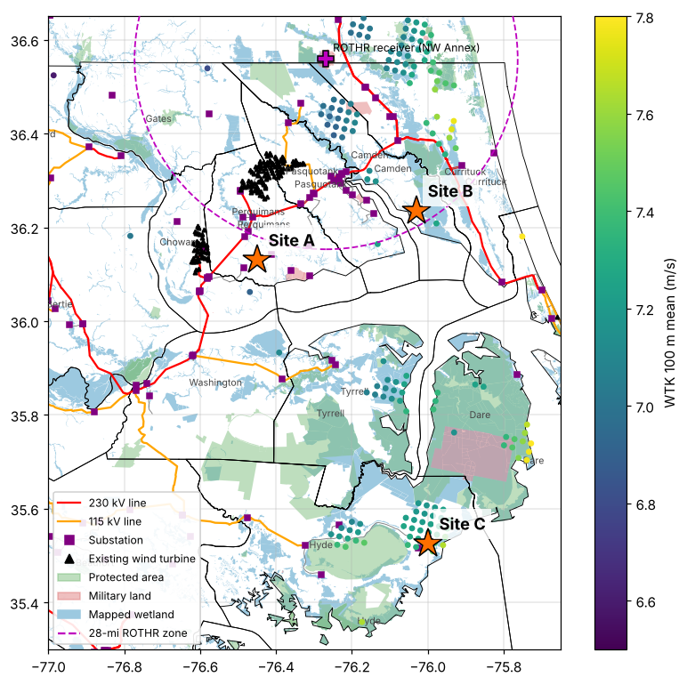
Figure 2-1. Candidate sites, WIND Toolkit 100 m resource, transmission and exclusion layers

2.2 Screening Outcomes
The four screening resources were applied to all three sites. The results below combine the site data in Table 2-1 with the published record for the existing Amazon Wind Farm US East (Perquimans/Pasquotank, 104 turbines, 2016) and Timbermill Wind (Chowan, 45 turbines, permitted 2023) projects, which sit about 12 to 15 km from Site A. Each subsection notes the official tool check that still has to be run. Paste that tool's output or a screenshot in where noted.

2.2.1 FAA
The selected turbine (Section 4.1) has a 95 m hub and 55 m blade, so the blade-tip height is 150 m (492 ft) above ground level. Ground elevation is about 10 m (34 ft) at Site A, about 1 m at Site B and about 0 m at Site C (Copernicus 30 m DEM), giving a structure top of about 527 ft AMSL at Site A. Every turbine exceeds the 200 ft AGL notice threshold of 14 CFR 77.9(a), so a Form 7460-1 must be filed for each turbine (and for any met tower) at all three sites. The 492 ft tip is below the 499 ft AGL general obstruction standard of 14 CFR 77.17(a)(1), so a turbine is only an obstruction if it penetrates an airport's imaginary or instrument-approach surfaces.
Site A: the nearest public-use airport is Northeastern Regional (KEDE, Edenton), about 9.5 mi away, outside the 20,000 ft notice-slope area of 77.9(b). The only other aviation uses nearby are private grass strips and the Harvey Point Defense Testing Activity (DoD) about 4.7 mi to the southeast, which needs DoD coordination. Site A is 31 mi from the Navy ROTHR receiver (NSA Hampton Roads Northwest Annex, Chesapeake, VA), outside the 28 mi zone in which the Navy has objected to wind turbines. A Determination of No Hazard is likely, with DoD Siting Clearinghouse review in parallel. Site B: it is 7.3 mi from USCG Air Station Elizabeth City (KECG, joint-use with the regional airport), whose instrument procedures may be affected, and 26 mi from the ROTHR receiver, inside the 28 mi zone. The Amazon Wind Farm needed a 2014 DoD mitigation agreement with Navy curtailment rights for this reason. A Determination of No Hazard is possible but conditional on DoD mitigation. Site C: it is 3.5 mi from Hyde County Airport (7W6) and 10.7 mi from the Dare County Bombing Range, which is used for low-level military training. The Pantego Wind project in Beaufort County stalled partly over F-15 training objections. A Determination of No Hazard is unlikely without layout changes.
To complete: enter each site's lat/long, ground elevation (34 / 5 / 1 ft) and 492 ft structure height in the FAA OE/AAA Notice Criteria Tool and paste the tool's result for each site.

2.2.2 USGS National Land Cover Database
Land cover was quantified with the ESA WorldCover 10 m (2021) map, which has classes equivalent to the NLCD. Site A is 34% cultivated crops and 11% grass/pasture, with the rest in scattered woodlots (53%) and less than 1% developed. Only 302 acres of mapped wetland lie in the study area. Site B is 23% cropland, 17% open water, and has about 3,700 acres of mapped wetland. Site C is 46% cropland but 17% herbaceous wetland, and the remaining tree cover is largely pocosin and swamp forest. Developed land and wetlands were treated as exclusions.
Protected areas (PAD-US equivalent): no protected land lies inside the Site A study area. The nearest units are small NCWRC boating access areas 7 mi away. Site B is 3.4 mi from the North River Game Land. Site C is 3.2 mi from Mattamuskeet National Wildlife Refuge and 5.7 mi from Alligator River National Wildlife Refuge, and the Gull Rock Game Land is nearby. The 16-turbine array (Section 4.3) occupies a footprint of about 4,472 acres, of which only about 1 to 2 acres per turbine are permanently disturbed. Site A has 2,094 acres of setback-compliant open land, enough for all 16 turbine positions (shown in Figure 8-1). Site B does not have enough contiguous land, and Site C has enough land but would need wetland permitting. Conclusion: A is suitable, B is marginal and C carries high wetland risk.
To complete: confirm in the PAD-US Data Explorer (or NLCD viewer) and add a screenshot of each study area.

2.2.3 USFWS Critical Habitat
IPaC is a preliminary screen, not a formal Section 7 consultation. For these coastal-plain counties it is expected to return: the northern long-eared bat (endangered since 2023), the tricolored bat (proposed endangered), the monarch butterfly (proposed threatened), the West Indian manatee (threatened, aquatic, in the sounds and tidal rivers), and bald eagle and migratory birds of conservation concern. No designated critical habitat is expected at any of the sites.
For wind, the key risk is bats. The USFWS Land-Based Wind Energy Technical Assistance for the northern long-eared bat assumes migrating bats are present in the rotor-swept zone. The project should expect seasonal low-wind-speed curtailment (raising cut-in speed at night from about April through October) and post-construction mortality monitoring at any of the sites. Site A has no additional federal species beyond this baseline, though bald eagles nest along the Perquimans River and Albemarle Sound and an eagle nest survey is recommended. Site B adds marsh-bird risk (eastern black rail, threatened) from the North River marshes. Site C lies inside the Red Wolf Recovery Area (non-essential experimental population) and next to Lake Mattamuskeet, which hosts very large wintering tundra swan and snow goose flocks, the same issue that delayed the Pantego Wind project. Conclusion: A has low to moderate risk (manageable with curtailment), B moderate risk and C high risk.
To complete: draw each project area in IPaC, export the official species list, and correct the list above to match.

2.2.4 NC Natural Heritage Program
The NCNHP screen catches state-listed species and natural areas that IPaC does not. Site A's interior is farmland. Element occurrences within a 1 mile buffer are expected only along the wooded Perquimans River and Albemarle Sound shoreline, which the layout avoids, and the only managed areas nearby are NCWRC boating access sites. Site B is bordered by the North River Game Land and tidal marsh natural communities, which are likely to contain state-listed marsh birds and significant natural heritage areas. Site C is adjacent to Lake Mattamuskeet, a nationally significant natural heritage area and managed area, and to the extensive Alligator River pocosin and marsh complex. Conclusion: A has low risk, B moderate risk and C high risk.
To complete: run each site plus a 1 mile buffer in the NCNHP Data Explorer and paste the report summary (element occurrences, natural areas and managed areas).

2.3 Final Site Selection and Justification
Selected site: Site A, Perquimans County (Durants Neck area), 36.130° N, 76.450° W. Ranking: A > B > C.
Site A has the lowest wind speed of the three (6.91 m/s at 100 m, against 7.23 and 7.30 m/s). It nevertheless wins because it is the only site with no fatal flaw in any screen. It has open, farmed, upland land with few wetlands, and a Dominion 230 kV line and the South Hertford 230 kV substation 4 mi away. It is outside the Navy ROTHR 28 mi zone, far from public airports and military training airspace, and has only baseline wildlife risk. It also sits between two wind farms that have already been built and permitted, Amazon Wind Farm US East and Timbermill Wind, so the regional permitting path, local construction workforce and turbine logistics are proven. Site B is windier, but it is constrained by open water and marsh, sits inside the ROTHR zone and is 7 mi from a Coast Guard air station. Site C has the best wind, but it is 18 mi from 115 kV transmission and next to two National Wildlife Refuges, the red wolf recovery area and a bombing range.
The main risk at Site A is local. In 2016 the Perquimans County Board of Commissioners denied (3 to 2) the conditional-use permit for the 57 Perquimans turbines of the original Timbermill proposal, citing impacts on adjoining owners. Early landowner and neighbor engagement, compliance with the ordinance setbacks and a good-neighbor payment program are therefore part of the project plan. If the county permit cannot be obtained, the fallback is the adjacent Chowan County land west of Timbermill, which was also screened.

3. Wind Resource Assessment
Hourly WIND Toolkit data were obtained for the selected site at grid point gid 2266420 (36.1333° N, 76.4470° W), 0.3 km from the site center. The data were read directly from the public WIND Toolkit HDF5 files on the NLR AWS Open Data bucket (CONUS v1.0.0 for 2007 to 2013 and v1.1.0 for 2014), which hold the same data the Lecture 1 MATLAB API serves. The native resolution is 5 minutes. All eight years (2007 to 2014) were used. Wind speed was taken at 80, 100 and 120 m, and wind direction, temperature and pressure at 100 m. The 5-minute values were averaged to hourly means for the Weibull, energy and backup analysis (70,128 hours), and the 5-minute values within each hour were used for turbulence intensity. Time stamps are UTC and were converted to local time (America/New_York) for the seasonal and diurnal plots. The hub height is 95 m (Section 4.1).

3.1 Wind Resource Summary
All values in Table 3-1 are at the 95 m hub height and come from Sections 3.2 to 3.6.
Parameter | Value | Units
Hub height, H | 95 | m
Mean wind speed | 6.82 | m/s
Weibull shape parameter, k | 2.40 | dimensionless
Weibull scale parameter, a | 7.69 | m/s
Shear exponent, α | 0.262 | dimensionless
Turbulence intensity, TI | 9.4 (WTK proxy, rep. at 15 m/s) | %
IEC wind class | III (data: IIIC; IIIA turbine selected)
Table 3-1. Hub-height wind resource

3.2 Weibull Distribution
The hourly hub-height wind speeds were binned in 1 m/s bins, and the Weibull distribution was fitted by maximum likelihood (the same estimator MATLAB fitdist(data,'Weibull') uses; A = scale a, B = shape k).
$f_{Weibull}(v)=\frac{k}{a}{\left(\frac{v}{a}\right)}^{k−1}exp\left[−{\left(\frac{v}{a}\right)}^{k}\right]$ (1)
$v_{avg}=aΓ\left(1+\frac{1}{k}\right)$ (2)
where f_{Weibull}(v) = probability density of wind speed v (s/m); v = wind speed (m/s); k = shape parameter (dimensionless); a = scale parameter (m/s); v_{avg} = mean wind speed (m/s); Γ = gamma function (dimensionless).
The fit gives k = 2.40 and a = 7.69 m/s. From Eq. (2), v_{avg} = a·Γ(1 + 1/k) = 7.69 × Γ(1 + 1/2.40) = 7.69 × 0.8865 = 6.82 m/s. This matches the arithmetic mean of the hourly data (6.82 m/s). The relatively high k (above the Rayleigh value of 2) reflects a fairly steady coastal-plain resource with few very calm or very windy hours (Figure 3-1).
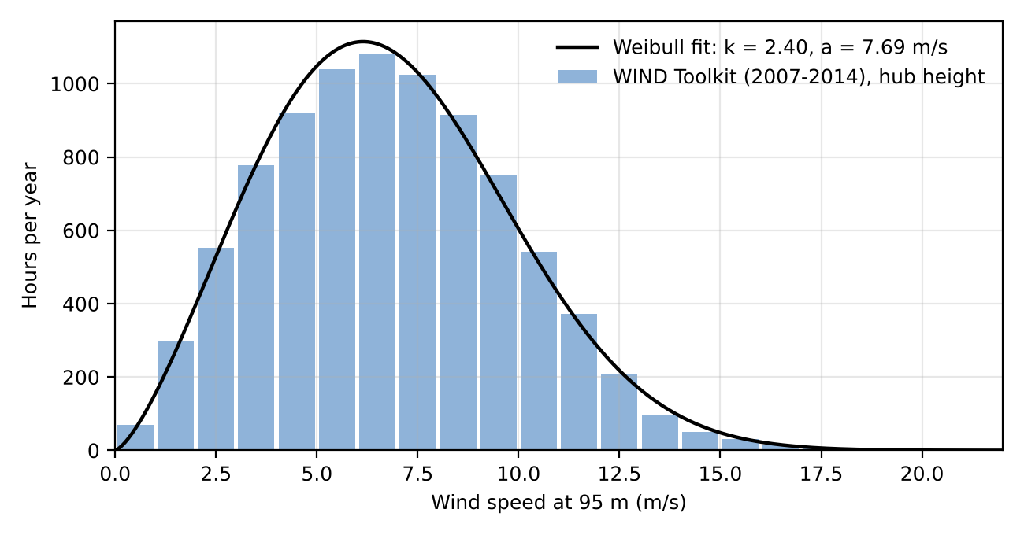
Figure 3-1. Hours per year in 1 m/s bins at 95 m and fitted Weibull distribution (2007 to 2014)

3.3 Wind Shear
Eight-year mean wind speeds at the two lowest WIND Toolkit heights bracketing the hub were used in Eq. (3).
$\left(\frac{v}{v_{0}}\right)={\left(\frac{H}{H_{0}}\right)}^{α} → α=\frac{ln\left(\frac{v}{v_{0}}\right)}{ln\left(\frac{H}{H_{0}}\right)}$ (3)
where v = wind speed at height H (m/s); v₀ = wind speed at the reference height (m/s); H = hub height (m); H₀ = reference height (m); α = shear (Hellman) exponent (dimensionless).
v₈₀ = 6.519 m/s and v₁₀₀ = 6.911 m/s, so α = ln(6.911/6.519) / ln(100/80) = 0.0585 / 0.2231 = 0.262. The 100 to 120 m pair gives α = 0.260, confirming the value. The exponent is higher than the 1/7 (0.143) rule of thumb, which is typical of the stable night-time boundary layer over the coastal plain. Because the 95 m hub is not a WIND Toolkit height, the 100 m series was scaled to hub height: v₉₅ = v₁₀₀(95/100)^{α} = 6.911 × 0.95^{0.262} = 6.82 m/s.

3.4 Turbulence Intensity
IEC 61400-1 defines σ_{v} from high-frequency (1 Hz) samples within 10-minute periods. The WIND Toolkit only provides 5-minute averages, so TI was approximated as the standard deviation of the twelve 5-minute values in each hour divided by the hourly mean (at 100 m, the nearest height), and the results were binned by hourly mean speed. This proxy removes the short-period turbulence that IEC TI includes, so it underestimates true TI and is used only as an indicator.
$TI=\frac{σ_{v}}{v_{avg,10min}}$ (4)
where TI = turbulence intensity (dimensionless); σ_{v} = standard deviation of wind speed (m/s); v_{avg,10min} = 10-minute mean wind speed (m/s).
Across all hours above 3 m/s the mean TI proxy is 5.7%. In the 15 m/s bin (353 hours over 8 years) the mean is 4.3% with a standard deviation of 4.0%, giving a representative (90th-percentile, mean + 1.28σ) value of TI₁₅ ≈ 9.4%. Measured TI over flat farmland with scattered woodlots is typically 10 to 14%, so the site is conservatively treated as turbulence category A (16%) in Section 3.6.

3.5 Seasonal and Diurnal Variation
Figure 3-2 shows a clear cool-season maximum. March (7.85 m/s), April (7.76 m/s) and February (7.52 m/s) are the windiest months, driven by passing mid-latitude storms and fronts. August (5.33 m/s) and July (5.90 m/s) are the calmest, under the Bermuda High. Figure 3-3 shows that at hub height the wind is strongest at night: speeds of about 7.6 m/s from 21:00 to 02:00 local time, driven by the nocturnal low-level jet above a stable surface layer. They are weakest in late morning (5.7 m/s around 10:00 to 11:00), when daytime mixing couples the 95 m level to the slower surface flow. Both patterns matter for a flat 14 MW load (Section 5.2).
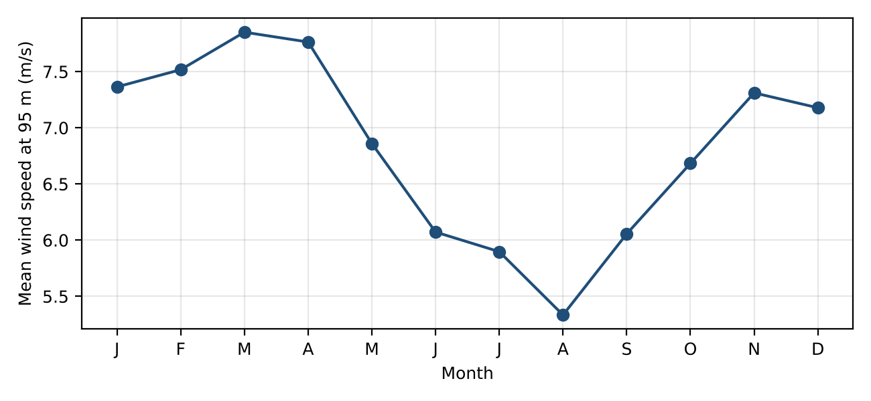
Figure 3-2. Seasonal variation (monthly mean wind speed at 95 m, 2007 to 2014)
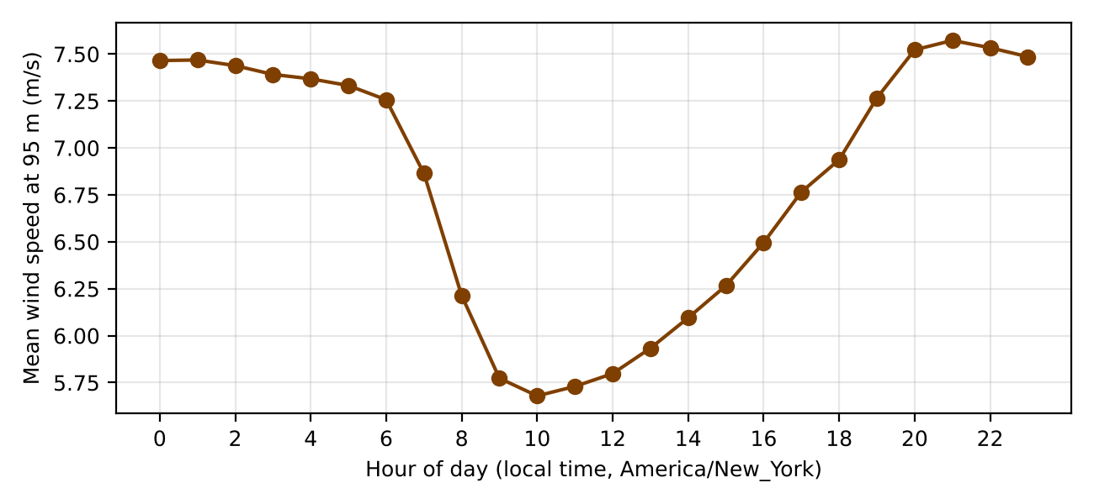
Figure 3-3. Diurnal variation (mean wind speed at 95 m by local hour)

3.6 IEC Wind Class
The hub-height mean wind speed of 6.82 m/s is below the 7.5 m/s Class III limit, so the site is IEC Class III.
IEC 61400-1 Class | I | II | III
Average wind speed at hub height (m/s) | 10.0 | 8.5 | 7.5
50-year maximum 10-minute wind speed (m/s) | 50 | 42.5 | 37.5
50-year extreme 3-second gust (m/s) | 70 | 59.5 | 53.5
Turbulence Class A | 16% | 16% | 16%
Turbulence Class B | 14% | 14% | 14%
Turbulence Class C | 12% | 12% | 12%
Table 3-2. IEC 61400-1 wind turbine classes
The WIND Toolkit TI proxy (9.4%) would place the site in turbulence category C. Because that proxy underestimates IEC turbulence, the design is based on category A, so the site is designated IIIA. Category A (16%) envelopes categories B and C, so a Class IIIA turbine is the conservative choice and is selected in Section 4.1. The 50-year extreme wind (tropical storms) should be confirmed against the 37.5 m/s Class III limit during final design. Optional: cite ASCE 7 / NOAA extreme-wind data for Perquimans County.

4. Turbine Selection, Sizing, and Micrositing

4.1 Selected Turbine
The Vestas V110-2.0 MW (IEC IIIA) was selected. It is a low-wind-speed turbine with a very large rotor relative to its rating: 2,000 kW over 9,503 m² of swept area gives a specific power of 210 W/m², among the lowest of commercial onshore turbines, which raises capacity factor at a 6.8 m/s site. It is the Lecture 3/4 example turbine, and its power curve is in the NLR SAM turbine library, so the hand calculation and the SAM model (Sections 4.4, 5.5 and 6.4) use an identical curve. The 95 m hub keeps the tip height at 150 m (492 ft), below the 499 ft FAA obstruction standard and below Perquimans County's 600 ft height cap. 2 MW-class low-wind turbines are also proven locally: the neighboring Amazon Wind Farm US East uses 104 Gamesa G114-2.0 MW units. Larger current platforms (e.g., Vestas V150-4.2 MW at Timbermill, or the Siemens Gamesa SG 2.1-114) would reduce the turbine count to about 8. They are a reasonable alternative, but their full power-curve tables are not public.
Cite the current Vestas V110-2.0 MW product datasheet. The power curve used is the SAM library curve "Vestas V110-2.0".
Parameter | Value
Manufacturer / model | Vestas V110-2.0 MW
Rated power (MW) | 2.0
Rotor diameter, D (m) | 110 (swept area 9,503 m²; 210 W/m²)
Hub height (m) | 95 (options 80 / 95 / 125)
Cut-in / cut-out speed (m/s) | 3.0 / 20.0 (rated about 11.5)
IEC class | IIIA
Table 4-1. Selected turbine

4.2 Number of Turbines
The per-turbine capacity factor from the Section 5.1 bin calculation is used in Eq. (5).
$n_{T}=\frac{E_{demand}}{P_{rated}×8760×CF}, P_{inst}=n_{T}×P_{rated}$ (5)
where n_{T} = number of turbines, rounded up; E_{demand} = annual energy demand, 122,640 MWh/yr; P_{rated} = turbine rated power (MW); 8760 = hours per year (h/yr); CF = capacity factor (dimensionless); P_{inst} = installed capacity (MW).
CF = 0.4602 (Section 5.1), so n_{T} = 122,640 / (2.0 × 8,760 × 0.4602) = 122,640 / 8,063 = 15.21, which rounds up to n_{T} = 16 turbines. Installed capacity is P_{inst} = 16 × 2.0 = 32 MW. This is a gross (no-loss) sizing, as in class. With typical availability, electrical and wake losses (Section 4.4) about 19 turbines would be required to meet 100% of demand on a net basis.

4.3 Array Layout
The prevailing energy-weighted wind direction at 100 m is from 210° (SSW to SW, Figure 4-2), so turbine rows were oriented perpendicular to that direction. Following the Lecture 5 example, 5D crosswind and 10D downwind spacing was used. The lattice was placed on the setback-compliant land map, and each node was kept only if it landed on open land at least 375 m from every structure and outside wetlands and road setbacks. The result is 5 rows of 2, 7, 3, 1, 3 turbines (Figures 4-1 and 8-1), with a minimum distance to any structure of 377 m. The array footprint is about 4,472 acres.
$S_{down}=x×D, S_{cross}=y×D$ (6)
where S_{down} = downwind spacing (m); S_{cross} = crosswind spacing (m); D = rotor diameter (m); x = downwind multiplier, 6 to 10 rotor diameters; y = crosswind multiplier, 3 to 5 rotor diameters.
Turbines are spaced at 10D (1,100 m) downwind and 5D (550 m) crosswind relative to the prevailing wind direction. Wake losses are not included in this analysis.
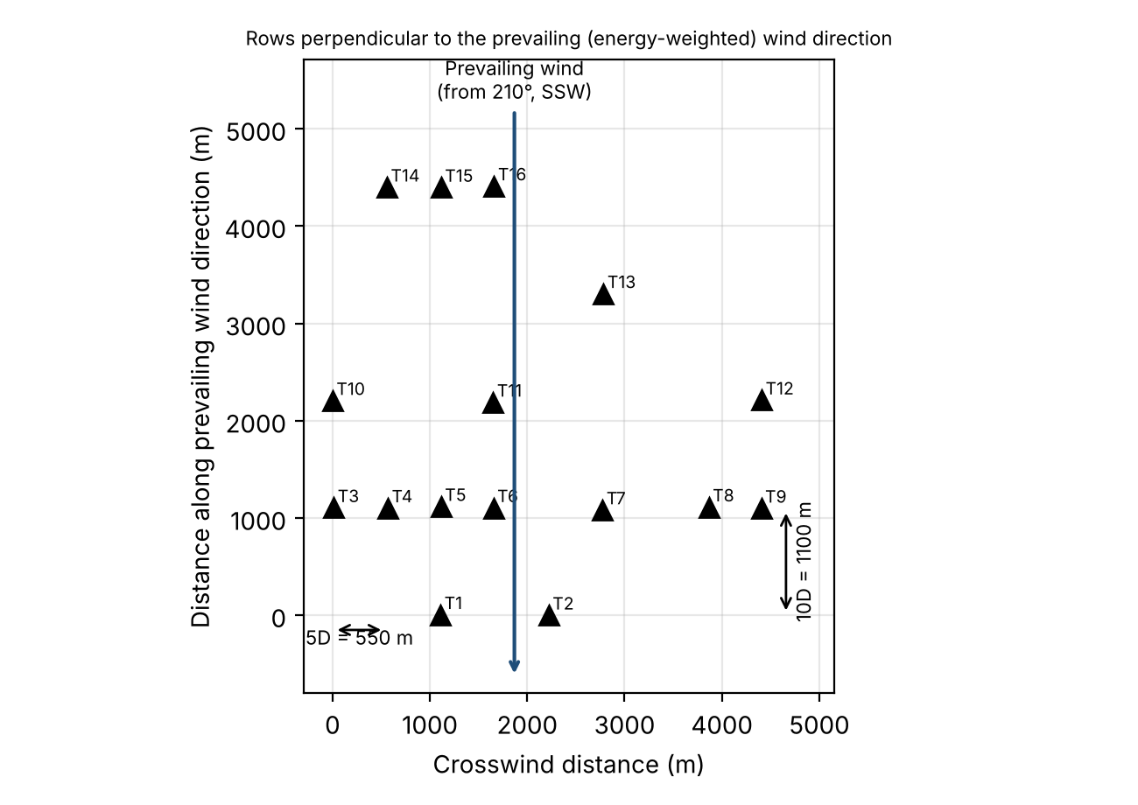
Figure 4-1. Array layout
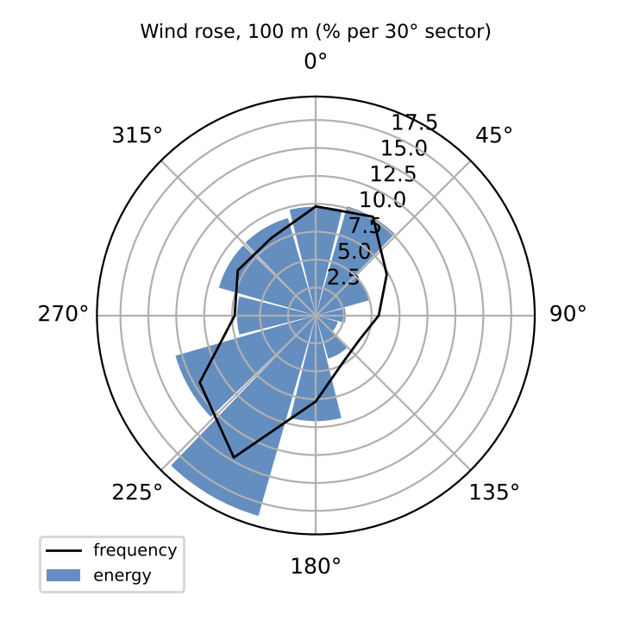
Figure 4-2. Wind rose at 100 m, frequency and energy (v³) per 30° sector, 2007 to 2014

4.4 SAM Analysis
The Phase 3 analysis was repeated with the NLR SAM simulation engine (PySAM 7.1.1.post1, the SAM Wind Power model) using the same eight years of WIND Toolkit data. The data were converted to SAM's resource format with speed and direction at 80, 100 and 120 m and temperature and pressure at 100 m. The model used the SAM library "Vestas V110-2.0" power curve, a 95 m hub, the 16-turbine coordinates from Figure 8-1, wakes off (constant 0% loss) and all other losses set to 0%, to match the hand calculation. SAM gives 8,111 MWh/yr per turbine (CF 46.3%), so n_{T} = 122,640 / 8,111 = 15.12, which rounds up to 16 turbines, the same as the hand calculation.
Sensitivity: with SAM's default loss assumptions (availability, electrical, environmental and turbine-performance losses) and the SAM Simple wake model enabled, net farm output falls to 107,222 MWh/yr (CF 38.2%, 87% of demand). About 19 turbines would therefore be needed to meet 100% of demand on a net basis.
Graduate requirement: reproduce this run in the SAM desktop application (Wind / Single Owner) and paste screenshots of the inputs and results.

5. Annual Energy Production and System Sizing

5.1 AEP and Capacity Factor
The Lecture 3/4 workflow was followed: Weibull fit (Section 3.2), then the V110-2.0 power curve, then the bin table below. Energy is gross, with no wake, availability or electrical losses.
$h_{i}=8760×f_{Weibull}\left(v_{i}\right)×Δv$ (7)
${AEP}_{turbine}=\sum_{i}{}P\left(v_{i}\right)×h_{i}, {AEP}_{farm}=n_{T}×{AEP}_{turbine}$ (8)
$CF=\frac{P_{avg}}{P_{rated}}=\frac{AEP}{P_{rated}×8760}$ (9)
where h_{i} = hours per year in wind speed bin i (h/yr); v_{i} = wind speed of bin i (m/s); Δv = bin width, 1 m/s; P(v_{i}) = turbine power output from the manufacturer power curve (kW); AEP_{turbine} = annual energy production of one turbine (kWh/yr); AEP_{farm} = annual energy production of the wind farm (MWh/yr); P_{avg} = annual average power output (kW); P_{rated} = turbine rated power (kW); CF = capacity factor (dimensionless).
v_{i} (m/s) | f(v_{i}) (s/m) | h_{i} (h/yr) | P(v_{i}) (kW) | E_{i} (MWh/yr)
1 | 0.0178 | 156 | 0 | 0
2 | 0.0455 | 398 | 0 | 0
3 | 0.0752 | 659 | 28 | 18
4 | 0.1015 | 889 | 143 | 127
5 | 0.1197 | 1,049 | 315 | 330
6 | 0.1271 | 1,114 | 552 | 614
7 | 0.1233 | 1,080 | 904 | 976
8 | 0.1099 | 963 | 1,349 | 1,299
9 | 0.0905 | 793 | 1,774 | 1,407
10 | 0.0689 | 604 | 1,970 | 1,190
11 | 0.0486 | 426 | 1,998 | 850
12 | 0.0317 | 278 | 2,000 | 555
13 | 0.0191 | 168 | 2,000 | 335
14 | 0.0107 | 93 | 2,000 | 187
15 | 0.0055 | 48 | 2,000 | 96
16 | 0.0026 | 23 | 2,000 | 46
17 | 0.0011 | 10 | 2,000 | 20
18 | 0.0005 | 4 | 2,000 | 8
19 | 0.0002 | 1 | 2,000 | 3
20 | 0.0001 | 1 | 0 | 0
21 | 0.0000 | 0 | 0 | 0
22 | 0.0000 | 0 | 0 | 0
Total | 0.999 | 8,755 |  | 8,063
Table 5-1. AEP bin table, one V110-2.0 at 95 m (Weibull k = 2.40, a = 7.69 m/s; v ≥ 23 m/s bins are zero)
AEP_{turbine} = Σ P(v_{i})·h_{i} = 8,063 MWh/yr, and AEP_{farm} = 16 × 8,063 = 129,003 MWh/yr. CF = 8,063 / (2.0 × 8,760) = 46.0%. As a check, running the 70,128 hourly hub-height speeds directly through the power curve gives 8,160 MWh/yr per turbine (1.2% higher).
Metric | Hand Calculation | SAM
AEP, one turbine (MWh/yr) | 8,063 | 8,111
AEP, wind farm (MWh/yr) | 129,003 | 129,780
Capacity factor (%) | 46.0 | 46.3
Table 5-2. Energy production

5.2 Comparison to Data Center Demand
On an annual basis, Eq. (10) compares wind farm output with the flat 14 MW demand.
$Share=\frac{{AEP}_{farm}}{E_{demand}}×100\%$ (10)
where Share = fraction of annual demand supplied by wind (%); AEP_{farm} = wind farm annual energy production (MWh/yr); E_{demand} = annual energy demand, 122,640 MWh/yr.
The wind farm produces 129,003 MWh/yr, supplying 105.2% of the data center's 122,640 MWh/yr demand.
The load is flat but the wind is not. Running the hourly hub-height data through the power curve (Figures 5-1 and 5-2) shows a surplus from October to May, peaking in March (+3,512 MWh), and a deficit from June to September, worst in August (-3,950 MWh, when wind supplies only 62% of demand). Within the day, the farm averages about 17.5 MW from 20:00 to 06:00 (surplus) but only 10 to 12 MW from 09:00 to 14:00 (deficit). Hour by hour, wind output is below the load in 4,660 h/yr. 42,069 MWh/yr must be imported and 49,901 MWh/yr of surplus is exported, so wind serves about 66% of the load in real time. The other 34% is met by the grid and offset by the exports.
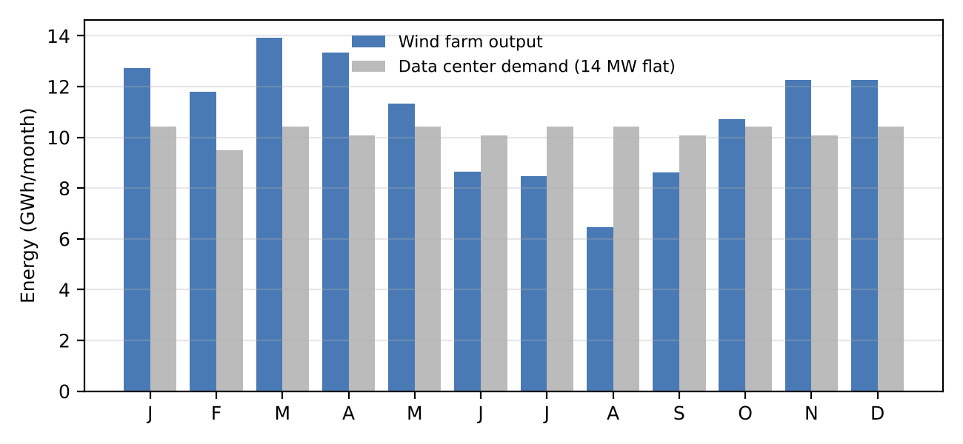
Figure 5-1. Monthly wind farm energy vs. data center demand
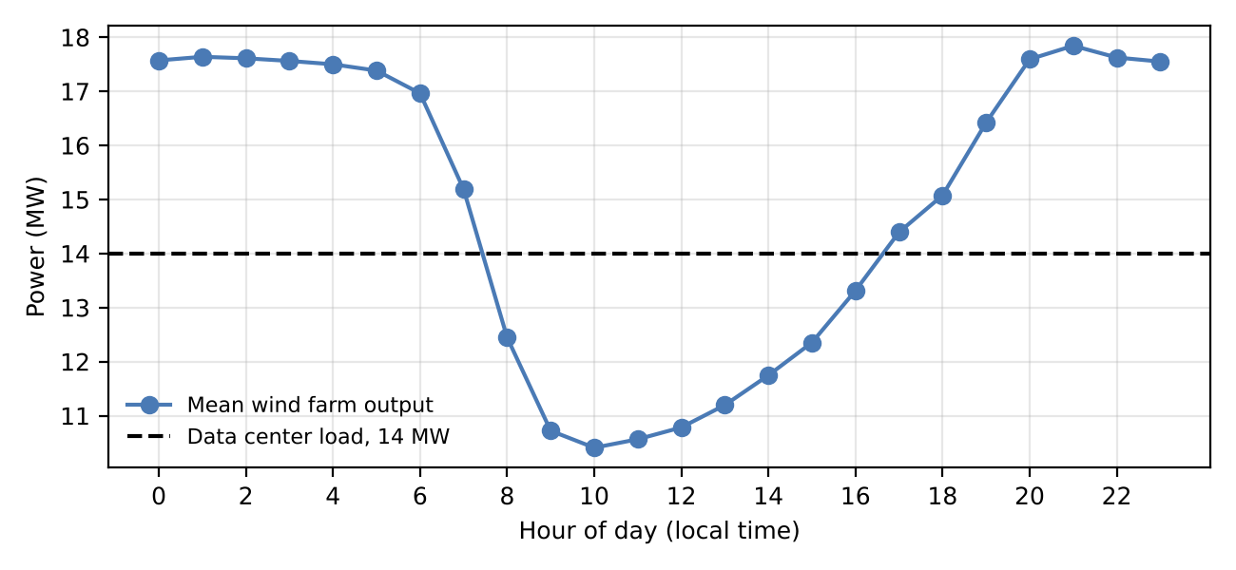
Figure 5-2. Mean wind farm output by local hour vs. the 14 MW load

5.3 Grid Backup Sizing
The hourly WIND Toolkit hub-height speeds (2007 to 2014) were run through the V110-2.0 power curve, multiplied by 16 turbines, and compared with the 14 MW load each hour.
$P_{backup}=P_{load}=14 MW$ (11)
Wind output falls to zero below cut-in and above cut-out wind speed, and the data center cannot tolerate interruption. The grid backup is therefore sized to carry the full 14 MW facility load. Wind output is below 14 MW for 4,660 h/yr (53% of hours, including 918 h/yr at zero output), requiring 42,069 MWh/yr of grid energy (Figure 5-3).
On-site UPS and standby generators (standard for any data center) ride through grid outages. They are not part of the wind/grid energy balance.
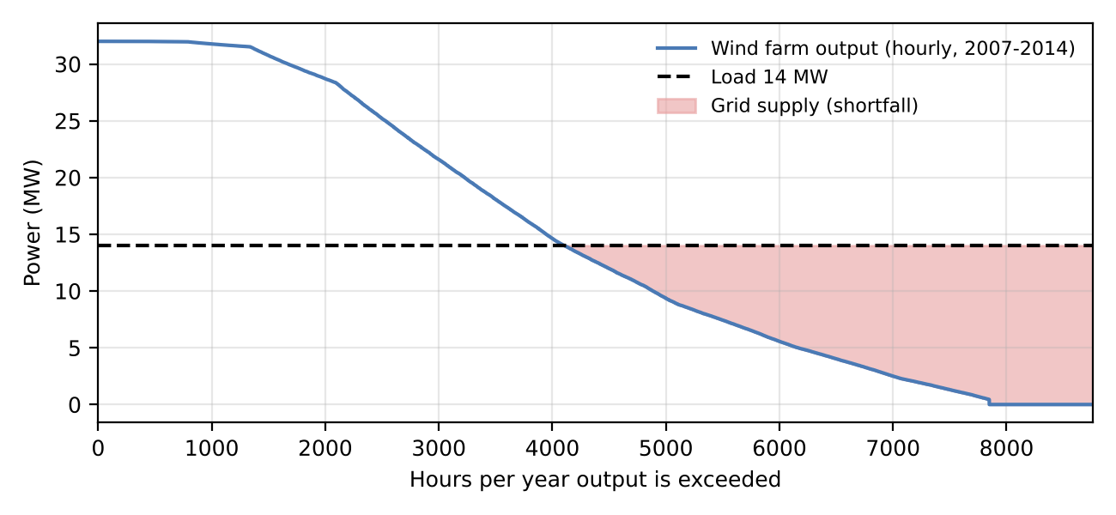
Figure 5-3. Hourly output duration curve; the shaded area is energy supplied by the grid

5.4 Interconnection Capacity
The interconnection at the point of interconnection (POI) must import the full load when wind is zero and export any surplus above the load (Eq. 12). The data center is placed behind the POI on the project substation bus (Section 8.2).
$P_{IC}=max\left(P_{load}, P_{inst}−P_{load}\right)$ (12)
where P_{IC} = required interconnection capacity (MW); P_{load} = import required when wind output is zero, 14 MW; P_{inst} = installed wind capacity (MW).
With 32 MW installed, maximum export is 32 − 14 = 18 MW. The required interconnection capacity is P_{IC} = max(14, 18) = 18 MW. The project main transformer is still rated for the full 32 MW of wind output (40 MVA), because the wind serves the data center through the shared project bus.

5.5 SAM Analysis
In SAM the farm produces 129,780 MWh/yr (CF 46.3%), +0.6% relative to the hand calculation. The small difference is because SAM runs the hourly time series (with air-density correction) rather than the Weibull bins. Year-to-year output ranges from 122,081 MWh (2012) to 135,894 MWh (2008). In SAM's hourly output the farm is below 14 MW for 4,684 h/yr with a 42,095 MWh/yr grid requirement, within 1% of the hand calculation. Add the SAM desktop screenshot.

6. Economic Analysis

6.1 Capital and O&M Cost
Costs are from the NLR Annual Technology Baseline (ATB) 2025, land-based wind, Moderate scenario, 2025 cost year, wind resource Class 8 (the ATB class covering a 6.5 to 7.1 m/s resource, Technology 2), in 2023 dollars. The ATB overnight capital cost is OCC = $1,779.7/kW and fixed O&M is $40.3/kW-yr. With Eq. (13), CAPEX = $1,779.7/kW × 32,000 kW = $56.95 M, and OPEX = $40.3/kW-yr × 32,000 kW = $1.290 M/yr. The grid price is the EIA North Carolina industrial average retail price (7.51 ¢/kWh). Verify the latest EIA NC industrial price (Electric Power Monthly Table 5.6.A), or substitute the applicable Dominion Energy NC or Duke Energy industrial rate.
$CAPEX=OCC×P_{inst}$ (13)
where CAPEX = total plant capital cost ($); OCC = overnight capital cost ($/kW); P_{inst} = installed capacity (kW).
Input | Value | Source
CAPEX ($) | 56,950,400 | NLR ATB 2025, LBW Class 8, Moderate, 2025: OCC $1,779.7/kW × 32 MW
OPEX ($/yr) | 1,289,600 | NLR ATB 2025 fixed O&M $40.3/kW-yr × 32 MW
Grid power price ($/MWh) | 75.0 | EIA, NC industrial average, 7.51 ¢/kWh
Required rate of return, r | 7% | Given
Project life, N (yr) | 25 | Lecture 5 example; typical wind design life
Table 6-1. Cost inputs

6.2 Levelized Cost of Energy
CRF and LCOE follow Eq. (14) with r = 7% and N = 25 years.
$LCOE=\frac{CAPEX×CRF+OPEX}{AEP}, CRF=\frac{r{\left(1+r\right)}^{N}}{{\left(1+r\right)}^{N}−1}$ (14)
where LCOE = levelized cost of energy ($/MWh); CRF = capital recovery factor (1/yr); OPEX = annual operating cost ($/yr); AEP = wind farm annual energy production (MWh/yr); r = required rate of return, 0.07; N = project life (yr).
CRF = 0.07(1.07)²⁵ / [(1.07)²⁵ − 1] = 0.07 × 5.4274 / 4.4274 = 0.08581. LCOE = (56,950,400 × 0.08581 + 1,289,600) / 129,003 = (4,886,943 + 1,289,600) / 129,003 = $47.88/MWh.
This is $27.12/MWh below the $75/MWh grid price. Using ATB's all-in CAPEX ($1,987.5/kW, which adds grid connection and construction financing) instead of OCC raises LCOE to $52.3/MWh, and applying the SAM default losses (net 107,222 MWh/yr) raises it to about $58/MWh. Both remain below the grid price.

6.3 Net Present Value and Internal Rate of Return
Revenue is the avoided cost of grid purchases (Eq. 15), with constant real prices and a level annual cash flow over 25 years.
$Revenue=AEP×P_{e}, {CF}_{t}=Revenue−OPEX$ (15)
$NPV=−CAPEX+\sum_{t=1}^{N}{\frac{{CF}_{t}}{{\left(1+r\right)}^{t}}}$ (16)
$0=−CAPEX+\sum_{t=1}^{N}{\frac{{CF}_{t}}{{\left(1+IRR\right)}^{t}}}$ (17)
where Revenue = annual value of energy produced (avoided grid purchases) ($/yr); P_{e} = grid electricity price ($/MWh); CF_{t} = net cash flow in year t ($/yr); NPV = net present value ($); IRR = internal rate of return (%); r = required rate of return, 0.07; t = year (yr); N = project life (yr).
Revenue = 129,003 MWh × $75 = $9,675,230/yr, and CF_{t} = 9,675,230 − 1,289,600 = $8,385,630/yr. NPV = −56,950,400 + 8,385,630 × Σ 1/(1.07)^{t} = −56,950,400 + 8,385,630 × 11.6536 = $40.77 M. Solving Eq. (17) gives IRR = 14.2%. Because NPV > 0 and IRR > 7%, the project is economically viable at the required return. This is before any federal tax credits, which were excluded as a conservative assumption.
Metric | Hand Calculation | SAM
LCOE ($/MWh) | 47.88 | 47.59
Grid power price ($/MWh) | 75.00 | 75.00
NPV at 7% ($) | 40,772,236 | 41,450,954
IRR (%) | 14.2 | 14.3
Table 6-2. Economic results

6.4 SAM Analysis
The Phase 5 analysis was repeated with the SAM Single Owner financial model (PySAM), using the SAM hourly generation from Section 5.5. Inputs were set to match the hand calculation: installed cost $56,950,400, O&M $40.3/kW-yr, 25-year analysis period, 7% real discount rate, 0% inflation, all-equity, no taxes, depreciation, incentives or reserves, and a 7.5 ¢/kWh PPA price representing the avoided grid cost. SAM returns a real LCOE of $47.59/MWh, an NPV of $41.45 M and an after-tax IRR of 14.3% (Table 6-2), within 2% of the hand values. The small differences come from SAM's slightly higher AEP. Add the SAM desktop screenshot.

7. Permitting Checklist and Timeline
The table below lists the approvals for Site A (Perquimans County, coastal plain, Dominion Energy NC / PJM transmission area). Durations are rough estimates from statute and from the Timbermill and Amazon Wind Farm precedents. The site is in Dominion Energy North Carolina's service area, so the generator interconnection is studied by PJM rather than Duke Energy. Duke Energy's NC generator interconnection procedures (cluster-based studies) are the equivalent process if the data center is moved into Duke territory.
Permit / Approval | Agency | Applies (Y/N) | Est. Duration
FAA Determination of No Hazard (14 CFR Part 77) | FAA | Y | 3 to 6 months (file 7460-1 per turbine; DoD Clearinghouse review in parallel)
Mountain Ridge Protection Act (NCGS 113A, Art. 14) | County | N | n/a: coastal plain, ground about 10 m; protected ridges are ≥ 3,000 ft in the mountain counties
Coastal wind energy facility permit (NCGS 143-215.115 to .121) | NCDEQ (DEMLR) | Y | 12 to 18 months (pre-application meeting ≥ 180 days before filing; Timbermill: application May 2022, permit Mar 2023)
County zoning / conditional use permit | Perquimans County | Y | 4 to 9 months (quasi-judicial CUP hearing; 2.5 × height setbacks, 600 ft cap. Note the 2016 Timbermill denial.)
Generator interconnection | Dominion Energy NC / PJM (Duke procedures for reference) | Y | 2 to 4 years (PJM cycle study and interconnection agreement; critical path)
USFWS technical assistance (bats, eagles); eagle take permit if needed | USFWS | Y | 6 to 12 months, including 1 to 2 seasons of bat and eagle surveys
USACE Sec. 404 / NCDEQ 401, stormwater and erosion control | USACE / NCDEQ | Y | 3 to 6 months (minimal; wetlands avoided)
Table 7-1. Permitting checklist
With the environmental surveys and FAA filings run in parallel with the county and state permits, all non-utility approvals take about 18 to 24 months. Interconnection (2 to 4 years) is the critical path, so the earliest commercial operation is about 3 to 4 years after the interconnection request is filed. Verify the current Perquimans County wind ordinance (setbacks, height, noise and shadow-flicker limits) and cite it.

8. Site Plan and Single-Line Diagram

8.1 Site Plan
Figure 8-1 shows the 16 turbine locations on the land-cover base map, together with mapped structures and roads. The 34.5 kV underground collection circuits (about 23 km) run one per row along new gravel access roads to the project substation at 36.1571° N, 76.4688° W. A 2.8 km 230 kV gen-tie connects the project substation to the point of interconnection at Dominion's South Hertford 230 kV substation. The data center is sited next to the project substation. Each turbine is at least 375 m from any structure and outside mapped wetlands.
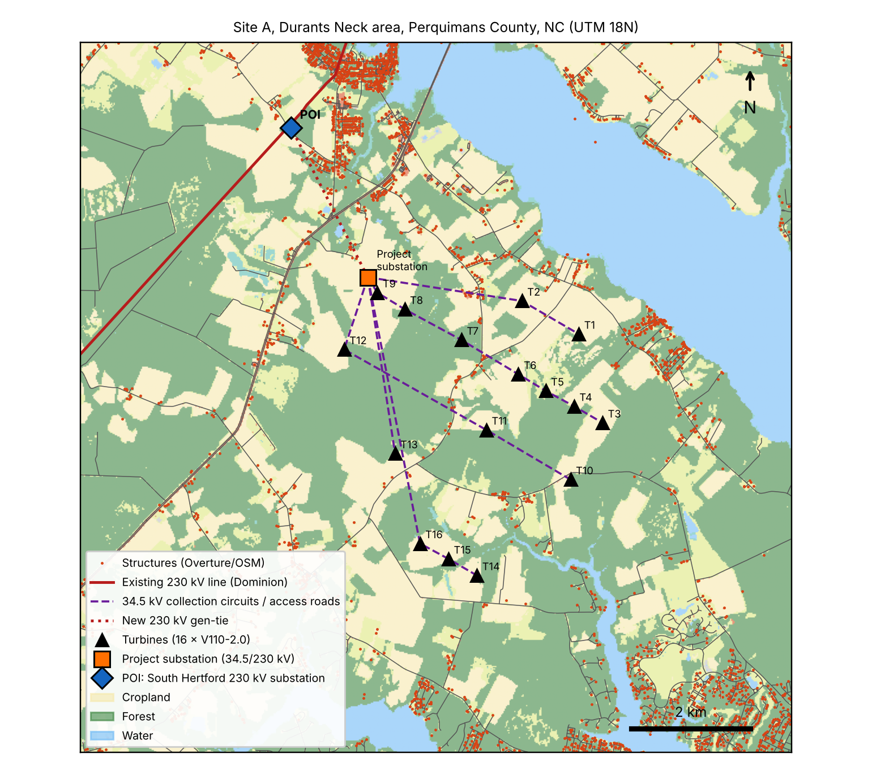
Figure 8-1. Site plan

8.2 Single-Line Electrical Diagram
Each V110-2.0 doubly fed induction generator (690 V) feeds a 2.3 MVA pad-mount step-up transformer (0.69/34.5 kV) at the tower base. The turbines in each row are daisy-chained on a 34.5 kV underground feeder (5 feeders, 2 to 14 MW each) to feeder breakers on the project 34.5 kV collector bus. A 34.5/230 kV, 40 MVA main power transformer with 34.5 kV and 230 kV breakers feeds the 230 kV project bus, which also supplies the data center through a 230/34.5 kV, 20 MVA transformer. Bidirectional revenue metering at the POI measures the net exchange (import up to 14 MW, export up to 18 MW) on the 230 kV gen-tie to the Dominion South Hertford substation.
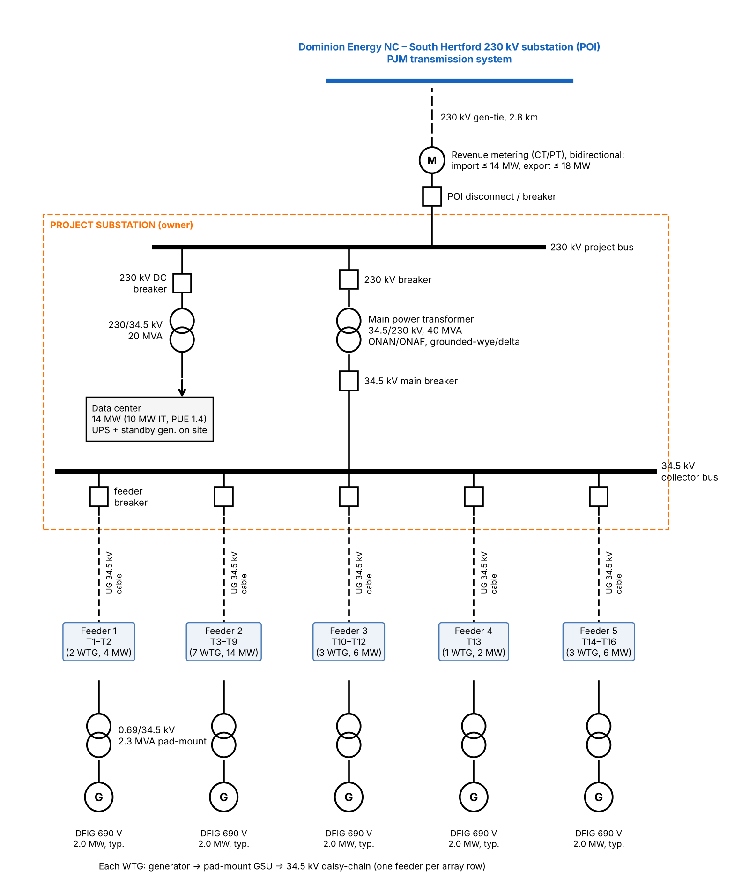
Figure 8-2. Single-line diagram

References
[1] Draxl, C., Hodge, B.-M., Clifton, A., & McCaa, J. (2015). The Wind Integration National Dataset (WIND) Toolkit. Applied Energy, 151, 355–366. Data: NLR WIND Toolkit CONUS v1.0.0/v1.1.0, s3://nrel-pds-wtk (AWS Open Data).
[2] National Laboratory of the Rockies (NLR). System Advisor Model (SAM), Wind Power and Single Owner models; PySAM 7.1.1. https://sam.nlr.gov
[3] NLR. (2025). Annual Technology Baseline 2025, Electricity: Land-Based Wind (ATBe.csv v1.0.0). https://atb.nlr.gov
[4] Wiser, R., Bolinger, M., et al. (2024). Land-Based Wind Market Report: 2024 Edition. Lawrence Berkeley National Laboratory. https://emp.lbl.gov/wind-technologies-market-report
[5] Vestas Wind Systems A/S. V110-2.0 MW product datasheet; power curve from the SAM turbine library ("Vestas V110-2.0"). add datasheet URL/date
[6] IEC 61400-1 Ed. 4 (2019). Wind energy generation systems – Part 1: Design requirements. International Electrotechnical Commission.
[7] IEC 61400-12-1 (2022). Power performance measurements of electricity producing wind turbines.
[8] 14 CFR Part 77, Safe, Efficient Use, and Preservation of the Navigable Airspace; FAA OE/AAA Notice Criteria Tool, https://oeaaa.faa.gov
[9] U.S. Geological Survey. National Land Cover Database and PAD-US Data Explorer, https:www.mrlc.gov, https:maps.usgs.gov/padusdataexplorer/; Zanaga, D. et al. (2022). ESA WorldCover 10 m 2021 v200.
[10] U.S. Fish and Wildlife Service. Information for Planning and Consultation (IPaC), https://ipac.ecosphere.fws.gov; Land-Based Wind Energy Voluntary Avoidance / Technical Assistance for the Northern Long-Eared Bat (2023).
[11] North Carolina Natural Heritage Program. NCNHP Data Explorer, https://ncnhp.org
[12] Overture Maps Foundation (2026). Overture Maps release 2026-10-21.0 (buildings, infrastructure, land, land use, transportation; includes OpenStreetMap data, ODbL).
[13] European Space Agency. Copernicus DEM GLO-30, s3://copernicus-dem-30m.
[14] N.C. Gen. Stat. Chapter 113A, Article 14 (Mountain Ridge Protection Act of 1983).
[15] N.C. Gen. Stat. §§ 143-215.115 to 143-215.126 (Permitting of Wind Energy Facilities); NCDEQ DEMLR Onshore Wind Energy Program.
[16] Perquimans County, NC. Zoning Ordinance, Wind Energy Facilities. add ordinance citation; Ashe County Wind Energy System Ordinance (OpenEI) as reference.
[17] NC Wind Working Group (2008). Model Wind Ordinance for Wind Energy Facilities in North Carolina.
[18] Duke Energy Carolinas / Duke Energy Progress. North Carolina Interconnection Procedures (generator interconnection). https://www.duke-energy.com; PJM Interconnection, Manual 14H (cycle process).
[19] U.S. Energy Information Administration. Electric Power Monthly, Table 5.6.A, Average Price of Electricity to Ultimate Customers by End-Use Sector, by State.
[20] NC DEQ (2023, Mar. 14). DEQ approves permit for onshore wind facility in North Carolina (Timbermill Wind). Coastal Review (2016, Nov.). Perquimans board denies wind farm permit.
[21] Carolina Journal / U.S. DOE (2014 to 2017). Amazon Wind Farm US East and the Navy ROTHR mitigation agreement; MIT Lincoln Laboratory ROTHR wind study (2012).
[22] ASHRAE TC 9.9, Thermal Guidelines for Data Processing Environments; Uptime Institute Tier Standard; LBNL (2024) United States Data Center Energy Usage Report.

