Wind Farm Design for a Small Data Center in North Carolina
Midterm Project Report
AEEE 5250 Analysis of Renewable Energy Systems, Fall 2026
Prepared by
David Salisbury
Dmitrii Nikiforov

Submitted to: Dr. Maciej Noras
Date: 10/26/2026

1. Design Basis
Parameter | Value | Basis
IT critical load | 10 MW | Given
Power Usage Effectiveness (PUE) | 1.4 | Given
Total facility demand | 14 MW | 10 MW × 1.4
Annual energy demand | 122,640 MWh/yr | 14 MW × 8,760 h/yr
Reliability requirement | Near-continuous | Firm grid interconnection for backup and balancing
Table 1-1. Data center design load

2. Site Selection and Screening

2.1 Candidate Sites
Three candidate sites were chosen in the northeastern coastal plain, which has the best wind resource in North Carolina outside the ridges protected by the Mountain Ridge Protection Act. All three are open farmland within reach of transmission. Wind resources for all three sites are evaluated from year 2007 to year 2014 using WIND Toolkit at elevation of 100 m above the ground. The NLCD/PAD-US, FAA, IPaC, and NCNHP resources were evaluated for each site and results are stated in the Table 2-1.
Criterion | Site A | Site B | Site C
County / location | Perquimans County (Durants Neck)  36.130° N, 76.450° W | Camden County (South of Shiloh)  36.235° N, 76.030° W | Hyde County  (near Engelhard)  35.525° N, 76.000° W
Wind resource (m/s) | 6.91 | 7.23 | 7.30
Land availability (acres) | ~5,600 open;  ~2,100 after setbacks | ~3,500 open;  ~800 after setbacks | ~6,700 open;  ~4,400 after setbacks
Transmission proximity (mi) | ~4  (230 kV substation) | ~10  (230 kV substation) | ~20  (115 kV line)
Airports / airspace | KEDE 9.5 mi; outside Navy radar zone | USCG Air Sta. Elizabeth City 7.3 mi; inside Navy radar zone | Hyde Co. Airport 3.5 mi; near Dare Co. Bombing Range
Protected ridges | None | None | None
Wetlands | Few | Extensive (marsh, open water) | Extensive (herbaceous wetland)
Residential setbacks | Feasible | Feasible, but land is fragmented | Feasible
Table 2-1. Candidate site screening
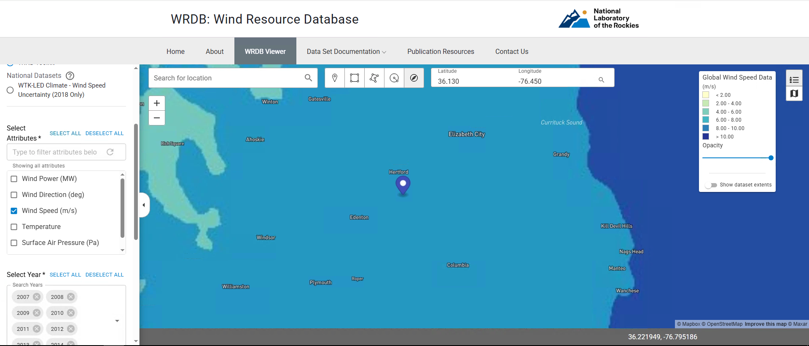
Figure 2-1-1: Site A NLR Wind Resource Database (WRDB) map, 100 m wind speed

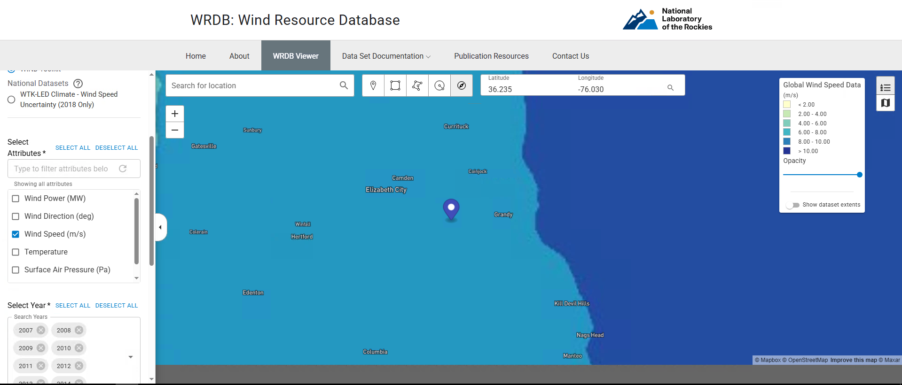
Figure 2-1-2: Site B NLR WRDB map, 100 m wind speed

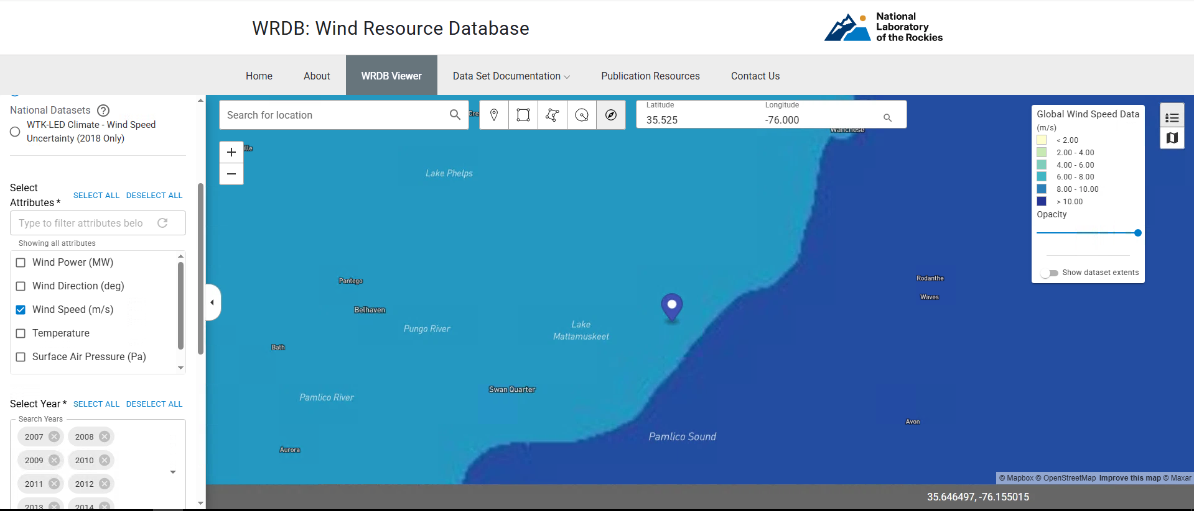
Figure 2-1-3: Site C NLR WRDB map, 100 m wind speed

Year | Average Wind Speed at 100 m - Site A (m/s) | Average Wind Speed at 100 m - Site B (m/s) | Average Wind Speed at 100 m - Site C (m/s)
2007 | 6.78 | 7.08 | 7.26
2008 | 7.08 | 7.44 | 7.45
2009 | 6.94 | 7.29 | 7.34
2010 | 7.04 | 7.43 | 7.45
2011 | 6.95 | 7.25 | 7.46
2012 | 6.69 | 6.95 | 7.03
2013 | 6.93 | 7.19 | 7.22
2014 | 6.89 | 7.20 | 7.22
Mean Wind Speed Resource (m/s) | 6.91 | 7.23 | 7.30
Table 2-2: WIND Toolkit mean wind speed at 100 m by year (2007–2014)

2.2 Screening Outcomes
Each candidate site was screened with the four tools required by the assignment: the FAA OE/AAA Pre-Screening (Notice Criteria) Tool for airspace, the USGS PAD-US Data Explorer for protected and managed land, the USFWS IPaC tool for federally listed species, and the NC Natural Heritage Program (NCNHP) Data Explorer for state natural areas and managed areas. All three sites were entered at the coordinates in Table 2-1, and the results for each tool are summarized below. None of the four screens rules out Site A, while Sites B and C each sit next to protected land or highly rated natural areas that add significant permitting and environmental risk.

2.2.1 FAA
The FAA OE/AAA Pre-Screening Tool was run for each site with the structure type set to Wind Turbine, a height of 493 ft above ground level (95 m hub plus 55 m blade, 150 m tip height), and site elevations of 12 ft (Site A), 5 ft (Site B) and 1 ft (Site C) (Figures 2-2-1-1 to 2-2-1-3). The tool returned the same result for all three sites: notice must be filed with the FAA (Form 7460-1) at least 45 days before construction starts, because each turbine is taller than 200 ft (14 CFR 77.9). Because a wind turbine is classed as an energy structure, the FAA also sends the filing to the Department of Defense (DoD) for formal review, and an informal review through the DoD Energy Siting Clearinghouse is recommended before filing. Since the tool does not rule out any site on its own, the airspace risk was judged from the airports and military facilities near each site. Site A is about 9.5 mi from the nearest public-use airport (Northeastern Regional, KEDE) and about 31 mi from the Navy ROTHR radar in Chesapeake, VA, outside the 28 mi zone in which the Navy has objected to wind farms, so a Determination of No Hazard is likely. Site B is about 7.3 mi from USCG Air Station Elizabeth City and inside the radar zone, so it would likely need a DoD mitigation agreement. Site C is about 3.5 mi from Hyde County Airport and near the Dare County Bombing Range military airspace, so the risk of an FAA or DoD objection is high.

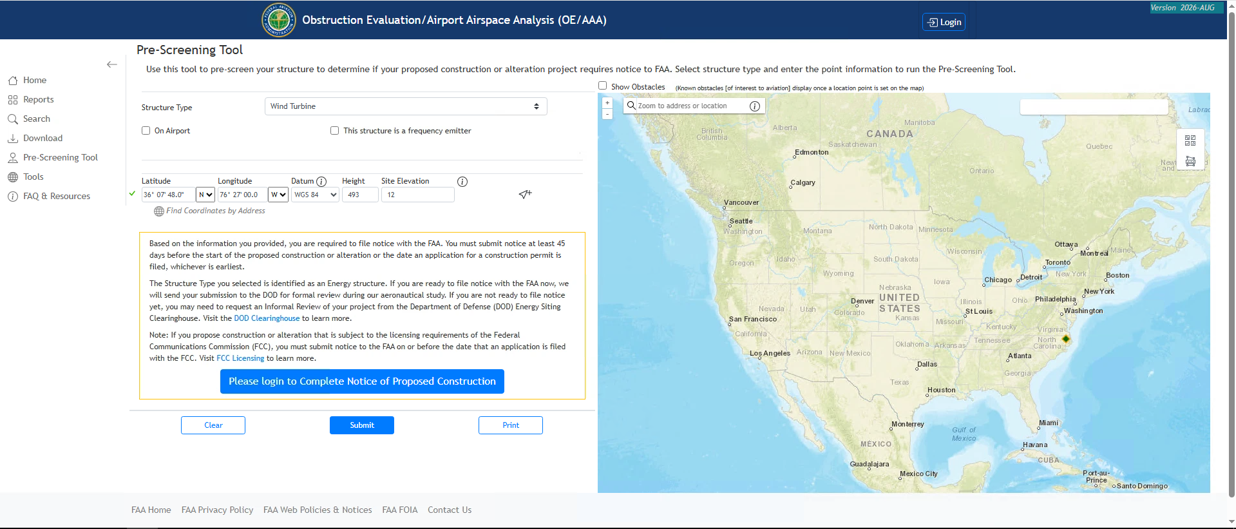
Figure 2-2-1-1: FAA Result for the Site A
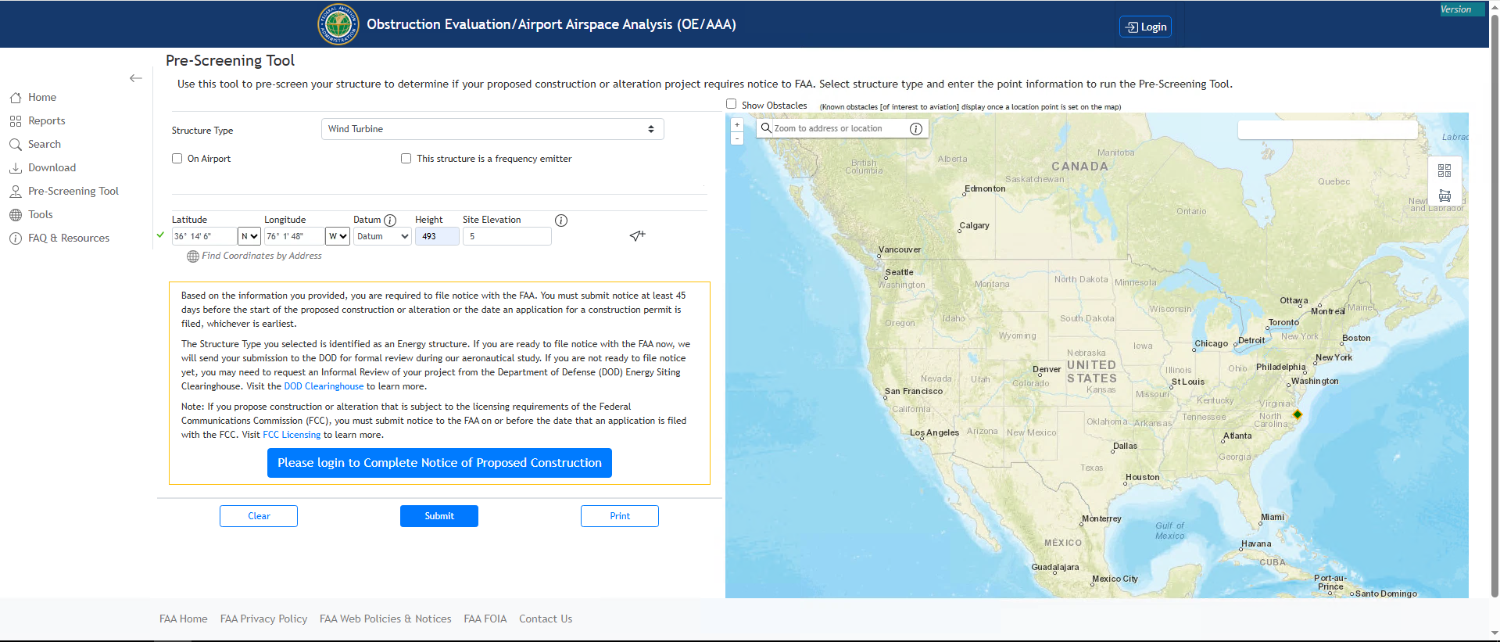
Figure 2-2-1-2: FAA Result for the Site B
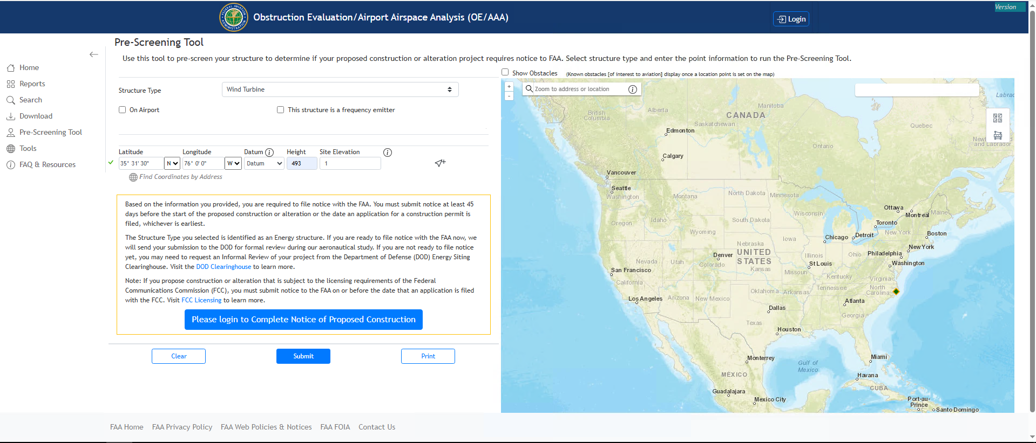
Figure 2-2-1-3: FAA Result for the Site C

2.2.2 USGS National Land Cover Database
The USGS PAD-US Data Explorer was used to check for protected and managed land at and around each site (Figures 2-2-2-1 to 2-2-2-3). Site A sits on private cropland with scattered woodlots, and no protected area covers the site. The nearest PAD-US unit is the Harvey Point Defense Testing Activity, a 3,019-acre military property (GAP 3) about 4 to 5 mi to the southeast; it is not a land-use conflict, but it supports the need for early DoD coordination. Site B is immediately west of the North River Game Land Dedicated Nature Preserve, a 7,701-acre state conservation area, and the remaining open land around it is broken up by water and marsh. Site C is surrounded by state Conservation Reserve Enhancement Program (CREP) easements on nearby farm parcels and is about 3 mi east of Mattamuskeet National Wildlife Refuge. No protected land blocks Site A, and it has enough open cropland for the 16-turbine array, while Sites B and C are constrained by the conservation land next to them.
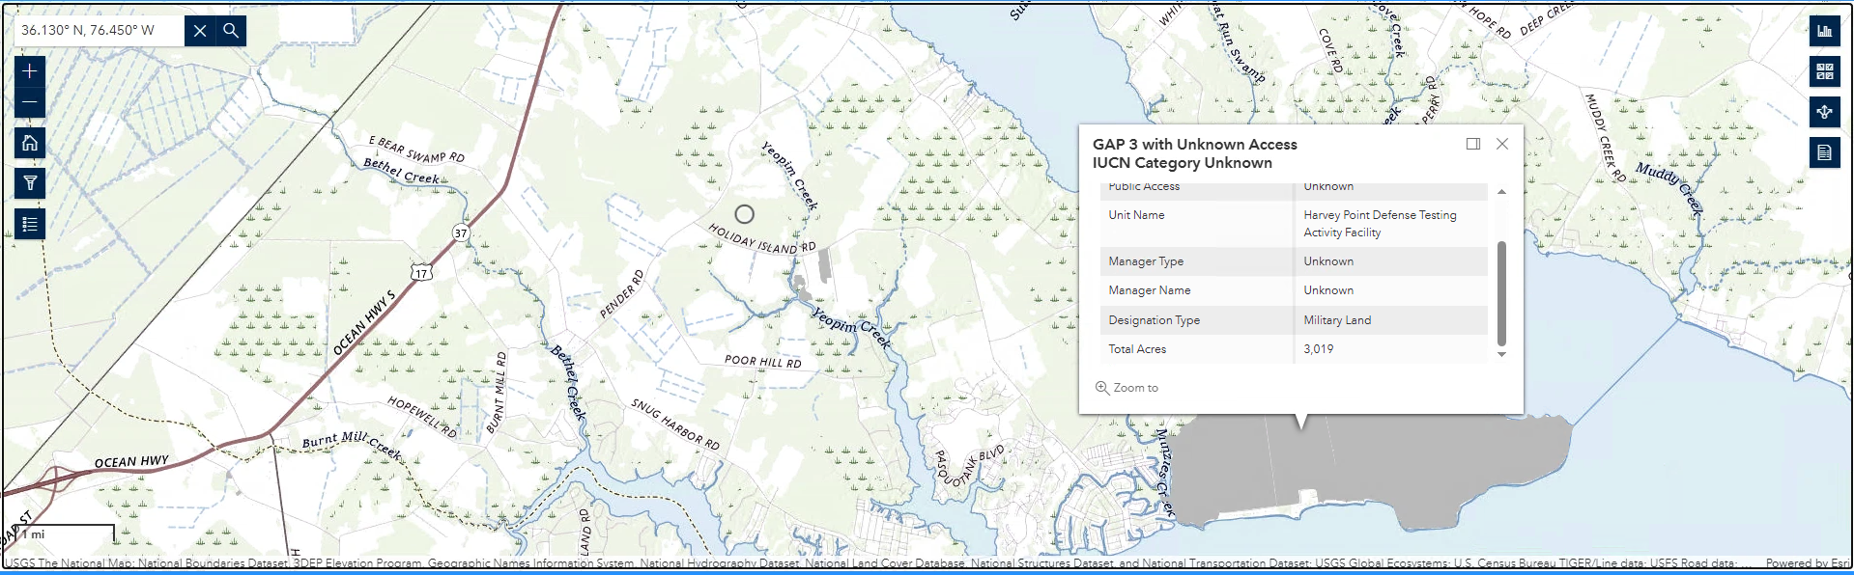
Figure 2-2-2-1: PAD-US Result for the Site A
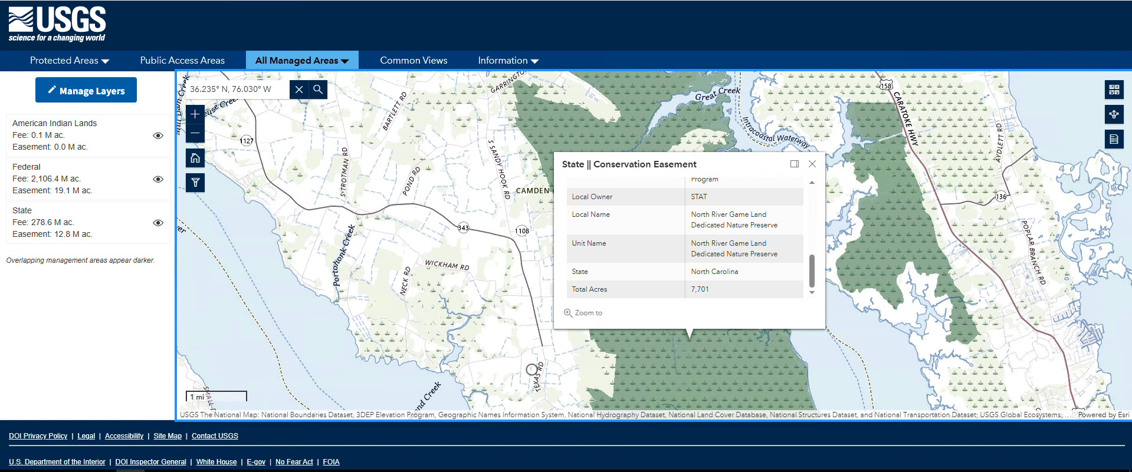
Figure 2-2-2-2: PAD-US Result for the Site B
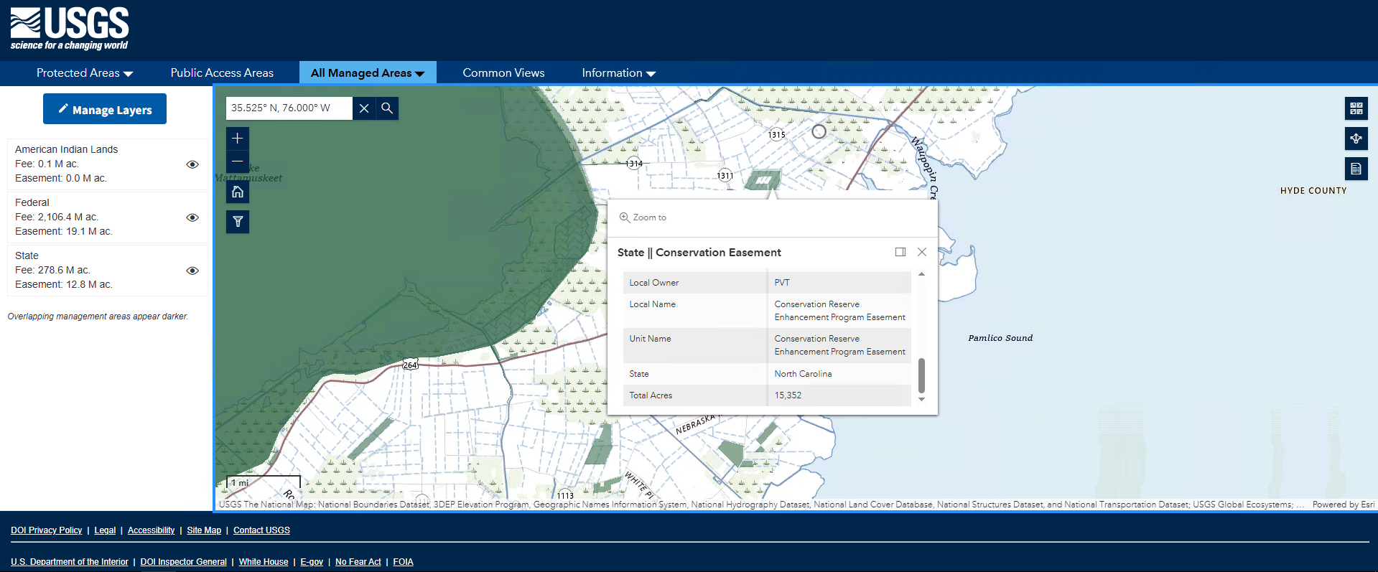
Figure 2-2-2-3: PAD-US Result for the Site C

2.2.3 USFWS Critical Habitat
USFWS IPaC was run for a project area at each site, and the results are listed in Table 2-2-3-1. IPaC is a preliminary screen, not a formal Section 7 consultation. No designated critical habitat was returned at any of the three sites. All three sites returned the tricolored bat, the monarch butterfly, the rufa red knot and the bald eagle, along with migratory birds of conservation concern. For a wind project the bats are the main concern: Site B also returned the northern long-eared bat, and either bat species could require seasonal low-wind-speed curtailment at night and post-construction monitoring. Site A returned the shortest list; its only aquatic species, the West Indian manatee, would not be affected by turbines on farmland, and its migratory birds are mostly upland and woodland species. Site B added the eastern black rail, the red-cockaded woodpecker and the American alligator, which point to marsh and pine habitat near the site. Site C returned the longest list, including the red wolf, piping plover, eastern black rail and sea turtles, and many coastal and water birds such as loons, terns, gulls and pelicans, reflecting its location on Pamlico Sound next to Lake Mattamuskeet. The wildlife risk is therefore low to moderate at Site A, moderate at Site B and high at Site C.

Species | Status | Site A | Site B | Site C | Relevance to a wind project
Northern long-eared bat | Endangered |  | ✓ |  | High: turbine collision risk; seasonal curtailment likely
Tricolored bat | Proposed endangered | ✓ | ✓ | ✓ | High: turbine collision risk; seasonal curtailment likely
Bald eagle | Protected (BGEPA) | ✓ | ✓ | ✓ | Moderate: collision risk; nest survey, possible eagle take permit
Rufa red knot | Threatened | ✓ | ✓ | ✓ | Low–moderate: migratory shorebird passing through
Eastern black rail | Threatened |  | ✓ | ✓ | Low–moderate: marsh habitat disturbance
Piping plover | Threatened |  |  | ✓ | Low: beach-nesting, coastal
Red-cockaded woodpecker | Threatened |  | ✓ | ✓ | Low: avoid clearing mature pine stands
Red wolf | Endangered (experimental population) |  |  | ✓ | Low: construction disturbance only
Monarch butterfly | Proposed threatened | ✓ | ✓ | ✓ | Low: habitat only
West Indian manatee | Threatened | ✓ |  | ✓ | None: aquatic
Hawksbill / green sea turtles | Endangered / Threatened |  |  | ✓ | None: marine
American alligator | Similarity of appearance |  | ✓ | ✓ | None
Designated critical habitat |  | None | None | None | No critical habitat at any site
Migratory birds of conservation concern |  | 10 | 8 | 19 | Site C adds coastal and water birds (loons, terns, gulls, pelicans)
Overall wildlife risk |  | Low to moderate | Moderate | High

Table 2-2-3-1: IPaC Species Results for each site

2.2.4 NC Natural Heritage Program
The NCNHP Data Explorer map was checked at each site with the Natural Areas and Managed Areas layers turned on, looking at about a 1 mi buffer around each point (Figures 2-2-4-1 to 2-2-4-3). Site A has no NCNHP natural area within 1 mi, and only a few small conservation-easement parcels lie nearby; the closest natural areas are a High-rated area and the Harvey Point federal land on the Albemarle Sound shore about 3.5 to 4 mi to the southeast. Site B is about 1 mi from a large Very High-rated natural area that overlaps the state-owned North River Game Land, with an Exceptional-rated area farther east along the North River. Site C is about 1 mi from a High-rated natural area along the Pamlico Sound shoreline and about 3 mi from Lake Mattamuskeet, which is rated Exceptional and is under federal ownership, and several conservation easements lie within 1 mi. The state-level risk is therefore low at Site A and moderate to high at Sites B and C, because both are next to highly rated natural areas.

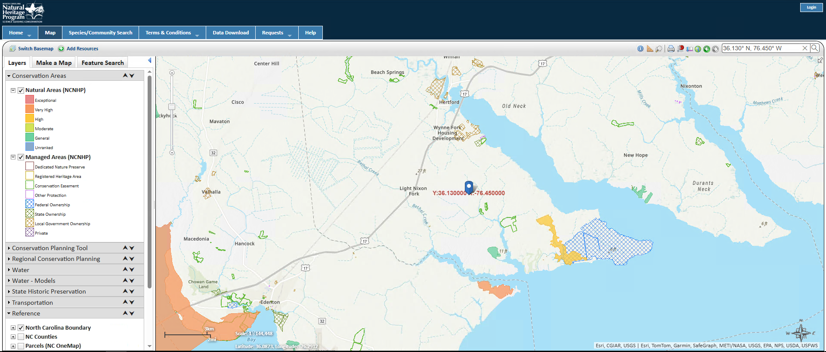
Figure 2-2-4-1: NCNHP Result for the Site A
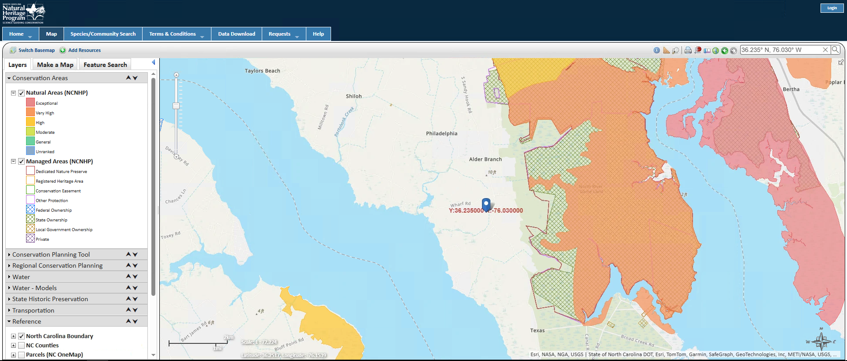
Figure 2-2-4-2: NCNHP Result for the Site B
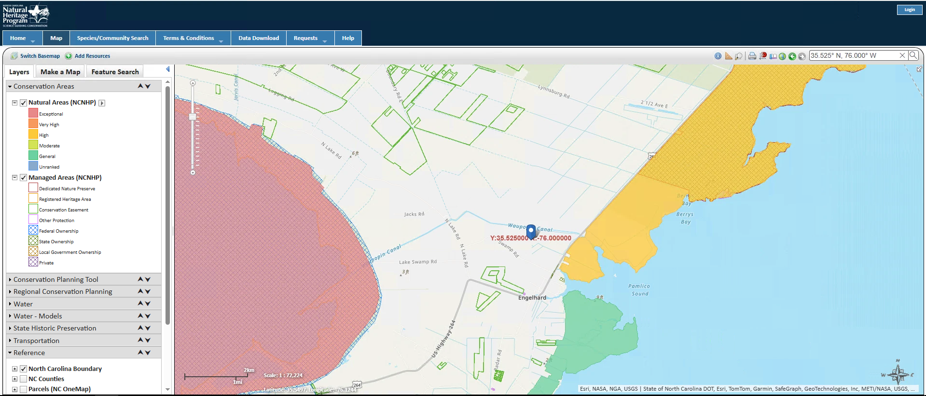
Figure 2-2-4-3: NCNHP Result for the Site C

2.3 Final Site Selection and Justification
Selected site: Site A, Perquimans County (36.130° N, 76.450° W). Ranking: A, B, C. Site A has the lowest wind (6.91 m/s at 100 m), but it is the only site with no fatal flaw: it is open farmland with few wetlands, ~4 mi from a 230 kV substation, outside the Navy radar zone and away from airports. It also lies near two operating NC wind farms (Amazon Wind Farm US East and Timbermill Wind). Site B is limited by water, wetlands and the Navy radar, and Site C by wetlands, wildlife refuges, military airspace and distance to transmission. The main risk at Site A is the county permit, since Perquimans County denied a wind permit in 2016.

3. Wind Resource Assessment
WIND Toolkit data for grid point 36.1333° N, 76.4470° W (POINT(-76.447 36.133)) were used for all eight years, 2007 to 2014, at 80, 100 and 120 m. The data were read directly from the WIND Toolkit HDF5 datasets, the second download method in Lecture 1 (HSDS); the Lecture 1 MATLAB API script returns the same data. The 5-minute values were averaged to hourly values. The hub height is 95 m.

3.1 Wind Resource Summary
All values are at the 95 m hub height.
Parameter | Value | Units
Hub height, H | 95 | m
Mean wind speed | 6.82 | m/s
Weibull shape parameter, k | 2.40 | dimensionless
Weibull scale parameter, a | 7.69 | m/s
Shear exponent, α | 0.262 | dimensionless
Turbulence intensity, TI | 9.4 | %
IEC wind class | IIIA | dimensionless
Table 3-1. Hub-height wind resource

3.2 Weibull Distribution
Figure 3-1 shows the hub-height histogram and the Weibull fit (MATLAB fitdist, maximum likelihood).

$f_{Weibull}(v)=\frac{k}{a}{\left(\frac{v}{a}\right)}^{k−1}exp\left[−{\left(\frac{v}{a}\right)}^{k}\right]$ (1)
$v_{avg}=aΓ\left(1+\frac{1}{k}\right)$ (2)
where f_{Weibull}(v) = probability density of wind speed v (s/m); v = wind speed (m/s); k = shape parameter; a = scale parameter (m/s); v_{avg} = mean wind speed (m/s); Γ = gamma function.
k = 2.40 and a = 7.69 m/s, so from Eq. (2) v_avg = 7.69 × Γ(1 + 1/2.40) = 6.82 m/s.

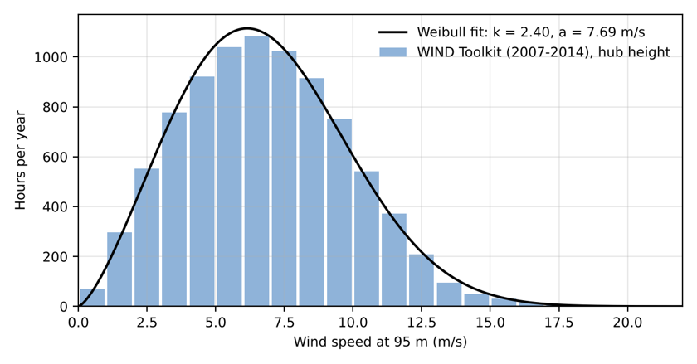
Figure 3-1. Hub-height wind speed distribution and Weibull fit

3.3 Wind Shear
Annual means were v80 = 6.52 m/s and v100 = 6.91 m/s.
$\left(\frac{v}{v_{0}}\right)={\left(\frac{H}{H_{0}}\right)}^{α} → α=\frac{ln\left(\frac{v}{v_{0}}\right)}{ln\left(\frac{H}{H_{0}}\right)}$ (3)
where v = wind speed at height H (m/s); v₀ = wind speed at the reference height (m/s); H = hub height (m); H₀ = reference height (m); α = shear (Hellman) exponent.
α = ln(6.911/6.519) / ln(100/80) = 0.262. Extrapolating to the hub: v95 = 6.91 × (95/100)0.262 = 6.82 m/s.

3.4 Turbulence Intensity
WIND Toolkit data are 5-minute averages, so TI was approximated as the standard deviation of the 5-minute values within each hour divided by the hourly mean, evaluated in the 15 m/s bin. This approximation underestimates IEC turbulence.

$TI=\frac{σ_{v}}{v_{avg,10min}}$ (4)
where TI = turbulence intensity; σ_{v} = standard deviation of wind speed (m/s); v_{avg,10min} = 10-minute mean wind speed (m/s).
The representative TI at 15 m/s is about 9.4%.

3.5 Seasonal and Diurnal Variation
The wind is strongest from November to April (peak in March, 7.9 m/s) and calmest in summer (August, 5.3 m/s). Each day it is strongest at night (about 7.6 m/s) and weakest in late morning (about 5.7 m/s). Times were converted from UTC to local time.
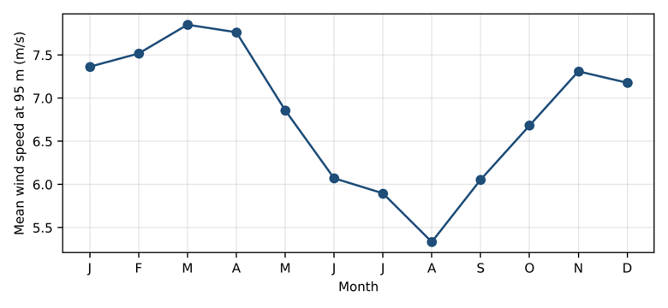
Figure 3-2. Seasonal variation

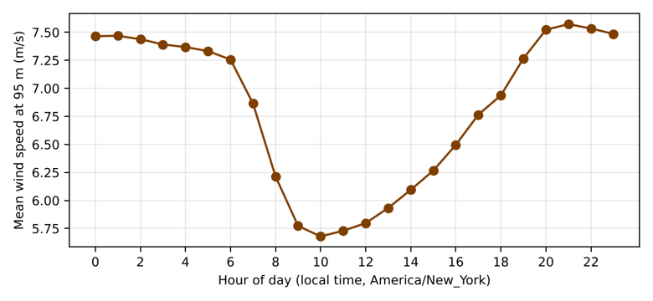
Figure 3-3. Diurnal variation

3.6 IEC Wind Class
The hub-height mean wind speed of 6.82 m/s is below the 7.5 m/s limit, so the site is IEC Class III for average wind. The turbulence estimate (9.4% at 15 m/s) falls in category C, but because the 5-minute WIND Toolkit data underestimate turbulence, the conservative category A is used, giving Class IIIA (Table 3-2).

IEC 61400-1 Class | I | II | III
Average wind speed at hub height (m/s) | 10.0 | 8.5 | 7.5
50-year maximum 10-minute wind speed (m/s) | 50 | 42.5 | 37.5
50-year extreme 3-second gust (m/s) | 70 | 59.5 | 53.5
Turbulence Class A | 16% | 16% | 16%
Turbulence Class B | 14% | 14% | 14%
Turbulence Class C | 12% | 12% | 12%
Table 3-2. IEC 61400-1 wind turbine classes
Because northeastern North Carolina is exposed to hurricanes and nor’easters, the 50-year extreme wind was also checked against the Class III limits. The annual maximum 10-minute mean wind speed at hub height was taken from the 5-minute WIND Toolkit record for each year from 2007 to 2014 (Table 3-3). The highest value, 25.2 m/s, occurred on 28 August 2011 during Hurricane Irene. A Gumbel (extreme value type I) distribution was fitted to the eight annual maxima by the method of moments (mean 22.4 m/s, standard deviation 1.86 m/s):
Year | Annual maximum 10-min wind speed at 95 m (m/s) | Date (UTC)
2007 | 20.9 | 2 Mar 2007
2008 | 19.6 | 25 Sep 2008
2009 | 21.4 | 2 Mar 2009
2010 | 23.0 | 25 Jan 2010
2011 | 25.2 | 28 Aug 2011 (Hurricane Irene)
2012 | 22.0 | 23 Jul 2012
2013 | 22.5 | 31 Jan 2013
2014 | 24.6 | 7 Mar 2014
Table 3-3. Annual maximum 10-minute wind speed at hub height, WIND Toolkit 2007–2014
β = s√6/π = 1.86 × 2.449/3.1416 = 1.45 m/s, u = x̄ − 0.5772β = 22.39 − 0.84 = 21.55 m/s
V_{ref,site} = u − β ln[−ln(1 − 1/50)] = 21.55 + 1.45 × 3.90 = 27.2 m/s (50-year 10-minute mean)
V_{e50} ≈ 1.4 × V_{ref,site} = 38.1 m/s (50-year 3-second gust, IEC 61400-1)
Both values are below the Class III limits of 37.5 m/s (10-minute) and 53.5 m/s (3-second gust) in Table 3-2, so the Vestas V110-2.0 Class IIIA rating covers the site’s extreme wind as well as its mean wind, with a margin of about 10 m/s. Eight years is a short record for a 50-year estimate, and the 2 km WIND Toolkit model tends to smooth out peak hurricane winds, so the extreme wind should be confirmed with the ASCE 7 Hazard Tool or a site-specific assessment during final design.

4. Turbine Selection, Sizing, and Micrositing

4.1 Selected Turbine

The Vestas V110-2.0 MW (IEC IIIA) was selected. Its large rotor for its rating (210 W/m²) suits a low-wind site. It is the Lecture 3/4 example turbine, and its power curve is in the SAM turbine library. At a 95 m hub its tip height is 150 m (492 ft).

Parameter | Value
Manufacturer / model | Vestas V110-2.0 MW
Rated power (MW) | 2.0
Rotor diameter, D (m) | 110
Hub height (m) | 95
Cut-in / cut-out speed (m/s) | 3/20
IEC class | IIIA
Table 4-1. Selected turbine

4.2 Number of Turbines
Using CF from Section 5.1:
$n_{T}=\frac{E_{demand}}{P_{rated}×8760×CF}, P_{inst}=n_{T}×P_{rated}$ (5)
where n_{T} = number of turbines, rounded up; E_{demand} = annual energy demand, 122,640 MWh/yr; P_{rated} = turbine rated power (MW); 8760 = hours per year (h/yr); CF = capacity factor; P_{inst} = installed capacity (MW).

nT = 122,640 / (2.0 × 8,760 × 0.460) = 15.2, rounded up to 16 turbines, so Pinst = 16 × 2.0 = 32 MW.

4.3 Array Layout
The 16 turbines are arranged in 4 rows of 4 (T1-T4, T5-T8, T9-T12 and T13-T16), using the 5D crosswind by 10D downwind spacing from the Lecture 5 example. The rows run east-west, roughly perpendicular to the prevailing south-southwest wind (from about 210°), so the turbines in each row face the wind side by side and each row sits 10D (1,100 m) behind the one upwind of it. The grid covers about 1.65 km east-west by 3.3 km north-south on open farmland (Figure 4-1). The same 4 × 4 layout is used in the SAM model (Section 4.4) and on the site plan (Section 8.1).

$S_{down}=x×D, S_{cross}=y×D$ (6)
where S_{down} = downwind spacing (m); S_{cross} = crosswind spacing (m); D = rotor diameter (m); x = downwind multiplier, 6 to 10 rotor diameters; y = crosswind multiplier, 3 to 5 rotor diameters.
Turbines are spaced at 10D (1,100 m) downwind and 5D (550 m) crosswind relative to the prevailing wind direction. Wake losses are not included in this analysis.
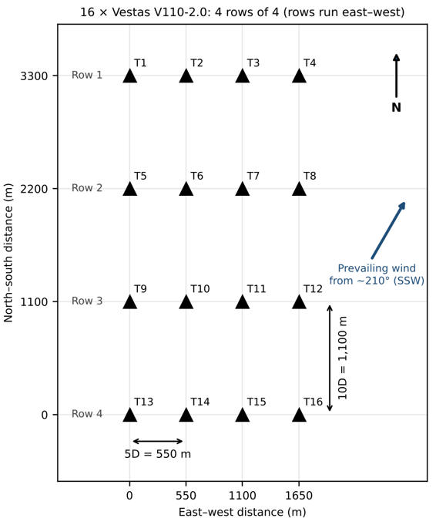
Figure 4-1. Array layout

4.4 SAM Analysis
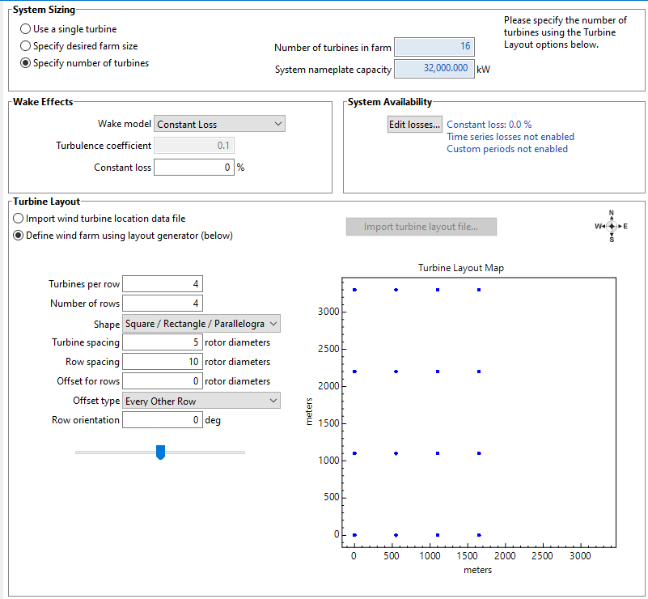
Figure 4-2. SAM wind farm setup: 16 turbines in 4 rows of 4, 5D × 10D spacing, 0% wake and availability losses

The Phase 3 analysis was repeated in the NLR System Advisor Model (SAM) Wind Power model with 2014 WIND Toolkit data for the site, the SAM library Vestas V110-2.0 power curve at a 95 m hub height, and the array layout from Section 4.3: 4 rows of 4 turbines with 5D turbine spacing and 10D row spacing (Figure 4-2). Wake and availability losses were set to 0% to match the hand calculation. SAM predicts 124,810 MWh/yr for the 32 MW farm, or about 7,801 MWh/yr per turbine (capacity factor 44.5%), compared with 8,063 MWh/yr per turbine (46.0%) from the hand calculation. Using SAM's capacity factor, nT = 122,640 / (2.0 × 8,760 × 0.445) = 15.7, which also rounds up to 16 turbines, so SAM confirms the turbine count and the 32 MW installed capacity. The roughly 3% lower SAM estimate comes mainly from using a single year (2014) of wind data instead of the 2007–2014 Weibull fit.

5. Annual Energy Production and System Sizing

5.1 AEP and Capacity Factor

Weibull fit (Section 3.2), then the V110-2.0 power curve, then the bin table below. There are no wake losses.
$h_{i}=8760×f_{Weibull}\left(v_{i}\right)×Δv$ (7)
${AEP}_{turbine}=\sum_{i}{}P\left(v_{i}\right)×h_{i}, {AEP}_{farm}=n_{T}×{AEP}_{turbine}$ (8)
$CF=\frac{P_{avg}}{P_{rated}}=\frac{AEP}{P_{rated}×8760}$ (9)
where h_{i} = hours per year in wind speed bin i (h/yr); v_{i} = wind speed of bin i (m/s); Δv = bin width, 1 m/s; P(v_{i}) = turbine power output from the manufacturer power curve (kW); AEP_{turbine} = annual energy production of one turbine (kWh/yr); AEP_{farm} = annual energy production of the wind farm (MWh/yr); P_{avg} = annual average power output (kW); P_{rated} = turbine rated power (kW); CF = capacity factor.

v_{i}  (m/s) | h_{i}  (h/yr) | P  (v_{i}) (kW) | E_{i} (MWh/yr) | v_{i}  (m/s) | h_{i}  (h/yr) | P  (v_{i}) (kW) | E_{i} (MWh/yr)
1 | 156 | 0 | 0 | 11 | 426 | 1,998 | 850
2 | 398 | 0 | 0 | 12 | 278 | 2,000 | 555
3 | 659 | 28 | 18 | 13 | 168 | 2,000 | 335
4 | 889 | 143 | 127 | 14 | 93 | 2,000 | 187
5 | 1,049 | 315 | 330 | 15 | 48 | 2,000 | 96
6 | 1,114 | 552 | 614 | 16 | 23 | 2,000 | 46
7 | 1,080 | 904 | 976 | 17 | 10 | 2,000 | 20
8 | 963 | 1,349 | 1,299 | 18 | 4 | 2,000 | 8
9 | 793 | 1,774 | 1,407 | 19 | 1 | 2,000 | 3
10 | 604 | 1,970 | 1,190 | 20 | 1 | 0 | 0
 |  |  |  | Total | 8,755 |  | 8,063
Table 5-1. AEP bin table, one turbine

AEPturbine = 8,063 MWh/yr, AEPfarm = 16 × 8,063 = 129,003 MWh/yr, and CF = 8,063 / (2 × 8,760) = 46.0%.

Metric | Hand Calculation | SAM
AEP, one turbine (MWh/yr) | 8,063 | 7,801
AEP, wind farm (MWh/yr) | 129,003 | 124,809
Capacity factor (%) | 46.0 | 44.5
Table 5-2. Energy production

5.2 Comparison to Data Center Demand
Annual comparison:
$Share=\frac{{AEP}_{farm}}{E_{demand}}×100\%$ (10)
where Share = fraction of annual demand supplied by wind (%); AEPfarm = wind farm annual energy production (MWh/yr); Edemand = annual energy demand, 122,640 MWh/yr.
The wind farm produces 129,003 MWh/yr, supplying 105.2% of the data center's 122,640 MWh/yr demand.
Following the seasonal and diurnal patterns in Section 3.5, wind output exceeds the flat 14 MW load from October to May and at night, and falls short in June to September and during the day. For example, the farm produces about 13,900 MWh in March against 10,416 MWh of demand (a surplus of about 3,500 MWh), but only about 6,500 MWh in August (a deficit of about 3,950 MWh). Within the day, output averages about 17.5 MW at night but only 10 to 12 MW in late morning.

5.3 Grid Backup Sizing
The hourly WIND Toolkit speeds were run through the power curve for 16 turbines and compared with the 14 MW load.
$P_{backup}=P_{load}=14 MW$ (11)
Wind output falls to zero below cut-in and above cut-out wind speed, and the data center cannot tolerate interruption. The grid backup is therefore sized to carry the full 14 MW facility load. Wind output is below 14 MW for 4,660 h/yr, requiring 42,069 MWh/yr of grid energy.

5.4 Interconnection Capacity
From Eq. (12):

$P_{IC}=max\left(P_{load}, P_{inst}−P_{load}\right)$ (12)
where PIC = required interconnection capacity (MW); Pload = import required when wind output is zero, 14 MW; Pinst = installed wind capacity (MW).
With 32 MW installed, maximum export is 18 MW. The required interconnection capacity is 18 MW.

5.5 SAM Analysis
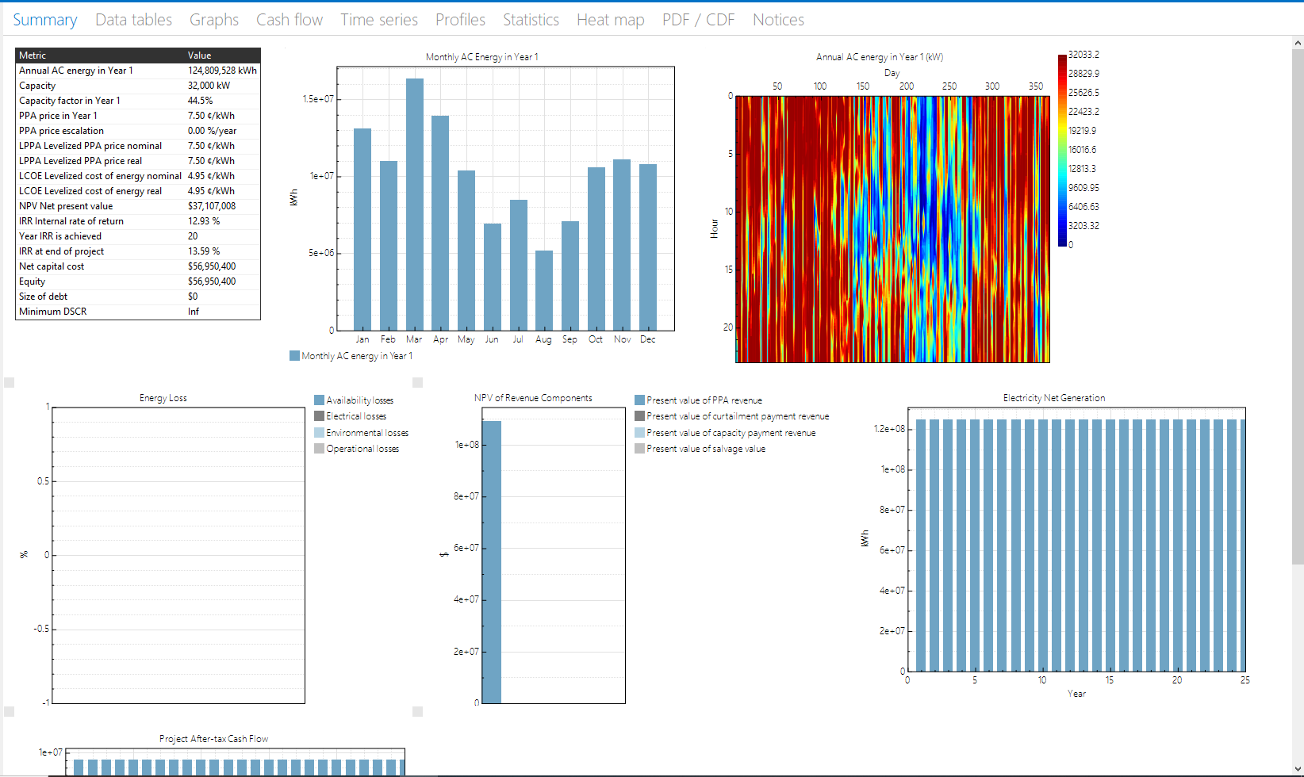
Figure 5-5: SAM Analysis of the Wind Farm for AEP and Capacity factor (Vestas V110-2.0)

The annual energy production (AEP) of the proposed 32-MW wind farm was independently evaluated using the NLR System Advisor Model (SAM) with 2014 WIND Toolkit data and sixteen Vestas V110-2.0 MW turbines operating at a 95-m hub height. The simulation assumed zero specified wake and operational losses and predicted an annual energy production of 124,809.53 MWh with a capacity factor of 44.5%. In comparison, the hand calculation based on the 2007–2014 Weibull wind-speed distribution estimated approximately 129,003 MWh/year and a capacity factor of 46.0%. Thus, the SAM estimate was approximately 3.25% lower, primarily reflecting differences in the wind-resource period and calculation methodology. Although the simulated annual production slightly exceeds the data center's annual demand of 122,640 MWh, grid backup is still required because electricity generation varies with wind conditions.

6. Economic Analysis

6.1 Capital and O&M Cost
NLR ATB 2025, land-based wind, Moderate scenario, 2025, wind Class 8 (2023$): OCC $1,780/kW and fixed O&M $40.3/kW-yr. The grid price is the EIA NC industrial average.

$CAPEX=OCC×P_{inst}$ (13)
where CAPEX = total plant capital cost ($); OCC = overnight capital cost ($/kW); P_{inst} = installed capacity (kW).
Input | Value | Source
CAPEX ($) | 56,950,400 | ATB 2025: $1,779.7/kW × 32 MW
OPEX ($/yr) | 1,289,600 | ATB 2025: $40.3/kW-yr × 32 MW
Grid power price ($/MWh) | 75 | EIA, NC industrial avg. (7.51 ¢/kWh)
Required rate of return, r | 7% | Given
Project life, N (yr) | 25 | Lecture 5 example
Table 6-1. Cost inputs

6.2 Levelized Cost of Energy
With r = 7% and N = 25 yr:

$LCOE=\frac{CAPEX×CRF+OPEX}{AEP}, CRF=\frac{r{\left(1+r\right)}^{N}}{{\left(1+r\right)}^{N}−1}$ (14)
where LCOE = levelized cost of energy ($/MWh); CRF = capital recovery factor (1/yr); OPEX = annual operating cost ($/yr); AEP = wind farm annual energy production (MWh/yr); r = required rate of return, 0.07; N = project life (yr).
CRF = 0.08581, LCOE = (56,950,400 × 0.08581 + 1,289,600) / 129,003 = $47.88/MWh, which is $27.12/MWh below the $75/MWh grid price.

6.3 Net Present Value and Internal Rate of Return
Revenue is the avoided grid purchase.

$Revenue=AEP×P_{e}, {CF}_{t}=Revenue−OPEX$ (15)
$NPV=−CAPEX+\sum_{t=1}^{N}{}\frac{{CF}_{t}}{{\left(1+r\right)}^{t}}$ (16)
$0=−CAPEX+\sum_{t=1}^{N}{}\frac{{CF}_{t}}{{\left(1+IRR\right)}^{t}}$ (17)
where Revenue = annual value of energy produced (avoided grid purchases) ($/yr); P_{e} = grid electricity price ($/MWh); CF_{t} = net cash flow in year t ($/yr); NPV = net present value ($); IRR = internal rate of return (%); r = required rate of return, 0.07; t = year (yr); N = project life (yr).

Revenue = 129,003 × $75 = $9,675,230/yr and CFt = $8,385,630/yr, so NPV = $40.8 M and IRR = 14.2%. Because NPV > 0 and IRR > 7%, the project is viable.

Metric | Hand Calculation | SAM
LCOE ($/MWh) | 47.88 | 49.50
Grid power price ($/MWh) | 75.00 | 75.00
NPV at 7% ($) | 40,772,236 | 37,107,008
IRR (%) | 14.2 | 13.59
Table 6-2. Economic results

6.4 SAM Analysis

Figure 6-4: SAM Analysis of the Wind Farm for LCOE, NPV, IRR, and financial results (Vestas V110-2.0)

The economic performance of the proposed wind farm was evaluated using the NLR System Advisor Model (SAM), assuming a capital cost of $56,950,400, annual operating expenses of $1,289,600, a 25-year project lifetime, a 7% discount rate, and an assumed electricity value of $75/MWh. The simplified SAM comparison excluded income taxes, project debt, annual AC degradation, and specified wake and operational losses. The simulation produced a levelized cost of energy (LCOE) of $49.50/MWh, a net present value (NPV) of approximately $37.11 million, and an end-of-project internal rate of return (IRR) of 13.59%. Compared with the hand-calculated values of $47.88/MWh, $40.77 million, and 14.2%, respectively, SAM predicted slightly less favorable economic performance, partly due to its lower estimated electricity generation and differences in financial modeling. Both analyses indicate favorable preliminary economics under the assumed costs and electricity value; however, actual feasibility remains dependent on site-specific conditions and a verified electricity-pricing arrangement.

7. Permitting Checklist and Timeline
Site A: Perquimans County, coastal plain.
Permit / Approval | Agency | Applies (Y/N) | Est. Duration
FAA Determination of No Hazard (14 CFR Part 77) | FAA | Y | 3-6 Months
Mountain Ridge Protection Act (NCGS 113A, Art. 14) | County | N | N/a - not near a protected ridge
Coastal wind energy facility permit (NCGS 143-215.115 to .121) | NCDEQ | Y | 12-18 Months
County zoning / conditional use permit | County | Y | 4-9 Months
Generator interconnection | Dominion Energy | Y | 2-4 Years
Table 7-1. Permitting checklist
Interconnection is the critical path, so commercial operation is about 3 to 4 years out. Note: Site A is served by Dominion Energy NC (PJM), which follows an interconnection process equivalent to Duke Energy's.

8. Site Plan and Single-Line Diagram

8.1 Site Plan

The 16 turbines, 34.5 kV collection along the access roads, the project substation, and a 5.8 km 230 kV line to the South Hertford 230 kV substation (point of interconnection).

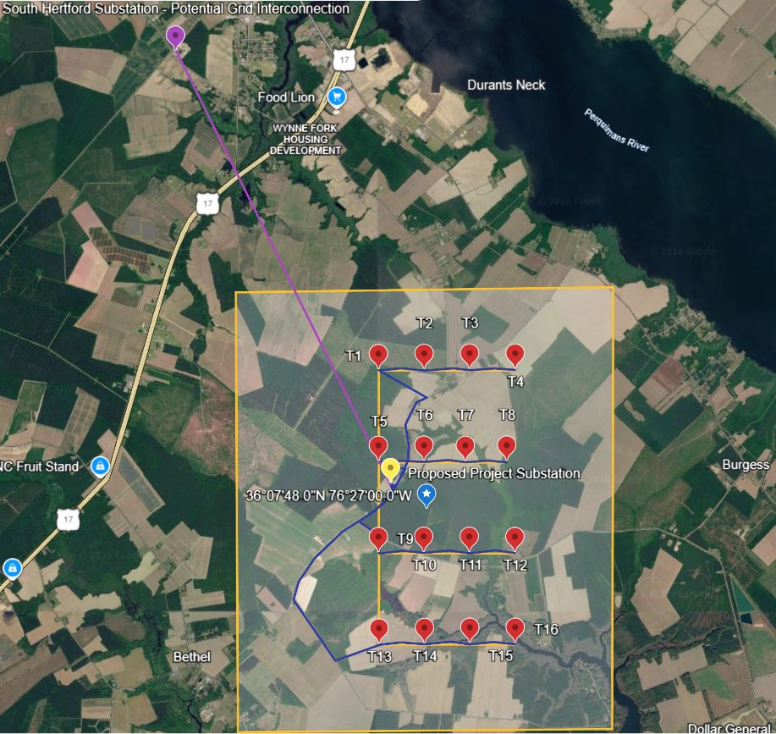
Figure 8-1. Site plan

8.2 Single-Line Electrical Diagram
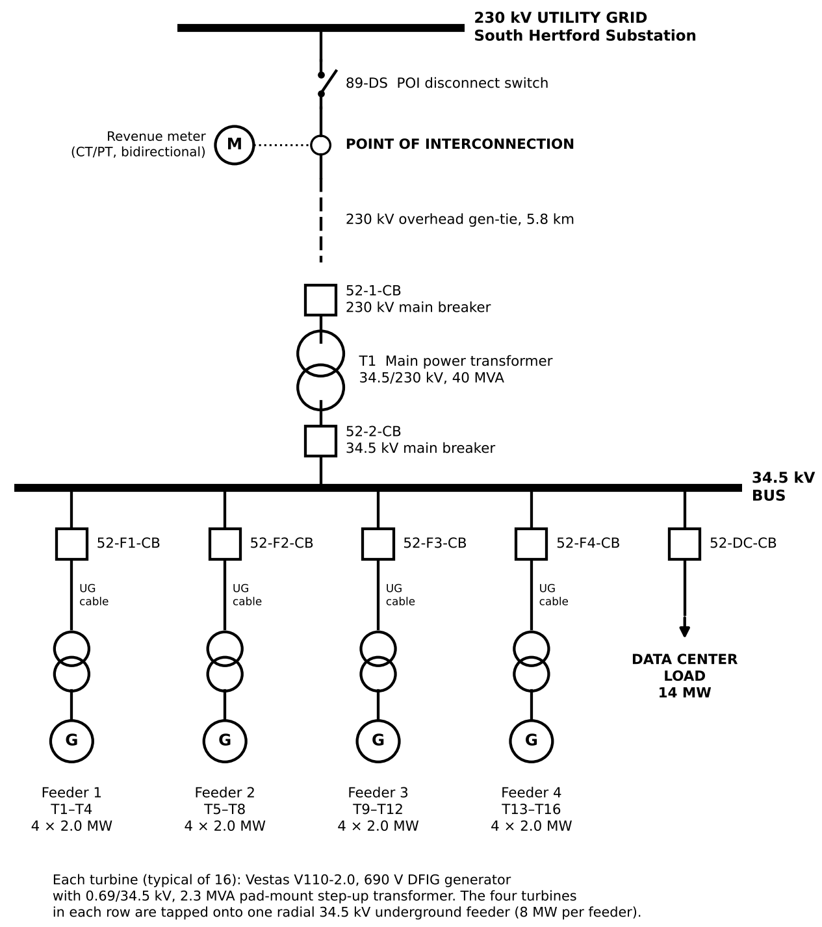
Figure 8-2. Single-line diagram

Figure 8-2 shows the single-line diagram of the wind farm, from the turbines to the utility grid. Each turbine’s generator output is stepped up to 34.5 kV by a pad-mount transformer at its base. The turbines in each row share one underground 34.5 kV feeder, and the four feeders connect through circuit breakers to a common 34.5 kV bus at the project substation, which also supplies the data center. A 34.5/230 kV main power transformer raises the voltage for a 5.8 km, 230 kV gen-tie line to the South Hertford substation, the point of interconnection. There, a disconnect switch and a bidirectional revenue meter connect the project to the utility grid. The meter records the net power exchanged, which is up to 14 MW imported when the wind is calm and up to 18 MW exported at full output.

References
[1] NLR WIND Toolkit (Draxl et al., 2015, Applied Energy 151, 355–366).
[2] NLR System Advisor Model (SAM), https://sam.nlr.gov
[3] NLR Annual Technology Baseline 2025, Land-Based Wind, https://atb.nlr.gov
[4] LBNL, Land-Based Wind Market Report, https://emp.lbl.gov/wind-technologies-market-report
[5] Vestas, V110-2.0 MW datasheet, https://www.vestas.com/content/dam/vestas-com/global/en/brochures/onshore/2MW_Platform_Brochure_.pdf.coredownload.inline.pdf
[6] IEC 61400-1 Ed. 4, Wind turbines: Design requirements.
[7] FAA, 14 CFR Part 77 and OE/AAA Notice Criteria Tool, https://oeaaa.faa.gov
[8] USGS, NLCD (https://www.mrlc.gov) and PAD-US Data Explorer.
[9] USFWS, IPaC, https://ipac.ecosphere.fws.gov
[10] NC Natural Heritage Program Data Explorer, https://ncnhp.org
[11] NCGS Chapter 113A, Article 14 (Mountain Ridge Protection Act); NCGS 143-215.115 to .121 (wind energy facility permits).
[12] Perquimans County wind energy ordinance. https://perquimanscountync.gov/county-information/ordinances?download=366:zoning-ordinance-262012
[13] Duke Energy, NC Generator Interconnection Procedures, https://www.duke-energy.com
[14] EIA, Electric Power Monthly, Table 5.6.A.

