Stage at Diagnosis and Years of Life Lost Across 21 Cancer Types in the United States

Authors: David Jones,¹ Libby Ellis,¹ Christina A. Clarke,² Earl Hubbell,² Graham A. Colditz,³ Allison W. Kurian,⁴ Ellen T. Chang²

Affiliations:

- GRAIL Bio UK, Ltd., London, UK
- GRAIL, LLC., Menlo Park, California, USA
- Washington University School of Medicine. St. Louis, Missouri, USA
- Stanford School of Medicine, Stanford, California, USA

Potential Target Journal: Journal of Clinical Oncology - new interest in cancer epi and format free submission -> then passed on the sister journal

Abstract Word Count:
Main Text Word Count (Excluding Tables, Figures, Abstract, and References):

Figures / Tables: 5 Figures

Supplementary Figures / Tables:

References: 25

Abstract
Background: Years of life lost (YLL) measures the impact of cancer incidence on premature mortality. We evaluate the extent to which YLL differs by cancer type and stage at diagnosis.

Methods:
Incident cancers were obtained from Surveillance, Epidemiology, and End Results (SEER) 17. Included patients were those with a first primary malignancy, restricted to 21 stageable cancer types, diagnosed between 50-79 years of age in 2006–2015 and followed for up to 15.9 years through 2021. We used a Bayesian flexible parametric survival model framework to estimate median life expectancy with 95% credible intervals (CrI) by cancer type, age, sex, and stage. YLL were calculated by comparing estimated patient life expectancy with age- and sex-specific US life tables. Additionally, we estimate proportional YLL, aggregate YLL across the SEER population, and changes in aggregate YLL caused by different stage-shift scenarios.

Results: Across all cancers, YLL for women aged 60-64 at diagnosis increased five-fold between stage I (3.67 years (95% CrI: 3.53, 4.54)) and IV (20.98 years (20.68, 21.20)) disease, and increased three-fold for men (Stage I: 5.95 years (5.46, 6.30); stage IV: 17.37 years (16.88, 17.54)). For nearly half of cancer types the difference in YLL was greatest between stages III and IV. Older age at diagnosis increased the proportional impact of cancer on YLL at early stages. Aggregated across the SEER patients, stage IV cancer was responsible for 46% of YLL. Shifting all stage IV diagnoses equally to stages III, II, and I would reduce overall YLL by 18% – a gain of 6.6 life years per stage IV cancer patient. At younger ages, estimated YLL were sensitive to the assumption of cure.

Conclusion: For many cancers, the largest increase in YLL is between stage III and IV disease.

Background
Earlier stage at cancer diagnosis is a key determinant of higher probability of cure and associated short- and long-term survival across the spectrum of cancer types.¹ National cancer statistics are routinely published from population-based cancer registry data demonstrating differences in survival probability by stage.² However, metrics such as survival and mortality probability are typically reported at a maximum of 10 years after diagnosis, which may not fully capture the full life-long impact of cancer at the population level. Even after 10 years, cancer-related mortality events may still occur even in the metastatic setting with the advent of immuno- and targeted- therapies.³ And in those cured, there may be long-term treatment-related sequelae which may increase mortality.⁴ Moreover, comparisons of short-term survival by stage are susceptible to bias due to the lead time – the time that the diagnosis of cancer is brought forward through screening – added to the survival of certain early-stage cancer types by population screening programs.
Extrapolation of observed cancer outcomes to the full patient lifespan provides the basis for estimating life expectancy (LE) and, subsequently, loss of life expectancy relative to the general population expectation, referred to hereafter as year of life lost (YLL).⁵ Such metrics can provide a more intuitive and understandable measure of the overall population health impact of cancer than survival and mortality, and the long-term nature minimizes the influence of lead-time bias.^{6,7} Additionally LE-based measures are a particularly important input in analyses of the potential benefits of cancer prevention and screening, and readily enable cross-disease comparisons.^{8,9}
Previously, US studies have focused on LE-based measures relating to specific cancers and/or did not differentiate by stage at diagnosis.^{10–14} In this study, we focus on differences in YLL associated with the stage at cancer diagnosis, enabling assessment of the potential long-term benefit of earlier cancer diagnosis for the full range of stageable cancer types. We provide a comprehensive set of estimates by stage and age at diagnosis from 50 to 79 years, for both sexes and 21 cancer types.

Methods

Survival extrapolation method
Few data sources have sufficient follow-up and information on stage at diagnosis for the direct calculation of stage-specific LE and YLL from patient observations. As such, extrapolation of patient survival past the last point of observation is typically required. Flexible methods for survival analysis have come to the forefront which can better account for the incorporation of multiple sources of data and the often resultant complex hazard function.^{5,15–22} For this analysis, we utilize a Bayesian flexible parametric survival model framework.²³
Such a Bayesian framework enables the synthesis of observed survival data with background mortality and provides an estimate of uncertainty based on the posterior distribution.²³ Briefly, the framework directly models the hazard as a piecewise or smooth function of time using an M-spline model.²⁴ For the model, a prespecified number and placement of knots splits time into intervals, with each interval then associated with a cubic polynomial function. The hazard of death at a given time is calculated based on the weighted average of these functions at that time. General population mortality can be incorporated assuming additive hazards/relative survival. Here, the overall hazard at a given time, $h(t)$, is the sum of hazards relating to death, e.g. ${h_{b}(t)+}_{}h_{e}(t)$: the background mortality hazard and excess mortality hazard, at a given time. The corollary overall survival function for a given time, $S(t)$, is then the product of the survival functions relating to death, e.g. ${S_{b}(t).}_{}S_{e}(t)$. A mixture cure model can also be specified within the additive hazards model framework including the placement of priors on the cure fraction probability.

Data sources
We extracted cancer cases from the US Surveillance, Epidemiology, and End Results (SEER) population-based cancer registries for 17 geographic regions using SEER*Stat version 8.4.1. Included patients were those with a first primary malignancy diagnosed between 50 to 79 years of age (with age given in 5 year bands) from the beginning of 2006 to the end of 2015. These years of diagnosis were chosen to ensure use of a unified staging system (American Joint Committee on Cancer, 6th edition), sufficient follow-up time, and recency.
We excluded patients diagnosed by death certificate only or autopsy and those with missing/unknown data on age, vital status, and survival interval. Cases were followed through to the end of 2020 with patient survival interval defined in months based on the length of time from diagnosis until death, or end of follow-up. We included patients categorized into the following types, with their corresponding ICD-O-3 codes listed in the Supplemental Table S1: Anus, Bladder, Breast, Cervix, Colon/Rectum, Gallbladder, Head and Neck, Kidney, Liver/Bile Duct, Lung, Lymphoma, Melanoma, Oesophagus, Ovary, Pancreas, Prostate, Sarcoma, Stomach, Thyroid, Urothelial Tract, and Uterus.
In addition to the SEER individual patient data, we obtained the most recent (2019) sex-specific US life tables.²⁵ The hazard of death at a given attained age was derived as the corresponding mortality rate ($\frac{d_{x}}{L_{x}}$), assuming a constant force of mortality over the year interval. Finally, to inform the extrapolation we incorporated cure fraction estimates by cancer type, stage and age band previously derived from SEER data (Supplemental Table S2).¹

Application and outcomes
Bayesian flexible parametric survival models were estimated for 888 patient diagnosis scenarios. These encompassed the exhaustive combinations of the 21 cancer types (of which breast, cervix, ovary, uterus and prostate were considered sex-specific), four stages of disease (AJCC 6th edition stage I, II, III, IV), male and female sex, and six 5-year age bands of diagnosis from 50-54 years to 75-79 years. For the age bands, the patient age at diagnosis was assumed to be the rounded midpoint (53, 57, 63, 67, 73).
The primary specification of the survival model utilized the SEER patient-level data, general population hazard estimates from the US life tables, a mixture-cure component, and priors of the cure fraction probability for each cancer type by stage and age. The later priors were in the form of a beta distribution with α and β shape parameters estimated from the mean and confidence intervals given in the informing study, using the fitdist function in the SHELF R package.^{1,26} Additionally, the cure fraction estimates included a small constant lifetime excess hazard, which was incorporated into the additive hazard framework. Sensitivity analyses were performed to check the impact of model specification on results. Here, the model was run for lung cancer patients with three alternative specifications; i) the addition of spline knots placed in 5 year intervals after 10 years of follow-up data, ii) the same additional knots placed instead at 10 year intervals, and iii) without the assumption of cure (No cure fraction probability priors and associated small constant lifetime excess hazard.)
To estimate patient life expectancy, we calculated the restricted mean survival time to 100 years of attained age from each estimated model as well as accompanying 95% credible intervals (CrI). Years of life lost (and CrI intervals) was subsequently calculated based on the expected remaining years of life from sex-specific US life tables for 2019 matched to the age at diagnosis.²⁵ The proportional YLL was subsequently calculated by further dividing the YLL by the related age-and sex specific general population life expectancy. With YLL being highly dependent on age, the PYLL provides an alternative relative measure of the impact of cancer with respect to remaining expected life.
The per-patient YLL estimates by age band at diagnosis, sex, cancer type, and stage were merged back to the SEER individual patient data to produce tabulations of the total burden of YLL. As such, this total burden is a result of both incidence and the magnitude of YLL. We additionally considered the impact on total YLL under three hypothetical scenarios involving stage-shift of cancer diagnoses through a multi-cancer early detection intervention, assuming stage-specific decreases in probability of death.²⁷ These three scenarios involved i) all stage IV cancers shifted to stage III, ii) all stage IV cancers shifted equally (33.3%) to stages III, II and I, and iii) all stages IV and III cancers shifted to stage II.
Analysis was performed in the R statistical programming language. The Bayesian flexible parametric survival models were fitted through the survextrap package using the Markov chain Monte Carlo procedure.²³ Computation was performed on an Amazon EC2 m6i.32xlarge instance.
This study was not subject to institutional review board approval or informed consent due to its secondary use of de-identified data. Analysis code is available at https://github.com/grailbio-publications/. Due to privacy concerns related to providing data with small numbers of events in some cells, the repository does not contain the original SEER data. Specifications for the original SEER data draw are provided, as well as synthetic SEER data generated by the synthpop R package.(reference) Figures and tables reported in this paper are from the original data only.

Results

SEER population
The extracted SEER population consisted of 1,776,541 individuals diagnosed with cancer across the 21 cancer types. Tabulation of case characteristics by stage including vital status at the end of observation, sex, age at diagnosis, race/ethnicity, index cancer type, and length of observed follow-up are provided in Table 1.

Table 1: Characteristics of cancer cases for 21 cancer types diagnosed between 50 to 79 years of age from 2006 to 2015, followed for mortality through 2020 in Surveillance, Epidemiology, and End Results (SEER) 17 registries

 |  | All stages | Stage I | Stage II | Stage III | Stage IV
Status | Alive | 949084 (53%) | 375554 (72%) | 403550 (69%) | 116470 (41%) | 53510 (14%)
Status | Dead | 827457 (47%) | 148935 (28%) | 179834 (31%) | 167114 (59%) | 331574 (86%)
Sex | Female | 811950 (46%) | 346513 (66%) | 167712 (29%) | 137376 (48%) | 160349 (42%)
Sex | Male | 964591 (54%) | 177976 (34%) | 415672 (71%) | 146208 (52%) | 224735 (58%)
Age at diagnosis (years) | 50 to 54 | 236706 (13%) | 80797 (15%) | 68621 (12%) | 40163 (14%) | 47125 (12%)
Age at diagnosis (years) | 55 to 59 | 309422 (17%) | 94006 (18%) | 99310 (17%) | 50821 (18%) | 65285 (17%)
Age at diagnosis (years) | 60 to 64 | 354549 (20%) | 101800 (19%) | 120775 (21%) | 56391 (20%) | 75583 (20%)
Age at diagnosis (years) | 65 to 69 | 358329 (20%) | 100984 (19%) | 126784 (22%) | 55538 (20%) | 75023 (19%)
Age at diagnosis (years) | 70 to 74 | 289289 (16%) | 81501 (16%) | 97489 (17%) | 44815 (16%) | 65484 (17%)
Age at diagnosis (years) | 75 to 79 | 228246 (13%) | 65401 (12%) | 70405 (12%) | 35856 (13%) | 56584 (15%)
Race/ethnicity | Hispanic (All Races) | 177114 (10%) | 48379 (9%) | 59193 (10%) | 29885 (11%) | 39657 (10%)
Race/ethnicity | Non-Hispanic American Indian/Alaska Native | 10361 (1%) | 2985 (1%) | 2903 (0%) | 1838 (1%) | 2635 (1%)
Race/ethnicity | Non-Hispanic Asian or Pacific Islander | 121315 (7%) | 36187 (7%) | 35858 (6%) | 21832 (8%) | 27438 (7%)
Race/ethnicity | Non-Hispanic Black | 192749 (11%) | 40361 (8%) | 74997 (13%) | 30930 (11%) | 46461 (12%)
Race/ethnicity | Non-Hispanic Unknown Race | 11493 (1%) | 4751 (1%) | 5467 (1%) | 681 (0%) | 594 (0%)
Race/ethnicity | Non-Hispanic White | 1263509 (71%) | 391826 (75%) | 404966 (69%) | 198418 (70%) | 268299 (70%)
Index cancer type | Anus | 7134 (0%) | 1602 (0%) | 2506 (0%) | 2314 (1%) | 712 (0%)
Index cancer type | Bladder | 36263 (2%) | 18060 (3%) | 8401 (1%) | 3385 (1%) | 6417 (2%)
Index cancer type | Breast | 299779 (17%) | 151419 (29%) | 99445 (17%) | 31957 (11%) | 16958 (4%)
Index cancer type | Cervix | 11656 (1%) | 4225 (1%) | 1982 (0%) | 2925 (1%) | 2524 (1%)
Index cancer type | Colon/Rectum | 170904 (10%) | 43346 (8%) | 42638 (7%) | 46728 (16%) | 38192 (10%)
Index cancer type | Esophagus | 19455 (1%) | 3067 (1%) | 3923 (1%) | 4544 (2%) | 7921 (2%)
Index cancer type | Gallbladder | 12608 (1%) | 2925 (1%) | 3684 (1%) | 1221 (0%) | 4778 (1%)
Index cancer type | Head and Neck | 65954 (4%) | 14842 (3%) | 8360 (1%) | 10794 (4%) | 31958 (8%)
Index cancer type | Kidney | 66819 (4%) | 39533 (8%) | 5941 (1%) | 9702 (3%) | 11643 (3%)
Index cancer type | Liver/Bile-duct | 41511 (2%) | 15021 (3%) | 8049 (1%) | 9939 (4%) | 8502 (2%)
Index cancer type | Lung | 252822 (14%) | 49087 (9%) | 11437 (2%) | 63460 (22%) | 128838 (33%)
Index cancer type | Lymphoma | 81053 (5%) | 23106 (4%) | 12945 (2%) | 14936 (5%) | 30066 (8%)
Index cancer type | Melanoma | 82218 (5%) | 61834 (12%) | 10719 (2%) | 6145 (2%) | 3520 (1%)
Index cancer type | Ovary | 29258 (2%) | 6023 (1%) | 2645 (0%) | 11746 (4%) | 8844 (2%)
Index cancer type | Pancreas | 51765 (3%) | 3504 (1%) | 13891 (2%) | 4935 (2%) | 29435 (8%)
Index cancer type | Prostate | 392225 (22%) | 1222 (0%) | 330421 (57%) | 33087 (12%) | 27495 (7%)
Index cancer type | Sarcoma | 9720 (1%) | 3535 (1%) | 1716 (0%) | 2276 (1%) | 2193 (1%)
Index cancer type | Stomach | 26539 (1%) | 7077 (1%) | 3653 (1%) | 3250 (1%) | 12559 (3%)
Index cancer type | Thyroid | 41619 (2%) | 22447 (4%) | 5171 (1%) | 8572 (3%) | 5429 (1%)
Index cancer type | Urothelial Tract | 5837 (0%) | 1667 (0%) | 723 (0%) | 1548 (1%) | 1899 (0%)
Index cancer type | Uterus | 71402 (4%) | 50947 (10%) | 5134 (1%) | 10120 (4%) | 5201 (1%)
Observed follow-up duration (months) | 0-12 | 332350 (19%) | 29316 (6%) | 31756 (5%) | 60745 (21%) | 210533 (55%)
Observed follow-up duration (months) | 13-24 | 131506 (7%) | 19759 (4%) | 24239 (4%) | 32870 (12%) | 54638 (14%)
Observed follow-up duration (months) | 25-36 | 82220 (5%) | 17540 (3%) | 19634 (3%) | 19930 (7%) | 25116 (7%)
Observed follow-up duration (months) | 37-48 | 62698 (4%) | 16002 (3%) | 17764 (3%) | 14262 (5%) | 14670 (4%)
Observed follow-up duration (months) | 49-60 | 55116 (3%) | 15901 (3%) | 17625 (3%) | 11429 (4%) | 10161 (3%)
Observed follow-up duration (months) | 61-72 | 160463 (9%) | 62183 (12%) | 58407 (10%) | 24654 (9%) | 15219 (4%)
Observed follow-up duration (months) | 73-84 | 143283 (8%) | 57013 (11%) | 53940 (9%) | 20520 (7%) | 11810 (3%)
Observed follow-up duration (months) | 85-96 | 131798 (7%) | 51822 (10%) | 52689 (9%) | 17892 (6%) | 9395 (2%)
Observed follow-up duration (months) | 97-108 | 122111 (7%) | 47713 (9%) | 50788 (9%) | 15918 (6%) | 7692 (2%)
Observed follow-up duration (months) | 109-120 | 116090 (7%) | 43290 (8%) | 51923 (9%) | 14497 (5%) | 6380 (2%)
Observed follow-up duration (months) | 121-132 | 106920 (6%) | 40153 (8%) | 48235 (8%) | 12996 (5%) | 5536 (1%)
Observed follow-up duration (months) | 133-144 | 98526 (6%) | 36960 (7%) | 45213 (8%) | 11896 (4%) | 4457 (1%)
Observed follow-up duration (months) | 145-156 | 87949 (5%) | 33064 (6%) | 41011 (7%) | 10055 (4%) | 3819 (1%)
Observed follow-up duration (months) | 157-168 | 79033 (4%) | 29040 (6%) | 38041 (7%) | 8715 (3%) | 3237 (1%)
Observed follow-up duration (months) | 169-180 | 66478 (4%) | 24733 (5%) | 32119 (6%) | 7205 (3%) | 2421 (1%)

Absolute and proportional years of life lost
Estimates of YLL by stage and cancer type for the 50-54, 60-64 and 70-74 age bands at diagnosis are provided in Figures 2 and 3 for females and males, respectively. Tables for all 6 age bands are given in Supplementary tables S3 and S4. In general, YLL increased with later stage and decreased at older age bands. For a female patient aged between 60-64 at diagnosis, estimated YLL across all cancers combined decreased from 20.98 (20.68 to 21.20) years with a stage IV diagnosis to 3.67 (3.53 to 4.54) years when diagnosed at stage I. Whilst for men, the respective YLL were 17.37 (16.88 to 17.54) years and 5.95 (5.46 to 6.30) years.
For men, YLL was lower at stage II than stage I across all cancers combined. This exception to the trend of increasing YLL by increasing stage was driven by prostate cancer. A stage II diagnosis is the standard classification for prostate cancer detected by prostate-specific antigen. Excluding prostate from all cancers combined among men, the respective YLL were 17.37 (16.88 to 17.54) years and 5.95 (5.46 to 6.3) years for stages IV and I, with monotonically increasing YLL by higher stage.
Cancers with high overall mortality rates such as esophagus, gallbladder, liver/intrahepatic bile duct, lung, pancreas, stomach, and urothelial tract cancer exhibited substantial reductions in YLL between stages IV and I, in line with previous findings on cure probability and cancer cause of death.^{1,28} For nearly half of the cancer types, the difference in YLL was greatest between stages IV and III (Figure 3; Figure 4). This pattern was particularly pronounced for anus, colon/rectum, breast, kidney, melanoma, prostate, thyroid and uterus.
The PYLL results show a trend towards an increasing proportional loss at increasing ages at diagnosis for stages I, II, and III for females (Figure 5) and for stages I and II males (Supplemental Figure S1). Cancer diagnosis at stage IV (and III for males) generally imparted a similar PYLL within cancer type, irrespective of age.

  - Aggregate years of life lost
In total, the 1,776,541 cases in the SEER population led to an estimated 14,450,308 years of life lost as a consequence of cancer, assuming that these patients would otherwise live to their general population life expectancy. Figure 5 apportions this total by cancer type and stage. Stage IV cancer contributed 46% of the aggregate YLL, while stages III, II, and I were responsible for 22%, 15% and 17%, respectively.

Three idealized scenarios were investigated in which; i) all stage IV cancers were shifted to stage III, ii) all stage IV cancers were shifted equally (33.3%) to stages III, II, and I, and iii) all stage IV and III cancers were shifted to stage II. Under scenario i), aggregate YLL would decrease from 14,450,308 years to 12,867,299 years (11% decrease), an aggregate gain of 1,583,009 life-years for 333,571 stage IV cancer patients (4.11 life-years per patient). Under scenario ii), aggregate YLL would decrease to 11,912,524 (18% decrease), resulting in an aggregate gain of 2,537,784 years (6.59 life-years per patient). Lastly under scenario iii), aggregate YLL would decrease to 11,173,795 (23% decrease), resulting in an aggregate gain of 3,276,513 years for 668,668 stages III and IV cancer patients (4.90 life-years per patient).

Sensitivity analysis
In addition to the primary specification, we estimated YLL for 48 lung cancer age, sex, and stage at diagnosis combination using three alternative specifications of the Bayesian flexible parametric survival model involving: i) & ii) alternative placement of internal knots in the M-spline function, and iii) a non-cure model. Table 2 gives the estimated median YLL and 95% CrIs from the primary and alternative specifications for females.
Alternative knot placements had little effect on the median estimate and CrIs. However, the non-cure specification estimates became increasingly divergent from that of the primary specification as the age of diagnosis decreased. For example, at an age of diagnosis of 75, women lung cancer patients were estimated to have a median YLL of xx (95% CI) under the primary specification and xx () under the non-cure model. Whereas he median YLL was xx () and xx () respectively at an age of diagnosis of 50.

Table 2: estimated median YLL and 95% CrIs from the primary and alternative specifications for females.

Discussion

Our analysis utilizes US population life tables both for extrapolation and the estimation of life years lost. For particular cancers that have strong associations with behaviors and conditions such as smoking and obesity, such general population comparisons may overestimate life expectancy had no cancer been present.
Discussion ideas (to be developed; Ellen can assist later)
- Emphasize why it’s important to estimate LOLE by stage at diagnosis, which most prior studies of cancer-related LOLE have not done
  - Stage (along with age) is one of the strongest influences on LOLE
  - It’s something that we can potentially intervene on
- Compare with results of Maas et al. 2023, which I think is the most comprehensive analysis of cancer LOLE published to date
- Any discrepancies with Hubbell et al. 2023 by cancer type? If so, why? If not, can limit this to a sentence
- Bayesian model vs. other approaches – assume that this is unlikely to matter (would not change overall conclusion that earlier stage of dx → less LOLE across all stageable cancer types)
- Strengths and limitations from Hubbell et al. 2023, Chang et al. 2024
  - Note that LOLE does not account for non-mortality impacts of cancer, such as morbidity, quality of life, and patient-reported outcomes

References
https://stacks.cdc.gov/view/cdc/113096
1. Hubbell E, Clarke CA, Smedby KE, Adami HO, Chang ET. Potential for Cure by Stage across the Cancer Spectrum in the United States. Cancer Epidemiol Biomarkers Prev. Published online December 13, 2023:OF1-OF9. doi:10.1158/1055-9965.EPI-23-1018
2. Siegel RL, Giaquinto AN, Jemal A. Cancer statistics, 2024. CA Cancer J Clin. 2024;74(1):12-49. doi:10.3322/caac.21820
3. Luyendijk M, Visser O, Blommestein HM, et al. Changes in survival in de novo metastatic cancer in an era of new medicines. JNCI J Natl Cancer Inst. 2023;115(6):628-635. doi:10.1093/jnci/djad020
4. de Vries S, Schaapveld M, Janus CPM, et al. Long-Term Cause-Specific Mortality in Hodgkin Lymphoma Patients. JNCI J Natl Cancer Inst. 2021;113(6):760-769. doi:10.1093/jnci/djaa194
5. Chudasama YV, Khunti K, Gillies CL, et al. Estimates of years of life lost depended on the method used: tutorial and comparative investigation. J Clin Epidemiol. 2022;150:42-50. doi:10.1016/j.jclinepi.2022.06.012
6. Rutherford MJ, Andersson TML, Björkholm M, Lambert PC. Loss in life expectancy and gain in life years as measures of cancer impact. Cancer Epidemiol. 2019;60:168-173. doi:10.1016/j.canep.2019.04.005
7. Yang SC, Wang JD, Wang SY. Considering lead-time bias in evaluating the effectiveness of lung cancer screening with real-world data. Sci Rep. 2021;11(1):12180. doi:10.1038/s41598-021-91852-6
8. Latimer NR, Adler AI. Extrapolation beyond the end of trials to estimate long term survival and cost effectiveness. BMJ Med. 2022;1(1). doi:10.1136/bmjmed-2021-000094
9. Maas CCHM, Klaveren D van, Visser O, et al. Number of life-years lost at the time of diagnosis and several years post-diagnosis in patients with solid malignancies: a population-based study in the Netherlands, 1989–2019. eClinicalMedicine. 2023;60. doi:10.1016/j.eclinm.2023.101994
10. Devasia TP, Howlader N, Dewar RA, Stevens JL, Mittu K, Mariotto AB. Increase in the Life Expectancy of Patients with Cancer in the United States. Cancer Epidemiol Biomarkers Prev. 2024;33(2):196-205. doi:10.1158/1055-9965.EPI-23-1006
11. Lee AK, Jing B, Jeon SY, Boscardin WJ, Lee SJ. Predicting Life Expectancy to Target Cancer Screening Using Electronic Health Record Clinical Data. J Gen Intern Med. 2022;37(3):499-506. doi:10.1007/s11606-021-07018-7
12. Chase EC, Bryant AK, Sun Y, et al. Development and validation of a life expectancy calculator for US patients with prostate cancer. BJU Int. 2022;130(4):496-506. doi:10.1111/bju.15740
13. Song M, Hildesheim A, Shiels MS. Premature Years of Life Lost Due to Cancer in the United States in 2017. Cancer Epidemiol Biomarkers Prev. 2020;29(12):2591-2598. doi:10.1158/1055-9965.EPI-20-0782
14. Sohlberg EM, Thomas IC, Yang J, et al. Life expectancy estimates for patients diagnosed with prostate cancer in the Veterans Health Administration. Urol Oncol Semin Orig Investig. 2020;38(9):734.e1-734.e10. doi:10.1016/j.urolonc.2020.05.015
15. van Oostrum I, Ouwens M, Remiro-Azócar A, et al. Comparison of Parametric Survival Extrapolation Approaches Incorporating General Population Mortality for Adequate Health Technology Assessment of New Oncology Drugs. Value Health. 2021;24(9):1294-1301. doi:10.1016/j.jval.2021.03.008
16. Mozumder SI, Rutherford MJ, Lambert PC. Estimating restricted mean survival time and expected life-years lost in the presence of competing risks within flexible parametric survival models. BMC Med Res Methodol. 2021;21(1):52. doi:10.1186/s12874-021-01213-0
17. Andersson TML, Dickman PW, Eloranta S, Lambe M, Lambert PC. Estimating the loss in expectation of life due to cancer using flexible parametric survival models. Stat Med. 2013;32(30):5286-5300. doi:10.1002/sim.5943
18. Jakobsen LH, Andersson TML, Biccler JL, El-Galaly TC, Bøgsted M. Estimating the loss of lifetime function using flexible parametric relative survival models. BMC Med Res Methodol. 2019;19:23. doi:10.1186/s12874-019-0661-8
19. Lee S, Lambert PC, Sweeting MJ, Latimer NR, Rutherford MJ. Evaluation of Flexible Parametric Relative Survival Approaches for Enforcing Long-Term Constraints When Extrapolating All-Cause Survival. Value Health. Published online October 17, 2023. doi:10.1016/j.jval.2023.10.003
20. Jackson C, Stevens J, Ren S, et al. Extrapolating Survival from Randomized Trials Using External Data: A Review of Methods. Med Decis Making. 2017;37(4):377-390. doi:10.1177/0272989X16639900
21. Andersson TML, Rutherford MJ, Lambert PC. Illustration of different modelling assumptions for estimation of loss in expectation of life due to cancer. BMC Med Res Methodol. 2019;19(1):145. doi:10.1186/s12874-019-0785-x
22. Rutherford MJ, Lambert PC, Sweeting MJ, et al. NICE DSU TECHNICAL SUPPORT DOCUMENT 21: Flexible Methods for Survival Analysis.; 2020. Accessed November 28, 2023. https://www.sheffield.ac.uk/nice-dsu/tsds/flexible-methods-survival-analysis
23. Jackson CH. survextrap: a package for flexible and transparent survival extrapolation. BMC Med Res Methodol. 2023;23(1):282. doi:10.1186/s12874-023-02094-1
24. Brilleman SL, Elci EM, Novik JB, Wolfe R. Bayesian Survival Analysis Using the rstanarm R Package. Published online February 22, 2020. Accessed November 28, 2023. http://arxiv.org/abs/2002.09633
25. Arias E, Xu J. United States life tables, 2019. National Center for Health Statistics (U.S.), ed. 2022;70(19). https://stacks.cdc.gov/view/cdc/113096
26. Oakley J. SHELF: Tools to Support the Sheffield Elicitation Framework. Published online June 7, 2023. Accessed February 28, 2024. https://cran.r-project.org/web/packages/SHELF/index.html
27. Clarke CA, Hubbell E, Kurian AW, Colditz GA, Hartman AR, Gomez SL. Projected Reductions in Absolute Cancer–Related Deaths from Diagnosing Cancers Before Metastasis, 2006–2015. Cancer Epidemiol Biomarkers Prev. 2020;29(5):895-902. doi:10.1158/1055-9965.EPI-19-1366
28. Chang ET, Clarke CA, Colditz GA, Kurian AW, Hubbell E. Avoiding lead-time bias by estimating stage-specific proportions of cancer and non-cancer deaths. Cancer Causes Control. Published online January 18, 2024. doi:10.1007/s10552-023-01842-4

Figures
Figure 1: Female median year of life lost and 95% credible interval by cancer type, stage and age band at diagnosis

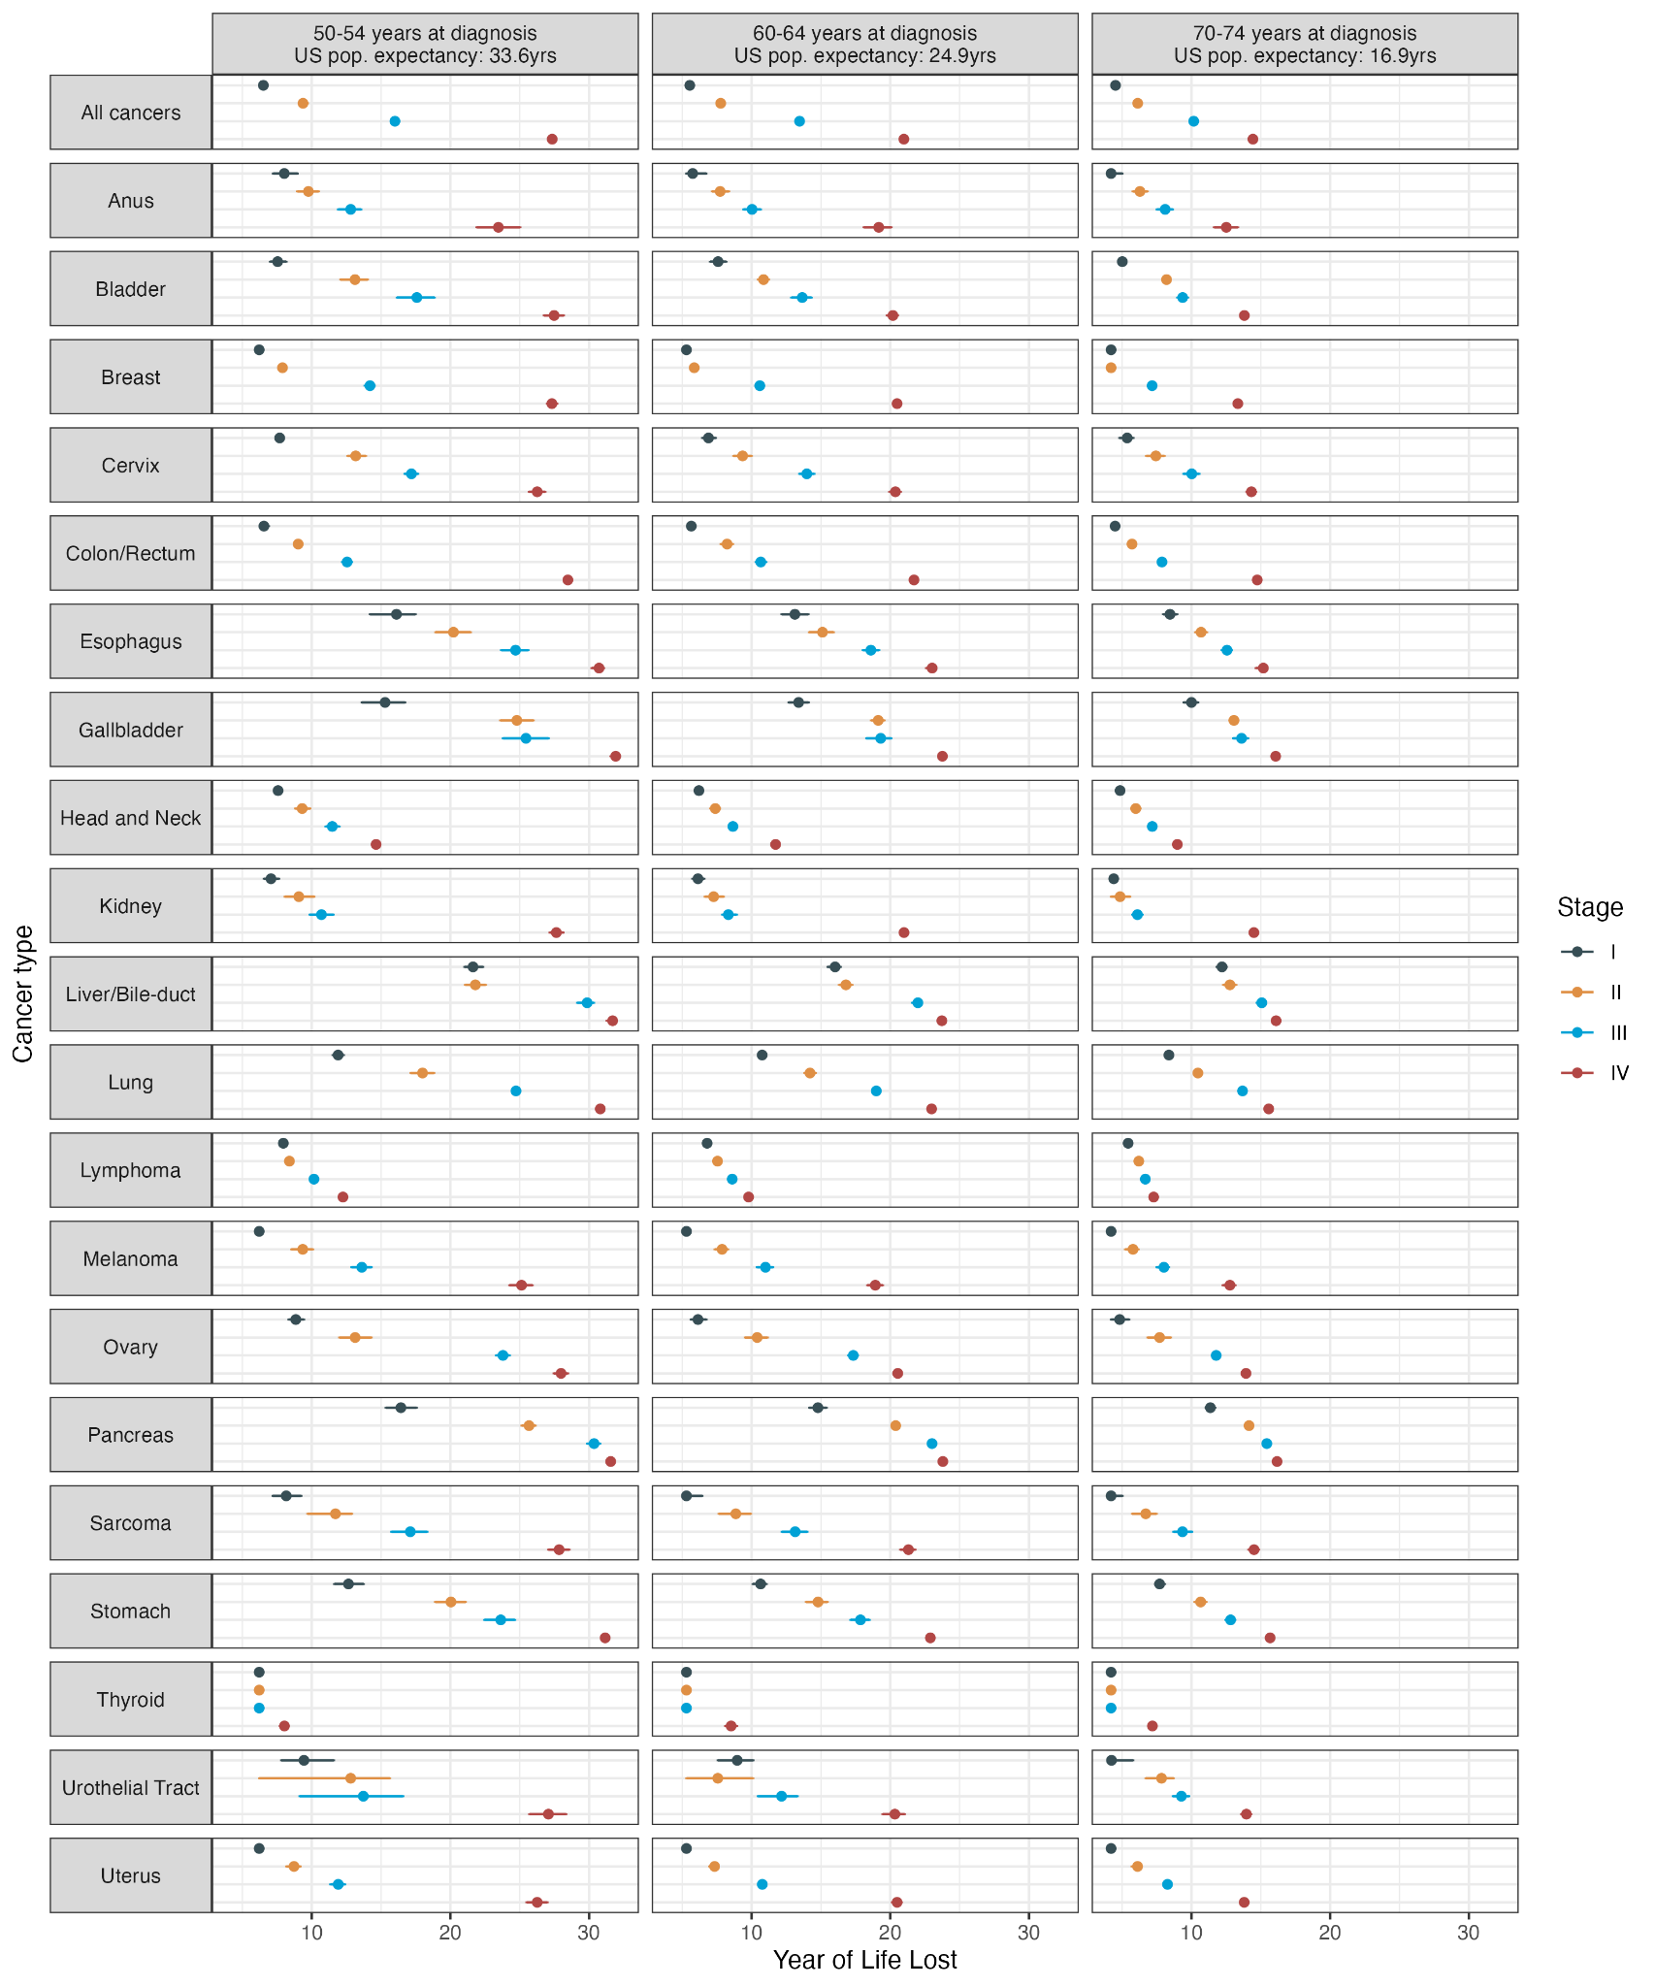

Figure 2: Male median years of life lost and 95% credible interval by cancer type, stage and age band at diagnosis

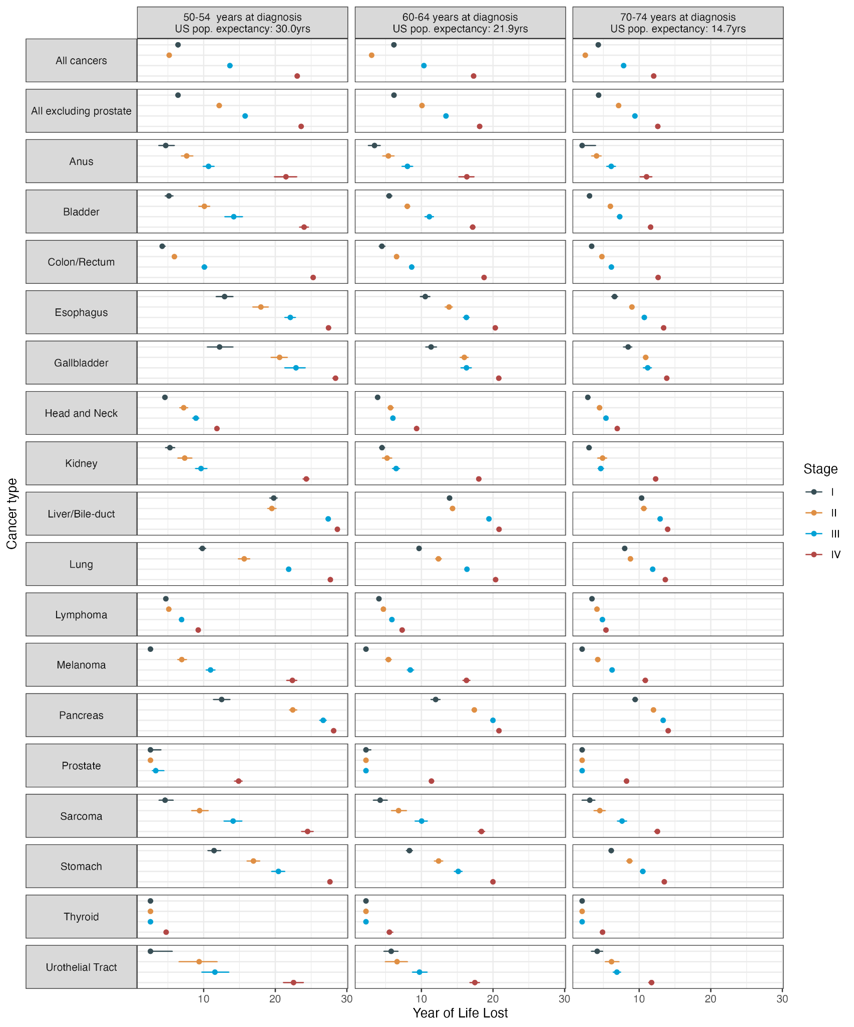

Figure 3: Difference in median years of life lost between stages by cancer type for a patient aged 60 at diagnosis

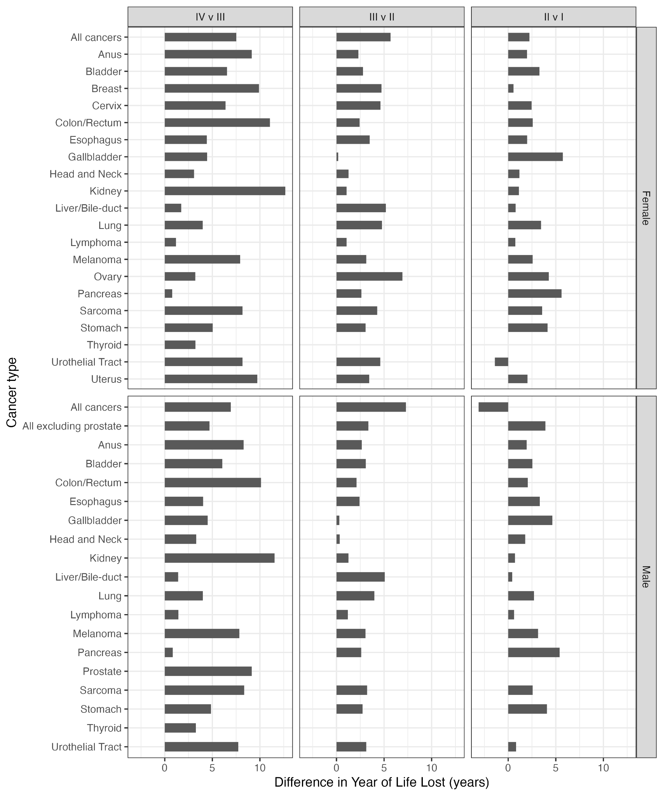

Figure 4: Female proportional years of life lost by cancer type, stage and age band at diagnosis

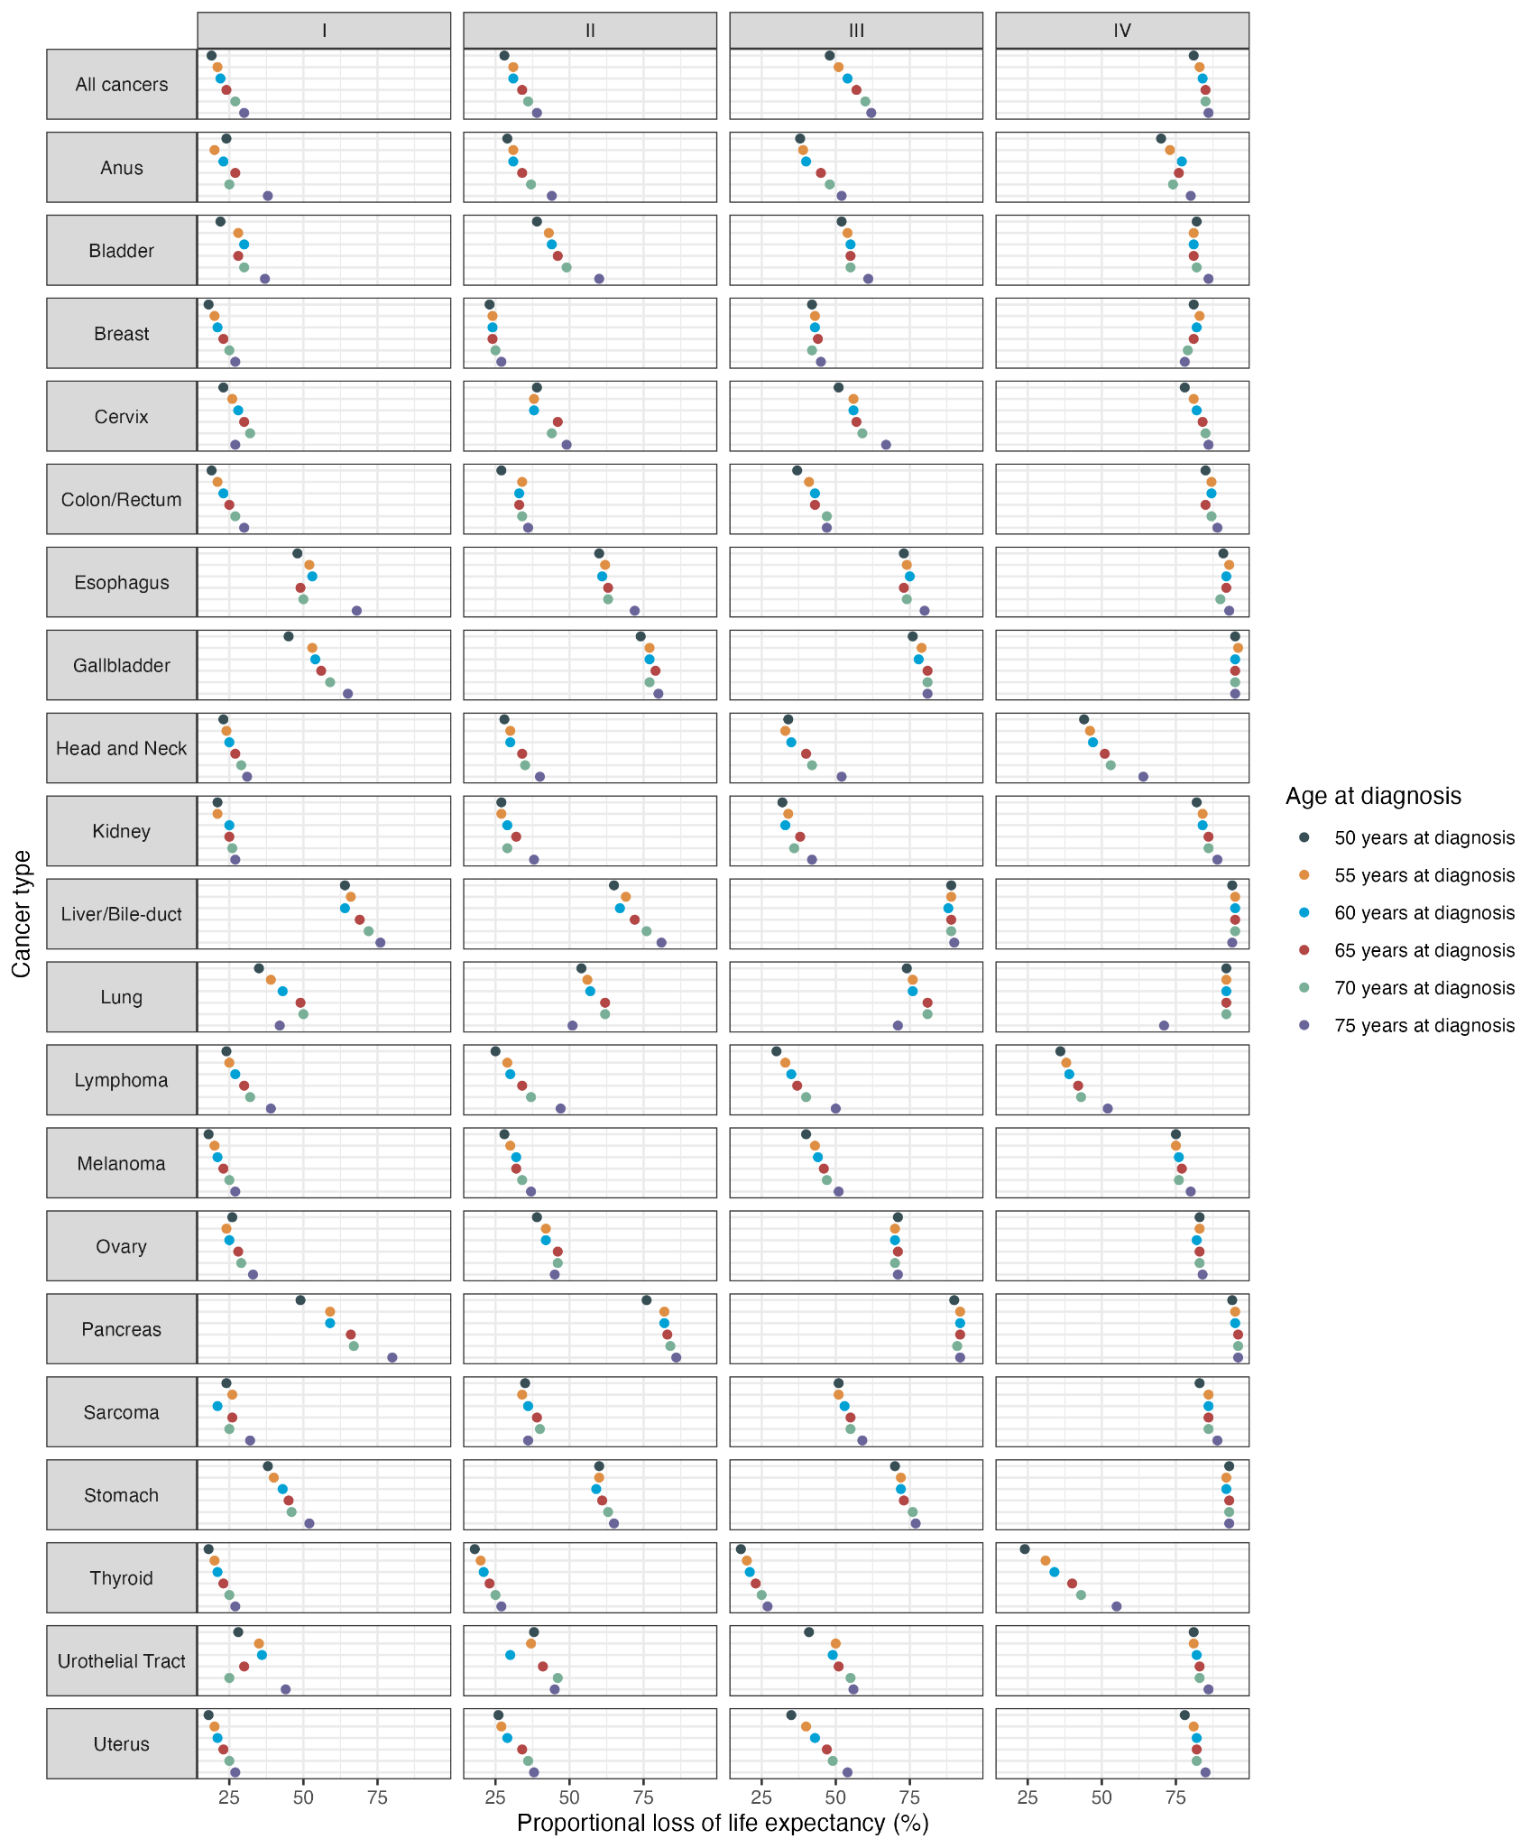
Figure 5: Distribution by index cancer type and stage of the total estimated loss of life expectancy for the 1,776,541 cases
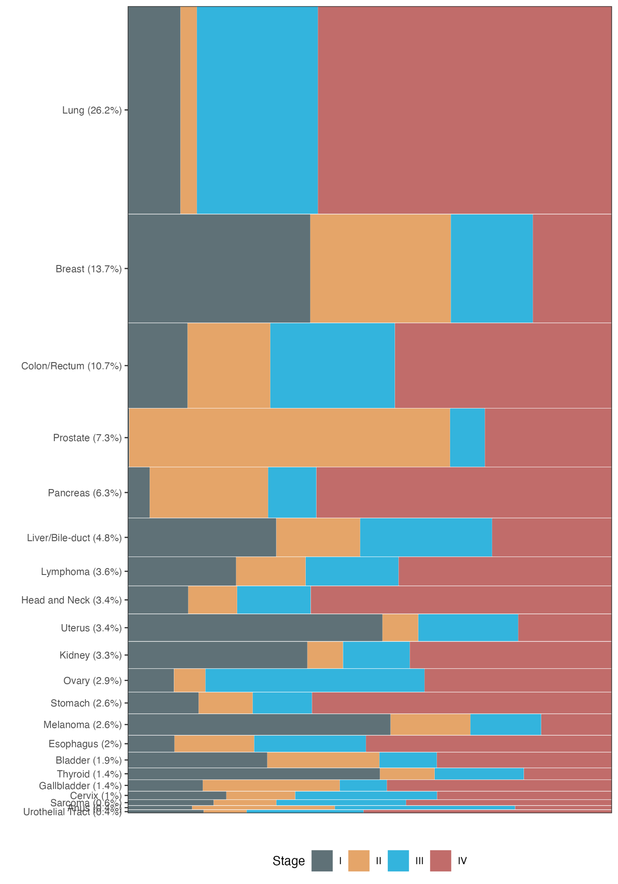

Supplemental Material
Table S1: ICD-O-3 codes listed

Table S2: Cure by age and stage

Table S3: Estimated years of life lost for female patients by cancer type, stage, and age at diagnosis.

 |  | Stage
Cancer site | Age at diagnosis | I | II | III | IV
All | 50 | 4.39 (4.3 to 5.77) | 7.99 (7.5 to 10) | 16.4 (15.62 to 17.71) | 27.82 (27.16 to 28.22)
All | 60 | 3.67 (3.53 to 4.54) | 7.07 (6.49 to 7.8) | 13.28 (12.88 to 13.77) | 20.98 (20.68 to 21.2)
All | 70 | 3.23 (3.1 to 3.41) | 5.66 (5.36 to 5.92) | 10.08 (9.32 to 10.29) | 14.37 (13.49 to 14.48)
Anus | 50 | 7.99 (6.35 to 11.18) | 11.1 (7.88 to 13.89) | 12.93 (10.94 to 15.63) | 25.12 (22.1 to 28.02)
Anus | 60 | 4.18 (3.07 to 6.5) | 7.83 (6.42 to 9.46) | 9.24 (7.87 to 10.39) | 20.77 (19.29 to 22.01)
Anus | 70 | 2.68 (2.19 to 5.4) | 6.61 (5.5 to 7.83) | 8.46 (7.15 to 9.43) | 13.12 (11.5 to 14.06)
Bladder | 50 | 6.53 (4.61 to 9.38) | 18.78 (15.52 to 21.63) | 21.17 (17.09 to 24.66) | 29.2 (27.92 to 30.39)
Bladder | 60 | 8.52 (7.09 to 9.99) | 11.68 (10.16 to 13) | 16.17 (14.06 to 17.79) | 20.68 (19.79 to 21.54)
Bladder | 70 | 6.26 (5.39 to 6.73) | 10.75 (9.93 to 11.54) | 11.15 (10.08 to 12.24) | 14.68 (14.11 to 15.11)
Breast | 50 | 3.67 (3.67 to 3.67) | 6.61 (6.61 to 6.61) | 15.41 (15.41 to 15.41) | 28.01 (28.01 to 28.01)
Breast | 60 | 3.07 (3.07 to 3.07) | 5.04 (5.04 to 5.04) | 10.17 (10.17 to 10.17) | 20.56 (20.56 to 20.56)
Breast | 70 | 2.19 (2.19 to 2.19) | 3.6 (3.6 to 3.6) | 7.2 (7.2 to 7.2) | 13.09 (11.55 to 13.55)
Cervix | 50 | 7.81 (7.81 to 7.81) | 17.07 (17.07 to 17.07) | 20.46 (20.46 to 20.46) | 29.18 (29.18 to 29.18)
Cervix | 60 | 6.46 (6.46 to 6.46) | 12.19 (12.19 to 12.19) | 15.7 (15.7 to 15.7) | 21.16 (21.16 to 21.16)
Cervix | 70 | 4.97 (4.97 to 4.97) | 7.7 (7.7 to 7.7) | 10.69 (10.69 to 10.69) | 15.14 (15.14 to 15.14)
Colon/Rectum | 50 | 5.02 (5.02 to 5.02) | 7.56 (7.56 to 7.56) | 12.04 (12.04 to 12.04) | 28.88 (28.88 to 28.88)
Colon/Rectum | 60 | 4.2 (4.2 to 4.2) | 7.14 (7.14 to 7.14) | 9.63 (9.63 to 9.63) | 21.34 (19.76 to 21.59)
Colon/Rectum | 70 | 3.81 (3.81 to 3.81) | 5.32 (5.32 to 5.32) | 7.39 (7.39 to 7.39) | 14.41 (12.21 to 14.67)
Esophagus | 50 | 16.55 (16.55 to 16.55) | 23.96 (23.96 to 23.96) | 25.86 (21.92 to 27.88) | 30.71 (30.71 to 30.71)
Esophagus | 60 | 15.25 (15.25 to 15.25) | 16.36 (16.36 to 16.36) | 19.98 (19.98 to 19.98) | 22.78 (22.78 to 22.78)
Esophagus | 70 | 11.57 (11.57 to 11.57) | 11.94 (11.94 to 11.94) | 13.17 (13.17 to 13.17) | 14.86 (13.85 to 15.4)
Gallbladder | 50 | 18.37 (18.37 to 18.37) | 27.93 (27.93 to 27.93) | 28.87 (28.87 to 28.87) | 32.43 (32.43 to 32.43)
Gallbladder | 60 | 13.03 (13.03 to 13.03) | 19.42 (18.13 to 20.2) | 19.64 (17.53 to 21.23) | 24.01 (24.01 to 24.01)
Gallbladder | 70 | 8.91 (6.75 to 10.14) | 13.24 (13.24 to 13.24) | 14.29 (14.29 to 14.29) | 16.17 (16.17 to 16.17)
Head and Neck | 50 | 10.32 (10.32 to 10.32) | 17.99 (17.99 to 17.99) | 19.36 (19.36 to 19.36) | 22.61 (22.61 to 22.61)
Head and Neck | 60 | 7.6 (7.6 to 7.6) | 12.11 (12.11 to 12.11) | 13.06 (13.06 to 13.06) | 17.09 (17.09 to 17.09)
Head and Neck | 70 | 5.15 (5.15 to 5.15) | 8.47 (8.47 to 8.47) | 9.88 (9.88 to 9.88) | 11.87 (11.87 to 11.87)
Kidney | 50 | 6.51 (6.51 to 6.51) | 12.44 (12.44 to 12.44) | 15.84 (15.84 to 15.84) | 29.82 (29.82 to 29.82)
Kidney | 60 | 6.68 (6.68 to 6.68) | 8.06 (8.06 to 8.06) | 11.65 (11.65 to 11.65) | 22.63 (22.63 to 22.63)
Kidney | 70 | 4.36 (4.36 to 4.36) | 5.9 (5.9 to 5.9) | 7.3 (7.3 to 7.3) | 14.33 (11.09 to 14.82)
Liver/Bile-duct | 50 | 24.21 (24.21 to 24.21) | 26.26 (26.26 to 26.26) | 31.56 (31.56 to 31.56) | 32.29 (32.29 to 32.29)
Liver/Bile-duct | 60 | 16.49 (16.49 to 16.49) | 17.47 (17.47 to 17.47) | 21.65 (21.65 to 21.65) | 24.06 (24.06 to 24.06)
Liver/Bile-duct | 70 | 12.4 (12.4 to 12.4) | 13.47 (13.47 to 13.47) | 14.69 (12.5 to 15.27) | 16.07 (16.07 to 16.07)
Lung | 50 | 15.66 (15.66 to 15.66) | 23.43 (23.43 to 23.43) | 27.64 (27.64 to 27.64) | 31.27 (31.27 to 31.27)
Lung | 60 | 13.05 (13.05 to 13.05) | 17.51 (17.51 to 17.51) | 21.1 (21.1 to 21.1) | 23.36 (23.36 to 23.36)
Lung | 70 | 8.44 (8.44 to 8.44) | 11.84 (11.84 to 11.84) | 14.22 (14.22 to 14.22) | 15.77 (15.77 to 15.77)
Lymphoma | 50 | 6.53 (6.53 to 6.53) | 8.88 (8.88 to 8.88) | 9.86 (9.86 to 9.86) | 12.47 (12.47 to 12.47)
Lymphoma | 60 | 6.58 (6.58 to 6.58) | 8.76 (8.76 to 8.76) | 7.81 (6.42 to 8.42) | 10.79 (10.79 to 10.79)
Lymphoma | 70 | 5.33 (5.33 to 5.33) | 6.72 (6.72 to 6.72) | 7.81 (7.81 to 7.81) | 7.41 (5.04 to 8.11)
Melanoma | 50 | 3.67 (3.67 to 3.67) | 8.61 (8.61 to 8.61) | 13.53 (13.53 to 13.53) | 27.68 (27.68 to 27.68)
Melanoma | 60 | 3.07 (3.07 to 3.07) | 6.88 (6.88 to 6.88) | 10.17 (10.17 to 10.17) | 19.38 (19.38 to 19.38)
Melanoma | 70 | 2.19 (2.19 to 2.19) | 5.9 (5.9 to 5.9) | 8.15 (8.15 to 8.15) | 13.57 (13.57 to 13.57)
Ovary | 50 | 7.65 (7.65 to 7.65) | 15.92 (15.92 to 15.92) | 25.58 (25.58 to 25.58) | 28.6 (28.6 to 28.6)
Ovary | 60 | 4.77 (4.77 to 4.77) | 9.79 (9.79 to 9.79) | 16.7 (16.7 to 16.7) | 20.33 (20.33 to 20.33)
Ovary | 70 | 4.13 (4.13 to 4.13) | 6.99 (6.99 to 6.99) | 11.83 (11.83 to 11.83) | 13.84 (13.84 to 13.84)
Pancreas | 50 | 19.71 (17.63 to 21.5) | 29.55 (29.55 to 29.55) | 31.59 (31.59 to 31.59) | 32.29 (32.29 to 32.29)
Pancreas | 60 | 18.71 (18.71 to 18.71) | 21.59 (21.59 to 21.59) | 23.21 (23.21 to 23.21) | 24.12 (24.12 to 24.12)
Pancreas | 70 | 12.26 (12.26 to 12.26) | 14.78 (14.78 to 14.78) | 15.57 (15.57 to 15.57) | 16.3 (16.3 to 16.3)
Sarcoma | 50 | 7.72 (7.72 to 7.72) | 13.39 (13.39 to 13.39) | 20.93 (20.93 to 20.93) | 30.35 (30.35 to 30.35)
Sarcoma | 60 | 4.61 (4.61 to 4.61) | 8.47 (8.47 to 8.47) | 13.96 (13.96 to 13.96) | 22.5 (22.5 to 22.5)
Sarcoma | 70 | 3.9 (3.9 to 3.9) | 6.55 (6.55 to 6.55) | 10.11 (10.11 to 10.11) | 14.72 (13.44 to 15.3)
Stomach | 50 | 14.27 (14.27 to 14.27) | 24.98 (24.98 to 24.98) | 25.67 (25.67 to 25.67) | 32.13 (32.13 to 32.13)
Stomach | 60 | 10.14 (10.14 to 10.14) | 15.7 (15.7 to 15.7) | 19.32 (19.32 to 19.32) | 23.14 (23.14 to 23.14)
Stomach | 70 | 7.95 (7.95 to 7.95) | 11.1 (11.1 to 11.1) | 13.81 (12.69 to 14.56) | 15.81 (15.81 to 15.81)
Thyroid | 50 | 3.67 (3.67 to 3.67) | 3.67 (3.67 to 3.67) | 3.67 (3.67 to 3.67) | 9.78 (9.78 to 9.78)
Thyroid | 60 | 3.07 (3.07 to 3.07) | 3.07 (3.07 to 3.07) | 3.07 (3.07 to 3.07) | 10.35 (10.35 to 10.35)
Thyroid | 70 | 2.19 (2.19 to 2.19) | 2.2 (2.2 to 2.2) | 2.19 (2.19 to 2.19) | 9.36 (9.36 to 9.36)
Urothelial Tract | 50 | 13.35 (13.35 to 13.35) | 14.96 (14.96 to 14.96) | 12.8 (12.8 to 12.8) | 28.94 (25.97 to 30.45)
Urothelial Tract | 60 | 10.18 (10.18 to 10.18) | 7.66 (7.66 to 7.66) | 12.65 (12.65 to 12.65) | 20.9 (20.9 to 20.9)
Urothelial Tract | 70 | 5.87 (5.87 to 5.87) | 7.7 (7.7 to 7.7) | 10.19 (10.19 to 10.19) | 14.42 (14.42 to 14.42)
Uterus | 50 | 4.05 (4.05 to 4.05) | 7.36 (7.36 to 7.36) | 11.33 (11.33 to 11.33) | 26.59 (23.52 to 27.65)
Uterus | 60 | 3.3 (3.3 to 3.3) | 6.68 (6.68 to 6.68) | 10.56 (10.56 to 10.56) | 21.15 (21.15 to 21.15)
Uterus | 70 | 2.6 (2.6 to 2.6) | 5.28 (5.28 to 5.28) | 8.07 (8.07 to 8.07) | 13.87 (11.95 to 14.38)

Table S4: Estimated years of life lost for male patients by cancer type, stage, and age at diagnosis.

 |  | Stage
Cancer site | Age at diagnosis | I | II | III | IV
All | 50 | 6.02 (5.18 to 7.3) | 4.06 (3.49 to 4.67) | 14.03 (13.27 to 15.15) | 23.34 (23 to 23.82)
All | 60 | 5.95 (5.46 to 6.3) | 2.14 (1.85 to 2.43) | 10.48 (10.01 to 11) | 17.37 (16.88 to 17.54)
All | 70 | 4.64 (4.32 to 4.84) | 2.03 (1.78 to 2.16) | 7.93 (7.2 to 8.1) | 11.99 (11.44 to 12.1)
Anus | 50 | 11.3 (6.91 to 15.72) | 16.28 (13.53 to 19.03) | 19.39 (17.18 to 21.75) | 26.3 (24.5 to 27.93)
Anus | 60 | 6.17 (3.19 to 9.35) | 9.96 (7.91 to 11.37) | 12.9 (10.27 to 14.81) | 18.19 (16.27 to 19.85)
Anus | 70 | 0.03 (0.03 to 1.51) | 5.95 (3.48 to 7.54) | 7.8 (6 to 9.79) | 12.16 (10.25 to 13.12)
Bladder | 50 | 6.15 (4.23 to 8.19) | 12.62 (10.64 to 15.02) | 18.52 (15.96 to 20.8) | 25.57 (24.42 to 26.68)
Bladder | 60 | 5.72 (4.91 to 6.56) | 11.05 (10.12 to 11.94) | 12.95 (11.74 to 14.21) | 17.44 (16.88 to 17.91)
Bladder | 70 | 4.49 (4.19 to 4.88) | 7.37 (6.89 to 7.83) | 8.69 (8.14 to 9.27) | 12.24 (11.87 to 12.44)
Colon/Rectum | 50 | 3.76 (3.76 to 3.76) | 8.42 (8.42 to 8.42) | 10.43 (10.43 to 10.43) | 25.65 (24.19 to 26.01)
Colon/Rectum | 60 | 3.25 (3.25 to 3.25) | 6.65 (6.65 to 6.65) | 8.94 (8.94 to 8.94) | 18.59 (15.68 to 18.89)
Colon/Rectum | 70 | 3.39 (3.39 to 3.39) | 4.6 (4.6 to 4.6) | 6.41 (6.41 to 6.41) | 12.69 (12.69 to 12.69)
Esophagus | 50 | 15.14 (15.14 to 15.14) | 21.96 (21.96 to 21.96) | 24.63 (24.63 to 24.63) | 28.53 (28.53 to 28.53)
Esophagus | 60 | 11.42 (11.42 to 11.42) | 15.19 (15.19 to 15.19) | 18.07 (18.07 to 18.07) | 20.79 (20.79 to 20.79)
Esophagus | 70 | 8.26 (8.26 to 8.26) | 10.8 (10.8 to 10.8) | 12 (12 to 12) | 13.69 (13.69 to 13.69)
Gallbladder | 50 | 14.51 (14.51 to 14.51) | 23.76 (23.76 to 23.76) | 25.77 (23.49 to 27.54) | 28.71 (28.71 to 28.71)
Gallbladder | 60 | 15.35 (15.35 to 15.35) | 15.86 (13.96 to 16.89) | 18.06 (18.06 to 18.06) | 21.07 (21.07 to 21.07)
Gallbladder | 70 | 9.84 (9.84 to 9.84) | 11.05 (9.7 to 11.8) | 11.94 (11.94 to 11.94) | 13.79 (13.79 to 13.79)
Head and Neck | 50 | 9.46 (9.46 to 9.46) | 14.12 (14.12 to 14.12) | 12.12 (12.12 to 12.12) | 16.48 (16.48 to 16.48)
Head and Neck | 60 | 7.65 (7.65 to 7.65) | 8.84 (8.84 to 8.84) | 11.34 (11.34 to 11.34) | 13.18 (13.18 to 13.18)
Head and Neck | 70 | 4.12 (4.12 to 4.12) | 6.8 (6.8 to 6.8) | 8.65 (8.65 to 8.65) | 9.29 (9.29 to 9.29)
Kidney | 50 | 4.32 (4.32 to 4.32) | 9.05 (9.05 to 9.05) | 13.62 (13.62 to 13.62) | 26.37 (26.37 to 26.37)
Kidney | 60 | 4.54 (4.54 to 4.54) | 7.21 (7.21 to 7.21) | 9.32 (9.32 to 9.32) | 19.48 (19.48 to 19.48)
Kidney | 70 | 2.76 (2.76 to 2.76) | 5.23 (5.23 to 5.23) | 6.41 (6.41 to 6.41) | 12.79 (12.79 to 12.79)
Liver/Bile-duct | 50 | 22.13 (22.13 to 22.13) | 22.18 (22.18 to 22.18) | 27.95 (27.28 to 28.37) | 29 (29 to 29)
Liver/Bile-duct | 60 | 14.4 (13.48 to 14.9) | 15.67 (15.67 to 15.67) | 19.81 (19.26 to 20.16) | 21.16 (21.16 to 21.16)
Liver/Bile-duct | 70 | 10.61 (10.61 to 10.61) | 11.11 (11.11 to 11.11) | 13.33 (13.33 to 13.33) | 14 (14 to 14)
Lung | 50 | 17.93 (17.93 to 17.93) | 21.88 (21.88 to 21.88) | 26.06 (26.06 to 26.06) | 28.37 (25.39 to 28.53)
Lung | 60 | 13.57 (13.57 to 13.57) | 15.8 (15.8 to 15.8) | 18.96 (18.96 to 18.96) | 20.84 (20.84 to 20.84)
Lung | 70 | 8.73 (8.73 to 8.73) | 10.72 (10.72 to 10.72) | 12.64 (12.64 to 12.64) | 13.77 (12.9 to 13.83)
Lymphoma | 50 | 5.55 (5.55 to 5.55) | 8.32 (8.32 to 8.32) | 12.38 (12.38 to 12.38) | 13.08 (13.08 to 13.08)
Lymphoma | 60 | 5.56 (5.56 to 5.56) | 6.89 (6.89 to 6.89) | 9.35 (9.35 to 9.35) | 10.91 (10.91 to 10.91)
Lymphoma | 70 | 4.54 (4.54 to 4.54) | 6.3 (6.3 to 6.3) | 6.81 (6.81 to 6.81) | 7.57 (7.57 to 7.57)
Melanoma | 50 | 0.03 (0.03 to 0.03) | 7.83 (7.83 to 7.83) | 13.07 (13.07 to 13.07) | 24.58 (24.58 to 24.58)
Melanoma | 60 | 0.03 (0.03 to 0.03) | 4.76 (4.76 to 4.76) | 8.69 (8.69 to 8.69) | 16.99 (16.99 to 16.99)
Melanoma | 70 | 0.99 (0.99 to 0.99) | 4.4 (4.4 to 4.4) | 6.48 (6.48 to 6.48) | 11.8 (11.8 to 11.8)
Pancreas | 50 | 15.8 (15.8 to 15.8) | 25.19 (25.19 to 25.19) | 27.34 (27.34 to 27.34) | 28.91 (28.91 to 28.91)
Pancreas | 60 | 14.42 (14.42 to 14.42) | 18.62 (18.62 to 18.62) | 20.35 (20.35 to 20.35) | 20.95 (20.33 to 21.07)
Pancreas | 70 | 10.05 (8.15 to 10.88) | 12.3 (12.3 to 12.3) | 13.53 (13.53 to 13.53) | 14.04 (12.37 to 14.14)
Prostate | 50 | 7.68 (7.68 to 7.68) | 0.03 (0.03 to 0.03) | 1.96 (1.96 to 1.96) | 17.71 (17.71 to 17.71)
Prostate | 60 | 3.48 (3.48 to 3.48) | 0.71 (0.71 to 0.71) | 1.77 (1.77 to 1.77) | 11.7 (11.7 to 11.7)
Prostate | 70 | 3.14 (3.14 to 3.14) | 1.01 (1.01 to 1.01) | 0.95 (0.95 to 0.95) | 8.45 (8.45 to 8.45)
Sarcoma | 50 | 6.2 (6.2 to 6.2) | 9.3 (9.3 to 9.3) | 18.17 (18.17 to 18.17) | 27.89 (27.89 to 27.89)
Sarcoma | 60 | 4.62 (4.62 to 4.62) | 6.52 (6.52 to 6.52) | 11.33 (11.33 to 11.33) | 18.96 (18.96 to 18.96)
Sarcoma | 70 | 2.41 (2.41 to 2.41) | 5.01 (5.01 to 5.01) | 8.68 (8.68 to 8.68) | 13.05 (13.05 to 13.05)
Stomach | 50 | 14.73 (14.73 to 14.73) | 20.68 (20.68 to 20.68) | 23.44 (23.44 to 23.44) | 28.46 (28.46 to 28.46)
Stomach | 60 | 10.05 (10.05 to 10.05) | 13.73 (13.73 to 13.73) | 17 (17 to 17) | 19.99 (18.25 to 20.3)
Stomach | 70 | 6.63 (6.63 to 6.63) | 9.69 (9.69 to 9.69) | 11.49 (11.49 to 11.49) | 13.51 (12.34 to 13.67)
Thyroid | 50 | 0.03 (0.03 to 0.03) | 0.04 (0.04 to 0.04) | 0.87 (0.87 to 0.87) | 9.42 (9.42 to 9.42)
Thyroid | 60 | 0.03 (0.03 to 0.03) | 0.49 (0.49 to 0.49) | 2.95 (2.95 to 2.95) | 8.56 (8.56 to 8.56)
Thyroid | 70 | 0.04 (0.04 to 0.04) | 0.08 (0.08 to 0.08) | 1.35 (1.35 to 1.35) | 7.55 (7.55 to 7.55)
Urothelial Tract | 50 | 12.43 (12.43 to 12.43) | 13.45 (13.45 to 13.45) | 14.49 (14.49 to 14.49) | 25.97 (25.97 to 25.97)
Urothelial Tract | 60 | 4.9 (4.9 to 4.9) | 7.67 (7.67 to 7.67) | 9.9 (9.9 to 9.9) | 18.45 (16.6 to 19.2)
Urothelial Tract | 70 | 4.98 (4.98 to 4.98) | 6.75 (6.75 to 6.75) | 7.93 (7.93 to 7.93) | 12.41 (12.41 to 12.41)

