

CSC210 (C++ Object Oriented Programming) Name: ___________________________________________________
Lab 2: Deriving a Cylinder, Sphere, & Cone Class Signature: ________________________________________________
Due Date: February 22, 2021 (has neither given nor received aid on this program)

Purpose: The purpose of this lab is to familiarize students with inheritance and to override print() and area() functions. Chapter 11 of our textbook has excellent examples, and this lab will call on these techniques from Object Oriented Design (OOD).

Problem:
- Example 10.8 p.689-691 has been modified. Please use my website for an updated circleType base class.

- Derive a CylinderType class, a SphereType class, and a ConeType class from the base CircleType class. Follow all specifications in each respective header file for these classes. Each derived class overrides the base class’ print(ostream&) function, an area() function that redefines each class’ surface area, and getName(). Each derived class separately defines a volume() function, an accessor ("getter") function for the height, and a mutator ("setter") function for setHeight(). Be sure to define all surface areas for each 3D object. Your sphere, cylinder, and cone function definitions must reuse the CircleType formulas such as CircleType::area() and circumference() whenever possible. The algorithms and examples of other derived classes will be discussed in class.
- To maximize your documentation points heavily document your C++ source code with copious comments!
Also, as a good programming practice, keep your main function “clean” using mostly class and client function calls.

- Without reading any data call a function to: First, test circle, cylinder, sphere, & cone without parameters. Second, use the built-in constant acos(-1)for π to test the setRadius() for each of the default objects. Print each object’s calculations with these mutated radius computations. Third, test the cylinder’s, sphere’s, & cone’s setHeight() functions using 0.142857 as the height. Again, print each object’s calculations with the new height values. (Hint: I provided a “client function” called defaultObjects() for this mandatory default section that does not read any data.)

- For reading in the data, use my input file named ccsInput.txt. Your client main program ccsTest.cpp should read in the dimensions (radius and height) of 6 pairs of data, use constructors to construct these with a 2 parameter and 1 parameter constructor using the “while not end-of-file” loop. These objects should process and print their outputs to a file (echoed to the console) in neat right-justified columns with headings, including the radius, circumference, height, area, and volume of each derived cylinder and sphere. Use acos(-1) for the constant PI found in <cmath>. This will compile fine using the C++11 setting on the compiler. You must use your instructor’s same data sample (ccscIn.txt) found on the website, for the first 6 inputs to make the identically formatted output in the example to demonstrate the correct solutions to 3 decimal places. Additionally, you choose 6 more inputs at the end of this input file. Note: your name is centered in the "by" line. Also, you should use the same vertical spacing as in my example output. Very important: Please override the volume and area in each derived class function using already defined base functions, specifically as circleType::area(). Defining acos(-1) * radius * radius in these derived class function definitions, instead of the Circle’s area already defined, shows a lack of understanding the usefulness of inheritance and its reusability. This misuse of the overridden function definitions will receive a penalty.

- Helpful cylinder formulas: volume = Π ● radius² ● height
area = 2 Π ● radius² + circumference ● height
- Helpful sphere formulas: volume = 4.0 /3.0 ● Π ● radius³
area = 4.0 ● Π ● radius²
- Helpful cone formulas: volume = 1.0 /3.0 ● Π ● radius² ● height
area = Π ● radius² + Π ● radius ● slantHeight

- Please submit these 7 files in Canvas:

ccscTest.cpp (contains the main, title, defaults, and fileProcess functions)* (use at least these client functions)
CylinderType.cpp (contains the derived class implementation)
SphereType.cpp (contains the derived class implementation)
ConeType.cpp (contains the derived class implementation)
CircleType.cpp (contains the base class implementation)
ccscIn.txt (input file with radius and height data for my 6 + your 6 pairs of data for cylinders, spheres, & cones)
ccscOut.txt (contains your program’s output report with appropriate title and your name in the by line, centered)

EXTRA CREDIT: 5 points (maximum)
- By implementing an additional class FrustumType, which is derived from the ConeType class, you may earn an additional 0 to 5 points (maximum). The specifications for this class are in the last header file (below the Cone.h).
- Use the same defaults as in paragraph #4. When reading the Frustum’s data, hard code 2.5 as the smaller radius in the constructor call. The output of the extra credit is shown on the last page of these specifications.
- If you choose to do this extra credit, please turn in the extra .cpp implementation file in addition to the checklist (above).

// CircleType.h Class specifications header file for the base class CircleType
#ifndef H_CircleType
#define H_CircleType

class CircleType
{
public:
CircleType(double r = 1.0);
//Constructor with one default parameter.
//Radius is set according to the parameter.
//Postcondition: radius = r or 1.0 if not specified

~CircleType();
//Destructor destroys circle objects [and returns memory to the heap]

string getName() const;
// function to return the name of the object

double getRadius() const;
//Function to return the radius.
//Postcondition: The value of radius is returned.

double circumference() const;
//Function to return the circumference of a circle.
//Postcondition: Circumference is calculated and returned.

double area() const;
//Function to return the area of a circle.
//Postcondition: Area is calculated and returned.

void print(ostream & ) const;
// function to print the radius, area, and circumference
// of the object (in one complete line)

void setRadius(double);
//Function to set the radius.
//Postcondition: if (r >= 0) radius = r;
// otherwise radius = 1;

protected:
double radius;
string name;
};
#endif

// CylinderType.h Class specifications header file for the derived class CylinderType
#ifndef H_CylinderType
#define H_CylinderType

class CylinderType : public CircleType
{
public:
CylinderType(double rad = 1.0, double heit = 1.0);
//Constructor with two default parameters. Client assigned.
//Postcondition: if parameters given: radius = r; height = h;
// without parameters: radius = 1.0; and height = 1.0;
// name is assigned "Cylinder"

~CylinderType();
//Destructor destroys cylinder objects [and returns memory to the heap]

string getName() const;
// overrides base class & gets the name of the cylinder ** override **

double area() const;
//Function to return the surface area of a cylinder
//Overrides the circle's area function ** override **
//Postcondition: Surface area is calculated and returned.

void print(ostream & ) const;
// function to override circle's print ** override **
// displays the radius, surface area, and volume

double volume() const;
//Function to return the volume of a cylinder.
//Postcondition: Volume is calculated and returned.

double getHeight() const;
// gets the height of the cylinder

void setHeight(double);
// set the height of the cylinder

private:
double height;
string name;
};
#endif

// SphereType.h Class specifications header file for the derived class SphereType
#ifndef H_SphereType
#define H_SphereType

class SphereType : public CircleType
{
public:
SphereType(double rad = 1.0);
//Constructor with one default parameter. Client assigned.
//Postcondition: if parameters are given: radius = r
// without parameters: radius = 1.0
// name is assigned "Sphere"

~SphereType();
//Destructor destroys sphere objects [and returns memory to the heap]

string getName() const;
//overrides base class & gets the name of the sphere ** override **

double area() const;
//Function to return the surface area of a sphere
//Overrides the circle's area function ** override **
//Postcondition: Surface area is calculated and returned.

void print(ostream & ) const;
// function to override circle's print ** override **
// displays the radius, height, surface area, and volume

double volume() const;
//Function to return the volume of a sphere
//Postcondition: Volume is calculated and returned.

double getHeight() const;
// Function to return the height of a sphere (really the same as diameter)
// Postcondition: height (diameter) is calculated and returned

void setHeight(double);
// sets the height (diameter) of a sphere
// by setting the sphere’s height to double the circle’s radius

private:
string name;
};
#endif

// ConeType.h Class specifications header file for the derived class ConeType
#ifndef H_ConeType
#define H_ConeType

class ConeType : public CircleType
{
public:
ConeType(double rad = 1.0, double heit = 1.0);
//Constructor with two default parameters. Client assigned.
//Postcondition: if parameters are given: radius = rad, height = heit
// without parameters: radius = 1.0 height = 1.0
// name is assigned "Cone"

~ConeType();
//Destructor destroys cone objects [and returns memory to the heap]

string getName() const;
//overrides base class & gets the name of the cone ** override **

double area() const;
//Function to return the surface area of a cone
//Overrides the circle's area function ** override **
//Postcondition: Surface area is calculated and returned.

void print(ostream& ) const;
// function to override circle's print ** override **
// displays the radius, height, surface area, and volume

double volume() const;
//Function to return the volume of a cone
//Postcondition: Volume is calculated and returned.

double getHeight() const;
// Function to return the height of a cone (really the same as diameter)
// Postcondition: height (diameter) is calculated and returned

double getSlantHeight() const;
// Function to return the slant height of a cone (based on pythag. theorem)
// Postcondition: slant height is calculated and returned

void setHeight(double);
// sets the height of a cone
// by altering the cone’s protected member

protected:
double height;
string name;
};
#endif

// Frustum.h Class specifications header file for the derived class Frustum
// (extra credit for implementing these Frustum of a right circular cone functions)
#ifndef H_Frustum
#define H_Frustum

class FrustumType : public ConeType
{
public:
FrustumType(double radR = 1.0, double heit = 0.5, double radr = 0.5);
//Constructor with three default parameters. Client assigned.
//Postcondition: if parameters are given: radius = rad, height = heit
// without parameters: radius R = 1.0 height = 1.0
// name is assigned "Frustum"

~FrustumType();
//Destructor destroys cone objects [and returns memory to the heap]

string getName() const;
//overrides base cone class & gets the name of the frustum ** override **

double area() const;
//Function to return the surface area of a frustum
//Overrides the cone's area function ** override **
//Postcondition: Surface area is calculated and returned.

void print(ostream& ) const;
// function to override cone's print ** override **
// displays the radius, height, surface area, and volume

double volume() const;
//Function to return the volume of a cone ** override **
//Postcondition: Volume is calculated and returned.

double getHeight() const;
// Function to return the height of a frustum ** override **
// Postcondition: height (diameter) is calculated and returned

double getSlantHeight() const;
// Function to return the slant height of the frustum (based on pythag. theorem)
// Postcondition: slant height is calculated and returned ** override **

void setHeight(double);
// sets the height of a frustum ** override **

private:
double rSmaller; // minor (smaller radius of frustum)
string name; // object name Frustum
};
#endif

Your mandatory input file (found on my website and Y: drive) must be used. (You will append 6 more data pairs):

3.0 4.0
2.5035 7.114
5.81 12.240
3.8938 19.754
25.33 8.099
46.73 0.014979
(plus your additional 6 pairs of data lines, thus appending to the original input file)

My output file (except for your centered name, your format and spacing should be identical):

C I R C L E, C Y L I N D E R, S P H E R E, & C O N E C A L C U L A T I O N S

by Jeff Goldstein

Object Name Radius Circumf Area Height Volume Slant ht
----------- ------ ------- ---- ------ ------ --------
2D Circle 1.000 6.283 3.142
Cylinder 1.000 6.283 12.566 1.000 3.142
Sphere 1.000 6.283 12.566 2.000 4.189
Cone 1.000 6.283 7.584 1.000 1.047 1.414

2D Circle 3.142 19.739 31.006
Cylinder 3.142 19.739 81.752 1.000 31.006
Sphere 3.142 19.739 124.025 6.283 129.879
Cone 3.142 19.739 63.545 1.000 10.335 3.297

Cylinder 3.142 19.739 64.832 0.143 4.429
Sphere 0.071 0.449 0.064 0.143 0.002
Cone 3.142 19.739 62.045 0.143 1.476 3.145

2D Circle 3.000 18.850 28.274
Cylinder 3.000 18.850 131.947 4.000 113.097
Sphere 3.000 18.850 113.097 6.000 113.097
Cone 3.000 18.850 75.398 4.000 37.699 5.000

2D Circle 2.503 15.730 19.690
Cylinder 2.503 15.730 151.283 7.114 140.074
Sphere 2.503 15.730 78.760 5.007 65.725
Cone 2.503 15.730 79.005 7.114 46.691 7.542

2D Circle 5.810 36.505 106.048
Cylinder 5.810 36.505 658.921 12.240 1298.026
Sphere 5.810 36.505 424.192 11.620 821.518
Cone 5.810 36.505 353.352 12.240 432.675 13.549

2D Circle 3.894 24.465 47.632
Cylinder 3.894 24.465 578.554 19.754 940.919
Sphere 3.894 24.465 190.527 7.788 247.292
Cone 3.894 24.465 293.927 19.754 313.640 20.134

2D Circle 25.330 159.153 2015.674
Cylinder 25.330 159.153 5320.328 8.099 16324.942
Sphere 25.330 159.153 8062.695 50.660 68076.023
Cone 25.330 159.153 4131.875 8.099 5441.647 26.593

2D Circle 46.730 293.613 6860.274
Cylinder 46.730 293.613 13724.945 0.015 102.760
Sphere 46.730 293.613 27441.094 93.460 427440.779
Cone 46.730 293.613 13720.547 0.015 34.253 46.730

(plus your additional computations computed from your 6 additional input data pairs)

C I R C L E, C Y L I N D E R, S P H E R E, & C O N E C A L C U L A T I O N S

by Jeff Goldstein (Ex. Credit)

Object Name Radius Circumf Area Height Volume Slant ht
----------- ------ ------- ---- ------ ------ --------
2D Circle 1.000 6.283 3.142
Cylinder 1.000 6.283 12.566 1.000 3.142
Sphere 1.000 6.283 12.566 2.000 4.189
Cone 1.000 6.283 7.584 1.000 1.047 1.414
Frustum 1.000 6.283 7.259 0.500 0.916 0.707

2D Circle 3.142 19.739 31.006
Cylinder 3.142 19.739 81.752 1.000 31.006
Sphere 3.142 19.739 124.025 6.283 129.879
Cone 3.142 19.739 63.545 1.000 10.335 3.297
Frustum 3.142 19.739 62.549 0.500 6.121 2.688

Cylinder 3.142 19.739 64.832 0.143 4.429
Sphere 0.071 0.449 0.064 0.143 0.002
Cone 3.142 19.739 62.045 0.143 1.476 3.145
Frustum 3.142 19.739 62.057 0.143 1.749 2.645

2D Circle 3.000 18.850 28.274
Cylinder 3.000 18.850 131.947 4.000 113.097
Sphere 3.000 18.850 113.097 6.000 113.097
Cone 3.000 18.850 75.398 4.000 37.699 5.000
Frustum 3.000 18.850 117.562 4.000 95.295 4.031

2D Circle 2.503 15.730 19.690
Cylinder 2.503 15.730 151.283 7.114 140.074
Sphere 2.503 15.730 78.760 5.007 65.725
Cone 2.503 15.730 79.005 7.114 46.691 7.542
Frustum 2.503 15.730 151.150 7.114 139.879 7.114

2D Circle 5.810 36.505 106.048
Cylinder 5.810 36.505 658.921 12.240 1298.026
Sphere 5.810 36.505 424.192 11.620 821.518
Cone 5.810 36.505 353.352 12.240 432.675 13.549
Frustum 5.810 36.505 456.706 12.240 698.963 12.680

2D Circle 3.894 24.465 47.632
Cylinder 3.894 24.465 578.554 19.754 940.919
Sphere 3.894 24.465 190.527 7.788 247.292
Cone 3.894 24.465 293.927 19.754 313.640 20.134
Frustum 3.894 24.465 465.046 19.754 644.300 19.803

2D Circle 25.330 159.153 2015.674
Cylinder 25.330 159.153 5320.328 8.099 16324.942
Sphere 25.330 159.153 8062.695 50.660 68076.023
Cone 25.330 159.153 4131.875 8.099 5441.647 26.593
Frustum 25.330 159.153 4153.227 8.099 6031.731 24.224

2D Circle 46.730 293.613 6860.274
Cylinder 46.730 293.613 13724.945 0.015 102.760
Sphere 46.730 293.613 27441.094 93.460 427440.779
Cone 46.730 293.613 13720.547 0.015 34.253 46.730
Frustum 46.730 293.613 13720.548 0.015 36.184 44.230

(plus your additional computations computed from your 6 additional input data pairs)

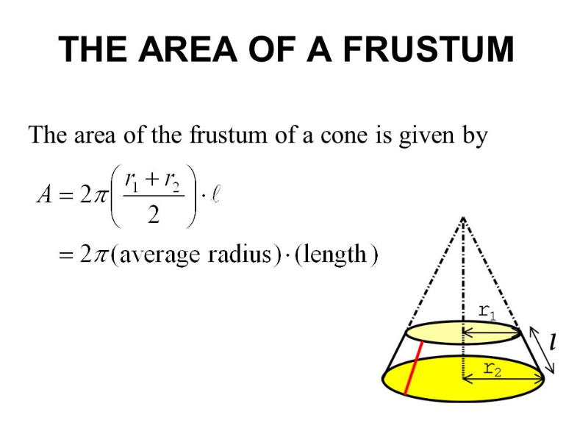

Lateral Surface Area (only) = Pi (r + R) s (where s = slant height l )
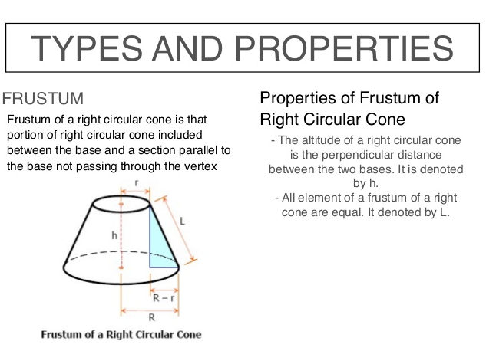
Volume = 1/3 Pi h (r² + rR + R²) Cited: http://www.mathwords.com/f/frustum.htm

Total Surface Area of Frustum = Pi [(r + R) s + r² + R² ] (where s = slant height l)
Cited: https://www.slideshare.net/christinelee1996/math-slide-area-and-volume

