Activity 1. Factor 1 (problem size)

The first table for PythonA1.py looks like this (times in milliseconds):

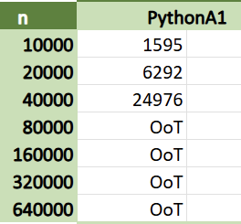

Activity 2. Factor 2 (computer power)

The second table, where we compare the algorithm’s performance on two different computers, is as follows:

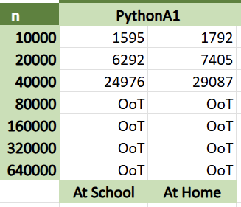

The computer at school has an i7 processor and 16GB of RAM, whereas my laptop at home is equipped with an AMD Ryzen 9 6900HX processor and 32GB of RAM. We can see the school computer is slightly faster, perhaps since it has more CPU cores, but not to the point of being statistically significant.

Activity 3. Factor 3 (implementation environment)

The execution times for JavaA1.java are the following:

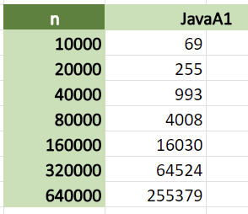

We can see that they are much lower than those in Python, since Java is a lot faster as a language. Python is higher level, and thus less efficient.

Activity 4. Factor 4 (algorithm that is used)

The full table with all the requested times is this:

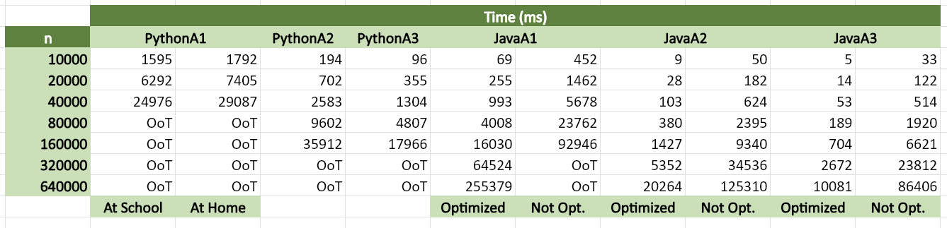From this data we can conclude that the most important factors are the programming language, optimization (in the case of Java), and the algorithm used. In this case Java is faster than Python, optimization is better than no optimization, and the last algorithms are more efficient than the first ones.