Activity 1. Minimum Paths

The times for **MinimumPathsTimes.java** are the following:

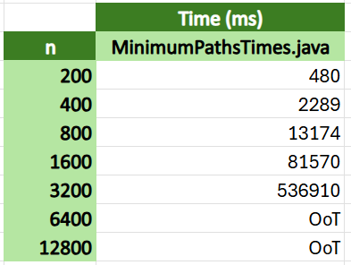

In this case, the numbers don’t really suggest O(n^3) to me, although I could tell they were growing increasingly fast. I guess the effect becomes a lot more noticeable for bigger values of n.