NEXUS
Neural Executive Xperiment for Unified Software Automation
ITSC 4681 — Project 2 Report

1. System Specification & Architecture

Goal
NEXUS is a command-line coding assistant that behaves like an autonomous agent rather than a chatbot. The user provides a task once, and the system keeps reasoning, invoking tools, observing results, and continuing until it finishes or reaches a safe stopping condition.
The PNG above (generated by scripts/generate_diagrams.py) shows the final implementation architecture. The Mermaid flowcharts below are the canonical planning and implementation records.

Original Planning Architecture
flowchart LR
User["User"] --> CLI["CLI REPL"]
CLI --> Agent["Agentic Loop"]
Agent --> Provider["LLM Provider Layer"]
Provider --> Groq["Groq / Cloud Model"]
Provider --> Ollama["Ollama / Local Model"]
Agent --> MCP["MCP Client"]
MCP --> FS["Filesystem MCP Server"]
MCP --> Search["External Search MCP Server"]
MCP --> RAG["Local RAG MCP Server"]
Agent --> Session["Session Store"]

Updated Implementation Architecture
flowchart LR
User["User"] --> REPL["REPLInterface"]
REPL --> Agent["Agent.execute()"]
REPL --> Store["SessionStore"]
Store --> Disk["JSON session files"]

Agent --> Session["SessionContext"]
Agent --> Provider["LLMProvider"]
Agent --> Executor["MCPToolExecutor"]
Agent --> Retry["RetryManager / CircuitBreaker"]

Provider --> Groq["GroqProvider"]
Provider --> Ollama["OllamaProvider"]

Executor --> MCP["MCPClientManager"]
MCP --> FS["Official Filesystem MCP"]
MCP --> Search["Tavily Remote MCP"]
MCP --> RAG["Local RAG stdio MCP"]

RAG --> Service["RAGService"]
Service --> Chunker["MarkdownChunker"]
Service --> Embedder["HashEmbeddingModel"]
Service --> Fusion["Fusion Retrieval"]
Service --> Chroma["Persistent ChromaDB"]

What Changed
- The MCP layer was split into MCPClientManager and MCPToolExecutor so discovery and execution are isolated and testable.
- The filesystem integration now uses the official @modelcontextprotocol/server-filesystem package instead of only a local placeholder server.
- The custom local RAG MCP server is now implemented and loaded dynamically alongside the other MCP servers.
- The local RAG subsystem persists an index to disk so documentation only needs to be ingested once.
- The REPL acts as the interaction handler for tool visibility and confirmation prompts.

Runtime Rules
- The LLM provider decides whether to answer directly or request tools.
- The session stores user turns, assistant turns, tool calls, and tool results.
- The agent loop continues until the model returns a final answer or the iteration cap is reached.
- Execution mode controls confirmations:
- auto: execute every tool automatically
- manual: confirm every tool
- confirmation: confirm only higher-risk tools
- The local RAG server uses:
- markdown-aware chunking
- deterministic local embeddings
- query rewrites
- reciprocal rank fusion
- persistent ChromaDB storage

Assignment Checklist
Implemented in this repo:
- Agentic loop
- Provider abstraction for Ollama and a cloud provider
- CLI REPL with visible tool activity and confirmation modes
- Dynamic MCP tool discovery
- Official filesystem MCP server
- External resource MCP server
- Custom local RAG MCP server
- Advanced RAG technique in code
- Persistent sessions
- Planning and deliverable docs
Operational note:
- The live external MCP demo path requires a valid TAVILY_API_KEY.

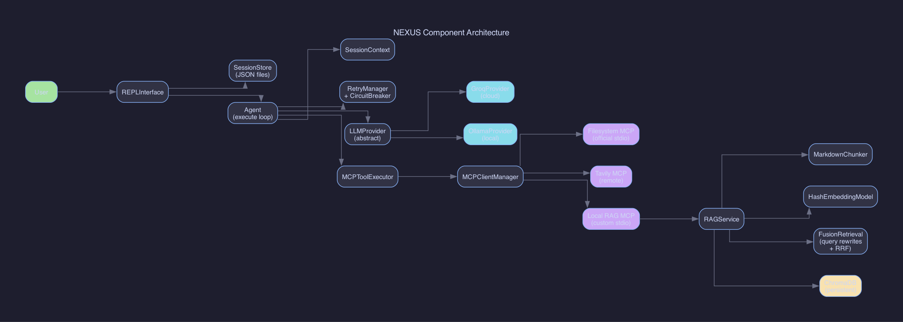
Figure 1 — NEXUS Component Architecture (final implementation)

2. State Diagram
The state machine below captures the runtime behavior of the CLI assistant from a single user turn through completion.
The rendered PNG above is generated by scripts/generate_diagrams.py. The Mermaid source below is the canonical reference and renders directly on GitHub.
stateDiagram-v2
[*] --> Idle
Idle --> AcceptingInput: user enters task
AcceptingInput --> Reasoning: agent invokes LLM
Reasoning --> Completed: model returns final answer
Reasoning --> ToolSelection: model emits tool call(s)
ToolSelection --> AwaitingConfirmation: manual or high-risk mode
ToolSelection --> ExecutingTools: auto-approved tool call
AwaitingConfirmation --> ExecutingTools: user approves
AwaitingConfirmation --> ObservingResults: user declines
ExecutingTools --> ObservingResults: MCP tool returns result
ObservingResults --> Reasoning: tool result added to context
Reasoning --> Failed: provider or tool error exceeds recovery limits
Completed --> PersistingSession: save session to disk
Failed --> PersistingSession: save session to disk
PersistingSession --> Idle: ready for next task
Idle --> [*]: /exit

Notes
- The ObservingResults state covers both success and failure. Tool failures still become model context so the agent can recover or explain what happened.
- Confirmation is only a distinct state when the current execution mode demands it.
- Persistence happens on shutdown so work can be resumed with --session.

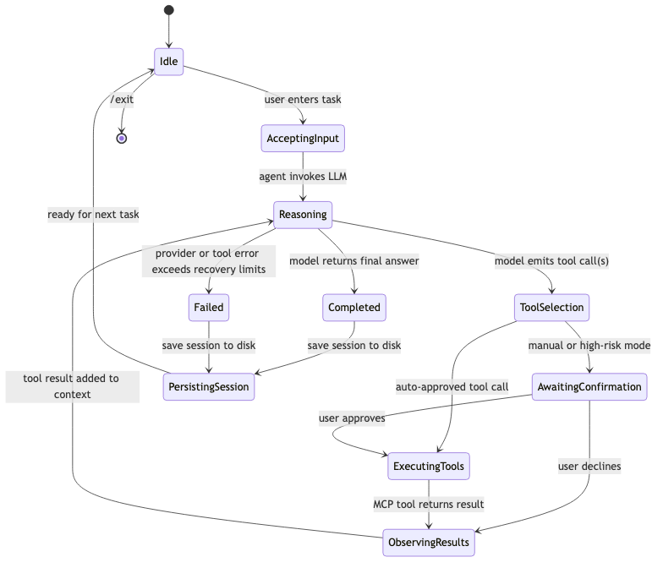
Figure 2 — NEXUS Runtime State Machine

3. Sequence Diagrams
These diagrams show the interactions the assignment asks us to document between the user, CLI, agent loop, LLM, MCP client, and MCP servers.
Pre-rendered PNGs (generated by scripts/generate_diagrams.py):
The Mermaid sources below are the canonical reference and render on GitHub.

Scenario 1: Read and Edit a File

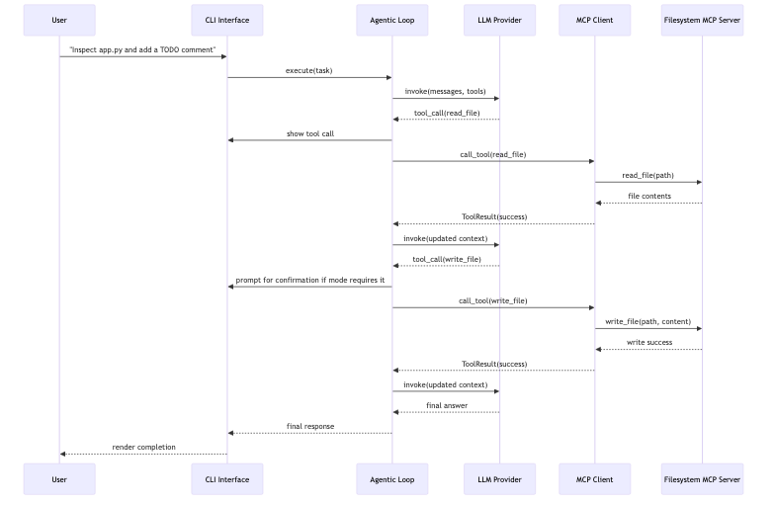
Figure 3 — Scenario 1: Read and Edit a File

Scenario 2: Search the Web and Produce a Plan

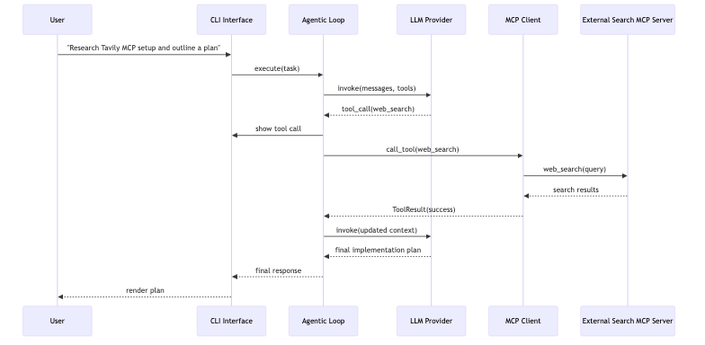
Figure 4 — Scenario 2: Web Research via Tavily MCP

Scenario 3: Build and Use the Local Documentation Index

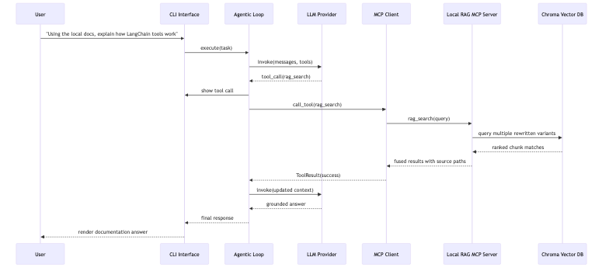
Figure 5 — Scenario 3: Local RAG Documentation Query

Scenario 4: Initial RAG Index Build

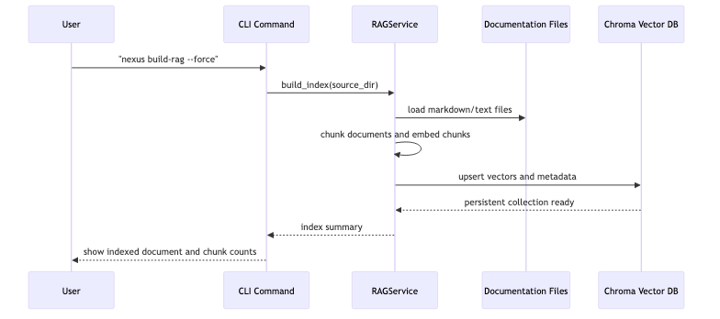
Figure 6 — Scenario 4: Initial RAG Index Build

4. Reflection

Design Decisions
The project is organized around clear subsystem boundaries:
- core/ owns the agent loop, retries, error handling, and session state.
- llm/ hides provider-specific logic behind one shared interface.
- mcp/ handles server registration, tool discovery, and tool routing.
- rag/ isolates indexing and retrieval logic from the rest of the assistant.
- cli/ focuses on user experience, tool visibility, and confirmation prompts.
That separation made the later phases much easier to complete. The phase 4 local RAG server was added without rewriting the agent loop, and the CLI improvements were made by attaching the REPL as an interaction handler instead of mixing terminal code into the core reasoning path.

LLM Comparison
We compared Groq and Ollama on the same style of coding task: read a file, reason about it, and then make a code change.
- Groq was the stronger fit for autonomous coding because the provider adapter supports tool schemas and returns tool calls.
- Ollama works as a local fallback, but the current adapter is still text-only, so it cannot drive autonomous tool use in the same way.
The main insight is that provider abstraction is not only about swapping API endpoints. It also needs to account for capability differences. Two providers can fit the same interface while still producing very different agent behavior.

Advanced RAG Technique
The implemented advanced RAG technique is fusion retrieval.
Pipeline:
- Load local documentation files.
- Chunk them with markdown-aware boundaries and overlap.
- Embed chunks into a persistent ChromaDB collection.
- Rewrite each query into several lightweight variants.
- Retrieve ranked results for each variant.
- Merge the rankings with reciprocal rank fusion before returning the best chunks.
Why this helped:
- Documentation questions are often underspecified, so one phrasing of the query can miss the right section heading or terminology.
- Query rewrites improved recall on the local docs corpus.
- Reciprocal rank fusion gave more stable results than trusting a single nearest-neighbor query.

Safety and UX Lessons
The assistant became much more believable once tool calls were surfaced clearly in the terminal and confirmation mode actually enforced user approval for riskier actions. That transparency matters because an autonomous coding assistant is making real file-system changes, not just chatting.

What I Would Do Differently
- Add true token-level provider streaming instead of only turn-level response rendering.
- Extend the Ollama adapter with tool-calling support once the local model stack supports it reliably.
- Add an edit review mode so users can preview or reject diffs before file writes.
- Benchmark several documentation corpora to compare fusion retrieval against HyDE or semantic chunking in a more formal way.

