CPE301 – SPRING 2019

Design Assignment 3B

Student Name: David Flores

Student #: 2000881655

Student Email: flored6@unlv.nevada.edu

Primary Github address: https://github.com/David-Floress/submission_da.git

Directory: https://github.com/David-Floress/submission_da

Submit the following for all Labs:

1. In the document, for each task submit the modified or included code (only) with highlights and justifications of the modifications. Also, include the comments.
2. Use the previously create a Github repository with a random name (no CPE/301, Lastname, Firstname). Place all labs under the root folder ESD301/DA, sub-folder named LABXX, with one document and one video link file for each lab, place modified asm/c files named as LabXX-TYY.asm/c.
3. If multiple asm/c files or other libraries are used, create a folder LabXX-TYY and place these files inside the folder.
4. The folder should have a) Word document (see template), b) source code file(s) and other include files, c) text file with youtube video links (see template).

1. **COMPONENTS LIST AND CONNECTION BLOCK DIAGRAM w/ PINS**

List of Components used

ATmega328P

FTDI Basic

Micro USB cable

Wires

LM34

Block diagram with pins used in the Atmega328P

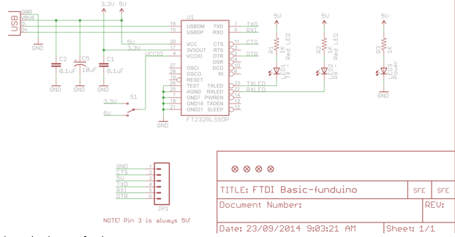

1. **INITIAL/MODIFIED/DEVELOPED CODE OF TASK 1/A**

/*

* DA3B.c

*

* Created: 3/30/2019 2:51:02 PM

* Author : David Flores

*/

#define *F_CPU* 16000000UL

#define BAUD_RATE 9600

#include <avr/io.h>

#include <util/delay.h>

#include <avr/interrupt.h>

void usart_init ();

void usart_send (unsigned char ch);

int main (void)

{

TCNT1 = 49911;

TIMSK1 = (1<<TOIE1); //

TCCR1B = 5; //Prescalar of 1024

usart_init ();

/** Setup and enable ADC **/

ADMUX = (0<<REFS1)| // Reference Selection Bits

(1<<REFS0)| // AVcc - external cap at AREF

(0<<ADLAR)| // ADC Left Adjust Result

(1<<MUX2)| // Analog Channel Selection Bits

(0<<MUX1)| // ADC5 (PC5 PIN27)

(1<<MUX0);

ADCSRA = (1<<ADEN)| // ADC ENable

(0<<ADSC)| // ADC Start Conversion

(0<<ADATE)| // ADC Auto Trigger Enable

(0<<ADIF)| // ADC Interrupt Flag

(0<<ADIE)| // ADC Interrupt Enable

(1<<ADPS2)| // ADC Prescaler Select Bits

(0<<ADPS1)|

(1<<ADPS0);

sei();

while (1)

{

}

return 0;

}

ISR(TIMER1_OVF_vect) //Interrupt subroutine

{

ADCSRA|=(1<<ADSC); //start conversion

while((ADCSRA&(1<<ADIF))==0);//wait for conversion to finish

ADCSRA |= (1<<ADIF);

int a = ADCL;

a = a | (ADCH<<8);

a = (a/1024.0) * 5000/10;

usart_send((a/100)+'0');

a = a % 100;

usart_send((a/10)+'0');

a = a % 10;

usart_send((a)+'0');

usart_send('\r');

TCNT1 = 49911;

}

void usart_init (void)

{

UCSR0B = (1<<TXEN0);

UCSR0C = (1<< UCSZ01)|(1<<UCSZ00);

UBRR0L = *F_CPU*/16/BAUD_RATE-1;

}

void usart_send (unsigned char ch)

{

while (! (UCSR0A & (1<<UDRE0))); //wait until UDR0 is empty

UDR0 = ch; //transmit ch

}

void usart_print(char* str)

{

int i = 0;

while(str[i] != 0)

usart_send(str[i]);

}

1. **DEVELOPED MODIFIED CODE OF TASK 2/A from TASK 1/A**

**N/A**

1. **SCHEMATICS**

Use fritzing.org

1. **SCREENSHOTS OF EACH TASK OUTPUT (ATMEL STUDIO OUTPUT)**

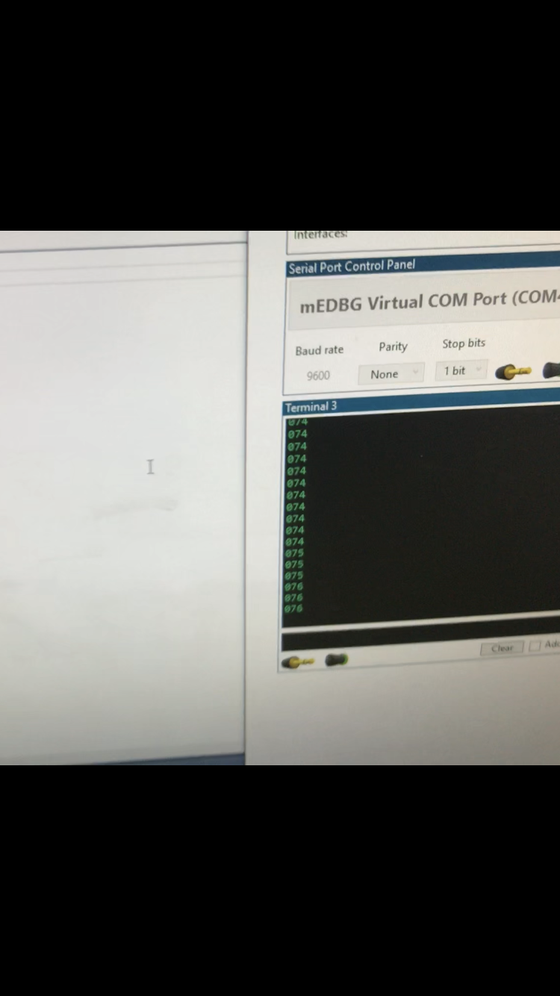

Temperature changes a bit after putting finger on sensor

1. **SCREENSHOT OF EACH DEMO (BOARD SETUP)**

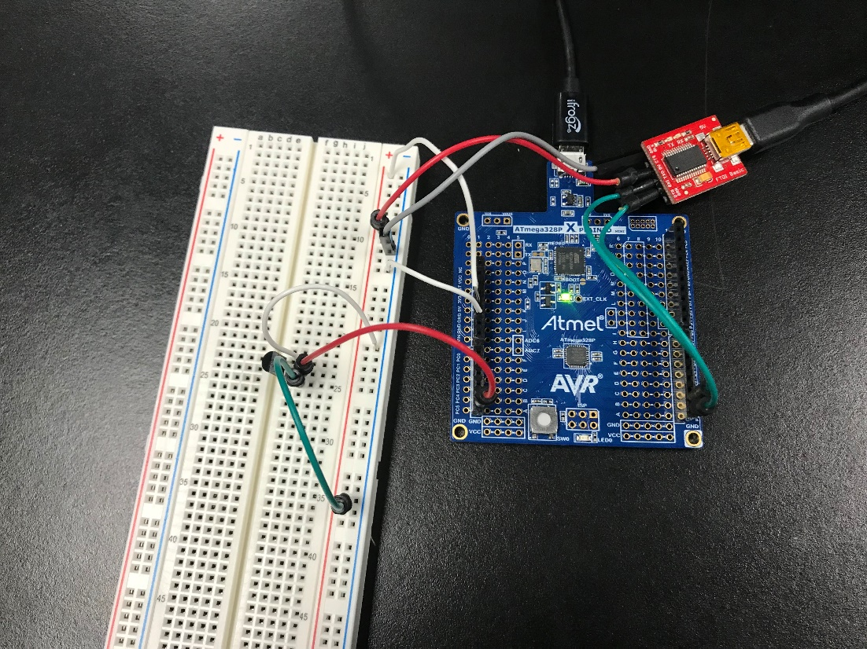

1. **VIDEO LINKS OF EACH DEMO**

<https://www.youtube.com/watch?v=qjiUVz_tNJ4>

1. **GITHUB LINK OF THIS DA**

<https://github.com/David-Floress/submission_da/tree/master/DA3B1>

**Student Academic Misconduct Policy**

<http://studentconduct.unlv.edu/misconduct/policy.html>

“This assignment submission is my own, original work”.

NAME OF THE STUDENT