CPE301 – SPRING 2019

Design Assignment 5

Student Name: David Flores

Student #: 2000881655

Student Email: flored6@unlv.nevada.edu

Primary Github address: https://github.com/David-Floress/submission_da.git

Directory :DA5: <https://github.com/David-Floress/submission_da/tree/master/DA5/DA5>

Submit the following for all Labs:

1. In the document, for each task submit the modified or included code (only) with highlights and justifications of the modifications. Also, include the comments.
2. Use the previously create a Github repository with a random name (no CPE/301, Lastname, Firstname). Place all labs under the root folder ESD301/DA, sub-folder named LABXX, with one document and one video link file for each lab, place modified asm/c files named as LabXX-TYY.asm/c.
3. If multiple asm/c files or other libraries are used, create a folder LabXX-TYY and place these files inside the folder.
4. The folder should have a) Word document (see template), b) source code file(s) and other include files, c) text file with youtube video links (see template).

1. **COMPONENTS LIST AND CONNECTION BLOCK DIAGRAM w/ PINS**

ATmega328p

Arduino Shield

Wires

Stepper Motor

Servo Motor

ULN2003A Driver

Potentiometer

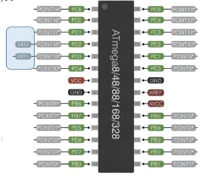

I used PB0 PB1 PB2 and PB3 as output. I had PC0 for the potentiometer

1. **INITIAL/MODIFIED/DEVELOPED CODE OF TASK 1/A**

Part 1:

/*

* DA4B.c

*

* Created: 4/20/2019 2:11:59 PM

* Author : David Flores

*/

#define *F_CPU* 16000000UL /* Define CPU Frequency 16MHz */

#include <avr/io.h> /* Include AVR std. library file */

#include <util/delay.h> /* Include delay header file */

volatile unsigned int ADCVal;

int main(void)

{

int period;

timer_init();

ADC_init();

while(1)

{

ADCSRA |= (1<< ADSC); //starts the conversion

while((ADCSRA&(1<<ADIF))==0); //waits for the conversion

ADCVal = ADC & 0x03FF; //takes right 10bits of ADC register

OCR1A = 10*ADCVal; //Duty Cycle

PORTB = 0x09;

while (!(TIFR1 & (1<<OCF1A)));

TIFR1 |= (1<<OCF1A);

PORTB = 0x03;

while (!(TIFR1 & (1<<OCF1A)));

TIFR1 |= (1<<OCF1A);

PORTB = 0x06;

while (!(TIFR1 & (1<<OCF1A)));

TIFR1 |= (1<<OCF1A);

PORTB = 0x0C;

while (!(TIFR1 & (1<<OCF1A)));

TIFR1 |= (1<<OCF1A);

}

}

void timer_init(void)

{

DDRB = 0x0F; //Sets the lower bits of portb as outputs

DDRC = 0; //PortC is as an input

PORTB = 0; //Turns off all PB5 initially

TCCR1B = (1<< WGM12) | (1<<CS11); //Prescalar = 8

}

void ADC_init(void)

{

// Analog to digital converter initialization

DIDR0 = 0x1;

ADMUX = (1<<REFS0);

//right justified data

ADCSRA |= (1<<ADEN)|(1<<ADPS2)| //system clock used for ADC

(1<<ADPS1)|(1<<ADPS0); //free running

ADCSRB = 0x0;

}

Part 2:

/*

* DA4Bp2.c

*

* Created: 4/20/2019 7:03:04 PM

* Author : user11

*/

//DA4B part 2

#define *F_CPU* 16000000UL

#include <avr/io.h>

#include <util/delay.h>

void adc_init(void);

int main(void)

{

while(1)

{

//Timer1

TCCR1A = (1 << COM1A1) | (1<<COM1B1) | (1<<WGM11);

TCCR1B = (1<<WGM13) | (1<<WGM12) | (1<<CS11) | (1<<CS10); //set the prescalar to 64

adc_init();

ICR1=4999; //sets to 50Hz

DDRB |= (1<<PB1); //output pin to the servo motor

OCR1A = ADC; //for potentiometer

*_delay_ms*(50); //delay between pot input and output of servo motor

}

}

void adc_init (void)

{

ADMUX = (1<<REFS0); //reference selection; AVcc

ADCSRA |= (1<<ADEN) | //enable ADC

(1<<ADSC) |

(1<<ADPS2) | //prescalar 128

(1<<ADPS1) |

(1<<ADPS0);

ADCSRB = 0x0; //adc control and status register free running mode

}

1. **SCHEMATICS**

**Stepper Motor**

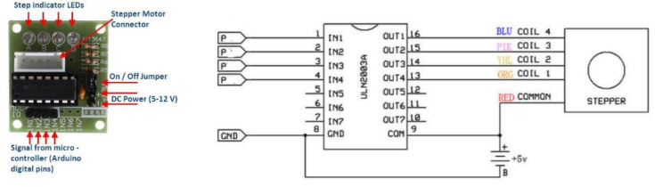

Servo Motor

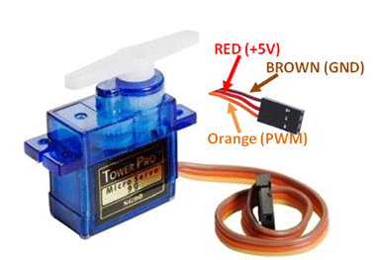

1. **SCREENSHOTS OF EACH TASK OUTPUT (ATMEL STUDIO OUTPUT)**

N/A

1. **SCREENSHOT OF EACH DEMO (BOARD SETUP)**

Don’t have pictures look at Youtube links for “picture”

1. **VIDEO LINKS OF EACH DEMO**

Part 1:

Stepper Motor

<https://www.youtube.com/watch?v=lTHySwMsa2s>

Part 2:

Servo Motor

<https://www.youtube.com/watch?v=ES7dLf_m2B8>

1. **GITHUB LINK OF THIS DA**

**Student Academic Misconduct Policy**

<http://studentconduct.unlv.edu/misconduct/policy.html>

“This assignment submission is my own, original work”.

David Flores