Greenmount catchment study - soil management
Note
Copy from www at end of doc, transfer images to that section and delete this origina;
1976-1993
Greenmount south of Toowoomba north of Oakey (QLD)
Keywords: runoff, erosion, sediment, soil cover, tillage, conservation tillage
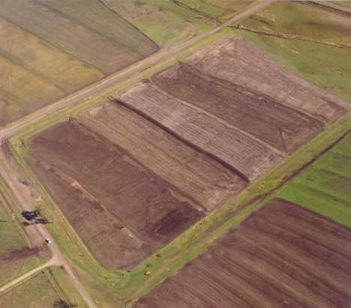 add with arrows

1. Overview (Level 1)
This catchment study near Greenmount was established to examine the influence of soil surface conditions on runoff and soil erosion, on a site representative of a major soil types of the eastern Darling Downs. The study was established in 1976 on a soil representative of cracking Black Earths (Irving clay). Although runoff leaving a contour bay catchment may entrain material along unstable sections of drainage lines, management at the paddock scale is likely to strongly influence water quality for the whole catchment.
This project examined the influence of antecedent soil water, rainfall intensity, runoff and ground cover on suspended sediment moving through a flume at the exit from a contour bay and the effects of contour banks on sediment delivery to nearby streams. Methods of sampling and calculating suspended soil loss were evaluated.

Key findings
Surface cover was effective in reducing soil movement and runoff from contour bay catchments. Runoff and sediment concentration were both inversely related to surface cover and total soil movement was greatly reduced by surface cover. Greater than 75% of the variance in soil movement from single events was explained by surface cover and peak runoff rate.
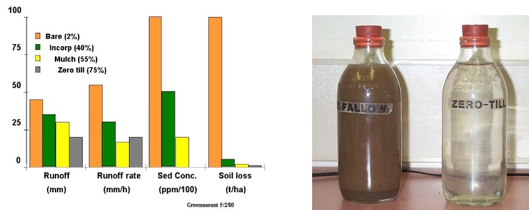
Table 1 Summary of average annual observed and predicted (Cover model) runoff and soil erosion at Greenmount

Management | Years |  | Observed runoff (mm) |  | Predicted runoff (mm) |  | Observed erosion (t/ha) |  | Predicted erosion (t/ha)
Wheat, stubble burnt | 1978-90 (13) | 69 |  | 65 |  | 45 |  | 44
Wheat, stubble incorporated (disc tillage) | 1978-90 (13) | 56 |  | 55 |  | 14 |  | 23
Wheat, stubble mulch (blade tillage) | 1978-90 (13) | 49 |  | 44 |  | 9 |  | 8
Wheat, zero till | 1980-90 (11) | 53 |  | 46 |  | 2 |  | 2
Pasture (A) | 1987-90 (4) | 32 |  | 33 |  | 2 |  | 1

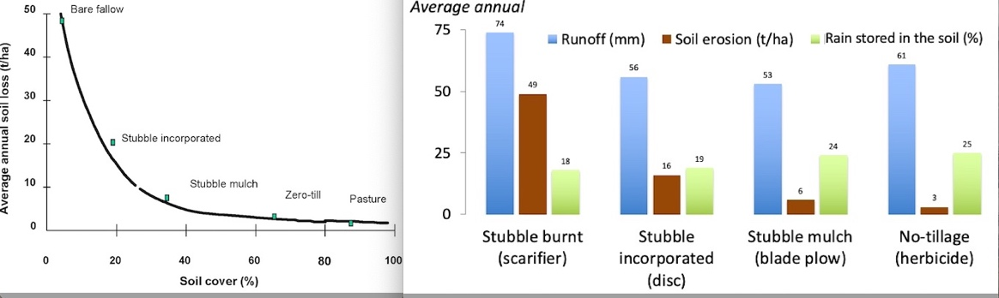

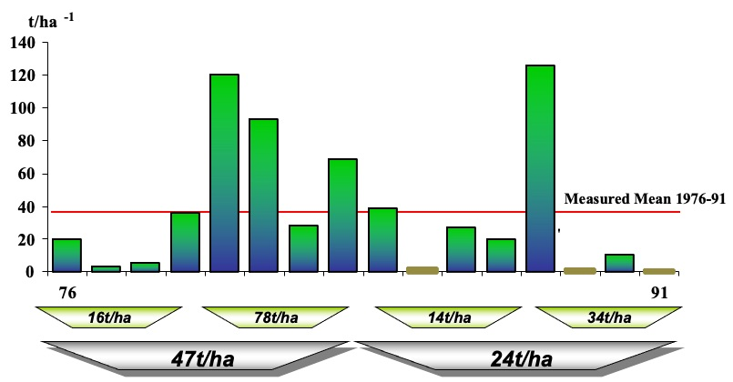

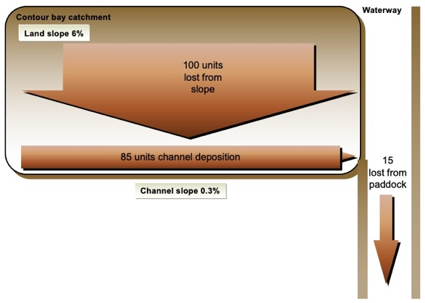

Observed and predicted mean annual runoff, erosion and suspended sediment loss at Greenmount. (1978-1990).Site slope (7%), slope length (65m) LS = 1
Management system | Measured |  |  | Predicted
Management system | Runoff  (mm) | Hillslope erosion  (t/ha) | Suspended Sediment loss¹  (t/ha) | Runoff  (mm) | Hillslope erosion  (t/ha) | Suspended Sediment loss²  (t/ha)
Stubble burnt (1978-89) | 68 | 45 | 4.6 | 66 | 42 | 9
Stubble incorporated (1976-89) | 47 | 13 | 1.4 | 46 | 14 | 4.3
Stubble mulch (1978 -89) | 47 | 9 | 0.8 | 47 | 10 | 2.9
Minimum tillage (1979-89) | 35 | 1 | 0.3 | 33 | 1.5 | 0.6
Perennial pasture (1987-90) | 32 | 1 | 0.2 | 35 | 1.1 | 0.4

¹ Based on available data, some smaller events not sampled
² No tuning, assumed delivery ratio of 0.14, K=0.35 metric units

Location: The “Marylands” property is located 1.3 km northeast of Greenmount, (151⁰ 55'E , 27⁰ 46'S, 151.95, 27.78) 500 m above sea level and has a northerly aspect

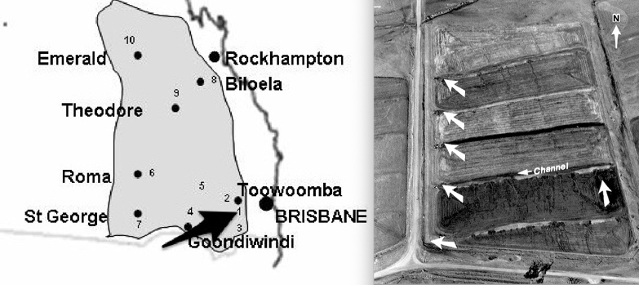

Related studies
Greenwood catchment study 1976-2000 Freebairn and Wockner 1986
Wallumbilla catchment study 1982-2000 Freebairn et al 2009

2. Experimental conditions

Site management
The catchment study's configuration was based on an existing soil conservation plan with an established grassed waterway and contour banks (graded) (see aerial photograph above).
While "treatments" were applied, the aim was to create a range of soil surface conditions (soil cover, tillage) by applying five arbitrary tillage/crop regimes. This resulted in soil cover being very low (stubble burnt) to very high (zero tillage), with soil water increasing during summer fallows. A summer crop was grown in one catchment (bay) which has a declined soil water and increasing green cover. Summer fallow treatments were rotated or moved to different bays each year in order to attempt to remove results being attributed to a bay rather than a soil condition. Implicit in this design was that any long term impacts of a "treatment" were ignored or avoided, given the study has no replication and such subtle treatment effects are were unlikely to be observed if they did exist. This was the design philosophy - to create a range of soil conditions, not compare treatments per sec, although data is generally summarised by treatment.
Tillage, planting and harvest operations were carried out by the cooperating farmer (Mr Terry Cuskelly) with his equipment and by Queensland Government staff and equipment.

Treatments
Four catchments were devoted to winter crop (wheat) with intervening summer fallow and a fifth to summer crop. Throughout the summer fallows, a variety of stubble management and fallowing practices provides a range of soil conditions (cover, tillage). Treatments were described as:
- winter crop, stubble burnt, bare soil summer fallow
- winter crop, disc tillage, stubble incorporated summer fallow
- winter crop, blade or chisel tillage, stubble mulched sumerm fallow
- winter crop, no tillage (herbicide weed control), zero tillage summer fallow
- summer crop, chisel tillage, winter fallow
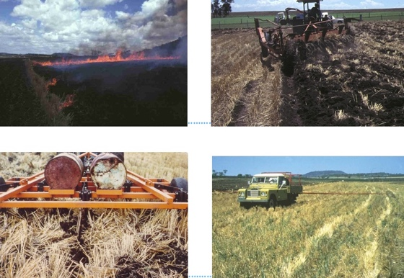
Photograph of tillage/crop treatments
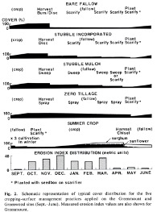
Figure Schematic representation of typical cover distribution for the five cropping-surface management practices applied on the Greenmount site (Sept.-June). Measured erosion index values are also shown.
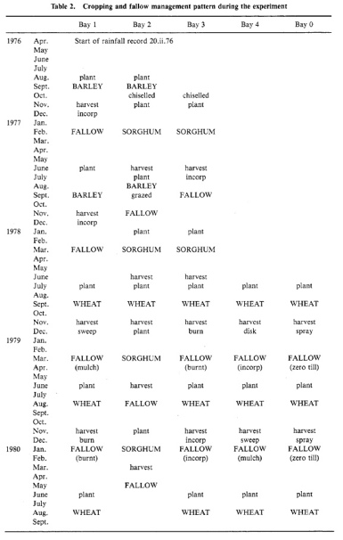
Treatment plan for Greenmount, showing rotation of treatments around unreplicated contour bays in order to minimise bias associated with each catchment 1976 -1980 (from paper 1981.
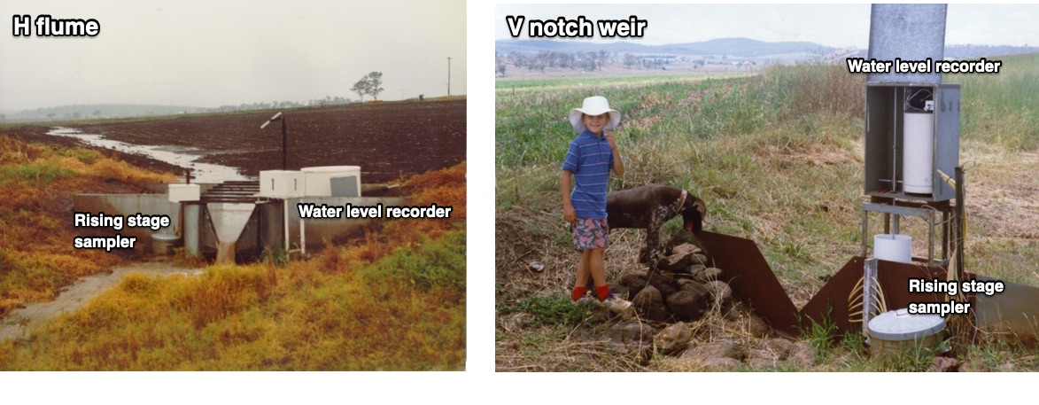
Schematic of 90⁰ V notch weir, water level recorder and rising stage sediment samplers.
Table Site characteristics -Greenmount
Property
Soil type | Black Earth
Parent material | Basalt
Catchment area (ha) | 0.77-1.4
Slope (%) | 6-7
Slope length (m) | 60 m
Channel slope (%) | 0.3
Channel length (m) | 250
Runoff control | One 90⁰ V notch weir four H flumes
Water sampling | Rising stage, auto pumping samplers at times
Erosion measures | Rill, fans, suspended sediment, bedload at flume or weir
Duration | 1976-1993

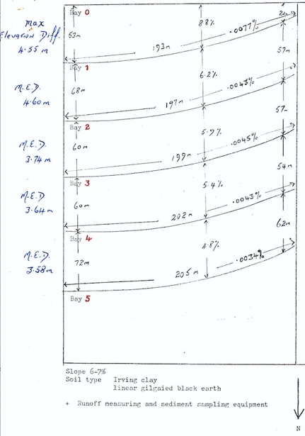

3. Project & data management

Project Code: SMPG
Principal investigator: Freebairn D.
Principal data managers: -DM Freebairn GH Wockner
Principal organisations: Queensland Department of Natural Resources, Department of Primary Industries
Data custodian: Queensland Department of Natural Resources
Key co-operators: Mr Terry Cuskelly
Data access policy: Open access
Planned pathway for data: completed study
Data warehousing: Hydstra, DARTS, this web site
Planned data upload frequency: N/A
Funding Source: DPI Base 100%
Data Ownership: Department of Natural Resources
Data Quality: The same two officers collected all the sediment and soil loss data over the entire project duration (26/10/1976 to 08/02/1991). The methods never changed and that consistency contributed to making this data set unique.

Measured data
Rainfall was measured using a network of three tipping bucket recording rain gauges, a manual rain gauge at each side of the catchment, and a gauge at the farm residence approximately 1 km south.
Runoff was measured through recorded gauge heights using 2’H flumes and one 90º V notch weir at 5 minute time intervals and summed to daily (9am to 9am) values in this data collection. Flow heights recorded on paper charts were digitised and stored in the RRUMS database.
Runoff water was sampled using rising stage and in some cases timed samplers at catchment outlets to determine suspended sediment concentrations.
Total soil movement, as described by Freebairn and Wockner (1986a) was measured in this study by estimating the volume of rills and sediment deposits after each major runoff event.
Surface cover (green and dead) was measured after each runoff event, after cultivation operations, at time of soil sampling and periodic site visits. Expressed as percentage (%) of total soil cover
Surface roughness was described using a semi-quantitative scale (1-smooth to 5- rough) based on a visual assessment made at the same time as soil cover.
Soil moisture was determined at nine locations in each bay to a depth of 1.5 m in 6 depth increments. A mean of the nine-samples per depth was used in further analyses. Soil moisture was determined three times per year: post-harvest, mid-fallow and pre-planting, typically November, February and May.
Bulk density was measured on several occasions using 10 cm diameter cores, and used to convert gravimetric values to a volumetric basis.
To estimate a PAWC for the site, the mean of the five driest and wettest samplings were used. Expressed as mm available to plants.
Grain yield was determined by harvesting 400 m long strips in each bay using a commercial harvester (6m wide).
Evaporation (E) in fallows was determined by difference as E = Rainfall-Runoff -change in soil water over the fallow.
Fallow efficiency was defined as the change in plant available soil water over a fallow period as a percentage of rainfall, expressed as percentage (%).
Measured data is in two formats: as MS Excel or MS Word documents where most data preparation was done, and files in Howleaky model input format

Data management
A diary of all agronomic operations was kept. See "Other documents' folder.
Sites: These five sites are shared between several projects. Subsequent to this study this particular series of catchments was been monitored under the “Fate of Nutrients” project (Geoff Titmarsh) although the station numbers remain constant and common to both projects.

AB42204 Greenmount Contour Bay 0 at Marylands
AB42205 Greenmount Contour Bay 1 at Marylands
AB42206 Greenmount Contour Bay 2 at Marylands
AB42207 Greenmount Contour Bay 3 at Marylands
AB42208 Greenmount Contour Bay 4 at Marylands

Sample management:
- Changes during the project: No significant changes to the procedures described in this brief occurred during the lifetime of the project.
- Frequency: Erosion and soil movement were episodic with 84 runoff events occurring over 15 years (5.6 events per year) and rising stage samples were collected on 56 occasions. When prolonged wet weather and local flooding denied access the rising stage sample on the initial event was used to determine a total sediment loss in the subsequent runoff. A justification for less rigorous sampling procedures in this type of study could be that suspended sediment represents only 10 to 20% of total soil movement, and is therefore of relatively less importance than other modes of soil movement. If the main objective of a study were to determine accurately total suspended sediment, this simplification would not be appropriate
- Collection time delays: Sample bottles would normally be changed between the first event, and the second compound event, but local flooding could preclude access, demonstrating the limitations of rising stage sampling.
- Bottle preparation: Standard 600ml glass milk bottles were used for the collection of all rising stage samples. These bottles were thoroughly washed and used as replacement bottles through the life of the project.

The following estimated parameters were stored as comments with the sample master record: Event rills (t.ha⁻¹); Event sediment fans (t.ha⁻¹)
NB. Event = Generally same day but for long events may continue for several days.

Data Type:

Integrated (Flow- Weighted Mean) Suspended Sediment Concentration (variable number 769.23)
Samples of runoff were collected at the weir or flume for determination of suspended sediment. Samples were collected by a rising stage sediment sampler. Methods of calculating suspended loads are presented in detail by Freebairn and Wockner (1986). While approach conditions to all sampling points were similar, it is likely that the size of ‘suspended’ material would be dependent on discharge rates to some extent. Nevertheless, the samples collected provide a robust estimate of the influence of rainfall and soil conditions on suspended sediment. Entrainment of ‘suspended’ material from the graded channel was unlikely due to the low slope (0.3%) and consequent low stream power of channel flow. The graded channels were typically aggraded with eroded material from the plane.

Suspended Sediment Concentration for Individual Samples:

This procedure is not NATA accredited.
- Non- sieved or settled samples
This category describes the bulk of the sample analyses previously performed by staff at DNR Resource Management Toowoomba. The procedure is simple enough for untrained personnel to undertake in batches with a minimum of supervision.
- Record sample bottle identification in record book
- Assign and record a beaker for each sample bottle
- Transfer contents of bottle into assigned beaker
- Weigh and record mass of beaker and respective sample
- Add flocculant if necessary, wait for sediment to settle and decant excess water
- Dehydrate beakers at 105° Celsius for no less than 48 hours in suitable dehydrating oven
- Remove beakers from oven, weigh while hot and record
- Discard sediment, wash beakers and re- tare hot if necessary
The procedural aim is to define the respective masses of sediment and water in order to determine the sediment concentration in grams per litre (g.l⁻¹). Masses must be recorded to resolve one hundredth of a gram (0.01g), Ie. grams to two decimal places.
A supply of hot- tared and numbered beakers is set aside specifically for this and other similar procedures. Except for the initial mass of beaker, water and sediment, the masses are recorded hot. This is to ensure that the dry beaker or dry sediment is not permitted to absorb significant quantities of atmospheric moisture. This phenomenon commonly experienced while analysing low sediment concentrations or low masses of sediment in larger surface area receptacles. Simple experiments conducted by staff at DPI Wheat Research Institute (now Leslie Research Centre) indicated that cooling receptacles and sediment could absorb significant quantities of moisture producing incorrect analyses.

Integrated Suspended Sediment Concentration
Total suspended sediment loss was based on determining a mean sediment concentration for each event:
A mean concentration for rising stage samples collected for each event was determined by flow- weighting the sediment concentration of each stage.
Runoff samples were collected at the weir or flume for suspended sediment determination. Flumes or weirs were installed so that the approach velocity of water was less than 0.04 m.s⁻¹ and a pondage area was constructed upstream from each flume to allow coarse sediment to settle out rather than passing through the structure. This area was cleaned out annually and was large enough to prevent bedload entering the flume on most occasions. This was necessary as H-flumes and V-notch weirs are not designed to pass bedload without affecting the rating of the structure. A Rising Stage Sampler collected the runoff samples with individual samples collected at 5, 10, 15, 20, 25, 30 and 35 cm stage heights. Each sample was drawn at mid-flow depth (e.g. the sample taken at 10 cm stage was drawn from 5 cm depth of flow). The integrated flow-weighted concentration (C_{FW}) was calculated (Barrett and Loh 1982):

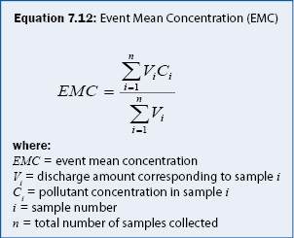
In the use of this method, it is assumed that the sediment concentration-discharge relationship for the falling stage is the same as the rising stage and that hydrographs are triangular, i.e. constant rate of rise and fall.
Runoff hydrographs in this study generally had one major peak approximating a triangular hydrograph. The stage-concentration relationship of the falling stage is similar to the rising stage, resulting in a representative sample of the whole flow being collected by the rising stage samplers.
For this study it was not surprising that rising stage samplers collected representative samples of the whole flow for most events as:
- The majority of bedload material is deposited in the contour channel.
- The bedload component of channel flow was purposefully ‘dropped out’ in the low velocity settling area immediately upstream of the control structure.
- Runoff hydrographs are generally ‘peaky’ and have a short duration due to the small catchment area and high intensity storms.

Event Runoff (mm) (Variable number 766.23)
Surface runoff. Runoff was measured from each individual catchment through either 0.61m (2’) H flumes or in the case of Bay 0, a 90⁰ V-Notch weir. Water levels were recorded on Stevens Type F float recorders or locally manufactured float recorders.
Construction of contour or graded banks results in major changes in the flow path of runoff. Using the Greenmount site as an example, runoff from the entire paddock would normally flow 360m down a 5 to 7% slope before entering an ephemeral drainage line. When contour banks were installed, flow was divided into six separate hydrologic units, each of 60m at the same slope, with a 250m channel of 0.3% slope leading to a grassed waterway.
Rating information for Greenmount flow-measuring structures:
Bay | GS | Area (Ha) | Structure Type
0 | AB42204 | 0.711 | 90 degree V-Notch Weir
1 | AB42205 | 1.320 | 2' H Flume
2 | AB42206 | 1.218 | 2' H Flume
3 | AB42207 | 1.157 | 2' H Flume
4 | AB42208 | 1.436 | 2' H Flume

Flume Type Calibration (ht is mm GHt)
90⁰ V-Notch ls = 0.00004375*(ht^2.5); cumecs = ls/1000
2' H Flume LQ = (0.0237+2.4918*log(ht/1000)+0.2605*(log(ht/1000))^2); cumecs = 10^(LQ)

The ponded approach area was cleared annually to ensure that the flume or weir rating remained valid.
The volume of runoff was calculated using point discharges multiplied by delta time (from previous point to subsequent point ÷ 2). This was divided by catchment area to give runoff in millimetres.

Event Total Soil Movement (t.ha⁻¹) (variable number 767.23)
The volume of soil deposited in the contour channels was determined after each major erosion event. The depth and area of each fan was determined by walking through the wet fans and measuring depth of loose soil. Allowance was made for the depth of cultivated soil. When the catchments had dried, cross-sections were cut through some fans to check the depth of cultivated and deposited soil against the above measures. The fan soil density was measured on drying to convert the measured fan volume into a mass value.
This procedure was compared with two other methods:
- Change in channel cross-section was measured after a major event (5 February 1980) at Greenmount (Galletly, personal communication). The change in cross-section represented 92 t.ha⁻¹ compared to 85 t.ha⁻¹ determined by fan volume.
- Sheet steel plates (10 cm by 10 cm) attached to 20 mm diameter by 30 cm long rods were placed flush with the soil surface where sedimentation was expected (at the base of rill depressions and the ponding areas in front of weirs and flumes).
Soil movement determined using the plates was compared with the survey method in March 1984 (Lovell, personal communication), and measurements of 14 and 15 t.ha⁻¹ were obtained respectively.
Independent operator estimates of soil movement were in agreement, with 10% variation for losses less than 20 t.ha⁻¹ and ± 10 t.ha⁻¹ for losses greater than 50 t.ha⁻¹. Soil movement as estimated by the same two operators throughout the experiment.
In situ soil loss was also measured using steel pins. Pins (10 mm diameter by 40 cm long) were placed 25 cm into the soil to determine depth of soil removed due to rill and interrill erosion. They were found to be unsatisfactory due to the need for replacement after cultivation and soil swelling.

Calculation of Total Soil Movement
Total soil movement is defined as the mass of soil that moves into or through the contour channel. That is, total soil movement equals deposition in fans plus total suspended load (calculated from Integrated Suspended Sediment Concentration, stored separately as variable 769.23, and Total Runoff, stored as 766.23). The component deposited in fans is not lost from the paddock, but is removed from the cultivation and crop production plane and deposited in a channel. When the channel fills with sediment, it must be cleaned out to maintain the performance of the drainage and sediment trap network and also the flow- measuring structures.
Measurement of total soil movement allows data from these experiments to be related to most plot erosion studies where net soil movement to the bottom of the slope is measured. Inter-rill erosion is almost impossible to determine directly from changes in soil level due to this soil’s distinct swelling characteristic. Therefore the amount of inter-rill erosion was determined by subtracting rill movement from total soil movement. This analysis allowed the definition of sources and sinks of soil movement within the catchment. Volumes were converted to masses using measured bulk densities for fans and the cultivated layer.

Time Series data collected:
- Rainfall total and intensity was determined from digitised Mort Pluviograph charts and stored in the RRUMS database.
- Runoff was measured as it discharged into a grassed waterway through either a 0.61 m H-flume or a 90⁰ V-notch weir. Water levels were digitised from Stevens Type Float recorder charts or locally manufactured direct height-float recorder charts and likewise were stored in the RRUMS database.

Laboratory: Toowoomba DNR laboratory

Var | Bottle | Parameter | Analysis Method | Reference Code | Min Reporting Level | Units
766.23 | IS | Total Runoff | Float recorder and rated structure | DPI | 1 | mm
767.23 | IS | Total Soil Movement | Freebairn and Wockner | DPI | 2 | t.ha⁻¹
769.23 | IS | Integrated Suspended Sediment Concentration | Gravimetric flow- weighted mean | DPI | 0 | mg.l⁻¹

4. Publications
Ciesiolka, C.C. and D.M. Freebairn, 1982, The influence of scale on runoff and erosion, Agric. Eng. Conf., Inst. Eng. Aust., Nat. Conf. Publ., 82/8: 203-206.
Freebairn, D., and Boughton, W. C. (1981). Surface runoff experiments in the eastern Darling Downs. Aust. J. Soil Res., 19, 133-46.
Freebairn, D. M., and Wockner, G. H. (1986). A study of soil erosion on vertisols of the eastern Darling Downs, Queensland. I. Effect of surface conditions on soil movement within contour bay catchments. Aust J. Soil Res. 24, 135‑58.
Freebairn, D. M., and Wockner. G. H. (1986). A study of soil erosion on vertisols of the eastern Darling Downs, Queensland. II. The effect of soil, rainfall and flow conditions on suspended sediment losses. Aust. J. Soil Res. 24, 159-72.
Freebairn DM, Wockner GH, Hamilton NA, Rowland P. 2009, Impact of soil conditions on hydrology and water quality for a brown clay in the north eastern cereal zone of Australia. Aust. J. Soil Research, 47 (4):389-402 (http://www.publish.csiro.au/nid/84/issue/5031.htm).

5. Other documents
data and documents that do not fit into the above categores
.xls, doc pdf images

6. Climate
Daily weather data was sourced from the SILO database ( https://www.longpaddock.qld.gov.au/silo/) and daily rainfall recorded at the site from a digitised record from a Mort Pluviograph. This data was originally stored in the RRUMS database and moved to Project HYDSTRA. Daily rainfall data is available in calendar and .p51 format

Greenmount rainfall summary 1976-93
Year | Winter rainfall March -October (mm) | Summer rainfall Oct-March (mm) | % Summer rainfall | Annual rainfall (mm)
1976-77 | 262 | 497 | 65 | 759
1977-78 | 391 | 337 | 46 | 728
1978-79 | 168 | 584 | 78 | 752
1979-80 | 99 | 463 | 83 | 562
1980-81 | 285 | 617 | 68 | 902
1981-82 | 134 | 700 | 83 | 834
1982-83 | 544 | 357 | 40 | 901
1983-84 | 375 | 519 | 58 | 894
1984-85 | 252 | 305 | 55 | 557
1985-86 | 192 | 509 | 73 | 701
1986-87 | 152 | 392 | 72 | 544
1987-88 | 403 | 642 | 61 | 1045
1988-89 | 216 | 412 | 66 | 628
1989-90 | 287 | 463 | 62 | 750
1990-91 | 108 | 365 | 77 | 473
1991-92 | 173 | 487 | 74 | 660
Mean 1976-1992 |  | 478 | 66 | 731
Mean 1912-1975 (Greenmount PO) |  | 490 | 68 | 738
*Water year October to September

7. Soil description
The soil is a black earth Ug 5.15 (Northcote, 1979) derived from basalt and belongs to the Irving Clay Soil Association (Thompson and Beckmann, 1959). It has a relatively high water holding capacity with 250 mm of plant-available water able to be stored in the top 1.5 m of soil.
Infiltration rate is very high when the soil is dry and cracked. However, closure of the cracks through swelling and formation of surface seals due to instability of the soil under rainfall reduces infiltration rates (Smith et al. 1984). The soil is strongly self-mulching and exhibits gross cracking in a dry condition. A full description of this soil has been presented by Freebairn and Boughton (1981).

Table Soil properties at the Irving clay at the Greenmount experimental site (April 1977)
Soil property (0-10 cm depth)
pH | 8.0
CEC^{A} (C g ⁻¹) | 68
Coarse sand (%) | 3
Fine sand (%) | 13
Silt (%) | 21
Clay (%) | 62
0. 33 bar water content (g g⁻¹) | 0.49
15 bar water content (g g ⁻¹) | 0.33
PAWC ^{B}, (0- 150 cm depth) (mm) | 201
Parent material | Basalt
Slope (%) | 6-7
Slope length (m) | 60
Area (ha) | 0.7-1.4
^{A} Cation exchange capacity.
^{B} Plant available water capacity determined by the difference between the mean wettest
and the mean driest profiles in the 1978-84 period.
This is new
Soil properties of Irving clay at Greenmount experimental site
Depth  (cm) | pH | Electrical Conductivity ms/cm | Cation exch.capacity (m.e./100g) | Particle size distribution (% of total) |  |  |  | Moisture holding capacity (% g/g |  | Bulk density (gm/cm^3)
() |  |  |  | Coarse sand | Fine sand | Silt | Clay | ) min max
 |  | 0.15
0_10 | 7.97 | 0.13 | 68.5 | 3.5 | 12.8 | 20.7 | 62.2 | 12.5 | 49.7 | 1.00
10_30 | 8.17 | 0.18 | 65.5 | 5.2 | 12.8 | 18.5 | 62.2 | 29.6 | 50.7 | 1.17
30_60 | 8.40 | 0.19 | 63.0 | 6.5 | 12.3 | 17.2 | 63.7 | 29.1 | 47.8 | 1.26
60_90 | 8.60 | 0.30 | 60.0 | 8.0 | 13.3 | 19.2 | 59.8 | 28.1 | 44.7 | 1.31
90_120 | 8.65 | 0.31 | 59.5 | 7.3 | 14.0 | 19.3 | 60.0 | 27.1 | 41.1 | 1.34

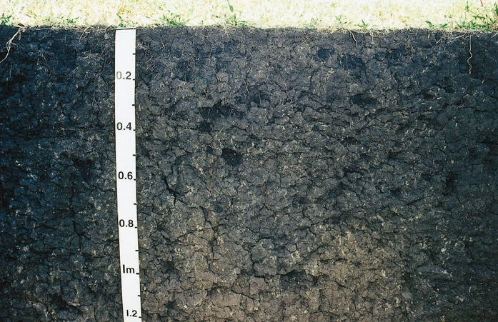

Vegetation

9. Simulation reports and packages

10. Measured Data
Time series of observations are attached. Note format varies between projects.

11. Simulations

12. Simulation reports, papers

1. Overview
Introduction
This catchment study near Greenmount was established to examine the influence of soil surface conditions on runoff and soil erosion, on a site representative of one of the major soil types of the eastern Darling Downs.
The study was established in 1976 on a soil representative of one of the major soil types (Black Earth – Irving clay) on the eastern Darling Downs. Although runoff leaving a contour bay catchment may entrain material along unstable sections of drainage lines, management at the paddock scale is likely to strongly influence water quality for the whole catchment.
This project examined the influence of rainfall intensity, runoff rate and ground cover on suspended sediment moving through a flume at the exit from a contour bay and the effects of contour banks on sediment delivery to streams were evaluated. Several methods of sampling and calculating suspended soil loss were evaluated.
Key findings
Surface cover was effective in reducing soil movement and runoff from contour bay catchments. Runoff and sediment concentration were both inversely related to surface cover and total soil movement was greatly reduced by surface cover. Greater than 75% of the variance in soil movement from single events was explained by surface cover and peak runoff rate.

Runoff, peak runoff rate, sediment concentration and soil erosion for an event in February 1980 for four tilage treatments with various soil cover (%) (left) and
management of soil conditions during fallows can greatly influence water quality, showing a runoff sample for bare fallow and zero tillage conditions (right).

Table 1 Summary of average annual observed and predicted (Cover model) runoff and soil erosion at Greenmount
Management | Years |  | Observed  runoff (mm) |  | Predicted  runoff (mm) |  | Observed  erosion (t/ha) |  | Predicted  erosion (t/ha)
Wheat, stubble burnt | 1978-90 (13) | 69 |  | 65 |  | 45 |  | 44
Wheat, stubble incorporated (disc tillage) | 1978-90 (13) | 56 |  | 55 |  | 14 |  | 23
Wheat, stubble mulch (blade tillage) | 1978-90 (13) | 49 |  | 44 |  | 9 |  | 8
Wheat, zero till | 1980-90 (11) | 53 |  | 46 |  | 2 |  | 2
Pasture (A) | 1987-90 (4) | 32 |  | 33 |  | 2 |  | 1

Relationship between soil cover in the summer fallow and soil loss (M Silburn graphic) (left) and Annual average runoff, soil erosion and soil water storage in the fallow (% of rain) at Greenmount (1978-1989 11 years)

Time series of annula erosion at greenmount showing variability. Bars at bottom indicate that an "average" erosion rate can vary
from 14 to 78 t/ha/year depending on the sample period.

Soil erosion needs to be defined by scale of study. While 100 units of soil erosion may occur at the hillslope scale, this value may decline to 15 units after deposition in a contour channel. This schematic is typical for the Greenmount site with a 6& landslope and a 0.35 channel slope.

Location
The “Marylands” property is located 1.3 km northeast of Greenmount, (1510 55'E , 270 46'S, 151.95, 27.78) 500 m above sea level and has a northerly aspect

Location of the Greenmount study and aerial photograph showing catchment layout
Related studies
Greenwood catchment study 1976-2000 Freebairn and Wockner 1986
Wallumbilla catchment study 1982-2000 Freebairn et al 2009
2. Experimental conditions
Site management
The catchment study's configuration was based on an existing soil conservation plan with an established grassed waterway and contour banks (graded) (see aerial photograph above).
While "treatments" were applied, the aim was to create a range of soil surface conditions (soil cover, tillage) by applying five arbitrary tillage/crop regimes. This resulted in soil cover being very low (stubble burnt) to very high (zero tillage), with soil water increasing during summer fallows. A summer crop was grown in one catchment (bay) which has a declined soil water and increasing green cover. Summer fallow treatments were rotated or moved to different bays each year in order to attempt to remove results being attributed to a bay rather than a soil condition. Implicit in this design was that any long term impacts of a "treatment" were ignored or avoided, given the study has no replication and such subtle treatment effects are were unlikely to be observed if they did exist. This was the design philosophy - to create a range of soil conditions, not compare treatments per sec, although data is generally summarised by treatment.
Tillage, planting and harvest operations were carried out by the cooperating farmer (Mr Terry Cuskelly) with his equipment and by Queensland Government staff and equipment.
Treatments
Four catchments were devoted to winter crop (wheat) with intervening summer fallow and a fifth to summer crop. Throughout the summer fallows, a variety of stubble management and fallowing practices provides a range of soil conditions (cover, tillage). Treatments were described as:
- winter crop, stubble burnt, bare soil summer fallow
- winter crop, disc tillage, stubble incorporated summer fallow
- winter crop, blade or chisel tillage, stubble mulched Summer fallow
- winter crop, no tillage (herbicide weed control), zero tillage summer fallow
- summer crop, chisel tillage, winter fallow

Photographs of four tillage/crop treatments applied to create a range of soil conditions in each catchment

Schematic representation of typical cover distribution for the five cropping-surface management practices applied on the Greenmount site (Sept.-June).
Erosion index (EI) values are also shown.

Equipment

Measuring runoff through H flumes (left) and an 90oV notch weir (right). water level was recorded using either Stevens recorder local direct float-pen recorders. Water was sampled using rising stage samplers and in some cases, automatic pumping samplers.

Site characteristics

Property
Soil type | Black Earth
Parent material | Basalt
Catchment area (ha) | 0.77-1.4
Slope (%) | 6-7
Slope length (m) | 60 m
Channel slope (%) | 0.3
Channel length (m) | 250
Runoff control | One 900 V notch weir four H flumes
Water sampling | Rising stage, auto pumping samplers at times
Erosion measures | Rill, fans, suspended sediment, bedload at flume or weir
Duration | 1976-1993

Contour catchment (bay) dimensions at Greenmount

Treatment plan showing rotation of treatments around unreplicated contour bays in order to minimise bias associated with each catchment
1976 -1980 (Freebairn and Boughton 1981)

3. Admin. and data management
Measured data
Rainfall was measured using a network of three tipping bucket recording rain gauges, a manual rain gauge at each side of the catchment, and a gauge at the farm residence approximately 1 km south.
Runoff was measured through recorded gauge height using Cipoletti (trapezoidal) weirs at 5 minute time intervals and summed to daily (9am to 9am) values in this data collection.
Runoff water was sampled using rising stage and in some cased timed samplers at the weir outlet to determine suspended sediment concentrations.
Total soil movement, as described by Freebairn and Wockner (1986a) was measured in this study by estimating the volume of rills and sediment deposits after each major runoff event.
Surface cover (green and dead) was measured after each runoff event, after cultivation operations, at time of soil sampling and periodic site visits. Expressed as percentage (%) of total soil cover
Surface roughness was described using a semi-quantitative scale (1-5) based on a visual assessment made at the same time as soil cover.
Soil moisture was determined at nine locations in each bay to a depth of 1.5 m in 6 depth increments. A mean of the nine-samples per depth was used in further analyses. Soil moisture was determined three times per year; post harvest, mid fallow and pre-planting, typically November, February and May.
Bulk density was measured on several occasions using 10 cm diameter cores, and used to convert gravimetric values to a volumetric basis.
To estimate a PAWC for the site, the mean of the five driest and wettest samplings were used. Expressed as mm available to plants.
Grain yield was determined by harvesting 400 m long strips in each bay using a commercial harvester (6m wide).
Evaporation (E) in fallows was determined by difference as E = Rainfall-Runoff -change in soil water over the fallow.
Fallow efficiency was defined as the change in plant available soil water over a fallow period as a percentage of rainfall. Expressed as percentage (%)
Data management
Project Code: SMPG
Principal investigator: Freebairn D.
Principal data managers: -DM Freebairn GH Wockner
Principal organisations: Queensland Department of Natural Resources, Department of Primary Industries
Data custodian: Queensland Department of Natural Resources
Key co-operators: Mr Terry Cuskelly
Data access policy: Open access
Planned pathway for data: completed study
Data warehousing: Hydstra, DARTS, this web site
Planned data upload frequency: N/A
Funding Source: DPI Base 100%
Data Ownership: Department of Natural Resources
Data Quality: The same two officers collected all the sediment and soil loss data over the entire project duration (26/10/1976 to 08/02/1991). The methods never changed and that consistency contributed to making this data set unique.
A diary of all agronomic operations was kept. See "Other documents' folder.
Sites: These five sites are shared between several projects. Subsequent to this study this particular series of catchments was been monitored under the “Fate of Nutrients” project (Geoff Titmarsh) although the station numbers remain constant and common to both projects.
AB42204 Greenmount Contour Bay 0 at Marylands
AB42205 Greenmount Contour Bay 1 at Marylands
AB42206 Greenmount Contour Bay 2 at Marylands
AB42207 Greenmount Contour Bay 3 at Marylands
AB42208 Greenmount Contour Bay 4 at Marylands
Sample management:
- Changes during the project: No significant changes to the procedures described in this brief occurred during the lifetime of the project.
- Frequency: Erosion and soil movement were episodic with 84 runoff events occurring over 15 years (5.6 events per year) and rising stage samples were collected on 56 occasions. When prolonged wet weather and local flooding denied access the rising stage sample on the initial event was used to determine a total sediment loss in the subsequent runoff. A justification for less rigorous sampling procedures in this type of study could be that suspended sediment represents only 10 to 20% of total soil movement, and is therefore of relatively less importance than other modes of soil movement. If the main objective of a study were to determine accurately total suspended sediment, this simplification would not be appropriate
- Collection time delays: Sample bottles would normally be changed between the first event, and the second compound event, but local flooding could preclude access, demonstrating the limitations of rising stage sampling.
- Bottle preparation: Standard 600ml glass milk bottles were used for the collection of all rising stage samples. These bottles were thoroughly washed and used as replacement bottles through the life of the project.

The following estimated parameters were stored as comments with the sample master record: Event rills (t.ha-1); Event sediment fans (t.ha-1)
NB. Event = Generally same day but for long events may continue for several days.
Data Type:
Integrated (Flow- Weighted Mean) Suspended Sediment Concentration (variable number 769.23)
Samples of runoff were collected at the weir or flume for determination of suspended sediment. Samples were collected by a rising stage sediment sampler. Methods of calculating suspended loads are presented in detail by Freebairn and Wockner (1986). While approach conditions to all sampling points were similar, it is likely that the size of ‘suspended’ material would be dependent on discharge rates to some extent. Nevertheless, the samples collected provide a robust estimate of the influence of rainfall and soil conditions on suspended sediment. Entrainment of ‘suspended’ material from the graded channel was unlikely due to the low slope (0.3%) and consequent low stream power of channel flow. The graded channels were typically aggraded with eroded material from the plane.
Suspended Sediment Concentration for Individual Samples:
This procedure is not NATA accredited.
- Non- sieved or settled samples
This category describes the bulk of the sample analyses previously performed by staff at DNR Resource Management Toowoomba. The procedure is simple enough for untrained personnel to undertake in batches with a minimum of supervision.
- Record sample bottle identification in record book
- Assign and record a beaker for each sample bottle
- Transfer contents of bottle into assigned beaker
- Weigh and record mass of beaker and respective sample
- Add flocculant if necessary, wait for sediment to settle and decant excess water
- Dehydrate beakers at 105° Celsius for no less than 48 hours in suitable dehydrating oven
- Remove beakers from oven, weigh while hot and record
- Discard sediment, wash beakers and re- tare hot if necessary
The procedural aim is to define the respective masses of sediment and water in order to determine the sediment concentration in grams per litre (g.l-1). Masses must be recorded to resolve one hundredth of a gram (0.01g), Ie. grams to two decimal places.
A supply of hot- tared and numbered beakers is set aside specifically for this and other similar procedures. Except for the initial mass of beaker, water and sediment, the masses are recorded hot. This is to ensure that the dry beaker or dry sediment is not permitted to absorb significant quantities of atmospheric moisture. This phenomenon commonly experienced while analysing low sediment concentrations or low masses of sediment in larger surface area receptacles. Simple experiments conducted by staff at DPI Wheat Research Institute (now Leslie Research Centre) indicated that cooling receptacles and sediment could absorb significant quantities of moisture producing incorrect analyses.
Integrated Suspended Sediment Concentration
Total suspended sediment loss was based on determining a mean sediment concentration for each event:
A mean concentration for rising stage samples collected for each event was determined by flow- weighting the sediment concentration of each stage.
Runoff samples were collected at the weir or flume for suspended sediment determination. Flumes or weirs were installed so that the approach velocity of water was less than 0.04 m.s-1 and a pondage area was constructed upstream from each flume to allow coarse sediment to settle out rather than passing through the structure. This area was cleaned out annually and was large enough to prevent bedload entering the flume on most occasions. This was necessary as H-flumes and V‑notch weirs are not designed to pass bedload without affecting the rating of the structure. A Rising Stage Sampler collected the runoff samples with individual samples collected at 5, 10, 15, 20, 25, 30 and 35 cm stage heights. Each sample was drawn at mid‑flow depth (e.g. the sample taken at 10 cm stage was drawn from 5 cm depth of flow). The integrated flow‑weighted concentration (CFW) was calculated (Barrett and Loh 1982):

In the use of this method, it is assumed that the sediment concentration‑discharge relationship for the falling stage is the same as the rising stage and that hydrographs are triangular, i.e. constant rate of rise and fall. Runoff hydrographs in this study generally had one major peak approximating a triangular hydrograph. The stage‑concentration relationship of the falling stage is similar to the rising stage, resulting in a representative sample of the whole flow being collected by the rising stage samplers. For this study it was not surprising that rising stage samplers collected representative samples of the whole flow for most events as:
- The majority of bedload material is deposited in the contour channel.
- The bedload component of channel flow was purposefully ‘dropped out’ in the low velocity settling area immediately upstream of the control structure.
- Runoff hydrographs are generally ‘peaky’ and have a short duration due to the small catchment area and high intensity storms.
Event Runoff (mm) (Variable number 766.23)
Surface runoff. Runoff was measured from each individual catchment through either 0.61m (2’) H flumes or in the case of Bay 0, a 900 V-Notch weir. Water levels were recorded on Stevens Type F float recorders or locally manufactured float recorders.
Construction of contour or graded banks results in major changes in the flow path of runoff. Using the Greenmount site as an example, runoff from the entire paddock would normally flow 360m down a 5 to 7% slope before entering an ephemeral drainage line. When contour banks were installed, flow was divided into six separate hydrologic units, each of 60m at the same slope, with a 250m channel of 0.3% slope leading to a grassed waterway.
Rating information for Greenmount flow-measuring structures:

Bay | GS | Area (Ha) | Structure Type
0 | AB42204 | 0.711 | 90 degree V-Notch Weir
1 | AB42205 | 1.320 | 2' H Flume
2 | AB42206 | 1.218 | 2' H Flume
3 | AB42207 | 1.157 | 2' H Flume
4 | AB42208 | 1.436 | 2' H Flume
Flume Type Calibration (ht is mm GHt)
900 V-Notch ls = 0.00004375*(ht^2.5); cumecs = ls/1000
2' H Flume LQ = (0.0237+2.4918*log(ht/1000)+0.2605*(log(ht/1000))^2); cumecs = 10^(LQ)
The ponded approach area was cleared annually to ensure that the flume or weir rating remained valid.
The volume of runoff was calculated using point discharges multiplied by delta time (from previous point to subsequent point ÷ 2). This was divided by catchment area to give runoff in millimetres.
Event Total Soil Movement (t.ha-1) (variable number 767.23)
The volume of soil deposited in the contour channels was determined after each major erosion event. The depth and area of each fan was determined by walking through the wet fans and measuring depth of loose soil. Allowance was made for the depth of cultivated soil. When the catchments had dried, cross-sections were cut through some fans to check the depth of cultivated and deposited soil against the above measures. The fan soil density was measured on drying to convert the measured fan volume into a mass value.
This procedure was compared with two other methods:
- Change in channel cross-section was measured after a major event (5 February 1980) at Greenmount (Galletly, personal communication). The change in cross-section represented 92 t.ha-1 compared to 85 t.ha-1 determined by fan volume.
- Sheet steel plates (10 cm by 10 cm) attached to 20 mm diameter by 30 cm long rods were placed flush with the soil surface where sedimentation was expected (at the base of rill depressions and the ponding areas in front of weirs and flumes).
Soil movement determined using the plates was compared with the survey method in March 1984 (Lovell, personal communication), and measurements of 14 and 15 t.ha-1 were obtained respectively.
Independent operator estimates of soil movement were in agreement, with 10% variation for losses less than 20 t.ha-1 and ± 10 t.ha-1 for losses greater than 50 t.ha-1. Soil movement as estimated by the same two operators throughout the experiment.
In situ soil loss was also measured using steel pins. Pins (10 mm diameter by 40 cm long) were placed 25 cm into the soil to determine depth of soil removed due to rill and interrill erosion. They were found to be unsatisfactory due to the need for replacement after cultivation and soil swelling.
Calculation of Total Soil Movement
Total soil movement is defined as the mass of soil that moves into or through the contour channel. That is, total soil movement equals deposition in fans plus total suspended load (calculated from Integrated Suspended Sediment Concentration, stored separately as variable 769.23, and Total Runoff, stored as 766.23). The component deposited in fans is not lost from the paddock, but is removed from the cultivation and crop production plane and deposited in a channel. When the channel fills with sediment, it must be cleaned out to maintain the performance of the drainage and sediment trap network and also the flow- measuring structures.
Measurement of total soil movement allows data from these experiments to be related to most plot erosion studies where net soil movement to the bottom of the slope is measured. Inter-rill erosion is almost impossible to determine directly from changes in soil level due to this soil’s distinct swelling characteristic. Therefore the amount of inter-rill erosion was determined by subtracting rill movement from total soil movement. This analysis allowed the definition of sources and sinks of soil movement within the catchment. Volumes were converted to masses using measured bulk densities for fans and the cultivated layer.
Time Series data collected:
- Rainfall total and intensity was determined from digitised Mort Pluviograph charts and stored in the RRUMS database.
- Runoff was measured as it discharged into a grassed waterway through either a 0.61 m H‑flume or a 900 V‑notch weir. Water levels were digitised from Stevens Type Float recorder charts or locally manufactured direct height‑float recorder charts and likewise were stored in the RRUMS database.
Laboratory: Toowoomba DNR laboratory
Var | Bottle | Parameter | Analysis Method | Reference Code | Min Reporting Level | Units
766.23 | IS | Total Runoff | Float recorder and rated structure | DPI | 1 | mm
767.23 | IS | Total Soil Movement | Freebairn and Wockner | DPI | 2 | t.ha-1
769.23 | IS | Integrated Suspended Sediment Concentration | Gravimetric flow- weighted mean | DPI | 0 | mg.l-1
4. Climate
Daily weather data was sourced from the SILO database ( https://www.longpaddock.qld.gov.au/silo/) and daily rainfall recorded at the site from a digitised record from a Mort Pluviograph.
This data was originally stored in the RRUMS database and moved to Project HYDSTRA. Daily rainfall data is available in calendar and .p51 format
Greenmount rainfall summary 1976-93
Year | Winter rainfall March -October (mm) | Summer rainfall Oct-March (mm) | % Summer rainfall | Annual rainfall (mm)
1976-77 | 262 | 497 | 65 | 759
1977-78 | 391 | 337 | 46 | 728
1978-79 | 168 | 584 | 78 | 752
1979-80 | 99 | 463 | 83 | 562
1980-81 | 285 | 617 | 68 | 902
1981-82 | 134 | 700 | 83 | 834
1982-83 | 544 | 357 | 40 | 901
1983-84 | 375 | 519 | 58 | 894
1984-85 | 252 | 305 | 55 | 557
1985-86 | 192 | 509 | 73 | 701
1986-87 | 152 | 392 | 72 | 544
1987-88 | 403 | 642 | 61 | 1045
1988-89 | 216 | 412 | 66 | 628
1989-90 | 287 | 463 | 62 | 750
1990-91 | 108 | 365 | 77 | 473
1991-92 | 173 | 487 | 74 | 660
Mean 1976-1992 |  | 478 | 66 | 731
Mean 1912-1975 (Greenmount PO) |  | 490 | 68 | 738
*Water year October to September
Greenmount PO Greenmount BoM from Silo 1900-2011
Trial site Greenmount trial site climate data 1976-1993 Base data from SILO, with catchment site rainfall data added
5. Soil description
The soil is a black earth Ug 5.15 (Northcote,1979) derived from basalt and belongs to the Irving Clay Soil Association (Thompson and Beckmann, 1959). It has a relatively high water holding capacity with 250 mm of plant-available water able to be stored in the top 1.5 m of soil.
Infiltration rate is very high when the soil is dry and cracked. However, closure of the cracks through swelling and formation of surface seals due to instability of the soil under rainfall reduces infiltration rates (Smith et al. 1984).
The soil is strongly self-mulching and exhibits gross cracking in a dry condition. A full description of this soil has been presented by Freebairn and Boughton (1981).
Infiltration rates are very high when the soil is dry and cracked. However, closure of the cracks through swelling and the formation of surface seals due to instability of the soil under rainfall (Smith et al., 1984) results in a sharp reduction in infiltration capacity. Most clay soils have high water holding capacity > 180mm of plant available water in the top 1.5m of soil.

Profile of a black cracking clay or vertosol. Note highly structured units and a "mound" of subsoil associated with linear gilgai in the middle of the photo.

Catchment characteristics and soil properties of the Irving clay (0-10cm depth) at the Greenmount site
Attribute
Catchment area (ha) | 0.7-1.4
Slope (%) | 6-7
Slope length (m) | 55-70
Soil type | Irving clay
Parent material | Basalt
pH | 8.0
Cation exchange capacity (C g -1) | 68
Particle size analysis | 3
Coarse sand (%) | 3
Fine sand (%) | 13
Silt (%) | 21
Clay (%) | 62
0. 33 bar water content (g g-1) | 0.49
15 bar water content (g g -1) | 0.33
PAWC1, (mm) | 201
Soil depth (mm) | >1800
1Plant available water capacity (10-150 cm depth) determined by the difference between the mean wettest and the mean driest profiles in the 1978-84 period. Site sampled April 1977
Soil properties of Irving clay at Greenmount experimental site
Depth (cm) | pH | EC (ms/cm) | CEC (m.e./100g) | Coarse sand (%) | Fine sand (%) | Silt (%) | Clay (%) | Soil moisture min (%g/g) | Soil moisture max (%g/g) | Bulk density (g/cm3)
0-10 | 8.0 | 0.13 | 68.5 | 3.5 | 13 | 21 | 62 | 12.5 | 49.7 | 1.00
10-30 | 8.2 | 0.18 | 65.5 | 5.2 | 13 | 18 | 62 | 29.6 | 50.7 | 1.17
30-60 | 8.4 | 0.19 | 63.0 | 6.5 | 12. | 17 | 64 | 29.1 | 47.8 | 1.26
60-90 | .60 | 0.30 | 60.0 | 8.0 | 13 | 19 | 60 | 28.1 | 44.7 | 1.31
90-120 | 8.6 | 0.31 | 59.5 | 7.3 | 14 | 19 | 60 | 27.1 | 41.1 | 1.34

Black Earth Greenmount black earth 4 layer soil description Based on PAW using mean LL and DUL over a 17 year sampling period PAWC 288mm DMF 17/1/2012 adjusted 28/2/2021
Black Earth ZT Greenmount black earth 4 layer soil description Adjusted for Zero tillage, CN cover response from 15 to 10 Based on PAW using mean LL and DUL PAWC 288mm DMF 17/1/2012 adjusted 28/2/2021
Black Earth pasture Greenmount black earth 4 layer soil water description Soil used to describe hydrology of a summer active pasture -PAWC 288mm CN set to 80 with no cover -CN response, all other variables unchanged from base soil Note calibration period only 1987 - 1990 DMF 18/1/2012, 28/2/2021
6. Vegetation
Vegetation (crop or pasture) is described in Howleaky in two modes: Leaf Area Index (LAI) or Cover models
An LAI model (from the EPIC model) specifies an LAI development pattern, heat sum development and yield based on water and heat stress. An LAI model is dynamic, driven by daily environmental conditions. While being more "realistic" compared to a Cover model, the model requires some crop physiology expertise to parameterise.
A Cover model specified a vegetation by a time series of green (growing) and dead (crop residue) soil cover. Green cover specifies a transpiration pattern while residue cover specifies soil conditions resulting from tillage and residue management. This information can be easily sourced from local agronomic expertise.
Total cover moderates evaporation, infiltration and erosion in both model styles
This project includes four specified cover models: stubble burnt, stubble incorporated, stubble mulch and zero tillage after wheat harvest.
Two LAI models are specified:Fixed planting date of 15th June, and actual planting dates for the trail period
Pasture A
Wheat 10June Winter crop LAI model Max LAI to 8 as max crop cover was too low Radiation efficiency reduced from 2.4 to to 1.8 as DM was too high, residue cover too high Sowing dates adjusted to reflect conditions at Greenwood site June 1 David Freebairn 7/7/2015
wheat stubble burnt
wheat stubble mulch
Wheat LAI plant date
wheat stubble incorporated
Wheat zero till
7. Tillage

Plant Used as a stubble reduction associated with planting, to ensure stubble does not accumulate in zero till. A model artefact that needs to be considered
Disc 60% stubble cover reduction with disc plow per PERFECT manual
Zero till Herbiicide weed control only - stubble erduction from natural eweathering, controlled by time, temperature and rainfall
Burn Dec1 95% stubble cover reduction withstubble burning as per PERFECT manual V3
Blade 20% stubble cover reduction with Blade plow per PERFECT manual V3
8. Measured Data

Plant harvest yield Plant, harvest date wheat yield Greenmount catchment study 1976-90 Data type: Planting and Harvest dates for cropped catchments Plant Flag =9, Harvest flag=99, Wheat yield kg/ha. Discontinuous data on dates of observation Data source: Data was compiled from field notes and hydrologic databases (RRUMS, Hydstra) by David Freebairn and Graeme Wockner, Queensland Department of Natural Resources 2007 and revised in 2021 This datafile is based on or contains data provided by the State of Queensland (Department of Environment and Resource Management) 2012. © The State of Queensland (Department of Environment and Resource Management) 2012
Cover Total soil cover % Greenmount catchment study 1976-1993 Data type: Spot observations of soil cover (total) (%). Discontinuous data on dates of observation Total cover (%) is cover from green growing vegetation crop residue or pasture Used to check crop plant harvest and tillage conditions are being described by the model Observation dates typically when runoff occurred soil sampling and site visits Data source: Data was compiled from field notes and hydrologic databases (RRUMS, Hydstra) (GH Wockner 2007) Queensland Department of Natural Resources 2007 and revised in 2021 This datafile is based on or contains data provided by the State of Queensland (Department of Environment and Resource Management) 2012 © The State of Queensland (Department of Environment and Resource Management)
Runoff erosion daily rainfall, runoff, soil erosion, sediment load Greenmount catchment study 1976-90 Data type: Daily Rainfall (mm), Runoff (mm) Soil Erosion (t/ha),Suspended sediment load (t/ha) for four winter crop-fallow treatments (stubble burnt, incorporated, mulch, zero tillage), a summer crop-winter fallow and pasture Non-Continuous data Soil erosion represents movement of soil to the bottom of the cultivated plane Suspended sediment load calculated from a flow weighted mean concentration and runoff depth (Freebairn and Wockner 1986) Possible timing errors of +-1 day between some observations. Data source: Data was compiled from field notes and hydrologic databases (RRUMS, Hydstra) by David Freebairn and Graeme Wockner, Queensland Department of Natural Resources 2007 and revised in 2021 This datafile is based on or contains data provided by the State of Queensland (Department of Environment and Resource Management) 2012. © The State of Queensland (Department of Environment and Resource Management) 2012.
PAW Plant available soil water (PAW) (mm) Greenmount Catchment study 1976-90 Data type: Plant available water (PAW) (mm) (0-150cm) organised by tillage treatments PAW based on gravimetric sampling to 150 cm in six increments. Discontinuous data on dates of observation. On change-over of bays to anew treatment, the site mean PAW for that day is presented on the next day, to indicate a bay change at planting of the next winter crop. Bay number is included in this data Field measured bulk density values used to convert gravimetric values (g/g) to volumetric (cc/cc) Lower limit (LL) or Permanent Wilting Point (PWP) based on minimum soil moisture value for each increment (mean of 9 samples for a date) in each bay except 20.9 g/g% used for surface 0-10 cm layer all bays. Adjustment of PAW PAW adjusted to remove treatment/catchment artefacts, to better test water balance model for capability to estimate fallow water accumulation. PAW was averaged across the site at the start of each fallow period (around Nov each year). Subsequent PAW changes used this common reference value and each individual bay �s in subsequent PAW changes were referenced to this common start value Data source: Data was compiled from field notes and hydrologic databases (RRUMS, Hydstra) by David Freebairn (revised 6/5/2015) and Graeme Wockner, Queensland Department of Natural Resources 2007 and revised in 2021 This datafile is based on or contains data provided by the State of Queensland (Department of Environment and Resource Management) 2012. (C) The State of Queensland (Department of Environment and Resource Management)
9. Simulations

10. Simulation reports

Greenmount Howleaky model assessment (2021)
Summary
Data from the Greenmount runoff and soil erosion catchment study represents 17 years of monitoring rainfall, runoff, soil water sediment and erosion from 5 contour bay catchments with four tillage treatments (stubble burnt, stubble incorporated, stubble mulched and zero tillage) after winter cropping, a summer crop and pasture land uses.
The Howleaky model (V5.37.06, McClymont et al. 2011) was applied to this data. The model was not tuned to specific crop management practices such as specific planting and tillage dates or site and management descriptions. A set of generalised soil, crop and tillage regimes were applied.
The model describes field observations of hydrology such that the resultant parameter sets can be used with confidence to explore the impact of a range of management practices on hydrology and sediment loss. Plant available soil water was less well predicted. Hillslope erosion and suspended sediment loss were well described by the model although suspended sediment loss was the least accurate. Model predictions are sensitive to soil type and vegetation management.
A summary of hydrology and water quality observations and predictions is shown in Table below.
Table Summary of measured and predicted Average Annual Runoff, Hillslope Erosion and Suspended Sediment Loss for the Greenmount catchment study (1978-1990).
Management system | Measured |  |  | Predicted
Management system | Runoff  (mm) | Hillslope  erosion  (t/ha) | Suspended  Sediment loss1  (t/ha) | Runoff  (mm) | Hillslope  erosion  (t/ha) | Suspended  Sediment loss2  (t/ha)
Stubble burnt (1978-89) | 68 | 45 | 4.6 | 59 | 43 | 6
Stubble incorporated (1976-89) | 47 | 13 | 1.4 | 47 | 15 | 2
Stubble mulch (1978 -89) | 47 | 9 | 0.8 | 47 | 7 | 0.9
Minimum tillage (1979-89) | 35 | 1 | 0.3 | 47 | 5 | 0.7
Perennial pasture (1987-90) | 32 | 1 | 0.2 | 33 | 1 | 0.1
1 Based on available data, some smaller events not sampled
2 No tuning, assumed delivery ratio of 0.14, K=0.35 metric units

Files describing time series of climate variables, soil cover, soil water, plant and harvest dates, runoff, erosion and sediment are documented. A set of soil and vegetation parameter files (Howleaky? format) have been constructed to provide a starting point for further analysis and model refinement.

Runoff and sediment measured through weirs or flumes, and hill-slope soil erosion measured within each catchment
Methodology
Howleaky has approximately 40 variables which can be manipulated to varying degrees: 12-40 values to describe soil water holding capacity; two for evaporation, four for infiltration; two for sediment delivery; a set of curves to describe vegetation (green and dead cover and root depth); and several tillage parameters.
Rather than apply exhaustive model fitting, a pragmatic process was followed to ensure the model reproduced field observations. Once data was assembled, model tuning took ~4 hours to complete. Little attempt was made to improve model performance if model estimates were in the ballpark of observed values. The Pareto principle[1] was applied ruthlessly. If model outputs describing the main hydrologic processes survived a quick visual inspection for sensibility (absolute values and trends), parameter sets were accepted. More iterations of parameter values would likely improve the coincidence of modelled and measured values, but the aim was to generate a set of useful parameter values that can be applied with fair confidence in other studies.
Tuning strategy
- Soil description based on observed soil water values, generating best bet lower limit (LL) and field capacity or Drained Upper Limit (DUL) values.
- Plant and harvest dates and crop yields used to tune an LAI model for winter cropping. A fixed plant date of 1st June was used to avoid uncertainties of variable plant rules.
- Tillage rules and parameters sets were constructed to reproduce soil cover measurements in the study. Cover models were used to describe generalised management scenarios using the ABCD framework. Crop and residue cover were checked to ensure the model was growing crops as expected and fallow residue levels were within sensible observation values.
- Observed soil water was used to check the model was using water sensibly.
- Optimise the infiltration parameter (CN) and CN-Cover response to describe runoff, then tune either or both drainable porosity and maximum drainage rate for the lower soil layers to estimates of deep drainage if available. In this case, no attempt was made to tune drainage rates as values appeared sensible using a generic drainage rate of 12 mm/day.
- Erosion was tuned using soil erodibility (K) with observed slope and slope length. The P factor was set to 1. Delivery Ratio was adjusted to tune for suspended sediment loads.
A fixed plant date of 15th May resulted in sensible reproduction of crop planting dates for the LAI model even though these varied between years. A cover model was also constructed to represent the cropping catchment as it is stable and simpler to generalise.
Model performance
Soil water

Simulated and measured plant available soil water (mm) for the stubble burnt treatment

Runoff and soil erosion

Simulated and measured cumulative runoff and soil erosion from the stubble burnt –winter crop catchments at Greenmount (1976-1990)

Table Summary of Annual Simulated Water Balance and Soil Erosion for Greenmount (1978-1993). Annual average rainfall 760 mm.
Simulation Name | Runoff  (mm/yr) | Soil Evaporation  (mm/yr) | Transpiration  (mm/yr) | Drainage  (mm/yr) | Erosion  (t/ha/yr)
Stubble burnt | 67 | 384 | 311 | 9 | 43
Stubble incorporated | 489 | 340 | 328 | 19 | 15
Stubble mulch | 48 | 325 | 360 | 37 | 7
Minimum tillage | 47 | 246 | 383 | 82 | 5
Perennial pasture | 33 | 391 | 336 | 0 | 1

Long term runoff and erosion
Annual runoff and erosion for Greenmount (1900-2005). Annual average rainfall 724 mm.
Simulation Name | Runoff  (mm/yr) | Drainage  (mm/yr) | Soil erosion  (t/ha) | EMC  (g/L))
Stubble burnt | 47.8 | 7 | 29.3 | 8.6
Stubble incorporated | 34.1 | 17.5 | 9.2 | 3.8
Stubble mulch | 30.8 | 21.7 | 5.7 | 2.6
Minimum tillage | 22.3 | 53.9 | 0.78 | 0.49
Perennial pasture | 7.9 | 0.81 | 0.22 | 0.38

Generalised water quality assessment (ABCD framework)
A summary of the features of the southern Queensland, using Greenmount as a template, for grain cropping environment and land use system including climate, soil type and management options are presented.
In order to explore the impact of a range of cropping systems and management practices on water quality, eight systems were analysed (Table 4.1). Fixed crop rotations are not common in this region due to the highly variable nature of rainfall. Grain growers need to react to the conditions as they emerge, increasing crop frequency in sequences of above average rainfall and reducing frequency when water supply is limited. The range of systems below aims to provide a picture of the extremes of tillage, compaction, crop intensity and season of cropping.
Table4: Description of eight cropping management practices for southern Queensland
Cropping system and management | Description
Controlled traffic, opportunity cropping, No till (A+) | Maximum cropping frequency to maximum water use, no tillage to maximise soil cover and controlled traffic to minimise compaction
Opportunity cropping, No till (A) | Maximum cropping frequency to maximum water use and no tillage to maximise soil cover
Summer crop, No till (B) | Summer cropping (sorghum and sunflower) with no tillage to maximise soil cover
Winter crop, no till (B) | Winter cropping (wheat and chickpea) with no tillage to maximise soil cover
Summer crop, reduced till (C) | Summer cropping (sorghum and sunflower) with reduced tillage to maintain soil cover with some mechanical weed control
Winter crop, reduced till (C) | Winter cropping (wheat and chickpea) with reduced tillage to maintain soil cover with some mechanical weed control
Summer crop, conventional till (D) | Summer cropping (sorghum and sunflower) with weed control relying mainly on mechanical tillage and rapid stubble cover breakdown
Winter crop, conventional till (D) | Winter cropping (wheat and chickpea) with weed control relying mainly on mechanical tillage and rapid stubble cover breakdown
Monthly green cover for summer cropping (blue), winter cropping (brown) and opportunity cropping (green) are shown in Figure 4.4. Opportunity cropping represents a higher intensity of cropping with growing crops in both summer and winter seasons. Figure 4.5 shows crop residue cover for three management practices for summer, winter and opportunity cropping.

Mean monthly crop cover for summer cropping (blue), winter cropping (brown) and opportunity cropping (green).

Mean monthly residue cover for summer and opportunity cropping (A) and winter cropping (B). Crop residue management is shown for aggressive tillage (1); reduced tillage (2) and no tillage (3). An estimate of residue for an opportunity cropping system under no tillage is shown as (4).
Results
Water balance
Table 4.3 shows the water balance components of eight management scenarios. Mean annual runoff varies from 8 mm for opportunity cropping, maximum stubble retention and controlled traffic farming to 53 mm for winter cropping with aggressive tillage and low stubble retention. The differences in runoff set the driving conditions for subsequent water quality. Deep drainage is highest under winter cropping with no till (high cover) conditions.
Table 4.3: Annual water balance summary for eight cropping systems in southern Queensland based on a deep black vertosol at Greenmount. Climate data (1981-2010) Annual average rainfall is 732 mm/year
Management practice | Runoff  (mm) | Evaporation  (mm) | Transpiration  (mm) | Drainage  (mm)
Winter crop, aggressive till (D) | 53 | 433 | 240 | 14.4
Summer crop, aggressive till (D) | 24 | 418 | 300 | 1
Winter crop, reduced till (C) | 41 | 426 | 250 | 23.3
Summer crop, reduced till (C) | 20 | 408 | 311 | 4.6
Winter crop, no till (B) | 33 | 409 | 265 | 33
Summer crop, No till (B) | 18 | 394 | 324 | 6.9
Opportunity cropping, No till (A) | 17 | 408 | 317 | 0.67
Controlled traffic, opportunity cropping, No till (A+) | 8 | 409 | 317 | 4.4
Water quality
Table 4.below summarises sediment, phosphorous, nitrate and atrazine movement for eight scenarios for a typical soil type/slope in Southern Queensland. Given this describes only one land configuration, results are presented as values relative to summer crop with reduced tillage (Condition C) in Table 4.5 and Figure 4.6. Table below shows the Event Mean Concentration values (EMCs) for the eight scenarios. There is roughly a 5-10-fold difference between best and worst case management conditions, demonstrating the scope for significant improvements in sediment, nutrient and pesticide flows possible through management.
Summary of key water quality attributes for 8 cropping systems in southern Queensland based on a deep black vertosol, 7% slope, 70 m slope length, Greenmount climate data (1981-2010
Management practice | Runoff  (mm) | Sediment loss  (t/ha) | Phosph. loss  (kg/ha) | Dissolved N in Runoff  (kg/ha) | Dissolved N in Leachate  (kg/ha) | Atrazine or 2,4D loss  (g/ha)
Winter crop, aggressive till (D) | 53 | 4 | 3.5 | 1.5 | 2 | 0.2
Summer crop, aggressive till (D) | 24 | 1 | 0.9 | 0.3 | 0 | 3.1
Winter crop, reduced till (C) | 41 | 1 | 0.9 | 1.2 | 3.1 | 0.2
Summer crop, reduced till (C) | 20 | 0.2 | 0.2 | 0.3 | 0.1 | 1.8
Winter crop, no till (B) | 33 | 0.2 | 0.2 | 0.9 | 4.3 | 0.1
Summer crop, No till (B) | 18 | 0.1 | 0.1 | 0.2 | 0.1 | 1.1
Opportunity cropping, No till (A) | 17 | 0.1 | 0.1 | 0.2 | 0 | 0.5
Controlled traffic, opportunity cropping,  No till (A+) | 8 | 0.04 | 0.04 | 0.1 | 0 | 0.1

Table Water quality as a % relative to summer crop with reduced tillage (condition C) for 8 cropping systems at Greenmount on a deep black vertosol, 7% slope, 60 m slope length, Greenmount climate (1981-2010).
Management practice | Runoff | Sediment loss | Phosphorous | Dissolved N in Runoff | Dissolved N in Leachate | Pesticide
Winter crop, aggressive till (D) | 269 | 1773 | 1714 | 500 | 2000 | 13
Summer crop, aggressive till (D) | 122 | 441 | 419 | 100 | 0 | 172
Winter crop, reduced till (C) | 207 | 455 | 438 | 400 | 3100 | 12
Summer crop, reduced till (C) | 100 | 100 | 100 | 100 | 100 | 100
Winter crop, no till (B) | 165 | 95 | 95 | 300 | 4300 | 8
Summer crop, no till (B) | 90 | 41 | 43 | 67 | 100 | 67
Opportunity cropping, no till (A) | 88 | 40 | 42 | 67 | 0 | 27
Opportunity cropping Controlled traffic, no till (A+) | 40 | 20 | 20 | 33 | 0 | 6

Table 4.6: Water quality as Event Mean Concentrations for 8 cropping systems in Darling Downs based on a deep black vertosol, 7% slope, 60 m slope length, Greenmount climate (1981-2010).
Management practice | Sediment delivery  (g/L) | Pesticide  (ug/L) |  | Phosphorous  (mg/L)
Management practice | Sediment delivery  (g/L) | Atrazine | 2,4D | Phosphorous  (mg/L)
Winter crop, aggressive till (D) | 3.5 | 4.4 | 1.1 | 6.3
Summer crop, aggressive till (D) | 1 | 14.9 | 1.9 | 3.4
Winter crop, reduced till (C) | 0.9 | 4.3 | 1.4 | 2
Summer crop, reduced till (C) | 0.3 | 10.6 | 0.89 | 1.1
Winter crop, no till (B) | 0.2 | 4.2 | 1.1 | 0.6
Summer crop, no till (B) | 0.1 | 7.9 | 0.82 | 0.52
Opportunity cropping, no till (A) | 0.1 | 4.7 | 0.73 | 0.48
Opportunity cropping Controlled traffic, no till (A+) | 0.05 | 3.3 | 0.39 | 0.47

Relative runoff, sediment, phosphorous, nitrate and pesticide movement (as % of C treatment) from a paddock on the eastern Darling Downs.

Prepared by: David Freebairn, revised 2021

[1] The Pareto principle (also known as the 80–20 rule, the law of the vital few, and the principle of factor scarcity) states that, for many events, roughly 80% of the effects come from 20% of the causes (Wickipedia)
11. Publications
Boughton, W.C. and D.M. Freebairn, 1981, Variations in unit hydrographs on a very small agricultural catchment, Aust. J. Soil Res., 19: 121-31.
Boughton, W.C. and D.M. Freebairn, 1985, Hydrograph recession characteristics of some small agricultural catchments, Aust. J. Soil Res., 23: 373-382.
Ciesiolka, C.C. and D.M. Freebairn, 1982, The influence of scale on runoff and erosion, Agric. Eng. Conf., Inst. Eng. Aust., Nat. Conf. Publ., 82/8: 203-206.
Freebairn, D. M., and Wockner, G. H. (1986). A study of soil erosion on vertisols of the eastern Darling Downs, Queensland. I. Effect of surface conditions on soil movement within contour bay catchments. Aust J. Soil Res. 24, 135‑58.
Freebairn, D. M., and Wockner. G. H. (1986). A study of soil erosion on vertisols of the eastern Darling Downs, Queensland. II. The effect of soil, rainfall and flow conditions on suspended sediment losses. Aust. J. Soil Res. 24, 159-72.
Freebairn, D., and Boughton, W. C. (1981). Surface runoff experiments in the eastern Darling Downs. Aust. J. Soil Res., 19, 133-46.
Freebairn, D.M. and W.C. Boughton, 1985, Hydrological effects of crop residue management practices on a cracking black earth, Aust. J. Soil Res., 23: 23-35.
Freebairn, D.M., D.M. Silburn and R.J. Loch, 1989, Evaluation of soil erosion models for clay soils, Aust. J. Soil Res., 27: 199-211.
Freebairn, D.M., G.H. Wockner and D.M. Silburn, 1986, Effects of catchment management on runoff, water quality and yield potential, Agric. Water Manag., 12: 1-19.
Wockner, G. H. and D.M. Freebairn. 1990. Water balance and erosion studies on the eastern Darling Downs - an update. Australian J. Soil and Water Conservation, 4:41-47.

Freebairn, D. M., G. H. Wockner and M. Rees, 1985, The role of legumes as an Intercrop in reducing erosion in sunflowers, CSIRO Annual Report. pp 128-9.
Freebairn, D. M., Loch, R. J. and Cogle, A. L. (1993). Tillage methods and soil and water conservation in Australia. Soil Tillage Res. 27:303-25
Freebairn, D.M. and G.H. Wockner, 1984, A comparison of runoff and erosion from wheat, sorghum and sunflowers on the eastern Darling Downs, Proc. Aust. Sunflower Association 5th Workshop, Emerald.
Freebairn, D.M., D.M. Silburn and R.J. Loch, 1989, Evaluation of soil erosion models for clay soils, Aust. J. Soil Res., 27: 199-211.
Freebairn, D.M., G.H. Wockner and B. Alcock, 1982, Tillage methods trial - comparative costs Farmnote F215, Queensland Department of Primary Industries.
Freebairn, D.M., L.D. Ward, A.L. Clarke and G.D. Smith, 1986, Research and development of reduced tillage systems for vertisols in Queensland, Australia., Soil and Tillage Res., 8: 211-229.
Ghahramani A, Freebairn DM, Sena DR, Cutajar JL, Silburn DM (2020) A pragmatic parameterisation and calibration approach to model hydrology and water quality of agricultural landscapes and catchments. Environmental Modelling and Software 130 (2020) 104733
Littleboy M, Silburn DM, Freebairn DM, Woodruff DR, Hammer GL, Leslie JK. 1992. Impact of soil erosion on production in cropping systems. I. Development and validation of a simulation model. Aust. J. Soil Res., 30:757-74.
Littleboy, M., D. M. Freebairn, G. L. Hammer and D. M. Silburn. 1992. Impact of soil erosion on production in cropping systems. 11. Simulation of production and erosion risks for a wheat cropping system. Aust. J. Soil Res., 30:775-88.
Littleboy, M., Silburn, D.M., Freebairn, D.M., Woodruff, D.R. and Hammer, G.L., 1989, PERFECT, A simulation model of Productivity Erosion Runoff Functions to Evaluate Conservation Techniques, QDPI Bulletin, QB89005.
Loch, R.J., D.M. Silburn and D.M. Freebairn, 1989, Evaluation of the CREAMS model. II. Use of rainulator data to derive soil erodibility parameters and prediction of field soil losses using derived parameters., Aust. J. Soil Res., 561-574.
Saffigna, P.G., G.H. McTainsh, D.M. Freebairn, A.L. Cogle C.L. Palmer and H. Humphrey-Thomas, May 1984, Effect of soil erosion on crop productivity, Proc. Nat. Soils Conf. Brisbane. p. 206
Silburn DM, Tolmie PE, Biggs AJW, Whish JPM, French V. 2011. Deep drainage rates of Grey Vertosols depend on land use in semi-arid subtropical regions of Queensland, Australia Soil Research, 49, 424–438.
Silburn, D. M. and D. M. Freebairn. (1992). Evaluations of the Creams Model. 1II. Simulation of the hydrology of vertisols. Aust. J. Soil Res.,, 30:547-64.
Silburn, DM, Freebairn DM and Rattray DJ (2007) Tillage and the environment in sub-tropical Australia - tradeoffs and challenges. Soil and Tillage Res. 97 306–317
Thomas GA, Titmarsh GW, Freebairn DM, Radford BJ. 2007. No-tillage and conservation farming practices in grain growing areas of Queensland –a review of 40 years of development. Aust. J. Experimental Agric. 47(8) :887-898.
Tolmie PE, Silburn DM, Biggs AJW 2011. Deep drainage and soil salt loads in the Queensland Murray–Darling Basin using soil chloride: comparison of land uses. Soil Research, 49, 408–423.
12. Other documents
These links access a range of miscellaneous outputs from the Greenmount study, from progresssive summaries to details on side experiments (crop establishment, impct of roughness on runoff,statistical analyses) and extension articles in local media. These are added for completeness and as a library for the the site
Surface runoff experiments 1981
Soil erosion research finds management answers 1983
Tillage trial comparative costs 1982
Soil erosion study I. Surface conditions and soil movement 1986
Water balance and erosion studies -an update 1991
Catchment management, hydrology, water quality, productivity 1986
Site history note 1989
List of related publications

