Number Plate Detection and OCR
End-to-End Vehicle Number-Plate Detection, Recognition and Review System
Final Project Report
Domain: Computer Vision / Deep Learning / OCR
Skills: Python • YOLO • OpenCV • PaddleOCR • EasyOCR • Tesseract • Streamlit • Model Evaluation
Prepared from the finalized EDA, YOLO training, OCR evaluation, final detector evaluation, and repository documentation

1. Executive Summary
This project implements an end-to-end vehicle number-plate detection and optical character recognition (OCR) workflow. The final system accepts a vehicle image, localizes one or more number plates using a YOLO detector, passes each detected plate crop to PaddleOCR, applies generic Indian-registration cleanup, presents structured results for human review, and supports CSV export through a Streamlit application.
The frozen dataset contains 115 images and 233 annotated number-plate boxes using a single detection class. The final fixed split contains 90 training images, 13 validation images, and 12 untouched test images. EDA confirmed zero image-label mismatches and zero invalid YOLO annotations. The task is challenging because plates are usually small relative to the full 3000 × 4000 vehicle images and can occur at different distances, scales and angles.
Controlled detector experiments compared the existing best.pt checkpoint against YOLO26s retraining at 832 and 1024 pixels and a larger YOLO26m model at 832 pixels. Model selection used validation mAP@50-95. None of the retraining experiments beat the incumbent, so the existing best.pt checkpoint was retained as the final detector. On validation it achieved 99.11% precision, 86.96% recall, 96.35% mAP@50 and 52.16% mAP@50-95. On the untouched test split, precision remained high at 93.05%, while recall fell to 60.00% and mAP@50 to 68.62%, revealing a meaningful generalization gap.
The detector operating confidence was selected on validation only and frozen at 0.50 before test operating-point evaluation. At that threshold, the test set produced 14 true positives, 1 false positive and 11 false negatives, corresponding to 93.33% precision, 56.00% recall and 70.00% F1. The primary detector limitation is therefore missed plates, especially difficult small-object cases, rather than excessive false detections.
OCR was evaluated on a frozen benchmark of 19 independently verified readable plates. Three OCR engines and six preprocessing variants produced 342 controlled OCR evaluations. The selected OCR pipeline was PaddleOCR on the original crop followed by generic Indian registration cleanup. Final character accuracy reached 93.63% and strict full-plate exact match reached 84.21%. YOLO inference averaged 19.73 ms/image on an NVIDIA Tesla T4, satisfying the project target of less than 50 ms/image for detector inference.
Final measure | Result
Dataset | 115 images / 233 plate boxes
Final detector | Existing models/best.pt
Validation mAP@50 | 96.35%
Untouched test mAP@50 | 68.62%
Frozen confidence threshold | 0.50 (selected on validation)
Test operating-point F1 | 70.00%
OCR engine | PaddleOCR + original crop + generic cleanup
OCR character accuracy | 93.63%
OCR strict exact match | 84.21%
Mean YOLO inference | 19.73 ms/image on Tesla T4

2. Problem Statement and Objective
Manual identification of vehicle registration plates is slow and difficult to scale across parking, toll, traffic and security workflows. The objective of this project is to build a practical computer-vision pipeline that automatically locates number plates in vehicle images and converts the visible plate text into a structured machine-readable value.
The implementation separates the problem into two measurable stages:
- Detection: identify and localize every visible number-plate region with a YOLO object detector.
- Recognition: read the alphanumeric registration text from each localized crop with OCR and generic post-processing.

2.1 Business Use Cases
- Parking management and vehicle-entry workflows.
- Toll collection and checkpoint assistance.
- Fleet monitoring and asset movement logging.
- Traffic analytics and transport operations.
- Security checkpoints and controlled-access systems.
- Human-reviewed number-plate logging where OCR uncertainty must remain visible.

2.2 Scope Clarification
The project is a prototype detection-and-OCR system, not a fully autonomous enforcement or identity-verification platform. The final Streamlit application supports image upload and single-frame camera capture. Continuous live-video streaming, production-scale access control, data-retention policy enforcement, and legal/privacy governance remain outside the current prototype scope.

3. Dataset Description
The final processed dataset is a single-class YOLO detection dataset. Each image has a corresponding text annotation file containing normalized bounding-box coordinates for the class number_plate.
Split | Images | Label files | Bounding boxes
Training | 90 | 90 | 185
Validation | 13 | 13 | 23
Test | 12 | 12 | 25
Total | 115 | 115 | 233

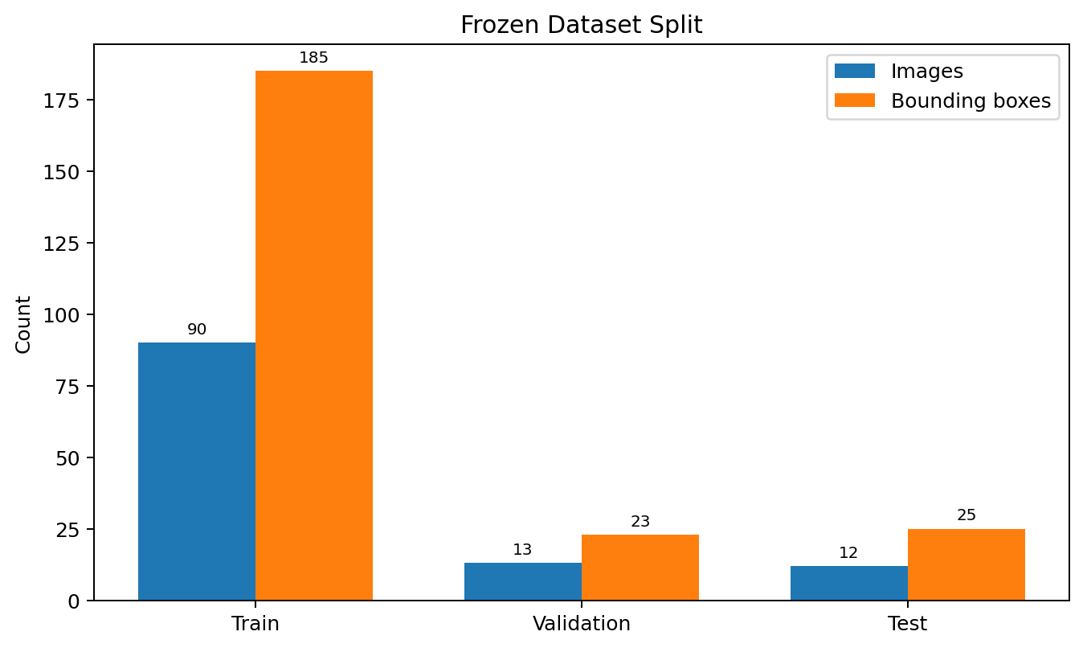
Figure 1. Frozen dataset image and bounding-box counts by split.
The split ratio is approximately 78.3% training, 11.3% validation and 10.4% test. All 115 images have 3000 × 4000 resolution. The dataset contains an average of 2.03 annotated plates per image and up to seven plates in a single image.

3.1 Annotation Format
YOLO annotations use the standard class_id, x_center, y_center, width and height representation with coordinates normalized to the image dimensions. The task has one class only: number_plate. Individual registration strings are not detector classes; they are recognized later by OCR.

4. Data Understanding and Exploratory Data Analysis
EDA audited dataset structure, annotation validity, image quality and bounding-box geometry before training. All image-label pairs were present and all 233 YOLO annotations were valid. Eight images were flagged for low sharpness and retained for review rather than automatically removed, preserving difficult but valid real-world examples.
EDA measure | Result
Image-label mismatches | 0
Invalid YOLO annotations | 0
Low-sharpness images flagged | 8
Images removed after review | 0
Dark images by threshold | 0
Overexposed images by threshold | 0
Low-resolution images | 0
Mean brightness | 141.72
Median sharpness | 344.33

4.1 Bounding-Box Geometry
Measure | Mean | Median | Minimum | Maximum
Normalized box width | 0.0980 | 0.0827 | 0.0063 | 0.4853
Normalized box height | 0.0499 | 0.0393 | 0.0030 | 0.2045
Normalized box area | 0.00725 | 0.00362 | 0.00002 | 0.09925
Aspect ratio | 2.287 | 2.045 | 0.773 | 6.533

The mean normalized plate area is only about 0.72% of the full image area and the median is lower still. Plates are generally wider than tall, with a mean aspect ratio of 2.29, but the wide range in size and shape confirms substantial scale and viewpoint variation. This makes the project partly a small-object detection problem.

4.2 EDA Limitations
- Explicit weather and day/night metadata is unavailable.
- Regional plate-style frequencies cannot be derived from the detection labels.
- Augmentation methods were demonstrated, but a dedicated augmentation-only A/B effectiveness experiment was not isolated.
- The dataset is small, so individual difficult images can materially affect validation and test metrics.

5. Dataset Preparation and Experimental Controls
The project intentionally freezes the train/validation/test split before controlled experimentation. Training is performed on the training split, model selection uses validation only, and the untouched test split is reserved for the selected final model. This prevents test performance from influencing model choice.
Control | Implementation
Frozen split | 90 train / 13 validation / 12 test
Fixed class definition | Single class: number_plate
Fixed seed | Used for reproducible retraining experiments
Pretrained weights | Used for YOLO transfer learning
Optimizer | AdamW in controlled retraining
Early stopping | Patience-based stopping
Batch sizing | Automatic batch sizing
Selection metric | Validation mAP@50-95
Test usage | Only after final model selection

Training candidates used the same frozen dataset and comparable augmentation controls. Augmentation settings included modest rotation, translation, scaling, horizontal flip, HSV variation, mosaic, mixup and erasing. Higher input resolution and larger model capacity were tested as specific hypotheses rather than assumed improvements.

6. Detector Training and Model Selection
Four detector configurations were considered. The existing best.pt checkpoint acted as the incumbent baseline. Controlled retraining then tested whether more input resolution or greater model capacity could improve number-plate localization and generalization.
Experiment | Purpose | Validation outcome / decision
Existing best.pt | Incumbent baseline | Final winner; mAP@50-95 = 0.5216
YOLO26s @ 832 | Controlled retraining at high resolution | Did not beat baseline; mAP@50-95 ≈ 0.482
YOLO26s @ 1024 | Test additional resolution for small plates | Did not beat baseline; mAP@50-95 ≈ 0.467
YOLO26m @ 832 | Test greater model capacity | Did not beat baseline; mAP@50-95 = 0.5171

Increasing the input resolution from 832 to 1024 pixels did not improve validation performance and increased computational cost. The larger YOLO26m model improved some recall behavior but still failed to beat the incumbent on the predefined validation mAP@50-95 selection metric. Because it lost on validation, it was not allowed to replace the final model or influence final test selection.
This anti-regression result is important: retraining was still useful because it demonstrated, under controlled comparisons, that the existing checkpoint remained the strongest available detector. The final selected detector is therefore models/best.pt with an 832-pixel inference size.

7. Detector Evaluation
The selected best.pt detector was evaluated separately on validation and the untouched test split using standard object-detection metrics. Precision measures the fraction of predicted plates that are correct; recall measures the fraction of real plates detected. mAP@50 summarizes average precision at an IoU threshold of 0.50, while mAP@50-95 averages across progressively stricter IoU thresholds from 0.50 to 0.95.
Metric | Validation | Untouched test
Precision | 99.11% | 93.05%
Recall | 86.96% | 60.00%
mAP@50 | 96.35% | 68.62%
mAP@50-95 | 52.16% | 38.32%

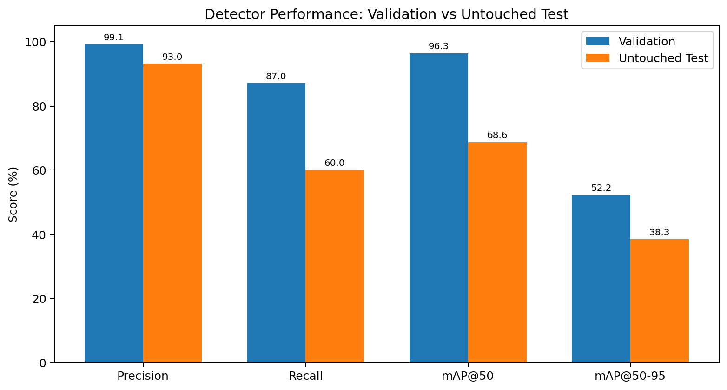
Figure 2. Final detector performance on validation and untouched test data.
Validation performance is strong, but unseen test performance is materially lower. Precision remains high on test, meaning most reported detections are valid; the larger decline is in recall, indicating that real plates are being missed. The difference between validation mAP@50 of 96.35% and test mAP@50 of 68.62% is therefore reported transparently as a generalization gap rather than presenting the validation score as the final unseen-data result.

8. Operating-Point Selection and Error Analysis
The final confidence threshold was selected using a validation-only sweep from 0.05 to 0.90. Each threshold reused the same cached low-confidence predictions and was evaluated using one-to-one prediction-to-ground-truth matching at IoU ≥ 0.50. Thresholds were ranked primarily by F1, with precision and then confidence used as tie-breakers.
Metric | Selected validation operating point | Frozen threshold on test
Confidence threshold | 0.50 | 0.50
TP | 20 | 14
FP | 1 | 1
FN | 3 | 11
Precision | 95.24% | 93.33%
Recall | 86.96% | 56.00%
F1 | 90.91% | 70.00%
Mean matched IoU | 0.775 | 0.786

The test operating point contains only one false positive but eleven false negatives. This explains the high precision and lower recall and shows that missed detections are the dominant failure mode. Mean matched IoU remains 0.786 for successful test matches, which indicates reasonably good localization when the model does detect a plate; it does not offset the lower recall.

8.1 Failure Patterns
- Very small number plates and distant vehicles.
- Wide street scenes where plates occupy only a tiny fraction of the image.
- Partially visible plates and difficult viewing angles.
- Some localization cases where a predicted box is near the correct region but does not reach the IoU ≥ 0.50 matching rule.
- One test image contains several extremely small annotated plates and contributes disproportionately to the false-negative count.
The error analysis supports the conclusion that the remaining detector limitation is more strongly related to data diversity, object scale and generalization than to simply choosing a larger model or higher resolution.

9. OCR Evaluation and Selection
OCR was evaluated independently from detector metrics so that text-recognition quality could be measured directly. A frozen benchmark of 19 independently verified readable plate crops was used. Unverified YOLO diagnostic crops were kept separate from accuracy calculations.

9.1 Controlled OCR Experiment
Experiment dimension | Options
OCR engines | Tesseract, EasyOCR, PaddleOCR
Preprocessing variants | Original, grayscale, CLAHE, Otsu, bilateral filtering, Canny edges
Benchmark size | 19 verified readable plates
Total evaluations | 19 × 6 × 3 = 342
Metrics | Strict exact match, character accuracy, confidence, unreadable rate, OCR time

The selected configuration was PaddleOCR using the original YOLO plate crop. In this benchmark, the original crop outperformed the tested preprocessing transformations for PaddleOCR. A generic Indian registration cleanup stage was then applied to remove unrelated OCR fragments such as IND and retain plausible registration-format content without benchmark-specific corrections.
OCR metric | Raw OCR | Final after generic cleanup
Strict full-plate exact match | 47.37% | 84.21%
Mean character accuracy | 75.03% | 93.63%
Unreadable rate | — | 5.26%
Mean OCR time | — | 1117.39 ms/plate

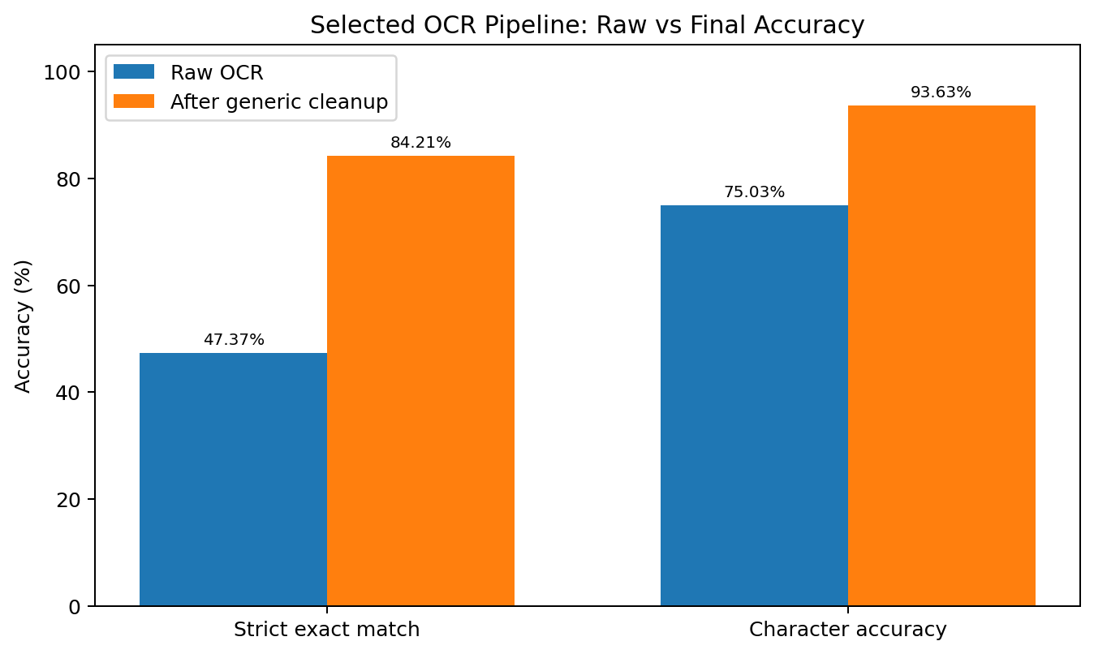
Figure 3. Raw and post-processed accuracy for the selected OCR configuration.

9.2 OCR Failure Analysis
Ground truth | OCR result | Character accuracy
KL07BT2347 | Blank / unreadable | 0.00%
KL22N2122 | KL22M2122 | 88.89%
KL01CJ4909 | L01CJ4909 | 90.00%

Sixteen of the 19 benchmark plates were exact matches after generic cleanup. Character-level accuracy exceeded the 90% project target at 93.63%, but strict full-plate exact match remained below 90% at 84.21%. The project therefore distinguishes these two OCR measures rather than claiming a single unsupported “90% OCR accuracy” result.

10. End-to-End Application Pipeline
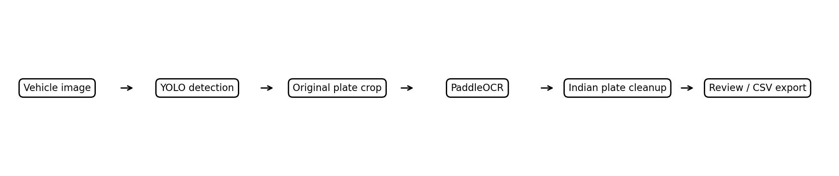
Figure 4. Final production pipeline from vehicle image to reviewed OCR result.
The final production pipeline uses the selected detector and OCR configuration without benchmark-specific corrections. For each input image, YOLO detects one or more number-plate boxes. Each crop is sent directly to PaddleOCR in its original crop form, generic Indian-registration cleanup is applied, and the result is presented with detection/OCR confidence and review status.

10.1 Streamlit Application Features
- Upload JPG, JPEG or PNG vehicle images.
- Capture a single frame using the connected camera through Streamlit.
- Display number-plate bounding boxes and detection confidence.
- Show enlarged plate crops for inspection.
- Run PaddleOCR and display extracted text plus OCR confidence.
- Allow manual correction of uncertain OCR output before final use.
- Maintain a structured detection log and export reviewed results to CSV.
- Display a performance dashboard containing detector, operating-point, OCR and inference metrics.

10.2 Human Review
Manual review is deliberately retained because OCR confidence is not a guarantee of text correctness and the test detector still misses difficult plates. This makes the prototype appropriate for assisted logging and review workflows rather than unsupervised high-stakes enforcement.

11. Runtime and Deployment
Final detector timing was verified on an NVIDIA Tesla T4 after three warm-up runs. The same final detector input size (832) and frozen confidence threshold (0.50) were used across the test images.
Runtime measure | Result
Hardware | NVIDIA Tesla T4
Mean YOLO inference | 19.73 ms/image
Median YOLO inference | 19.71 ms/image
Project detector target | <50 ms/image
Detector target status | ACHIEVED
Selected OCR mean time | 1117.39 ms/plate

The 19.73 ms/image figure represents YOLO model inference, not complete end-to-end application latency. Full application time also includes image I/O, preprocessing, post-processing, crop handling, PaddleOCR and Streamlit overhead. OCR is substantially slower than the detector and is therefore the dominant processing stage when one or more plates are recognized.

11.1 Local Deployment
- Recommended local Python version: Python 3.12.
- Install dependencies from requirements.txt in a virtual environment.
- Place the selected checkpoint at models/best.pt.
- Start the interface with streamlit run app.py.
- The tested OCR environment uses PaddlePaddle 3.2.0 and PaddleOCR 3.2.0.
- The current camera interface captures individual frames; continuous streaming would require a component such as WebRTC.

12. Project Requirement Assessment
The original project brief listed target outcomes for detection, OCR, inference speed and deployment. Final results are assessed against measured evidence rather than assuming that target values were achieved.
Project requirement | Measured evidence | Assessment
95%+ detection accuracy | Validation mAP@50 = 96.35%; untouched test mAP@50 = 68.62% | Validation target reached, but not maintained on unseen test data
90%+ OCR precision/accuracy | Character accuracy = 93.63%; strict exact match = 84.21% | Character-level target achieved; strict full-plate target not achieved
<50 ms detector inference | Mean YOLO inference = 19.73 ms/image on Tesla T4 | ACHIEVED
Interactive deployment | Streamlit upload/camera, detection, OCR, review and CSV export implemented | ACHIEVED as prototype

This transparent target assessment is important because detector “accuracy” is not a single universal metric. The report therefore uses standard object-detection measures and separates validation results from untouched test generalization.

13. Business Insights and Recommendations
- High test precision suggests the detector is suitable for assisted workflows where false alarms should be limited, but the lower recall means a review process is still needed for missed vehicles.
- Additional diverse labeled data is a higher-priority improvement than repeatedly increasing detector size or image resolution, because controlled larger-model and higher-resolution experiments did not beat the incumbent.
- Future data collection should deliberately include tiny/distant plates, wide scenes, oblique angles, partial visibility, glare, blur and different plate layouts.
- Confidence threshold selection should remain validation-driven and frozen before future test evaluations to avoid leakage.
- OCR should continue to expose confidence and editable review output because exact full-plate recognition is not yet reliable enough for fully autonomous use.
- Production deployments should add monitoring, access control, privacy/legal review, retention policies and auditability.

14. Limitations
- The dataset is small: 115 images and 233 boxes, with only 12 images in the untouched test split.
- Validation performance is materially stronger than test performance, indicating limited generalization.
- Tiny and distant plates remain difficult and are the main source of false negatives.
- OCR can fail under blur, glare, occlusion, low resolution, extreme angle or missing characters.
- The OCR benchmark contains only 19 verified readable plates, so more independent OCR ground truth is needed for stronger external validation.
- OCR character accuracy and exact-match accuracy answer different questions and should not be merged into one headline accuracy number.
- The current camera feature processes single frames rather than continuous live video.
- Detector inference timing is hardware-specific and does not represent complete end-to-end application latency.
- Production use would require stronger privacy, security, monitoring and legal controls.

15. Conclusion
The project completed the requested end-to-end vehicle number-plate workflow from dataset audit and EDA through controlled YOLO experiments, final detector selection, validation/test evaluation, operating-point optimization, OCR benchmarking, Streamlit integration and report export.
The final detector is the retained best.pt checkpoint. It achieved 96.35% validation mAP@50 but 68.62% untouched-test mAP@50, with high test precision and lower recall. At the validation-selected confidence threshold of 0.50, test performance was 93.33% precision, 56.00% recall and 70.00% F1, with 11 false negatives. These results show that generalization and small-object recall are the main detector improvement areas.
The final OCR pipeline uses the original YOLO plate crop, PaddleOCR and generic Indian-registration cleanup. On the frozen 19-plate benchmark, it achieved 93.63% character accuracy and 84.21% strict exact match. The detector itself met the speed requirement with 19.73 ms/image mean inference on a Tesla T4. The completed Streamlit prototype combines these components into a reviewable workflow with structured results and CSV export.
Overall, the project demonstrates a complete, reproducible and transparently evaluated computer-vision pipeline. Its strongest production-readiness improvement would come from collecting a larger and more diverse labeled dataset, followed by external detector/OCR validation and stronger deployment controls.

Appendix A — Requirement Coverage
Requirement | Status
Dataset audit and EDA | Complete
YOLO-format annotation validation | Complete — 0 invalid annotations
Train / validation / test split | Complete — frozen 90 / 13 / 12
YOLO detector training / comparison | Complete
Controlled resolution experiment | Complete — 832 vs 1024
Controlled capacity experiment | Complete — YOLO26m @ 832
Validation-based model selection | Complete — mAP@50-95
Untouched test evaluation | Complete
Confidence-threshold sweep | Complete — validation only
TP / FP / FN and IoU analysis | Complete
Detector failure visualization | Complete
Tesseract OCR | Complete
EasyOCR | Complete
PaddleOCR candidate | Complete — selected
Six OCR preprocessing variants | Complete
Frozen OCR benchmark | Complete — 19 verified plates
OCR exact-match and character accuracy | Complete
Generic Indian plate cleanup | Complete
Streamlit application | Complete
Image upload and camera capture | Complete
Manual OCR review and CSV export | Complete
Detector speed verification | Complete — 19.73 ms/image on Tesla T4
Final project documentation | Complete — this report plus repository docs
Demo video / final repository push | To be completed if not already submitted

Appendix B — Final Repository Structure and Key Artifacts
Number-Plate-Detection-Final/
├── app.py
├── README.md
├── PROJECT_CHECKLIST.md
├── requirements.txt
├── .streamlit/config.toml
├── configs/
│ ├── data.yaml
│ └── final_eval_data.yaml
├── data/
│ ├── processed/{train,val,test}/
│ └── ocr_benchmark/crops/
├── models/best.pt
├── notebooks/
│ ├── 01_eda.ipynb
│ ├── 02_train_on_colab.ipynb
│ ├── 03_ocr_evaluation.ipynb
│ └── 04_final_evaluation.ipynb
├── src/ocr_pipeline.py
├── reports/
│ ├── eda_final/
│ ├── yolo_test_evaluation/
│ ├── detection_operating_point/
│ └── ocr_final_experiment/
└── docs/
├── PROJECT_REPORT.md
├── PERFORMANCE_REPORT.md
├── DEPLOYMENT_GUIDE.md
└── DEMO_VIDEO_GUIDE.md

Appendix C — Final Configuration Snapshot
Component | Final configuration
Detector model | models/best.pt
Detector input size | 832
Confidence threshold | 0.50 — selected on validation only
GT matching rule | IoU ≥ 0.50 for TP/FP/FN analysis
OCR engine | PaddleOCR
OCR input | Original detected plate crop
OCR post-processing | Generic Indian registration cleanup
Application | Streamlit
Detector timing hardware | NVIDIA Tesla T4

Number Plate Detection and OCR — Final Project Report

