NutriClass
Food Classification Using Nutritional Data
Final Project Report

Domain: Food & Nutrition / Machine Learning
Skills: Data Preprocessing • Feature Engineering • Multi-class Classification • Evaluation Metrics

Prepared from the finalized NutriClass notebook and project specification

1. Executive Summary
NutriClass is a multi-class machine learning system that classifies a food profile into one of ten predefined food categories using nutritional, dietary, meal, and preparation attributes. The project follows an end-to-end workflow covering data understanding, exploratory data analysis, data cleaning, outlier treatment, preprocessing, feature selection, model benchmarking, cross-validation, interpretability, and prediction.
The raw dataset contained 31,700 records and 16 columns. After removing records with completely missing nutritional inputs and duplicate rows, 31,260 records remained. The final modelling workflow used an 80/20 stratified split, training-only IQR bounds for outlier capping, StandardScaler for numerical variables, OneHotEncoder for categorical variables, and a Gradient Boosting classifier.
Seven required classifiers were benchmarked. The final Gradient Boosting model with outlier capping achieved 99.50% accuracy and 99.52% Macro F1 on the 6,252-record holdout set. Five-fold stratified cross-validation produced a mean Macro F1 of 99.5361% with a standard deviation of 0.0886 percentage points, indicating stable performance.
Final measure | Result
Clean records | 31,260
Final test records | 6,252
Final model | Gradient Boosting + IQR capping
Holdout Accuracy | 99.50%
Holdout Macro F1 | 99.52%
5-fold CV Mean Macro F1 | 99.54%
5-fold CV Std. Dev. | 0.09 percentage points
Misclassifications | 31

2. Problem Statement and Objective
Increasing dietary awareness creates a need for automated food-classification capabilities. NutriClass aims to learn the relationship between nutritional profiles and predefined food categories so that a new structured profile can be classified automatically.
The target variable is Food_Name. Nutritional metrics and related categorical or Boolean attributes are treated as predictors. This framing follows the assigned project requirement to predict one precise food category rather than building a separate recommendation or optimization engine.

2.1 Business Use Cases
- Smart dietary applications: classify structured food profiles within nutrition-oriented workflows.
- Health monitoring tools: support nutritionists and diet-planning workflows with automated classification.
- Food logging systems: classify user-entered food profiles for tracking applications.
- Educational platforms: demonstrate relationships between nutritional attributes and food categories.
- Grocery and meal-planning applications: provide a classification layer that can support same-category replacement workflows.

2.2 Scope Clarification
The implemented system is a classifier. It predicts the most likely predefined food category from a supplied profile. It does not independently solve a constrained meal-planning or recommendation optimization problem; such a layer could be added later on top of the classifier.

3. Dataset Description
The project dataset is a synthetic tabular food dataset with 31,700 records and 16 columns.
Feature group | Columns
Numerical | Calories, Protein, Fat, Carbs, Sugar, Fiber, Sodium, Cholesterol, Glycemic_Index, Water_Content, Serving_Size
Categorical | Meal_Type, Preparation_Method
Boolean | Is_Vegan, Is_Gluten_Free
Target | Food_Name

The target contains ten food classes: Apple, Banana, Burger, Donut, Ice Cream, Pasta, Pizza, Salad, Steak, and Sushi.

4. Data Understanding and Exploratory Data Analysis
EDA focused on dataset size, data types, missingness, duplicates, target balance, categorical distributions, correlations, and class-level nutritional differences.
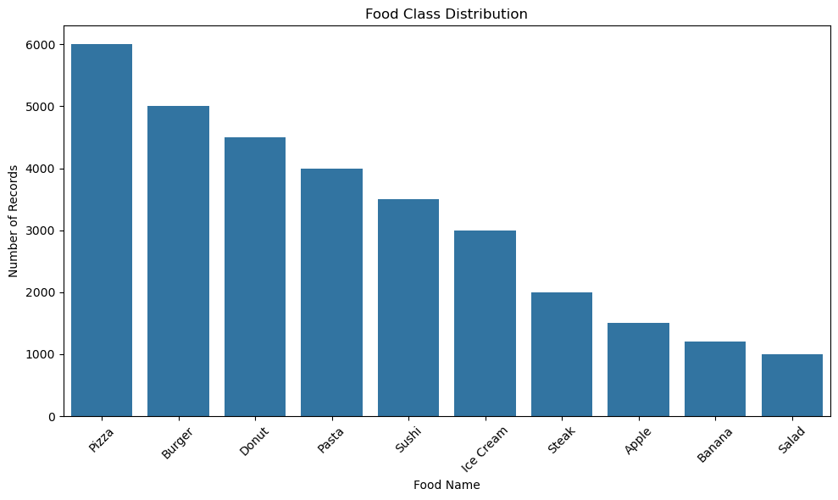
Figure 1. Food-class distribution. The target is imbalanced, with Pizza as the largest class and Salad as the smallest.
The class distribution is uneven: Pizza has 6,000 records while Salad has 1,000. Because of this imbalance, model evaluation uses Macro F1 in addition to accuracy and weighted metrics.
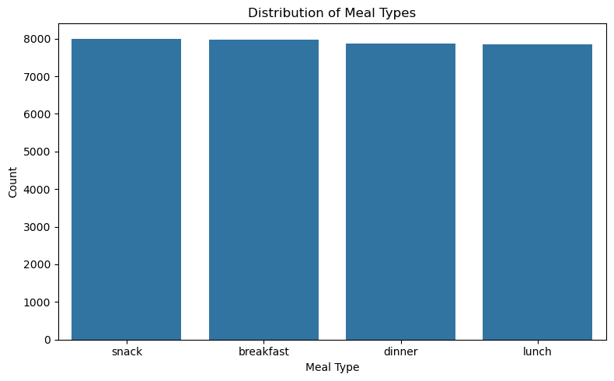
Figure 2. Meal-type distribution. Breakfast, lunch, dinner, and snack are represented with broadly similar frequencies.
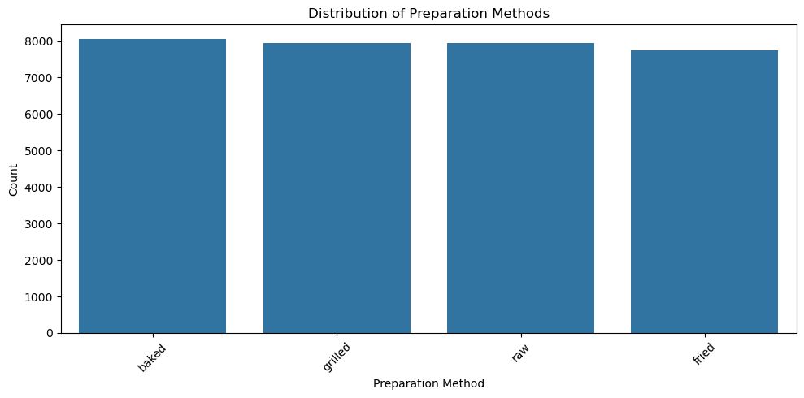
Figure 3. Preparation-method distribution. Baked, grilled, raw, and fried are broadly balanced.
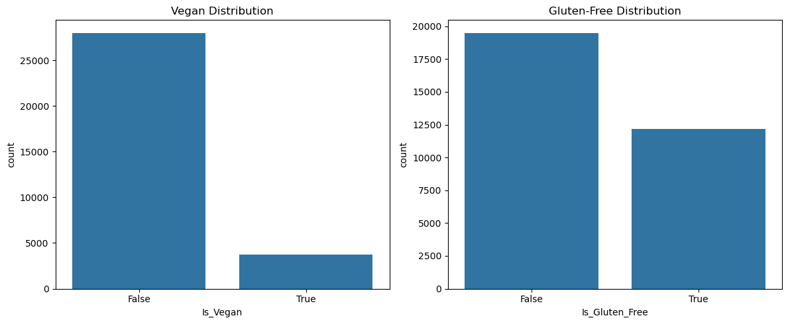
Figure 4. Boolean feature distributions. Is_Vegan is strongly imbalanced; Is_Gluten_Free is more broadly distributed.
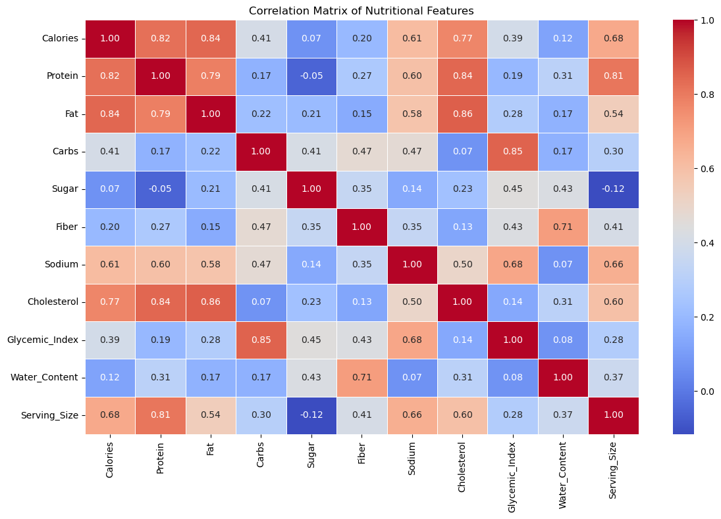
Figure 5. Correlation matrix of numerical nutritional variables. Strong relationships include Calories–Protein, Calories–Fat, Protein–Cholesterol, Fat–Cholesterol, and Carbs–Glycemic Index.
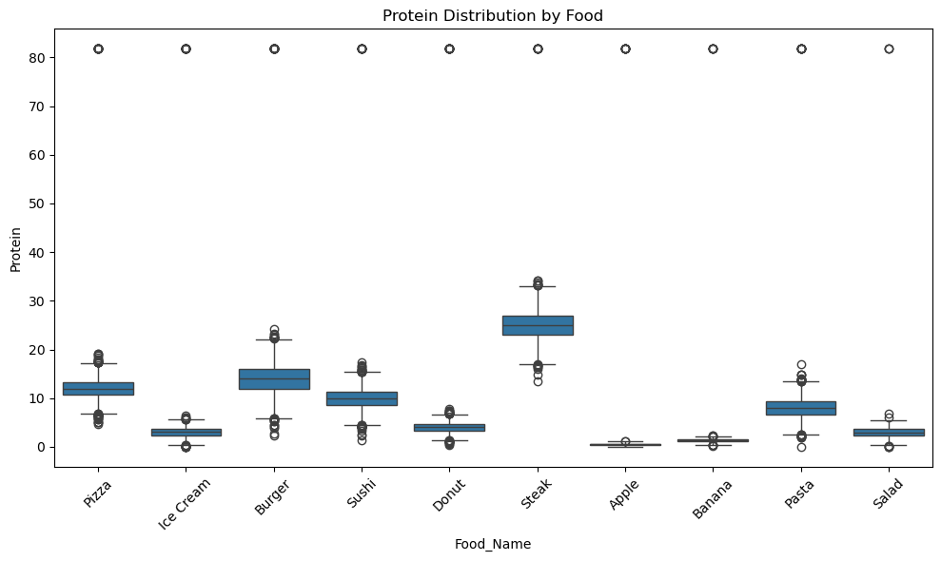
Figure 6. Protein distributions by food category.
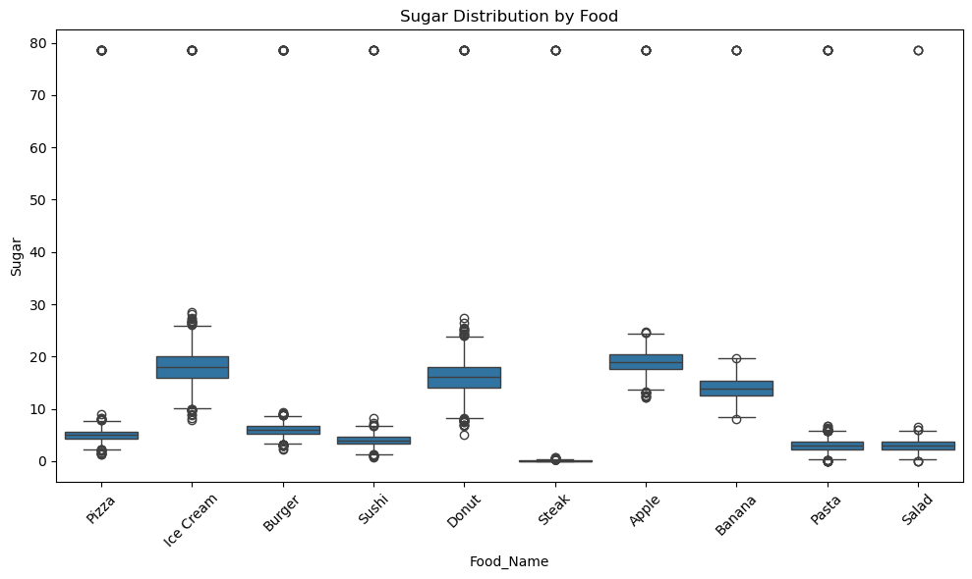
Figure 7. Sugar distributions by food category.

5. Data Cleaning and Preprocessing

5.1 Missing Values
Each of the 11 numerical nutritional variables contained 375 missing values (1.18%). The categorical, Boolean, and target columns had no missing values. The incomplete records had all numerical nutritional fields missing simultaneously. Because only 1.18% of records were affected and there was insufficient numerical information for reliable imputation, these records were removed.

5.2 Duplicate Records
The original dataset contained 313 duplicate rows. After the missing-record removal step, 65 additional exact duplicates remained and were removed. The resulting clean dataset contains 31,260 records.
Stage | Rows | Change
Original | 31,700 | —
After missing-value removal | 31,325 | -375
After duplicate removal | 31,260 | -65 from the post-missing dataset

5.3 Outlier Detection and Treatment
Outliers were initially identified using the IQR method. Global IQR counts were high for several variables because food categories naturally occupy different nutritional ranges. Class-wise analysis showed that many flagged observations were plausible within their food categories.
For the final modelling refinement, IQR capping was applied instead of deletion. Lower and upper bounds were calculated from the training data only, then applied to both training and test sets. This prevented test-set information from influencing preprocessing while preserving all observations.
Feature | Before max | After cap max
Calories | 1289.96 | 508.33
Protein | 81.76 | 25.90
Fat | 88.62 | 27.06
Carbs | 140.59 | 48.86
Sugar | 78.55 | 30.22
Fiber | 18.89 | 5.56
Sodium | 2724.24 | 1482.54
Cholesterol | 260.15 | 68.58
Glycemic Index | 286.13 | 98.47
Water Content | 251.84 | 72.35
Serving Size | 554.72 | 308.18

6. Feature Engineering and Preprocessing
The 15 predictor columns consist of 11 numerical variables, two categorical variables, and two Boolean variables. A ColumnTransformer/Pipeline architecture was used so that preprocessing is reproducible and identical during training and prediction.
Component | Method | Purpose
Numerical variables | StandardScaler | Put numerical features on comparable scales for scale-sensitive algorithms such as Logistic Regression, KNN, and SVM.
Categorical variables | OneHotEncoder(handle_unknown="ignore") | Convert Meal_Type and Preparation_Method into model-ready indicator features.
Boolean variables | Pass through | Retain Is_Vegan and Is_Gluten_Free as binary predictors.
Target | LabelEncoder | Convert Food_Name into class labels for model training/evaluation.

The preprocessing transformation expands the original 15 predictors to 21 processed features.

7. Model Selection and Training
Seven classifiers required by the project specification were trained and evaluated using the same benchmark split and metric framework: Logistic Regression, Decision Tree, Random Forest, K-Nearest Neighbors, Support Vector Machine, XGBoost, and Gradient Boosting.
Model | Accuracy | Precision | Recall | Weighted F1 | Macro F1
Logistic Regression | 99.39% | 99.40% | 99.39% | 99.39% | 99.37%
Decision Tree | 98.72% | 98.72% | 98.72% | 98.72% | 98.87%
Random Forest | 99.46% | 99.46% | 99.46% | 99.46% | 99.48%
KNN | 99.25% | 99.25% | 99.25% | 99.25% | 99.23%
SVM | 99.46% | 99.46% | 99.46% | 99.46% | 99.44%
XGBoost | 99.46% | 99.46% | 99.46% | 99.46% | 99.49%
Gradient Boosting (initial benchmark) | 99.52% | 99.52% | 99.52% | 99.52% | 99.53%

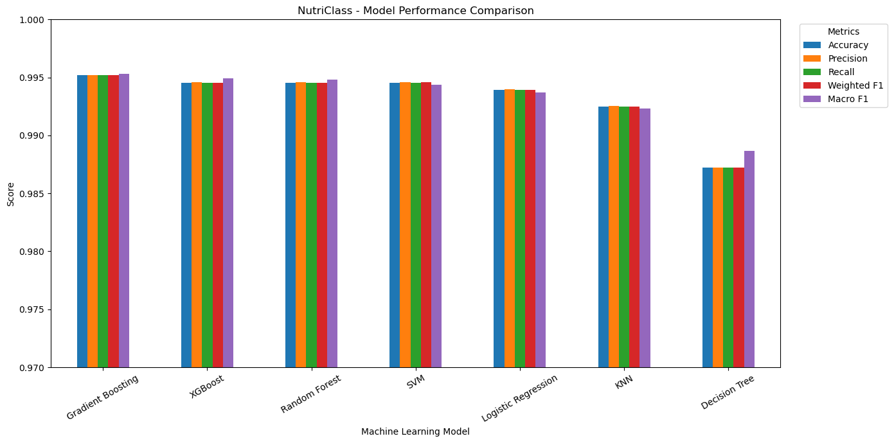
Figure 8. Benchmark comparison across accuracy, precision, recall, weighted F1, and Macro F1.
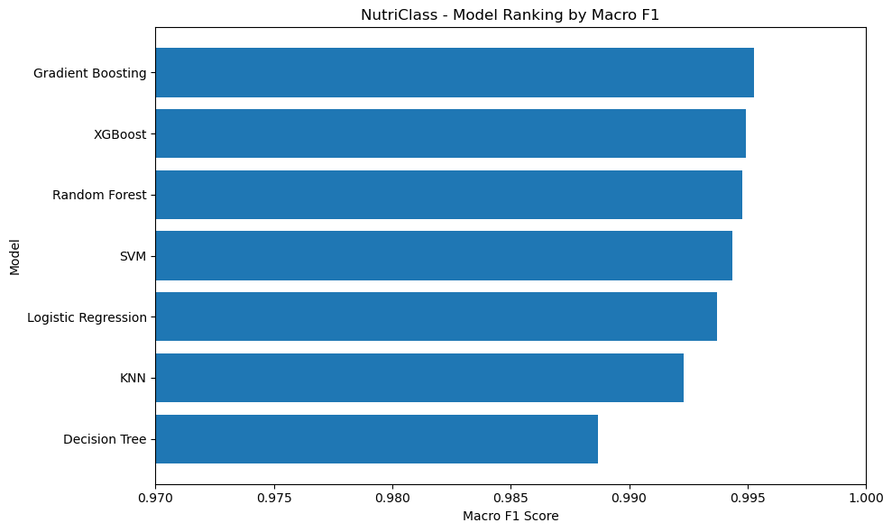
Figure 9. Initial benchmark ranking by Macro F1.
The leading models were very close. Gradient Boosting was selected as the candidate for final refinement because it achieved the strongest initial benchmark performance while providing a tree-based non-linear modelling approach.

8. Model Evaluation

8.1 Confusion Matrices for All Seven Models
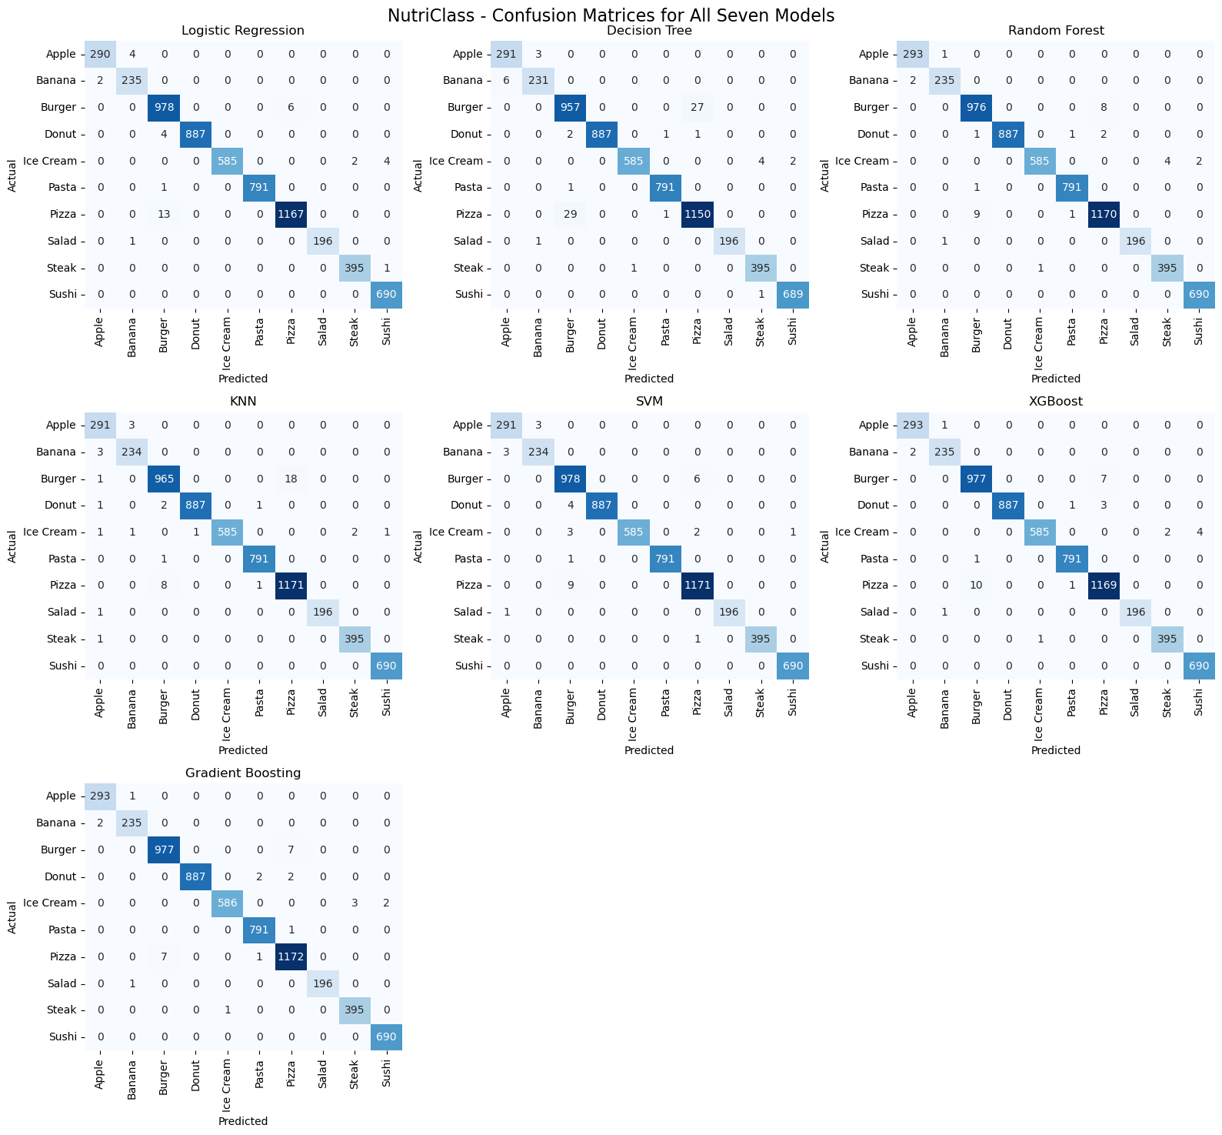
Figure 10. Confusion matrices for all seven benchmark models. Diagonal values indicate correct classifications; off-diagonal values indicate class confusion.
The matrices show that nearly all predictions lie on the diagonal for every model, matching the high accuracy and F1 scores. This also satisfies the requirement to evaluate each classifier using a confusion matrix.

9. Feature Selection Experiment
Feature selection was explicitly required by the project specification. SelectKBest with the ANOVA F-test reduced the 21 processed features to 15 selected features.
Experiment | Processed features | Accuracy | Macro F1 | Decision
Full processed feature set | 21 | 99.50% (final capped model) | 99.52% | Retained for final system
SelectKBest + Gradient Boosting | 15 | 99.46% | 99.54% | Documented as experiment

The selected features were all 11 numerical nutritional variables, Meal_Type dinner, Meal_Type lunch, Is_Vegan, and Is_Gluten_Free. Preparation Method was not selected. The feature-selected model slightly improved Macro F1 but reduced accuracy, so the full-feature final model was retained.

10. Final Model and Validation

10.1 Final Model Definition
The final implementation is a Gradient Boosting classifier trained on the outlier-capped training data using all 21 processed features. The model uses 200 boosting estimators, learning_rate=0.1, max_depth=3, and random_state=42.

10.2 Holdout Performance
Metric | Result
Accuracy | 99.50%
Precision | 99.50%
Recall | 99.50%
Weighted F1 | 99.50%
Macro F1 | 99.52%

The final test set contains 6,252 records. The model correctly classified 6,221 and misclassified 31. The most noticeable confusion is between Burger and Pizza, which have relatively similar nutritional profiles in the dataset.
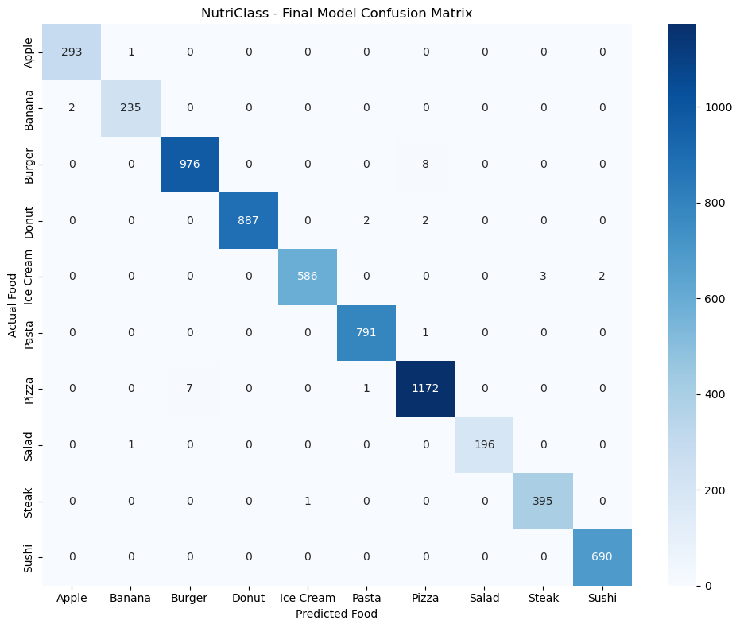
Figure 11. Final confusion matrix for Gradient Boosting with outlier capping.

10.3 Five-Fold Stratified Cross-Validation
The final capped model was validated with 5-fold stratified cross-validation using Macro F1 as the scoring metric. Stratification preserves the class distribution across folds.
Fold | Macro F1
1 | 99.4927%
2 | 99.5434%
3 | 99.6904%
4 | 99.5339%
5 | 99.4201%
Mean | 99.5361%
Std. Dev. | 0.0886 percentage points

The low standard deviation indicates that the model maintains stable performance across different training/validation partitions.

11. Feature Importance and Interpretation
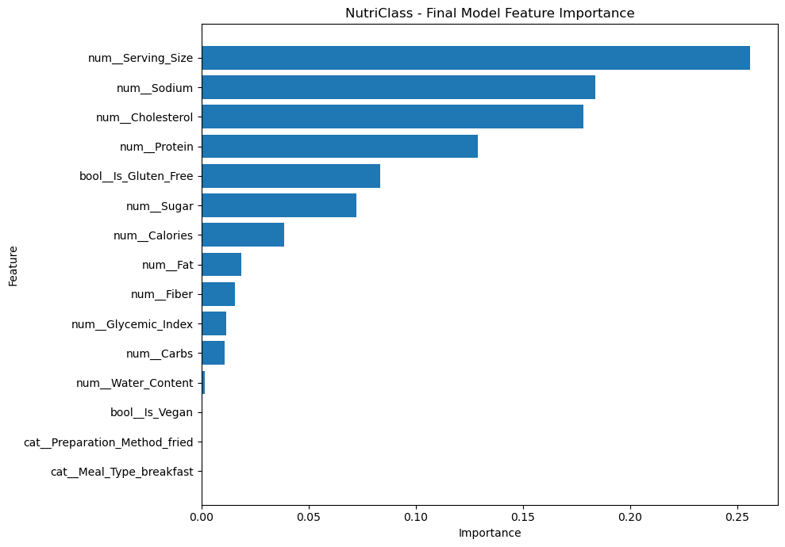
Figure 12. Final Gradient Boosting feature importance.
Feature | Importance
Serving Size | 25.61%
Sodium | 18.38%
Cholesterol | 17.83%
Protein | 12.91%
Is Gluten Free | 8.35%
Sugar | 7.21%
Calories | 3.84%
Fat | 1.86%
Fiber | 1.56%
Glycemic Index | 1.14%
Carbs | 1.07%
Water Content | 0.16%
Is Vegan | 0.04%

Serving Size, Sodium, Cholesterol, and Protein are the four dominant predictors and together account for approximately 74.7% of total feature importance. Meal Type and Preparation Method have minimal individual importance in the final tree ensemble.
These values describe the model’s relative use of features for prediction; they do not imply causal effects or that a feature is medically determinative.

12. Prediction Demonstration
The trained model is persisted as a reusable pipeline so that raw user inputs can be passed through the same preprocessing and classification process without retraining.
Input profile example | Value
Calories | 403
Protein | 25 g
Fat | 25 g
Carbs | 1 g
Sugar | 0.5 g
Fiber | 0.1 g
Sodium | 100 mg
Cholesterol | 80 mg
Glycemic Index | 2
Water Content | 2 (dataset units)
Serving Size | 200
Meal Type | Dinner
Preparation | Grilled
Vegan | False
Gluten Free | True

Prediction: **Steak — 100.00% model probability**. Burger and Pizza were the next-ranked classes with effectively zero probability for this particular input. The displayed percentage is the model’s predicted probability for the supplied profile, not a guarantee of real-world identity.

13. Business Insights and Recommendations
- Nutritional and serving characteristics are strong classification signals; the model relies most on Serving Size, Sodium, Cholesterol, and Protein.
- Automated food logging is a practical first application because a structured nutritional profile can be classified without manual label selection.
- The model can support nutrition-oriented dashboards and educational tools by exposing which attributes are most informative for a predefined category.
- A future recommendation layer could use user goals and constraints to search among allowed foods; this is distinct from the current classification model.
- Real-world deployment should validate the model on non-synthetic, independently collected food data before making health-related decisions from predictions.

14. Limitations
- The dataset is synthetic, so the very high measured performance may not transfer directly to real-world food data.
- The model predicts among ten predefined food classes and cannot identify a food outside those classes.
- The classifier is not a complete dietary recommendation engine and does not optimize meal plans against user-specific health constraints.
- The model’s predicted probability is a model output and should not be interpreted as medical certainty.
- External validation on a representative real-world dataset would be required before production use.

15. Conclusion
NutriClass completed the requested multi-class food-classification workflow from data understanding through final prediction. The project addressed missing values and duplicates, investigated and capped outliers, standardized and encoded features, performed feature selection, benchmarked all seven specified classifiers, evaluated model quality using multiple metrics and confusion matrices, and validated the final model using five-fold stratified cross-validation.
The final Gradient Boosting model achieved 99.50% holdout accuracy and 99.52% Macro F1, with a five-fold cross-validation mean Macro F1 of 99.54% and a standard deviation of 0.09 percentage points. These results demonstrate strong and stable performance on the supplied synthetic dataset.
The trained model and preprocessing pipeline were saved as `models/nutriclass_final_model.pkl` for reuse in future applications.

Appendix A — Requirement Coverage
Requirement | Status
Data understanding and EDA | Complete
Missing-value handling | Complete
Duplicate removal | Complete
Outlier detection and treatment | Complete — IQR capping
Standardization/normalization | Complete — StandardScaler
Feature selection / PCA | Complete — SelectKBest, 21 to 15
Target encoding | Complete — LabelEncoder
Seven required classifiers | Complete
Accuracy, Precision, Recall, F1 | Complete
Confusion matrix evaluation | Complete — all seven models
Cross-validation | Complete — 5-fold stratified final model
Reproducibility | Complete — fixed random seeds
Feature importance | Complete — final Gradient Boosting
Source notebook | Complete / finalized
Visualizations | Complete
Comprehensive report | This document
Version control | Repository setup is the remaining delivery step

