Smart Camera

Backtrace调试

**Black.lian Version 0.1**

© 2017 MStar Semiconductor, Inc. All rights reserved.

MStar Semiconductor makes no representations or warranties including, for example but not limited to, warranties of merchantability, fitness for a particular purpose, non-infringement of any intellectual property right or the accuracy or completeness of this document, and reserves the right to make changes without further notice to any products herein to improve reliability, function or design. No responsibility is assumed by MStar Semiconductor arising out of the application or use of any product or circuit described herein; neither does it convey any license under its patent rights, nor the rights of others.

MStar is a trademark of MStar Semiconductor, Inc. Other trademarks or names herein are only for identification purposes only and owned by their respective owners.

REVISION HISTORY

| Revision No. | Description | Date |
| --- | --- | --- |
| 1.0 | * Initial release | 07/11/2017 |

TABLE OF CONTENTS

1. 查找错误及定位函数 3

1.1. 定位Backtrace点 3

# 查找错误及定位函数

## 定位Backtrace点

1. 当程序出现kernel 崩溃时，可能会出现Backtrace信息

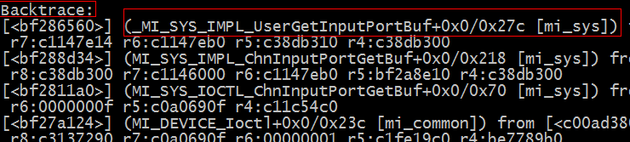

(2) 将错误log往上移，找到PC，以下为关键信息

_MI_SYS_IMPL_UserGetInputPorBuf 挂掉的函数

0x258 函数中crash的位置

[mi_sys] 函数所属的ko

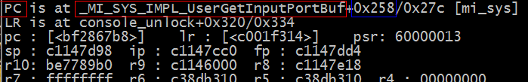

(3) 重启板子，将板子上所属的ko拷贝到电脑上



(4) 在电脑上对拷贝下来的ko 执行反汇编操作

arm-none-linux-gnueabi-objdump -d



(5) 打开objdump.txt文件 找到 _MI_SYS_IMPL_UserGetInputPorBuf 函数

关键信息为 00006560 (16进制)

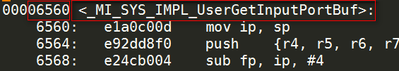

(6) 计算位置 0x6560+0x258=0x678b

(7) 将位置转化为代码具体行数

arm-none-linux-gnueabi-addr2line –e

关键信息 mi_sys_impl.c

1573



函数crash的位置为mi_sys_impl.c 1573行