- How many distinct spatiotemporal signals are present in the dataset? Please provide an explanation of the methodology used to determine this number.

The singular-value spectrum shows that only a few singular values are significant.
According to the 99.9% cumulative energy criterion, the effective rank is approximately r = 3, which means that only three dominant spatiotemporal modes contain almost all the energy of the dataset. Therefore, the data are effectively low-rank and can be represented by three major dynamic components from the singular value spectrum and the 99.9% cumulative energy curve.
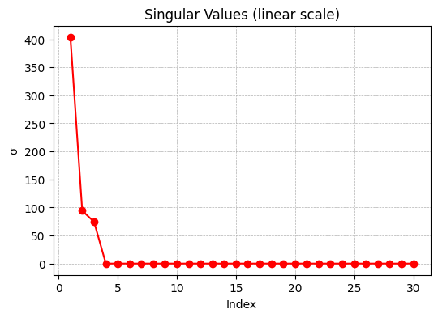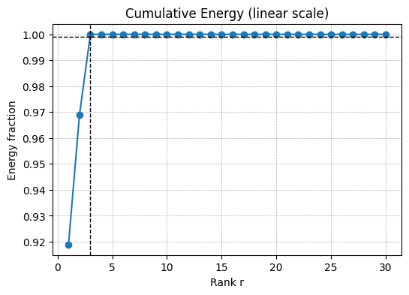

- Could you specify the frequencies associated with each individual spatiotemporal signal? Explain how you arrived at this number.

Using the DMD eigenvalues μ, the continuous-time eigenvalues are computed as
ω= log(μ)/Δt, f=|Im(ω)|/(2π)
The three dominant frequencies are:
- f1≈0.255288
- f2≈0.542486
- f3≈1.021151 (cycles per unit time)
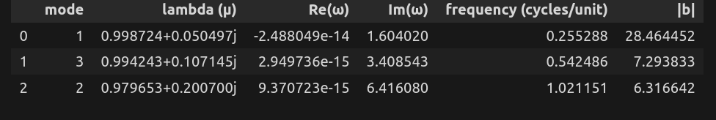

These correspond to three main oscillatory spatiotemporal components observed in the data. Figure below shows the time evolution of the three dominant DMD modes, oscillating at approximately 0.102, 0.216, and 0.407 cycles per unit time.
、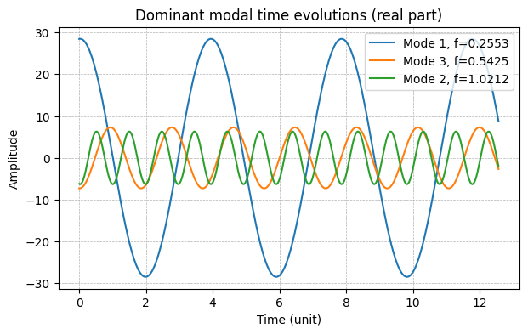
[3] Could you please generate visual representations of both the spatial modes of the data and the data reconstructed using Dynamic Mode Decomposition (DMD)? Subsequently, compare the reconstructed data to the ground truth and offer insights on your observations.

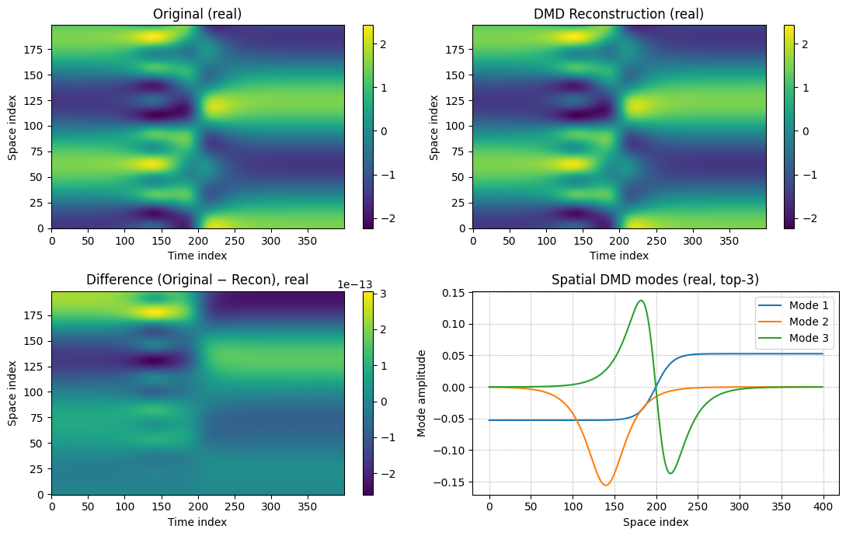

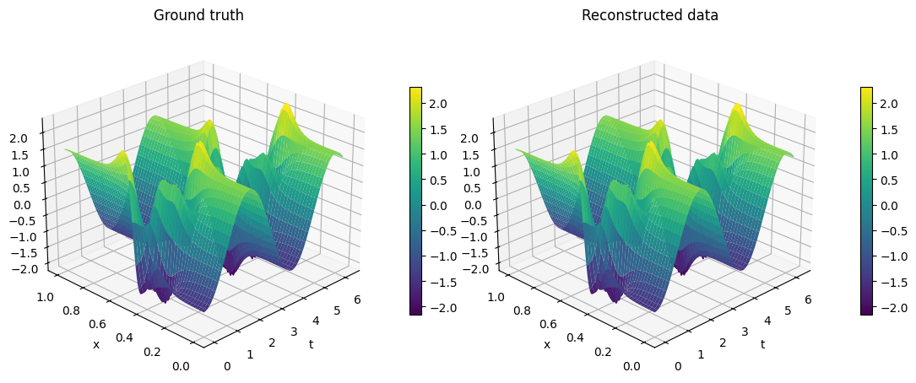
The DMD reconstruction reproduces the original spatiotemporal field with extremely small error (< 1e-13). The heatmaps (top-left vs top-right) and the 3D surfaces show that the reconstructed dynamics match the ground truth almost perfectly, confirming that three dominant modes capture the essential system behavior.
(a) Original data (real part) and DMD reconstruction.
(b) Difference (Original − Reconstructed) showing negligible residuals.
(c) Spatial DMD modes (top-3) representing the primary spatial structures.
(d) 3D surface comparison of the ground-truth and reconstructed fields.

[4] Can you make predictions for future values within the time interval ranging from 5π to 6π, using the same sampling interval (∆t) as that of the ground truth data?

Using the learned DMD modes Φ, eigenvalues ω, and coefficients b, the system evolution was predicted from 5π to 6π with the same sampling interval Δt.
The predicted spatiotemporal field shows a smooth continuation of the dynamics beyond the observation window. When combining the original and predicted data, the DMD model exhibits stable extrapolation, preserving both spatial structure and temporal periodicity.

