R Notebook

library(ggplot2)

# Functions

The following function is the function which will be used to get the mode of the data

mymode <- function(x){  
 xtable <- table(x)  
 idx <- xtable == max(xtable)  
 names(xtable)[idx]  
}

# Read in the data from the csv file

churn_data <- read.csv("./eurocomPHONEchurners.csv")

First thing to do is to print out the data summary.

summary(churn_data)

## CUST_ID AREA_CODE MINUTES_CURR_MONTH MINUTES_PREV_MONTH  
## Min. : 1.0 Min. :10040 Min. : 1.0 Min. : 0.0   
## 1st Qu.: 517.5 1st Qu.:15563 1st Qu.: 33.0 1st Qu.: 15.0   
## Median :1035.0 Median :21750 Median : 105.0 Median : 98.0   
## Mean :1035.1 Mean :29816 Mean : 747.7 Mean : 863.9   
## 3rd Qu.:1552.5 3rd Qu.:45987 3rd Qu.: 555.0 3rd Qu.: 444.0   
## Max. :2070.0 Max. :55166 Max. :14000.0 Max. :16754.0   
##   
## MINUTES_3MONTHS_AGO CUST_MOS LONGDIST_FLAG CALLWAITING_FLAG  
## Min. : 0 Min. : 1.00 Min. :0.0000 Min. :0.0000   
## 1st Qu.: 29 1st Qu.: 6.00 1st Qu.:0.0000 1st Qu.:0.0000   
## Median : 97 Median :11.00 Median :1.0000 Median :0.0000   
## Mean : 453 Mean :16.05 Mean :0.5649 Mean :0.4346   
## 3rd Qu.: 598 3rd Qu.:26.00 3rd Qu.:1.0000 3rd Qu.:1.0000   
## Max. :12456 Max. :50.00 Max. :1.0000 Max. :1.0000   
## NA's :3 NA's :3   
## NUM_LINES VOICEMAIL_FLAG MOBILE_PLAN CONVERGENT_BILLING  
## Min. :1.000 Min. :0.0000 Min. :0.0000 No :1241   
## 1st Qu.:1.000 1st Qu.:0.0000 1st Qu.:0.0000 Yes: 830   
## Median :1.000 Median :1.0000 Median :0.0000   
## Mean :1.391 Mean :0.5654 Mean :0.3477   
## 3rd Qu.:2.000 3rd Qu.:1.0000 3rd Qu.:1.0000   
## Max. :3.000 Max. :1.0000 Max. :1.0000   
##   
## GENDER INCOME PHONE_PLAN EDUCATION   
## F: 731 Min. : 17000 : 4 : 8   
## M:1340 1st Qu.: 46000 Euro-Zone : 59 Bachelors :400   
## Median : 75000 International:1067 High School : 3   
## Mean : 85784 National : 671 Masters :330   
## 3rd Qu.: 98000 Promo_plan : 270 PhD :410   
## Max. :320000 Post Primary:829   
## Primary : 91   
## TOT_MINUTES_USAGE CHURNER   
## Min. : 0 no :1021   
## 1st Qu.: 116 yes:1050   
## Median : 264   
## Mean : 2040   
## 3rd Qu.: 1677   
## Max. :36237   
## NA's :4

# Preprocess the data

## Identify duplicate values

ref: <http://www.cookbook-r.com/Manipulating_data/Finding_and_removing_duplicate_records/>

churn_data[duplicated(churn_data$CUST_ID), ]

## CUST_ID AREA_CODE MINUTES_CURR_MONTH MINUTES_PREV_MONTH  
## 152 246 10040 2 0  
## MINUTES_3MONTHS_AGO CUST_MOS LONGDIST_FLAG CALLWAITING_FLAG NUM_LINES  
## 152 0 1 0 0 1  
## VOICEMAIL_FLAG MOBILE_PLAN CONVERGENT_BILLING GENDER INCOME PHONE_PLAN  
## 152 1 0 No F 29000 National  
## EDUCATION TOT_MINUTES_USAGE CHURNER  
## 152 Post Primary 0 no

## Remove the duplicates

churn_data <- churn_data[!duplicated(churn_data$CUST_ID), ]

nrow(churn_data)

## [1] 2070

## Identify null values

The summary data can be used to identify the columns which contain null values.

The columns with null values are:

* MINUTES_3MONTHS_AGO (3 records)
* CUST_MOS (3 records)
* TOT_MINUTES_USAGE (4 records)
* PHONE_PLAN (4 records)
* EDUCATION (8 records)

## Addressing the issues of the missing values.

For the numeric values they will be replaced with median value for the columns

### MINUTES_3MONTHS_AGO

median(churn_data$MINUTES_3MONTHS_AGO, na.rm = TRUE)

## [1] 97

MINUTES_3MONTHS_AGO_median <- median(churn_data$MINUTES_3MONTHS_AGO, na.rm = TRUE)

churn_data$MINUTES_3MONTHS_AGO[is.na(churn_data$MINUTES_3MONTHS_AGO)] <- MINUTES_3MONTHS_AGO_median

### CUST_MOS

median(churn_data$CUST_MOS, na.rm = TRUE)

## [1] 11

CUST_MOS_median <- median(churn_data$CUST_MOS, na.rm = TRUE)

churn_data$CUST_MOS[is.na(churn_data$CUST_MOS)] <- CUST_MOS_median

### TOT_MINUTES_USAGE

median(churn_data$TOT_MINUTES_USAGE, na.rm = TRUE)

## [1] 264

TOT_MINUTES_USAGE_median <- median(churn_data$TOT_MINUTES_USAGE, na.rm = TRUE)

churn_data$TOT_MINUTES_USAGE[is.na(churn_data$TOT_MINUTES_USAGE)] <- TOT_MINUTES_USAGE_median

### PHONE_PLAN

The first thing to do was to ceate a data frame which is comprised of the gender and phone plan

phone_plan_gender_subset <- data.frame(churn_data$PHONE_PLAN, churn_data$GENDER)

phone_plan_gender_subset[1:10,]

## churn_data.PHONE_PLAN churn_data.GENDER  
## 1 International M  
## 2 International M  
## 3 National F  
## 4 International M  
## 5 Promo_plan M  
## 6 National M  
## 7 International F  
## 8 International F  
## 9 National F  
## 10 International F

The data frame is then filtered again so it just contains data for record for male records

phone_plan_male_subset <- phone_plan_gender_subset[phone_plan_gender_subset$churn_data.GENDER == 'M', 1]

phone_plan_male_subset[1:10]

## [1] International International International Promo_plan National   
## [6] National International National National International  
## Levels: Euro-Zone International National Promo_plan

The mode of the phone plan is stored formale records

print(phone_plan_male_mode <- mymode(phone_plan_male_subset))

## [1] "International"

The data frame is then filtered again so it just contains data for record for female records

phone_plan_female_subset <- phone_plan_gender_subset[phone_plan_gender_subset$churn_data.GENDER == 'F', 1]

phone_plan_female_subset[1:10]

## [1] National International International National International  
## [6] International National International National International  
## Levels: Euro-Zone International National Promo_plan

print(phone_plan_female_mode <- mymode(phone_plan_female_subset))

## [1] "International"

We then find the indexes of the phone plan records with empty values

no_phone_plans <- which(churn_data$PHONE_PLAN == "")

churn_data[no_phone_plans,]

## CUST_ID AREA_CODE MINUTES_CURR_MONTH MINUTES_PREV_MONTH  
## 673 352 36785 6000 7899  
## 979 914 21750 7543 16754  
## 1191 1190 21750 12000 8000  
## 1465 1656 21750 5000 7000  
## MINUTES_3MONTHS_AGO CUST_MOS LONGDIST_FLAG CALLWAITING_FLAG NUM_LINES  
## 673 630 36 0 0 2  
## 979 598 30 1 1 2  
## 1191 598 30 1 1 2  
## 1465 75 6 1 0 1  
## VOICEMAIL_FLAG MOBILE_PLAN CONVERGENT_BILLING GENDER INCOME  
## 673 1 0 Yes M 145000  
## 979 0 1 Yes M 46000  
## 1191 0 1 Yes M 46000  
## 1465 1 0 No F 39000  
## PHONE_PLAN EDUCATION TOT_MINUTES_USAGE CHURNER  
## 673 Post Primary 14529 yes  
## 979 Post Primary 24895 yes  
## 1191 Post Primary 20598 yes  
## 1465 Post Primary 264 no

for (index in no_phone_plans)  
{  
 if (churn_data$GENDER[index] == 'M')   
 {  
 churn_data$PHONE_PLAN[index] <- phone_plan_male_mode  
 }   
 else   
 {  
 churn_data$PHONE_PLAN[index] <- phone_plan_female_mode  
 }  
}

churn_data$PHONE_PLAN[no_phone_plans]

## [1] International International International International  
## Levels: Euro-Zone International National Promo_plan

churn_data$PHONE_PLAN <- droplevels(churn_data$PHONE_PLAN)

summary(churn_data$PHONE_PLAN)

## Euro-Zone International National Promo_plan   
## 59 1071 670 270

### EDUCATION

The first thing to do was to ceate a data frame which is comprised of the gender and education

education_gender_subset <- data.frame(churn_data$EDUCATION, churn_data$GENDER)

education_gender_subset[1:10,]

## churn_data.EDUCATION churn_data.GENDER  
## 1 Masters M  
## 2 Bachelors M  
## 3 High School F  
## 4 High School M  
## 5 High School M  
## 6 M  
## 7 PhD F  
## 8 Bachelors F  
## 9 Bachelors F  
## 10 F

The data frame is then filtered again so it just contains data for record for male records

no_education_male_subset <- education_gender_subset[education_gender_subset$churn_data.GENDER == 'M', 1]

no_education_male_subset[1:10]

## [1] Masters Bachelors High School High School   
## [6] Primary PhD PhD Masters Masters   
## Levels: Bachelors High School Masters PhD Post Primary Primary

The mode of the phone plan is stored formale records

no_education_male_mode <- mymode(no_education_male_subset)

no_education_male_mode

## [1] "Post Primary"

The data frame is then filtered again so it just contains data for record for female records

no_education_female_subset <- education_gender_subset[education_gender_subset$churn_data.GENDER == 'F', 1]

no_education_female_mode <- mymode(no_education_female_subset)

no_education_female_mode

## [1] "Bachelors"

We then find the indexes of the phone plan records with empty values

no_education <- which(churn_data$EDUCATION == "")

churn_data[no_education,]

## CUST_ID AREA_CODE MINUTES_CURR_MONTH MINUTES_PREV_MONTH  
## 6 134 36785 97 56  
## 10 138 21750 5 15  
## 109 237 36785 398 144  
## 233 104 55166 344 232  
## 283 282 55166 550 55  
## 339 466 55166 550 100  
## 1366 228 15563 53 34  
## 1389 44 15563 53 34  
## MINUTES_3MONTHS_AGO CUST_MOS LONGDIST_FLAG CALLWAITING_FLAG NUM_LINES  
## 6 97 8 0 0 1  
## 10 75 6 1 0 1  
## 109 630 36 0 0 2  
## 233 455 11 1 1 2  
## 283 500 17 1 1 1  
## 339 500 17 1 1 1  
## 1366 29 50 1 1 1  
## 1389 29 50 1 1 1  
## VOICEMAIL_FLAG MOBILE_PLAN CONVERGENT_BILLING GENDER INCOME  
## 6 0 1 No M 125000  
## 10 1 0 No F 39000  
## 109 1 0 No M 145000  
## 233 1 1 Yes M 75000  
## 283 0 0 No M 320000  
## 339 0 0 No M 320000  
## 1366 0 0 No F 48000  
## 1389 0 0 No F 48000  
## PHONE_PLAN EDUCATION TOT_MINUTES_USAGE CHURNER  
## 6 National 250 no  
## 10 International 95 no  
## 109 National 1172 no  
## 233 Promo_plan 1031 no  
## 283 Promo_plan 1105 no  
## 339 Promo_plan 1150 no  
## 1366 International 116 yes  
## 1389 International 116 yes

for (index in no_education)  
{  
 if (churn_data$GENDER[index] == 'M')   
 {  
 churn_data$EDUCATION[index] <- no_education_male_mode  
 }   
 else   
 {  
 churn_data$EDUCATION[index] <- no_education_female_mode  
 }  
}

churn_data$EDUCATION[no_education]

## [1] Post Primary Bachelors Post Primary Post Primary Post Primary  
## [6] Post Primary Bachelors Bachelors   
## Levels: Bachelors High School Masters PhD Post Primary Primary

churn_data$EDUCATION <- droplevels(churn_data$EDUCATION)

summary(churn_data)

## CUST_ID AREA_CODE MINUTES_CURR_MONTH MINUTES_PREV_MONTH  
## Min. : 1.0 Min. :10040 Min. : 1.0 Min. : 0.0   
## 1st Qu.: 518.2 1st Qu.:15563 1st Qu.: 33.0 1st Qu.: 15.0   
## Median :1035.5 Median :21750 Median : 105.0 Median : 98.0   
## Mean :1035.5 Mean :29826 Mean : 748.1 Mean : 864.3   
## 3rd Qu.:1552.8 3rd Qu.:45987 3rd Qu.: 555.0 3rd Qu.: 444.0   
## Max. :2070.0 Max. :55166 Max. :14000.0 Max. :16754.0   
## MINUTES_3MONTHS_AGO CUST_MOS LONGDIST_FLAG CALLWAITING_FLAG  
## Min. : 0.0 Min. : 1.00 Min. :0.0000 Min. :0.0000   
## 1st Qu.: 29.0 1st Qu.: 6.00 1st Qu.:0.0000 1st Qu.:0.0000   
## Median : 97.0 Median :11.00 Median :1.0000 Median :0.0000   
## Mean : 452.7 Mean :16.05 Mean :0.5652 Mean :0.4348   
## 3rd Qu.: 598.0 3rd Qu.:26.00 3rd Qu.:1.0000 3rd Qu.:1.0000   
## Max. :12456.0 Max. :50.00 Max. :1.0000 Max. :1.0000   
## NUM_LINES VOICEMAIL_FLAG MOBILE_PLAN CONVERGENT_BILLING  
## Min. :1.000 Min. :0.0000 Min. :0.0000 No :1240   
## 1st Qu.:1.000 1st Qu.:0.0000 1st Qu.:0.0000 Yes: 830   
## Median :1.000 Median :1.0000 Median :0.0000   
## Mean :1.391 Mean :0.5652 Mean :0.3478   
## 3rd Qu.:2.000 3rd Qu.:1.0000 3rd Qu.:1.0000   
## Max. :3.000 Max. :1.0000 Max. :1.0000   
## GENDER INCOME PHONE_PLAN EDUCATION   
## F: 730 Min. : 17000 Euro-Zone : 59 Bachelors :403   
## M:1340 1st Qu.: 46000 International:1071 High School : 3   
## Median : 75000 National : 670 Masters :330   
## Mean : 85812 Promo_plan : 270 PhD :410   
## 3rd Qu.: 98000 Post Primary:833   
## Max. :320000 Primary : 91   
## TOT_MINUTES_USAGE CHURNER   
## Min. : 0 no :1020   
## 1st Qu.: 116 yes:1050   
## Median : 264   
## Mean : 2037   
## 3rd Qu.: 1677   
## Max. :36237

churn_data$INCOME <- cut(churn_data$INCOME, breaks=c(0,38000,88000,Inf), right = FALSE, labels=c("low income","medium income","high income"))

churn_data[1:10,]

## CUST_ID AREA_CODE MINUTES_CURR_MONTH MINUTES_PREV_MONTH  
## 1 129 45987 60 456  
## 2 130 15563 2 0  
## 3 131 10040 2 0  
## 4 132 21750 678 1222  
## 5 133 55166 110 98  
## 6 134 36785 97 56  
## 7 135 45987 45 23  
## 8 147 15563 105 15  
## 9 137 10040 1 2  
## 10 138 21750 5 15  
## MINUTES_3MONTHS_AGO CUST_MOS LONGDIST_FLAG CALLWAITING_FLAG NUM_LINES  
## 1 398 13 0 1 1  
## 2 4 4 0 0 1  
## 3 0 1 0 0 1  
## 4 598 30 1 1 2  
## 5 56 15 1 0 1  
## 6 97 8 0 0 1  
## 7 66 44 0 0 1  
## 8 99 11 0 0 2  
## 9 0 2 0 0 1  
## 10 75 6 1 0 1  
## VOICEMAIL_FLAG MOBILE_PLAN CONVERGENT_BILLING GENDER INCOME  
## 1 1 0 Yes M high income  
## 2 0 0 Yes M medium income  
## 3 1 0 No F low income  
## 4 0 1 Yes M medium income  
## 5 1 0 No M high income  
## 6 0 1 No M high income  
## 7 0 0 No F high income  
## 8 1 0 No F medium income  
## 9 0 0 Yes F low income  
## 10 1 0 No F medium income  
## PHONE_PLAN EDUCATION TOT_MINUTES_USAGE CHURNER  
## 1 International Masters 914 yes  
## 2 International Bachelors 6 no  
## 3 National High School 0 no  
## 4 International High School 2498 yes  
## 5 Promo_plan High School 264 no  
## 6 National Post Primary 250 no  
## 7 International PhD 134 no  
## 8 International Bachelors 219 no  
## 9 National Bachelors 0 no  
## 10 International Bachelors 95 no

# Predictor Information

## CUST_ID

Unique Account Number that identifies an account holder

|  |  |
| --- | --- |
| Predictor | CUST_ID |
| attribute type | Nominal ` |
| Max | 2070 |
| Min | 1 |

## AREA_CODE

Geographical area account holder resides

|  |  |
| --- | --- |
| Predictor | AREA_CODE |
| attribute type | Nominal |
| %Missing Values | 0% |
| Mode | 10040, 15563, 21750, 36785, 45987 |

plot_data <- data.frame(table(churn_data$AREA_CODE, churn_data$CHURNER))  
colnames(plot_data) <- c("Area_Code", "Churned", "Count" )  
ggplot(data=plot_data, aes(x = Area_Code, y = Count, fill = Churned, label = Count)) +   
 geom_bar(stat = "identity") +   
 geom_text(size = 3, position = position_stack(vjust = 0.5))

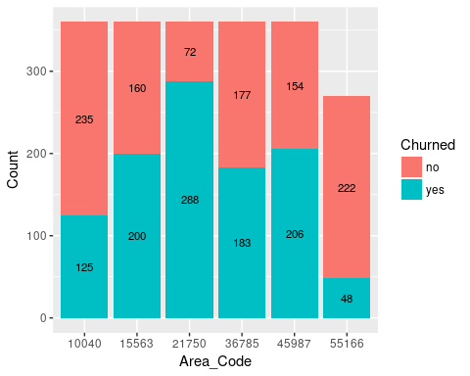

## LONGDIST_FLAG

Whether has signed up for the off-peak long distance call package

|  |  |
| --- | --- |
| Predictor | LONGDIST_FLAG |
| attribute type | Nominal |
| %Missing Values | 0 |
| Mode | 1 |

plot_data <- data.frame(table(churn_data$LONGDIST_FLAG, churn_data$CHURNER))  
colnames(plot_data) <- c("LONGDIST_FLAG", "Churned", "Count" )  
ggplot(data=plot_data, aes(x = LONGDIST_FLAG, y = Count, fill = Churned, label = Count)) +   
 geom_bar(stat = "identity") +   
 geom_text(size = 3, position = position_stack(vjust = 0.5))

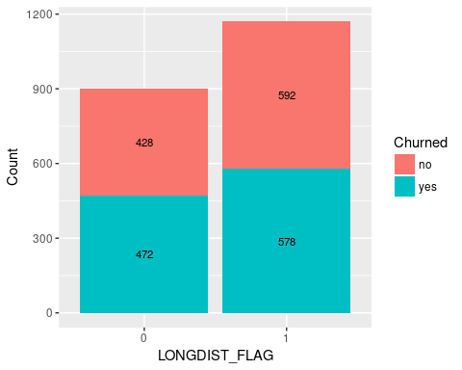

## CALLWAITING_FLAG

Whether the customer has call waiting

|  |  |
| --- | --- |
| Predictor | CALLWAITING_FLAG |
| attribute type | Nominal |
| %Missing Values | 0% |
| Mode | 0 |

plot_data <- data.frame(table(churn_data$CALLWAITING_FLAG, churn_data$CHURNER))  
colnames(plot_data) <- c("CALLWAITING_FLAG", "Churned", "Count")  
ggplot(data=plot_data, aes(x = CALLWAITING_FLAG, y = Count, fill = Churned, label = Count)) +   
 geom_bar(stat = "identity") +   
 geom_text(size = 3, position = position_stack(vjust = 0.5))

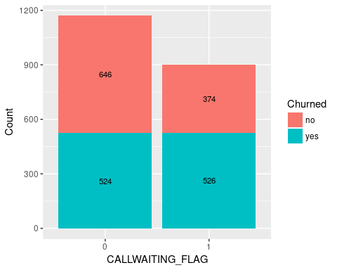

## VOICEMAIL_FLAG

Whether the customer has voice mail

|  |  |
| --- | --- |
| Predictor | VOICEMAIL_FLAG |
| attribute type | Nominal |
| %Missing Values | 0% |
| Mode | 1 |

plot_data <- data.frame(table(churn_data$VOICEMAIL_FLAG, churn_data$CHURNER))  
colnames(plot_data) <- c("VOICEMAIL_FLAG", "Churned", "Count" )  
ggplot(data=plot_data, aes(x = VOICEMAIL_FLAG, y = Count, fill = Churned, label = Count)) +   
 geom_bar(stat = "identity") +   
 geom_text(size = 3, position = position_stack(vjust = 0.5))

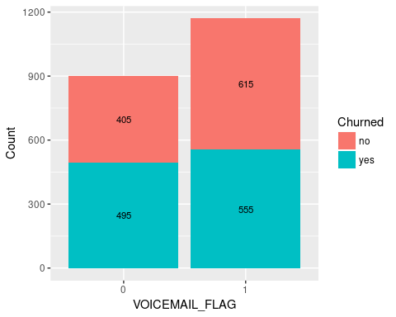

## MOBILE_PLAN

Has the customer signed up to the mobile phone plan

|  |  |
| --- | --- |
| Predictor | MOBILE_PLAN |
| attribute type | Nominal |
| %Missing Values | 0% |
| Mode | 0 |

plot_data <- data.frame(table(churn_data$MOBILE_PLAN, churn_data$CHURNER))  
colnames(plot_data) <- c("MOBILE_PLAN", "Churned", "Count" )  
ggplot(data=plot_data, aes(x = MOBILE_PLAN, y = Count, fill = Churned, label = Count)) +   
 geom_bar(stat = "identity") +   
 geom_text(size = 3, position = position_stack(vjust = 0.5))

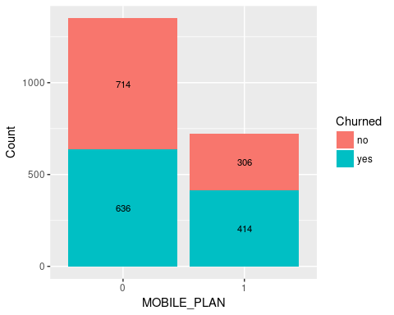

## CONVERGENT_BILLING

All service charges consolidated onto one bill

|  |  |
| --- | --- |
| Predictor | CONVERGENT_BILLING |
| attribute type | Nominal |
| %Missing Values | 0% |
| Mode | No |

plot_data <- data.frame(table(churn_data$CONVERGENT_BILLING, churn_data$CHURNER))  
colnames(plot_data) <- c("CONVERGENT_BILLING", "Churned", "Count" )  
ggplot(data=plot_data, aes(x = CONVERGENT_BILLING, y = Count, fill = Churned, label = Count)) +   
 geom_bar(stat = "identity") +   
 geom_text(size = 3, position = position_stack(vjust = 0.5))

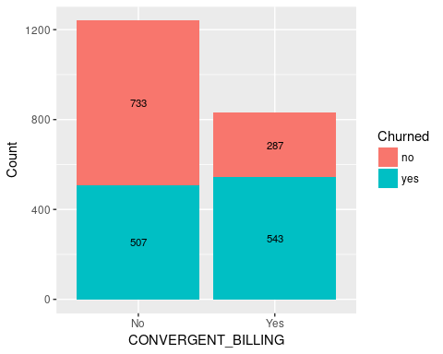

## GENDER

Account holder's gender

|  |  |
| --- | --- |
| Predictor | GENDER |
| attribute type | Nominal |
| %Missing Values | 0% |
| Mode | M |

plot_data <- data.frame(table(churn_data$GENDER, churn_data$CHURNER))  
colnames(plot_data) <- c("GENDER", "Churned", "Count" )  
ggplot(data=plot_data, aes(x = GENDER, y = Count, fill = Churned, label = Count)) +   
 geom_bar(stat = "identity") +   
 geom_text(size = 3, position = position_stack(vjust = 0.5))

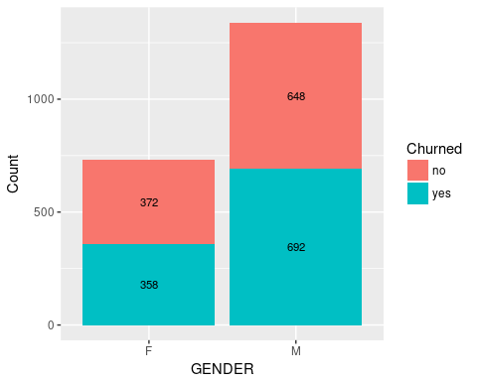

## INCOME

Account holder's annual income (€)

|  |  |
| --- | --- |
| Predictor | INCOME |
| attribute type | Ordinal |
| %Missing Values | 0% |
| Mode | medium income |

plot_data <- data.frame(table(churn_data$INCOME, churn_data$CHURNER))  
colnames(plot_data) <- c("INCOME", "Churned", "Count" )  
ggplot(data=plot_data, aes(x = INCOME, y = Count, fill = Churned, label = Count)) +   
 geom_histogram(stat = "identity") +   
 geom_text(size = 3, position = position_stack(vjust = 0.5))

## Warning: Ignoring unknown parameters: binwidth, bins, pad

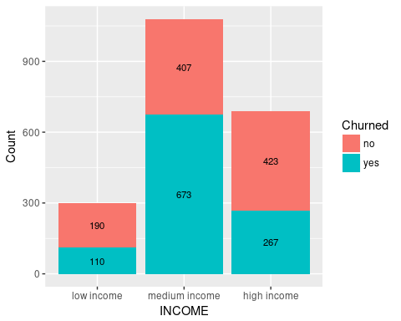

## PHONE_PLAN

The phone plan the customer has signed up for national, euro-zone, international (outside Euro-zone) and promo_plan (signed up to the promotional plan)

|  |  |
| --- | --- |
| Predictor | PHONE_PLAN |
| attribute type | Nominal |
| %Missing Values | 0% |
| Mode | International |

plot_data <- data.frame(table(churn_data$PHONE_PLAN, churn_data$CHURNER))  
colnames(plot_data) <- c("PHONE_PLAN", "Churned", "Count" )  
ggplot(data=plot_data, aes(x = PHONE_PLAN, y = Count, fill = Churned, label = Count)) +   
 geom_bar(stat = "identity") +   
 geom_text(size = 3, position = position_stack(vjust = 0.5))

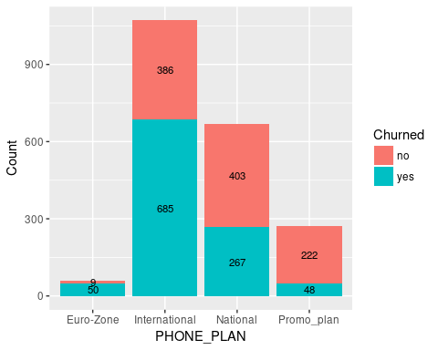

## EDUCATION

Highest Level of education attainment the account holder has achieved

|  |  |
| --- | --- |
| Predictor | EDUCATION |
| attribute type | Nominal |
| %Missing Values | 0% |
| Mode | Post Primary |

plot_data <- data.frame(table(churn_data$EDUCATION, churn_data$CHURNER))  
colnames(plot_data) <- c("EDUCATION", "Churned", "Count" )  
ggplot(data=plot_data, aes(x = EDUCATION, y = Count, fill = Churned, label = Count)) +   
 geom_bar(stat = "identity") +   
 geom_text(size = 3, position = position_stack(vjust = 0.5))

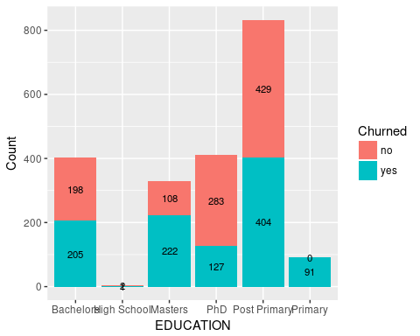

## MINUTES_CURR_MONTH

Phone Minutes currently for current months (to the time the data was extracted)

|  |  |
| --- | --- |
| Predictor | MINUTES_CURR_MONTH |
| attribute type | Numeric |
| %Missing Values | 0% |
| Max | 14000 |
| Min | 1 |
| Mean | 748.0917874 |
| Mode | 2, 5 |
| median | 105 |
| Standard deviation | 2017.5556123 |

### MINUTES_CURR_MONTH Skewness

(3 * (mean(churn_data$MINUTES_PREV_MONTH) - median(churn_data$MINUTES_PREV_MONTH)))/ sd(churn_data$MINUTES_PREV_MONTH)

## [1] 0.9312979

plot_data <- data.frame(table(churn_data$MINUTES_CURR_MONTH, churn_data$CHURNER))  
colnames(plot_data) <- c("MINUTES_CURR_MONTH", "CHURNER", "COUNT")  
ggplot(data=plot_data, aes(x = MINUTES_CURR_MONTH, y=COUNT, fill = CHURNER, label=COUNT)) +  
 geom_histogram(stat="identity", width = 1) +  
 geom_text(size = 2, position = position_stack(vjust = 0.5))+   
 theme(axis.text.x = element_text(angle = 90, hjust = 1))

## Warning: Ignoring unknown parameters: binwidth, bins, pad

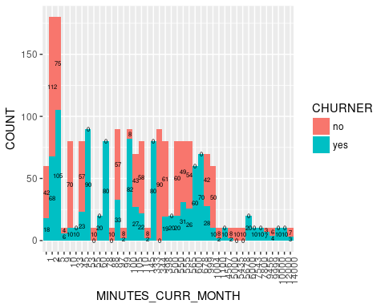

## MINUTES_PREV_MONTH

Phone Minutes used in the previous month

|  |  |
| --- | --- |
| Predictor | MINUTES_PREV_MONTH |
| attribute type | Numerical |
| %Missing Values |  |
| Max | 16754 |
| Min | 0 |
| Mean | 864.3188406 |
| Mode | 0 |
| median | 98 |

### MINUTES_PREV_MONTH Skewness

(3 * (mean(churn_data$MINUTES_PREV_MONTH) - median(churn_data$MINUTES_PREV_MONTH)))/ sd(churn_data$MINUTES_PREV_MONTH)

## [1] 0.9312979

plot_data <- data.frame(table(churn_data$MINUTES_PREV_MONTH, churn_data$CHURNER))  
colnames(plot_data) <- c("MINUTES_PREV_MONTH", "CHURNER", "COUNT")  
ggplot(data=plot_data, aes(x = MINUTES_PREV_MONTH, y=COUNT, fill = CHURNER, label=COUNT)) +  
 geom_histogram(stat="identity", width = 1) +  
 geom_text(size = 2, position = position_stack(vjust = 0.5))+   
 theme(axis.text.x = element_text(angle = 90, hjust = 1))

## Warning: Ignoring unknown parameters: binwidth, bins, pad

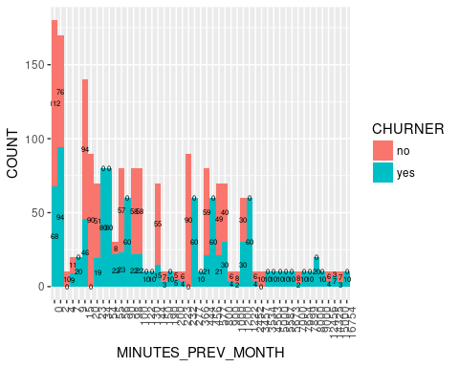 ## MINUTES_3MONTHS_AGO

Phone Minutes used in the 3 month PREVIOUS

|  |  |
| --- | --- |
| Predictor | MINUTES_3MONTHS_AGO |
| attribute type | Numerical |
| %Missing Values |  |
| Max | 12456 |
| Min | 0 |
| Mean | 452.7463768 |
| Mode | 0 |
| median | 97 |

### MINUTES_3MONTHS_AGO Skewness

Right-skewness data – Is positive, as mean is greater than the median

(3 * (mean(churn_data$MINUTES_3MONTHS_AGO) - median(churn_data$MINUTES_3MONTHS_AGO)))/ sd(churn_data$MINUTES_3MONTHS_AGO)

## [1] 0.9012361

plot_data <- data.frame(table(churn_data$MINUTES_3MONTHS_AGO, churn_data$CHURNER))  
colnames(plot_data) <- c("MINUTES_3MONTHS_AGO", "CHURNER", "COUNT")  
ggplot(data=plot_data, aes(x = MINUTES_3MONTHS_AGO, y=COUNT, fill = CHURNER, label=COUNT)) +  
 geom_histogram(stat="identity", width = 1) +  
 geom_text(size = 2, position = position_stack(vjust = 0.5))+   
 theme(axis.text.x = element_text(angle = 90, hjust = 1))

## Warning: Ignoring unknown parameters: binwidth, bins, pad

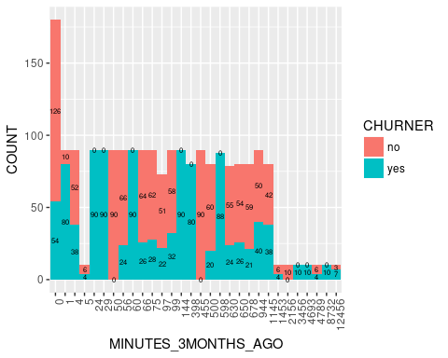

## CUST_MOS

The number of continuous months the Customer is with the provider

|  |  |
| --- | --- |
| Predictor | CUST_MOS |
| attribute type | Numerical |
| %Missing Values | 0 |
| Max | 50 |
| Min | 1 |
| Mean | 16.0545894 |
| Mode | 11 |
| median | 11 |

### CUST_MOS Skewness

Right-skewness data – Is positive, as mean is greater than the median

(3 * (mean(churn_data$CUST_MOS) - median(churn_data$CUST_MOS)))/ sd(churn_data$CUST_MOS)

## [1] 1.132926

plot_data <- data.frame(table(churn_data$CUST_MOS, churn_data$CHURNER))  
colnames(plot_data) <- c("CUST_MOS", "CHURNER", "COUNT")  
ggplot(data=plot_data, aes(x = CUST_MOS, y=COUNT, fill = CHURNER, label=COUNT)) +  
 geom_histogram(stat="identity", width = 1) +  
 geom_text(size = 2, angle = 90, position = position_stack(vjust = 0.5))+   
 theme(axis.text.x = element_text(size=6, angle = 90, hjust = .5))

## Warning: Ignoring unknown parameters: binwidth, bins, pad

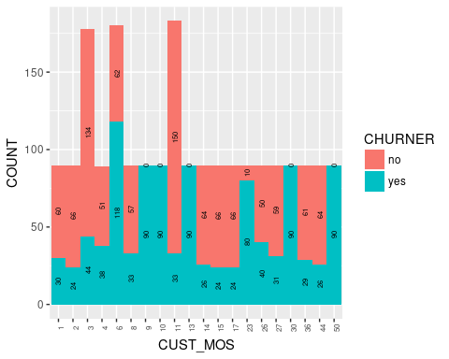

ggplot(churn_data, aes(x = CUST_MOS, fill = CHURNER)) +  
 geom_histogram(position="fill", binwidth = 6)

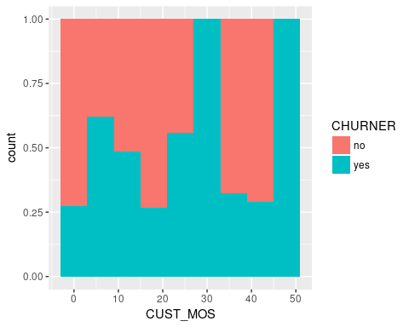

## TOT_MINUTES_USAGE

The total number of minutes used to date

|  |  |  |  |
| --- | --- | --- | --- |
| Predictor | TOT_MINUTES_USAGE | Predictor | TOT_MINUTES_USAGE |
| attribute type | Numeric |  |  |
| %Missing Values | 0% |  |  |
| Max | 3.623710^{4} |  |  |
| Min | 0 |  |  |
| Mean | 2037.0932367 |  |  |
| Mode | 0 |  |  |
| median | 264 |  |  |
| Standard deviation | 4883.9078032 |  |  |

### TOT_MINUTES_USAGE Skewness

Right-skewness data – Is positive, as mean is greater than the median

(3 * (mean(churn_data$TOT_MINUTES_USAGE) - median(churn_data$TOT_MINUTES_USAGE)))/ sd(churn_data$TOT_MINUTES_USAGE)

## [1] 1.089144

plot_data <- data.frame(table(churn_data$TOT_MINUTES_USAGE, churn_data$CHURNER))  
colnames(plot_data) <- c("TOT_MINUTES_USAGE", "CHURNER", "COUNT")  
ggplot(data=plot_data, aes(x = TOT_MINUTES_USAGE, y=COUNT, fill = CHURNER, label=COUNT)) +  
 geom_histogram(stat="identity", width = 1) +  
 geom_text(size = 2, angle = 90, position = position_stack(vjust = 0.5))+   
 theme(axis.text.x = element_text(size=6, angle = 90, hjust = .5))

## Warning: Ignoring unknown parameters: binwidth, bins, pad

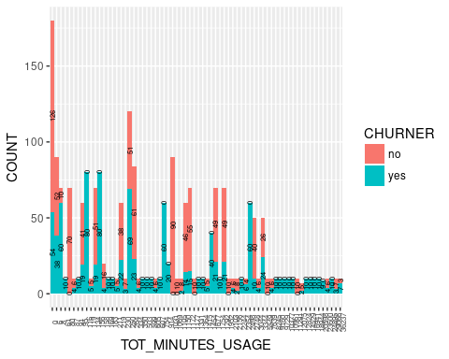

## NUM_LINES

The number of fixed lines the customer has leased.

|  |  |
| --- | --- |
| Predictor | NUM_LINES |
| attribute type | Numeric |
| %Missing Values | 0% |
| Max | 3 |
| Min | 1 |
| Mean | 1.3913043 |
| Mode | 1 |
| median | 1 |
| Standard deviation | 0.5703498 |

### NUM_LINES Skewness

Right-skewness data – Is positive, as mean is greater than the median

(3 * (mean(churn_data$NUM_LINES) - median(churn_data$NUM_LINES)))/ sd(churn_data$NUM_LINES)

## [1] 2.058233

plot_data <- data.frame(table(churn_data$NUM_LINES, churn_data$CHURNER))  
colnames(plot_data) <- c("NUM_LINES", "CHURNER", "COUNT")  
ggplot(data=plot_data, aes(x = NUM_LINES, y=COUNT, fill = CHURNER, label=COUNT)) +  
 geom_histogram(stat="identity", width = 1) +  
 geom_text(size = 2, position = position_stack(vjust = 0.5))+   
 theme(axis.text.x = element_text(angle = 90, hjust = 1))

## Warning: Ignoring unknown parameters: binwidth, bins, pad

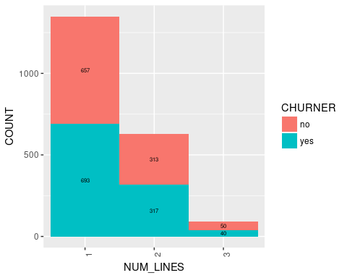

# Skewness for numeric data

Right-skewness data – Is positive, as mean is greater than the median Left skewness data – Mean is smaller than the median, generating negative values Perfectly symmetric data – mean, median and mode are equal, so skewness is zero

(3 * (mean(churn_data$MINUTES_3MONTHS_AGO) - median(churn_data$MINUTES_3MONTHS_AGO)))/ sd(churn_data$MINUTES_3MONTHS_AGO)

## [1] 0.9012361

(3 * (mean(churn_data$MINUTES_PREV_MONTH) - median(churn_data$MINUTES_PREV_MONTH)))/ sd(churn_data$MINUTES_PREV_MONTH)

## [1] 0.9312979

(3 * (mean(churn_data$MINUTES_CURR_MONTH) - median(churn_data$MINUTES_CURR_MONTH)))/ sd(churn_data$MINUTES_CURR_MONTH)

## [1] 0.956244

(3 * (mean(churn_data$TOT_MINUTES_USAGE) - median(churn_data$TOT_MINUTES_USAGE)))/ sd(churn_data$TOT_MINUTES_USAGE)

## [1] 1.089144

(3 * (mean(churn_data$NUM_LINES) - median(churn_data$NUM_LINES)))/ sd(churn_data$NUM_LINES)

## [1] 2.058233

(3 * (mean(churn_data$CUST_MOS) - median(churn_data$CUST_MOS)))/ sd(churn_data$CUST_MOS)

## [1] 1.132926

# Graphical methods to identify outliers

## MINUTES_3MONTHS_AGO

ggplot(data=churn_data, aes(x=CHURNER, y=MINUTES_3MONTHS_AGO))+ geom_boxplot()

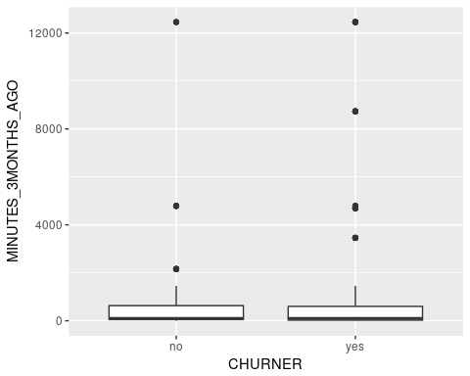

## MINUTES_PREV_MONTH

ggplot(data=churn_data, aes(x=CHURNER, y=MINUTES_PREV_MONTH))+ geom_boxplot()

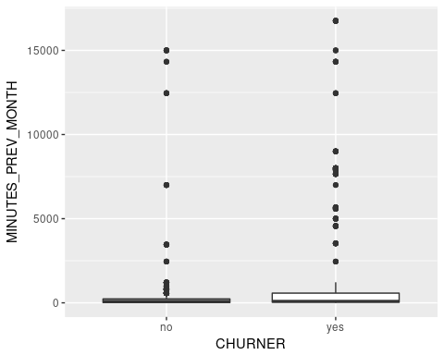

## MINUTES_CURR_MONTH

ggplot(data=churn_data, aes(x=CHURNER, y=MINUTES_CURR_MONTH))+ geom_boxplot()

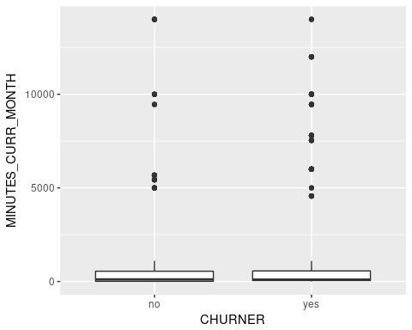

## TOT_MINUTES_USAGE

ggplot(data=churn_data, aes(x=CHURNER, y=TOT_MINUTES_USAGE))+ geom_boxplot()

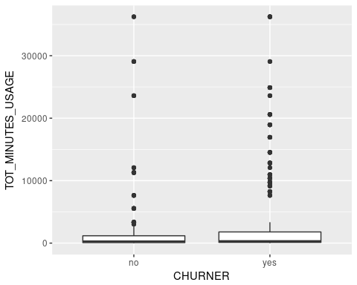

## NUM_LINES

ggplot(data=churn_data, aes(x=CHURNER, y=NUM_LINES))+ geom_boxplot()

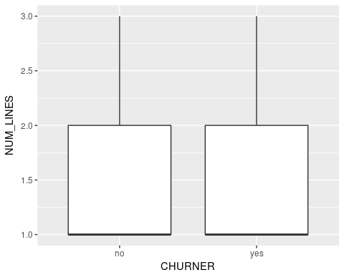

## CUST_MOS

ggplot(data=churn_data, aes(x=CHURNER, y=CUST_MOS))+ geom_boxplot()

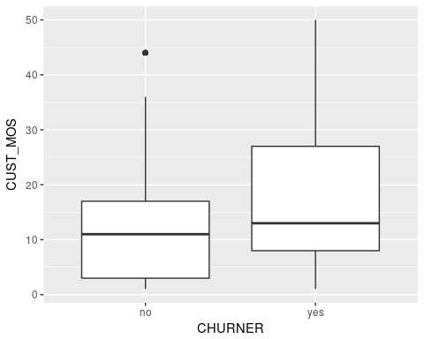

# Mathematically identifying outliers

Choose a numeric predictor variable that has possible outliers based on your analysis in 2 above. Use the IQR method and Z-Score Standardisation method to identify outliers. Discuss your findings.

## IQR method

minutesQuartileTolerance <- 1.5* IQR(churn_data$TOT_MINUTES_USAGE)  
minutesLowerQuantile <- quantile(churn_data$TOT_MINUTES_USAGE, 0.25)  
minutesUpperQuantile <- quantile(churn_data$TOT_MINUTES_USAGE, 0.75)  
  
print("lower outliers")

## [1] "lower outliers"

churn_data$TOT_MINUTES_USAGE[churn_data$TOT_MINUTES_USAGE < (minutesLowerQuantile - minutesQuartileTolerance)]

## numeric(0)

print("upper outliers")

## [1] "upper outliers"

churn_data$TOT_MINUTES_USAGE[churn_data$TOT_MINUTES_USAGE > (minutesUpperQuantile + minutesQuartileTolerance)]

## [1] 18944 14529 12824 23600 10961 20598 29066 9160 12075 11291 7639  
## [12] 36237 9729 16941 10377 11291 7639 36237 9729 5549 16941 10377  
## [23] 5549 24895 8245 5549 24895 8245 16941 10377 5549 24895 8245  
## [34] 18944 14529 12824 23600 10961 20598 16941 10377 24895 8245 5549  
## [45] 18944 14529 12824 23600 10961 20598 29066 9160 5549 12075 11291  
## [56] 18944 14529 12824 23600 10961 20598 29066 9160 11291 7639 36237  
## [67] 9729 29066 9160 12075 11291 7639 36237 9729 24895 8245 7639  
## [78] 36237 9729 16941 10377 24895 8245 5549 18944 14529 12824 23600  
## [89] 10961 29066 5549 9160 12075 11291 7639 36237 9729 5549 16941  
## [100] 10377 18944 14529 12824 5549 23600 10961 20598 29066 9160 11291  
## [111] 7639 36237 9729 16941 29066 9160 12075 11291 7639 36237 9729  
## [122] 16941 10377 24895 10961 20598 29066 9160 11291 7639 36237 9729  
## [133] 16941 10377 24895 8245 10377 24895 8245 18944 14529 12824 23600  
## [144] 10961 20598 8245 18944 14529 12824 23600 24895 8245 18944 14529  
## [155] 12824 23600 10961 20598 29066 9160 12075 18944 14529 12824 23600  
## [166] 10961 20598 29066 9160 12075 11291 7639 36237 9729 16941 10377

## zScore Standardisation method

# zScore Standardisation  
zscore.TOT_MINUTES_USAGE <-(churn_data$TOT_MINUTES_USAGE - mean(churn_data$TOT_MINUTES_USAGE))/sd(churn_data$TOT_MINUTES_USAGE)  
summary(zscore.TOT_MINUTES_USAGE)

## Min. 1st Qu. Median Mean 3rd Qu. Max.   
## -0.41710 -0.39340 -0.36300 0.00000 -0.07373 7.00300

zscore.TOT_MINUTES_USAGE[zscore.TOT_MINUTES_USAGE < -3 | zscore.TOT_MINUTES_USAGE > 3]

## [1] 3.461758 4.415093 3.800421 5.534279 7.002570 3.051636 7.002570  
## [8] 3.051636 4.680249 4.680249 3.051636 4.680249 3.461758 4.415093  
## [15] 3.800421 3.051636 4.680249 3.461758 4.415093 3.800421 5.534279  
## [22] 3.461758 4.415093 3.800421 5.534279 7.002570 5.534279 7.002570  
## [29] 4.680249 7.002570 3.051636 4.680249 3.461758 4.415093 5.534279  
## [36] 7.002570 3.051636 3.461758 4.415093 3.800421 5.534279 7.002570  
## [43] 3.051636 5.534279 7.002570 3.051636 4.680249 3.800421 5.534279  
## [50] 7.002570 3.051636 4.680249 4.680249 3.461758 4.415093 3.800421  
## [57] 3.461758 4.415093 4.680249 3.461758 4.415093 3.800421 5.534279  
## [64] 3.461758 4.415093 3.800421 5.534279 7.002570 3.051636

# Correcting skewness

# calculate skewness  
TOT_MINUTES_USAGESkewness <- (3 * (mean(churn_data$TOT_MINUTES_USAGE) - median(churn_data$TOT_MINUTES_USAGE)))/ sd(churn_data$TOT_MINUTES_USAGE)  
TOT_MINUTES_USAGESkewness

## [1] 1.089144

## Natural Log Transformation

# Natural Log Transformation  
natlog.TOT_MINUTES_USAGE <- log(churn_data$TOT_MINUTES_USAGE[churn_data$TOT_MINUTES_USAGE > 0])  
  
# applying log function to skewness  
logTOT_MINUTES_USAGESkewness <- (3 * (mean(natlog.TOT_MINUTES_USAGE) - median(natlog.TOT_MINUTES_USAGE)))/ sd(natlog.TOT_MINUTES_USAGE)  
logTOT_MINUTES_USAGESkewness

## [1] -0.7042918

## Square Root Transformation

# Square Root Transformation  
sqrt.TOT_MINUTES_USAGE <- sqrt(churn_data$TOT_MINUTES_USAGE)  
# applying sqr root function to skewness  
  
sqrTOT_MINUTES_USAGESkewness <- (3 * (mean(sqrt.TOT_MINUTES_USAGE) - median(sqrt.TOT_MINUTES_USAGE)))/ sd(sqrt.TOT_MINUTES_USAGE)  
sqrTOT_MINUTES_USAGESkewness

## [1] 1.289714

## zScore Standardisation

# zScore Standardisation  
zscore.TOT_MINUTES_USAGE <-(churn_data$TOT_MINUTES_USAGE - mean(churn_data$TOT_MINUTES_USAGE))/sd(churn_data$TOT_MINUTES_USAGE)  
  
# applying zScore function to skewness  
zscore.TOT_MINUTES_USAGE <- (3 * (mean(zscore.TOT_MINUTES_USAGE) - median(zscore.TOT_MINUTES_USAGE)))/ sd(zscore.TOT_MINUTES_USAGE)  
zscore.TOT_MINUTES_USAGE

## [1] 1.089144

# 2D Scatter plots to investigate correlation

2D Scatter plots to investigate correlation between numeric variables

## TOT_MINUTES_USAGE vs CUST_MOS

ggplot(churn_data, aes(x=TOT_MINUTES_USAGE, y=CUST_MOS)) +  
 geom_point() +  
 geom_smooth(method=lm)

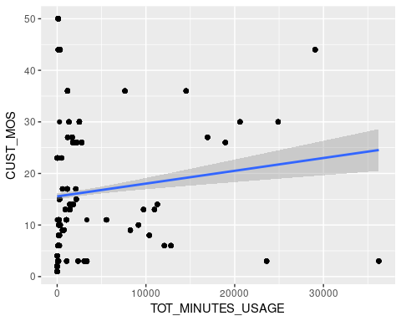

### Correlation

cor(x=churn_data$TOT_MINUTES_USAGE, y=churn_data$CUST_MOS, use="all.obs", method="pearson")

## [1] 0.09055857

# http://www.statmethods.net/stats/correlations.html

## TOT_MINUTES_USAGE vs MINUTES_CURR_MONTH

ggplot(churn_data, aes(x=TOT_MINUTES_USAGE, y=MINUTES_CURR_MONTH)) +  
 geom_point() +  
 geom_smooth(method=lm)

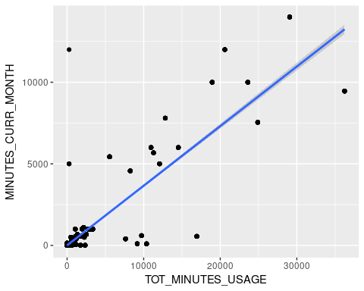

### Correlation

cor(x=churn_data$TOT_MINUTES_USAGE, y=churn_data$MINUTES_CURR_MONTH, use="all.obs", method="pearson")

## [1] 0.8844237

# http://www.statmethods.net/stats/correlations.html

## TOT_MINUTES_USAGE vs MINUTES_PREV_MONTH

ggplot(churn_data, aes(x=TOT_MINUTES_USAGE, y=MINUTES_PREV_MONTH)) +  
 geom_point() +  
 geom_smooth(method=lm)

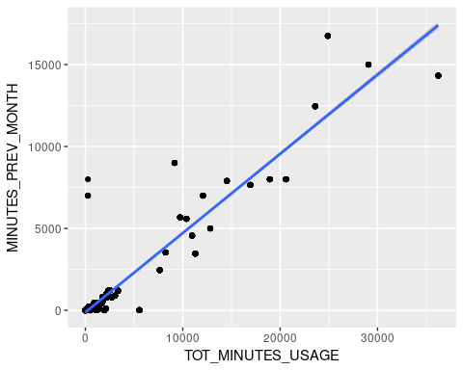 ### Correlation

cor(x=churn_data$TOT_MINUTES_USAGE, y=churn_data$MINUTES_PREV_MONTH, use="all.obs", method="pearson")

## [1] 0.9568583

# http://www.statmethods.net/stats/correlations.html

## TOT_MINUTES_USAGE vs MINUTES_3MONTHS_AGO

ggplot(churn_data, aes(x=TOT_MINUTES_USAGE, y=MINUTES_3MONTHS_AGO)) +  
 geom_point() +  
 geom_smooth(method=lm)

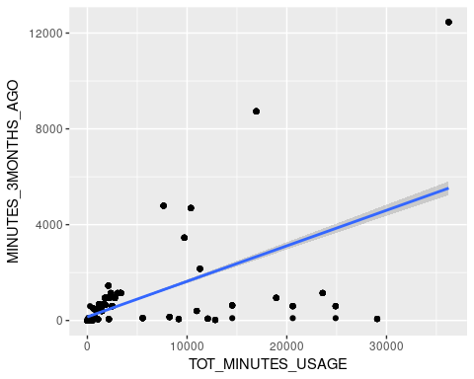 ### Correlation

cor(x=churn_data$TOT_MINUTES_USAGE, y=churn_data$MINUTES_3MONTHS_AGO, use="all.obs", method="pearson")

## [1] 0.611558

# http://www.statmethods.net/stats/correlations.html

## TOT_MINUTES_USAGE vs NUM_LINES

ggplot(churn_data, aes(x=TOT_MINUTES_USAGE, y=NUM_LINES)) +  
 geom_point() +  
 geom_smooth(method=lm)

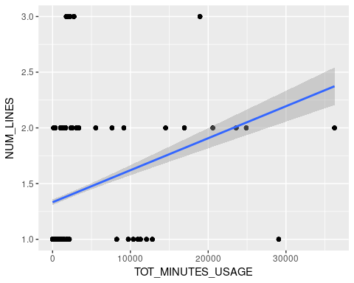 ### Correlation

cor(x=churn_data$TOT_MINUTES_USAGE, y=churn_data$NUM_LINES, use="all.obs", method="pearson")

## [1] 0.2460581

# http://www.statmethods.net/stats/correlations.html

## CUST_MOS vs MINUTES_CURR_MONTH

ggplot(churn_data, aes(x=CUST_MOS, y=MINUTES_CURR_MONTH)) +  
 geom_point() +  
 geom_smooth(method=lm)

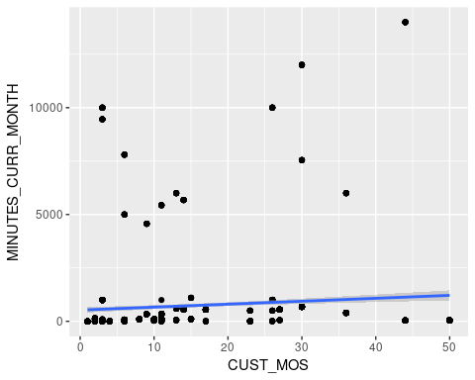 ### Correlation

cor(x=churn_data$TOT_MINUTES_USAGE, y=churn_data$MINUTES_CURR_MONTH, use="all.obs", method="pearson")

## [1] 0.8844237

# http://www.statmethods.net/stats/correlations.html

## CUST_MOS vs MINUTES_PREV_MONTH

ggplot(churn_data, aes(x=CUST_MOS, y=MINUTES_PREV_MONTH)) +  
 geom_point() +  
 geom_smooth(method=lm)

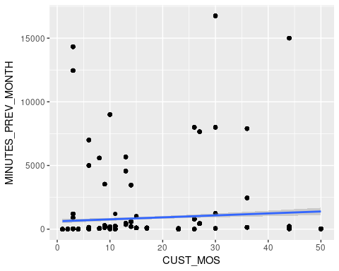 ### Correlation

cor(x=churn_data$TOT_MINUTES_USAGE, y=churn_data$MINUTES_PREV_MONTH, use="all.obs", method="pearson")

## [1] 0.9568583

# http://www.statmethods.net/stats/correlations.html

## CUST_MOS vs MINUTES_3MONTHS_AGO

ggplot(churn_data, aes(x=CUST_MOS, y=MINUTES_3MONTHS_AGO)) +  
 geom_point() +  
 geom_smooth(method=lm)

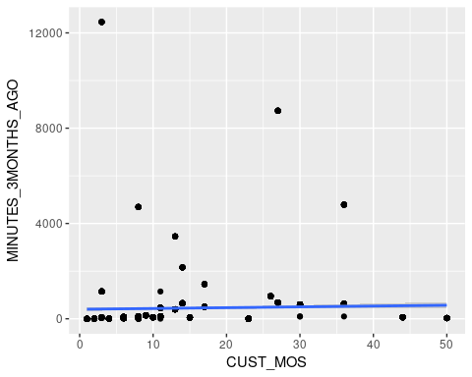 ### Correlation

cor(x=churn_data$CUST_MOS, y=churn_data$MINUTES_3MONTHS_AGO, use="all.obs", method="pearson")

## [1] 0.03824096

# http://www.statmethods.net/stats/correlations.html

## CUST_MOS vs NUM_LINES

ggplot(churn_data, aes(x=CUST_MOS, y=NUM_LINES)) +  
 geom_point() +  
 geom_smooth(method=lm)

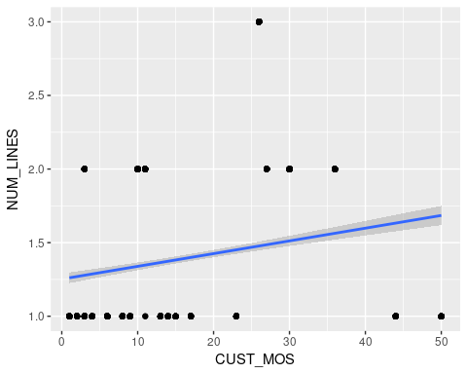

### Correlation

cor(x=churn_data$CUST_MOS, y=churn_data$NUM_LINES, use="all.obs", method="pearson")

## [1] 0.2028409

# http://www.statmethods.net/stats/correlations.html

## MINUTES_CURR_MONTH vs MINUTES_PREV_MONTH

ggplot(churn_data, aes(x=MINUTES_CURR_MONTH, y=MINUTES_PREV_MONTH)) +  
 geom_point() +  
 geom_smooth(method=lm)

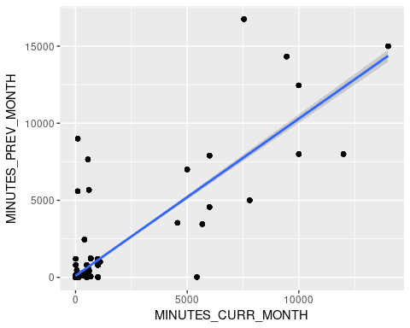

### Correlation

cor(x=churn_data$MINUTES_CURR_MONTH, y=churn_data$MINUTES_PREV_MONTH, use="all.obs", method="pearson")

## [1] 0.8332782

# http://www.statmethods.net/stats/correlations.html

## MINUTES_CURR_MONTH vs MINUTES_3MONTHS_AGO

ggplot(churn_data, aes(x=MINUTES_CURR_MONTH, y=MINUTES_3MONTHS_AGO)) +  
 geom_point() +  
 geom_smooth(method=lm)

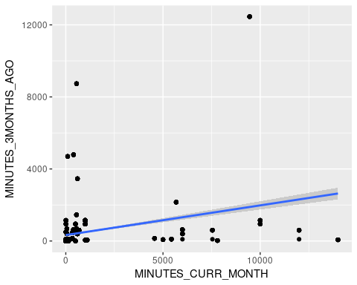 ### Correlation

cor(x=churn_data$MINUTES_CURR_MONTH, y=churn_data$MINUTES_3MONTHS_AGO, use="all.obs", method="pearson")

## [1] 0.2806732

# http://www.statmethods.net/stats/correlations.html

## MINUTES_CURR_MONTH vs NUM_LINES

ggplot(churn_data, aes(x=MINUTES_CURR_MONTH, y=NUM_LINES)) +  
 geom_point() +  
 geom_smooth(method=lm)

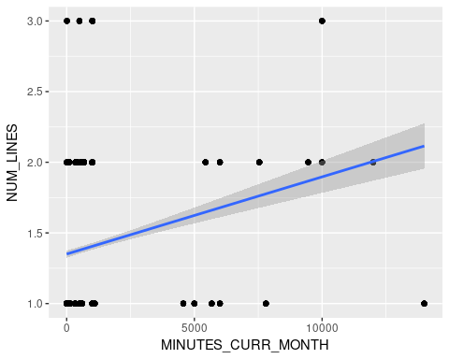 ### Correlation

cor(x=churn_data$MINUTES_CURR_MONTH, y=churn_data$NUM_LINES, use="all.obs", method="pearson")

## [1] 0.1932212

# http://www.statmethods.net/stats/correlations.html

## MINUTES_PREV_MONTH vs NUM_LINES

ggplot(churn_data, aes(x=MINUTES_PREV_MONTH, y=NUM_LINES)) +  
 geom_point() +  
 geom_smooth(method=lm)

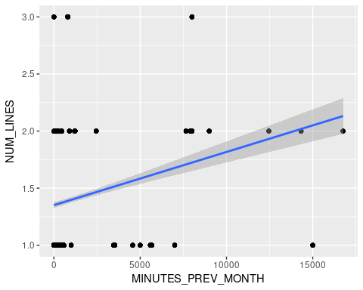 ### Correlation

cor(x=churn_data$MINUTES_PREV_MONTH, y=churn_data$NUM_LINES, use="all.obs", method="pearson")

## [1] 0.2016433

# http://www.statmethods.net/stats/correlations.html

## MINUTES_PREV_MONTH vs MINUTES_3MONTHS_AGO

ggplot(churn_data, aes(x=MINUTES_PREV_MONTH, y=MINUTES_3MONTHS_AGO)) +  
 geom_point() +  
 geom_smooth(method=lm)

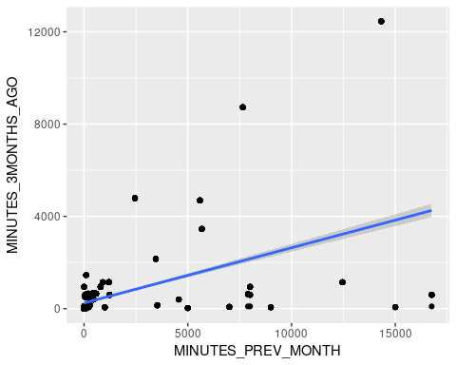 ### Correlation

cor(x=churn_data$MINUTES_PREV_MONTH, y=churn_data$MINUTES_3MONTHS_AGO, use="all.obs", method="pearson")

## [1] 0.4989065

# http://www.statmethods.net/stats/correlations.html

## MINUTES_3MONTHS_AGO vs NUM_LINES

ggplot(churn_data, aes(x=MINUTES_3MONTHS_AGO, y=NUM_LINES)) +  
 geom_point() +  
 geom_smooth(method=lm)

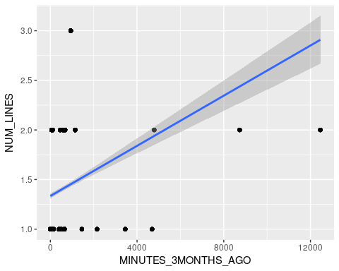

### Correlation

cor(x=churn_data$MINUTES_3MONTHS_AGO, y=churn_data$NUM_LINES, use="all.obs", method="pearson")

## [1] 0.2624494

# http://www.statmethods.net/stats/correlations.html