3/22/2017

David Lawlor X00107563

B.Sc in Computing

Enterprise Database Technologies

Contents

Introduction 4

Q1 Data Understanding 4

Q2 Discretise income predictor 5

Q3 Predictor information 5

Q4 Identifying Outliers 5

Q5 Skewness 6

Q6 Numerical Predictor with Response Variable Overlay 6

Q7 Investigating correlated variable 6

Weka 7

Conclusion 9

Appendix 10

Functions 10

1.1 Preprocess the data 11

1.2 Discretise Income predictor 16

1.3 Predictor Information 16

1.4 Identify Outliers 39

1.5 Skewness for numeric data 44

1.7 2D Scatter plots to investigate correlation 46

2 Weka 61

2.1 Mining algorithms 61

Bibliography 72

# Introduction

The aim of the assignment is to analyse a data set. The data set which we were given was a telecommunication provider which provides fixed line, mobile and broadband services to its customers.

The aim of the analysis is to try to discover why customers regularly change service providers or churn. The analysis will provide insight into why customers churn, enabling them to identify gaps in their service offering and increase their overall customer retention.

The analysis will use the CRISP-DM process

* data understanding,
* data pre-processing stages
* Data Mining task.

# Q1 Data Understanding

The dataset contained 2071 rows containing 18 columns.

To allow the building of an accurate model it is imperative that the dataset is cleaned by addressing duplicates, missing values and other erroneous data.

For each predictor variable, 16 in total, a table was created to detail the various characteristics of the predictor. In all cases these were data type (nominal, ordinal, numerical), percentage of missing values and mode. For the numerical data, the min, max, mean, median and standard deviation was also included. (Appendix 1.3)

## Missing Data

One step taken to understand the data was to print out a summary of the data. This enabled the identification of columns with NA values or blank values. The following table outlines the rows found to have missing values. (Appendix 1.1.2)

|  |  |
| --- | --- |
| Column | Number of missing values |
| MINUTES_3MONTHS_AGO | 3 Records |
| CUST_MOS | 3 Records |
| TOT_MINUTES_USAGE | 4 Records |
| PHONE_PLAN | 4 Records |
| EDUCATION | 8 Records |

For the numeric attributes, MINUTES_3MONTHS_AGO, TOT_MINUTES_USAGE and CUST_MOS they were replaced with the median value for the columns.

For the EDUCATION and PHONE_PLAN the missing values were replaced with the mode of the column based on the GENDER column e.g.: for Education, if the record was male, the missing value was replaced with the mode of education for that gender. (Appendix 1.1.2)

## Duplicate Data

There was 1 duplicate row identified. This row was positively identified as a duplicate as the CUST_ID was duplicated. This row was removed so that it did not impact the overall analysis. While there were other rows which were observed to be identical, exclusion was not possible due to the records having different CUST_ID’s (Appendix 1.1.1.1)

## Other data quality issues

A data quality issue which was observed was in the TOT_MINUTES_USAGE. This Column is the sum of MINUTES_3MONTHS_AGO, MINUTES_PREV_MONTH AND MINUTES_CURR_MONTH. Although this is the case for much of the dataset, there were 184 rows in which the TOT_MINUTES_USAGE was zero despite the other 3 columns in the row having non-zero data.

# Q2 Discretise income predictor

For the income, it was discretized using a binning operation which grouped income into an ordinal predictor consisting of Low Income (< 38,000), Medium Income (>= 38,000 and < 88,000) and High Income (>= 88,000). (Appendix 1.2)

# Q3 Predictor information

For the numerical predictors in the dataset all had a positive skewness when calculated with no transformations applied to the data. The MINUTES_3MONTHS_AGO predictor had the lowest positive skewness of 0.901 and NUM_LINES having the highest positive skewness. This means that all the numerical predictors do not have a normal distribution. Each predictor’s full characteristics can be found in full detain in Appendix 1.3.

The numerical predictors are covered in Q6.

# Q4 Identifying Outliers

The numeric predictor chosen for outliers is TOT_MINUTES_USAGE. This is the total minutes’ usage for a customer based on 3 months of minutes. (Appendix 1.4)

### IQR method

The interquartile method identified 0 outliers in the lower range and 176 in the upper range. This was interesting as it meant that 8.5% of the entire dataset were outliers in the upper range

### z-Score Standardisation method

Apply a z-score transformation on the column identified again 0 outliers in the lower range and just 69 in the upper range compare to 176 using the IQR method.

# Q5 Skewness

The numerical variable chosen for testing for skewness was TOT_MINUTES_USAGE. As a before any transformation was applied to the predictor the skewness measurement was taken. The predictor has a positive skewness of 1.089144. Three transformation methods were attempted to try to correct this skewness. (Appendix 1.5)

**Natural Log Transformation**

The natural log transformation transformed the data from a positive skewness to a negative skewness of -0.7042918. This method also required the exclusion of zero values from the calculation.

**Square Root Transformation**

The square root transformation had a negative impact on the skewness by increasing the positive skewness of the data to 1.289714 so this eliminated this transformation as a possibility.

**z-Score Standardisation**

The z-Score standardisation had no effect on the skewness as would be expected to be the case as z-Score does not actually transform the data but standardises it.

# Q6 Numerical Predictor with Response Variable Overlay

The numerical predictors with the churn overlay did not show anything significant within the minute’s data in terms of a pattern of even a consistent split between churners.

The CUST_MOS did show that customers which were with the company more than 44 months has a 100% churn rate.

The NUM_LINES did not appear to show and value to determining churn as each value had a nearly even split

# Q7 Investigating correlated variable

To investigate the correlation between the numerical variables they were each compared to one another graphically using a scatter plot.

All the numerical variables concerning minutes used show a correlation with each other. As the total minutes used is the sum of 3 months previous, previous month and current month, this was expected as they are all related to one another. When the minute columns were then compared to the other two numerical variables customer months and number of lines there was no correlation.

These correlations were also performed to mathematically to affirm these results. (Appendix 1.7)

For all the predictors, not all showed a possible reason for churn. Some of the main ones which did show a possible influence in the churn rate were:

|  |  |
| --- | --- |
| Predictor | Possible reason for churn |
| AREA_CODE | from the 6 area codes in the dataset, one area 21750 had a churn rate of 80%. |
| INCOME | The churn for medium income is much higher when compared to the churn rate for the low and medium incomes. |
| PHONE_PLAN | While there is not a huge number of customers (59) on the Euro-Zone plan in the dataset it does indicate a high churn of 85%. The international plan also has a high churn of 64% |
| EDUCATION | Primary level education has a 100% churn rate of the 91 record in the dataset. Masters education also has a high churn of 67%. |
| CUST_MOS | The churn is 100% after 44 months. |

# Weka

For the data mining task the data mining software Weka was used to create a model of the data. Several different algorithms are used as each create their own model which can then be analysed.

The output of the various algorithms is summarised in the table below. The formulas used to calculate these are detailed in (Appendix 2)

|  |  |  |  |  |
| --- | --- | --- | --- | --- |
|  | **J48** | **JRip** | **PART** | **ZeroR** |
| Proportion of false positives | 0.044 | 0.041 | 0.071 | 0.479 |
| Proportion of false negatives | 0.282 | 0.289 | 0.271 | 0 |
| Overall error rate | 0.197 | 0.203 | 0.195 | 0.479 |
| Overall Model Accuracy | 0.803 | 0.797 | 0.805 | 0.521 |
| Precision | 0.956 | 0.959 | 0.929 | 0.521 |
| Sensitivity(Recall) - True Positive Rate | 0.651 | 0.638 | 0.678 | 1 |
| Specificity - False Positive Rate | 0.967 | 0.97 | 0.944 | 0 |
| ROC | 0.843 | 0.809 | 0.847 | 0.5 |

For the analysis, the predictors CUST_ID, MINUTES_CURR_MONTH, MINUTES_PREV_MONTH, MINUTES_3MONTHS_AGO were excluded from the analysis. This was done from within the Weka application using the filters.

The unsupervised attribute filter NumericToNominal was applied to the AREA_CODE, LONGDIST_FLAG, CALLWAITING_FLAG, VOICEMAIL_FLAG and MOBILE_PLAN. This was required as these nominal predictors were imported as numerical. The normalise filter was also applied to the numerical data.

## ZeroR

**Description of Algorithm**

Class for building and using a 0-R classifier. Predicts the mean (for a numeric class) or the mode (for a nominal class). The algorithm looks at the yes/no churn split and bases its guessed on this.

As expected in this best guess algorithm the results show a rough 50 50 split on classifying as there is a near 50/50 split on the churn rate with 1020 No and 1051 yes.

This is also backed up by the Roc curve of 0.5 which show it has a 50/50 of predicting a churner

## JRip

Description of Algorithm

The JRip algorithm is a java implementation of the Ripper machine learning algorithm.

The predictor used in generating the model were:

* CONVERGENT_BILLING
* TOT_MINUTES_USAGE
* AREA_CODE
* CUST_MOS
* EDUCATION
* INCOME

Although didn’t perform quite as well as J48 and PART. The algorithm used just 6 predictors in the model and produced just 7 rules in total.

The algorithm used a combination of CONVERGENT_BILLING and TOT_MINUTES_USAGE to classify most of the record with 690 out of 890 correctly classified.

## J48

**Description of Algorithm**

J48 is a decision tree divide and conquer algorithm which is the Weka implementation of Iterative Dichotomiser 3(ID3). ID3 is a precursor to C4.5. Splits are based on the maximum information gain.

The predictor used in generating the model were:

* CUST_MOS
* CONVERGENT_BILLING
* GENDER
* AREA_CODE
* INCOME
* TOT_MINUTES_USAGE
* EDUCATION
* VOICEMAIL_FLAG
* PHONE_PLAN

This means that the algorithm used a total of 9/13 of the possible predictors in creating the model.

This algorithm identified the 100% churn after 44 months and used it as the first split in the tree. Interestingly after a split on CONVERGENT_BILLING, EDUCATION is only used in the no side of the tree for further splits.

## PART

**Description of Algorithm**

The PART algorithm creates a s partial j48 decision tree and makes the best leaf into a rule.

The predictor used in generating the model were:

* CUST_MOS
* CONVERGENT_BILLING
* GENDER
* AREA_CODE
* INCOME
* TOT_MINUTES_USAGE
* EDUCATION
* VOICEMAIL_FLAG
* PHONE_PLAN

The false positive rate is the lowest and its true positive rate is the highest. Similarly, J48 used the same 9 predictors in the model.

Comparing this to the JRip algorithm, PART produced a total of 17 rules compare to just 7 in JRip. The algorithm used a combination of PHONE_PLAN and INCOME to correctly classify 270 out of 350 records.

## Weka Conclusion

If based on solely on the ROC curve, the PART algorithm preforms the best at predicting churn with an 84.7% chance of predicting churn but only marginally with J48 having an 84.3% prediction rate.

Surprisingly, convergent billing is used in all models despite not showing a lot of potential in the histogram with churn overlay (Appendix 1.3.6).

The algorithms used the predictors which were identified from the histograms earlier apart from JRip which did not use phone plan.

# Conclusion

In conclusion, there seems to be no one single predictor of churn but more of a combination of several.

CUST_MOS would be one of the reasons for churn. A 100% churn after 44 months combined with the fact that it is used in all algorithms. In PART, it is used by itself as a single rule and in j48 it is used as the first split in the tree which means it immediately produced a pure node in the tree. As good as this predictor is for predicting churn over 44 months, less than that its predictive value decreases.

EDUCATION is a factor. Primary level education has a 100% churn rate and masters level education has a high churn rate of 69%. Looking at this when it is used it is used in J48, this seems to have more of an importance when customer months are less than 44 and convergent billing is NO.

AREA_CODE is a good predictor for churn. Its presence is prevalent across all models. This was evident from the histogram before the mining stage with Weka. This is an indication that some areas are more likely to churn which could be due to poor services or lack of advertising in these area compared to their competitors.

# Appendix

REFERENCES: <http://stackoverflow.com/questions/1330989/rotating-and-spacing-axis-labels-in-ggplot2> <http://stackoverflow.com/questions/30057765/histogram-ggplot-show-count-label-for-each-bin-for-each-category>

library(ggplot2)

## Functions

The following function is the function which will be used to get the mode of the data

mymode <- function(x){  
 xtable <- table(x)  
 idx <- xtable == max(xtable)  
 names(xtable)[idx]  
}

Read in the data from the csv file

churn_data <- read.csv("./eurocomPHONEchurners.csv")

First thing to do is to print out the data summary.

summary(churn_data)

## CUST_ID AREA_CODE MINUTES_CURR_MONTH MINUTES_PREV_MONTH  
## Min. : 1.0 Min. :10040 Min. : 1.0 Min. : 0.0   
## 1st Qu.: 517.5 1st Qu.:15563 1st Qu.: 33.0 1st Qu.: 15.0   
## Median :1035.0 Median :21750 Median : 105.0 Median : 98.0   
## Mean :1035.1 Mean :29816 Mean : 747.7 Mean : 863.9   
## 3rd Qu.:1552.5 3rd Qu.:45987 3rd Qu.: 555.0 3rd Qu.: 444.0   
## Max. :2070.0 Max. :55166 Max. :14000.0 Max. :16754.0   
   
## MINUTES_3MONTHS_AGO CUST_MOS LONGDIST_FLAG CALLWAITING_FLAG  
## Min. : 0 Min. : 1.00 Min. :0.0000 Min. :0.0000   
## 1st Qu.: 29 1st Qu.: 6.00 1st Qu.:0.0000 1st Qu.:0.0000   
## Median : 97 Median :11.00 Median :1.0000 Median :0.0000   
## Mean : 453 Mean :16.05 Mean :0.5649 Mean :0.4346   
## 3rd Qu.: 598 3rd Qu.:26.00 3rd Qu.:1.0000 3rd Qu.:1.0000   
## Max. :12456 Max. :50.00 Max. :1.0000 Max. :1.0000   
## NA's :3 NA's :3

## NUM_LINES VOICEMAIL_FLAG MOBILE_PLAN CONVERGENT_BILLING  
## Min. :1.000 Min. :0.0000 Min. :0.0000 No :1241   
## 1st Qu.:1.000 1st Qu.:0.0000 1st Qu.:0.0000 Yes: 830   
## Median :1.000 Median :1.0000 Median :0.0000   
## Mean :1.391 Mean :0.5654 Mean :0.3477   
## 3rd Qu.:2.000 3rd Qu.:1.0000 3rd Qu.:1.0000   
## Max. :3.000 Max. :1.0000 Max. :1.0000   
   
## GENDER INCOME PHONE_PLAN EDUCATION   
## F: 731 Min. : 17000 : 4 : 8   
## M:1340 1st Qu.: 46000 Euro-Zone : 59 Bachelors :400   
## Median : 75000 International:1067 High School : 3   
## Mean : 85784 National : 671 Masters :330   
## 3rd Qu.: 98000 Promo_plan : 270 PhD :410   
## Max. :320000 Post Primary:829   
 Primary : 91

## TOT_MINUTES_USAGE CHURNER   
## Min. : 0 no :1021   
## 1st Qu.: 116 yes:1050   
## Median : 264   
## Mean : 2040   
## 3rd Qu.: 1677   
## Max. :36237   
## NA's :4

## 1.1 Preprocess the data

## 1.1.1.1 Identify duplicate values

ref: <http://www.cookbook-r.com/Manipulating_data/Finding_and_removing_duplicate_records/>

churn_data[duplicated(churn_data$CUST_ID), ]

## CUST_ID AREA_CODE MINUTES_CURR_MONTH MINUTES_PREV_MONTH  
## 152 246 10040 2 0  
## MINUTES_3MONTHS_AGO CUST_MOS LONGDIST_FLAG CALLWAITING_FLAG NUM_LINES  
## 152 0 1 0 0 1  
## VOICEMAIL_FLAG MOBILE_PLAN CONVERGENT_BILLING GENDER INCOME PHONE_PLAN  
## 152 1 0 No F 29000 National  
## EDUCATION TOT_MINUTES_USAGE CHURNER  
## 152 Post Primary 0 no

## 1.1.1.2 Remove the duplicates

churn_data <- churn_data[!duplicated(churn_data$CUST_ID), ]

nrow(churn_data)

## [1] 2070

## 1.1.1.3 Identify null values

The summary data can be used to identify the columns which contain null values.

The columns with null values are:

* MINUTES_3MONTHS_AGO (3 records)
* CUST_MOS (3 records)
* TOT_MINUTES_USAGE (4 records)
* PHONE_PLAN (4 records)
* EDUCATION (8 records)

## 1.1.2 Addressing the issues of the missing values.

For the numeric values they will be replaced with median value for the columns

### 1.1.2.1 MINUTES_3MONTHS_AGO

median(churn_data$MINUTES_3MONTHS_AGO, na.rm = TRUE)

## [1] 97

MINUTES_3MONTHS_AGO_median <- median(churn_data$MINUTES_3MONTHS_AGO, na.rm = TRUE)

churn_data$MINUTES_3MONTHS_AGO[is.na(churn_data$MINUTES_3MONTHS_AGO)] <- MINUTES_3MONTHS_AGO_median

### 1.1.2.2 CUST_MOS

median(churn_data$CUST_MOS, na.rm = TRUE)

## [1] 11

CUST_MOS_median <- median(churn_data$CUST_MOS, na.rm = TRUE)

churn_data$CUST_MOS[is.na(churn_data$CUST_MOS)] <- CUST_MOS_median

### 1.1.2.3 TOT_MINUTES_USAGE

median(churn_data$TOT_MINUTES_USAGE, na.rm = TRUE)

## [1] 264

TOT_MINUTES_USAGE_median <- median(churn_data$TOT_MINUTES_USAGE, na.rm = TRUE)

churn_data$TOT_MINUTES_USAGE[is.na(churn_data$TOT_MINUTES_USAGE)] <- TOT_MINUTES_USAGE_median

### 1.1.2.4 PHONE_PLAN

The first thing to do was to create a data frame which is comprised of the gender and phone plan

phone_plan_gender_subset <- data.frame(churn_data$PHONE_PLAN, churn_data$GENDER)

The data frame is then filtered again so it just contains data for record for male records

phone_plan_male_subset <- phone_plan_gender_subset[phone_plan_gender_subset$churn_data.GENDER == 'M', 1]

phone_plan_male_subset[1:10]

## [1] International International International Promo_plan National   
## [6] National International National National International  
## Levels: Euro-Zone International National Promo_plan

The mode of the phone plan is stored for male records

print(phone_plan_male_mode <- mymode(phone_plan_male_subset))

## [1] "International"

The data frame is then filtered again so it just contains data for record for female records

phone_plan_female_subset <- phone_plan_gender_subset[phone_plan_gender_subset$churn_data.GENDER == 'F', 1]

phone_plan_female_subset[1:10]

## [1] National International International National International  
## [6] International National International National International  
## Levels: Euro-Zone International National Promo_plan

print(phone_plan_female_mode <- mymode(phone_plan_female_subset))

## [1] "International"

We then find the indexes of the phone plan records with empty values

no_phone_plans <- which(churn_data$PHONE_PLAN == "")

for (index in no_phone_plans)  
{  
 if (churn_data$GENDER[index] == 'M')   
 {  
 churn_data$PHONE_PLAN[index] <- phone_plan_male_mode  
 }   
 else   
 {  
 churn_data$PHONE_PLAN[index] <- phone_plan_female_mode  
 }  
}

churn_data$PHONE_PLAN[no_phone_plans]

## [1] International International International International  
## Levels: Euro-Zone International National Promo_plan

churn_data$PHONE_PLAN <- droplevels(churn_data$PHONE_PLAN)

summary(churn_data$PHONE_PLAN)

## Euro-Zone International National Promo_plan   
## 59 1071 670 270

### 1.1.2.5 EDUCATION

The first thing to do was to create a data frame which is comprised of the gender and education

education_gender_subset <- data.frame(churn_data$EDUCATION, churn_data$GENDER)

The data frame is then filtered again so it just contains data for record for male records

no_education_male_subset <- education_gender_subset[education_gender_subset$churn_data.GENDER == 'M', 1]

The mode of the phone plan is stored for male records

no_education_male_mode <- mymode(no_education_male_subset)

no_education_male_mode

## [1] "Post Primary"

The data frame is then filtered again so it just contains data for record for female records

no_education_female_subset <- education_gender_subset[education_gender_subset$churn_data.GENDER == 'F', 1]

no_education_female_mode <- mymode(no_education_female_subset)

no_education_female_mode

## [1] "Bachelors"

We then find the indexes of the phone plan records with empty values

no_education <- which(churn_data$EDUCATION == "")

for (index in no_education)  
{  
 if (churn_data$GENDER[index] == 'M')   
 {  
 churn_data$EDUCATION[index] <- no_education_male_mode  
 }   
 else   
 {  
 churn_data$EDUCATION[index] <- no_education_female_mode  
 }  
}

churn_data$EDUCATION[no_education]

## [1] Post Primary Bachelors Post Primary Post Primary Post Primary  
## [6] Post Primary Bachelors Bachelors   
## Levels: Bachelors High School Masters PhD Post Primary Primary

churn_data$EDUCATION <- droplevels(churn_data$EDUCATION)

summary(churn_data)

## CUST_ID AREA_CODE MINUTES_CURR_MONTH MINUTES_PREV_MONTH  
## Min. : 1.0 Min. :10040 Min. : 1.0 Min. : 0.0   
## 1st Qu.: 518.2 1st Qu.:15563 1st Qu.: 33.0 1st Qu.: 15.0   
## Median :1035.5 Median :21750 Median : 105.0 Median : 98.0   
## Mean :1035.5 Mean :29826 Mean : 748.1 Mean : 864.3   
## 3rd Qu.:1552.8 3rd Qu.:45987 3rd Qu.: 555.0 3rd Qu.: 444.0   
## Max. :2070.0 Max. :55166 Max. :14000.0 Max. :16754.0

## MINUTES_3MONTHS_AGO CUST_MOS LONGDIST_FLAG CALLWAITING_FLAG  
## Min. : 0.0 Min. : 1.00 Min. :0.0000 Min. :0.0000   
## 1st Qu.: 29.0 1st Qu.: 6.00 1st Qu.:0.0000 1st Qu.:0.0000   
## Median : 97.0 Median :11.00 Median :1.0000 Median :0.0000   
## Mean : 452.7 Mean :16.05 Mean :0.5652 Mean :0.4348   
## 3rd Qu.: 598.0 3rd Qu.:26.00 3rd Qu.:1.0000 3rd Qu.:1.0000   
## Max. :12456.0 Max. :50.00 Max. :1.0000 Max. :1.0000

## NUM_LINES VOICEMAIL_FLAG MOBILE_PLAN CONVERGENT_BILLING  
## Min. :1.000 Min. :0.0000 Min. :0.0000 No :1240   
## 1st Qu.:1.000 1st Qu.:0.0000 1st Qu.:0.0000 Yes: 830   
## Median :1.000 Median :1.0000 Median :0.0000   
## Mean :1.391 Mean :0.5652 Mean :0.3478   
## 3rd Qu.:2.000 3rd Qu.:1.0000 3rd Qu.:1.0000   
## Max. :3.000 Max. :1.0000 Max. :1.0000

## GENDER INCOME PHONE_PLAN EDUCATION   
## F: 730 Min. : 17000 Euro-Zone : 59 Bachelors :403   
## M:1340 1st Qu.: 46000 International:1071 High School : 3   
## Median : 75000 National : 670 Masters :330   
## Mean : 85812 Promo_plan : 270 PhD :410   
## 3rd Qu.: 98000 Post Primary:833   
## Max. :320000 Primary : 91

## TOT_MINUTES_USAGE CHURNER   
## Min. : 0 no :1020   
## 1st Qu.: 116 yes:1050   
## Median : 264   
## Mean : 2037   
## 3rd Qu.: 1677   
## Max. :36237

## 1.2 Discretise Income predictor

Bin the data into categories of low income, medium income and high income.

churn_data$INCOME <- cut(churn_data$INCOME, breaks=c(0,38000,88000,Inf), right = FALSE, labels=c("low income","medium income","high income"))

## 1.3 Predictor Information

### 1.3.1 AREA_CODE

Geographical area account holder resides

|  |  |
| --- | --- |
| Predictor | AREA_CODE |
| attribute type | Nominal |
| %Missing Values | 0% |
| Mode | 10040, 15563, 21750, 36785, 45987 |

**CHART CODE**

plot_data <- data.frame(table(churn_data$AREA_CODE, churn_data$CHURNER))  
colnames(plot_data) <- c("Area_Code", "Churned", "Count" )  
ggplot(data=plot_data, aes(x = Area_Code, y = Count, fill = Churned, label = Count)) +   
 geom_bar(stat = "identity") +   
 geom_text(size = 3, position = position_stack(vjust = 0.5))

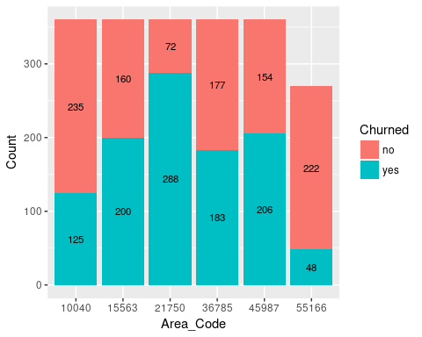

### 1.3.2 LONGDIST_FLAG

Whether has signed up for the off-peak long distance call package

|  |  |
| --- | --- |
| Predictor | LONGDIST_FLAG |
| attribute type | Nominal |
| %Missing Values | 0% |
| Mode | 1 |

**CHART CODE**

plot_data <- data.frame(table(churn_data$LONGDIST_FLAG, churn_data$CHURNER))  
colnames(plot_data) <- c("LONGDIST_FLAG", "Churned", "Count" )  
ggplot(data=plot_data, aes(x = LONGDIST_FLAG, y = Count, fill = Churned, label = Count)) +   
 geom_bar(stat = "identity") +   
 geom_text(size = 3, position = position_stack(vjust = 0.5))

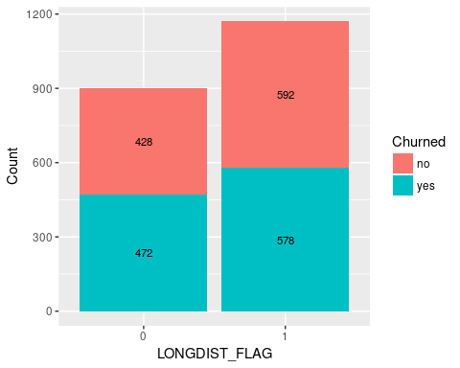

### 1.3.3 CALLWAITING_FLAG

Whether the customer has call waiting

|  |  |
| --- | --- |
| Predictor | CALLWAITING_FLAG |
| attribute type | Nominal |
| %Missing Values | 0% |
| Mode | 0 |

**CHART CODE**

plot_data <- data.frame(table(churn_data$CALLWAITING_FLAG, churn_data$CHURNER))  
colnames(plot_data) <- c("CALLWAITING_FLAG", "Churned", "Count")  
ggplot(data=plot_data, aes(x = CALLWAITING_FLAG, y = Count, fill = Churned, label = Count)) +   
 geom_bar(stat = "identity") +   
 geom_text(size = 3, position = position_stack(vjust = 0.5))

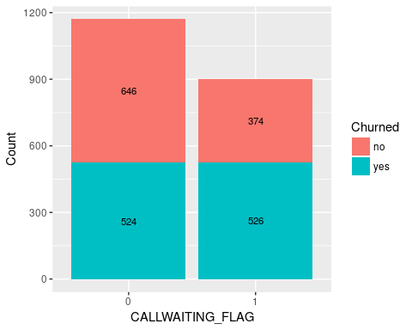

### 1.3.4 VOICEMAIL_FLAG

Whether the customer has voice mail

|  |  |
| --- | --- |
| Predictor | VOICEMAIL_FLAG |
| attribute type | Nominal |
| %Missing Values | 0% |
| Mode | 1 |

**CHART CODE**

plot_data <- data.frame(table(churn_data$VOICEMAIL_FLAG, churn_data$CHURNER))  
colnames(plot_data) <- c("VOICEMAIL_FLAG", "Churned", "Count" )  
ggplot(data=plot_data, aes(x = VOICEMAIL_FLAG, y = Count, fill = Churned, label = Count)) +   
 geom_bar(stat = "identity") +   
 geom_text(size = 3, position = position_stack(vjust = 0.5))

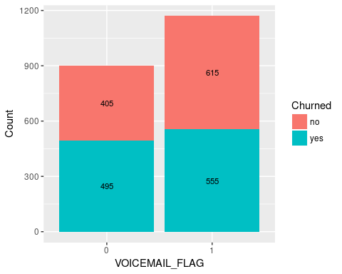

### 1.3.5 MOBILE_PLAN

Has the customer signed up to the mobile phone plan

|  |  |
| --- | --- |
| Predictor | MOBILE_PLAN |
| attribute type | Nominal |
| %Missing Values | 0% |
| Mode | 0 |

**CHART CODE**

plot_data <- data.frame(table(churn_data$MOBILE_PLAN, churn_data$CHURNER))  
colnames(plot_data) <- c("MOBILE_PLAN", "Churned", "Count" )  
ggplot(data=plot_data, aes(x = MOBILE_PLAN, y = Count, fill = Churned, label = Count)) +   
 geom_bar(stat = "identity") +   
 geom_text(size = 3, position = position_stack(vjust = 0.5))

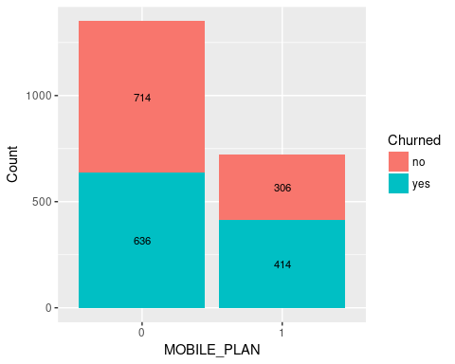

### 1.3.6 CONVERGENT_BILLING

All service charges consolidated onto one bill

|  |  |
| --- | --- |
| Predictor | CONVERGENT_BILLING |
| attribute type | Nominal |
| %Missing Values | 0% |
| Mode | No |

**CHART CODE**

plot_data <- data.frame(table(churn_data$CONVERGENT_BILLING, churn_data$CHURNER))  
colnames(plot_data) <- c("CONVERGENT_BILLING", "Churned", "Count" )  
ggplot(data=plot_data, aes(x = CONVERGENT_BILLING, y = Count, fill = Churned, label = Count)) +   
 geom_bar(stat = "identity") +   
 geom_text(size = 3, position = position_stack(vjust = 0.5))

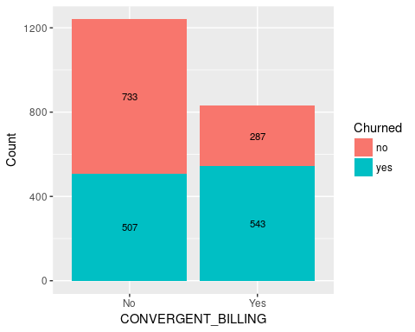

### 1.3.7 GENDER

Account holder's gender

|  |  |
| --- | --- |
| Predictor | GENDER |
| attribute type | Nominal |
| %Missing Values | 0% |
| Mode | M |

**CHART CODE**

plot_data <- data.frame(table(churn_data$GENDER, churn_data$CHURNER))  
colnames(plot_data) <- c("GENDER", "Churned", "Count" )  
ggplot(data=plot_data, aes(x = GENDER, y = Count, fill = Churned, label = Count)) +   
 geom_bar(stat = "identity") +   
 geom_text(size = 3, position = position_stack(vjust = 0.5))

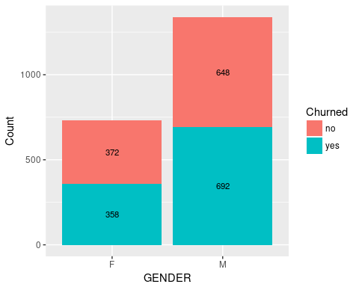

### 1.3.8 INCOME

Account holder's annual income (€)

|  |  |
| --- | --- |
| Predictor | INCOME |
| attribute type | Ordinal |
| %Missing Values | 0% |
| Mode | medium income |

**CHART CODE**

plot_data <- data.frame(table(churn_data$INCOME, churn_data$CHURNER))  
colnames(plot_data) <- c("INCOME", "Churned", "Count" )  
ggplot(data=plot_data, aes(x = INCOME, y = Count, fill = Churned, label = Count)) +   
 geom_histogram(stat = "identity") +   
 geom_text(size = 3, position = position_stack(vjust = 0.5))

## Warning: Ignoring unknown parameters: binwidth, bins, pad

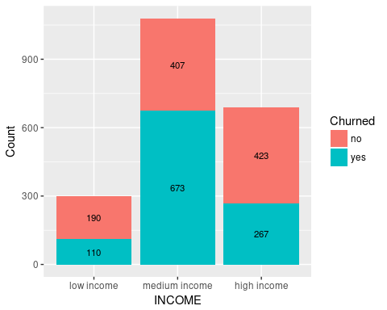

### 1.3.9 PHONE_PLAN

The phone plan the customer has signed up for national, euro-zone, international (outside Euro-zone) and promo_plan (signed up to the promotional plan)

|  |  |
| --- | --- |
| Predictor | PHONE_PLAN |
| attribute type | Nominal |
| %Missing Values | 0.193% |
| Mode | International |

**CHART CODE**

plot_data <- data.frame(table(churn_data$PHONE_PLAN, churn_data$CHURNER))  
colnames(plot_data) <- c("PHONE_PLAN", "Churned", "Count" )  
ggplot(data=plot_data, aes(x = PHONE_PLAN, y = Count, fill = Churned, label = Count)) +   
 geom_bar(stat = "identity") +   
 geom_text(size = 3, position = position_stack(vjust = 0.5))

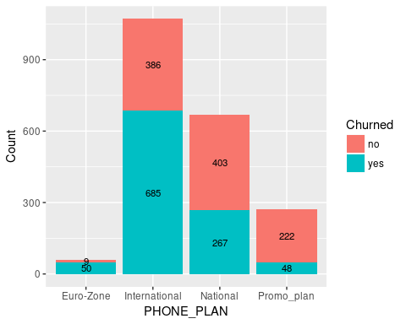

### 1.3.10 EDUCATION

Highest Level of education attainment the account holder has achieved

|  |  |
| --- | --- |
| Predictor | EDUCATION |
| attribute type | Nominal |
| %Missing Values | 0.386% |
| Mode | Post Primary |

**CHART CODE**

plot_data <- data.frame(table(churn_data$EDUCATION, churn_data$CHURNER))  
colnames(plot_data) <- c("EDUCATION", "Churned", "Count" )  
ggplot(data=plot_data, aes(x = EDUCATION, y = Count, fill = Churned, label = Count)) +   
 geom_bar(stat = "identity") +   
 geom_text(size = 3, position = position_stack(vjust = 0.5))

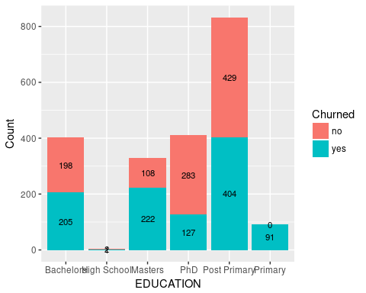

### 1.3.11 MINUTES_CURR_MONTH

Phone Minutes currently for current months (to the time the data was extracted)

|  |  |
| --- | --- |
| Predictor | MINUTES_CURR_MONTH |
| attribute type | Numeric |
| %Missing Values | 0% |
| Max | 14000 |
| Min | 1 |
| Mean | 748 |
| Mode | 2, 5 |
| median | 105 |
| Standard deviation | 2017.5556123 |

MINUTES_CURR_MONTH Skewness

(3 * (mean(churn_data$MINUTES_PREV_MONTH) - median(churn_data$MINUTES_PREV_MONTH)))/ sd(churn_data$MINUTES_PREV_MONTH)

## [1] 0.9312979

**CHART CODE**

plot_data <- data.frame(table(churn_data$MINUTES_CURR_MONTH, churn_data$CHURNER))  
colnames(plot_data) <- c("MINUTES_CURR_MONTH", "CHURNER", "COUNT")  
ggplot(data=plot_data, aes(x = MINUTES_CURR_MONTH, y=COUNT, fill = CHURNER, label=COUNT)) +  
 geom_histogram(stat="identity", width = 1) +  
 geom_text(size = 2, position = position_stack(vjust = 0.5))+   
 theme(axis.text.x = element_text(angle = 90, hjust = 1))

## Warning: Ignoring unknown parameters: binwidth, bins, pad

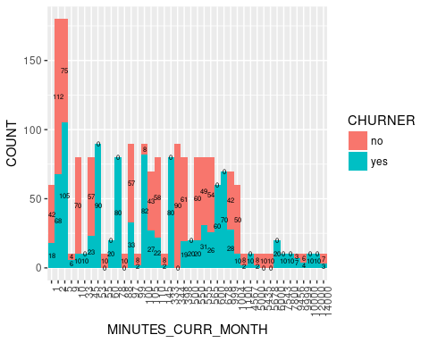

**CHART CODE**

ggplot(data=churn_data, aes(x=MINUTES_CURR_MONTH)) + geom_density(adjust=1, fill="#4F81BD") + ggtitle("Minutes Talked (Current Month)") + xlab("Minutes") + ylab("Customers")

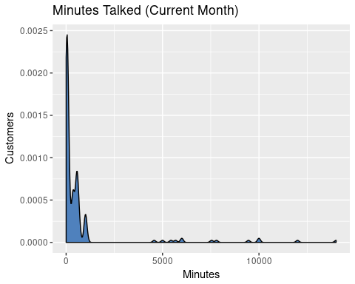

### 1.3.12 MINUTES_PREV_MONTH

Phone Minutes used in the previous month

|  |  |
| --- | --- |
| Predictor | MINUTES_PREV_MONTH |
| attribute type | Numerical |
| %Missing Values | 0% |
| Max | 16754 |
| Min | 0 |
| Mean | 864.31 |
| Mode | 0 |
| median | 98 |

MINUTES_PREV_MONTH Skewness

(3 * (mean(churn_data$MINUTES_PREV_MONTH) - median(churn_data$MINUTES_PREV_MONTH)))/ sd(churn_data$MINUTES_PREV_MONTH)

## [1] 0.9312979

**CHART CODE**

plot_data <- data.frame(table(churn_data$MINUTES_PREV_MONTH, churn_data$CHURNER))  
colnames(plot_data) <- c("MINUTES_PREV_MONTH", "CHURNER", "COUNT")  
ggplot(data=plot_data, aes(x = MINUTES_PREV_MONTH, y=COUNT, fill = CHURNER, label=COUNT)) +  
 geom_histogram(stat="identity", width = 1) +  
 geom_text(size = 2, position = position_stack(vjust = 0.5))+   
 theme(axis.text.x = element_text(angle = 90, hjust = 1))

## Warning: Ignoring unknown parameters: binwidth, bins, pad

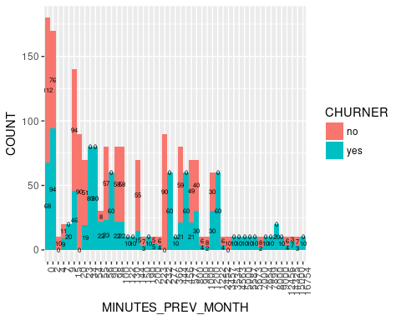

**CHART CODE**

ggplot(data=churn_data, aes(x=MINUTES_PREV_MONTH)) + geom_density(adjust=1, fill="#4F81BD") + ggtitle("Minutes Talked (Previous Month)") + xlab("Minutes") + ylab("Customers")

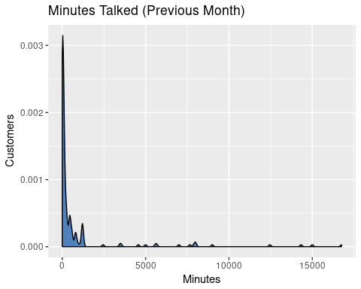

### 1.3.13 MINUTES_3MONTHS_AGO

Phone Minutes used in the 3 month PREVIOUS

|  |  |
| --- | --- |
| Predictor | MINUTES_3MONTHS_AGO |
| attribute type | Numerical |
| %Missing Values | 0.145% |
| Max | 12456 |
| Min | 0 |
| Mean | 452.74 |
| Mode | 0 |
| median | 97 |

MINUTES_3MONTHS_AGO Skewness

Right-skewness data – Is positive, as mean is greater than the median

(3 * (mean(churn_data$MINUTES_3MONTHS_AGO) - median(churn_data$MINUTES_3MONTHS_AGO)))/ sd(churn_data$MINUTES_3MONTHS_AGO)

## [1] 0.9012361

**CHART CODE**

plot_data <- data.frame(table(churn_data$MINUTES_3MONTHS_AGO, churn_data$CHURNER))  
colnames(plot_data) <- c("MINUTES_3MONTHS_AGO", "CHURNER", "COUNT")  
ggplot(data=plot_data, aes(x = MINUTES_3MONTHS_AGO, y=COUNT, fill = CHURNER, label=COUNT)) +  
 geom_histogram(stat="identity", width = 1) +  
 geom_text(size = 2, position = position_stack(vjust = 0.5))+   
 theme(axis.text.x = element_text(angle = 90, hjust = 1))

## Warning: Ignoring unknown parameters: binwidth, bins, pad

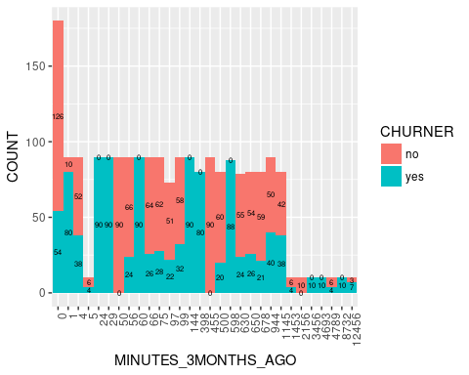

**CHART CODE**

ggplot(data=churn_data, aes(x=MINUTES_3MONTHS_AGO)) + geom_density(adjust=1, fill="#4F81BD") + ggtitle("Minutes Talked (3 Months ago)") + xlab("Minutes") + ylab("Customers")

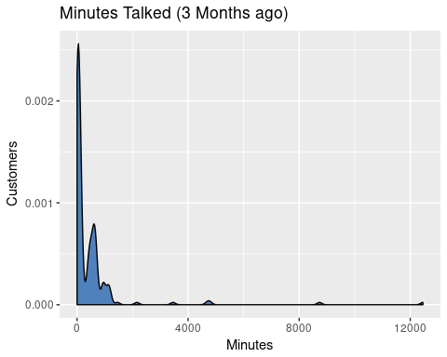

### 1.3.14 CUST_MOS

The number of continuous months the Customer is with the provider

|  |  |
| --- | --- |
| Predictor | CUST_MOS |
| attribute type | Numerical |
| %Missing Values | 0.145% |
| Max | 50 |
| Min | 1 |
| Mean | 16.05 |
| Mode | 11 |
| Mode | 11 |
| median | 11 |

CUST_MOS Skewness

Right-skewness data – Is positive, as mean is greater than the median

(3 * (mean(churn_data$CUST_MOS) - median(churn_data$CUST_MOS)))/ sd(churn_data$CUST_MOS)

## [1] 1.132926

**CHART CODE**

plot_data <- data.frame(table(churn_data$CUST_MOS, churn_data$CHURNER))  
colnames(plot_data) <- c("CUST_MOS", "CHURNER", "COUNT")  
ggplot(data=plot_data, aes(x = CUST_MOS, y=COUNT, fill = CHURNER, label=COUNT)) +  
 geom_histogram(stat="identity", width = 1) +  
 geom_text(size = 2, angle = 90, position = position_stack(vjust = 0.5))+   
 theme(axis.text.x = element_text(size=6, hjust = .5))

## Warning: Ignoring unknown parameters: binwidth, bins, pad

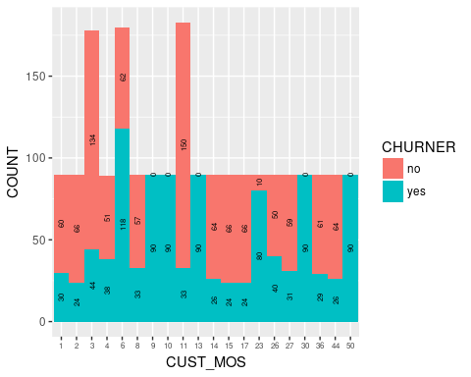

**CHART CODE**

ggplot(data=churn_data, aes(x=CUST_MOS)) + geom_density(adjust=1, fill="#4F81BD") + ggtitle("Number of months") + xlab("Months") + ylab("Customers")

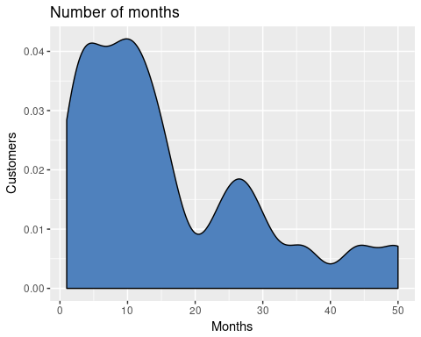

### 1.3.15 TOT_MINUTES_USAGE

The total number of minutes used to date

|  |  |
| --- | --- |
| Predictor | TOT_MINUTES_USAGE |
| attribute type | Numeric |
| %Missing Values | 0.193% |
| Max | 36237 |
| Min | 0 |
| Mean | 2037.09 |
| Mode | 0 |
| median | 264 |
| Standard deviation | 4883.9078032 |

TOT_MINUTES_USAGE Skewness

Right-skewness data – Is positive, as mean is greater than the median

(3 * (mean(churn_data$TOT_MINUTES_USAGE) - median(churn_data$TOT_MINUTES_USAGE)))/ sd(churn_data$TOT_MINUTES_USAGE)

## [1] 1.089144

**CHART CODE**

plot_data <- data.frame(table(churn_data$TOT_MINUTES_USAGE, churn_data$CHURNER))  
colnames(plot_data) <- c("TOT_MINUTES_USAGE", "CHURNER", "COUNT")  
ggplot(data=plot_data, aes(x = TOT_MINUTES_USAGE, y=COUNT, fill = CHURNER, label=COUNT)) +  
 geom_histogram(stat="identity", width = 1) +  
 geom_text(size = 2, angle = 90, position = position_stack(vjust = 0.5))+   
 theme(axis.text.x = element_text(size=6, angle = 90, hjust = .5))

## Warning: Ignoring unknown parameters: binwidth, bins, pad

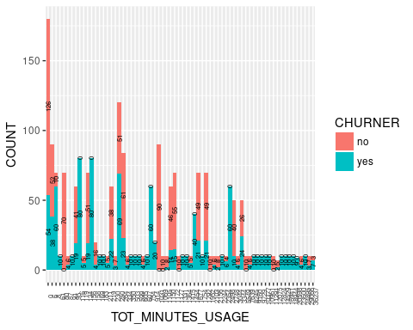

**CHART CODE**

ggplot(data=churn_data, aes(x=TOT_MINUTES_USAGE)) + geom_density(adjust=1, fill="#4F81BD") + ggtitle("Minutes Talked Total") + xlab("Minutes") + ylab("Customers")

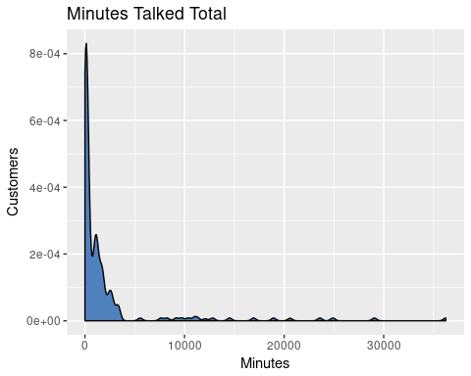

### 1.3.16 NUM_LINES

The number of fixed lines the customer has leased.

|  |  |
| --- | --- |
| Predictor | NUM_LINES |
| attribute type | Numeric |
| %Missing Values | 0% |
| Max | 3 |
| Min | 1 |
| Mean | 1.3913043 |
| Mode | 1 |
| median | 1 |
| Standard deviation | 0.5703498 |

**NUM_LINES Skewness**

Right-skewness data – Is positive, as mean is greater than the median

(3 * (mean(churn_data$NUM_LINES) - median(churn_data$NUM_LINES)))/ sd(churn_data$NUM_LINES)

## [1] 2.058233

**CHART CODE**

plot_data <- data.frame(table(churn_data$NUM_LINES, churn_data$CHURNER))  
colnames(plot_data) <- c("NUM_LINES", "CHURNER", "COUNT")  
ggplot(data=plot_data, aes(x = NUM_LINES, y=COUNT, fill = CHURNER, label=COUNT)) +  
 geom_histogram(stat="identity", width = 1) +  
 geom_text(size = 2, position = position_stack(vjust = 0.5))+   
 theme(axis.text.x = element_text(angle = 90, hjust = 1))

## Warning: Ignoring unknown parameters: binwidth, bins, pad

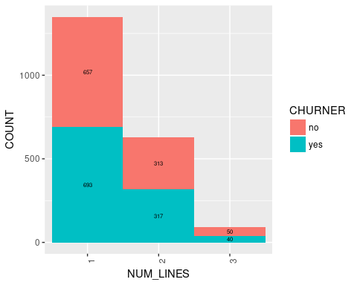

**CHART CODE**

ggplot(data=churn_data, aes(x=NUM_LINES)) + geom_density(adjust=1, fill="#4F81BD") + ggtitle("Number of lines per customer") + xlab("Number of lines") + ylab("Customers")

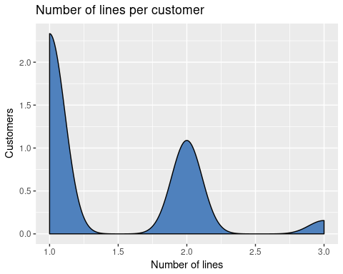

## 1.4 Identify Outliers

### 1.4.1 Graphical methods to identify outliers

#### 1.4.1.1 MINUTES_3MONTHS_AGO

ggplot(data=churn_data, aes(x=CHURNER, y=MINUTES_3MONTHS_AGO))+ geom_boxplot()

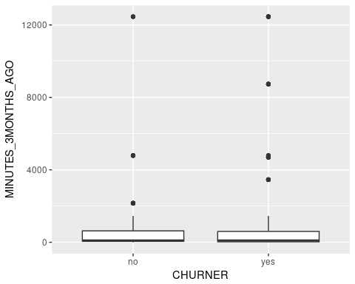

#### 1.4.1.2 MINUTES_PREV_MONTH

ggplot(data=churn_data, aes(x=CHURNER, y=MINUTES_PREV_MONTH))+ geom_boxplot()

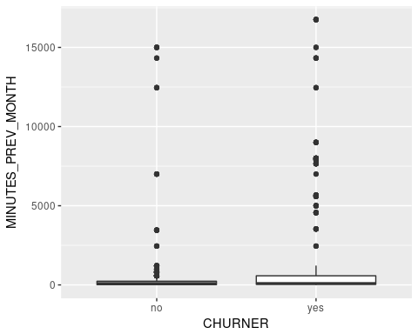

#### 1.4.1.3 MINUTES_CURR_MONTH

ggplot(data=churn_data, aes(x=CHURNER, y=MINUTES_CURR_MONTH))+ geom_boxplot()

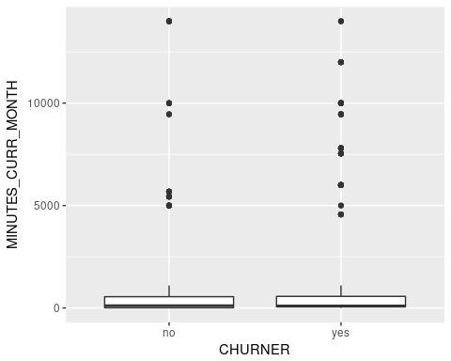

#### 1.4.1.4 TOT_MINUTES_USAGE

ggplot(data=churn_data, aes(x=CHURNER, y=TOT_MINUTES_USAGE))+ geom_boxplot()

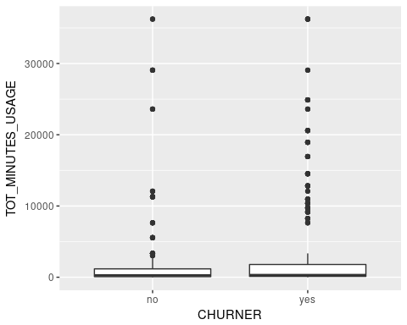

#### 1.4.1.5 NUM_LINES

ggplot(data=churn_data, aes(x=CHURNER, y=NUM_LINES))+ geom_boxplot()

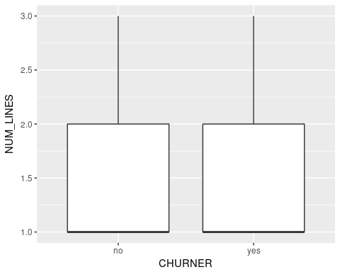

#### 1.4.1.6 CUST_MOS

ggplot(data=churn_data, aes(x=CHURNER, y=CUST_MOS))+ geom_boxplot()

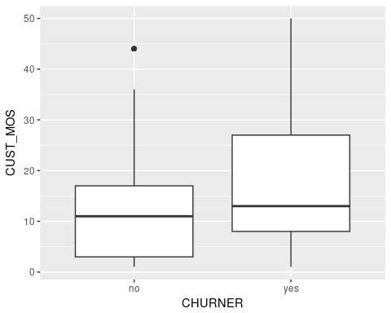

### 1.4.2 Mathematically identifying outliers

Choose a numeric predictor variable that has possible outliers based on your analysis in 2 above. Use the IQR method and Z-Score Standardisation method to identify outliers. Discuss your findings.

**IQR method**

minutesQuartileTolerance <- 1.5* IQR(churn_data$TOT_MINUTES_USAGE)  
minutesLowerQuantile <- quantile(churn_data$TOT_MINUTES_USAGE, 0.25)  
minutesUpperQuantile <- quantile(churn_data$TOT_MINUTES_USAGE, 0.75)  
  
print("lower outliers")

## [1] "lower outliers"

churn_data$TOT_MINUTES_USAGE[churn_data$TOT_MINUTES_USAGE < (minutesLowerQuantile - minutesQuartileTolerance)]

## numeric(0)

print("upper outliers")

## [1] "upper outliers"

churn_data$TOT_MINUTES_USAGE[churn_data$TOT_MINUTES_USAGE > (minutesUpperQuantile + minutesQuartileTolerance)]

## [1] 18944 14529 12824 23600 10961 20598 29066 9160 12075 11291 7639  
## [12] 36237 9729 16941 10377 11291 7639 36237 9729 5549 16941 10377  
## [23] 5549 24895 8245 5549 24895 8245 16941 10377 5549 24895 8245  
## [34] 18944 14529 12824 23600 10961 20598 16941 10377 24895 8245 5549  
## [45] 18944 14529 12824 23600 10961 20598 29066 9160 5549 12075 11291  
## [56] 18944 14529 12824 23600 10961 20598 29066 9160 11291 7639 36237  
## [67] 9729 29066 9160 12075 11291 7639 36237 9729 24895 8245 7639  
## [78] 36237 9729 16941 10377 24895 8245 5549 18944 14529 12824 23600  
## [89] 10961 29066 5549 9160 12075 11291 7639 36237 9729 5549 16941  
## [100] 10377 18944 14529 12824 5549 23600 10961 20598 29066 9160 11291  
## [111] 7639 36237 9729 16941 29066 9160 12075 11291 7639 36237 9729  
## [122] 16941 10377 24895 10961 20598 29066 9160 11291 7639 36237 9729  
## [133] 16941 10377 24895 8245 10377 24895 8245 18944 14529 12824 23600  
## [144] 10961 20598 8245 18944 14529 12824 23600 24895 8245 18944 14529  
## [155] 12824 23600 10961 20598 29066 9160 12075 18944 14529 12824 23600  
## [166] 10961 20598 29066 9160 12075 11291 7639 36237 9729 16941 10377

**zScore Standardisation method**

# zScore Standardisation  
zscore.TOT_MINUTES_USAGE <-(churn_data$TOT_MINUTES_USAGE - mean(churn_data$TOT_MINUTES_USAGE))/sd(churn_data$TOT_MINUTES_USAGE)  
summary(zscore.TOT_MINUTES_USAGE)

## Min. 1st Qu. Median Mean 3rd Qu. Max.   
## -0.41710 -0.39340 -0.36300 0.00000 -0.07373 7.00300

zscore.TOT_MINUTES_USAGE[zscore.TOT_MINUTES_USAGE < -3 | zscore.TOT_MINUTES_USAGE > 3]

## [1] 3.461758 4.415093 3.800421 5.534279 7.002570 3.051636 7.002570  
## [8] 3.051636 4.680249 4.680249 3.051636 4.680249 3.461758 4.415093  
## [15] 3.800421 3.051636 4.680249 3.461758 4.415093 3.800421 5.534279  
## [22] 3.461758 4.415093 3.800421 5.534279 7.002570 5.534279 7.002570  
## [29] 4.680249 7.002570 3.051636 4.680249 3.461758 4.415093 5.534279  
## [36] 7.002570 3.051636 3.461758 4.415093 3.800421 5.534279 7.002570  
## [43] 3.051636 5.534279 7.002570 3.051636 4.680249 3.800421 5.534279  
## [50] 7.002570 3.051636 4.680249 4.680249 3.461758 4.415093 3.800421  
## [57] 3.461758 4.415093 4.680249 3.461758 4.415093 3.800421 5.534279  
## [64] 3.461758 4.415093 3.800421 5.534279 7.002570 3.051636

## 1.5 Skewness for numeric data

Right-skewness data – Is positive, as mean is greater than the median Left skewness data – Mean is smaller than the median, generating negative values Perfectly symmetric data – mean, median and mode are equal, so skewness is zero

Skewness for MINUTES_3MONTHS_AGO

(3 * (mean(churn_data$MINUTES_3MONTHS_AGO) - median(churn_data$MINUTES_3MONTHS_AGO)))/ sd(churn_data$MINUTES_3MONTHS_AGO)

## [1] 0.9012361

Skewness for MINUTES_PREV_MONTH

(3 * (mean(churn_data$MINUTES_PREV_MONTH) - median(churn_data$MINUTES_PREV_MONTH)))/ sd(churn_data$MINUTES_PREV_MONTH)

## [1] 0.9312979

Skewness for MINUTES_CURR_MONTH

(3 * (mean(churn_data$MINUTES_CURR_MONTH) - median(churn_data$MINUTES_CURR_MONTH)))/ sd(churn_data$MINUTES_CURR_MONTH)

## [1] 0.956244

Skewness for TOT_MINUTES_USAGE

(3 * (mean(churn_data$TOT_MINUTES_USAGE) - median(churn_data$TOT_MINUTES_USAGE)))/ sd(churn_data$TOT_MINUTES_USAGE)

## [1] 1.089144

Skewness for NUM_LINES

(3 * (mean(churn_data$NUM_LINES) - median(churn_data$NUM_LINES)))/ sd(churn_data$NUM_LINES)

## [1] 2.058233

Skewness for CUST_MOS

(3 * (mean(churn_data$CUST_MOS) - median(churn_data$CUST_MOS)))/ sd(churn_data$CUST_MOS)

## [1] 1.132926

### 1.5.1 Correcting skewness

# calculate skewness  
TOT_MINUTES_USAGESkewness <- (3 * (mean(churn_data$TOT_MINUTES_USAGE) - median(churn_data$TOT_MINUTES_USAGE)))/ sd(churn_data$TOT_MINUTES_USAGE)  
TOT_MINUTES_USAGESkewness

## [1] 1.089144

**Natural Log Transformation**

# Natural Log Transformation  
natlog.TOT_MINUTES_USAGE <- log(churn_data$TOT_MINUTES_USAGE[churn_data$TOT_MINUTES_USAGE > 0])  
  
# applying log function to skewness  
logTOT_MINUTES_USAGESkewness <- (3 * (mean(natlog.TOT_MINUTES_USAGE) - median(natlog.TOT_MINUTES_USAGE)))/ sd(natlog.TOT_MINUTES_USAGE)  
logTOT_MINUTES_USAGESkewness

## [1] -0.7042918

**Square Root Transformation**

# Square Root Transformation  
sqrt.TOT_MINUTES_USAGE <- sqrt(churn_data$TOT_MINUTES_USAGE)  
# applying sqr root function to skewness  
  
sqrTOT_MINUTES_USAGESkewness <- (3 * (mean(sqrt.TOT_MINUTES_USAGE) - median(sqrt.TOT_MINUTES_USAGE)))/ sd(sqrt.TOT_MINUTES_USAGE)  
sqrTOT_MINUTES_USAGESkewness

## [1] 1.289714

**zScore Standardisation**

# zScore Standardisation  
zscore.TOT_MINUTES_USAGE <-(churn_data$TOT_MINUTES_USAGE - mean(churn_data$TOT_MINUTES_USAGE))/sd(churn_data$TOT_MINUTES_USAGE)  
  
# applying zScore function to skewness  
zscore.TOT_MINUTES_USAGE <- (3 * (mean(zscore.TOT_MINUTES_USAGE) - median(zscore.TOT_MINUTES_USAGE)))/ sd(zscore.TOT_MINUTES_USAGE)  
zscore.TOT_MINUTES_USAGE

## [1] 1.089144

## 1.7 2D Scatter plots to investigate correlation

2D Scatter plots to investigate correlation between numeric variables

### 1.7.1 TOT_MINUTES_USAGE vs CUST_MOS

ggplot(churn_data, aes(x=TOT_MINUTES_USAGE, y=CUST_MOS, col=CHURNER)) +  
 geom_point() +  
 geom_smooth(method=lm)

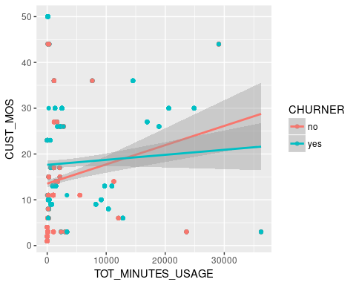

**Correlation**

cor(x=churn_data$TOT_MINUTES_USAGE, y=churn_data$CUST_MOS, use="all.obs", method="pearson")

## [1] 0.09055857

# <http://www.statmethods.net/stats/correlations.html>

### 1.7.2 TOT_MINUTES_USAGE vs MINUTES_CURR_MONTH

ggplot(churn_data, aes(x=TOT_MINUTES_USAGE, y=MINUTES_CURR_MONTH, col=CHURNER)) +  
 geom_point() +  
 geom_smooth(method=lm)

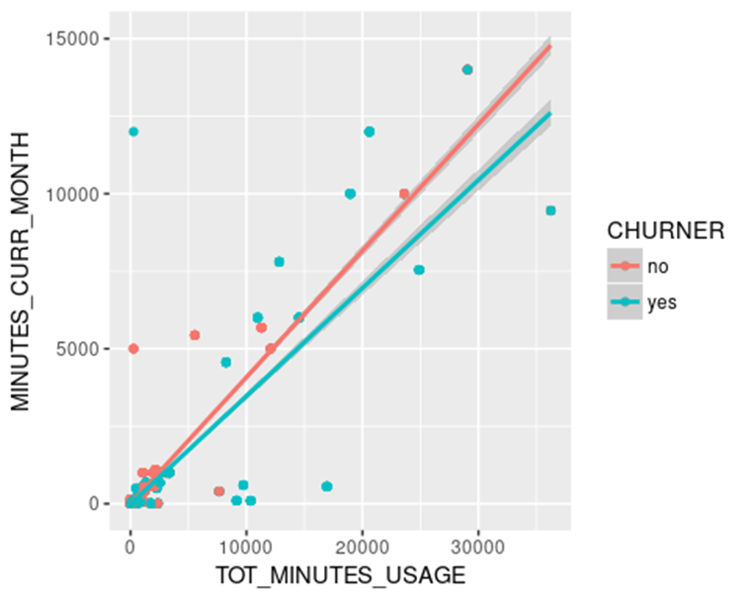

**Correlation**

cor(x=churn_data$TOT_MINUTES_USAGE, y=churn_data$MINUTES_CURR_MONTH, use="all.obs", method="pearson")

## [1] 0.8844237

# http://www.statmethods.net/stats/correlations.html

### 1.7.3 TOT_MINUTES_USAGE vs MINUTES_PREV_MONTH

ggplot(churn_data, aes(x=TOT_MINUTES_USAGE, y=MINUTES_PREV_MONTH, col=CHURNER)) +  
 geom_point() +  
 geom_smooth(method=lm)

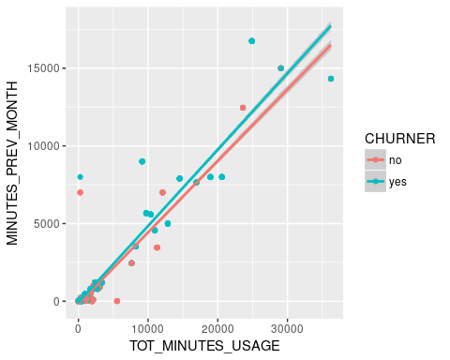

**Correlation**

cor(x=churn_data$TOT_MINUTES_USAGE, y=churn_data$MINUTES_PREV_MONTH, use="all.obs", method="pearson")

## [1] 0.9568583

# http://www.statmethods.net/stats/correlations.html

### 1.7.4 TOT_MINUTES_USAGE vs MINUTES_3MONTHS_AGO

ggplot(churn_data, aes(x=TOT_MINUTES_USAGE, y=MINUTES_3MONTHS_AGO, col=CHURNER)) +  
 geom_point() +  
 geom_smooth(method=lm)

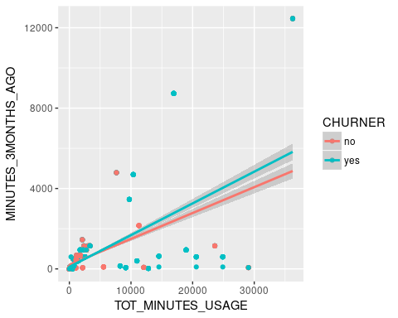

**Correlation**

cor(x=churn_data$TOT_MINUTES_USAGE, y=churn_data$MINUTES_3MONTHS_AGO, use="all.obs", method="pearson")

## [1] 0.611558

# http://www.statmethods.net/stats/correlations.html

### 1.7.5 TOT_MINUTES_USAGE vs NUM_LINES

ggplot(churn_data, aes(x=TOT_MINUTES_USAGE, y=NUM_LINES, col=CHURNER)) +  
 geom_point() +  
 geom_smooth(method=lm)

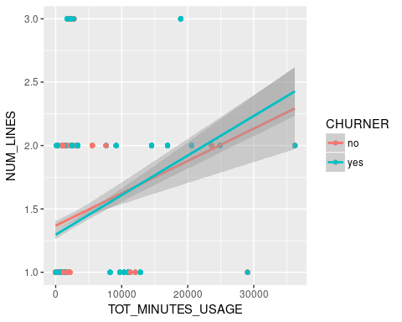

**Correlation**

cor(x=churn_data$TOT_MINUTES_USAGE, y=churn_data$NUM_LINES, use="all.obs", method="pearson")

## [1] 0.2460581

# http://www.statmethods.net/stats/correlations.html

### 1.7.6 CUST_MOS vs MINUTES_CURR_MONTH

ggplot(churn_data, aes(x=CUST_MOS, y=MINUTES_CURR_MONTH, col=CHURNER)) +  
 geom_point() +  
 geom_smooth(method=lm)

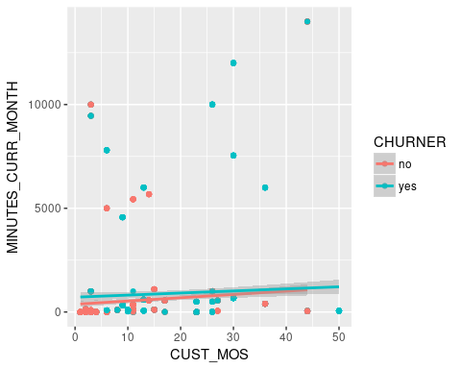

**Correlation**

cor(x=churn_data$TOT_MINUTES_USAGE, y=churn_data$MINUTES_CURR_MONTH, use="all.obs", method="pearson")

## [1] 0.8844237

# http://www.statmethods.net/stats/correlations.html

### 1.7.7 CUST_MOS vs MINUTES_PREV_MONTH

ggplot(churn_data, aes(x=CUST_MOS, y=MINUTES_PREV_MONTH)) +  
 geom_point() +  
 geom_smooth(method=lm)

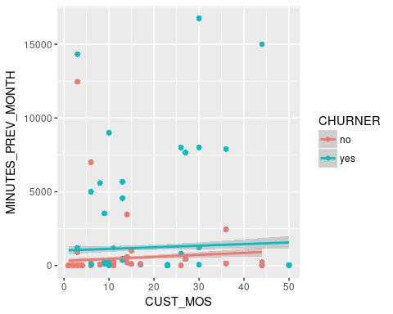

**Correlation**

cor(x=churn_data$TOT_MINUTES_USAGE, y=churn_data$MINUTES_PREV_MONTH, use="all.obs", method="pearson")

## [1] 0.9568583

# http://www.statmethods.net/stats/correlations.html

### 1.7.8 CUST_MOS vs MINUTES_3MONTHS_AGO

ggplot(churn_data, aes(x=CUST_MOS, y=MINUTES_3MONTHS_AGO, col=CHURNER)) +  
 geom_point() +  
 geom_smooth(method=lm)

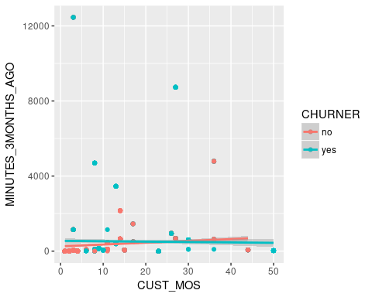

**Correlation**

cor(x=churn_data$CUST_MOS, y=churn_data$MINUTES_3MONTHS_AGO, use="all.obs", method="pearson")

## [1] 0.03824096

# http://www.statmethods.net/stats/correlations.html

### 1.7.9 CUST_MOS vs NUM_LINES

ggplot(churn_data, aes(x=CUST_MOS, y=NUM_LINES, col=CHURNER)) +  
 geom_point() +  
 geom_smooth(method=lm)

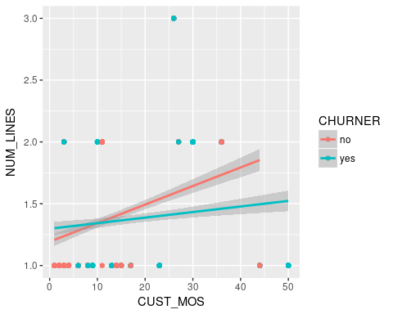

**Correlation**

cor(x=churn_data$CUST_MOS, y=churn_data$NUM_LINES, use="all.obs", method="pearson")

## [1] 0.2028409

# http://www.statmethods.net/stats/correlations.html

### 1.7.10 MINUTES_CURR_MONTH vs MINUTES_PREV_MONTH

ggplot(churn_data, aes(x=MINUTES_CURR_MONTH, y=MINUTES_PREV_MONTH, col=CHURNER)) +  
 geom_point() +  
 geom_smooth(method=lm)

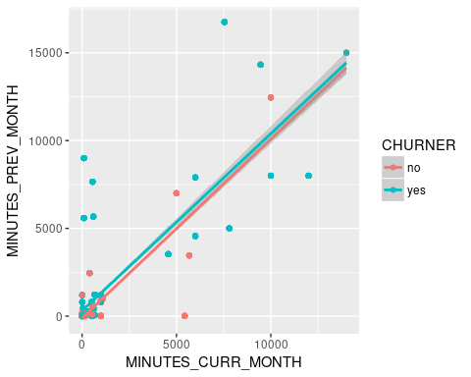

Correlation

cor(x=churn_data$MINUTES_CURR_MONTH, y=churn_data$MINUTES_PREV_MONTH, use="all.obs", method="pearson")

## [1] 0.8332782

# http://www.statmethods.net/stats/correlations.html

### 1.7.11 MINUTES_CURR_MONTH vs MINUTES_3MONTHS_AGO

ggplot(churn_data, aes(x=MINUTES_CURR_MONTH, y=MINUTES_3MONTHS_AGO, col=CHURNER))+  
 geom_point() +  
 geom_smooth(method=lm)

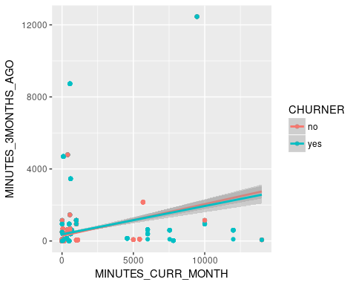

**Correlation**

cor(x=churn_data$MINUTES_CURR_MONTH, y=churn_data$MINUTES_3MONTHS_AGO, use="all.obs", method="pearson")

## [1] 0.2806732

# http://www.statmethods.net/stats/correlations.html

### 1.7.12 MINUTES_CURR_MONTH vs NUM_LINES

ggplot(churn_data, aes(x=MINUTES_CURR_MONTH, y=NUM_LINES, col=CHURNER)) +  
 geom_point() +  
 geom_smooth(method=lm)

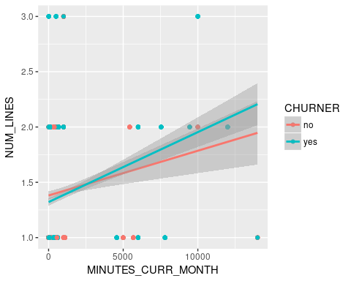

Correlation

cor(x=churn_data$MINUTES_CURR_MONTH, y=churn_data$NUM_LINES, use="all.obs", method="pearson")

## [1] 0.1932212

# http://www.statmethods.net/stats/correlations.html

### 1.7.13 MINUTES_PREV_MONTH vs NUM_LINES

ggplot(churn_data, aes(x=MINUTES_PREV_MONTH, y=NUM_LINES, col=CHURNER)) +  
 geom_point() +  
 geom_smooth(method=lm)

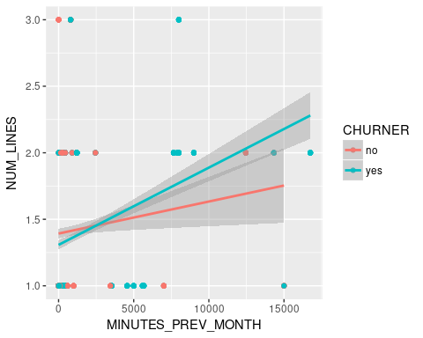

**Correlation**

cor(x=churn_data$MINUTES_PREV_MONTH, y=churn_data$NUM_LINES, use="all.obs", method="pearson")

## [1] 0.2016433

# http://www.statmethods.net/stats/correlations.html

### 1.7.14 MINUTES_PREV_MONTH vs MINUTES_3MONTHS_AGO

ggplot(churn_data, aes(x=MINUTES_PREV_MONTH, y=MINUTES_3MONTHS_AGO, col=CHURNER))+  
 geom_point() +  
 geom_smooth(method=lm)

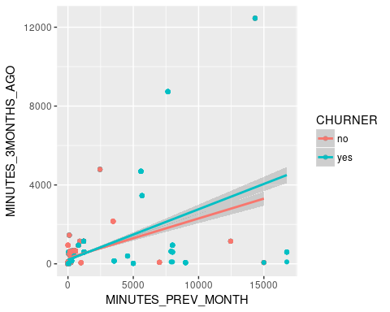

**Correlation**

cor(x=churn_data$MINUTES_PREV_MONTH, y=churn_data$MINUTES_3MONTHS_AGO, use="all.obs", method="pearson")

## [1] 0.4989065

# http://www.statmethods.net/stats/correlations.html

### 1.7.15 MINUTES_3MONTHS_AGO vs NUM_LINES

ggplot(churn_data, aes(x=MINUTES_3MONTHS_AGO, y=NUM_LINES, col=CHURNER)) +  
 geom_point() +  
 geom_smooth(method=lm)

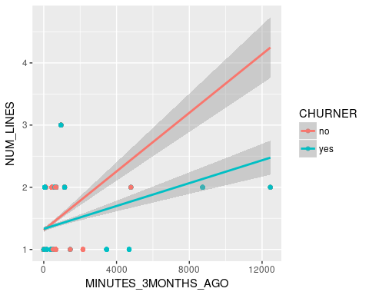

**Correlation**

# http://www.statmethods.net/stats/correlations.html  
cor(x=churn_data$MINUTES_3MONTHS_AGO, y=churn_data$NUM_LINES, use="all.obs", method="pearson")

## [1] 0.2624494

write.csv(churn_data, file="./churn_data_preprocessed.csv")

## 2 Weka

## 2.1 Mining algorithms

### 2.1.1 J48

Scheme: weka.classifiers.trees.J48 -C 0.25 -M 2

Relation: churn_data_preprocessed-weka.filters.unsupervised.attribute.Remove-R1-2,4-6-weka.filters.unsupervised.attribute.NumericToNominal-R1,3,4,6,7-weka.filters.unsupervised.attribute.Normalize-S1.0-T0.0

Instances: 2070

Attributes: 14

AREA_CODE

CUST_MOS

LONGDIST_FLAG

CALLWAITING_FLAG

NUM_LINES

VOICEMAIL_FLAG

MOBILE_PLAN

CONVERGENT_BILLING

GENDER

INCOME

PHONE_PLAN

EDUCATION

TOT_MINUTES_USAGE

CHURNER

Test mode: split 66.0% train, remainder test

=== Classifier model (full training set) ===

J48 pruned tree

------------------

CUST_MOS <= 0.877551

| CONVERGENT_BILLING = Yes

| | AREA_CODE = 10040

| | | CUST_MOS <= 0.020408: no (90.0/24.0)

| | | CUST_MOS > 0.020408

| | | | GENDER = M: no (50.0/24.0)

| | | | GENDER = F: yes (10.0/3.0)

| | AREA_CODE = 15563

| | | PHONE_PLAN = International

| | | | INCOME = High Income

| | | | | TOT_MINUTES_USAGE <= 0.049452: yes (10.0)

| | | | | TOT_MINUTES_USAGE > 0.049452: no (60.0/10.0)

| | | | INCOME = Medium Income: no (90.0/38.0)

| | | | INCOME = Low Income: yes (10.0)

| | | PHONE_PLAN = National: yes (10.0)

| | | PHONE_PLAN = Promo_plan: no (0.0)

| | | PHONE_PLAN = Euro-Zone: no (0.0)

| | AREA_CODE = 21750: yes (200.0)

| | AREA_CODE = 36785: yes (120.0)

| | AREA_CODE = 45987: yes (90.0)

| | AREA_CODE = 55166: no (90.0)

| CONVERGENT_BILLING = No

| | EDUCATION = Masters: no (120.0/32.0)

| | EDUCATION = Bachelors

| | | VOICEMAIL_FLAG = 0: yes (90.0)

| | | VOICEMAIL_FLAG = 1: no (111.0/41.0)

| | EDUCATION = High School: no (2.0)

| | EDUCATION = Post Primary

| | | CUST_MOS <= 0.326531: no (427.0/125.0)

| | | CUST_MOS > 0.326531

| | | | AREA_CODE = 10040: yes (0.0)

| | | | AREA_CODE = 15563: yes (0.0)

| | | | AREA_CODE = 21750: yes (70.0/10.0)

| | | | AREA_CODE = 36785: no (50.0/13.0)

| | | | AREA_CODE = 45987: yes (0.0)

| | | | AREA_CODE = 55166: yes (0.0)

| | EDUCATION = PhD: no (280.0/56.0)

| | EDUCATION = Primary: no (0.0)

CUST_MOS > 0.877551: yes (90.0)

Number of Leaves : 28

Size of the tree : 40

Time taken to build model: 0.02 seconds

=== Evaluation on test split ===

Time taken to test model on test split: 0 seconds

=== Summary ===

Correctly Classified Instances 565 80.2557 %

Incorrectly Classified Instances 139 19.7443 %

Kappa statistic 0.6099

Mean absolute error 0.2643

Root mean squared error 0.3802

Relative absolute error 52.8582 %

Root relative squared error 76.0351 %

Total Number of Instances 704

=== Detailed Accuracy By Class ===

TP Rate FP Rate Precision Recall F-Measure MCC ROC Area PRC Area Class

0.651 0.033 0.956 0.651 0.775 0.646 0.843 0.872 yes

0.967 0.349 0.718 0.967 0.824 0.646 0.843 0.785 no

Weighted Avg. 0.803 0.184 0.842 0.803 0.798 0.646 0.843 0.830

=== Confusion Matrix ===

a b <-- classified as

239 128 | a = yes

11 326 | b = no

### 2.1.1 jRip

Scheme: weka.classifiers.rules.JRip -F 3 -N 2.0 -O 2 -S 1

Relation: churn_data_preprocessed-weka.filters.unsupervised.attribute.Remove-R1-2,4-6-weka.filters.unsupervised.attribute.NumericToNominal-R1,3,4,6,7-weka.filters.unsupervised.attribute.Normalize-S1.0-T0.0

Instances: 2070

Attributes: 14

AREA_CODE

CUST_MOS

LONGDIST_FLAG

CALLWAITING_FLAG

NUM_LINES

VOICEMAIL_FLAG

MOBILE_PLAN

CONVERGENT_BILLING

GENDER

INCOME

PHONE_PLAN

EDUCATION

TOT_MINUTES_USAGE

CHURNER

Test mode: split 66.0% train, remainder test

=== Classifier model (full training set) ===

JRIP rules:

===========

(CONVERGENT_BILLING = No) and (TOT_MINUTES_USAGE >= 0.00436) => CHURNER=no (690.0/200.0)

(AREA_CODE = 55166) => CHURNER=no (90.0/0.0)

(CUST_MOS <= 0.061224) => CHURNER=no (397.0/122.0)

(TOT_MINUTES_USAGE <= 0.003698) and (CUST_MOS <= 0.204082) => CHURNER=no (82.0/28.0)

(EDUCATION = PhD) and (TOT_MINUTES_USAGE <= 0.092281) and (INCOME = High Income) and (TOT_MINUTES_USAGE >= 0.053868) => CHURNER=no (60.0/10.0)

(EDUCATION = PhD) and (AREA_CODE = 45987) => CHURNER=no (70.0/19.0)

=> CHURNER=yes (681.0/10.0)

Number of Rules : 7

Time taken to build model: 0.23 seconds

=== Evaluation on test split ===

Time taken to test model on test split: 0.01 seconds

=== Summary ===

Correctly Classified Instances 561 79.6875 %

Incorrectly Classified Instances 143 20.3125 %

Kappa statistic 0.599

Mean absolute error 0.2773

Root mean squared error 0.3848

Relative absolute error 55.4645 %

Root relative squared error 76.9526 %

Total Number of Instances 704

=== Detailed Accuracy By Class ===

TP Rate FP Rate Precision Recall F-Measure MCC ROC Area PRC Area Class

0.638 0.030 0.959 0.638 0.766 0.638 0.809 0.813 yes

0.970 0.362 0.711 0.970 0.821 0.638 0.809 0.707 no

Weighted Avg. 0.797 0.189 0.840 0.797 0.792 0.638 0.809 0.762

=== Confusion Matrix ===

a b <-- classified as

234 133 | a = yes

10 327 | b = no

### 2.1.1 PART

Scheme: weka.classifiers.rules.PART -M 2 -C 0.25 -Q 1

Relation: churn_data_preprocessed-weka.filters.unsupervised.attribute.Remove-R1-2,4-6-weka.filters.unsupervised.attribute.NumericToNominal-R1,3,4,6,7-weka.filters.unsupervised.attribute.Normalize-S1.0-T0.0

Instances: 2070

Attributes: 14

AREA_CODE

CUST_MOS

LONGDIST_FLAG

CALLWAITING_FLAG

NUM_LINES

VOICEMAIL_FLAG

MOBILE_PLAN

CONVERGENT_BILLING

GENDER

INCOME

PHONE_PLAN

EDUCATION

TOT_MINUTES_USAGE

CHURNER

Test mode: split 66.0% train, remainder test

=== Classifier model (full training set) ===

PART decision list

------------------

CUST_MOS <= 0.877551 AND CONVERGENT_BILLING = Yes AND AREA_CODE = 21750: yes (200.0)

CUST_MOS <= 0.877551 AND EDUCATION = Primary: yes (90.0)

CUST_MOS > 0.877551: yes (90.0)

TOT_MINUTES_USAGE > 0.22753 AND CONVERGENT_BILLING = Yes: yes (70.0/3.0)

PHONE_PLAN = National AND INCOME = Low Income: no (270.0/80.0)

EDUCATION = PhD AND TOT_MINUTES_USAGE > 0.002622 AND INCOME = High Income AND

TOT_MINUTES_USAGE <= 0.049452 AND MOBILE_PLAN = 0: no (170.0/48.0)

PHONE_PLAN = Promo_plan: no (260.0/44.0)

CUST_MOS <= 0.040816 AND AREA_CODE = 45987: no (89.0)

AREA_CODE = 45987 AND CUST_MOS <= 0.530612: yes (161.0/1.0)

INCOME = High Income AND EDUCATION = Post Primary: no (130.0/36.0)

INCOME = High Income AND TOT_MINUTES_USAGE > 0.049452: no (70.0/13.0)

CUST_MOS > 0.326531 AND PHONE_PLAN = International: yes (90.0/10.0)

INCOME = Medium Income AND GENDER = F: no (180.0/60.0)

INCOME = Medium Income AND PHONE_PLAN = International: no (90.0/38.0)

AREA_CODE = 36785: no (30.0/6.0)

PHONE_PLAN = National AND EDUCATION = PhD: no (20.0/9.0)

: no (60.0/29.0)

Number of Rules : 17

Time taken to build model: 0.21 seconds

=== Evaluation on test split ===

Time taken to test model on test split: 0.02 seconds

=== Summary ===

Correctly Classified Instances 567 80.5398 %

Incorrectly Classified Instances 137 19.4602 %

Kappa statistic 0.6147

Mean absolute error 0.2566

Root mean squared error 0.3732

Relative absolute error 51.3241 %

Root relative squared error 74.6475 %

Total Number of Instances 704

=== Detailed Accuracy By Class ===

TP Rate FP Rate Precision Recall F-Measure MCC ROC Area PRC Area Class

0.678 0.056 0.929 0.678 0.784 0.640 0.847 0.870 yes

0.944 0.322 0.729 0.944 0.823 0.640 0.847 0.787 no

Weighted Avg. 0.805 0.183 0.833 0.805 0.803 0.640 0.847 0.830

=== Confusion Matrix ===

a b <-- classified as

249 118 | a = yes

19 318 | b = no

### 2.1.1 ZeroR

Scheme: weka.classifiers.rules.ZeroR

Relation: churn_data_preprocessed-weka.filters.unsupervised.attribute.Remove-R1-2,4-6-weka.filters.unsupervised.attribute.NumericToNominal-R1,3,4,6,7-weka.filters.unsupervised.attribute.Normalize-S1.0-T0.0

Instances: 2070

Attributes: 14

AREA_CODE

CUST_MOS

LONGDIST_FLAG

CALLWAITING_FLAG

NUM_LINES

VOICEMAIL_FLAG

MOBILE_PLAN

CONVERGENT_BILLING

GENDER

INCOME

PHONE_PLAN

EDUCATION

TOT_MINUTES_USAGE

CHURNER

Test mode: split 66.0% train, remainder test

=== Classifier model (full training set) ===

ZeroR predicts class value: yes

Time taken to build model: 0 seconds

=== Evaluation on test split ===

Time taken to test model on test split: 0.01 seconds

=== Summary ===

Correctly Classified Instances 367 52.1307 %

Incorrectly Classified Instances 337 47.8693 %

Kappa statistic 0

Mean absolute error 0.5

Root mean squared error 0.5

Relative absolute error 100 %

Root relative squared error 100 %

Total Number of Instances 704

=== Detailed Accuracy By Class ===

TP Rate FP Rate Precision Recall F-Measure MCC ROC Area PRC Area Class

1.000 1.000 0.521 1.000 0.685 0.000 0.500 0.521 yes

0.000 0.000 0.000 0.000 0.000 0.000 0.500 0.479 no

Weighted Avg. 0.521 0.521 0.272 0.521 0.357 0.000 0.500 0.501

=== Confusion Matrix ===

a b <-- classified as

367 0 | a = yes

337 0 | b = no

# Bibliography

Your Bibliography: Gim.unmc.edu. (2017). The Area Under an ROC Curve. [online] Available at: http://gim.unmc.edu/dxtests/roc3.htm [Accessed 26 Mar. 2017].