Comando:

./manage.py migrate

./manage.py makemigrations

./manage.py check

source .venv/bin/activate

django-admin startproject mysite

$ python manage.py startapp polls

python manage.py runserver

Ir a seeting de django en la variable
INSTALLED_APPS [
'blog.apps.BlogConfig',
]
Usuario:
Nombre: alu
password: root

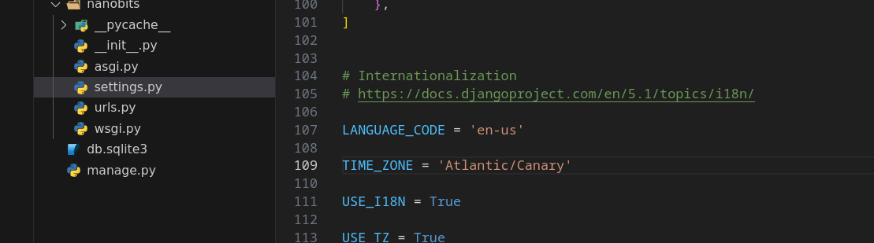

curl -L http://10.109.99.52:8000/scripts/update-vm.sh | bash

