
APPIonic
Local Data Persistence
────────────────────────────────────────────────────────────

The student will add persistence so that the information does not disappear when the application is closed



Student: | David Martínez Mercado
Email: | d.martinez.isw@unipolidgo.edu.mx
Subject: | Mobile Programming II
University: | Universidad Politécnica de Durango
Delivery: | Third — Local Data Persistence
Date: | Durango, Dgo., Mexico — September 2026

Contenido
Delivery Objective 4
Chosen Technology: Capacitor Preferences 4
Why 4
A deliberate limitation 5
What Was Implemented 5
Architecture 6
Class diagram of the persistence layer 6
StorageService — the base layer 6
Persistent session 7
Offline cache of the user CRUD 7
Nota entity: full CRUD without a server 8
Persistent CRUD Operations 8
How to Verify That the Information Persists 9
Test 1 — Notes (XAMPP not required) 9
Test 2 — Session 10
Test 3 — Offline cache of users 10
How to inspect it from the inside 10
Screenshots of the Running Application 10
Local notes: the full CRUD 10
The proof: the data survives a restart 12
Persistent session 13
User list with no connection 14
Technical Verification 14
A bug found while capturing the screenshots 15
Files Delivered 16
New files 16
Modified files 16
Resulting structure 16
Version control 17
How to run it 17
How AI Was Used 17
Observation on the use of AI 17

Delivery Objective
Add persistence to the application so that the information does not disappear when it is closed.
The starting point was the previous delivery, which already had the data model and the access layer organised into HttpService and UsuarioRepository. The remaining problem was that this layer depended entirely on the server:
What happened before | Consequence
The session lived only in memory | Closing the app meant typing the username and password again
The user list was always requested from the API | With XAMPP switched off, the view was left blank
No entity of its own lived on the device | Without a server, the application was of no use at all

The photo gallery (tab2) was the only part that already persisted, because the official Ionic template used Preferences to store the image paths. This delivery extends that same mechanism to the rest of the application.

Chosen Technology: Capacitor Preferences
Of the permitted options (Ionic Storage, Preferences, SQLite, file storage), @capacitor/preferences was chosen.

Why
- It was already installed and in use. The project used it in PhotoService from the base template. Adding Ionic Storage or SQLite would have meant introducing a new dependency to solve a problem that was already solved.
- It works the same on all three platforms. Preferences uses each system's native storage without any change to the code.
- The data volume is small. One session, one user list and a set of text notes. SQLite would be justified with thousands of records or queries with JOIN; here it would be over-engineering.

Platform | Where it actually stores the data
Android | SharedPreferences
iOS | UserDefaults
Browser (ng serve) | localStorage

A deliberate limitation
Preferences stores plain text; it is not encrypted. That is why a specific precaution is taken, explained in the architecture section: the password is never stored on the device.

What Was Implemented
The three gaps detected were addressed on three fronts:
# | What persists | Where | Key in Preferences
1 | Session of the authenticated user | SesionService | sesion
2 | Offline cache of the user list | UsuarioRepository | usuarios_cache
3 | Nota entity: fully local CRUD | NotaRepository | notas
— | (already existed) Photo gallery | PhotoService | photos

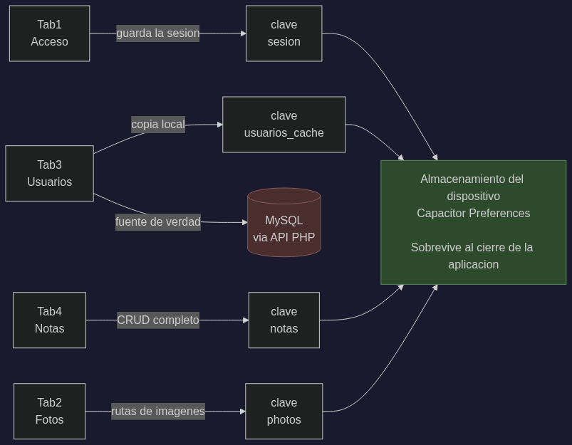
Figure 1. What each view stores and where it is stored.

Architecture

Class diagram of the persistence layer
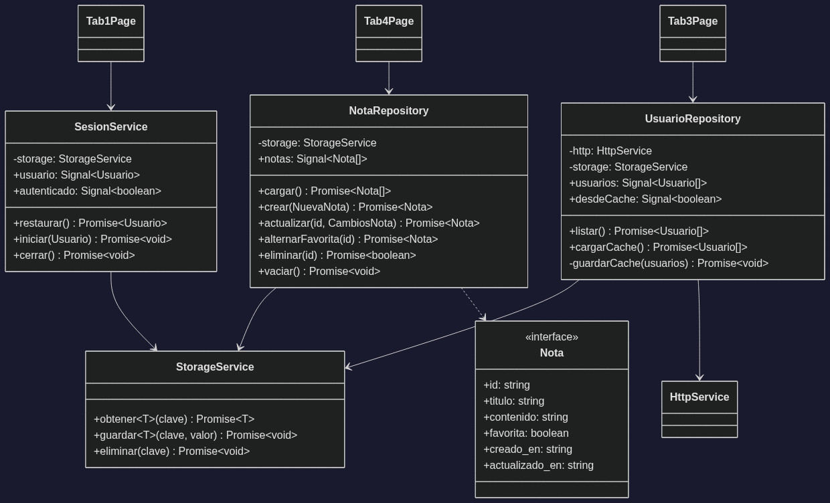
Figure 2. Class diagram of the persistence layer.

StorageService — the base layer
It wraps Preferences so that nobody else repeats the JSON.parse and JSON.stringify calls. It plays the same role for the device that HttpService plays for the server: it is the only class that knows the storage details.
async obtener<T>(clave: string): Promise<T | null> {
const { value } = await Preferences.get({ key: clave });

if (value === null) {
return null;
}

try {
return JSON.parse(value) as T;
} catch {
// Si el valor guardado quedo corrupto se descarta en lugar de
// tronar: vale mas empezar de cero que dejar la aplicacion sin
// arrancar.
await this.eliminar(clave);
return null;
}
}

The try/catch is not decorative. Preferences returns text, and if an earlier version of the app stored a different format, JSON.parse throws during start-up and the application does not open. Discarding the corrupted value is preferable.

Persistent session
SesionService stores the authenticated user and restores it when the app opens. Tab1Page reads it in ngOnInit:
async ngOnInit() {
const guardado = await this.sesion.restaurar();

if (guardado) {
this.usuario.set(guardado);
this.isActive = true; // entra directo al estado autenticado
}
}

Security decision. Only the Usuario object returned by the API is persisted, and that object never includes the password: the PHP removes it before responding (unset($fila['password'])). No credential is stored on the device, which matters because Preferences does not encrypt.

Offline cache of the user CRUD
Users still live in MySQL: that remains the source of truth. What was added is a local copy used only when the server does not respond:
async listar(): Promise<Usuario[]> {
try {
const usuarios = await this.http.get<Usuario[]>(this.url);

this.usuarios.set(usuarios);
this.desdeCache.set(false);
await this.guardarCache(usuarios);
return usuarios;
} catch (e) {
await this.cargarCache(); // deja los ultimos datos conocidos
throw e; // pero el error sigue propagandose
}
}

- The error is re-thrown. The view must still show the failure message; the cache does not hide the problem, it only avoids an empty screen.
- The view warns the user. When the data shown came from disk, an amber notice appears with the date of the last synchronisation, so that nobody mistakes stale data for current data.

Nota entity: full CRUD without a server
This is the most direct demonstration of the assignment: an entity whose entire life cycle happens on the device.
Field | Type | Description
id | string | Timestamp plus random suffix, generated by the client
titulo | string | Required
contenido | string | Free text
favorita | boolean | Allows partial editing to be tested
creado_en | string | ISO 8601
actualizado_en | string | ISO 8601, refreshed on every edit

Why the id is a string and not a number: there is no database engine to generate an AUTO_INCREMENT. The client assigns the id by combining the timestamp (which also gives the ordering) with a random suffix that avoids collisions if two notes are created in the same millisecond.
Every operation writes to disk before it finishes. This is what makes the persistence real rather than an in-memory cache:
async crear(datos: NuevaNota): Promise<Nota> {
const nota: Nota = { id: this.generarId(), ... };

this.notas.update((lista) => [nota, ...lista]);
await this.persistir(); // si la app se cierra aqui, el dato ya esta
return nota;
}

Persistent CRUD Operations
The four operations required by the assignment, in the Notas view (tab4):
Operation | Repository method | Effect on the device
Create | crear(NuevaNota) | Adds to the array and rewrites the notas key
Read | cargar() | Reads the notas key when the view is opened
Update | actualizar(id, CambiosNota) | Replaces the note and refreshes actualizado_en
Partial update | alternarFavorita(id) | Changes a single field
Delete | eliminar(id) | Removes it from the array and rewrites the key
Delete all | vaciar() | Leaves the array empty

In the Usuarios view (tab3) the CRUD still runs against MySQL, but every operation also updates the local copy, so the cache never falls behind the most recent action.
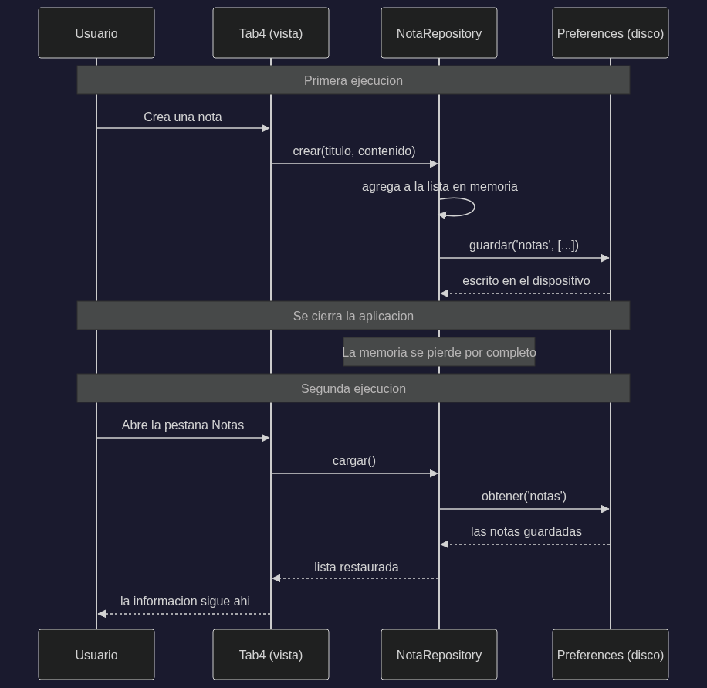
Figure 3. What happens when the application is closed and reopened.

How to Verify That the Information Persists
This is the procedure followed in the delivery video.

Test 1 — Notes (XAMPP not required)
- Open the Notas tab.
- Create two or three notes; mark one as a favourite.
- Close the application completely (in the browser, close the tab; on the phone, swipe it away from the recent apps list).
- Reopen it and go to Notas: the notes are still there, with their creation date and the favourite mark.
- Edit one and delete another; close and reopen: those changes persisted as well.

Test 2 — Session
- In the Acceso tab, sign in with admin / 123456.
- Close the application completely.
- Reopen it: it goes straight to the signed-in screen, without asking for the credentials again.
- Press the exit button and reopen: now it does ask for the login, because the session was deleted from the device.

Test 3 — Offline cache of users
- With XAMPP running, open Usuarios so that the list is downloaded.
- Stop Apache from the XAMPP control panel.
- Close and reopen the application, then go to Usuarios.
- The list is still displayed, together with the amber notice saying the data was stored on the device, and the date of the last synchronisation.

How to inspect it from the inside
In the browser, with the developer tools open: Application → Local Storage → http://localhost:4200. The keys CapacitorStorage.notas, CapacitorStorage.sesion and CapacitorStorage.usuarios_cache appear there with their JSON content.

Screenshots of the Running Application
The screens below were captured from the application actually running, following the three tests described above.

Local notes: the full CRUD
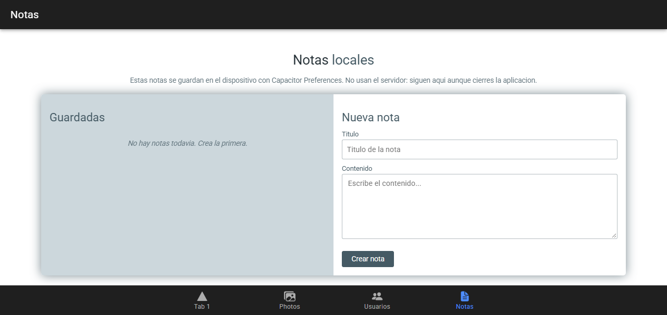
Figure 4. Empty state: the Notas tab before any note is created.

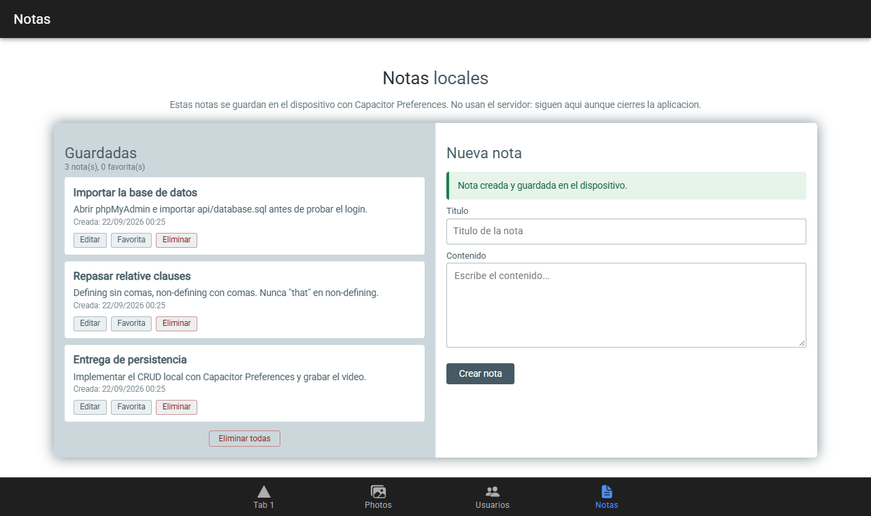
Figure 5. Create: three notes added, each stored on the device as it is created.

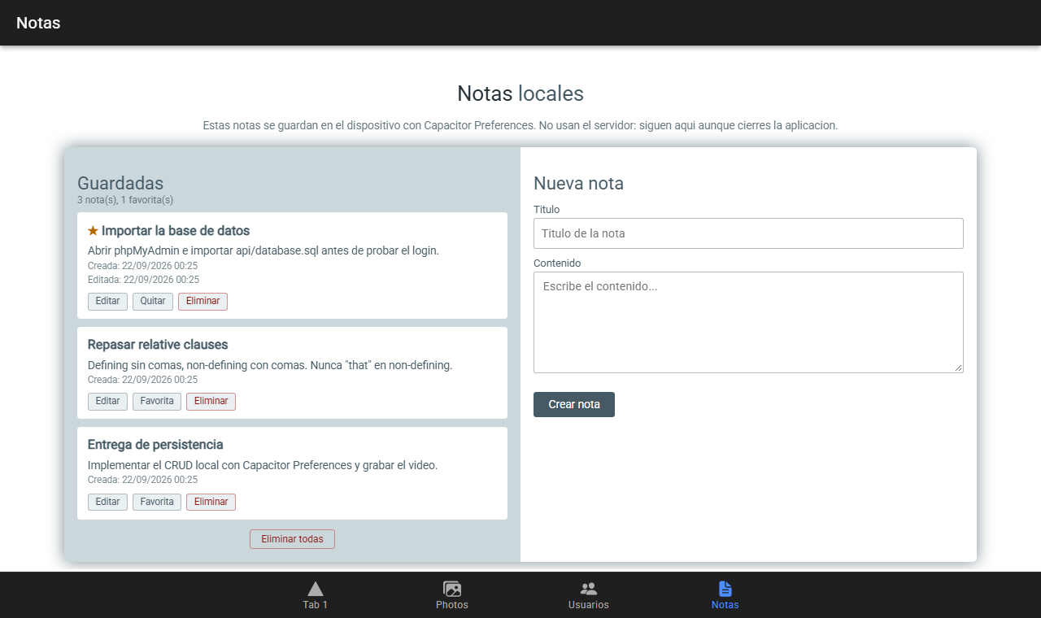
Figure 6. Partial update: only the favourite field changes, marked with a star.

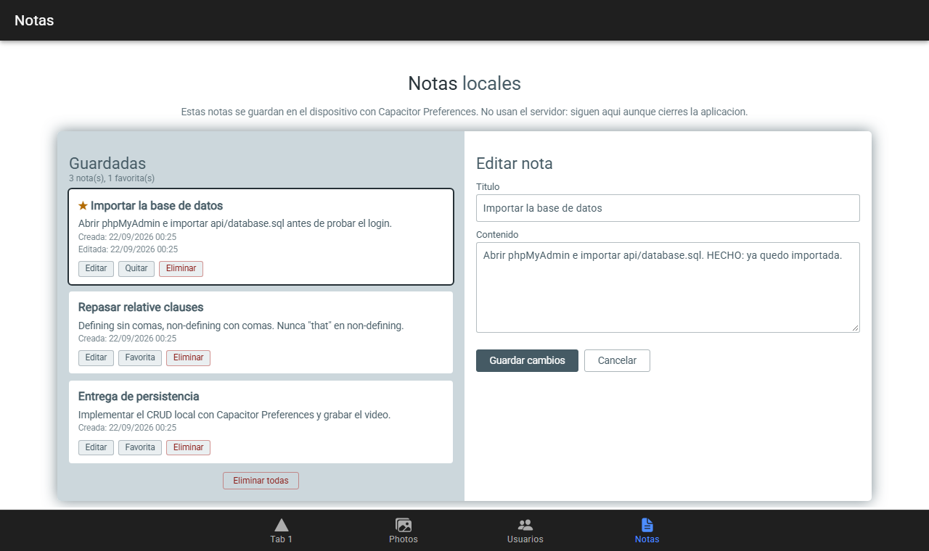
Figure 7. Update: the note is loaded into the form for editing.

The proof: the data survives a restart
The application was closed and reopened. Nothing was typed in again: the three notes come back from the device, keeping the star on the favourite one, the creation dates and the 'Editada' timestamp on the note that was modified.
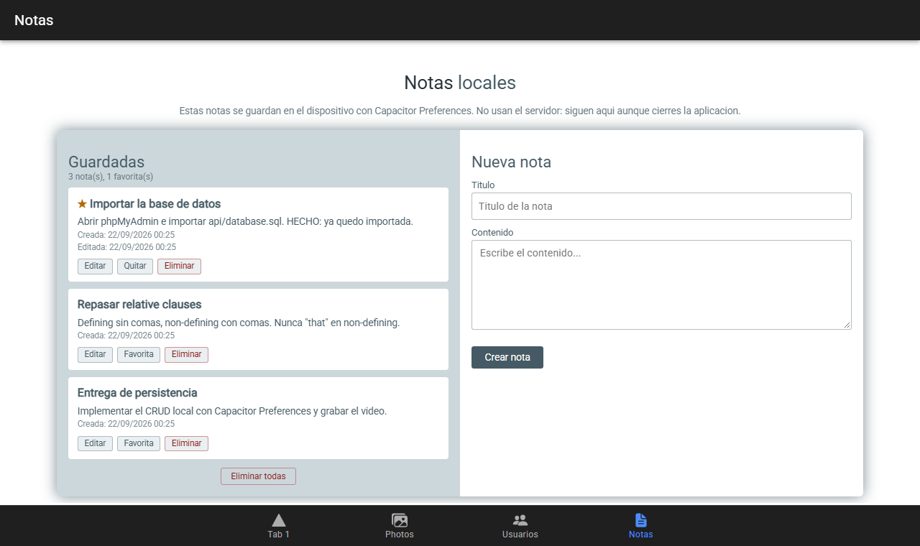
Figure 8. After closing and reopening the application, the information is still there.

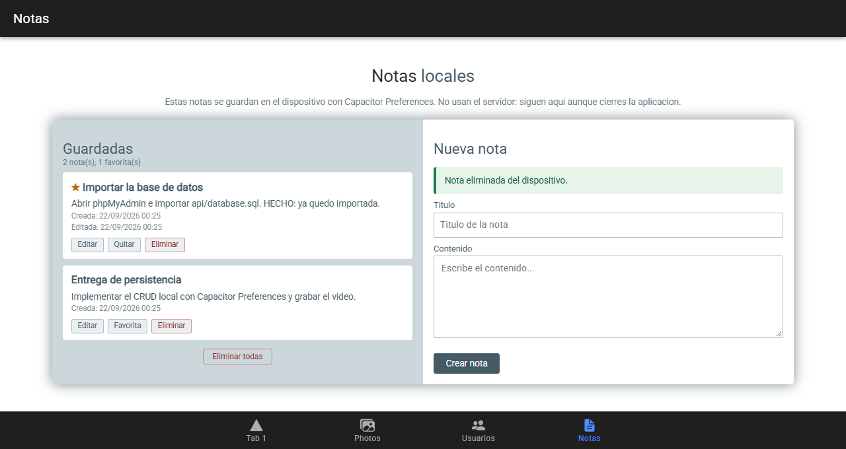
Figure 9. Delete: the note is removed from the device, and it does not come back after a restart either.

Persistent session
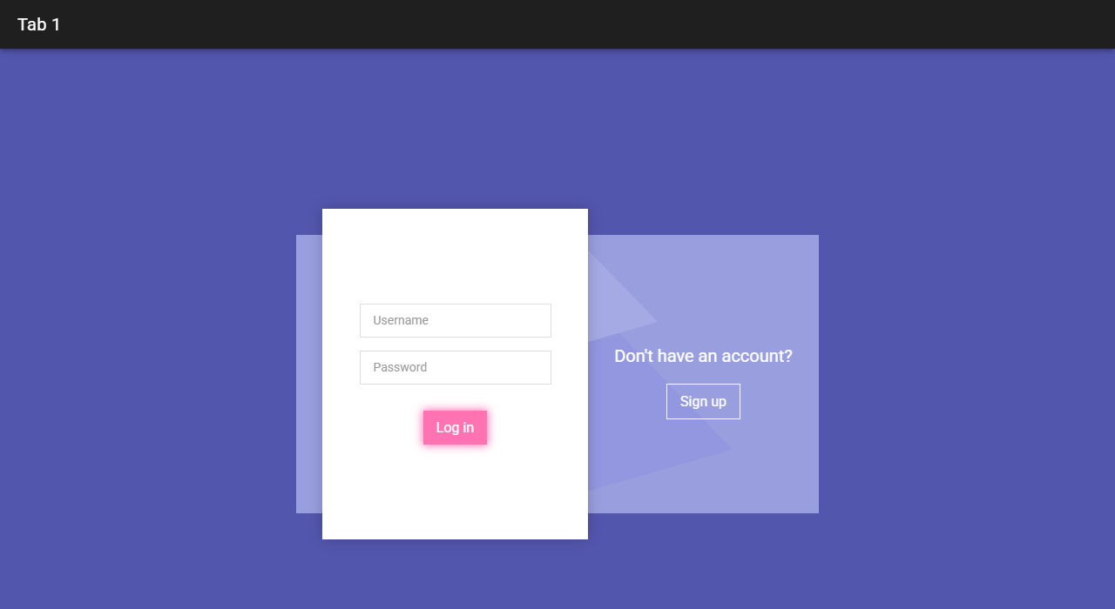
Figure 10. With no stored session, the application asks for the credentials.

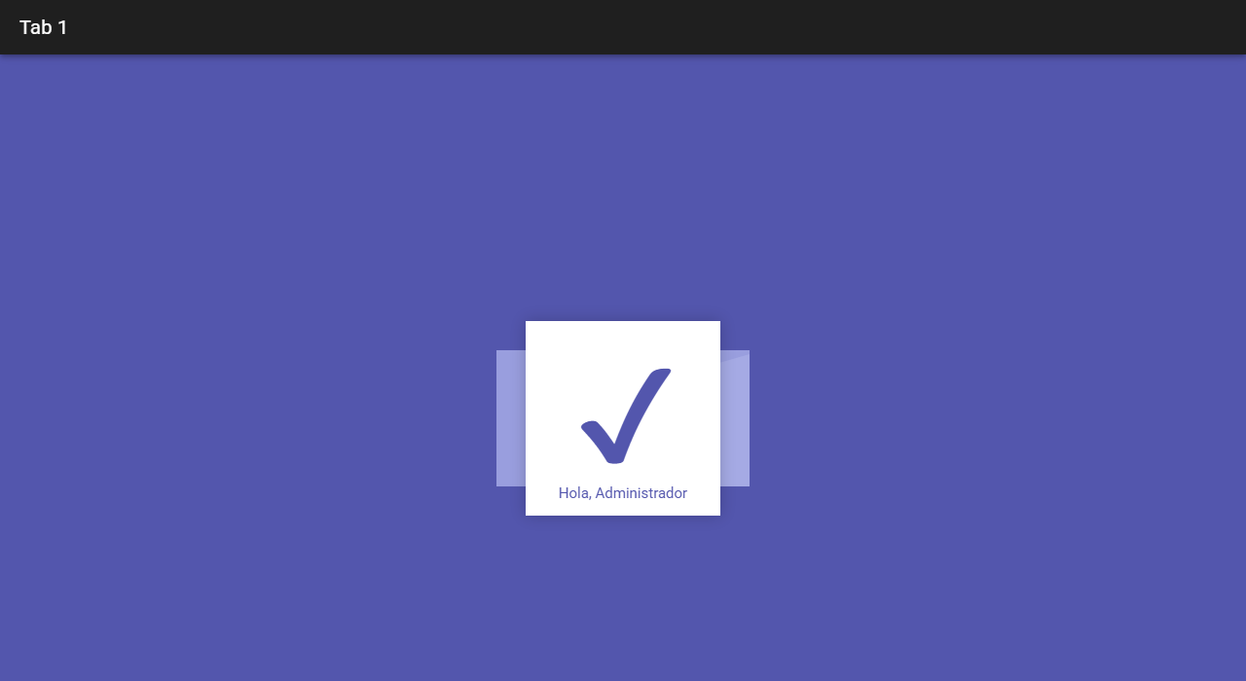
Figure 11. After signing in, closing and reopening: the session is restored without asking for the credentials again.

User list with no connection
With the API unreachable, the view keeps showing the users stored on the device. The amber notice states that the data is local and gives the time of the last synchronisation, while the red message reports the connection failure: the cache does not hide the error.
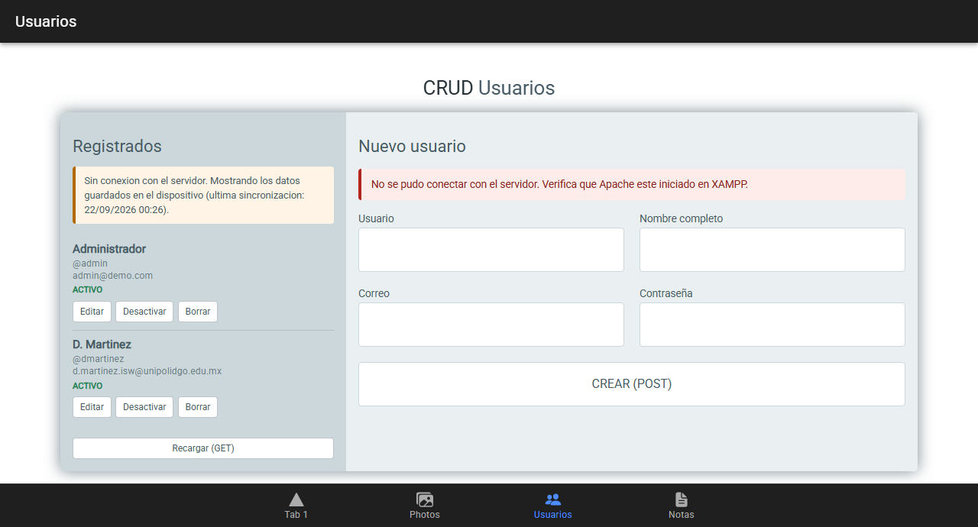
Figure 12. Users tab with the server unavailable.

Technical Verification
The build compiles cleanly and tab4-page appears as its own lazy chunk:
chunk-C45g5YBg.js | tab4-page | 12.54 kB | 3.61 kB

Application bundle generation complete. [7.316 seconds]

The persistence logic was verified with a script that replicates the repository over a simulated disk and checks that the data survives a restart. All ten checks pass, including the key one: the information is recovered after the application is closed, and a deleted note does not come back.
OK arranca vacio
OK alta: quedan 2 notas tras crear 3 y borrar 1
OK modificacion: la favorita quedo marcada
OK ids distintos
OK tras reiniciar, la memoria arranca vacia
OK consulta: se recuperaron las 2 notas del disco
OK el contenido sobrevivio
OK la marca de favorita sobrevivio
OK la nota eliminada NO volvio
OK las fechas se conservaron

10 pruebas OK, 0 fallidas

A unit test suite was also written in nota.repository.spec.ts, which covers the same cases through Karma. It could not be run on the development machine because the test runner exhausts the available memory (out of memory, with roughly 300 MB free out of 8 GB), a limitation of the environment rather than of the code.

A bug found while capturing the screenshots
Taking the screenshots was not merely documentation work: it exposed a real defect. The session was being stored correctly, but on reopening the application the login form appeared again, as if nothing had been saved.
The cause was not in the persistence layer. Tab1Page kept isActive as a plain property:
isActive = false; // antes
...
this.isActive = true; // despues de un await

The application is zoneless, so Angular does not watch plain properties. restaurar() resolves asynchronously, and by the time the value changed Angular was no longer observing: the state was correct in memory but the view was never repainted. The fix was to turn it into a signal, which is what the rest of the component already used:
isActive = signal(false); // despues
...
this.isActive.set(true);

It is worth noting that the code's own comment already warned about this (*"se usan signals porque la app es zoneless"*), and the rule was still broken on the two properties inherited from the original template. A defect of this kind does not show up in a build or in a unit test of the repository: only running the application reveals it.

Files Delivered

New files
src/app/models/nota.model.ts Entidad Nota y tipos derivados
src/app/services/storage.service.ts Envoltura de Preferences
src/app/services/sesion.service.ts Sesion persistente
src/app/services/nota.repository.ts CRUD contra el dispositivo
src/app/services/nota.repository.spec.ts Pruebas del repositorio
src/app/tab4/tab4.page.ts Vista del CRUD de notas
src/app/tab4/tab4.page.html
src/app/tab4/tab4.page.scss

Modified files
src/app/models/index.ts Exporta el modelo Nota
src/app/services/usuario.repository.ts Cache offline de la lista
src/app/tab1/tab1.page.ts Restaura y guarda la sesion
src/app/tab3/tab3.page.ts Carga la cache y su estado
src/app/tab3/tab3.page.html Aviso de datos sin conexion
src/app/tab3/tab3.page.scss Estilo del aviso
src/app/tabs/tabs.routes.ts Ruta /tabs/tab4
src/app/tabs/tabs.page.html Boton de la pestana Notas
src/app/tabs/tabs.page.ts Icono document-text

Resulting structure
src/app/
|-- models/
| |-- usuario.model.ts
| |-- foto.model.ts
| |-- nota.model.ts <-- nuevo
| |-- respuesta-api.model.ts
| +-- index.ts
|-- services/
| |-- http.service.ts transporte HTTP
| |-- storage.service.ts <-- nuevo: persistencia local
| |-- sesion.service.ts <-- nuevo: sesion
| |-- usuario.repository.ts entidad + cache offline
| |-- nota.repository.ts <-- nuevo: entidad local
| +-- photo.service.ts galeria (ya persistia)
|-- tab1/ Acceso (sesion persistente)
|-- tab2/ Galeria de fotos
|-- tab3/ CRUD de usuarios (con cache offline)
+-- tab4/ CRUD de notas (100% local) <-- nuevo

Version control
Repository: https://github.com/David-Martinez-Mercado/APPIonic
Commit of this delivery: c93b9cb — feat: persistencia local con Capacitor Preferences (20 files changed, 1835 insertions).

How to run it
cd 9b
npm install
npm start

The Notas tab works without XAMPP. The Acceso and Usuarios tabs need Apache and MySQL running, with api/database.sql imported.

How AI Was Used
The full detail of the prompts, what was requested, what the AI produced and what had to be corrected, is in the companion document PROMPTS-PERSISTENCIA.md. A summary follows.
Prompt | Purpose | Result
1 | Analyse the code and decide the scope | Found that the photos already persisted; three fronts were defined
2 | Choose the technology | Preferences, with the rule of never storing passwords
3 | Implement | 7 new files, 9 modified, clean build
4 | Diagnose a start-up failure | The problem was the Node version, not the project

Observation on the use of AI
The most useful part was not the code generation but the prior analysis. Two of the four prompts did not produce a single line of program: one served to discover that part of the work was already done, and another to show that a start-up failure had nothing to do with the code.
What the AI proposed also had to be validated. The clearest case was the lint errors: on review, git diff confirmed that they belonged to a template this delivery never touched, instead of assuming that the new code had introduced them.

