
SolarApp
Configurable Data Sources and Request Diagnostics
────────────────────────────────────────────────────────────

The student will make the server address configurable from the application and expose the technical detail of every failed request



Student: | David Martínez Mercado
Email: | d.martinez.isw@unipolidgo.edu.mx
Subject: | Mobile Programming II
University: | Universidad Politécnica de Durango
Delivery: | Fifth — Data Sources and Diagnostics
Date: | Durango, Dgo., Mexico — October 2026

Contenido
Delivery Objective 3
The Address as JSON 3
Reading it back 3
Every Screen Uses the Configured Address 4
Login screenshot 5
Dynamic Message Under the Password Field 5
Error Modal 7
Data Sources Screen 10
Sign-out Button 12
Verification 13
Problems Encountered 14
Problem 1 — The views kept requesting from localhost 14
Problem 2 — A failed retry showed nothing 14
Problem 3 — The IP of the test machine changed twice 15
A note on the tests themselves 15
Files Delivered 15
New files 15
Modified files 15
Version control 16
How to use it from a phone 16
Summary 16
Closing note 16

Delivery Objective
Make the server address configurable from inside the application, store it as JSON on the device, and expose the technical detail of every request so that a failure can actually be diagnosed.
The problem this solves is concrete. The application runs on a phone and the server (XAMPP with Apache, PHP and MySQL) lives on another machine on the same network. That address changes with the network, and recompiling the app every time it changes is not viable.
What was requested | Where it was implemented
The IP typed in the login is stored as JSON | ServidorService, key origen_datos
Every screen using an API takes that IP | Repositories read the URL on each call
New data sources screen | Tab6, with protocol, IP and ports
Dynamic message under the password field | Tab1, with destination, network state and HTTP status
Error modal on screens that consume APIs | ModalErrorComponent, in tabs 2 to 5
Sign-out button | Tab1, clears the session from the device

The Address as JSON
The configuration is no longer a bare string but a full object. Storing it as JSON allows two things: showing it complete in the data sources screen, and adding fields later without breaking what is already stored on devices.
{
"protocolo": "http",
"host": "192.168.5.45",
"puertoHttp": 80,
"puertoMysql": 3306,
"baseDatos": "app_usuarios",
"rutaApi": "/api",
"actualizado_en": "2026-10-01T22:57:03.412Z",
"ultimaPrueba": {
"ok": true,
"mensaje": "Conectado. El servidor respondio con 10 producto(s).",
"fecha": "2026-10-01T22:57:05.988Z"
}
}

Why MySQL port 3306 is stored but never used. The phone never talks to MySQL: the PHP connects to the database from the server itself, over localhost. Exposing 3306 to the network would open the database to anyone who can reach it, bypassing every validation in the PHP. The port is kept in the JSON so the data sources screen can show it, clearly marked as informational.

Reading it back
When the stored JSON is read, it is merged with the default rather than used as-is:
if (guardado?.host) {
// Se mezcla con el predeterminado: si una version anterior
// guardo menos campos, los que falten toman su valor por
// omision en lugar de quedar como undefined.
this.origen.set({ ...ORIGEN_PREDETERMINADO, ...guardado });
}

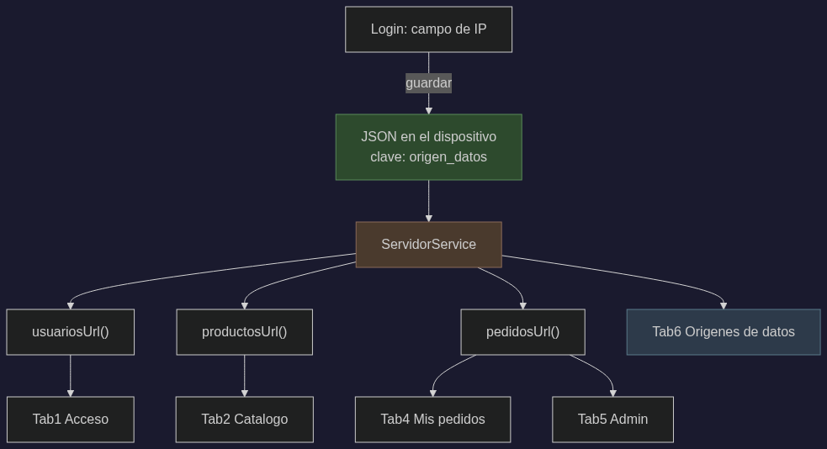
Figure 1. The address travels from the login to every screen.

Every Screen Uses the Configured Address
The repositories read the URL on each call instead of caching it in a property:
// Antes: se evaluaba una sola vez al crear el servicio
private readonly url = environment.productosUrl;

// Ahora: se lee en cada peticion
private get url(): string {
return this.servidor.productosUrl();
}

With a property computed when the service is constructed, changing the IP would have had no effect until the application restarted.

Login screenshot
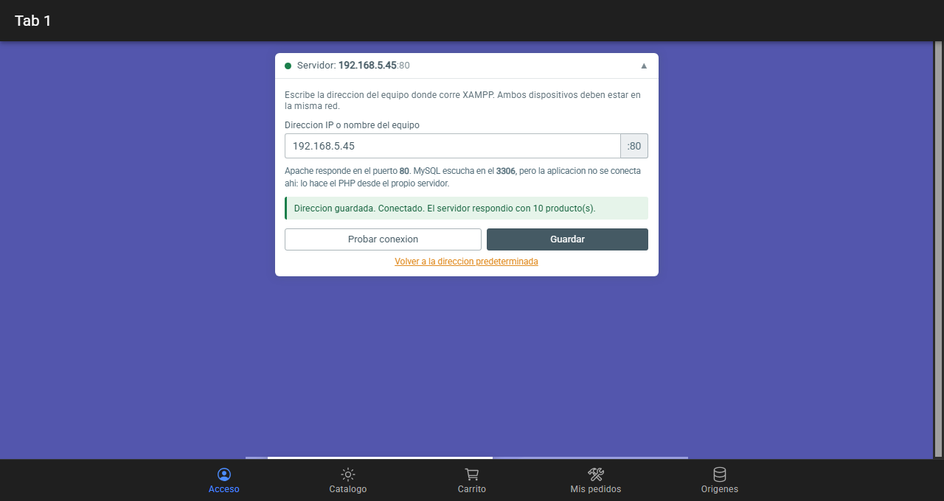
Figure 2. The server panel in the login, with the IP field and the fixed port 80.

Dynamic Message Under the Password Field
After each attempt the login shows whether access was granted and, when it was not, the technical detail. In an application whose address is configurable, a plain "could not sign in" is ambiguous: it may be the password, the server address or the network.
Field | What it answers
Destino | The exact URL the request was sent to
Red | Whether the device had a network, and of what type
Estado HTTP | What the server answered, if it answered
Tiempo | How long the request took
Intentos | How many retries were made before giving up

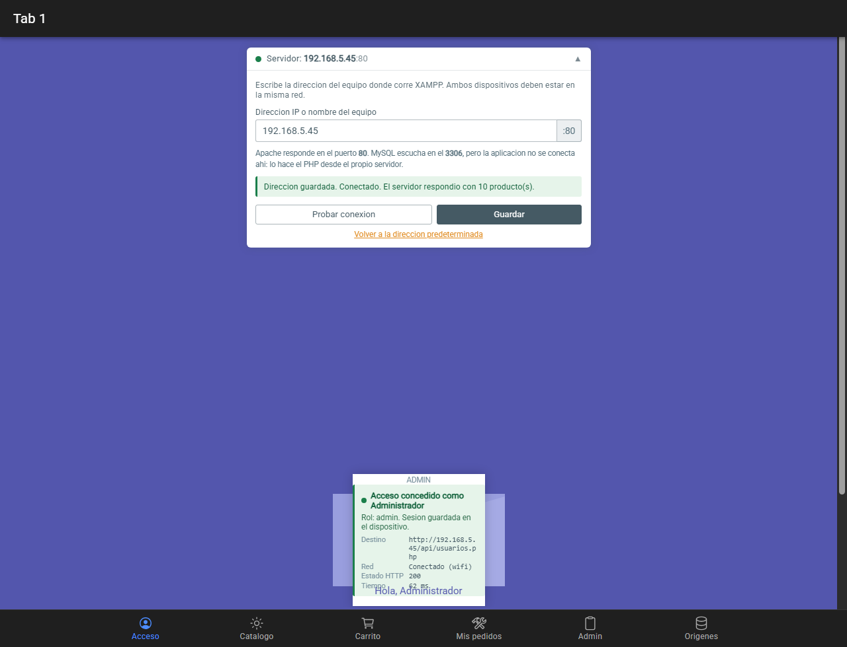
Figure 3. Successful access: role, destination URL, network state and response time.

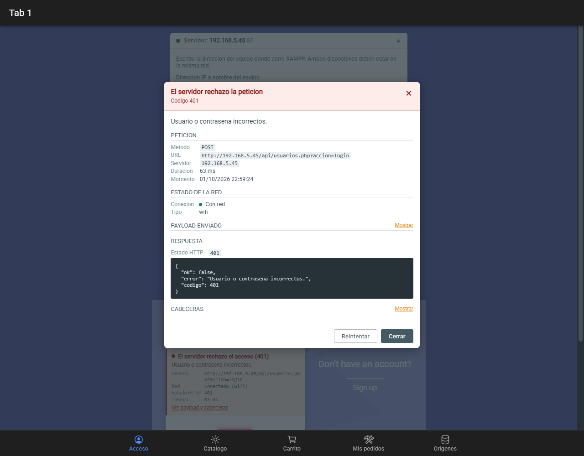
Figure 4. Rejected access: HTTP 401 with the destination and a link to the full detail.

Error Modal
The on-screen notice is short and in plain language; the modal holds what is needed to diagnose: where the request went, what was sent, what the server answered and how the network was at that moment.
To make this possible, ApiError now carries a diagnostic that HttpService fills in on every request:
export interface DiagnosticoPeticion {
url: string; // incluye la IP configurada
metodo: string;
payload?: unknown; // lo que se envio
estado?: number; // ausente si no hubo respuesta
cabeceras?: Record<string, string>;
respuesta?: unknown;
ms?: number;
fecha: string;
hayRed?: boolean; // estado de la red al fallar
tipoRed?: string;
intentos?: number;
}

Passwords are masked before display. The modal exists to diagnose, and a password on screen diagnoses nothing: it only leaves it visible to whoever walks past.
for (const clave of Object.keys(copia)) {
if (/password|contrasena|clave|token/i.test(clave)) {
copia[clave] = '********';
}
}

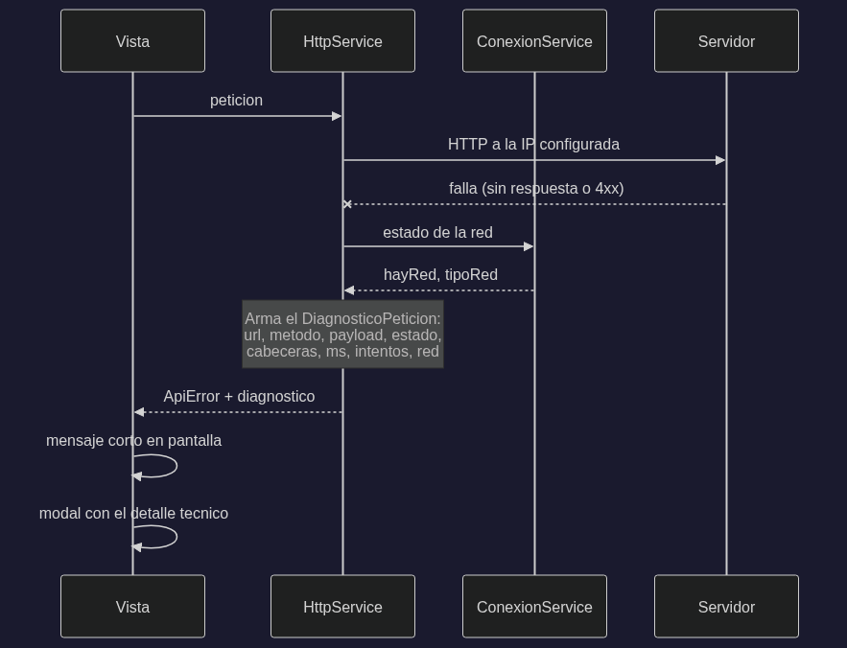
Figure 5. How the diagnostic is assembled when a request fails.

Figure 6. The modal: method, URL, server, duration, network state, payload, response and headers.

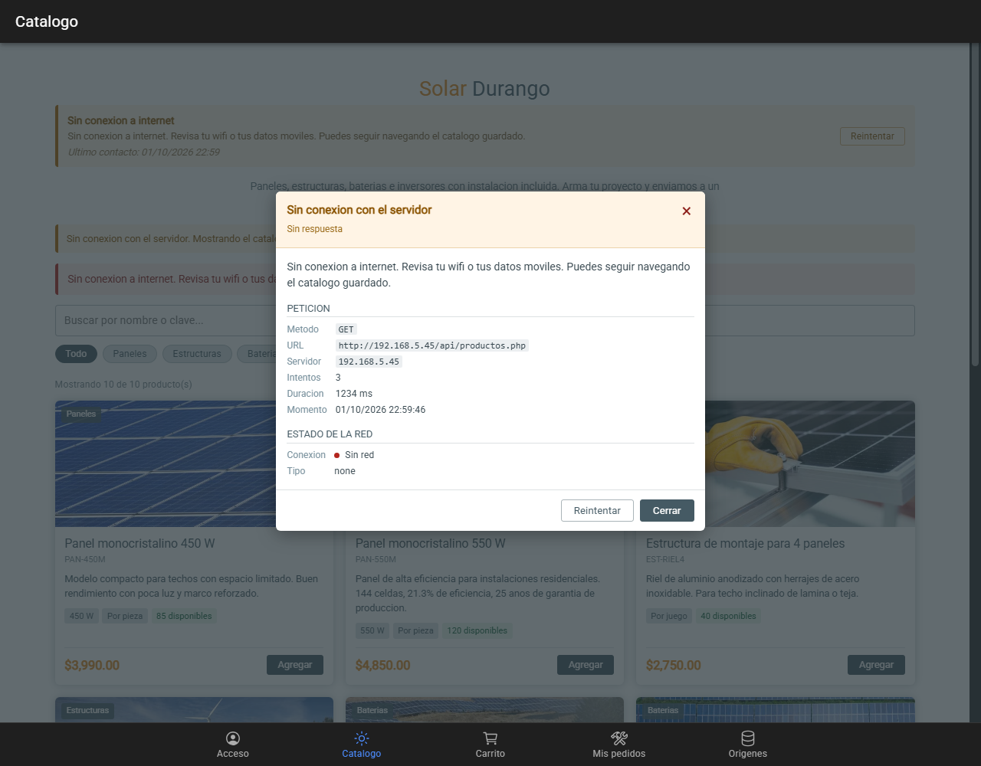
Figure 7. The same modal in the catalogue, after a network failure.

Data Sources Screen
A new tab shows where the application points: protocol, IP, ports, the database and the endpoints it consumes, all read from the stored JSON.
It exists because, once the address is configurable, knowing which server is being used stops being obvious. This screen answers that without opening the developer tools.
- Connection state with a traffic light and a button to test it.
- Full configuration: protocol, IP, HTTP port, MySQL port, database and API path.
- Endpoints with the complete URL each one resolves to.
- A diagram of how the data travels, which is where the 3306 port is explained.
- The raw JSON, hidden by default and copyable to the clipboard.

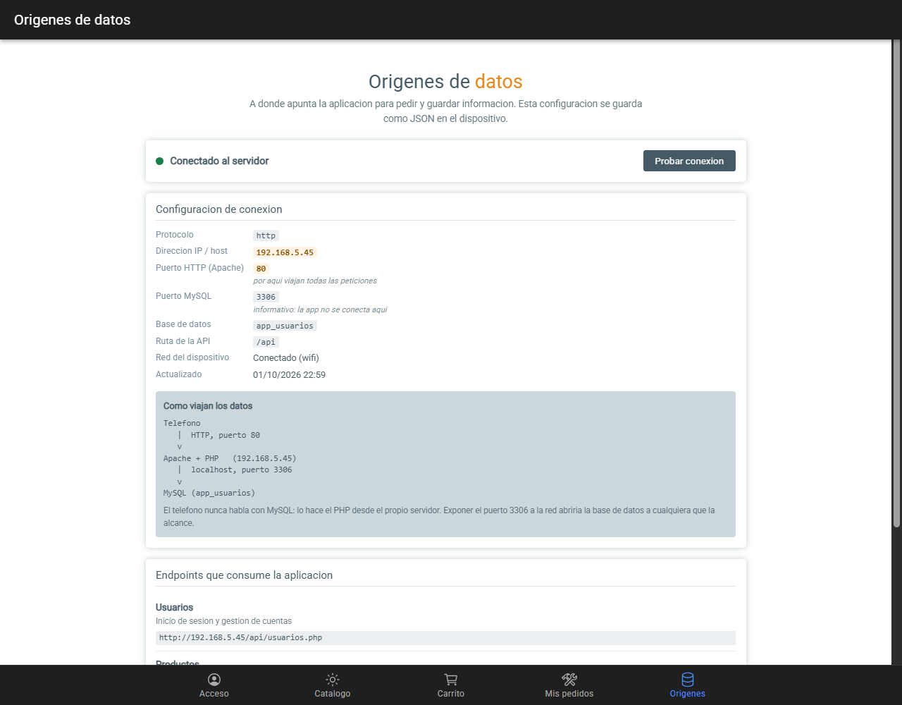
Figure 8. Data sources: ports, database and how the data travels.

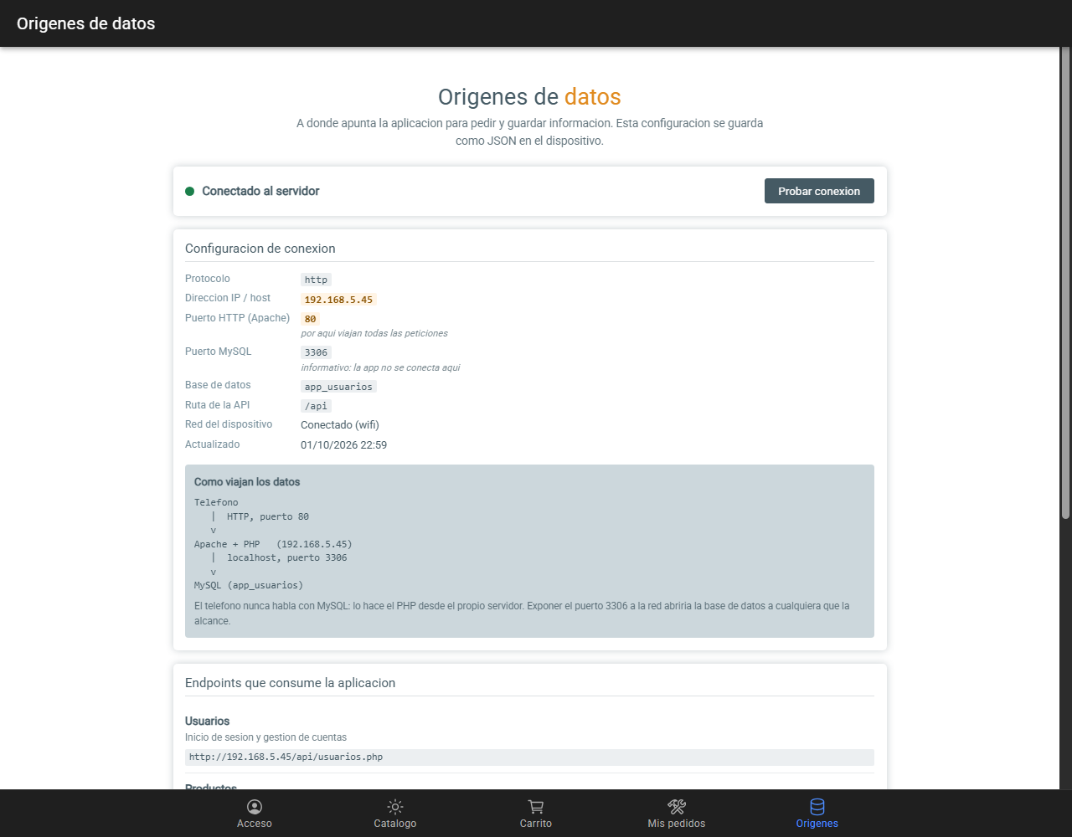
Figure 9. The raw JSON stored on the device.

Sign-out Button
The button clears the user from the device, not only from the screen: clearing the view alone would mean the application still found a session on the next start.
async cerrarSesion() {
await this.reset();
this.diagnostico.set(null);
this.mensajeError.set('');
}

// En SesionService
async cerrar(): Promise<void> {
this.usuario.set(null);
this.restauracion = Promise.resolve(null);
await this.storage.eliminar(SesionService.CLAVE);
}

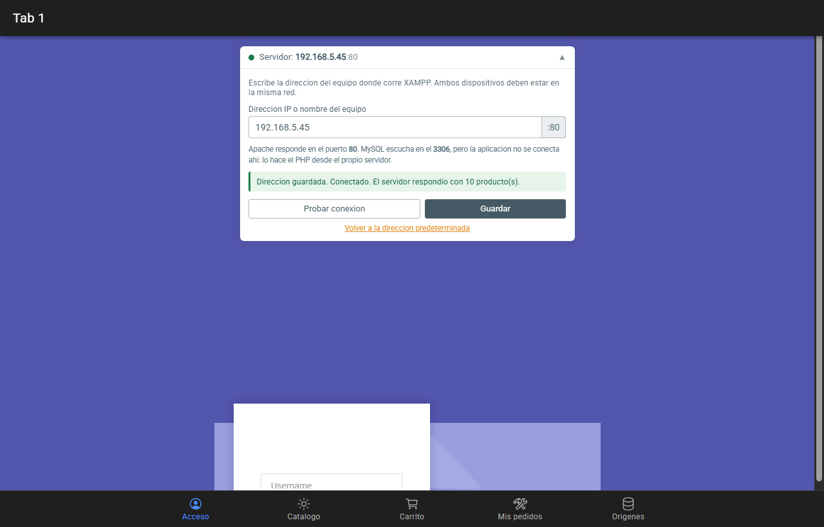
Figure 10. After signing out, the login is requested again.

Verification
The six features were tested with the Chrome debugging protocol, driving the real application against the real server.
Result: 17 of 17 checks passed.
# | Check | Result
1 | The IP is stored as JSON with protocol, host and ports | http://192.168.5.45:80, mysql 3306
2 | The login shows that access was granted | correct
3 | It states the destination URL | 192.168.5.45
4 | The sign-out button exists | present
5 | The session is cleared from the device | null
6 | A wrong password reports the HTTP code | 401
7 | It offers to view payload and headers | present
8 | The modal opens | correct
9 | The modal shows the destination URL | 192.168.5.45
10 | The modal shows the network state | Con red (wifi)
11 | Data sources shows the protocol | http
12 | It shows the configured IP | 192.168.5.45
13 | It shows port 80 | correct
14 | It shows port 3306 | correct
15 | It lists the endpoints | 3 endpoints
16 | The raw JSON can be displayed | correct
17 | The catalogue shows the modal on failure | correct

Problems Encountered

Problem 1 — The views kept requesting from localhost
Symptom. The IP was stored correctly and the panel displayed it, but the catalogue kept requesting data from localhost.
How it was found. By capturing the actual requests with the debugging protocol:
peticiones a la API: http://localhost/api/productos.php
FALLA las peticiones van a la IP configurada

Cause. Two causes of the same kind. The repositories stored the URL in private readonly url, evaluated once when the service is created; and the views requested data before the host had been read from the device, because they run their ngOnInit in parallel with the tab bar.
Solution. A getter that reads on each call, and await this.servidor.listo() in every view before the first request.
Lesson. This is the third time this same asynchronous pattern has appeared in the project. Any state that comes from device storage needs a promise the views can await.

Problem 2 — A failed retry showed nothing
Symptom. With the network cut, pressing Retry in the connection banner produced no visible result: no message, no modal.
Cause. The banner only reloaded the screen when the server responded:
const hayServidor = await this.conexion.comprobar();

if (hayServidor) { // <-- solo entraba si respondia
const recarga = this.recargar();
if (recarga) { await recarga(); }
}

If the server was still down, the real request was never made, so no ApiError was produced and the modal had nothing to show.
Solution. Reload regardless, and let the real request fail. That failure is exactly what feeds the diagnostic.
// Se recarga siempre, responda o no el servidor.
const recarga = this.recargar();
if (recarga) { await recarga(); }

if (hayServidor) {
this.avisarRecuperacion();
}

Problem 3 — The IP of the test machine changed twice
Symptom. Checks that had passed started failing: the login reported "could not contact the server" against an address that had worked minutes earlier.
Cause. It was not a defect. The machine moved between networks and its address changed from 192.168.1.195 to 192.168.201.102 and later to 192.168.5.45.
Why it is worth logging. It is precisely the scenario this delivery exists for. With the address compiled into the code, each change would have required editing a file and rebuilding; with the configurable panel it is a field and a button. And the diagnostic under the password field is what made the cause obvious: it showed the destination URL and that the network was up, so the problem was neither the credentials nor the wifi.

A note on the tests themselves
Three of the failures reported by the automated test were faults in the test, not in the application: a double JSON.parse, the use of innerText (which only returns what is visible on screen) and pressing a button that did not trigger the expected path.
Each was confirmed by inspecting the real screen before touching any code. A failing test may itself be wrong, and accepting its verdict without checking leads to modifying code that already worked.

Files Delivered

New files
src/app/models/origen-datos.model.ts Entidad OrigenDatos
src/app/components/modal-error.component.ts Modal de diagnostico
src/app/tab6/tab6.page.ts / .html / .scss Origenes de datos

Modified files
src/app/services/servidor.service.ts Guarda el JSON completo
src/app/services/http.service.ts Adjunta el diagnostico
src/app/models/respuesta-api.model.ts DiagnosticoPeticion en ApiError
src/app/components/estado-conexion.component.ts Recarga siempre
src/app/tab1/... Mensaje dinamico y cerrar sesion
src/app/tab2..tab5/... Modal de error
src/app/tabs/... Pestana de origenes

Version control
Repository: https://github.com/David-Martinez-Mercado/APPIonic
Commit of this delivery: 636e1ca — feat: origenes de datos en JSON, diagnostico de peticiones y cerrar sesion

How to use it from a phone
- Find the IP of the machine running XAMPP with ipconfig.
- Allow port 80 through the Windows firewall on that machine.
- From the phone browser, open http://<IP>/api/productos.php and check that the JSON is returned.
- In the app, Acceso tab, open the server panel, type the IP, press Probar conexion and then Guardar.
- Every tab now consumes the APIs from that address. The Origenes tab shows the stored configuration.

Summary
Requested | Where it is
IP stored as JSON | ServidorService, key origen_datos
Screens take the IP from there | Getter in each repository
Data sources screen | Tab6
Dynamic message under the password | Tab1
Error modal with payload and headers | ModalErrorComponent
Sign-out button | Tab1

Closing note
The diagnostic added in this delivery proved itself during the delivery itself: when the machine changed networks twice, it was the message under the password field that showed the destination URL and a working network, which pointed straight at the stale address rather than at the credentials.

