
SolarApp
Error Handling and Offline Operation
────────────────────────────────────────────────────────────

The student will implement a strategy so that the application can react to connection problems or failures when accessing data



Student: | David Martínez Mercado
Email: | d.martinez.isw@unipolidgo.edu.mx
Subject: | Mobile Programming II
University: | Universidad Politécnica de Durango
Delivery: | Fourth — Error Handling and Offline Operation
Date: | Durango, Dgo., Mexico — September 2026

Contenido
Delivery Objective 3
Connection State Detection 3
The central distinction 3
A known limitation 4
Error Handling 4
Code 0 as the transport-failure marker 4
Automatic retries 5
Messages Shown to the User 6
Cache and Temporary Storage Strategy 7
The cache does not hide the error 7
Queue of pending requests 8
Offline Operation Test 9
Screens captured during the test 10
How to reproduce it by hand 12
Log of Problems Encountered 13
Problem 1 — The admin panel was empty for an administrator 13
Problem 2 — The session was stored but login was asked again 14
Problem 3 — The offline test gave a false failure 14
Files Delivered 15
New files 15
Modified files 15
Version control 15
How to run it 16
Summary 16
Closing note 16

Delivery Objective
Implement a strategy so that the application reacts to connection problems or data access failures instead of going blank or showing a technical error the user cannot interpret.
The starting point already covered part of the ground: the persistence delivery left a local cache on the device and an ApiError that translated axios failures. What was missing was the part the user actually sees:
What was missing | Consequence
Nothing knew whether there was a network | The app requested data and failed without explaining why
Every failure looked the same | "No internet" and "the server is down" gave the same message
There was no way to retry | The application had to be closed and reopened
A failed submission was lost | The client built their project, pressed send, and lost everything

Connection State Detection
@capacitor/network was installed. It reports the operating system's network state and notifies through a listener as soon as it changes, instead of polling every few seconds.

The central distinction
ConexionService separates two things that are often confused:
Concept | What it means | How it is known
Network | The device has wifi or mobile data | Capacitor Network
Server | The API responds | Every HttpService request

Why it matters: they are not the same problem and the user cannot solve them the same way. With no network, the useful message is "check your wifi"; with a network but no server, the useful message is "it is not your phone, the service is down".
readonly enLinea = computed(() => this.hayRed() && this.servidorResponde());

readonly motivo = computed<MotivoDesconexion>(() => {
if (!this.hayRed()) {
return 'sin_red';
}
if (!this.servidorResponde()) {
return 'servidor_caido';
}
return 'ninguno';
});

A known limitation
In the browser, Capacitor Network relies on navigator.onLine, which only knows whether a network interface is up: being connected to a wifi with no route to the internet is reported as online. That is why the check against the server is not redundant — it is what catches that case.
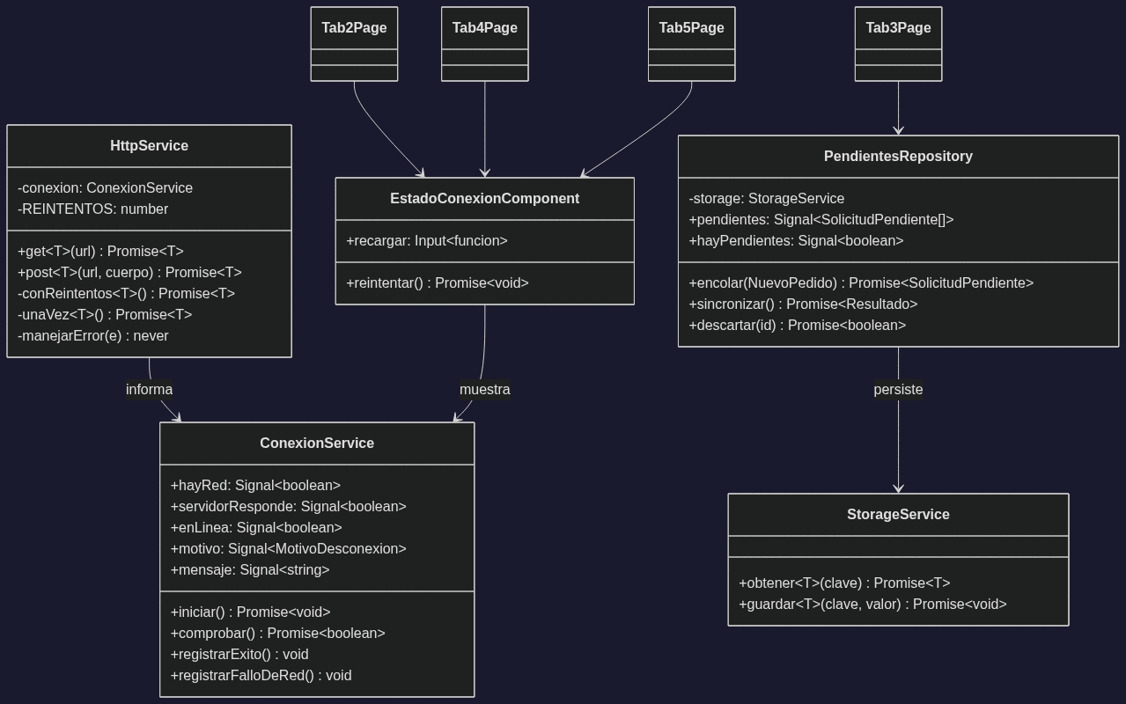
Figure 1. Architecture of the resilience layer.

Error Handling
All handling lives in HttpService, the single point every request goes through. Views never inspect error.response: they receive an ApiError that has already been translated.

Code 0 as the transport-failure marker
if (err.response) {
// El servidor respondio con 4xx o 5xx: esta vivo, contesto.
this.conexion.registrarExito();
throw new ApiError(cuerpo?.error ?? `Error ${err.response.status}`, ...);
}

// Sin respuesta: el problema es de conexion, no de la peticion.
this.conexion.registrarFalloDeRed();
throw new ApiError(this.conexion.mensaje(), 0);

A 404 or a 422 means the server is perfectly alive: it answered. What failed was the request. Only failures with no response mark the connection as down, and they are told apart by code 0.
That distinction is what later makes it possible to decide whether a request should be queued for retry or needs to be corrected.

Automatic retries
A network failure is usually momentary: the wifi blinking, the server taking a moment to start. HttpService retries up to twice with increasing back-off (400 ms, 800 ms).
Only reads are retried. Retrying a write is dangerous: if the POST reached the server and what was lost was the reply on the way back, a retry would create a second order without the user knowing.
async get<T>(url: string): Promise<T> {
return this.conReintentos(async () => { ... }); // reintenta
}

async post<T>(url: string, cuerpo: unknown): Promise<T> {
return this.unaVez(async () => { ... }); // NO reintenta
}

Nor is anything retried once the server has responded: if it answered 422, asking again will give exactly the same result and only delays the message to the user.
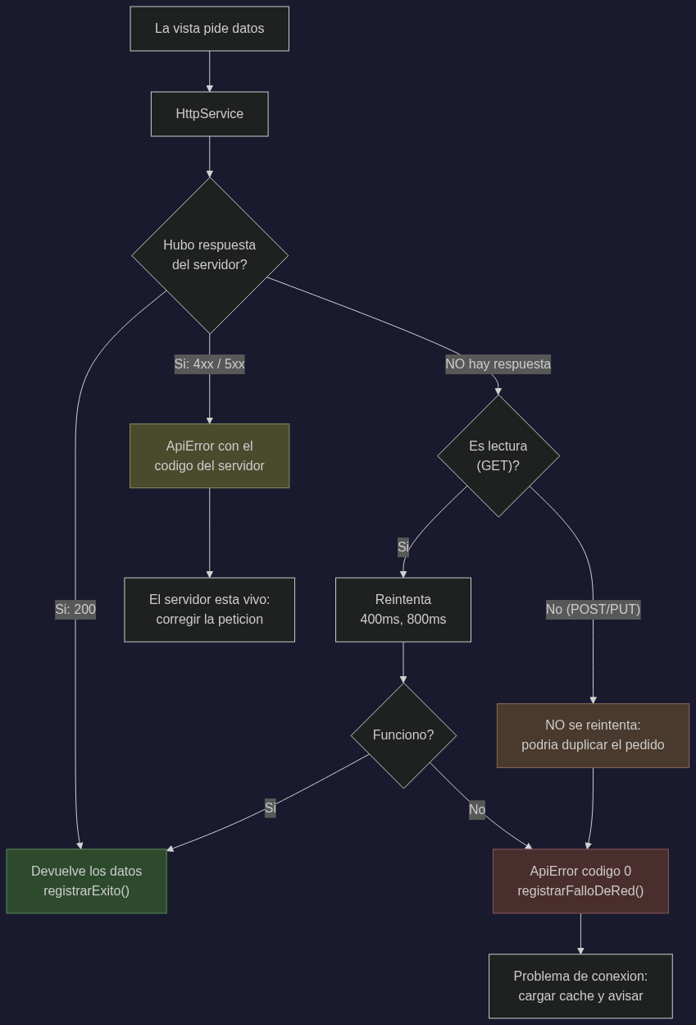
Figure 2. Decision flow when a request fails.

Messages Shown to the User
Every message states what happened and what the user can do. A bare "Connection error" helps nobody.
Situation | Message
No network | "Sin conexion a internet. Revisa tu wifi o tus datos moviles. Puedes seguir navegando el catalogo guardado."
Server down | "No se pudo contactar al servidor. Tu conexion funciona, pero el servicio no responde. Verifica que Apache este iniciado en XAMPP."
Timeout | "La peticion tardo demasiado y se cancelo. Revisa tu conexion e intenta de nuevo."
Cached data | "Sin conexion con el servidor. Mostrando el catalogo guardado en el dispositivo (ultima sincronizacion: ...)."

The notice is a reusable component, EstadoConexionComponent, placed once in each screen. It only appears when there is a problem: when everything works it takes no space and does not distract.
Making it a component rather than a block repeated in every template has two reasons: all five screens say exactly the same thing for the same failure, and changing a wording is a single change.
- Colors tell the failure apart. Amber for "no network" (the user can act on it), red for "server down" (it does not depend on them).
- It shows the time of the last successful contact, so it is obvious when the data has not been refreshed for a while.
- It offers a Retry button that really asks the server again instead of trusting the stored state: the user presses it precisely because they believe it is fixed now.
- It confirms when the connection returns, with a green message that disappears after a few seconds.

Cache and Temporary Storage Strategy
Everything is stored with Capacitor Preferences, the same technology as the previous delivery.
Key | Content | What it allows offline
productos_cache | Full catalogue | Browsing and building the project
productos_sincronizado | Last sync timestamp | Warns if the data is stale
pedidos_cache_<id> | Last known order state | Checking how the project is going
carrito | The project being built | It is fully local
sesion | Authenticated user | No need to sign in again
pedidos_pendientes | Requests that could not be sent | New in this delivery

The cache does not hide the error
When the request fails, the repository loads the local copy but re-throws the exception:
async listar(): Promise<Producto[]> {
try {
const productos = await this.http.get<Producto[]>(url);
...
} catch (e) {
await this.cargarCache(); // deja los ultimos datos conocidos
throw e; // pero el error sigue propagandose
}
}

Swallowing the error would have made the user mistake stale data for current data.

Queue of pending requests
This is the most important addition of this delivery. Without it, a client building their project on a rooftop with no signal loses the work: they press Send, it fails, and they are left with nothing.
With the queue, the request is stored on the device and sent by itself once the connection is back:
} catch (e) {
// Un fallo de red (codigo 0) no es culpa de la solicitud: se guarda
// para mandarla en cuanto vuelva la conexion.
if (e instanceof ApiError && e.codigo === 0) {
await this.cola.encolar(solicitud);
await this.carrito.vaciar();
this.mensajeOk.set('Sin conexion: tu solicitud quedo guardada...');
} else {
this.mostrarError(e);
}
}

Only network failures are queued. If the server answered 422 because stock is missing, retrying later will give the same error: that has to be corrected, not retried.
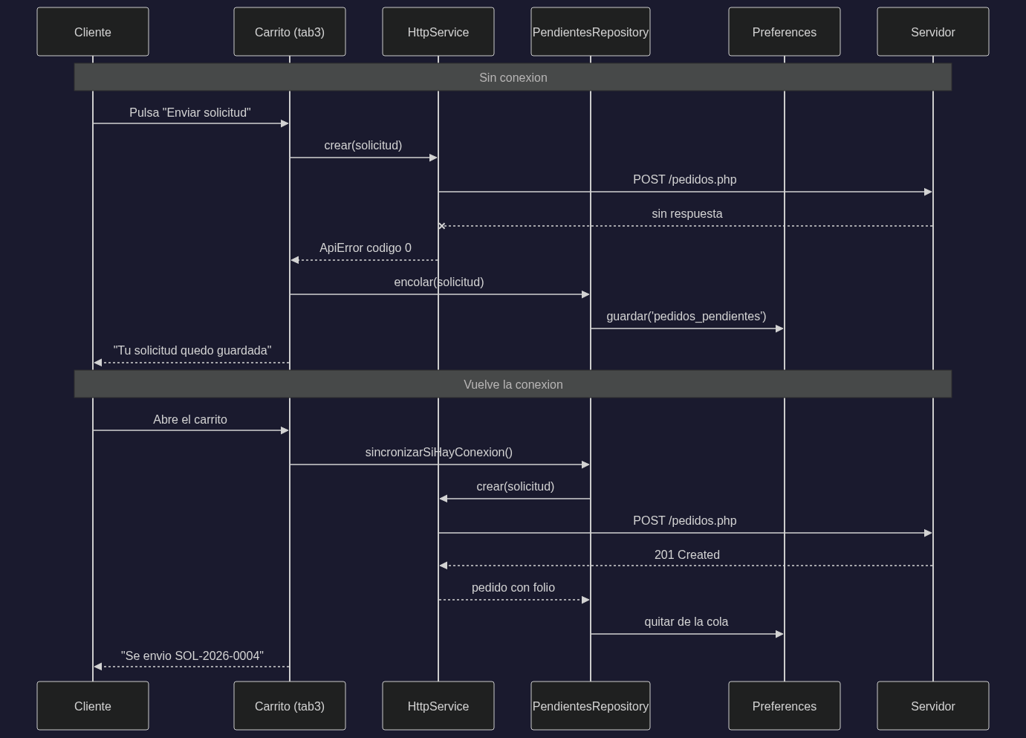
Figure 3. A request that survives the loss of connection.

Offline Operation Test
The test was automated with the Chrome debugging protocol (Network.emulateNetworkConditions), which is what the Offline checkbox in the developer tools does.
Result: 11 of 11 checks passed.
# | Check | Result
1 | The catalogue loads from the server | 10 products
2 | The cache is stored on the device | 10 cached
3 | With no problem, the notice stays out of the way | hidden
4 | Cutting the network shows the notice | visible
5 | The notice tells "no network" from "server down" | correct
6 | It offers a retry button | present
7 | The catalogue is still browsable from cache | 10 products
8 | Items can be added to the cart offline | 1 line stored
9 | The orders screen also warns | visible
10 | The notice disappears when the network returns | correct
11 | The catalogue loads from the server again | 10 products

Screens captured during the test

Figure 4. With connection: the catalogue loads and the cache is filled.


Figure 5. Network cut: amber notice, last contact time, retry button — and the catalogue is still fully usable.

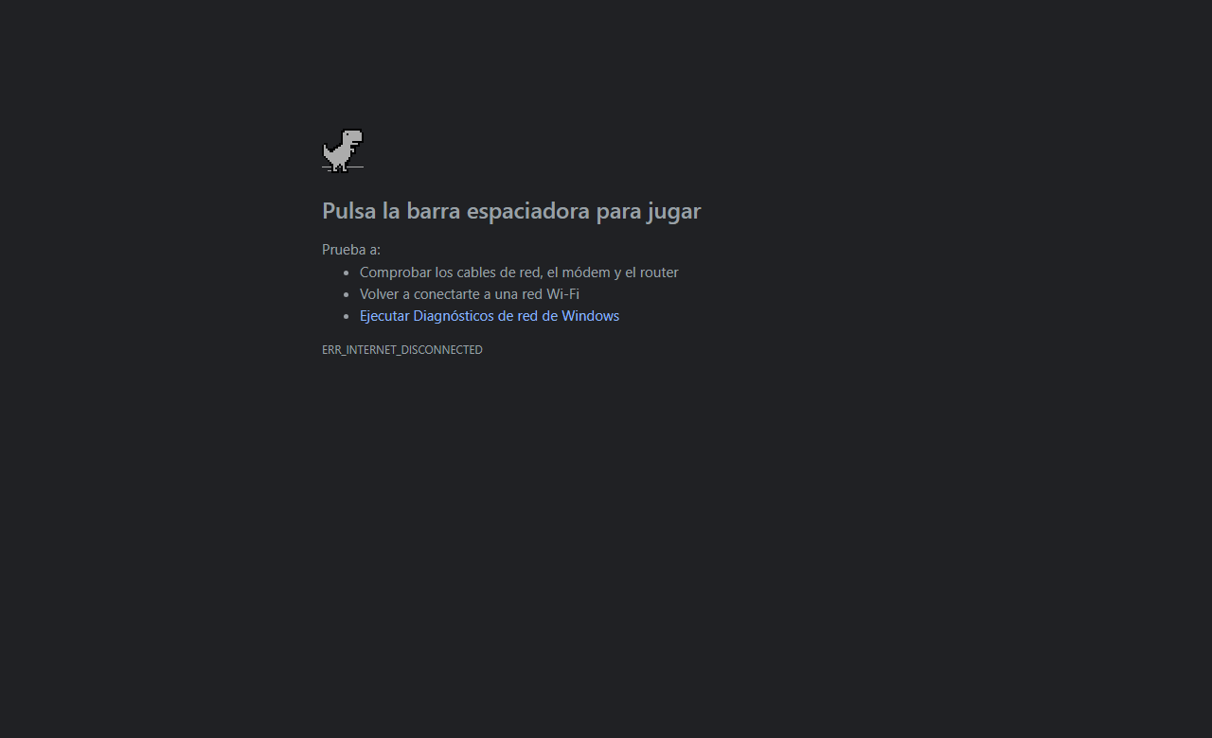
Figure 6. The cart keeps working offline: it is stored on the device.

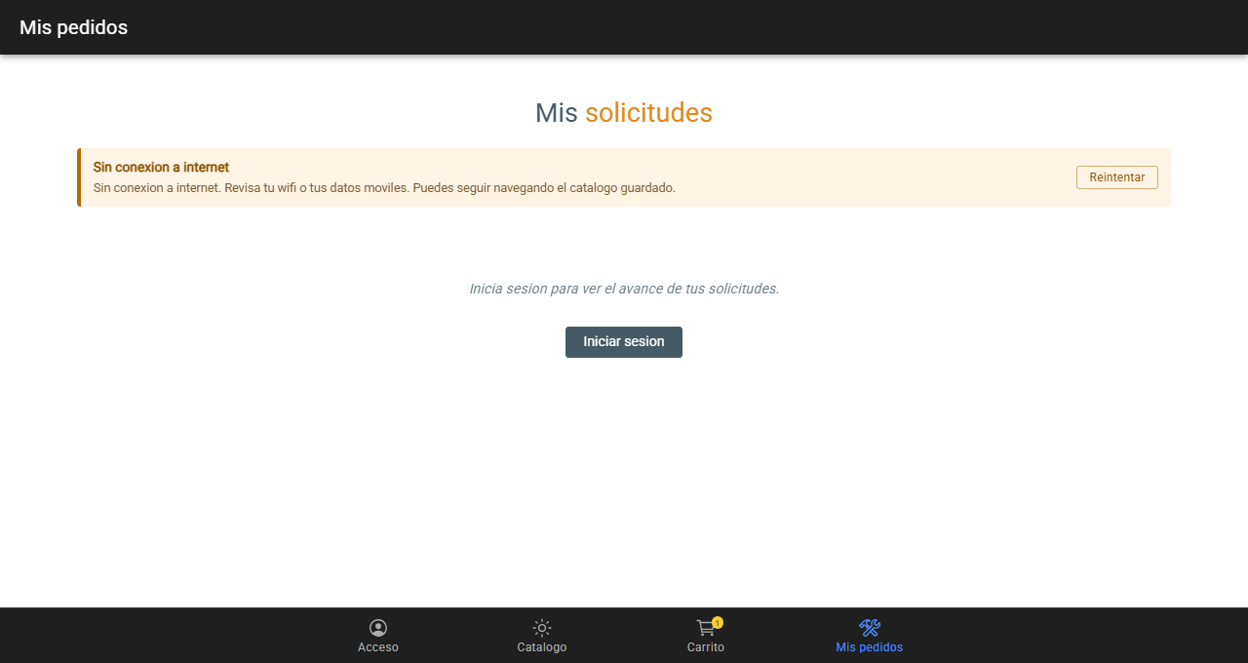
Figure 7. The orders screen warns with the same wording.


Figure 8. Connection restored: the notice disappears on its own.

How to reproduce it by hand
Test A — no network (XAMPP not required):
- Open the application with a connection and go to the catalogue, so the cache is filled.
- Open the developer tools, go to the Network tab and tick Offline.
- Switch tabs inside the app: the amber notice appears and the catalogue is still displayed.
- Add products to the cart: it works, because the cart is local.
- Untick Offline and press Retry: the notice disappears.
Test B — server down (with a network):
- With the application open, stop Apache from the XAMPP control panel.
- Go to Users or My Orders: the red notice appears, different from the amber one, saying the service is not responding.
- Start Apache again and press Retry.
Test C — pending request:
- Build a cart and sign in.
- Put the browser in Offline mode.
- Press send: the button reads "Guardar solicitud (sin conexion)" and the request goes to the pending list.
- Restore the connection and press "Intentar enviar ahora": it is sent and the folio appears.

Log of Problems Encountered

Problem 1 — The admin panel was empty for an administrator
Symptom. Signing in as admin, the administration tab showed "No requests" even though the database had three orders.
What was ruled out first. The API was tested directly with curl:
GET /api/pedidos.php -> ok: true, 3 pedido(s) encontrado(s)

The server responded correctly, so the fault was on the client. The browser console was also checked: there was no error at all.
Cause. Views run their ngOnInit in parallel with the tab bar, which is what restores the session from the device. When tab5 asked for the role, the session was still null, so esAdmin() returned false and cargar() returned without requesting anything.
Solution. SesionService now exposes a restoration promise that views can await:
restaurar(): Promise<Usuario | null> {
if (this.restauracion) {
return this.restauracion; // si ya hay una lectura en curso, la misma
}
this.restauracion = this.storage.obtener<Usuario>(...).then(...);
return this.restauracion;
}

async listo(): Promise<void> {
await this.restaurar();
}

Role of AI. The AI found the cause after the API was ruled out with curl and the console was checked. What makes the case notable is that the error appeared in no log: there was no exception, the request simply was never made.
Lesson. In a zoneless application with asynchronous loading, "the data arrived" and "the component can read it" are two different moments.

Problem 2 — The session was stored but login was asked again
Symptom. After signing in and reloading the application, the login form appeared again. In localStorage, the key CapacitorStorage.sesion did contain the stored user.
How it was found. It surfaced while automating the screenshots for the previous delivery: the script signed in, reloaded and expected the check mark, but found the form.
Cause. Tab1Page kept isActive as a plain property:
isActive = false; // antes
...
this.isActive = true; // se asigna DESPUES de un await

The application is zoneless: Angular does not watch plain properties. restaurar() resolves asynchronously, and by the time the value changed Angular was no longer observing. The state was correct in memory, but the view was never repainted.
Solution. Turn it into a signal, which is what the rest of the component already used:
isActive = signal(false); // despues
...
this.isActive.set(true);

Role of AI. The AI located the cause, but what exposed the fault was running the real application: neither the build nor the repository unit tests caught it, because the persistence logic was correct.
Lesson. The code's own comment already warned — "se usan signals porque la app es zoneless" — and the rule was still broken on two properties inherited from the original template. A convention written in a comment does not enforce itself.

Problem 3 — The offline test gave a false failure
Symptom. While automating the offline test, the check "the orders screen also warns" failed. The text the page returned was:
Pulsa la barra espaciadora para jugar. Prueba a: comprobar los cables
de red, el modem y el router...

Cause. That text is Chrome's own error page (the dinosaur game). The script cut the network and only then navigated to the route: since the application was not loaded, the browser never served it.
It was a fault in the test method, not in the application.
Solution. Reverse the order, which is also the real-world case: the user already has the application open and loses signal.
await red(true);
await ir('/tabs/tab4', 4500); // se carga CON conexion
await red(false); // y se corta despues
await ev(`window.dispatchEvent(new Event('offline'))`);

With the corrected order the check passed and the result was 11 of 11.
Role of AI. The AI wrote the test and also diagnosed its own fault by reading the returned text. What mattered was not accepting the negative result at face value: the first reading would have been "the orders screen does not warn", which was false.
Lesson. A failing test may itself be wrong. Before touching the code, confirm that the test measures what it claims to measure — here, the error text gave it away.

Files Delivered

New files
src/app/services/conexion.service.ts Deteccion de red y servidor
src/app/services/pendientes.repository.ts Cola de solicitudes sin enviar
src/app/components/estado-conexion.component.ts Aviso reutilizable

Modified files
src/app/services/http.service.ts Reintentos, y avisa a ConexionService
src/app/services/sesion.service.ts Promesa de restauracion (problema 1)
src/app/tab1/tab1.page.ts isActive e isLogIn como signals (problema 2)
src/app/tab2/tab2.page.ts / .html Aviso de conexion
src/app/tab3/tab3.page.ts / .html Aviso, cola de pendientes y su estilo
src/app/tab4/tab4.page.ts / .html Aviso de conexion
src/app/tab5/tab5.page.ts / .html Aviso de conexion
src/app/tabs/tabs.page.ts Inicia la deteccion al arrancar
src/environments/environment.ts pingUrl para comprobar el servidor
package.json @capacitor/network

Version control
Repository: https://github.com/David-Martinez-Mercado/APPIonic
Commit of this delivery: e7dac11 — feat: deteccion de conexion, manejo de errores y modo sin conexion

How to run it
cd 9b
npm install
npm start

The offline test is reproduced by hand with the browser developer tools, following the steps in the test section.

Summary
Deliverable | Where it is
Connection state detection | conexion.service.ts, with @capacitor/network
Error handling | http.service.ts — retries and translation to ApiError
Messages shown to the user | estado-conexion.component.ts, one per screen
Cache / temporary storage | Preferences, plus pendientes.repository.ts
Offline operation test | 11 of 11 checks, with 5 screenshots
Log of three problems | Section 7 of this document

Closing note
The three logged problems share a trait worth stating: none of them was caught by the compiler or by the unit tests. One produced no log at all, another passed every test because the logic was right, and the third was a fault in the test itself.
Running the real application, and cutting its network on purpose, found what static checking could not.

