TRIPOD ASSAULT

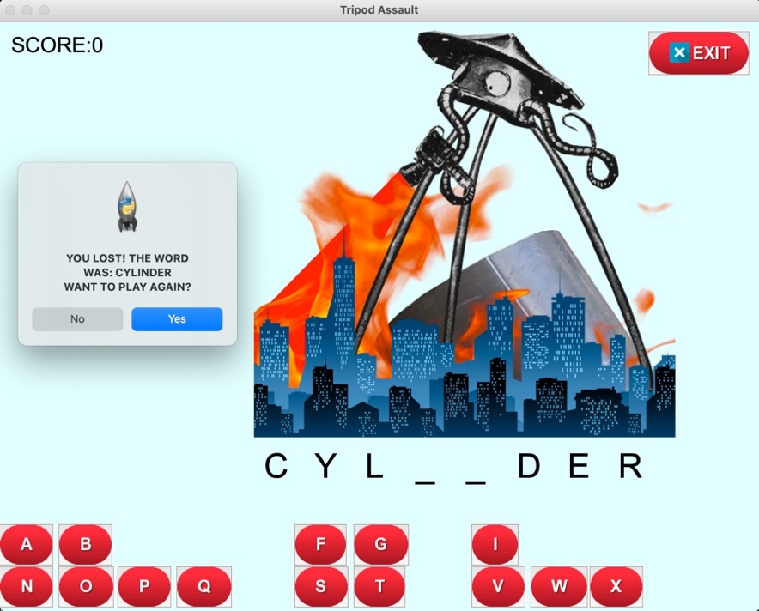

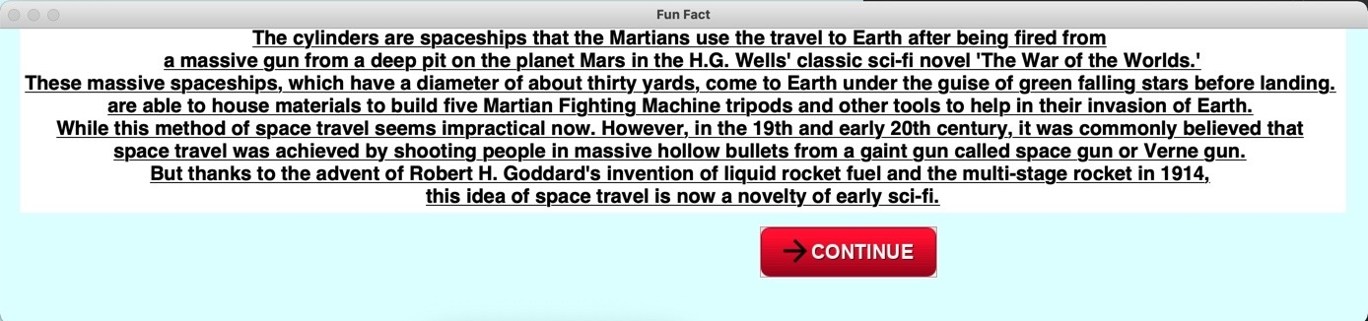

Tripod Assault is a word guessing game where players must stop a Martian invasion of Earth by guessing randomly selected words correctly. When a player correctly guesses all the letters in the word, they will get 100 points towards their score and will get a fact about the word in relation to the classic science fiction novel, The War of the Worlds by H.G. Wells. However, players will have six tries to guess the word correctly which if players make an incorrect guess, a Martian cylinder spaceship lands on Earth, opens, and a Martian Fighting Machine tripod starts to be built. Once the player rans out of guesses, the fully built Martian Fighting Machine tripod destroys the city with its heat-ray and the player’s score resets to zero.

