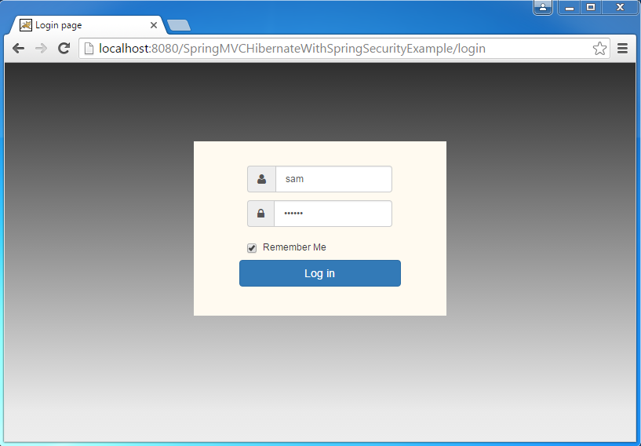

**A simple, but effective login page**

**Nothing too fancy**

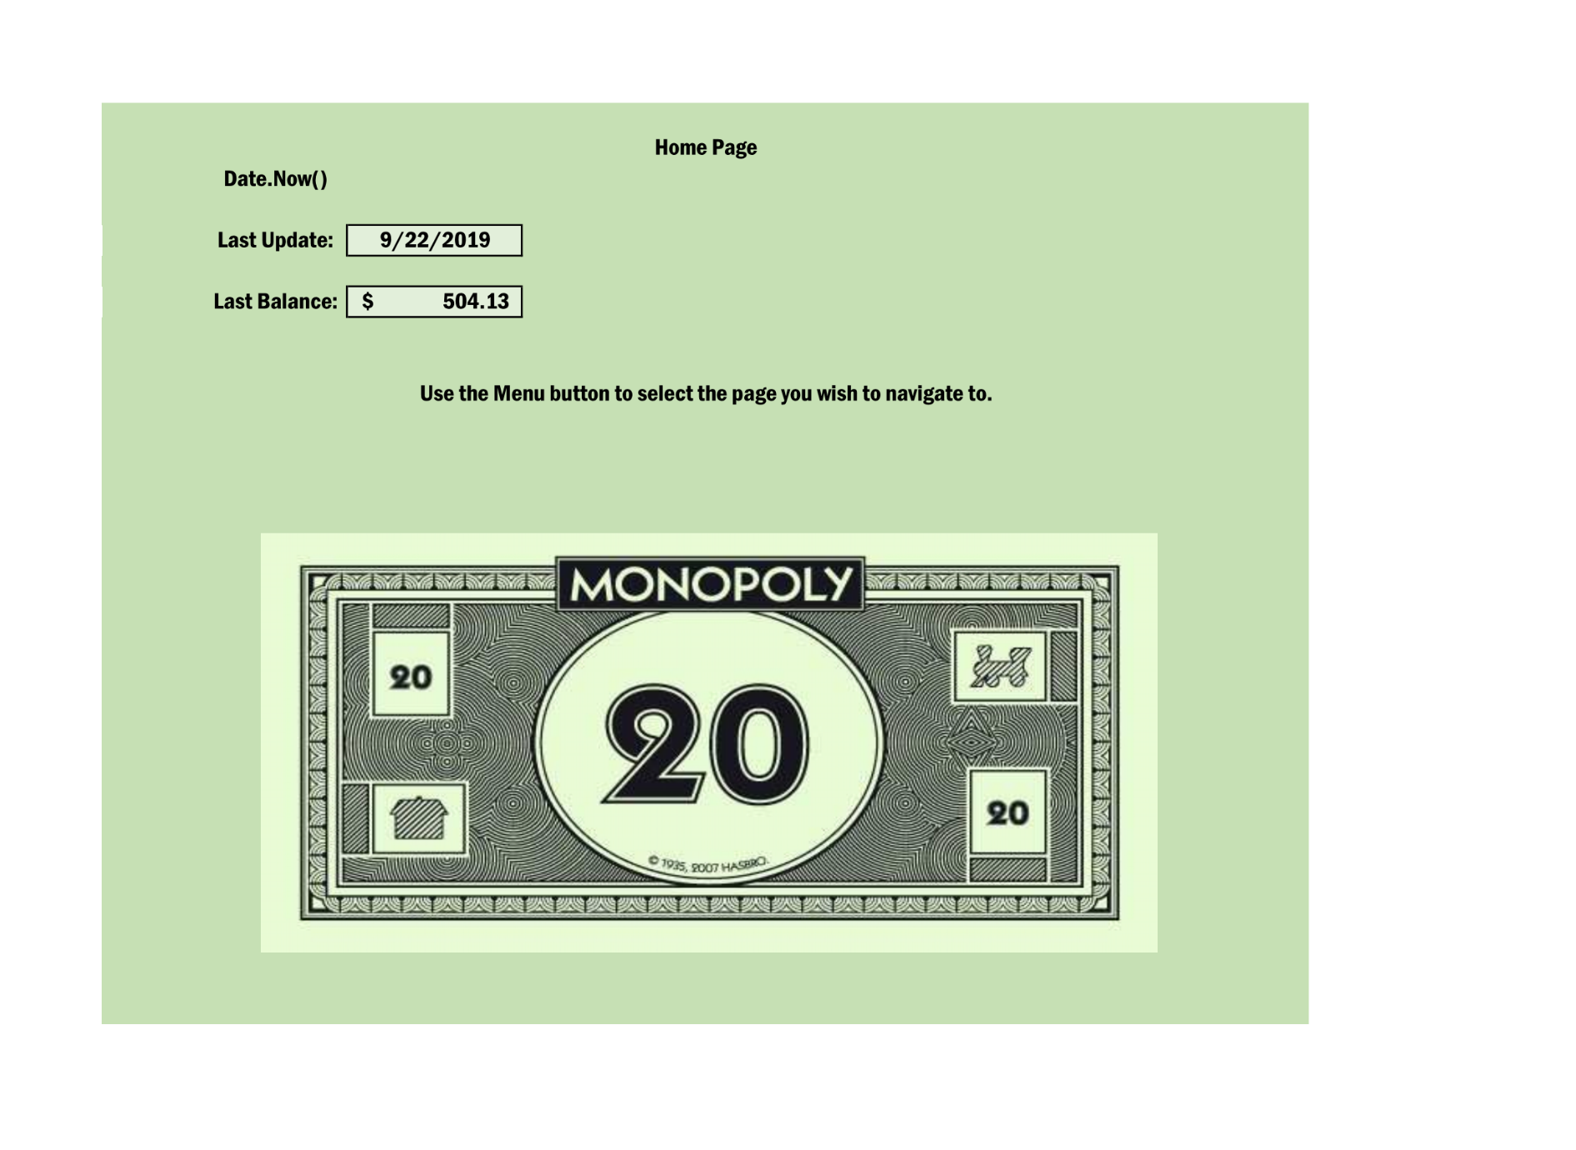**After the login you are sent to the Home page.**

**This page shows you the current date, last date you logged in and last reported balance.**

**The Menu button example is on the last page. You use it to navigate between pages.**

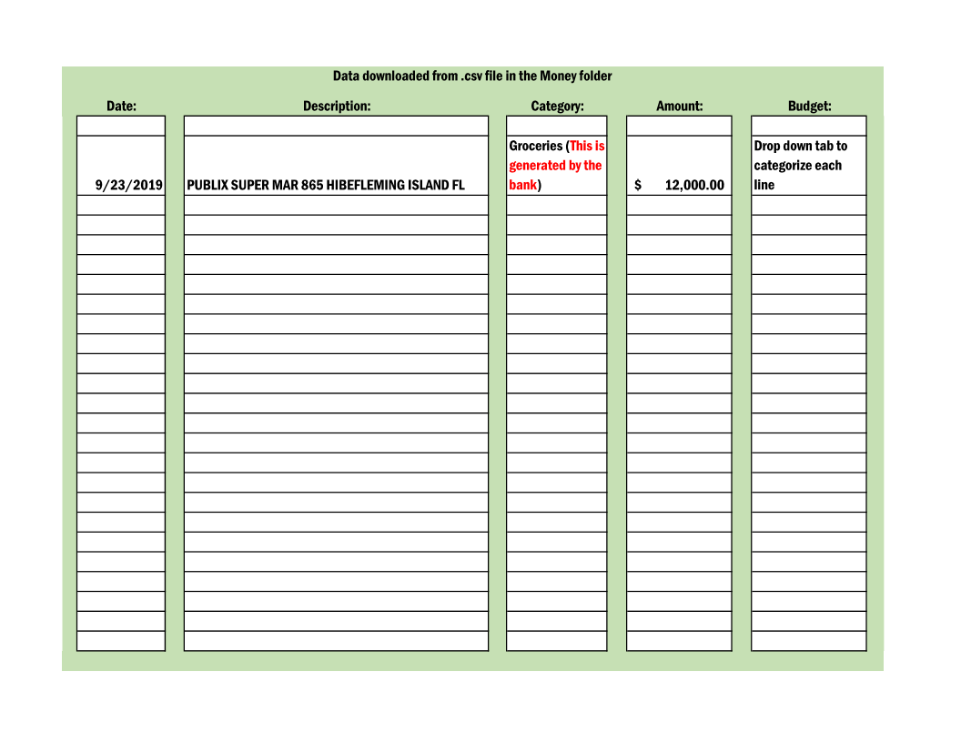

**The .csv file is downloaded separately and saved in a folder on the local computer (Money folder)**

**This page displays the data after it is scraped from the form.**

**The final column is used to select from a drop down list of Budget Categories.**

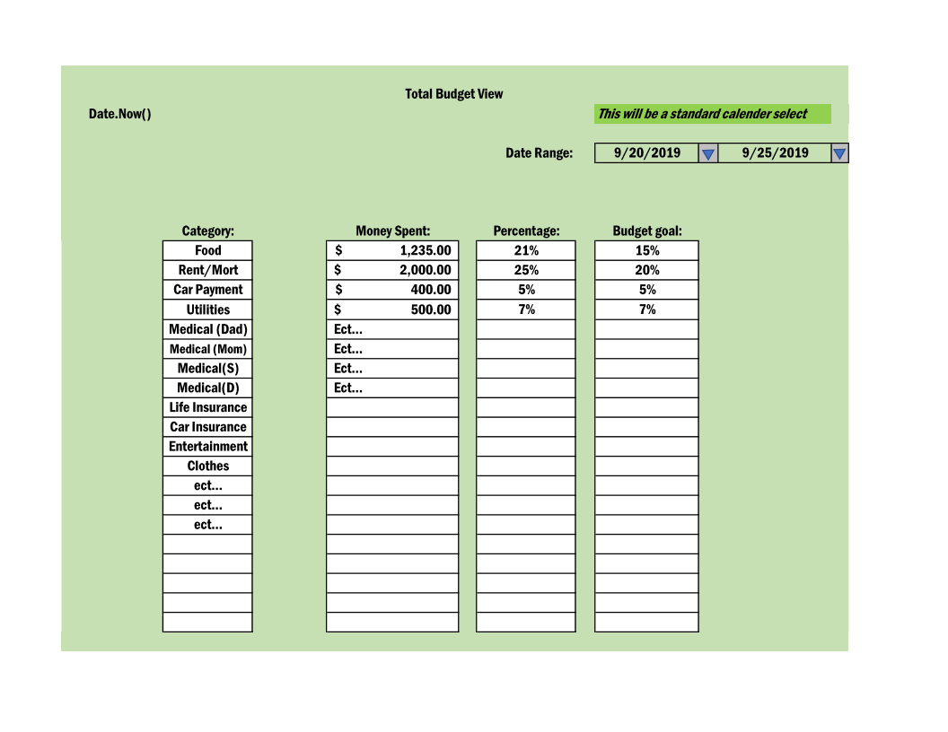

**This page shows the individual budget numbers determined by a specific date range**

**This will show you where your money is going, and help determine if you need to**

**Adjust your master budget.**

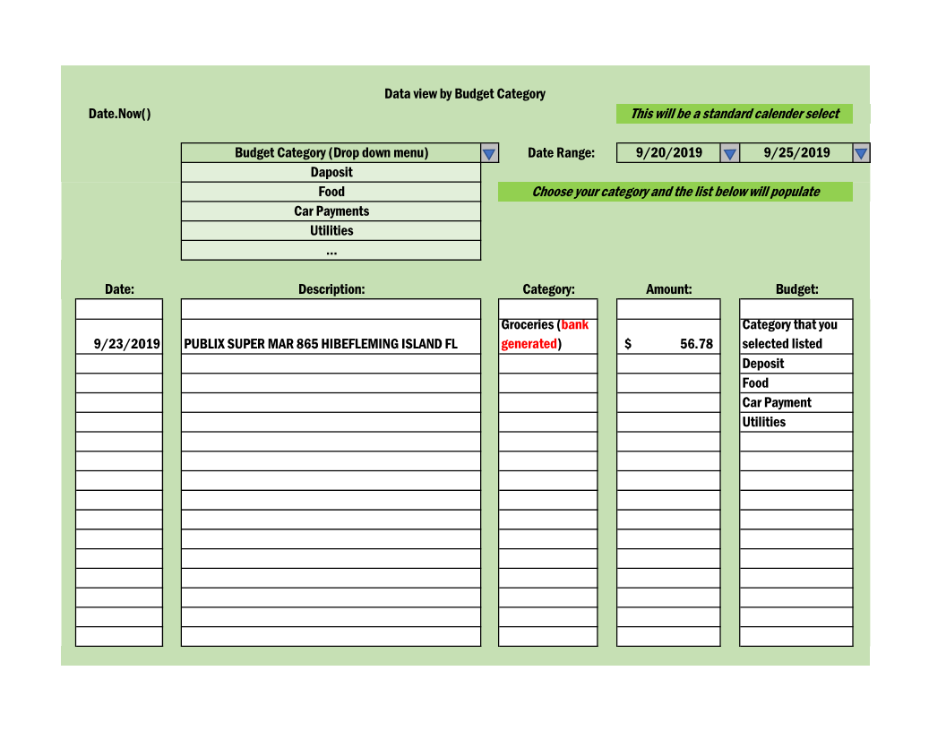

**This page will let you see the line by line spending in a selected Budget Category.**

**As I am typing this, I am thinking of adding an ability to change categories if the initial**

**Selection was determined to be wrong…**

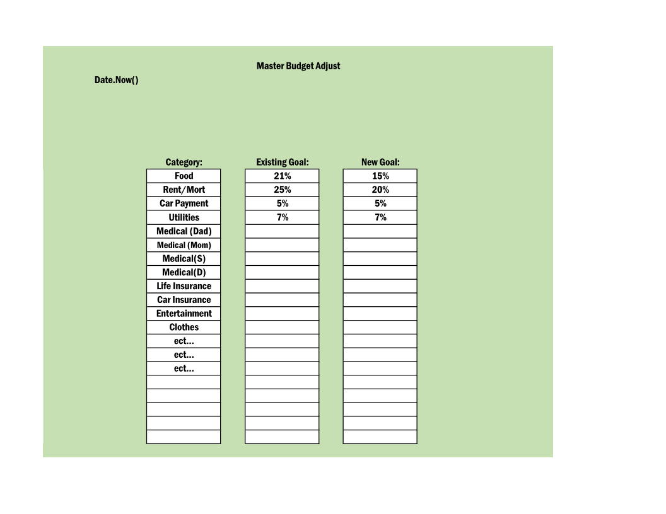

**This is the page that will be used to adjust your budget goals. If it is determined that you need to plan on spending more in a category, this is where you will make that change.**

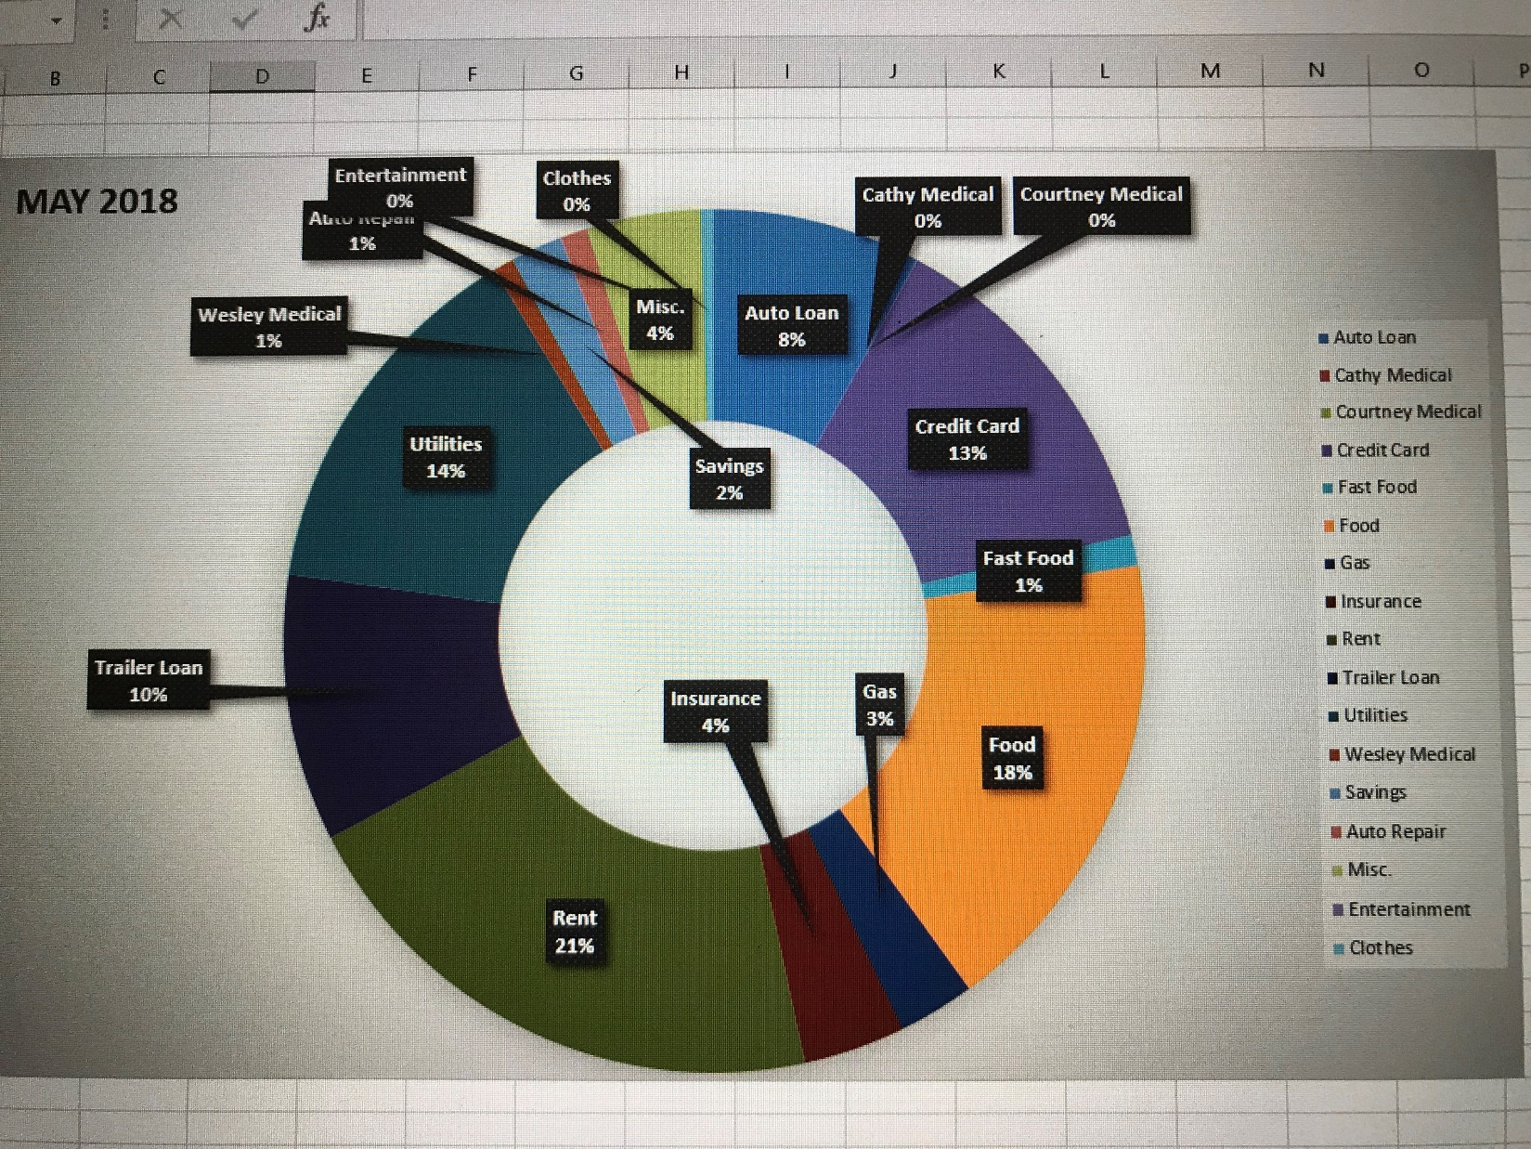

**I intend to figure out how to create this in the final product. I do not know if I will be able**

**To figure this out before the end of class, but this is being built for my personal use, so I will have this.**

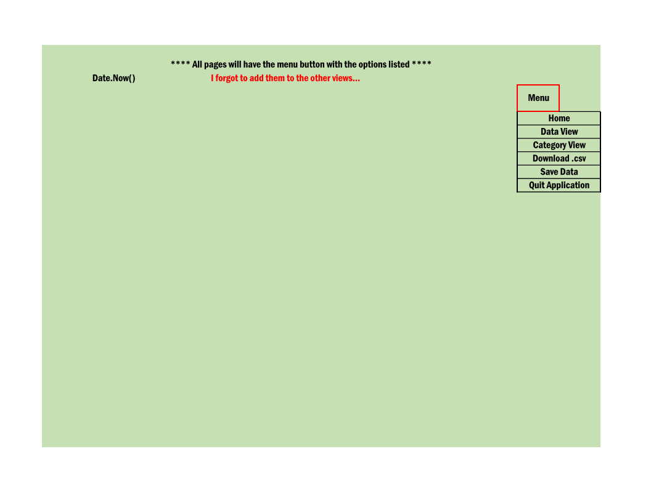

**Finally, this is the one item I forgot to add to all the pages before (Except the login)**

**The Menu button will drop down to display all of the pages you can directly navigate to.**