# Explanations Collagen_DegradationIndex_DR_vf.ijm

This macro treats a folder and computes a degradation index, which is the ratio between the area of collagen cleavage and the number of nuclei in the image. The collagen cleavage is revealed by the collagen 1-3/4C staining while the nuclei are detected with the DAPI channel.

1/ The macro asks the folder to treat; all images with the extension specified line 31 by ext_file:

In our case, ext_file = ".nd"; 3 files will be treated:

2/ The macro:

* asks for the channel representation: the nucleus and collagen 1-¾C,
* offers the possibility, if the image is a stack, to choose the slices for the maximum z-projection (if checked, for each Z-stack image, a maximum z-projection on **all slices** is performed)

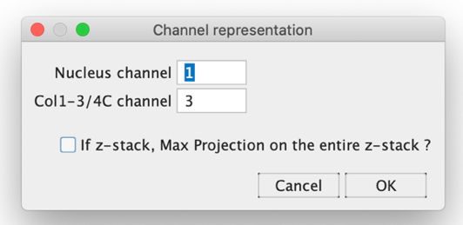

Remark: this means that all images treated together (*i.e.* in the same folder) should have the same order for the channel acquisitions (or at least for nucleus and collagen).

3/ For **each image** which name ends by the specified extension, the code checks if a result already exists for this image (from a previous analysis). If yes, the result is directly loaded, and the macro **loads the following image**. This result file should therefore be manually deleted from the Result folder if the user needs to re-analyze previously analyzed images.

If the image was not treated before:

a/ The nucleus channel is extracted and nuclei are counted on a maximum z-projection, thresholded (default threshold) after a blur of 2 pixels. Too small nuclei or nuclei on the border are removed from the analysis. The user is asked to validate this number of nuclei:

b/ 3 possibilities for the image studied in step c/:

* If the collagen 1-¾C image is a z-stack AND the user unchecked the option "If z-stack, Max Projection on the entire z-stack?", he is asked to choose the plans on which this image should be analyzed:

**Remark:** in case the user makes a mistake choosing the number for first and last slices (below 1 or above the real number of slices), the projection will be performed on all the slices; this is written in the Log:

If more than 1 plan are chosen, the maximum z-projection is performed on the selected slices.

* If the collagen 1-¾C image is a z-stack AND the user checked the option "If z-stack, Max Projection on the entire z-stack?", the maximum z-projection on all slices is performed
* If the collagen 1-¾C image is not a stack, the image is not changed and used as it is.

c/ On the image from step b/, the user is asked to choose the threshold to define what is degradation; the user should modify the sliders and click ok once all regions they consider to be degradation are highlighted in red:

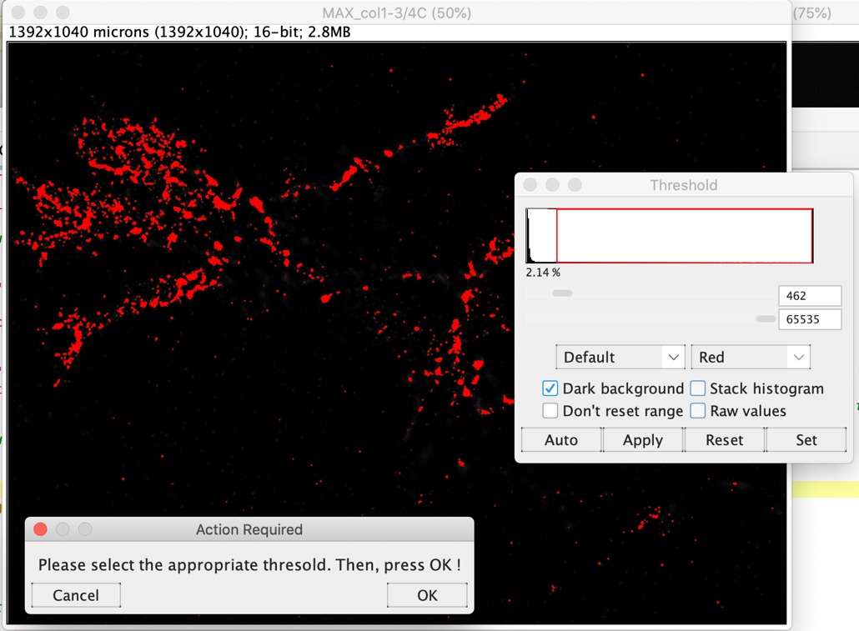

d/ The result table associated to this this threshold, for this image is saved in a folder created within the original folder.

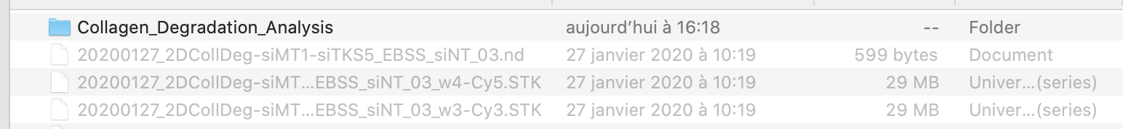

4/ Once all the images are treated, the result table summarizing the degradation index which is the area of degradation (**in pixels^2**) divided by the number of nuclei (column *Area/Nuclei*) per image is created and saved in the same folder as the intermediate results:

