Macro_spheroid_3dinvasion.ijm

This macro was used to measure the invasion of spheroids embedded in a 3D collagen gel. It uses the phalloidin channel and aims at measuring the distance between the center of the spheroid given by the user and the farthest cell having escaped the spheroid. This is done by analyzing a profile line (of the intensity), going through the center of the spheroid until the border of the image. Because the spheroid is not always symmetrical, the same analysis is performed on several orientation and the average distance is kept. The number of orientations can be changed by changing the value of the variable AngleInc, line 10 of the macro (initially at 5).

**Pre-requisites:** The input of the macro is a 1-color Z-Stack image, where each slice represents one acquisition of the condition. This means that if the acquisition on the microscope was a multi-color Z-stack the user should, for each picture of the condition: isolate the channel of phalloidin and proceed to a projection using maximum intensity. All these projections can be merged by Images to Stack” command. On this stack, using the (Single) Point Tool, add the center of each spheroid to the ROIManager. If the number of ROIs is not exactly the same as the number of slices the macro will stop directly.

**Steps of the macro**

1/ The macro asks for the saving directory which will contain the saved stack, the ROIManager data, an Excel file containing the size of each spheroid (in pixels and in scaled units), and a picture (.png) of the average profile of intensity of each spheroid.

2/ The macro asks the user to choose the threshold for mean intensity. When the mean profile reaches this value, we consider that it entered the background; the last value above this threshold defines then the size of the spheroid.

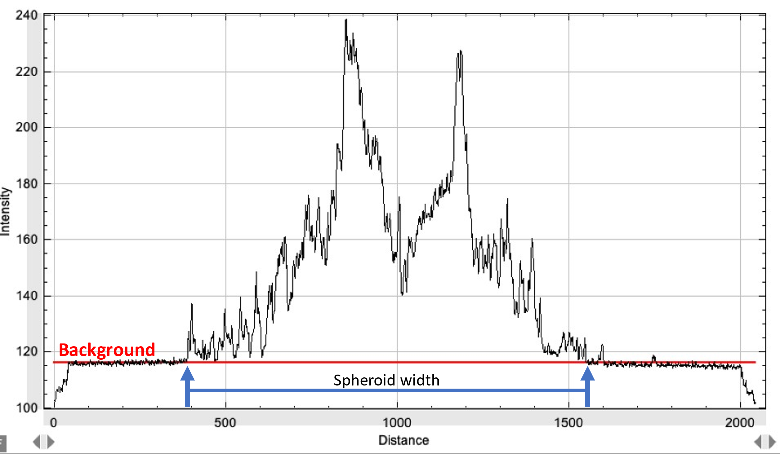

*Image: a mean plot profile of the spheroid computed from the different angles, representing the background and the spheroid mean width.*

To determine this value, we advise to create 3 to 4 rectangles in the background and measure the mean intensity to define the background mean intensity. Create a couple more rectangles on the spheroid to define the phalloidin mean intensity. From these values, set up a threshold for the background mean intensity in order to detect only the phalloidin signal. Click on OK.

3/ The macro computes a horizontal line going through the center of the spheroid and rotates the line every X degrees (as defined by parameter *AngleInc*).

*Image: Example of analysed profiles for an incremental angle of 30°*

4/ The mean intensity is measured along all the lines and the macro computes the mean of all those profiles to create a mean intensity profile which is displayed and saved in the folder chosen in step 1/

5/ From the background threshold that was input by the user, the macro calculates the distance between the two minima on each side of the profile which corresponds to the size of the spheroid.

6/ A Results table containing the Width (in microns) and the scaled width (in image units) for all the spheroids is displayed and saved in the directory.

