Task 2

Task 2.1

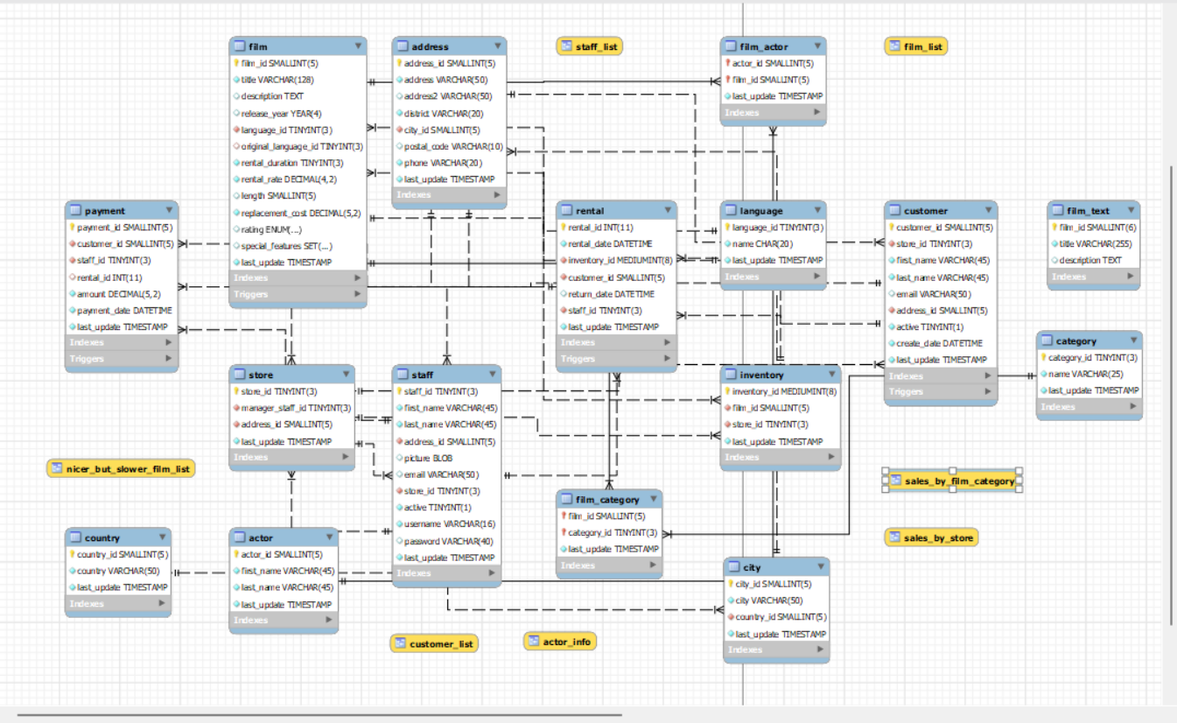
Task 2.2

This relation contains information about stores. The store id is stored as a tinyint, gives the unique id of the store. AddressID is stored as a SmallInt and stores a reference to an entry in the address table that gives the address of the store. The ManagerID is stored as a TinyInt. This stores the staff_ID of the staff member assigned as the manager. Last_Update is the last time this stores entries was updated this is stored as a Timestamp.

