Daniel Pagan

Hemanth Chittanuru

Duy Huynh

David Solodukhin

CS4400 Project Phase 2

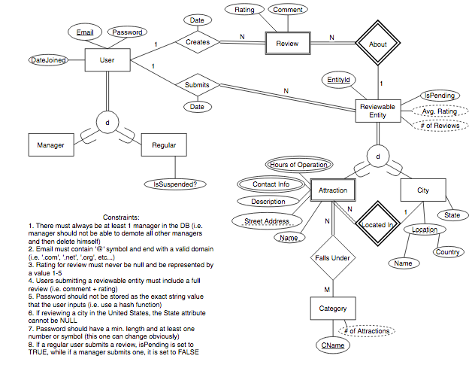

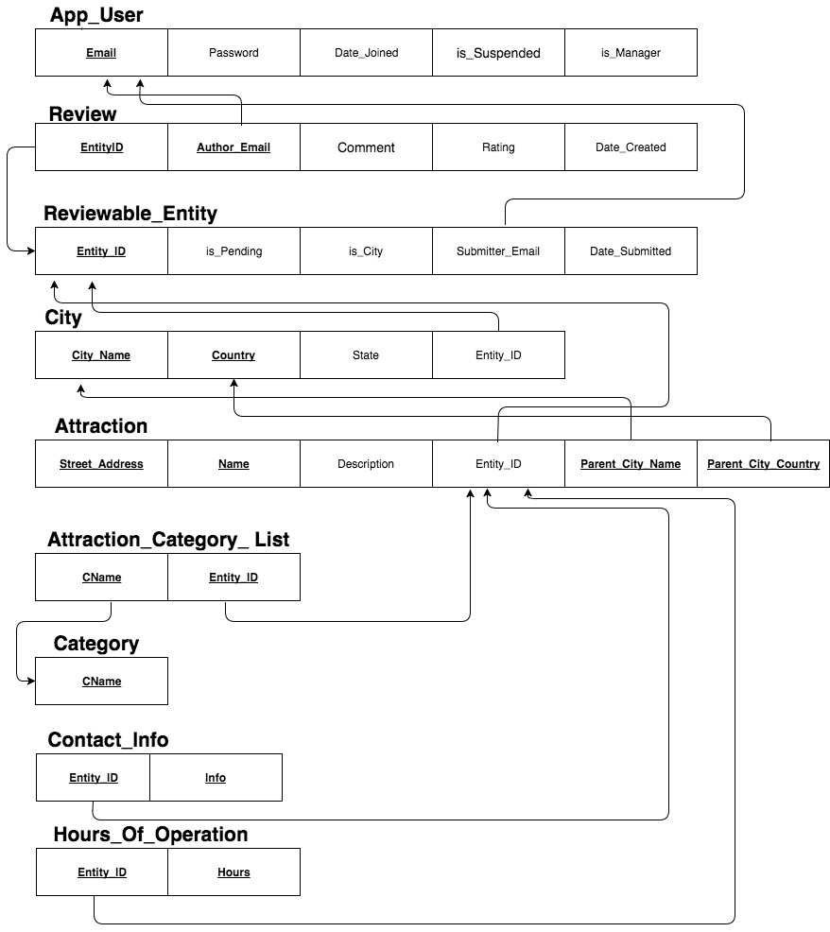

CREATE TABLE IF NOT EXISTS Category (

category_name varchar(25) NOT NULL,

PRIMARY KEY (category_name)

);

CREATE TABLE IF NOT EXISTS App_User (

email varchar(50) NOT NULL,

password varchar(25) NOT NULL,

date_joined timestamp DEFAULT CURRENT_TIMESTAMP,

is_manager boolean NOT NULL,

is_suspended boolean,

PRIMARY KEY (email)

);

CREATE TABLE IF NOT EXISTS Reviewable_Entity (

entity_id varchar(15) NOT NULL,

is_Pending boolean NOT NULL,

is_City boolean NOT NULL ,

submitter_email varchar(50),

date_submitted timestamp DEFAULT CURRENT_TIMESTAMP,

PRIMARY KEY (entity_id),

FOREIGN KEY (submitter_email) REFERENCES App_User (email) ON DELETE SET NULL ON UPDATE CASCADE

);

CREATE TABLE IF NOT EXISTS Review (

entity_id varchar(15) NOT NULL,

author_email varchar(50) NOT NULL,

comment text,

rating integer NOT NULL,

date_created timestamp DEFAULT CURRENT_TIMESTAMP,

FOREIGN KEY (entity_id) REFERENCES Reviewable_Entity (entity_id) ON DELETE CASCADE,

FOREIGN KEY (author_email) REFERENCES App_User (email) ON DELETE CASCADE ON UPDATE CASCADE,

CONSTRAINT PK_Review PRIMARY KEY (entity_id, author_email)

);

CREATE TABLE IF NOT EXISTS City (

city_name varchar(25) NOT NULL,

country varchar (30) NOT NULL,

state varchar (30),

entity_id varchar(15) NOT NULL,

CONSTRAINT PK_City PRIMARY KEY (city_name, country),

FOREIGN KEY (entity_id) REFERENCES Reviewable_Entity (entity_id) ON DELETE CASCADE,

UNIQUE (entity_id)

);

CREATE TABLE IF NOT EXISTS Attraction (

street_address varchar(50) NOT NULL,

name varchar(25) NOT NULL,

description text NOT NULL,

entity_id varchar(15) NOT NULL,

parent_city_name varchar(25) NOT NULL,

parent_city_country varchar(30) NOT NULL,

CONSTRAINT Pk_Attraction PRIMARY KEY (street_address, name, parent_city_name, parent_city_country),

CONSTRAINT Fk_City FOREIGN KEY (parent_city_name, parent_city_country) REFERENCES City (city_name, country) ON DELETE CASCADE,

FOREIGN KEY (entity_id) REFERENCES Reviewable_Entity(entity_id) ON DELETE CASCADE,

UNIQUE (entity_id)

);

CREATE TABLE IF NOT EXISTS Attraction_Category_List (

c_Name varchar(25) NOT NULL,

entity_id varchar(15) NOT NULL,

FOREIGN KEY (c_Name) REFERENCES Category (category_name) ON DELETE CASCADE ON UPDATE CASCADE,

FOREIGN KEY (entity_id) REFERENCES Attraction (entity_id) ON DELETE CASCADE,

CONSTRAINT Pk_Attraction_Category PRIMARY KEY (c_Name, entity_id)

);

CREATE TABLE IF NOT EXISTS Contact_Info (

entity_id varchar(15) NOT NULL,

info varchar(100) NOT NULL,

CONSTRAINT Pk_Contact_Info PRIMARY KEY (entity_id, info),

FOREIGN KEY (entity_id) REFERENCES Attraction (entity_id) ON DELETE CASCADE

);

CREATE TABLE IF NOT EXISTS Hours_Of_Operation (

entity_id varchar(15) NOT NULL,

hours varchar(100) NOT NULL,

FOREIGN KEY (entity_id) REFERENCES Attraction (entity_id) ON DELETE CASCADE,

CONSTRAINT Pk_Hours PRIMARY KEY (entity_id, hours)

);