vysvětlivky:

- private metoda nebo datová složka

+ public metoda nebo datová složka

**!** ToString budete muset udělat podle C# konvence - override a s velkým písmenem. Zbytek klidně může být malým - testy jsou na to koncipované.

1. **Exercises on Classes**

**Jednoduchá cvičení na třídy. Připomínám, že psáno pro Javu (proto je zde printLn)**

**1.1  The Circle Class (An Introduction to Classes and Instances)**

This first exercise shall lead you through all the *basic concepts* in OOP.

**viz: Diagram tříd na Wikipedii**

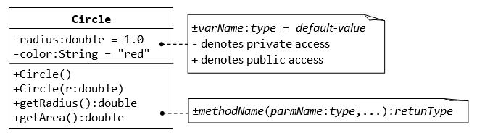

A class called **circle** is designed as shown in the following class diagram. It contains:

* Two private instance variables: radius (of the type double) and color (of the type String), with default value of 1.0 and "red", respectively.
* Two *overloaded* constructors - a *default* constructor with no argument, and a constructor which takes a double argument for radius.
* Two public methods: getRadius() and getArea(), which return the radius and area of this instance, respectively.

The source codes for Circle.java is as follows:

/*

* The Circle class models a circle with a radius and color.

*/

public class **Circle** { // Save as "Circle.java"

// private instance variable, not accessible from outside this class

private double radius;

private String color;

// The default constructor with no argument.

// It sets the radius and color to their default value.

public Circle() {

radius = 1.0;

color = "red";

}

// 2nd constructor with given radius, but color default

public Circle(double r) {

radius = r;

color = "red";

}

// A public method for retrieving the radius

public double getRadius() {

return radius;

}

// A public method for computing the area of circle

public double getArea() {

return radius*radius*Math.PI;

}

}

Compile "Circle.java". Can you run the Circle class? Why?

This Circle class does not have a main() method. Hence, it cannot be run directly. This Circle class is a “building block” and is meant to be used in another program.

Let us write a *test program* called TestCircle (in another source file called TestCircle.java) which uses the Circle class, as follows:

public class **TestCircle** { // Save as "TestCircle.java"

public static void main(String[] args) {

// Declare an instance of Circle class called c1.

// Construct the instance c1 by invoking the "default" constructor

// which sets its radius and color to their default value.

Circle c1 = new Circle();

// Invoke public methods on instance c1, via dot operator.

System.out.println("The circle has radius of "

+ c1.getRadius() + " and area of " + c1.getArea());

// Declare an instance of class circle called c2.

// Construct the instance c2 by invoking the second constructor

// with the given radius and default color.

Circle c2 = new Circle(2.0);

// Invoke public methods on instance c2, via dot operator.

System.out.println("The circle has radius of "

+ c2.getRadius() + " and area of " + c2.getArea());

}

}

Now, run the TestCircle and study the results.

**More Basic OOP Concepts**

1. **Constructor:** Modify the class Circle to include a third constructor for constructing a Circle instance with two arguments - a double for radius and a String for color.

// 3rd constructor to construct a new instance of Circle with the given radius and color

public Circle (double r, String c) { ...... }

Modify the test program TestCircle to construct an instance of Circle using this constructor.

**Getter:** Add a getter for variable color for retrieving the color of this instance.

// Getter for instance variable color

public String getColor() { ...... }

Modify the test program to test this method.

**public vs. private:** In TestCircle, can you access the instance variable radius directly (e.g., System.out.println(c1.radius)); or assign a new value to radius (e.g., c1.radius=5.0)? Try it out and explain the error messages.

**Setter:** Is there a need to change the values of radius and color of a Circle instance after it is constructed? If so, add two public methods called *setters* for changing the radius and color of a Circle instance as follows:

// Setter for instance variable radius

public void setRadius(double newRadius) {

radius = newRadius;

}

// Setter for instance variable color

public void setColor(String newColor) { ...... }

Modify the TestCircle to test these methods, e.g.,

Circle c4 = new Circle(); // construct an instance of Circle

c4.setRadius(5.0); // change radius

System.out.println("radius is: " + c4.getRadius()); // Print radius via getter

c4.setColor(......); // Change color

System.out.println("color is: " + c4.getColor()); // Print color via getter

// You cannot do the following because setRadius() returns void,

// which cannot be printed.

System.out.println(c4.setRadius(4.0));

**Keyword "this":** Instead of using variable names such as r (for radius) and c (for color) in the methods' arguments, it is better to use variable names radius (for radius) and color (for color) and use the special keyword "this" to resolve the conflict between instance variables and methods' arguments. For example,

// Instance variable

private double radius;

// Constructor

public Circle(double radius) {

this.radius = radius; // "this.radius" refers to the instance variable

// "radius" refers to the method's parameter

color = .......

}

// Setter of radius

public void setRadius(double radius) {

this.radius = radius; // "this.radius" refers to the instance variable

// "radius" refers to the method's argument

}

Modify ALL the constructors and setters in the Circle class to use the keyword "this".

**Method toString():** Every well-designed Java class should contain a public method called toString() that returns a short description of the instance (in a return type of String). The toString() method can be called explicitly (via *instanceName*.toString()) just like any other method; or implicitly through println(). If an instance is passed to the println(*anInstance*) method, the toString() method of that instance will be invoked implicitly. For example, include the following toString() methods to the Circle class:

// Return a description of this instance in the form of

// Circle[radius=r,color=c]

public String toString() {

return "Circle[radius=" + radius + " color=" + color + "]";

}

Try calling toString() method explicitly, just like any other method:

Circle c1 = new Circle(5.0);

System.out.println(c1.toString()); // explicit call

toString() is called implicitly when an instance is passed to println() method, for example,

Circle c2 = new Circle(1.2);

System.out.println(c2.toString()); // explicit call

System.out.println(c2); // println() calls toString() implicitly, same as above

System.out.println("Operator '+' invokes toString() too: " + c2); // '+' invokes toString() too

The final class diagram for the Circle class is as follows:

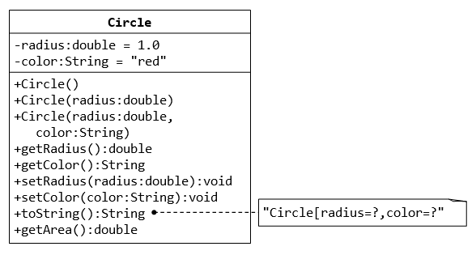

**1.2  Ex: The Rectangle Class**

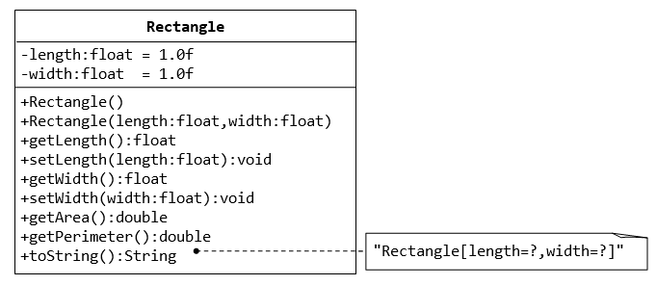

[**1.3**](https://www.inf.ed.ac.uk/teaching/courses/inf1/op/Labs/2008/doc/lab4.html#id5) **Lamp**

In this exercise you will model a lamp as a Java object. Make a Lamp class. This will contain at least one **instance variable** which will be of type boolean and will hold the *state* of the lamp: i.e., whether it is on or off. In addition, add **methods** to do the following things: switch the light on and off, and check its current state, i.e., whether it is on or off.

Next, write a launcher class with a main() method to carry out the following tasks:

* create a lamp object;
* turn it on and off;
* print the the lamp's on/off status to the console (i.e., using System.out.println()).

(poctivě ukradeno z <https://www.inf.ed.ac.uk/>)

**1.4  Ex: The Employee Class**

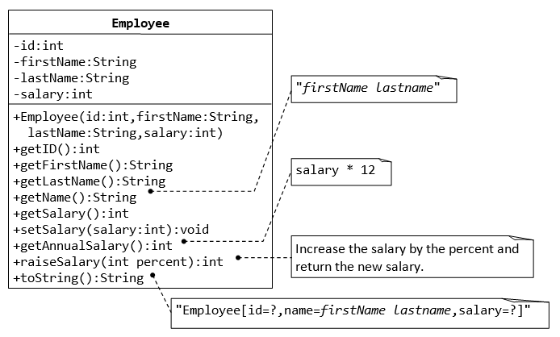

**1.5  Ex: The InvoiceItem Class**

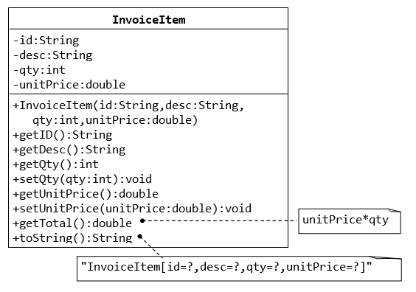

**1.7  Ex: The Date Class**

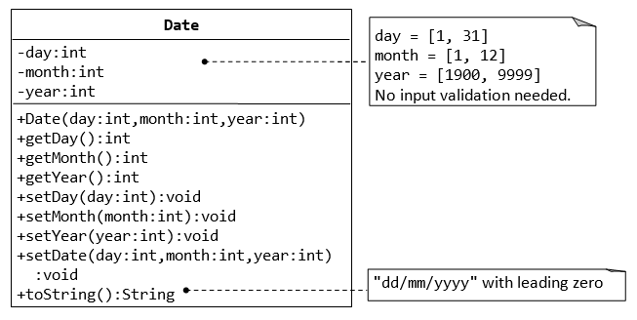

**1.8  Ex: The Time Class**

