EGR 125 - Introduction to Engineering Methods (C++) Name: _David Vermaak_

File: N125-Ch5LB (spring 2021) Due date: ___10/7/21___

**Chapter 5 Homework(b)**

**Reading Assignment:**

Read Chapter 5 in Introduction to Programming with C++, 3rd Edition by Liang

**Programing Assignments:**

1. **While loops (20 pts):**
   1. Create a flowchart and write a C++ program using a **while loop** for Programming **Exercise 5.15**

**on p. 215** (find the largest n such that n3 < 12,000). Additionally, display a table of values for n and n3 beginning with n = 0 and incrementing n until the result is found. Turn in printouts of the program and the results.

* 1. Create a flowchart and write a C++ program using a **while loop** for Programming **Exercise 5.27 on p. 218** with the following change: Instead of displaying π for values of i shown, use a while loop to continue adding terms until π is accurate to **5** digits after the decimal point. NOTE: the first 5 digits should match, but display 10 digits after the d.p.

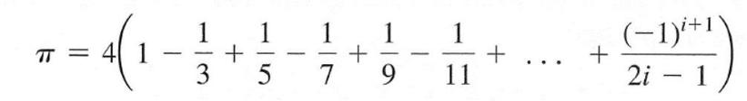

Display the following and turn in printouts of the program and the results.

The number of terms needed to find π to the 5 decimal digits of accuracy.

The value of π using acos(-1) with 10 digits displayed after the decimal point to compare to the series result.

The value of π found with the series using **8** digits after the decimal point, too.

1. **Do while loops (20 pts):**
   1. Create a flowchart and write a C++ program using a **do while loop** for Programming **Exercise 5.10 on p. 215** (Find the highest score). Run the program for 3 cases:
      * Case 1: 3 students, first grade is the highest
      * Case 2: 4 students, last grade is the highest
      * Case 3: 5 students, middle grade is the highest

Turn in a printout of the program and a printout of the results for all cases.

* 1. Create a flowchart and write a C++ program using a **do while loop** for Programming **Exercise 5.1 on p. 213**. Write a program that reads an unspecified number of integers, determines how many

positive and negative values have been read, and computes the total and average of

the input values (not counting zeros). Your program ends with the input 0. Display

the average as a floating-point number.

* + - Turn in a printout of the program and a printout of the results.
    - Test the program for the two test cases in the book along with a third test case that includes 10 valid numbers (including some negative and some positive).

1. **For loops (30 pts):**
   1. (10 pts) Write a C++ program to display a table of values for side B, side H, angle (in degrees) and (in degrees) for the right triangle shown. Use a **for loop** to calculate H, α, and β as side B from 2 m to 20 m in 2 m increments. The output should be a table of values for B, H, α, and β similar to the one shown below (no lines are required). Use 0 digits after the decimal point for B, 3 digits after the decimal point for H, and 2 digits after the decimal point for α, and β. Turn in a printout of the program and a printout of the results. The table should be nicely aligned

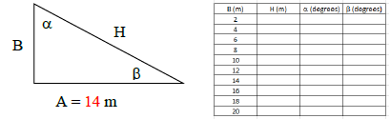

1. (10 pts) Create a flowchart and write a C++ program that uses a **for loop** for Programming **Exercise 5.53 on p. 223** Assume letters A, E, I, O, and U as the vowels.

Write a program that prompts the user to enter a string and displays the number of

vowels and consonants in the string.

* + Run the program for the example string in the text and for your full name.

1. (10 pts) Create a flowchart and write a C++ program that uses a **for loop** for Programming **Exercise 5.5 on p. 194** (table of conversions from kilograms to pounds and pounds to kilograms):
   * Turn in a copy of the program and the results
2. (30 pts) For each part below, show the output produced (***exactly*** as it would appear on the computer screen). Problem 0 is an example. Trace these program segments on paper (use a table) and in your head rather than using the C++ compiler.

|  |  |  |
| --- | --- | --- |
| Prob# | Loop to Trace | Output |
| 0 | for (int i = 2; i <= 10; i+=2)  cout << i << “squared = “  << i*i << endl; | **2 squared = 4**  **4 squared = 16**  **6 squared = 36**  **8 squared = 64**  **10 squared = 100** |
| 1 | for (int i = 3; i >= -3; i --)  cout << i << “ cubed = “  << i*i*i << endl; | **3 cubed = 27**  **2 cubed = 8**  **1 cubed = 1**  **0 cubed = 0**  **-1 cubed = -1**  **-2 cubed = -8**  **-3 cubed = -27** |
| 2 | for (int i = 1; i <= 5; i++)  { cout << i; | **1531**  **253**  **353**  **45**  **55** |
| 3 | int k = 1;  for (int i = 5; i >= -4; i-=2)  { cout << i + k << endl; k+=i;  } | **6**  **9**  **10**  **9**  **6** |
| 4 | for (int i = 3; i > 0; i--)  for (int j = i; j > 0; j--)  for (int k = j; k > 0; k--)  cout << i << j << k << endl; | **333**  **332**  **331**  **322**  **321**  **311**  **222**  **221**  **211**  **111** |
| 5 | for ( int i = 4; i > 1; i--)  for (int j = 4; j > 1; j--)  {  for (int k = j; k >= i; k--)  cout << i << j << k << endl;  } | **444**  **344**  **343**  **333**  **244**  **243**  **242**  **233**  **232**  **222** |
| 6 | int i = 6;  int k, j = 2; for (;;)  {k = 3 * i – j; if (k < 0) break;  cout << i << j << k << endl;  j++; i--;  }  cout << i << j << k << endl; | **6216**  **5312**  **448**  **354**  **260**  **17-4** |
| 7 | int k = 0;  int i = 1;  while (k < 7)  { cout << “log(base 2) of “ << i  << “ = “ << k << endl;  i *= 2;  k++;  } | **log(base 2) of 1 = 0**  **log(base 2) of 2 = 1**  **log(base 2) of 4 = 2**  **log(base 2) of 8 = 3**  **log(base 2) of 16 = 4**  **log(base 2) of 32 = 5**  **log(base 2) of 64 = 6** |
| 8 | int j, i =1;  while (i*i < 10)  {  j = i;  while (j*j*j < 100)  { cout << i + j << endl;  j++;  }  i++;  }  cout << “\n*****\n”; | **2**  **3**  **4**  **5**  **4**  **5**  **6**  **6**  **7**  **\*\*\*\*\*** |
| 9 | int k, i = 1;  do  { k = i * i * i – 4 * i + 1;  cout << i << k << endl;  i++;  } while (k <= 20); | **1-2**  **21**  **316**  **449** |
| 10 | int j, k, i = 1;  do  { j = i * i * i;  cout << i;  do  { k = i + 2*j;  cout << j << k;  j += 2;  }  while (k <= 10);  cout << endl;  i++;  } while (j <= 8); | **11337511**  **2818** |

**1: While loops (20 pts):**

**1A** Create a flowchart and write a C++ program using a **while loop** for Programming **Exercise 5.15:** (find the largest n such that n3 < 12,000). Additionally, display a table of values for n and n3 beginning with n = 0 and incrementing n until the result is found. Turn in printouts of the program and the results.

**PROGRAM #1A Flowchart**

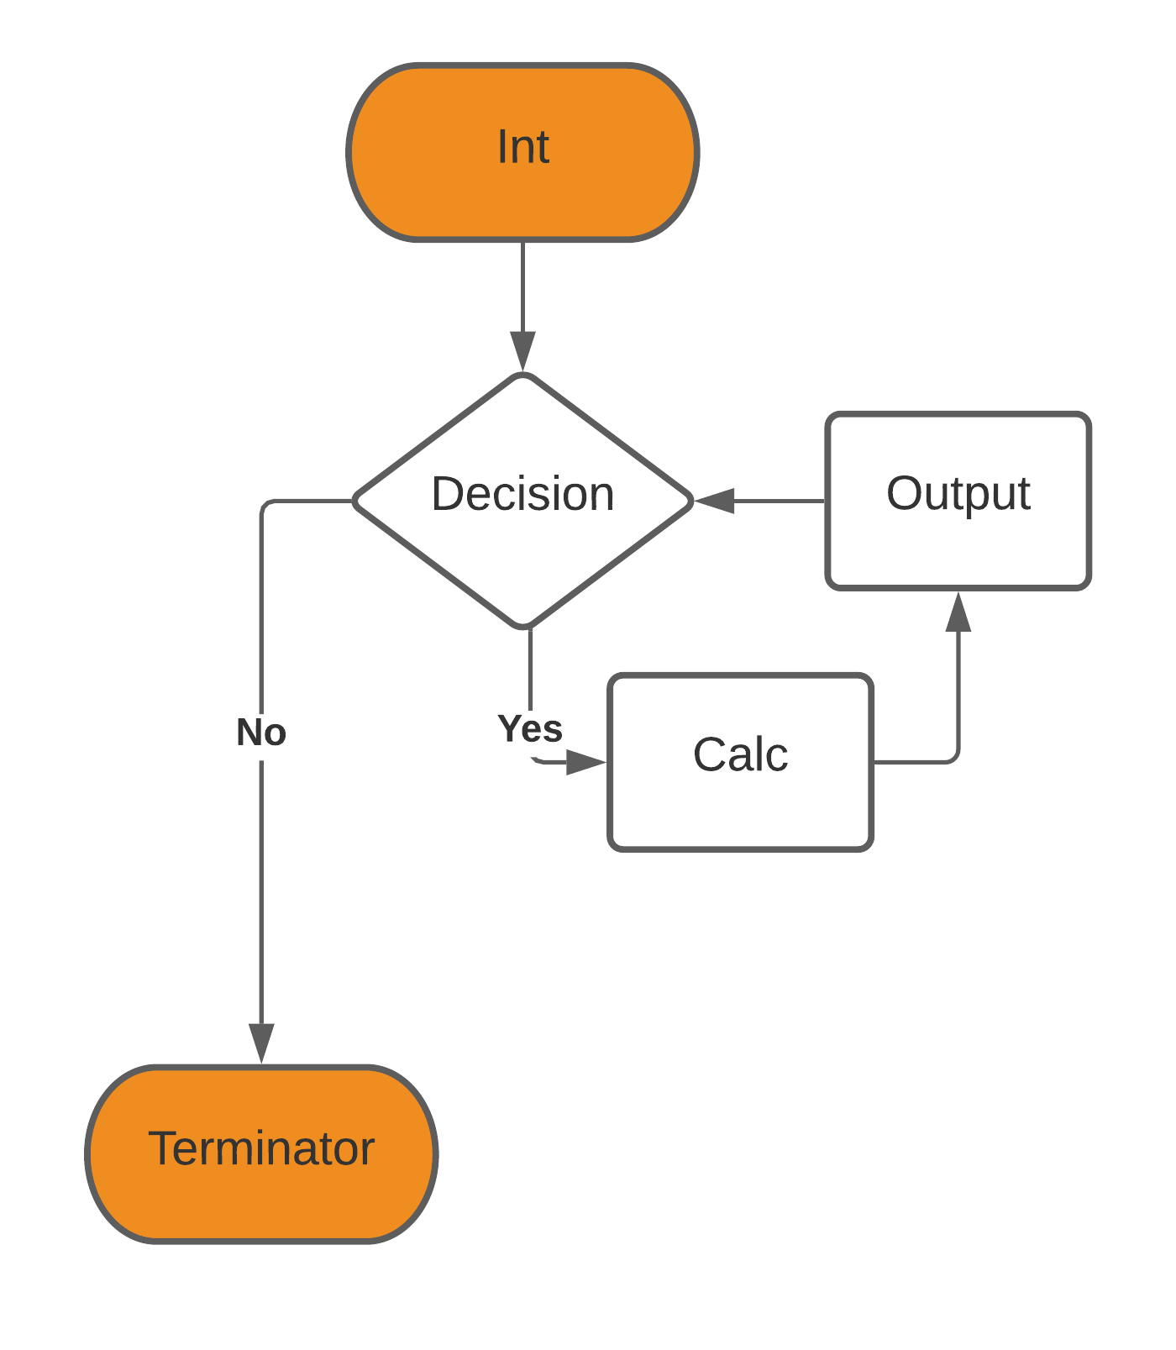

**PROGRAM #1A:**

// ____ __ __

// / / \ / \

// / / /

// / \___/ \___/

//

// Date: 10/07/2021

// Name: David Vermaak

// Project Description: Finding a number such that the cube is less than 12,000

// Inputs: n/a

// Outputs: A table with all the values of n calculated

//*************************************************************

#include <iostream> //header containing cout and cin

#include <cmath> //header containing better math functions

#include <iomanip> //This header contains functions to format output

using namespace std; //introduces namespace std

int main ( )

{

int n = 0, n3;

cout << "n: n3:\n";

while (n3 < 12000)

{

n3 = pow(n,3);

cout << n <<" " << n3<<endl;

n++;

}

return 0;

}

**OUTPUT FOR PROGRAM #1A:**

n: n3:

0 0

1 1

2 8

3 27

4 64

5 125

6 216

7 343

8 512

9 729

10 1000

11 1331

12 1728

13 2197

14 2744

15 3375

16 4096

17 4913

18 5832

19 6859

20 8000

21 9261

22 10648

23 12167

**1: While loops (20 pts):**

**1B:** Create a flowchart and write a C++ program using a **while loop** for Programming **Exercise 5.27:** Instead of displaying π for values of i shown, use a while loop to continue adding terms until π is accurate to **5** digits after the decimal point. NOTE: the first 5 digits should match, but display 10 digits after the d.p.

Display the following and turn in printouts of the program and the results.

The number of terms needed to find π to the 5 decimal digits of accuracy.

The value of π using acos(-1) with 10 digits displayed after the decimal point to compare to the series result.

The value of π found with the series using **8** digits after the decimal point, too.

**PROGRAM #1B Flowchart**

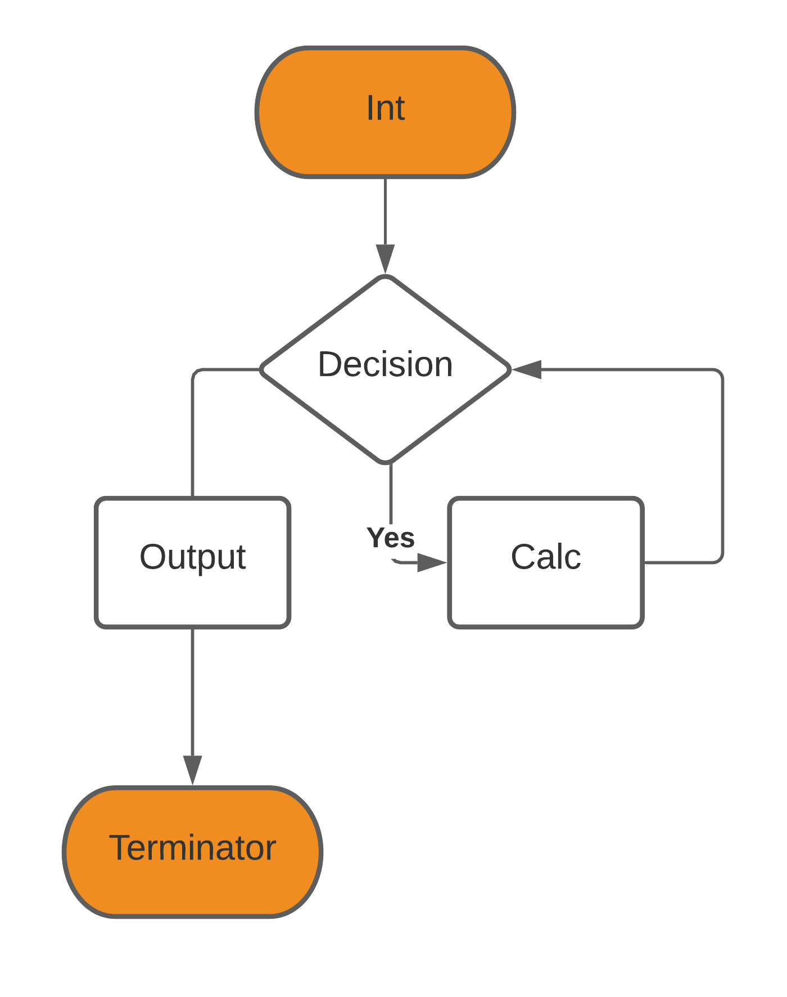

**PROGRAM #1B:**

// ____ __ __

// / / \ / \

// / / /

// / \___/ \___/

//

// Date: 10/07/2021

// Name: David Vermaak

// Project Description: Finding an approximation of pi

// Inputs: n/a

// Outputs: values of pi

//*************************************************************

#include <iostream> //header containing cout and cin

#include <cmath> //header containing better math functions

#include <iomanip> //This header contains functions to better format output

#include <string> //This header enables string functions

using namespace std; //introduces namespace std

int main ( )

{

const float pi = acos(-1);

double cpi, frac;

int i = 1, mpi, ref5 = 314159;

while (mpi != ref5)

{

frac = frac + ((pow(-1,(1+i)))/(2*i-1));

i++;

cpi = frac * 4;

mpi = cpi * 100000;

}

cout << "Iterations: " << i -1 << endl

<< "Pi\t\t" << fixed << setprecision(10) << pi << endl

<< "Pi Calculated\t" << setprecision(10) << cpi << endl

<< "Pi Calculated\t" << setprecision(8) << cpi << endl;

return 0;

}

**OUTPUT FOR PROGRAM #1B:**

Iterations: 136121

Pi 3.1415927410

Pi Calculated 3.1415904376

Pi Calculated 3.14159043

**2: Do while loops (20 pts):**

**2A:** Create a flowchart and write a C++ program using a **do while loop** for Programming **Exercise 5.10:** (Find the highest score). Run the program for 3 cases:

Case 1: 3 students, first grade is the highest

Case 2: 4 students, last grade is the highest

Case 3: 5 students, middle grade is the highest

**PROGRAM #2A Flowchart**

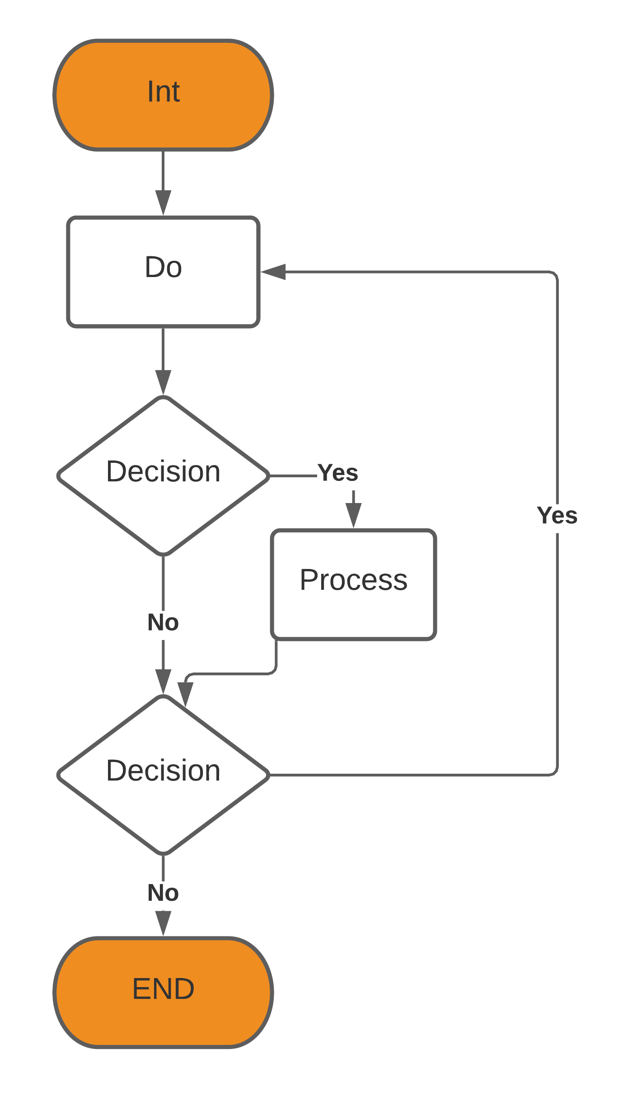

**PROGRAM #2A:**

// ____ __ __

// / / \ / \

// / / /

// / \___/ \___/

//

*// Date: 10/07/2021*

*// Name: David Vermaak*

*// Project Description: This program finds the highest grade and who earned it*

*// Inputs: names and grades*

*// Outputs: names and grades*

*//\*\*\*\*\*\*\*\*\*\*\*\*\*\*\*\*\*\*\*\*\*\*\*\*\*\*\*\*\*\*\*\*\*\*\*\*\*\*\*\*\*\*\*\*\*\*\*\*\*\*\*\*\*\*\*\*\*\*\*\*\**

*#include <iostream> //header containing cout and cin*

*#include <cmath> //header containing better math functions*

*#include <iomanip> //This header contains functions to better format output*

*#include <string> //This header enables string functions*

*using namespace std; //introduces namespace std*

*int main ( )*

*{*

*int n, Grade, highestGrade = 0, total = 0, i = 1;*

*string nameA, nameB;*

*double averageGrade = 0.0;*

*cout << "How many students are you entering grades for?\n";*

*cin >> n;*

*do*

*{*

*cout << "Please enter the first and last names separated with an underscore\n";*

*cin >> nameA;*

*cout << "What's the score?" << endl;*

*cin >> Grade;*

*total += Grade;*

*i++;*

*if (Grade > highestGrade)*

*{*

*highestGrade = Grade;*

*nameA = nameB;*

*}*

*} while (n>= i);*

*averageGrade = total / n;*

*cout << "The average grade is " << averageGrade << endl;*

*cout << "The student with highest Grade is " << nameA << " with a score of " << highestGrade << "." << endl;*

*}*

**OUTPUT FOR PROGRAM #2A:**

How many students are you entering grades for?

3

Please enter the first and last names separated with an underscore

Dave_Jones

What's the score?

98

Please enter the first and last names separated with an underscore

Bob_Smith

What's the score?

45

Please enter the first and last names separated with an underscore

Jean_Smith

What's the score?

78

The average grade is 73

The student with highest Grade is Dave_Jones with a score of 98.

_____________________________________________________________________

How many students are you entering grades for?

4

Please enter the first and last names separated with an underscore

Student_1

What's the score?

35

Please enter the first and last names separated with an underscore

Student_2

What's the score?

78

Please enter the first and last names separated with an underscore

Student_3

What's the score?

85

Please enter the first and last names separated with an underscore

Student_4

What's the score?

99

The average grade is 74

The student with highest Grade is Student_4 with a score of 99.

_____________________________________________________________________

How many students are you entering grades for?

5

Please enter the first and last names separated with an underscore

S1

What's the score?

23

Please enter the first and last names separated with an underscore

S2

What's the score?

45

Please enter the first and last names separated with an underscore

S3

What's the score?

100

Please enter the first and last names separated with an underscore

S4

What's the score?

85

Please enter the first and last names separated with an underscore

S5

What's the score?

12

The average grade is 53

The student with highest Grade is S3 with a score of 100.

**2: Do while loops (20 pts):**

**2B:** Create a flowchart and write a C++ program using a **do while loop** for Programming **Exercise 5.1:**

Turn in a printout of the program and a printout of the results.

Test the program for the two test cases in the book along with a third test case that includes 10 valid numbers (including some negative and some positive).

**PROGRAM #2B Flowchart**



**PROGRAM #2B:**

// ____ __ __

// / / \ / \

// / / /

// / \___/ \___/

//

// Date: 10/07/2021

// Name: David Vermaak

// Project Description: This program finds the largest number and the average number from a bunch of int inputs

// Inputs: ints

// Outputs: ints

//*************************************************************

#include <iostream> //header containing cout and cin

#include <cmath> //header containing better math functions

#include <iomanip> //This header contains functions to better format output

using namespace std; //introduces namespace std

int main ( )

{

int number, highestN = 0, total = 0, i = -1;

float average = 0.0;

do

{

cout << "Please enter the integer: \n(to quit enter the number zero (0))\n";

cin >> number;

total += number;

i++;

if (number > highestN)

{

highestN = number;

}

} while (number != 0);

average = total / i;

cout << "The average is " << average << endl;

cout << "The largest number is " << highestN << endl;

return 0;

}

**OUTPUT FOR PROGRAM #2B:**

Please enter the integer:

(to quit enter the number zero (0))

123

Please enter the integer:

(to quit enter the number zero (0))

-1

Please enter the integer:

(to quit enter the number zero (0))

0

The average is 61

The largest number is 123

_____________________________________________________________________

Please enter the integer:

(to quit enter the number zero (0))

0

____________________________________________________________________

Please enter the integer:

(to quit enter the number zero (0))

1

Please enter the integer:

(to quit enter the number zero (0))

-5

Please enter the integer:

(to quit enter the number zero (0))

12

Please enter the integer:

(to quit enter the number zero (0))

58

Please enter the integer:

(to quit enter the number zero (0))

5

Please enter the integer:

(to quit enter the number zero (0))

-6

Please enter the integer:

(to quit enter the number zero (0))

8

Please enter the integer:

(to quit enter the number zero (0))

3

Please enter the integer:

(to quit enter the number zero (0))

-15

Please enter the integer:

(to quit enter the number zero (0))

79

Please enter the integer:

(to quit enter the number zero (0))

0

The average is 14

The largest number is 79

**3: Do while loops (20 pts):**

**3A:** (10 pts) Write a C++ program to display a table of values for side B, side H, angle (in degrees) and (in degrees) for the right triangle shown. Use a for loop to calculate H, α, and β as side B from 2 m to 20 m in 2 m increments. The output should be a table of values for B, H, α, and β similar to the one shown below (no lines are required). Use 0 digits after the decimal point for B, 3 digits after the decimal point for H, and 2 digits after the decimal point for α, and β.

**PROGRAM #3A Flowchart**

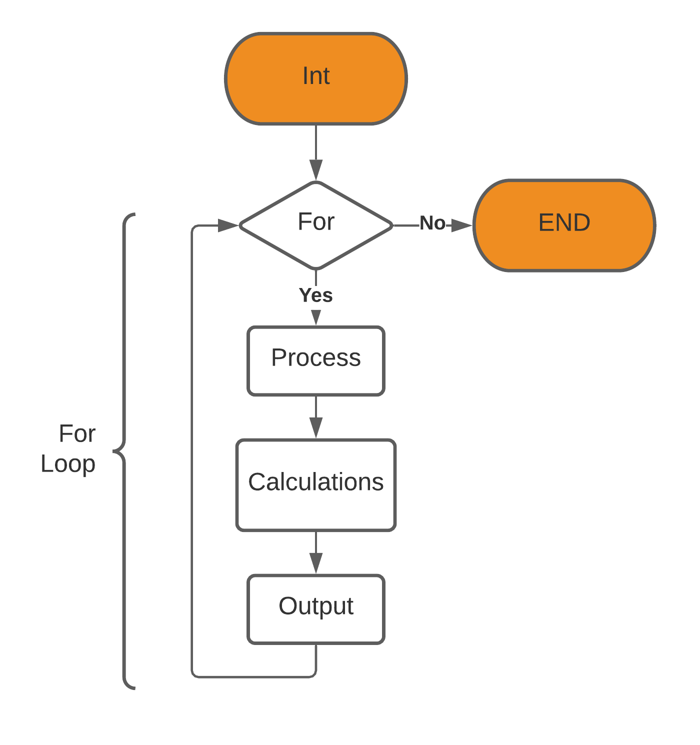

**PROGRAM #3A:**

// ____ __ __

// / / \ / \

// / / /

// / \___/ \___/

//

// Date: 10/07/2021

// Name: David Vermaak

// Project Description: Program that calculates the hypotenuse and angles of a right triangle

// Inputs: n/a

// Outputs: formatted table of values

//*************************************************************

#include <iostream> //header containing cout and cin

#include <cmath> //header containing better math functions

#include <iomanip> //This header contains functions to better format output

using namespace std; //introduces namespace std

int main ( )

{

// sets up a constant for the value of pi

const float pi = acos(-1.0);

int b = 1;

double h, angle_C, angle_A, angle_B;

cout << " B (m) H (m) A (deg) B (deg) \n";

for (int b = 1; 20 >= b; b++)

{

b++;

//calculates the hypotenuse

h = sqrt(pow(14,2)+pow(b,2));

//calculates the angles

angle_A = acos((pow(b, 2) + pow(h, 2) - pow(14, 2))/(2 * b * h));

//convert radians to degrees

angle_A = angle_A * ( 180/ pi);

//find the last angle

angle_B = (90 - angle_A);

cout << setw(4) << b << setw(12) <<fixed<< setprecision(3) << h

<< setw(10) <<fixed<< setprecision(2) << angle_A

<< setw(10) <<fixed<< setprecision(2) << angle_B << " \n";

}

return 0;

}

**OUTPUT FOR PROGRAM #3A:**

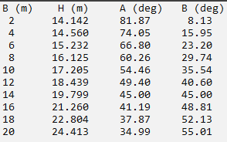

**3: Do while loops (20 pts):**

**3B:** (10 pts) Create a flowchart and write a C++ program that uses a for loop for Programming Exercise 5.53 on p. 203 (count the number of vowels and consonants in a string).

Turn in a printout of the program and a printout of the results.

Run the program for the example string in the text and for your full name.

**PROGRAM #3B Flowchart**

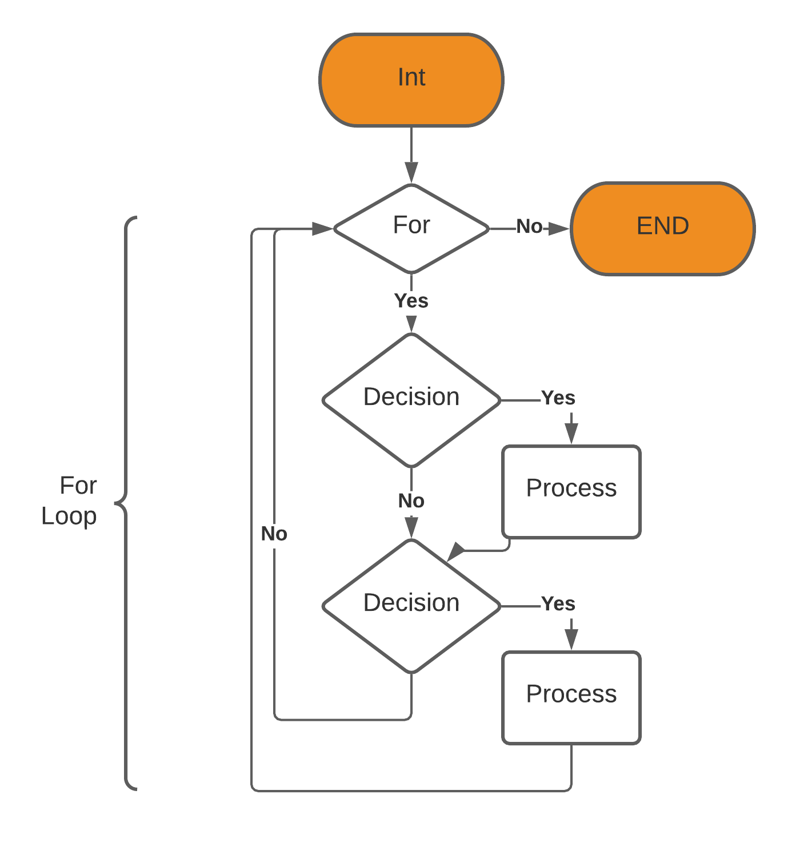

**PROGRAM #3B:**

// ____ __ __

// / / \ / \

// / / /

// / \___/ \___/

//

// Date: 10/07/2021

// Name: David Vermaak

// Project Description: This program counts the number of vowels and consonants in a string

// Inputs: String

// Outputs: string and ints

//*************************************************************

#include <iostream> //header containing cout and cin

#include <cmath> //header containing better math functions

#include <iomanip> //This header contains functions to better format output

#include <string> //This header enables string functions

#include <cctype> // contains functions that test the contents of chars

using namespace std; //introduces namespace std

int main ( )

{

int vowel = 0, cons = 0, i = 0;

string s1;

cout << "Please enter a phrase using underscores instead of spaces\n";

cin >> s1;

for (int i = 0; s1.length()>i; i++)

{

//find A, E, I, O, and U as the vowels

if (s1[i] == 'A' ||s1[i] == 'a' || s1[i] == 'E' ||s1[i] == 'e' || s1[i] == 'I' ||s1[i] == 'i' || s1[i] == 'O' ||s1[i] == 'o' || s1[i] == 'U' ||s1[i] == 'u' )

{ vowel++;

}

else if (s1[i] >64 && s1[i] <91 || s1[i] >96 && s1[i] <123)

{ cons++;

}

}

cout << "The phrase: " << s1 << " has " << vowel << " vowels and " << cons << " consonants";

return 0;

}

**OUTPUT FOR PROGRAM #3B:**

Please enter a phrase using underscores instead of spaces

Programming_is_fun

The phrase: Programming_is_fun has 5 vowels and 11 consonants

____________________________________________________________________

Please enter a phrase using underscores instead of spaces

David_Vermaak

The phrase: David_Vermaak has 5 vowels and 7 consonants

**3: Do while loops (20 pts):**

**3C:** (10 pts) Create a flowchart and write a C++ program that uses a **for loop** for Programming **Exercise 5.5 on p. 194** (table of conversions from kilograms to pounds and pounds to kilograms):

Turn in a copy of the program and the results

**PROGRAM #3C Flowchart**



**PROGRAM #3C:**

// ____ __ __

// / / \ / \

// / / /

// / \___/ \___/

//

// Date: 10/07/2021

// Name: David Vermaak

// Project Description: This program outputs a table of weight conversions

// Inputs: n\a

// Outputs: formatted table of Lb to Kg and Kg to Lb

//*************************************************************

#include <iostream> //header containing cout and cin

#include <cmath> //header containing better math functions

#include <iomanip> //This header contains functions to better format output

using namespace std; //introduces namespace std

int main ( )

{

int i = 0;

double Kg1, Kg2, Lb1, Lb2;

cout << " Kilograms Pounds | Pounds Kilograms\n";

for (int i = 0; 50 >= i; i++)

{

Lb1 = i * 2;

Kg1 = i;

Lb2 = Kg1 * 0.4535924;

Kg2 = Lb1 * 2.204623;

cout << setw(4) << setprecision(0) << Lb1 << " "

<< setw(12) <<fixed<< setprecision(2) << Kg2 << " | "

<< setw(4) << setprecision(0) << Kg1 << " "

<< setw(10) <<fixed<< setprecision(2) << Lb2 <<" \n";

}

return 0;

}

**OUTPUT FOR PROGRAM #3C:**

