# Cloud Data Centres David Williams Cybersecurity & IT security 4th Year C00263768 Lab 5

Installing Istio:



Setting the profile to demo

Adding namespace

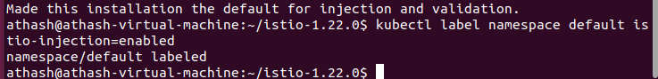

Deploying the sample application:

deploy the bookinfo sameple

Application start, getting services

and  
  
Verifying everything

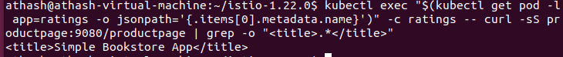

Opening the application to outside traffic:

associate this application with istio gateway

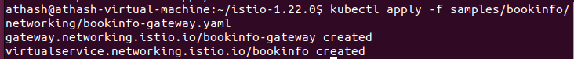

Ensuring no issues

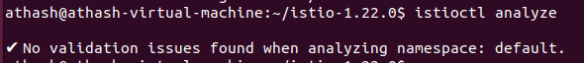

Determining the ingress IP and Ports:

set GATEWAY URL

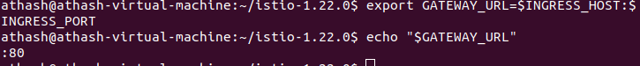

Verify external access



Installing Kiali and the other addons

Access the Kiali Dashboard

The dashboard namespace default

