David Wong

CSE 455

Autumn 2014

HW #1

1. ***kidney.pgm***

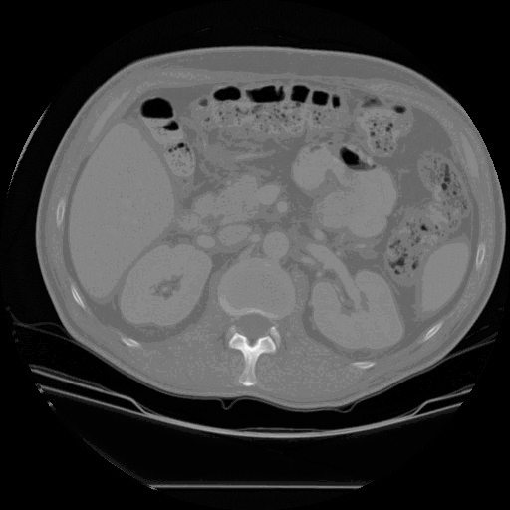

./thresh 130 255 images/kidney.pgm > images/kidney_thresh_1.pgm

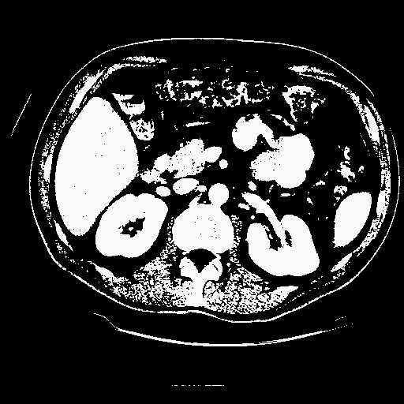

./erode d 5 images/kidney_thresh_1.pgm > images/kidney_erode_2.pgm

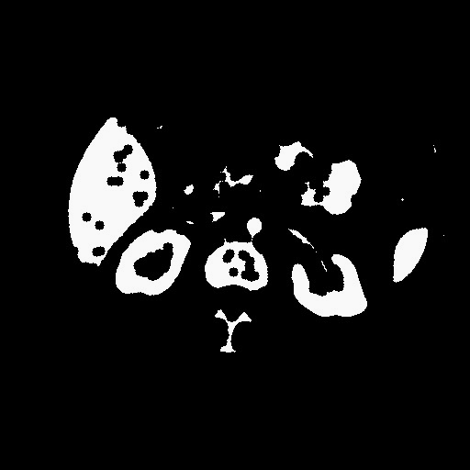

./dilate d 5 images/kidney_erode_2.pgm > images/kidney_dilate_3.pgm

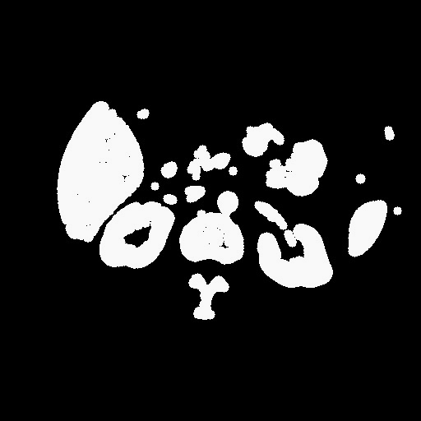

./dilate d 1 images/kidney_dilate_3.pgm > images/kidney_dilate_4.pgm

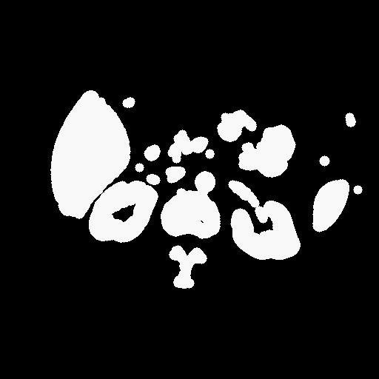

./erode d 1 images/kidney_dilate_4.pgm > images/kidney_erode_5.pgm

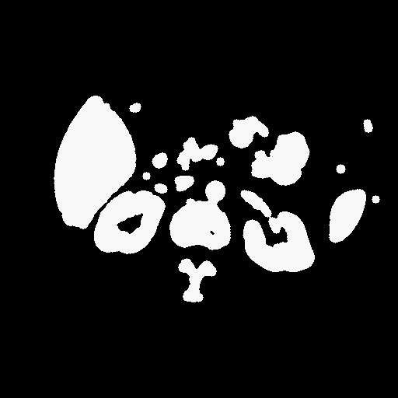

./conrgn g images/kidney_erode_5.pgm > images/kidney_conrgn_6.pgm

./autocolor images/kidney_conrgn_6.pgm > images/kidney_autocolor_7.pgm

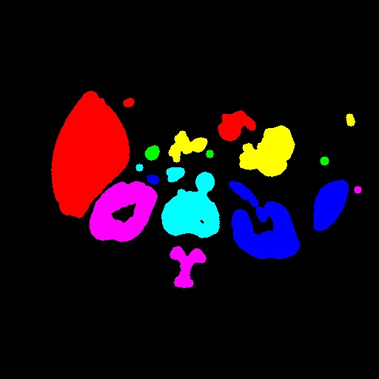

1. ***g006.pgm***

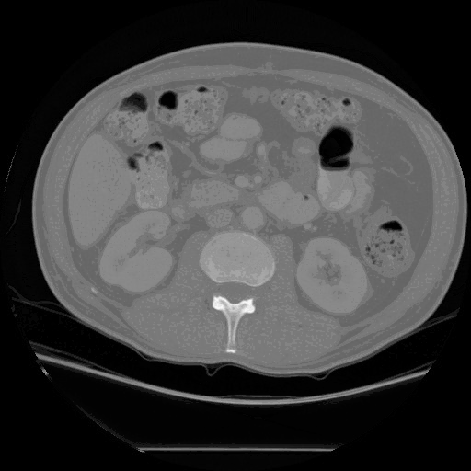

./thresh 130 255 images/g006.pgm > images/g006_thresh_1.pgm

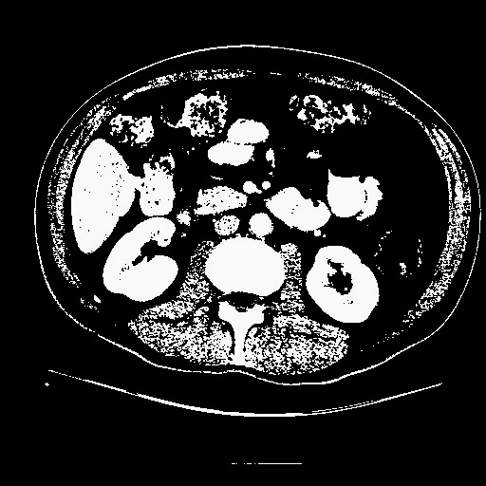

./erode d 5 images/g006_thresh_1.pgm > images/g006_erode_2.pgm

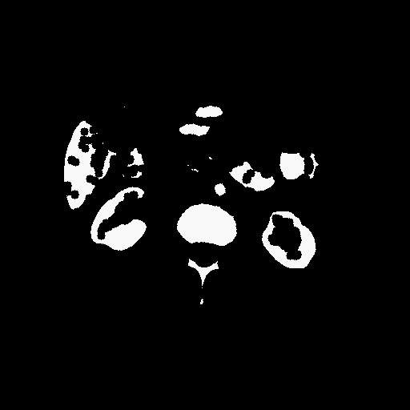

./dilate d 5 images/g006_erode_2.pgm > images/g006_dilate_3.pgm

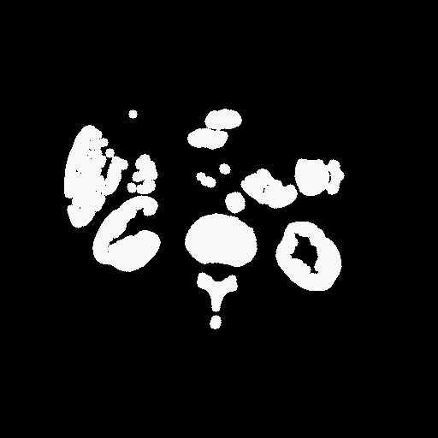

./dilate d 1 images/g006_dilate_3.pgm > images/g006_dilate_4.pgm

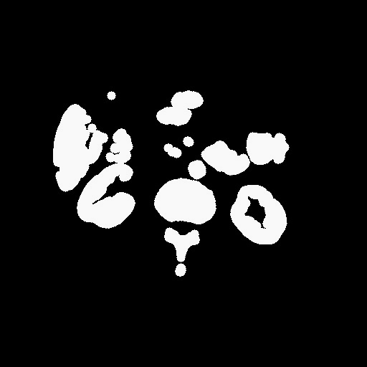

./erode d 1 images/g006_dilate_4.pgm > images/g006_erode_5.pgm

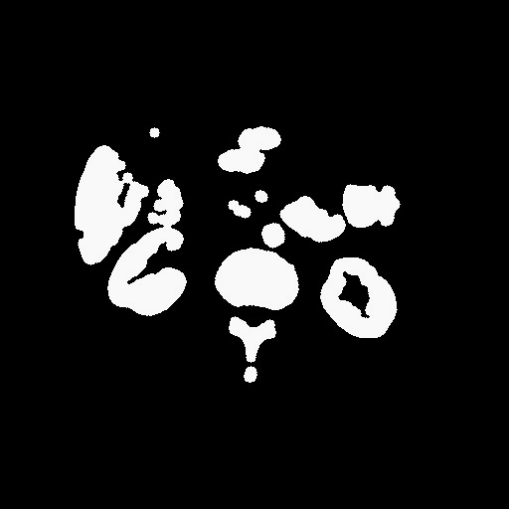

./conrgn g images/g006_erode_5.pgm > images/g006_conrgn_6.pgm

./autocolor images/g006_conrgn_6.pgm > images/g006_autocolor_7.pgm

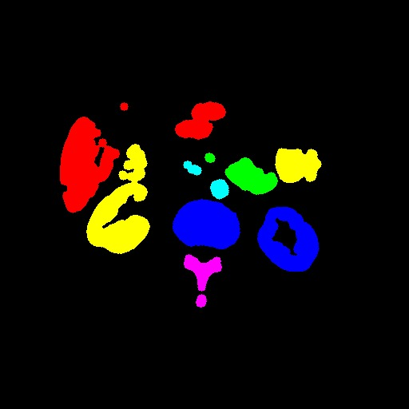

1. ***e030.pgm***

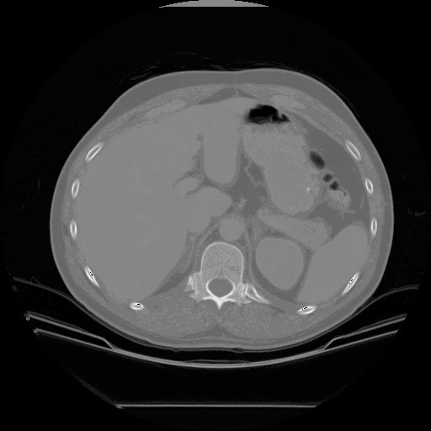

./thresh 130 255 images/e030.pgm > images/e030_thresh_1.pgm

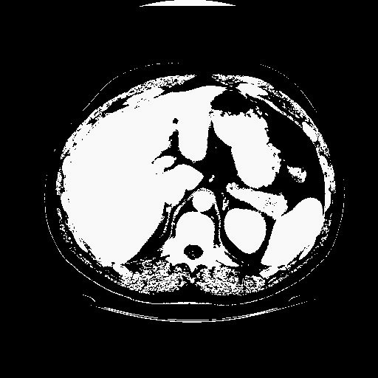

./erode d 5 images/e030_thresh_1.pgm > images/e030_erode_2.pgm

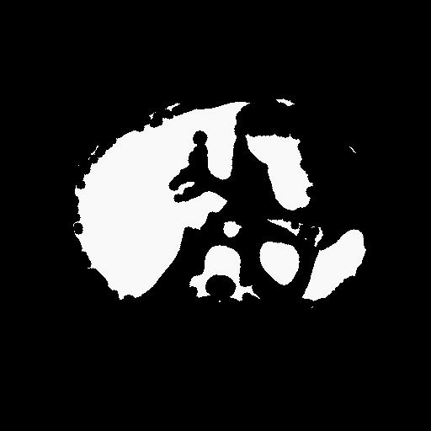

./dilate d 5 images/e030_erode_2.pgm > images/e030_dilate_3.pgm



./dilate d 1 images/e030_dilate_3.pgm > images/e030_dilate_4.pgm

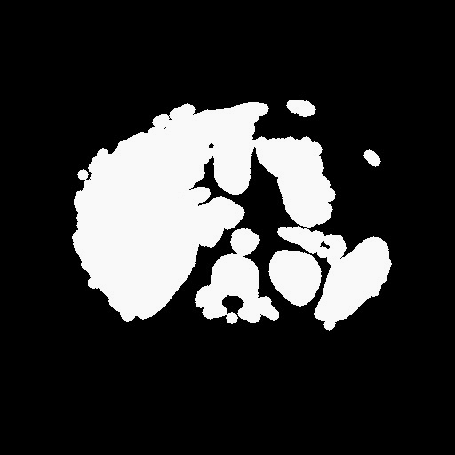

./erode d 1 images/e030_dilate_4.pgm > images/e030_erode_5.pgm



./conrgn g images/e030_erode_5.pgm > images/e030_conrgn_6.pgm

./autocolor images/e030_conrgn_6.pgm > images/e030_autocolor_7.pgm

