**Heuristic Analysis**

The three heuristics I experimented used the number of moves the player had, the number of moves the opponent had, and the player location in the board in each ply.

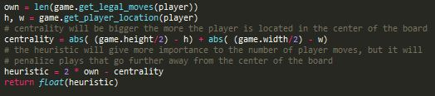The heuristic custom_score uses the number of legal player moves, and the location of the player. It gives importance to the number of legal moves, but it also penalizes moves that move away from the center of the board. The penalization will be the same either the player moves away in the x axis or in the y axis, so if it moves away in both axis it gives the double of the penalization. This will cause the agent to try to occupy the center of the board and then move away from the center in a uniform manner, but always giving importance to the number of plays available to him. This heuristic got a winning rate of 75,1 % , the only heuristic with a winning rate superior to that of the baseline.

1 - custom_score

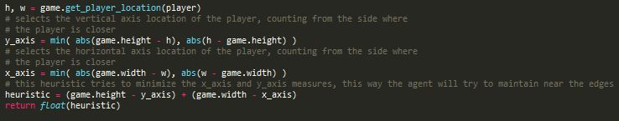The heuristic custom_score_2 uses only the location of the player. It gives better results the closer the player is to the edges of the board. Since it gives the same reward to either edge, when the player is in a corner it will give maximum score, and when the player is in the center of the board it will receive the least score possible. This heuristic got a winning rate of 70,6% .

2 - custom_score2

The heuristic custom_score_3 uses the number of legal player moves minus 2 times the number of opponent moves. This heuristic makes the agent chase after the opponent, because it gives more importance to minimize the opponent’s moves than to maximizing its own (given the choice of minimizing the opponent’s moves by 2 or maximizing its own moves by 2 this agent will choose the first alternative). This gives the impression the agent is chasing after the opponent. This heuristic got a winning rate of 72,9 % .



3 - custom_score3

The tournament.py script was run with a number of matches = 25 , five times superior to the original number of matches, in order to reduce randomness.

|  |  |  |  |  |  |  |  |  |  |
| --- | --- | --- | --- | --- | --- | --- | --- | --- | --- |
| Match# | Opponent | AB_Improved | | AB_Custom | | AB_Custom2 | | AB_Custom3 | |
|  |  | Won | Lost | Won | Lost | Won | Lost | Won | Lost |
| 1 | Random | 50 | 0 | 48 | 2 | 49 | 1 | 49 | 1 |
| 2 | MM_Open | 45 | 5 | 43 | 7 | 39 | 11 | 46 | 4 |
| 3 | MM_Center | 48 | 2 | 49 | 1 | 48 | 2 | 50 | 0 |
| 4 | MM_Improved | 39 | 11 | 41 | 9 | 38 | 12 | 39 | 11 |
| 5 | AB_Open | 26 | 24 | 25 | 25 | 27 | 23 | 23 | 27 |
| 6 | AB_Center | 31 | 19 | 29 | 21 | 24 | 26 | 27 | 23 |
| 7 | AB_Improved | 22 | 28 | 28 | 22 | 22 | 28 | 21 | 29 |
| Winning Percentage | | 74,6% | | 75,1% | | 70,6% | | 72,9% | |

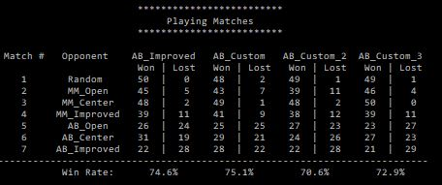

With these results we can conclude that between the 3 heuristics used, the better one is the first one, which tried to own the center of the board while paying attention to the number of legal moves. The second heuristic is worse than the first one, either because it doesn’t have into account the number of legal moves, or because owning the edges is a worse strategy than owning the center, or both. The third heuristic only has into account the number of legal moves, and in my previous tests I checked this aggressive heuristic has better results than others that only use this variable. Even so, it is worse than the first heuristic, making me believe that the best possible heuristic would have into account the number of legal moves and the location of the player.